MACHINE LEARNING FOR OBJECT ESTIMATION USING HIERARCHICAL CRITERIA SYSTEM

Andrey Styskin
Department of System Analysis
Research Nuclear University Moscow Engineering Physics Institute
115409, Kashirskoe sh. 31, Moscow, Russia
Tel: +7 926 8762705
e-mail: astyskin@gmail.com

ABSTRACT

This paper presents machine learning method to determine parameters of hierarchical criteria system for object estimation based on learning set. The hierarchical criteria model offers knowledge domain in native hierarchical view and therefore is clear to interpret. Machine learning algorithm is iterative. On each iteration it goes through hierarchy using breadth first algorithm and optimize each characteristic independently. This algorithm gives good approximation and works well for small learning set problem.

1 INTRODUCTION

In management, science and commercial field we are usually faced with multi-criteria optimization or choosing best object problems. Multi-criteria decision-analysis (MCDA) is used in such problems. But when there are many criteria the standard MCDA-methods becomes hard to use and interpret results and in this case hierarchical methods are used. In hierarchical methods object criteria are structured in tree/network form and aggregation functions are used to aggregate single criterion to more general ones. When the problem of building hierarchical models becomes regular it is good idea to machine learn the parameters of model: weights and parameters of aggregation functions. We can use expert values of objects or any other kind of ranking function output estimation for learning set objects. The resulting optimized model is well interpreted so a researcher could check the validness himself by comparing the parameter estimations with own fillings about the knowledge domain. And this approach works well for small learning set.

2 HIERARCHICAL MODEL

2.1 Model definition

While building hierarchical model[1] it is required to group and structure measures in form of tree (as we do while the Analytic Hierarchy Process[7]). Lives of such tree are called single criteria. The rest vertexes are called complex criteria. And the root is called integral criterion. Single and complex criteria differ in units in principle. Single criteria are measured in dimension units and complexes are measured in dimensionless units on interval [0; 1]. The values close to 0 indicate the small utility and in opposite values close to 1 indicate big utility. Hierarchical model present both the set of factors for knowledge domain (in form of single and complex criteria) and logical links between them. On each level there are criteria of the same generality level. Figure 1 illustrates automobile pricing problem tree:
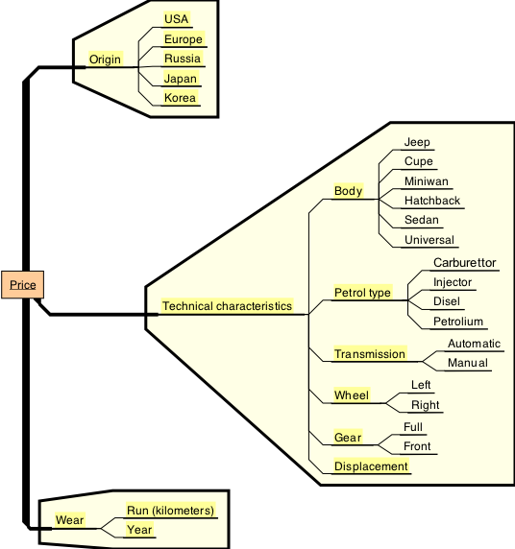

Figure 1: Hierarhical criteria system for auotomobile pricing problem.

To get estimations of objects with hierarchical model it is also required to define functional links between criteria (where logical links are). So the hierarchical model is:
- Knowledge domain organized in tree view;
- Conversion functions for dimension units that map measures to [0; 1] scale;
- Aggregation functions that aggregate several logical linked measures to more general measure

2.2 Aggregation functions

The aggregation functions are described in [2] in details.
To be recurrent the aggregation function for hierarchical model are to meet these properties:
- Input variables u₁,u₂,…,u_{m} are defined on [0,1] interval. The result of aggregation is also defined on [0, 1];
- Aggregation function is continuous and monotonous on u₁,u₂,…,u_{m};
- Aggregation function has parameters V₁,…,V_{m} (that mean children criteria weights)
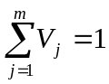;
- Edge condition:
h(1,1,…,1)=1;
h(u₁,1,…,1)<1 while u₁<l;
h(u₁,0,…,0)>0 while u₁>0;

The simplest and common used aggregation function is weighted sum:
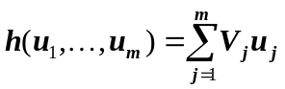
There are 5 distinct classes of aggregate functions:
- Additive function
Mathematically: 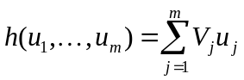
- Conjunctive – 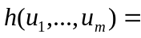1, when all u_{i}=1
- Disjunctive - 0, when all u_{i}=0
- Quasi-conjunctive – means 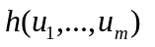is close to 1 only when all u_{i} are close to 1 and other hand is close to 0 when at least one u_{i} is close to 0.
Mathematically: 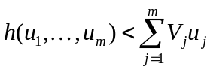
- Quasi-disjunctive – means is close to 0 only when all u_{i} are close to 0 and other hand is close to 1 when at least one u_{i} is close to 1
Mathematically: 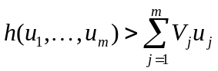

The problem of constructing aggregate function is described in [3] in details.
For example power function:
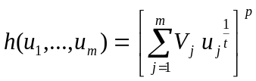where
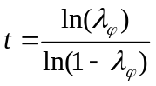 and 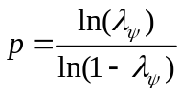
is quasi-conjunctive λ_{ψ} < 0.5 and λ_{φ} > λ_{ψ}
and is quasi-disjunctive λ_{ψ} >0.5 and λ_{φ} < λ_{ψ}
The parameters of such aggregation functions are easy to interpret and are close to logic “and” and “or” operators that are used to for describing priorities of objects.

3 MACHINE LEARNING

3.1 Problem definition

We have hierarchical model with logically linked criteria, conversion functions for single criteria and output learning set as input. We need to give such aggregation functions that gives the best estimation of output on testing set (we will mathematically define what we suppose to be the best estimation). We will search aggregation functions in form that was introduced in 2.2
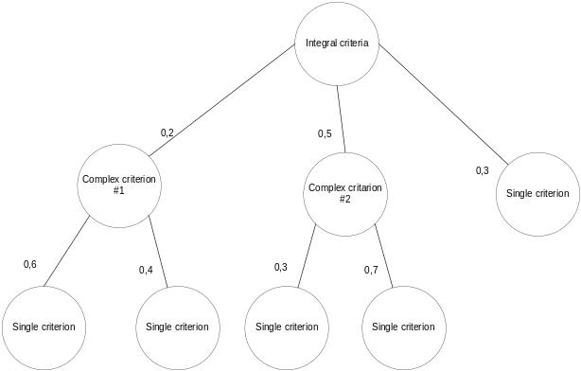
Figure 2: Hierarhical model.

Input:
Objective function:
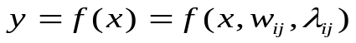, where 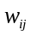- weights of j-th child of i-th complex criterion and 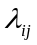- j-th parameter of i-th complex criterion
Region of acceptability for parameters:
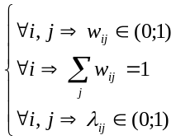
Staring points:
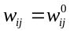
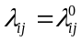
Learning set:
It is needed to choose such parameters and that
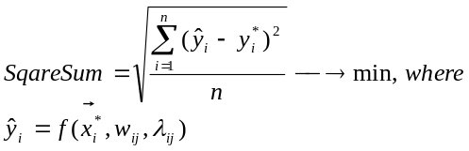

3.3 Algorithm

The iterative algorithm on each stage going through each criterion and performs the multidimensional optimization for it. Parameters of other criteria are fixed so dimensionality of optimization is the number of parameters of this particular criterion. Variables are weights and aggregation function parameters.
For optimization the algorithm for particular criteria is similar to Hook-Jeeves [3]:
- Take initiall base point b₁ (for example, randomly) and step h₁ (values about 10⁻³ works well) for each variable x_{j}, j = 1, 2,…, n. Calculate objective f(b₁) in base point b₁;
- Each variable x_{j} one by one is changed by adding h_{j}, so we calculate f (b₁+h₁e₁), where e₁ is a unit vector for x_{1.} In case:
f (b₁+h₁e₁) < f (b₁) => b₁ = b₁+h₁e₁ – new base point (we solve minimization problem)
In other case we check f (b₁-h₁e₁):
f (b₁-h₁e₁) < f (b₁) => b₁ = b₁-h₁e₁ - new base point.
If both steps didn’t decrease the objective then b₁ stays as it was and search around x₂ is started. After searching for all x_{i} we will have new base point b₂;
- If after previous step b₂ = b₁, which means that no objective decrease was done, then previous step is repeated with smaller step h_{i} =h_{i} /2
- If b₂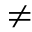b₁ then pattern search is started. The pattern search uses the fact, that the way (b₂-b₁) already gave us objective decrease, so we should move from base point b₂ this way. Calculate the value P_{i}=b_{i}+2(b_{i+1}-b_{i}) and if P_{i} < P_{i-1} continue pattern search along the (b_{i}-b_{i-1}). In other case come back to the step with search around base point
- Stop the process after several steps to prevent over optimize current particular complex criteria

Breadth first way is used to ensure uniform optimization. It was founded that the order on one level is insignificant.

3.4 Non unimodality problem
It is easy to show that SquareSum function is non unimodal. So optimization algorithm can find only local extremum.
To struggle with this property the idea of crossover (described in [5]-[6]) from genetic algorithm can be used.
We can take two trees from population, split them in the same criteria and generate two more trees made by concatenation of left side from one tree and right side of the other. The new trees should be added to population and optimized by algorithm.
Figure 3 illustrates details of splitting and creating new trees:

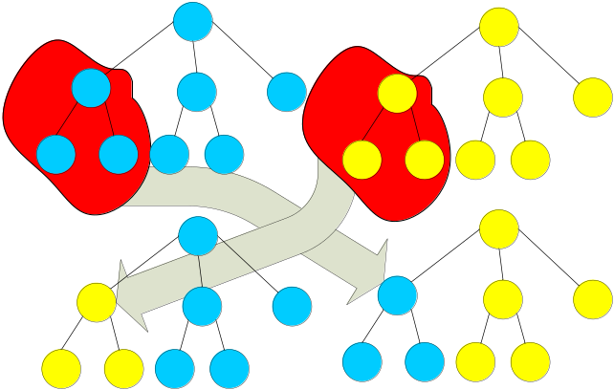
Figure 3: Crossover for two trees.

4 RESULTS

Application that helps building models and optimize their parameters was created.
The optimization is usually takes 100-200 iterations and several minutes for thousands examples with tens criteria in learning set.
The algorithm was tested on second-hand automobile pricing problem. There were about 1000 second-hand cars learning set with 9 criteria: year, run, engine, transmission, wheel, gear, petrol type, body, origin.
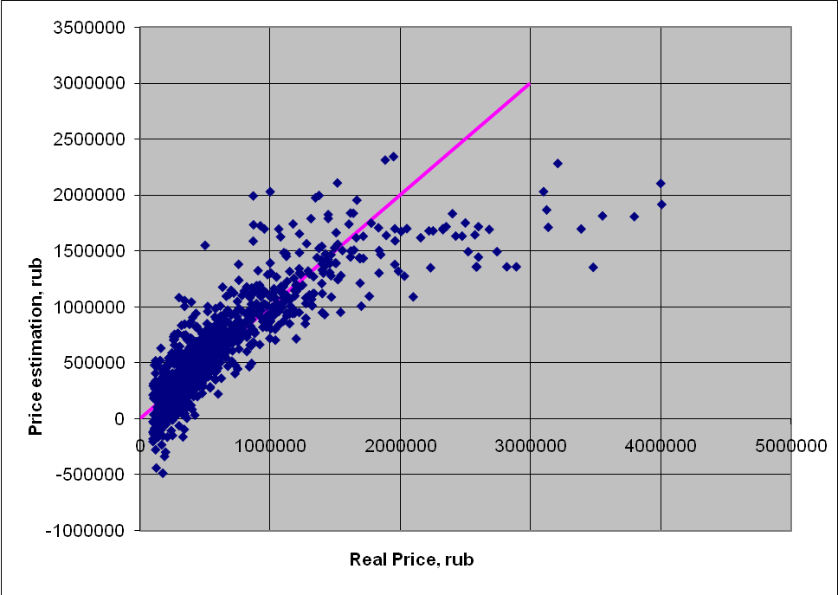
Figure 4: Estimated price to real price correlation graph for classical regression

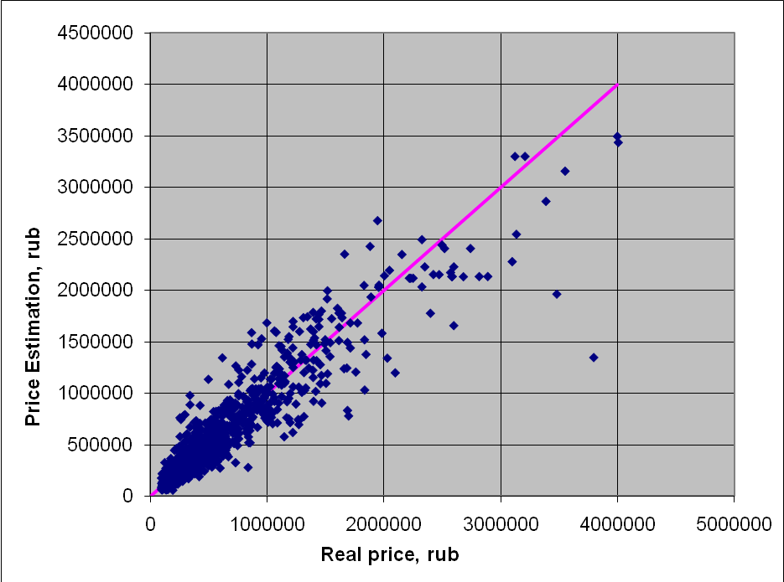
Figure 5: Estimated price to real price correlation graph for our algorithm

We compare our algorithm with classic polynomial regression (made in Weka[4]). The sum of squared residuals is compared.
There are estimated price to real price correlation graphs for classic polynomial regression on figure 5 and our method on fugure 6.

 | Classic regression | Our method
Mean sqare error | 54% | 33%

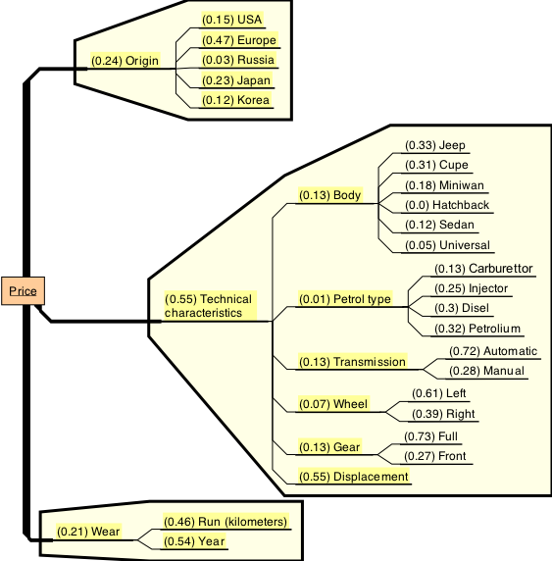

Figure 6: Hierarhical criteria system for auotomobile pricing problem with parameter estimates.

Figure 6 illustrates the hierarchical model for automobile pricing problem and its parameters after optimization with our algorithm. The weight of particular criteria are reasonable.

5 CONCLUSIONS

In this paper a new method for solving multi-criteria optimization or choosing best object problems was introduced. In comparison with classic data mining algorithms that are either black box which gives good predictions without the way to understand how and what criteria gives the best contribution or number of visualization and asking techniques which cannot be verified, our approach gives easy way both to describe knowledge domain for such problems and to score objects.
The results of second-hand automobile pricing problem indicate that the approach is good for scoring objects.

References

- Eltarenko E.A., Scoring and Choice by Multiple Criteria, MEPhI, Moscow, Russia, 2005 (in Russian)
- Eltarenko E.A., Aggregation Functions, MEPhI, Moscow, Russia, 2006 (in Russian)
- Hook, R. and Jeeves, T., “Direct Search Solution of Numerical and Statical Problems”, J. Assoc. Comput, 1961
- I. H. Witten, E. Frank (2005) "Data Mining: Practical machine learning tools and techniques," 2. edition, Morgan Kaufmann, San Francisco, 2005
- G. Sywerda, “Uniform crossover in genetic algorithms,” Proceedings of the 3rd International Conference on Genetic Algorithms, USA, 1989.
- J. Page, P. Poli, and W.B. Langdon, “Smooth uniform crossover with smooth point mutation in genetic programming: A preliminary study, Genetic Programming,” Proceedings of EuroGP’99, Sweden, 1999.
- Saaty, T.L.,“Decision making with the analytic hierarchy process”, Int. J. Services, Sciences, Vol. 1, No. 1, pp.83–98., 2008

