# CHAPTER 6: USER GUIDELINE

## **6.1. Guest**

1. **Guest accesses website with link:** [www.lowhope.com](http://www.lowhope.com)

 **2. Search challenge game**

On navigator guest click to button “Tìm kiếm thử thách”



Search page will display

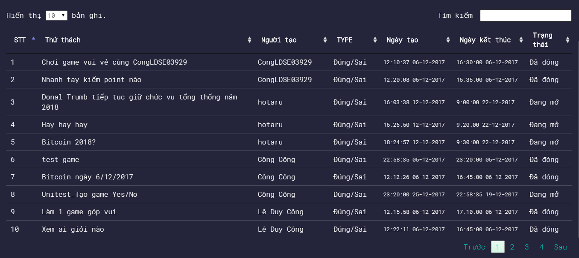

Guest can search anything in “Tìm kiếm” field

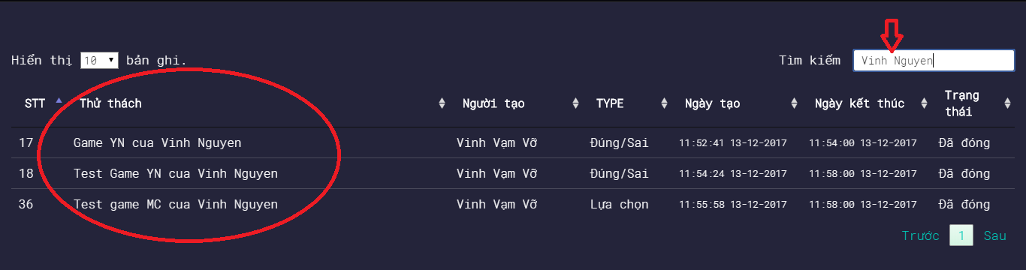

Search results are displayed. Guest can click to name of challenge to view details

**3. View details challenge**

On homepage, all challenges game was displayed

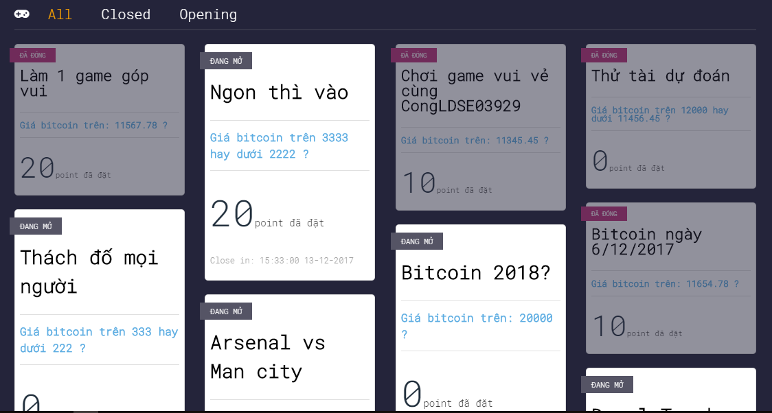

Guest clicks to each item and will be redirected to the challenge detail page

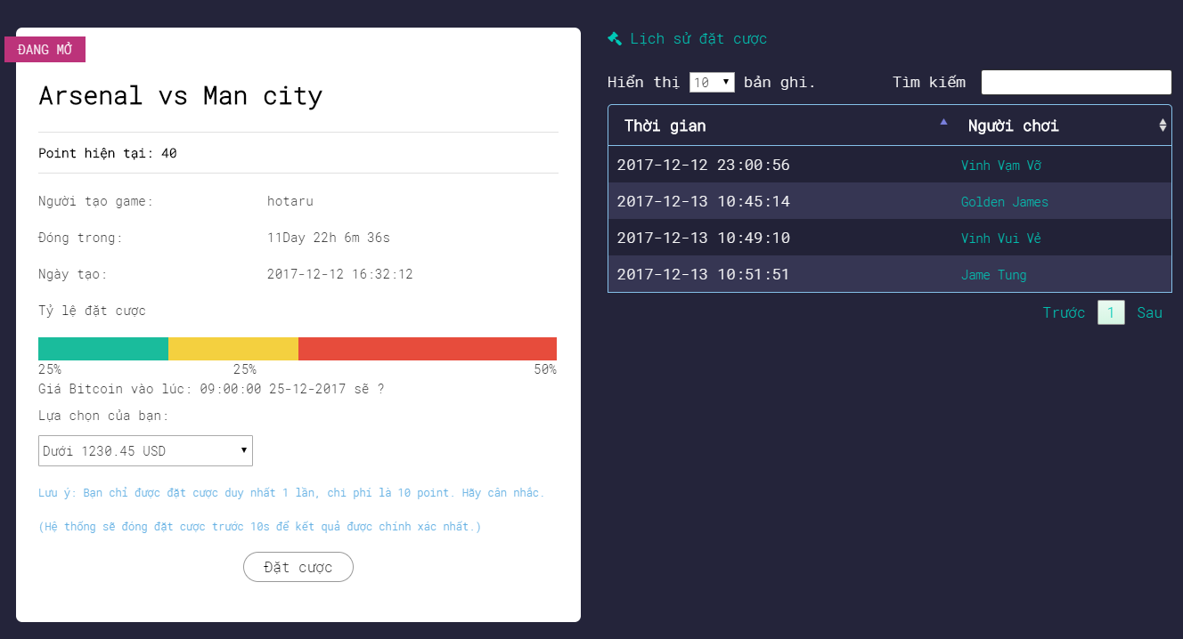

**4. Register**

4.1 Normal Account

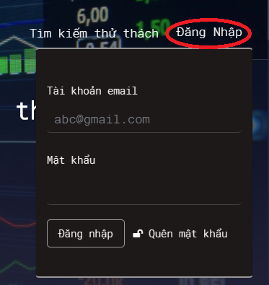

Guest click to button “Đăng nhập”, panel will appear

Guest fill email and password to fields and click button “Đăng nhập”.   
(Note: Password must contain number, letter, at least one uppercase and special character)

4.2 Google and Facebook account

If guest has Google account click to button “Google”, or click button “Facebook” if using Facebook account



After login success with Google or Facebook account, update information page will appear

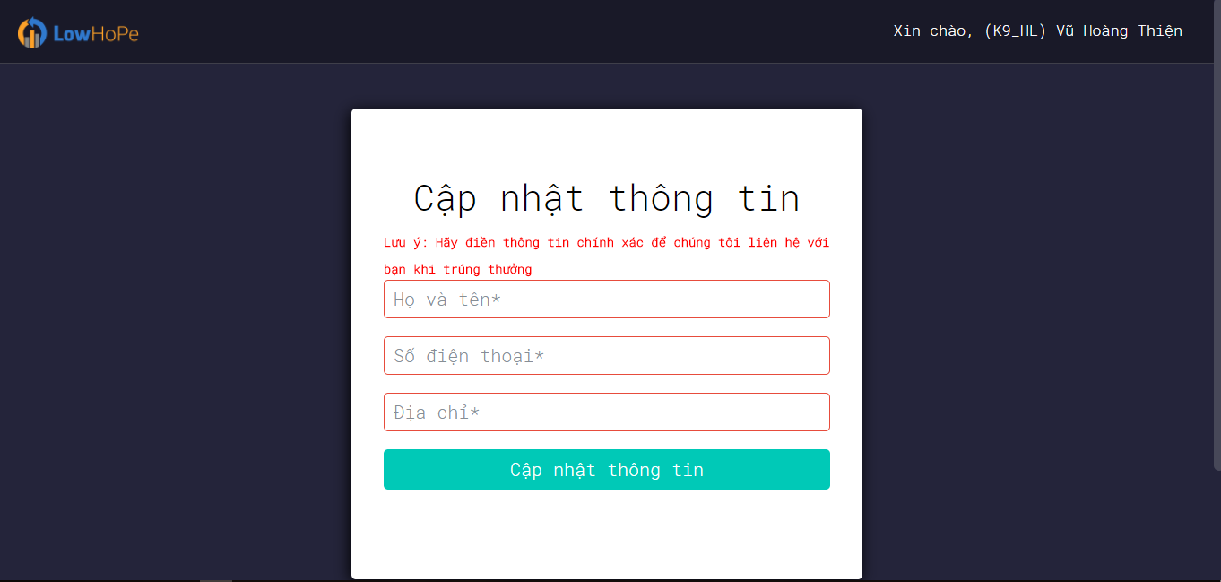

Fill correct data in all fields and click button “Cập nhật thông tin”. Welcome to the heaven.

## **6.2. Player**

After login success, main page was displayed

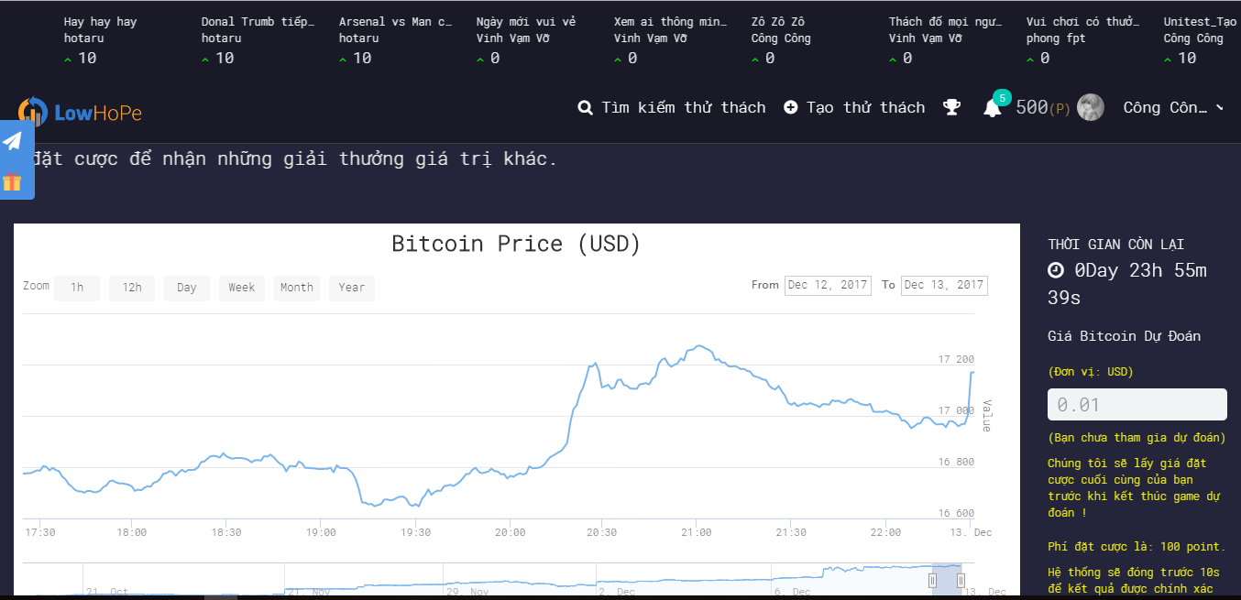

**A.** **How to play traditional game?**

Traditional game is question of about price of bitcoin at a specified date.

Betting cost of traditional game is 100 points.



Your answer is filled in here

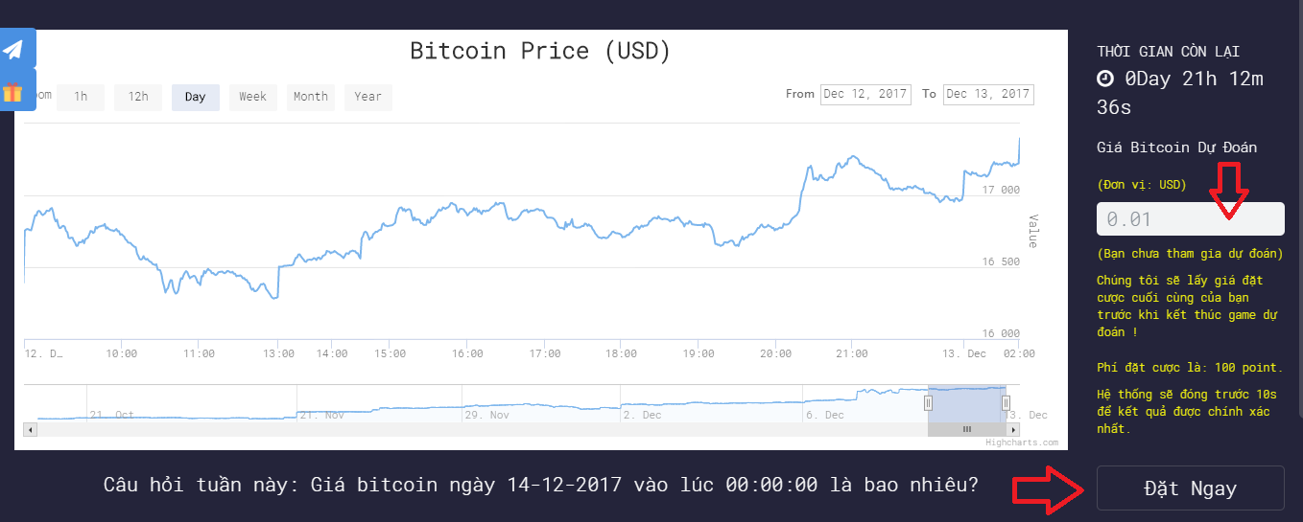

**B.** **How to play challenges?**

Challenges are questions that players create themselves and another player will answer that question (each item in slide is challenge). Player will receive or lost point after challenges close because theirs answer. Don’t worry about cheat, results after challenges close are automatic processing, not affected by humans.

There are some rules as follows:

* New player will be received 500 points.
* First time login in the day will be received 20 points.
* Betting cost of each challenge is 10 points.
* Correct answer will receive 20 points.
* Each challenge has maximum of 40 participants.
* Costs create challenges is 50 points

**Step by step to play challenge**

1. Click to the item on slide

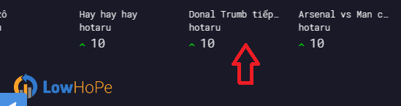

Or click button “Tìm kiếm thử thách”, search page will display.



Search challenge you want to play (you can search by name, author, status, date-created, end date)



Click to the name challenge then will be redirected to the challenge detail page.

2. Betting page appears

2.1. Yes/No Challenge

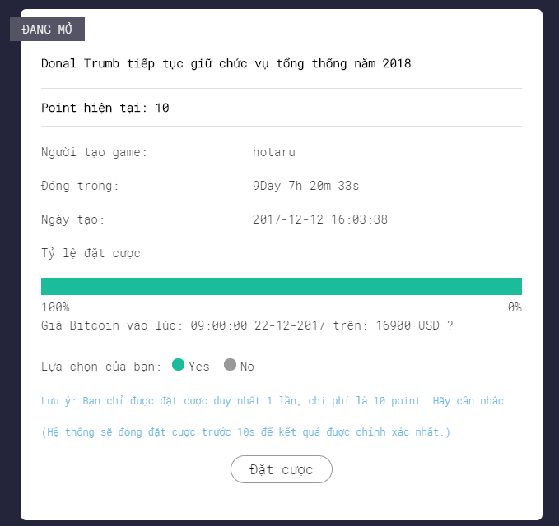

Click Yes or No to select your answer for this question.

Finally, click button “Đặt cược” and waiting for result.

2.2. Multiple choice challenge

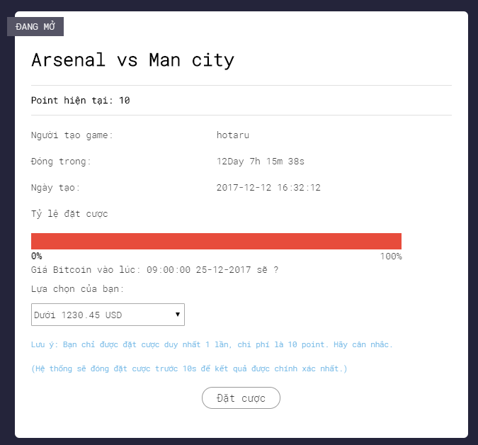

Select your answer in select options. Finally, click button “Đặt cược” and waiting for result.

**C.** **How to create challenges?**

1. Click button “Tạo thử thách” on navigation bar



2. Popup create challenge display.

2.1 Tab Yes/No challenge

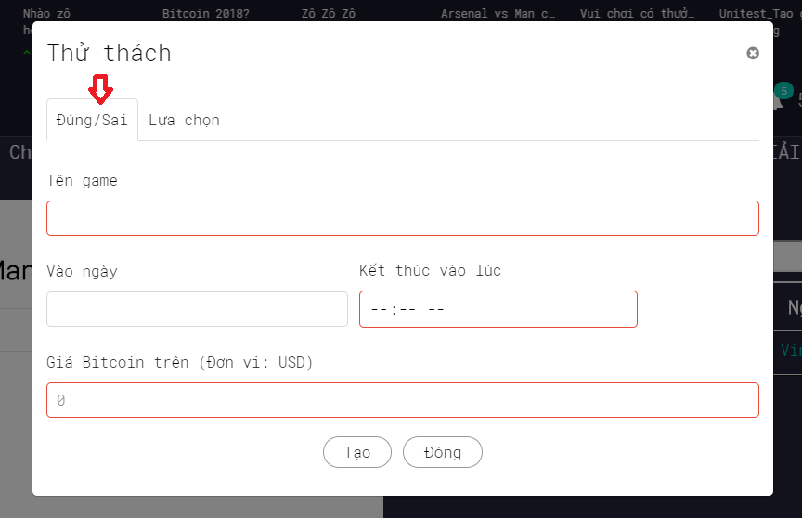

Next, fill correct data in all fields and click button “Tạo”.

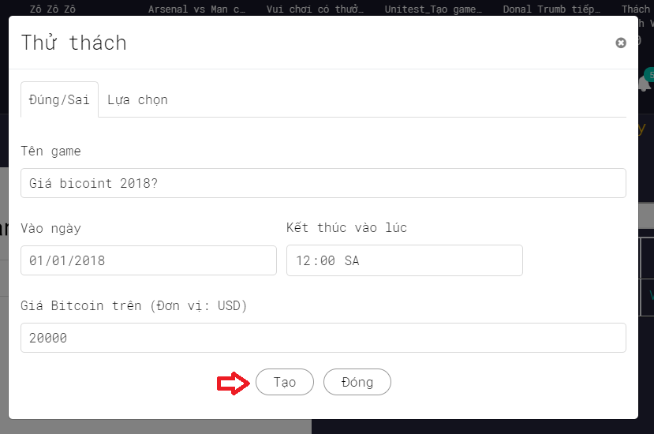

After create success, challenge detail will be displayed.

2.2 Tab Multiple choice challenge

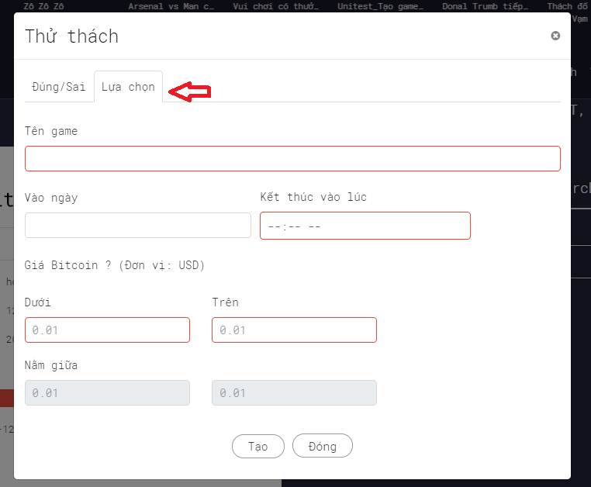

Next, fill correct data in all fields and click button “Tạo”.

