**MINISTRY OF EDUCATION AND TRAINING VIET NAM**

**FPT UNIVERSITY**

Capstone Project Document

[Low or High Price]

|  |  |  |
| --- | --- | --- |
| Low or High Price **Group** | | |
| **Group Members** | Lê Duy Công | SE03929 |
| Nguyễn Thanh Tùng | SE03924 |
| Trần Hồng Quân | SE03733 |
| Nguyễn Văn Vinh | SE03927 |
| Phong |  |
| **Supervisor** | **Mr. Trần Bình Dương** | |
| **Capstone Project code** | LowHoPe | |

Ha Noi 5th Oct, 2017

**Acknowledge**

We specially thank to Mr. Tran Binh Duong, our supervisor, for  
his support throughout this project. His instruction and  
motivation has been lessons for us not only about technique,   
but also about how to work as a team in a real project.  
We also thank to our families and friends. Their encouragement  
has helped us to overcome many pressure to complete our  
product

# CHAPTER 1: INTRODUCTION

## **Purpose**

The purpose of this chapter is to provide an overview of Low or High Price web service and why we chose it. And we also show Idea, solution, some basic functions in this project. Besides, we have some benefit and limitation in the project. Thereby, we will research orientation of future.

## **Project Information**

|  |  |
| --- | --- |
| **Project name** | Low or High Price |
| **Project code** | LowHoPe |
| **Project type** | Website |
| **Project manager** | Trần Hồng Quân |
| **Start** | 6ᵗʰ 10, 2017 |

### **Project members**

* **Supervisor:**

|  |  |  |
| --- | --- | --- |
| Full name | E-mail | Title |
| Trần Bình Dương | **duongtb@fpt.edu.vn** | **Lecturer** |

* **Team Members:**

|  |  |  |  |
| --- | --- | --- | --- |
| Full name | Roll Number | E-mail | Phone |
| **Tran Hong Quan** | SE03733 | Quanthse03733@fpt.edu.vn | 0962575594 |
| **Le Duy Cong** | SE03929 | Congldse03929@fpt.edu.vn |  |
| **Nguyen Thanh Tung** | SE03924 | Dungltse02166@fpt.edu.vn | 0974803191 |
| **Nguyen Van Vinh** | SE03927 | Vinhnvse03427@fpt.edu.vn |  |
| **Nguyen Huy Phong** |  |  |  |

### **Problems**

In the world today, the electronic money market is growing. There are many types of electronic money but the most popular nowadays is bitcoin. However, there are few websites can provide exact information about bitcoin prices; bitcoin prediction market and exchange or bitcoin game. So if there is a secure website can provide bitcoin prediction market and exchange, it is really convenient for people who are interested in electronic money.

### **Solution**

Creating a website provides exact information about market fluctuates bitcoin prices every day. Creating bitcoin prediction game and exchange market bitcoin. So the website will help people who are interested in bitcoin.

### **Existed system**

**SIMPLEFX**

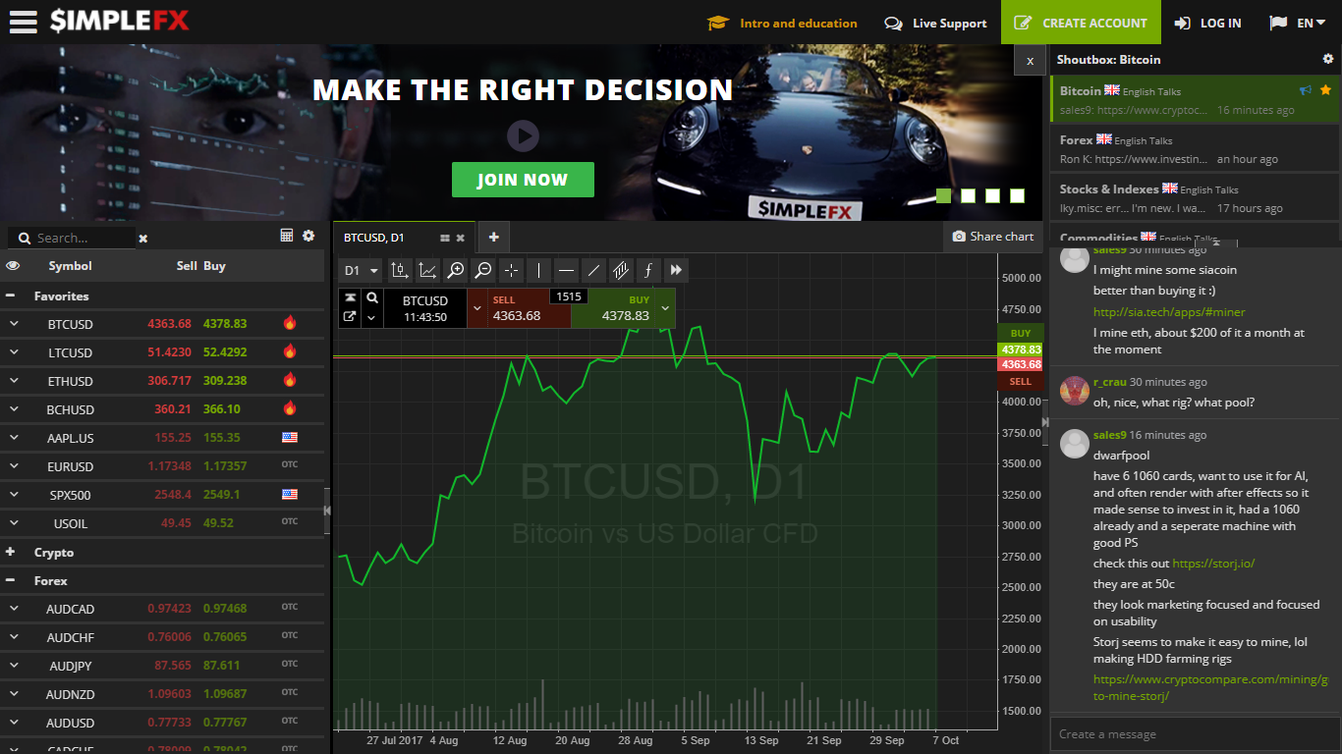

This website introduces advanced trading methods with the Electronic money especially bitcoin. The website allow users to exchange (buy or sell) electronic money, update bitcoin prices fluctuate all of time.

* Advantages:
* Power supply electronic money prices superfast.
* Support almost needed features about exchange electronic money.
* Update exact electronic money prices all of time.
* Disadvantages:
* Complicate.

**IQOPTION**

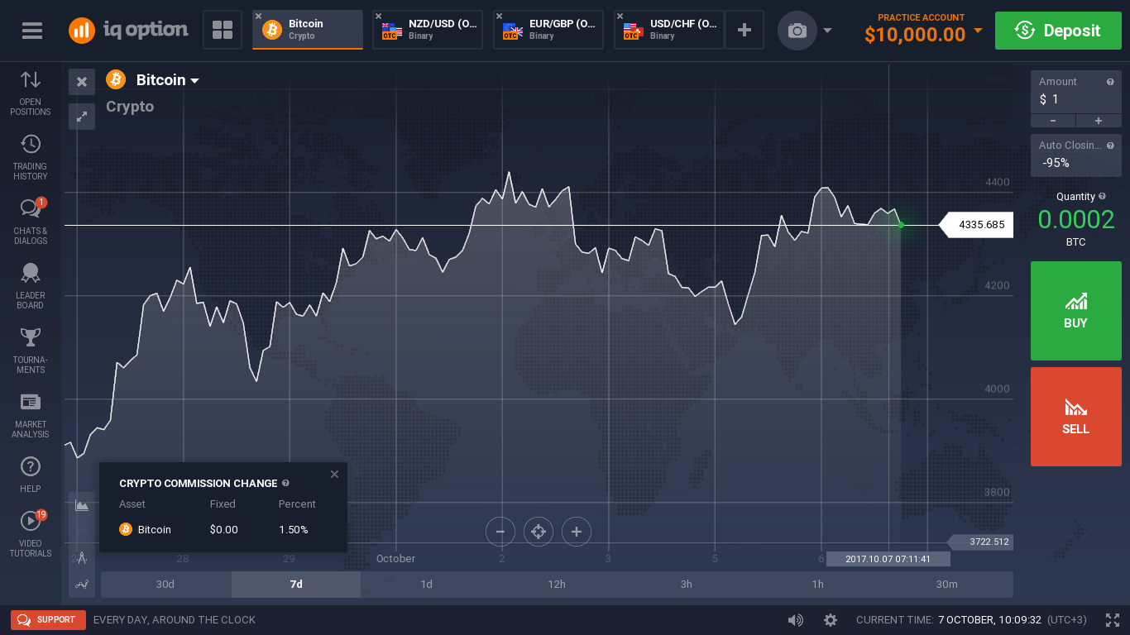

This website introduces advanced trading methods with the Electronic money especially bitcoin. The website allow users to exchange (buy or sell) electronic money, update bitcoin prices fluctuate all of time.

* Advantages:
* Power supply electronic money prices superfast.
* Support almost needed features about exchange electronic money.
* Update exact electronic money prices all of time.
* Disadvantages:
* Complicate.

### **Our Proposal**

We will develop a single website bitcoin prediction market and betting exchange that support people who are interested in bitcoin.

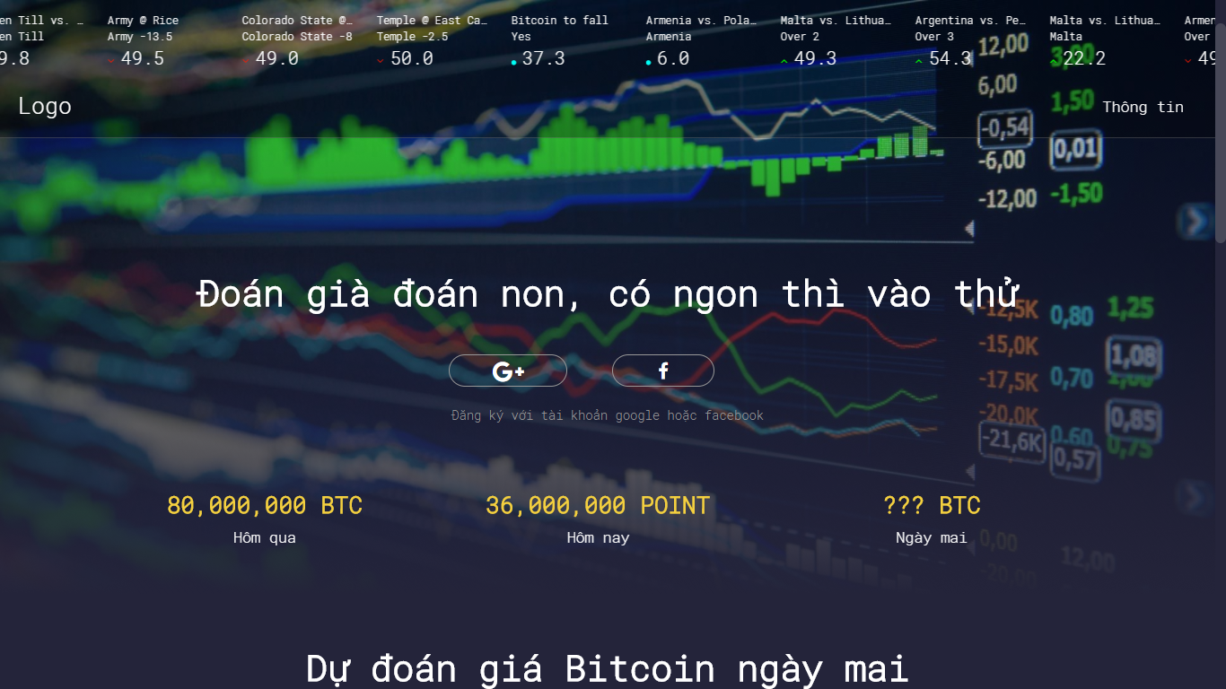

* We create some game bitcoin leading betting exchange. The essence of a betting exchange is that you don’t bet against the house, you bet against other users.
* Our website sets up the market, matches bettors each other and pays out the winner with the losers’ money.
* We update exact bitcoin prices all of time. It is showed by chart.
* Most of our predictions are on bitcoin prices betting.
* Our combination of a 0% fee policy, automation friendly UI (API) are the foundation of our outstanding odds.
* No account needed.

