**MINISTRY OF EDUCATION AND TRAINING VIET NAM**

**FPT UNIVERSITY**

Capstone Project Document

[Low or High Price]

|  |  |  |
| --- | --- | --- |
| Low or High Price **Group** | | |
| **Group Members** | Lê Duy Công | SE03929 |
| Nguyễn Thanh Tùng | SE03924 |
| Trần Hồng Quân | SE03733 |
| Nguyễn Văn Vinh | SE03927 |
| Phong | SE03697 |
| **Supervisor** | **Mr. Trần Bình Dương** | |
| **Capstone Project code** | LowHoPe | |

Ha Noi 5th Oct, 2017

**Acknowledge**

We specially thank to Mr. Tran Binh Duong, our supervisor, for  
his support throughout this project. His instruction and  
motivation has been lessons for us not only about technique,   
but also about how to work as a team in a real project.  
We also thank to our families and friends. Their encouragement  
has helped us to overcome many pressure to complete our  
product

Table of Contents

CHAPTER 1: INTRODUCTION 4

**1.1** **Purpose** 4

**1.2** **Project Information** 4

**1.2.1** **Project members** 5

**1.2.2** **Problems** 5

**1.2.3** **Solution** 6

**1.2.4** **Existed system** 6

**1.2.5** **Our Proposal** 8

# CHAPTER 1: INTRODUCTION

## **Purpose**

The purpose of this chapter is to provide an overview of Low or High Price web service and why we chose it. And we also show Idea, solution, some basic functions in this project. Besides, we have some benefit and limitation in the project. Thereby, we will research orientation of future.

## **Project Information**

|  |  |
| --- | --- |
| **Project name** | Low or High Price |
| **Project code** | LowHoPe |
| **Project type** | Website |
| **Project manager** | Trần Hồng Quân |
| **Start** | 6ᵗʰ 10, 2017 |

### **Project members**

* **Supervisor:**

|  |  |  |
| --- | --- | --- |
| Full name | E-mail | Title |
| Trần Bình Dương | **duongtb@fpt.edu.vn** | **Lecturer** |

* **Team Members:**

|  |  |  |  |
| --- | --- | --- | --- |
| Full name | Roll Number | E-mail | Phone |
| **Tran Hong Quan** | SE03733 | Quanthse03733@fpt.edu.vn | 0962575594 |
| **Le Duy Cong** | SE03929 | Congldse03929@fpt.edu.vn |  |
| **Nguyen Thanh Tung** | SE03924 | Dungltse02166@fpt.edu.vn | 0974803191 |
| **Nguyen Van Vinh** | SE03927 | Vinhnvse03427@fpt.edu.vn |  |
| **Nguyen Huy Phong** |  |  |  |

### **Problems**

In the world today, the electronic money market is growing. There are many types of electronic money but the most popular nowadays is bitcoin. However, there are few websites can provide exact information about bitcoin prices; bitcoin prediction market and exchange or bitcoin game. So if there is a secure website can provide bitcoin prediction market and exchange, it is really convenient for people who are interested in electronic money.

### **Solution**

Creating a website provides exact information about market fluctuates bitcoin prices every day. Creating bitcoin prediction game and exchange market bitcoin. So the website will help people who are interested in bitcoin.

### **Existed system**

**SIMPLEFX**

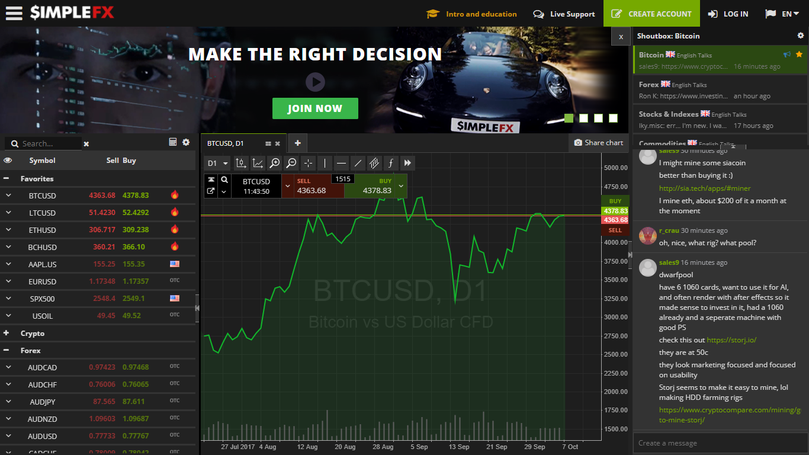

This website introduces advanced trading methods with the Electronic money especially bitcoin. The website allow users to exchange (buy or sell) electronic money, update bitcoin prices fluctuate all of time.

* Advantages:
* Power supply electronic money prices superfast.
* Support almost needed features about exchange electronic money.
* Update exact electronic money prices all of time.
* Disadvantages:
* Complicate.

**IQOPTION**

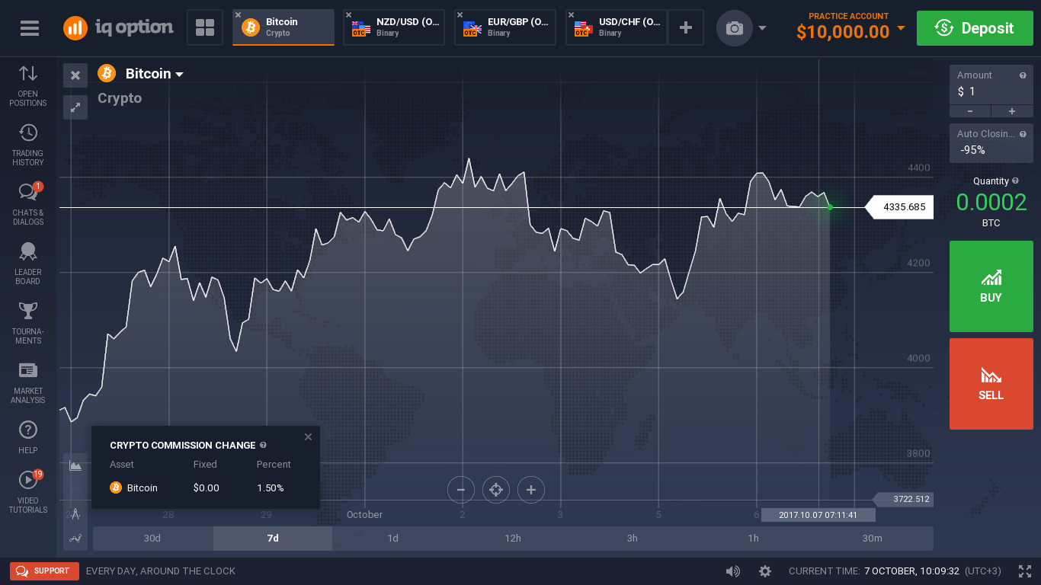

This website introduces advanced trading methods with the Electronic money especially bitcoin. The website allow users to exchange (buy or sell) electronic money, update bitcoin prices fluctuate all of time.

* Advantages:
* Power supply electronic money prices superfast.
* Support almost needed features about exchange electronic money.
* Update exact electronic money prices all of time.
* Disadvantages:
* Complicate.

### **Our Proposal**

We will develop a single website bitcoin prediction market and betting exchange that support people who are interested in bitcoin.

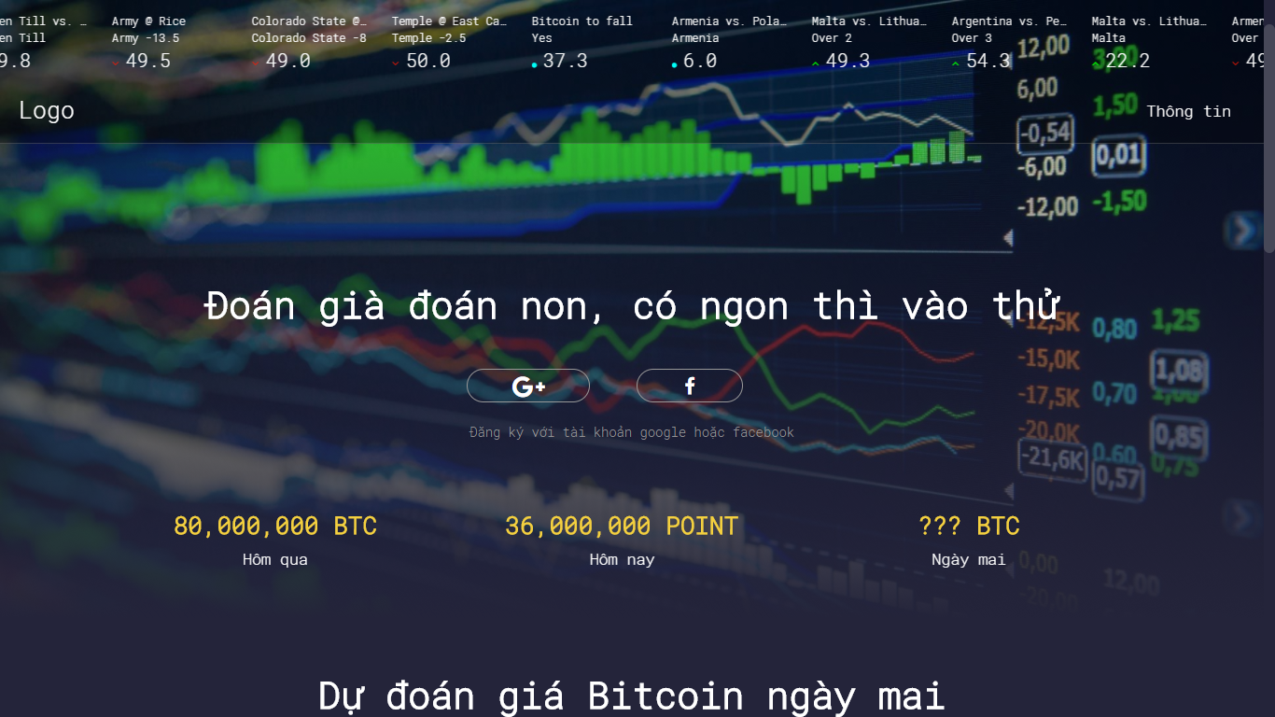

* We create some game bitcoin leading betting exchange. The essence of a betting exchange is that you don’t bet against the house, you bet against other users. The web will have the below main functions:
* Daily game
  + Game is played everyday
  + Each day is played only once
  + Allows to roll dice, players choose parity. Winning 50 points.
* Yes or No game.
  + Allows the player to make game bitcoin betting, exchange with answer Yes - No.
* Multiple choice game.
  + Allows players to create multiple choice games about bitcoin prices.
* Our website sets up the market, matches bettors each other and pays out the winner with the losers’ money.
* We update exact bitcoin prices all of time. It is showed by chart.
* Most of our predictions are on bitcoin prices betting.
* Our combination of a 0% fee policy, automation friendly UI (API) are the foundation of our outstanding odds.
* No account needed.

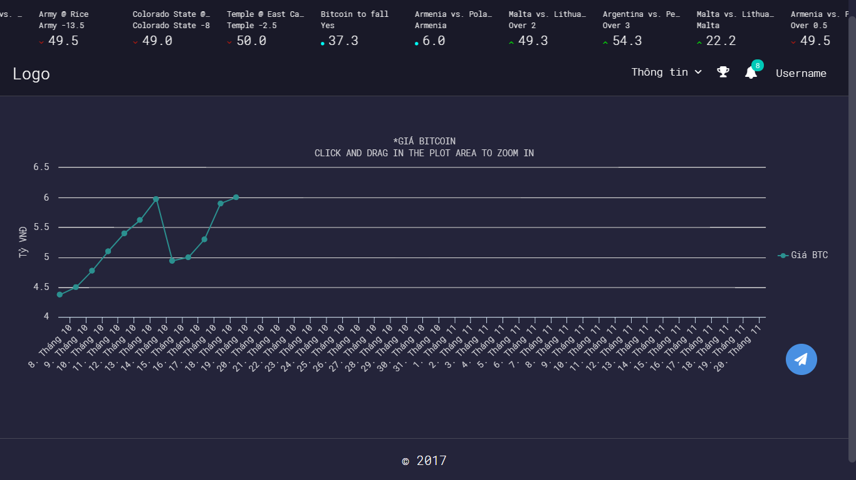

# CHAPTER 2: SOFTWARE PROJECT MANAGEMENT PLAN

## **2.1. Purpose**

In this chapter, we will talk about the specific roles of the project team members. Plan and organize the project, the responsibilities of the members in each task. Project team members use this document to know their responsibilities and actions in the project.

## **2.2. Problem Definition**

### **2.2.1. Name of this Capstone Project**

* **Capstone project name:** Low or High Price**.**
* **Abbreviation:** LowHPe

### **2.2.2. Problem Abstraction**

The electronic money market is growing and the most popular nowadays is bitcoin. There are a lot of websites where providing bitcoin prediction market and exchange (buy or sell) but there are very few game website about bitcoin for people who want to play some bitcoin betting games.

People feel bored with bitcoin websites that only bitcoin exchange (buy or sell).

Everyone has difficulty finding a bitcoin website that can update exact information about bitcoin prices and be entertained to play bitcoin betting games.

### **2.2.3. Project Overview.**

#### **2.2.3.1. Project description.**

In this project, we will develop an website with PHP to provide bitcoin prediction market and exchange through game bitcoin betting. User login website to play game bitcoin betting and update exact information about bitcoin prices all of times. This website will help user feel interesting. It is not boring as other bitcoin website. The website will be designed to be easy to use.

#### **2.2.3.2 Scope.**

This project covers all processes, from planning, requirement, specification, design, development, to testing. Project team will develop a website with PHP for user to play game bitcoin betting and update exact information about bitcoin, and a server to manage database crawling.

* **Functional requirements:**

The website allows user to play game bitcoin betting and update exact information about bitcoin. The server is developed for Admins and Manager of website. Admins and Manager can login, logout, manage their profile, manage database (upload, edit, delete). Admin can add/edit/delete manager’s account.

* **Non-functional requirements:**

The website must be design for user’s convenience and easy to use. Interface design should be beautiful looking and easy to understand.

#### **2.2.3.3. Standard Objectives.**

* This project must be finished no later than 15/12/2017.
* The final Application covers 100% of requirements.
* The 5 team members give best effort to complete the project.

#### **2.2.3.4. Development Environment.**

|  |  |  |
| --- | --- | --- |
|  | **Minimum Requirements** | **Recommended** |
| Internet Connection | Cable, Wi-Fi (4 Mbps) | Cable, Wi-Fi (8 Mbps) |
| Computer Processor | Intel® Core™ i3 | Intel® Core™ i7 |
| Computer Memory | 4 GB | 8 GB or more |
| Web Browser | Google Chrome 60.0.3112.101 | Google Chrome 60.0.3112.101 or higher |
| Operation System | Window 7 | Window 10 |

#### **2.2.3.5. Milestones and Deliverables.**

##### **2.2.3.5.1 Milestones**

|  |  |  |  |
| --- | --- | --- | --- |
| **No.** | **Task** | **Start date** | **End date** |
|  | Approve Project’s initial idea | 06/09/2017 | 06/09/2017 |
|  | Create and submit report 1: Introduction | 12/09/2017 | 16/09/2017 |
|  | Create and submit report 1: Management Plan ver1.0 | 22/09/2017 | 26/09/2017 |
|  |  |  |  |

##### **2.2.3.5.2 Deliverables**

|  |  |  |  |  |  |
| --- | --- | --- | --- | --- | --- |
| **No** | **Deliverables** | **Format** | **Delivery date** | **Verified by** | **Deliver Medium** |
|  | Approve Project’s initial idea |  |  |  |  |

## **2.3. Project organization**

### **2.3.1 Software Process Model**

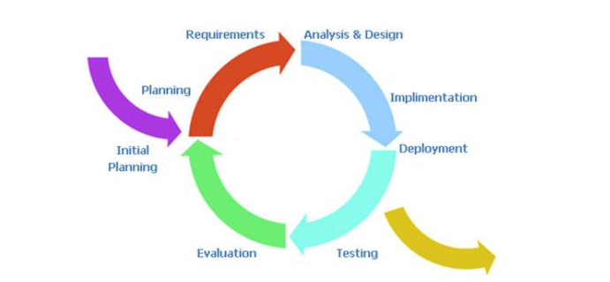

Figure 4: Iterative and Incremental process model

The reason why the project team chooses Iterative & Incremental software process model:

* This model is more flexible – less costly to change scope and requirements.
* Reduce the risk of delay due to the important work done first.
* Establish a good relationship between users and developers. Project team will always communicate with users to obtain information to meet the needs of users.
* Repetition of the phases can be built so that the system really met the demand of users
* Through every iterative, we can control scope and requirements, flexibly update or even change things if we think it will help us to have a better product.
* It is easy to manage risk by dividing it into pieces and solve it as quick as possible in each iterative.

### **2.3.2 Software Process Model**

#### **2.3.2.1 Team organization structure**

**Tran Binh Duong**

**Supervisor**

**Tran Hong Quan**

**PM**

**Nguyen Thanh Tung**

**Nguyen Van Vinh**

**Nguyen Thanh Tung**

**Le Duy Cong**

**Tran Hong Quan**

**QA & SRS Leader**

**Backend Leader**

**Testing Leader**

**FD Leader**

**Analysis&design Leader**

**Le Duy Cong**

**Tester #3**

**Le Huy Phong**

**Tester #2**

**DEV #2**

**DEV #1**

**Tester #1**

**Nguyen Van Vinh**

**Tran Hong Quan**

**Member #1**

**Designer #1**

**Le Huy Phong**

**Tran Hong Quan**

**Le Huy Phong**

**Nguyen Van Vinh**

**Le Duy Cong**

**Member #2**

**Nguyen Thanh Tung**

**Member #3**

**Tester #4**

#### **2.3.2.2. Roles and responsibilities**

|  |  |  |  |
| --- | --- | --- | --- |
| **Role** | **Full Name** | | **Quality Responsibility** |
| **Instructor** | Project Management | | - Give instruction for project team.  - Verify deliverables.  - Supervise project team’s status |
| **PM** | Tran Hong Quan | | Have overall responsibility of the project  - Create project plan  - Assign task to team members  - Tracking team member’s work  - Report work status to the instructor |
| * **Requirement analysis team** | | | |
| **QA & SRS Leader** | Nguyen Thanh Tung | | - Complete SRS Document and submit to PM.  - Manage the Quality Assurance function  - Audits and approve project deliverables from QA perspective. Review plans and deliverables for compliance with applicable standards. Provides guidance and assistance on process matters |
| * **Analysis and Design Team** | | | |
| **Analysis**  **&design leader** | Tran Hong Quan | - Analysis and design ideas for website and database | |
| **Member #1** | Nguyen Van Vinh | - Support in design for website | |
| **Member #2** | Le Duy Cong | - Support in design for database | |
| **Member #3** | Nguyen Thanh Tung | - Drawing details for entity relationship diagram. | |
| * **Front-end Design Team** | | | |
| **Front-end Design leader** | Nguyen Van Vinh | - Design interface for website screen. | |
| **Designer #2** | Le Huy Phong | - Support in design interface for screen website | |
| * **Backend Team** | | | |
| **Backend leader** | Le Duy Cong | - Train other member of website with PHP development  - Create coding convention  - Decide technique and tools to be used  - Develop Website with PHP  - Create SDD  - Code backend | |
| **DEV #1** | Tran Hong Quan | - Research on web crawler  - Code for crawl data  - Code for database related functions of website with php | |
| **DEV #2** | Le Huy Phong | - Code for database related functions of website with php | |
| * **Test Team** | | | |
| **Testing Leader** | Nguyen Thanh Tung | - Responsible for test execution, including test set-up and test run, evaluation of test run and error recovery, defect logging and test results recording.  - Create test plan  - Create test cases  - Execute text cases  - Report test result | |
| **Tester #1** | Tran Hong Quan | - Create test cases  - Execute text cases | |
| **Tester #2** | Nguyen Van Vinh | - Create test cases  - Execute text cases | |
| **Tester #3** | Le Huy Phong | - Create test cases  - Execute text cases | |
| **Tester #4** | Le Duy Cong | - Create test cases  - Execute text cases | |

### **2.3.3 Tool and Techniques.**

#### **2.3.3.1. Hardware**

- Personal computer for coding and testing with minimum configuration of 2GB RAM, 80GB of hard disk, Intel core 2 Duo.

- Internet network connection.

#### **2.3.3.2. Software**

|  |  |  |
| --- | --- | --- |
| Category | Software Name | Version |
| Operating system | Microsoft Windows 10 | Professional |
| Office tools | Microsoft word | 2013 |
| Microsoft Excel | 2013 |
| Microsoft Power Point | 2013 |
| Management Tool | Microsoft Project | 2013 |
| Trello |  |
| upm.fpt.edu.vn |  |
| Design Tool | Astah professional | 6.9.0 |
| Adobe ILLustrator | 2017 |
| Mysql Workbench | 6.3.9 |
| Development Tools | Sublime Text 3 |  |
| Visual Studio | 2015 |
| Database Tools | SQLite manager | 0.8.1 |
| MySQL |  |
| Source code management Tool | Github.com |  |
| Programming Language | C#, JavaScript, HTML, CSS, Bootstrap, PHP. |  |

## **2.4. Schedules**

## **2.5. Communication Management**

### **2.5.1 Stakeholders and Contacts**

|  |  |  |  |
| --- | --- | --- | --- |
| **Name** | **Title** | **Role** | **Contacts** |
| Tran Binh Duong | Mr. | Supervisor | [duongtb@fpt.edu.vn](mailto:duongtb@fpt.edu.vn)  (84) 936-168-165 |
| Tran Hong Quan | Mr. | PM | quanthse@fpt.edu.vn |
| Le Duy Cong | Mr. | Developer |  |
| Nguyen Van Vinh | Mr. | Front-end design |  |
| Le Huy Phong | Mr. | Developer |  |
| Nguyen Thanh Tung | Mr. | QA ; SRS Document and Tester |  |

### **2.5.2 Communication Management Approach.**

Project team communicate frequently to ensure the progress of each member’s work. Project manager report to the Supervisor frequently and honestly so that the Supervisor can track the team’s work and give support/advice as need.

All request for change or proposal of new ideal must be discussed in team. If project team agree to change, project team must then discuss with the Supervisor. Once the change is approved, project manager will update the plan and to project team and Supervisor.

The communications requirements are documented in the Communications Matrix of This document. The Communications matrix will be used as guide for what/when/how/who/whom to communicate throughout the project.

### **2.5.3 Communication Requirements**

The project manager will communicate with the Supervisor in order to determine his preferred frequency and time of communication.

As all project team members still take part in classes while doing project, project manager should communicate to understand their schedule, and therefore specify appropriate communication plan for the team.

### **2.5.4 Communication Method and Technologies**

- Create a Facebook private group for team member to discuss and share informal information and activity. This would be a place for member to communicate freely, and therefore would help in strengthen relationship between members.

- Use Google docs to share documents.

- Public weekly reports of team members in Google docs to keep them writing report. This will help project manager in tracking work of team members, and also help team member understand progress of the others.

- Update Work schedule before weekly meeting with Supervisor.

### **2.5.5 Communication Matrix**

|  |  |  |  |  |  |  |  |
| --- | --- | --- | --- | --- | --- | --- | --- |
| **Communication Type** | **Objective** | **Medium** | **Frequency** | **Audience** | **Owner** | **Deliverable** | **Format** |
| Kickoff Meeting | Discuss and agree on project objective, and scope | - Face to face | Once (At the start of the project) | - Instructor - Project Team | Project Manager | Meeting Minutes | - Soft copies on  Microsoft Word |
| Project Team Meeting | Review status of the project. Discuss solutions for any raised issues. Assign tasks for team members | - Face to face - Email - Conversation (Skype) | 3 times per week, base on personal schedule. | - Project Team | Project Manager | - Project schedule - Assigned tasks | - Soft copies on  Microsoft Word - Assigned tasks on  Trello |
| Project Plan Meeting | Discuss and planning project process | - Face to face - Email - Conversation (Skype) | As needed | - Project Team | Project Manager | - Meeting Minutes - Project Management Plan | - Soft copies on  Microsoft Word - WBS on Microsoft Project |
| Architecture Design Meeting | Review prototype Discuss, contribute and review System Architecture Design | - Face to face - Email | As needed | - Project Team | Backend Leader | - Meeting Minutes - System Architecture Design Document | - Soft copies on Microsoft Word - System Architecture Design on Astah |
| GUI Design Meeting | Discuss, contribute and review GUI Design | - Face to face - Email | As needed | - Project Team | Front-end Leader | - Meeting Minutes - GUI Design -Document | - Soft copies on Microsoft Word - GUI Design on Photoshop |
| Database Design Meeting | Discuss, contribute and review Database Design | - Face to face | As needed | - Project Team | Backend Leader | - Meeting Minutes - Database Design | - Soft copies on Microsoft Word |
| Test Plan Meeting | Discuss, and review Test Plan | -Face to face | As needed | Project team | -Front-end leader  -Backend leader | -Meeting Minutes  -Test Plan | -Soft copies on  Microsoft Word |

|  |  |  |  |  |  |  |  |
| --- | --- | --- | --- | --- | --- | --- | --- |
| Bug Report | Report found bugs to team members and assign fix tasks. | - Face to face - Email | As needed | - Project Team | Test Leader | - Bug Report | - Soft copies on Microsoft Excel |
| Personal Weekly Report | Report task status (what is done, what will be done next week, any issue) of personal work. | - Email - Google driver | Every Friday | - Project team | Project Manager | - Personal Weekly Report | - Soft copies on Microsoft Excel |
| Project team weekly report | Report task status (what is done, what will be done next week, any issue) | - Email | Every Saturday | - Instructor | Project manager | - Weekly report | - Soft copies on Microsoft word |
| Meeting with Instructor | Report project status of team’s work to instructor.  Get advices for project from instructor. | - Face to face - Email | Every Monday | - Instructor - Project Team | Project Manager | - Meeting Minutes - Team Weekly Report | - Soft copies on Microsoft Word |
| Unexpected Issue | Find a solution for any unexpected raised issues. | - Face to face - Conversation (Skype) - Facebook private group | As needed | - Instructor - Project Team | Project Manager | - Meeting Minutes | - Soft copies on Microsoft Word |

## **2.6. Risk Management**

### **2.6.1 Risk Management Approach**

The approach to manage risks for this project is the process by which project team identifies and ranks the various risks. The most likely and high impact risks will be added to the risk register and will be delivered to all team members, to ensure that every member perceive of these potential risks. Project manager must pay attention to all items in risk register during project and take appropriate action when a risk triggered. Upon the completion of the project, project manager will analyze each risk as well as the management process. Base on this analysis, project manager will identify any improvements that can be made to risk management process, and capture these improvements as a part of lessons learned.

### **2.6.2 Risk Identification**

Risk identification will be conducted in the first project team meeting. The method used by project team to identify risk will be brainstorming. Every team member raise their idea about any risk that might happen. PM will note down team member’s idea. There must be no judgment or bias during brainstorming. When there is no other idea, project team will review all risks that have been note down. Risks that is almost unlikely to happen will be erased. Risks with high impact or most likely to happen will be kept. There should be no more than 10 risks to be kept. Besides, project team will review other capstone project in order to determine the most common risks and the strategies used to mitigate those risks.

### **2.6.3 Risk Qualification and Prioritization**

In order to determine the severity of the risked identified by the project team, a probability and impact factor will be assigned to each risk. PM then will prioritize risks base on their probability and impact. Finally, PM will create a probability – impact matrix.

### **2.6.4 Risk Monitoring**

Risk monitoring will be a continuous process throughout the project. Avoidance plan should be taken carefully from start of the project. In case a risk is about to happen, PM will apply contingency plan to prevent risk. If risk is already happen, PM apply fall back plan to minimize impact.

### **2.6.4 Risk Register**

#### **2.6.4.1 Risk Description**

|  |  |  |  |  |  |  |  |
| --- | --- | --- | --- | --- | --- | --- | --- |
| **No** | **Risk Name** | **Description** | **Category** | **Probability** | **Avoidance Plan** | **Impact** | **Trigger** |
| **R1** | Team members lack technical skills and knowledge. | Team members are unable to complete work because they do not know how to do. | human | High | Person in charge of Development Team provides workshops and training sessions for developers to acquire needed knowledge and techniques.  Encourage team members to study on themselves for their technical personal needs.  Develop project plan with regards to training and self-study period. | High | Team members take a lot of time to do their task/Team member informed that they cannot do the task. |
| **R2** | Team member conflict. They refuse to cooperate with each other | Team member disagree with each other and refuse to work. | human | High | Hold teambuilding activities to build team’s spirit.  Create a friendly environment. | High | When somebody does not work because of disagreement |
| **R3** | Change of requirement | The scope may change, unplanned requirements may get added | Requirement | Medium | Take time to brainstorm features carefully with all team members.  Meticulously design system, take care of all possible situations to avoid changes. | High | When Supervisor or team member request to change requirement |
| **R4** | User reject the product | Unfriendly GUI Large for downloading Application is not suitable with market trend | Requirement | Medium | Front-end leader must be design GUI for user’s convenience and easy to use.  GUI design should be beautiful looking and easy to understand.  Listen to users' complaint and find solution  Conduct a market survey Follow coding construction | High | User complaint about the application |
| **R5** | Absences of team members | Team member do not pay enough time for the project | Human | Medium | Provide meeting schedules and deadlines in advance so that all team members know the time and place where they will be needed  PM should be warned immediately when team member plan to be absent for a period of time.  Arrange team work frequently. Sketch deadline for the assigned tasks | High | Team members does not spend time for work and tasks are not completed on time |
| **R6** | Lost data | Admin’s Computer is infected with virus resulting in data loss | Human | Low | Backup database automatically daily by using some Version Control Tools or Clouding Service | Medium |  |
| **R7** | Lack of Supervisor support | Supervisor may have not enough time to support project team | Human | Low | You can meet supervisors after slot in class.  Define a meeting schedule with Supervisor.  Use communication medium effectively.  Reference from other source. | Medium | It takes 2 day or more for mail response. Meeting with Supervisor is hard to arranged. |
| **R8** | Schedule flaws | Time for one task may too long or too short Trouble may occurs during process that makes task longer than expected | Estimates | High | You must to set the correct time for each task so as not to delay the progress of project.  Get to known team member skill.  Use Microsoft Project tool.  Add slack time for importance task | Medium | Somebody have much time to free and some did not finish their task on time |

#### **2.6.4.2 Probability – Impact matrix**

|  |  |  |  |
| --- | --- | --- | --- |
| **High** |  | **R8** | **R1, R2** |
| **Medium** |  | **R6, R7** | **R3, R4, R5** |
| **Low** |  |
|  | **Low** | **Medium** | **High** |

**Probability**

**Impact**