**BLOCKCHAIN**

**Definition**

A blockchain is a continuously growing list of records, called blocks, which are linked and secured using cryptography. Each block typically contains a hash pointer as a link to a previous block, a timestamp and transaction data. By design, blockchains are inherently resistant to modification of the data. Harvard Business Review defines it as "an open, distributed ledger that can record transactions between two parties efficiently and in a verifiable and permanent way." For use as a distributed ledger, a blockchain is typically managed by a peer-to-peer network collectively adhering to a protocol for validating new blocks. Once recorded, the data in any given block cannot be altered retroactively without the alteration of all subsequent blocks, which requires collusion of the network majority.

Blockchains are secure by design and are an example of a distributed computing system with high Byzantine fault tolerance. Decentralized consensus has therefore been achieved with a blockchain. This makes blockchains potentially suitable for the recording of events, medical records, and other records management activities, such as identity management, transaction processing, documenting provenance, or food traceability.

**Where It All Started**

Blockchain technology was first introduced in a whitepaper entitled: “Bitcoin: A Peer-to-Peer Electronic Cash System,” by Satoshi Nakamoto in 2008.

* No reliance on trust
* Digital signatures
* Peer-to-peer network
* Proof-of-work
* Public history of transactions
* Honest, independent nodes control majority of CPU computing power
* Nodes vote with CPU computing power
* Rules and incentives enforced through consensus mechanism

**Cryptocurrency Summarized**

* Bitcoin was the first digital, i.e., cryptocurrency
* A maximum of 21 million Bitcoins can be generated
* Just as with real world mining, energy must be invested to solve complex mathematical problems by which systems earn Bitcoins
* <https://www.cryptocoincharts.info/coins/info> claims to be indexing 4,220 cryptocurrencies
* Most circulated: Bitcoin, Ethereum, Litecoin

**The Technology Behind Bitcoin**

* Think of Bitcoin as an electronic asset (as well as a digital currency)
* A network of computers keeps track of Bitcoin payments, and adds them to an ever-growing list of all the Bitcoin payments that have been made, called “The Bitcoin Blockchain”
* The file that contains data about all the Bitcoin transactions is often called a “ledger”
* Bitcoin value is created through transaction processing, referred to as “mining,” which is performed by distributed processors called “nodes” of the peer-to-peer network

**Mining Evolution**

* Mining is the process whereby value is created through transaction processing that occurs on nodes of the network.
* In 2009, one could mine 200 Bitcoins with a personal, home computer. In 2015, it would take about 98 years to mine just 1 Bitcoin.
* Today there is almost no money to be made through traditional home mining.
* ASIC (Application Specific Integrated Circuit) has been designed strictly for mining Bitcoins.
* Groups of miners have formed mining pools, with each being paid their relative share for their contribution to the work performed.

**Three “Levels” of Blockchain**

1. Storage for digital records
2. Exchanging digital assets (called tokens)
3. Executing smart contracts
   * Ground rules – Terms & conditions recorded in code
   * Distributed network executes contract & monitors compliance
   * Outcomes are automatically validated without third-party

**A General Discussion about Tokens**

* A broader use is supported by the digital infrastructure introduced through Bitcoin, as represented by “tokens”.
* A “token” can be defined as a “scarce digital asset based on underlying technology inspired by Bitcoin.”
* Tokens may use similar codebases but different blockchain databases.
* Ethereum was Bitcoin-inspired but has its own blockchain and is engineered to be more programmable. Tokens can be issued on top of the Ethereum blockchain.
* Token buyers are buying private keys, which are similar to API keys, but can be transferred to other parties without consent.
* Tokens have a value and therefore a price.
* Tokens are a new model for technology and can be an alternative to equity-based financing.
* Tokens do not dilute capital. They introduce a huge increase to buyer base and time-to-liquidity.
* Token launches differ from equity sales; however, they can be issued as a way to share profits.
* Tokens can be sold internationally over the internet and are always open for business.
* Tokens decentralize the process of funding technology.
* Tokens enable a better-than-free new business model.
* Tokens will introduce the rise of the “tech savvy senior executive.”
* Tokens accommodate immediate custody without an intermediary.
* Tokens can be extended to hardware, as part of the internet of things.

**Smart Contracts**

Current paper-based systems drive $18 trillion in transactions per year. Consensus protocols are key to determining the sequence of actions resulting from the contract’s code. This enables peer-to-peer trading of everything from renewable energy to automated hotel room bookings.

## **4.3. Component Diagram**

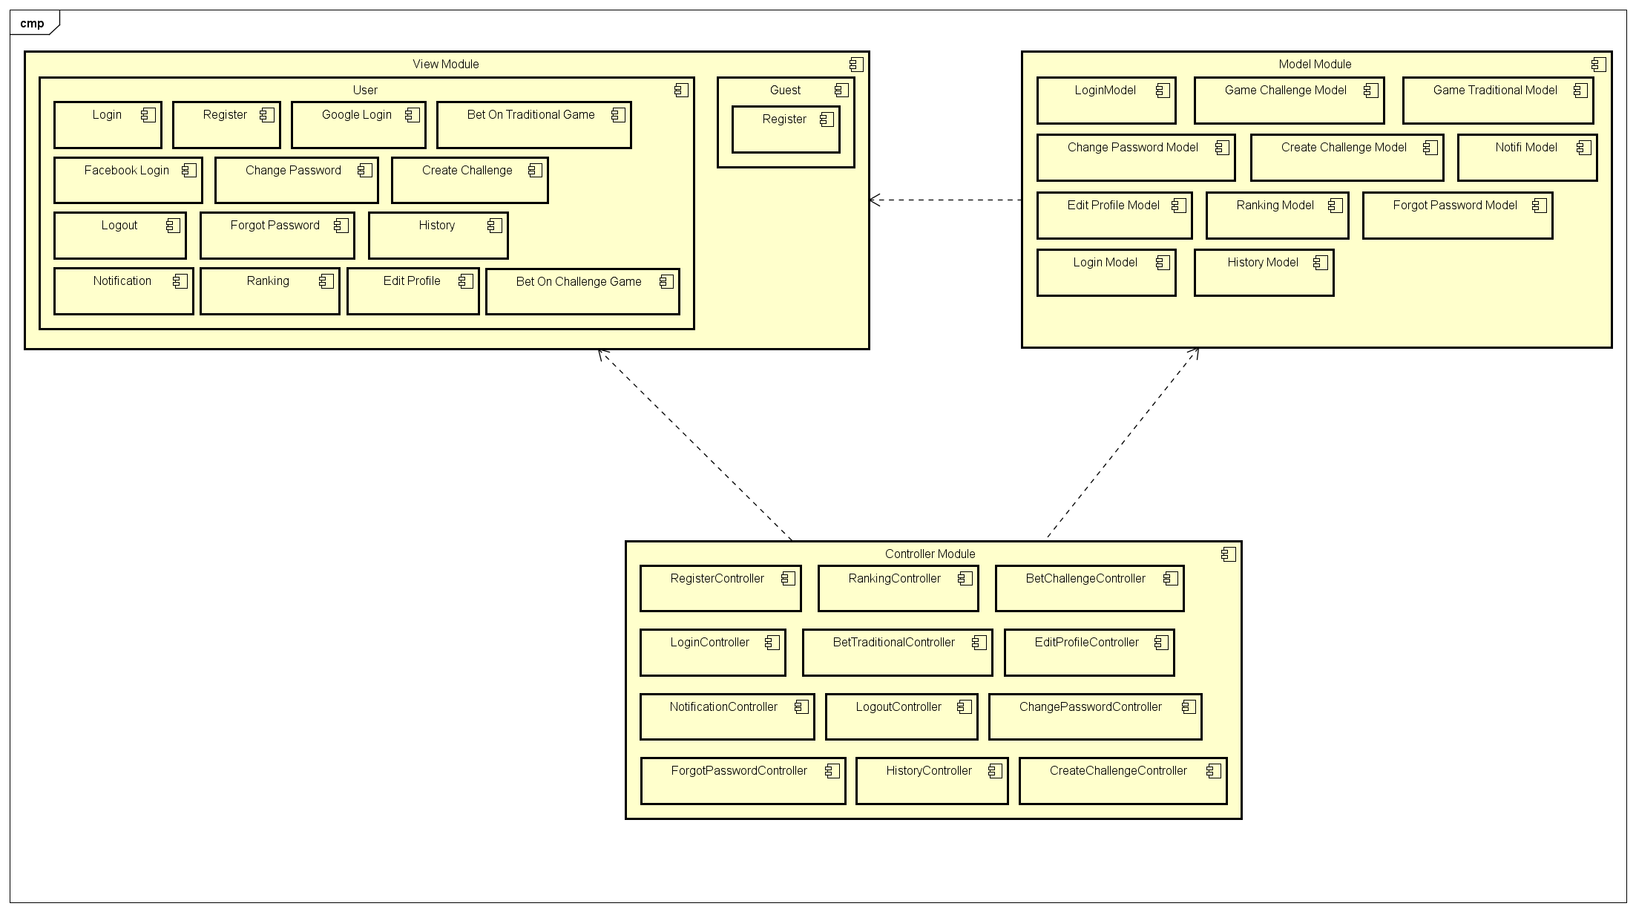

## **4.4. Sequence Diagram**

Several sequence diagrams are shown in the following:

### **4.4.1. Register**

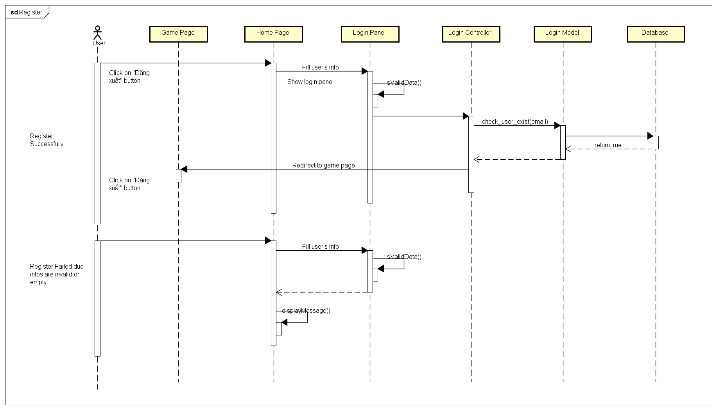

### **4.4.2. Login**

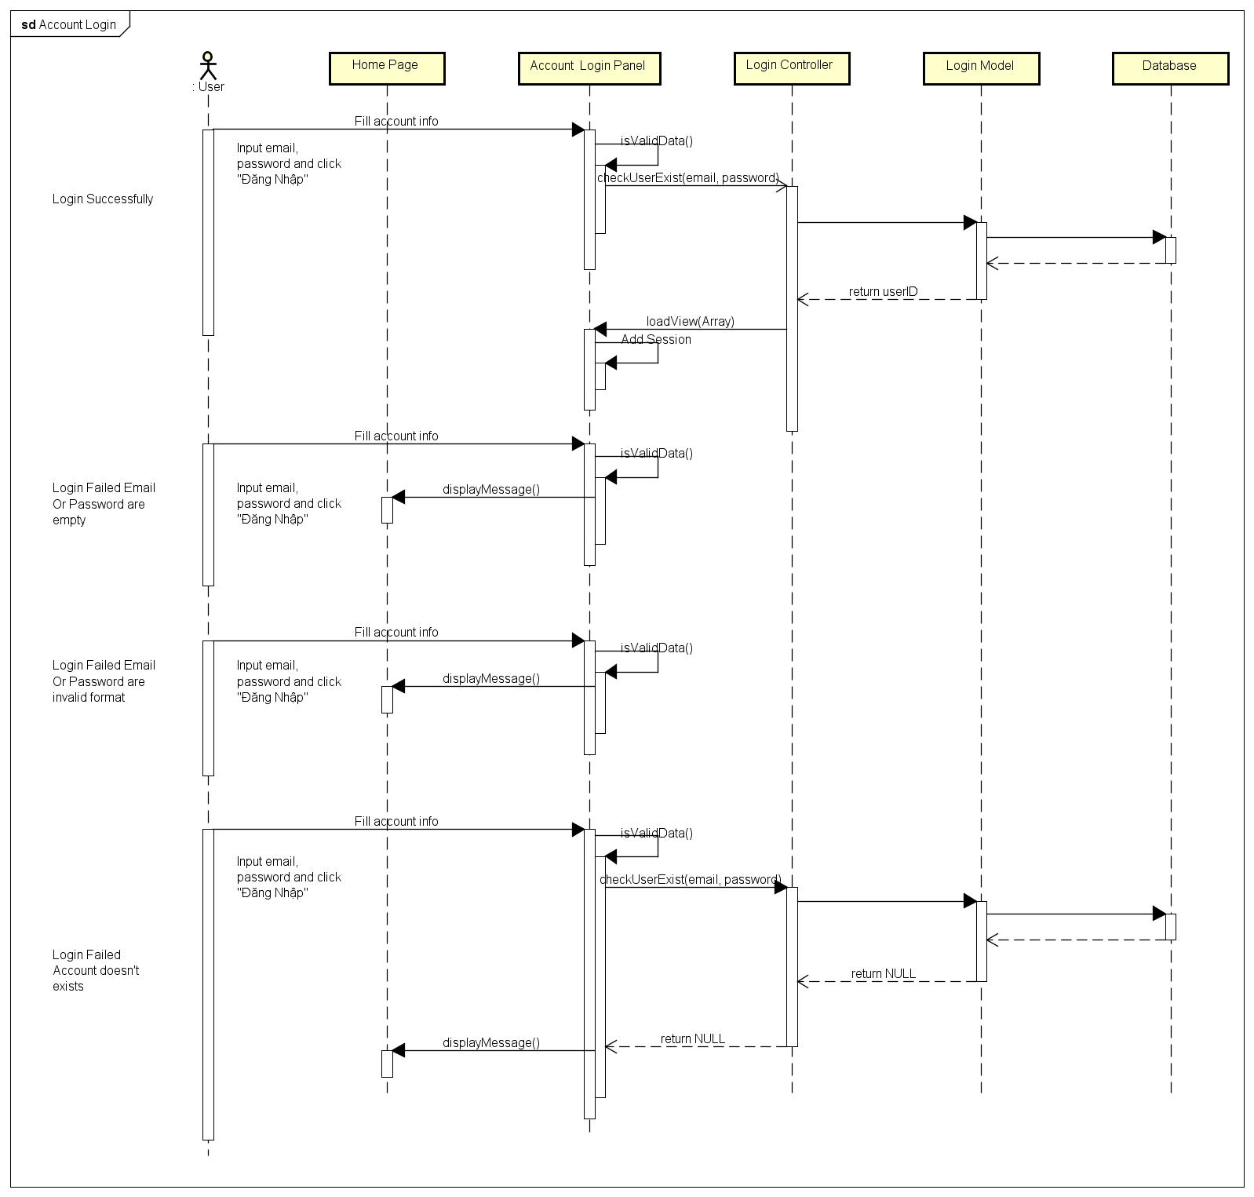

### **4.4.3. Login Using Facebook**

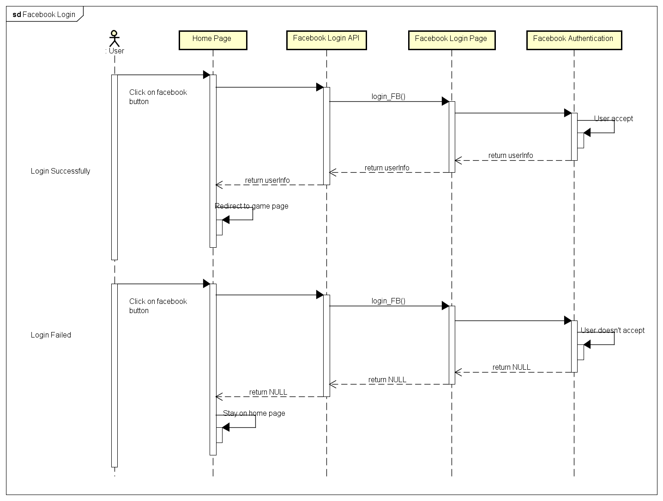

### **4.4.4. Login Using Google Plus**

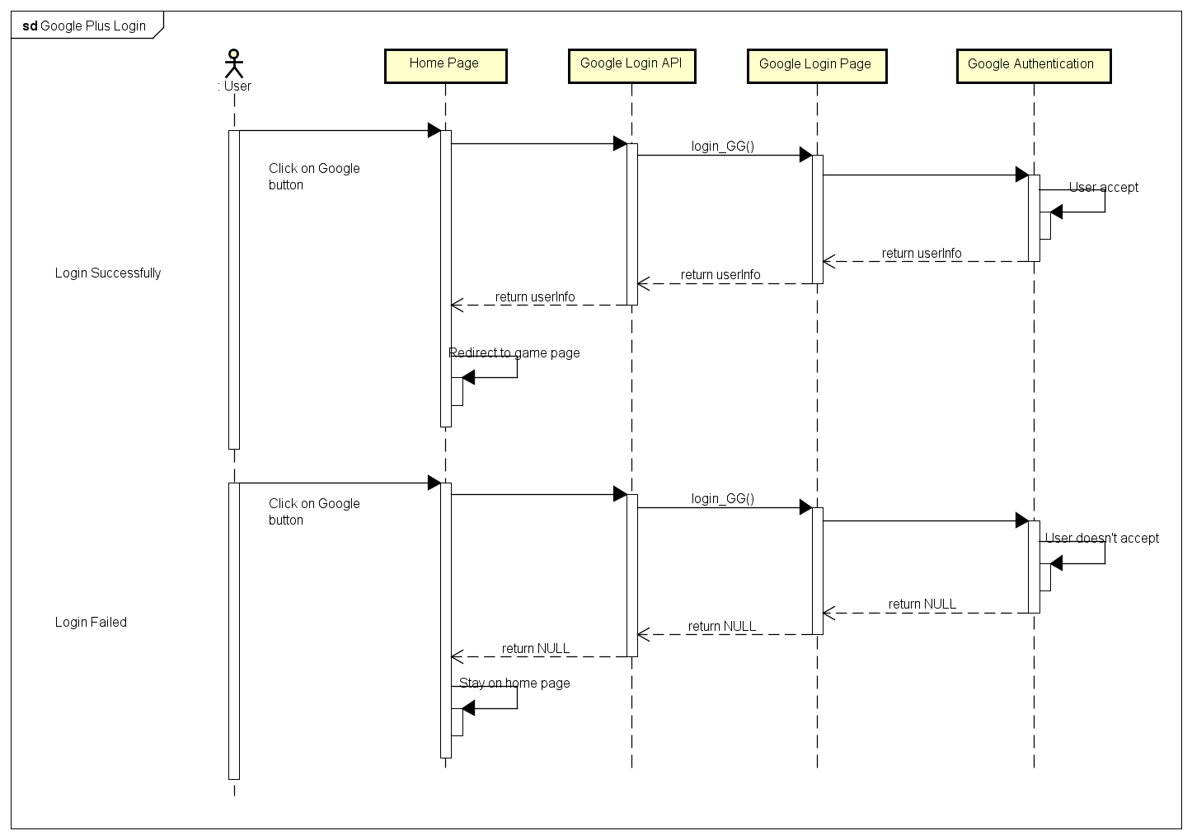

4.4.A.5. Logout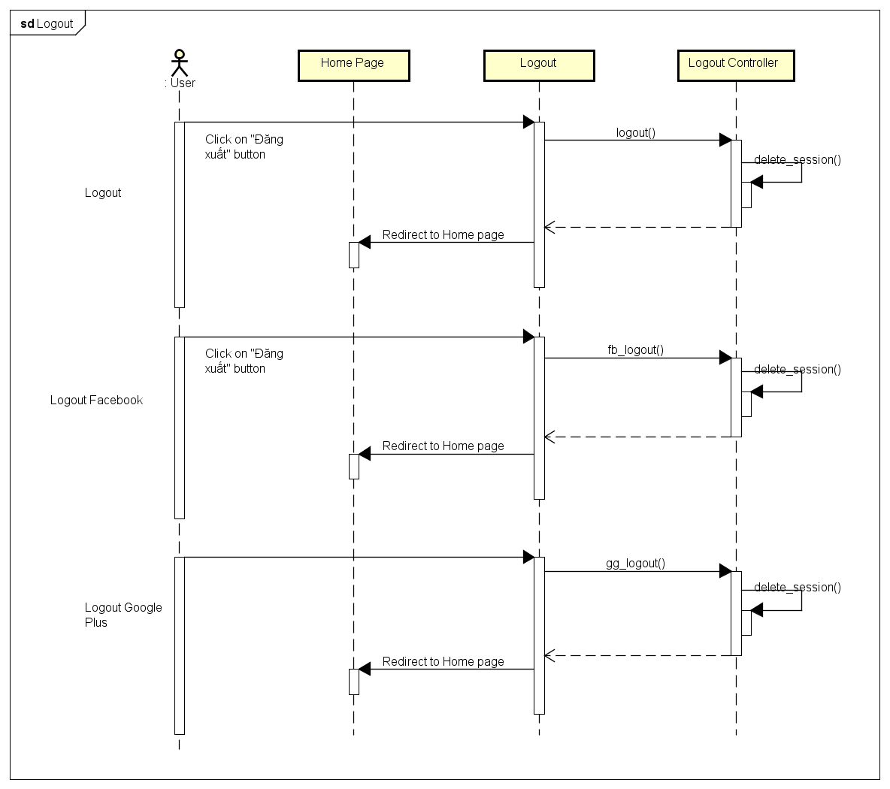

4.4.A.6. Change Password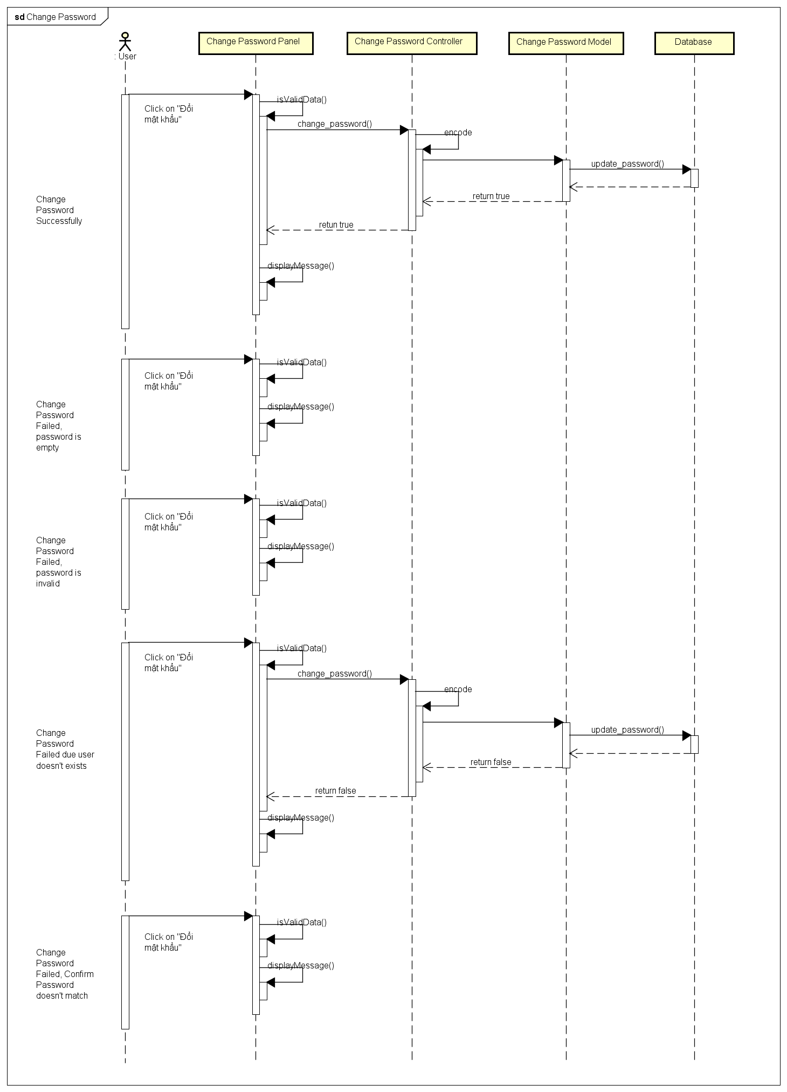

4.4.A.7. Forgot Password

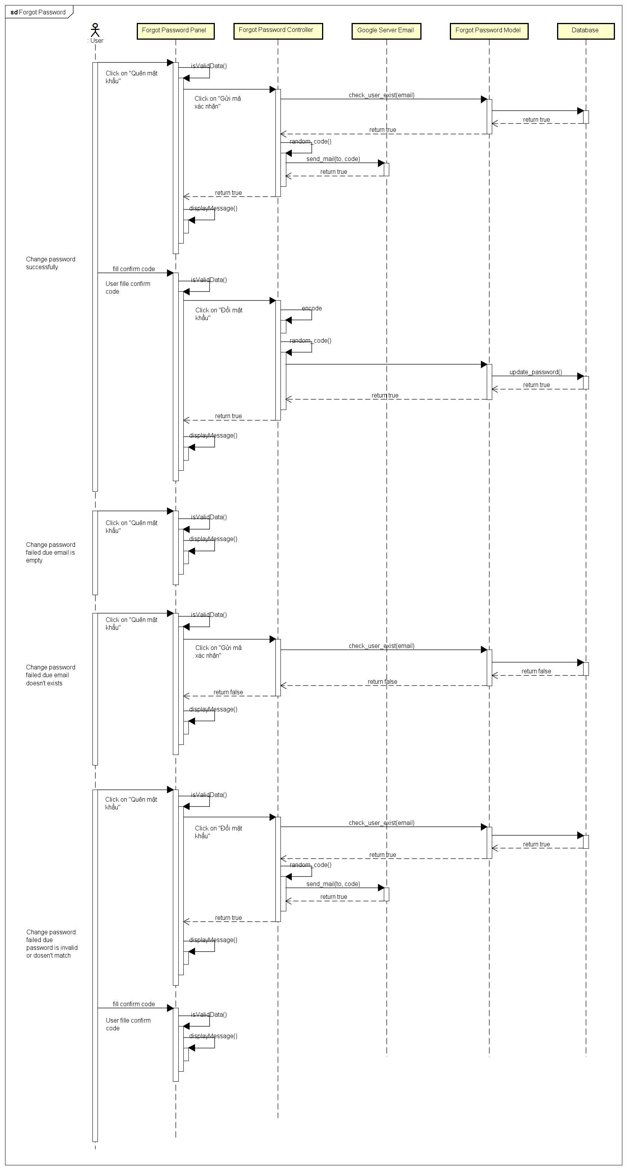

4.4.A.8. Edit Profile

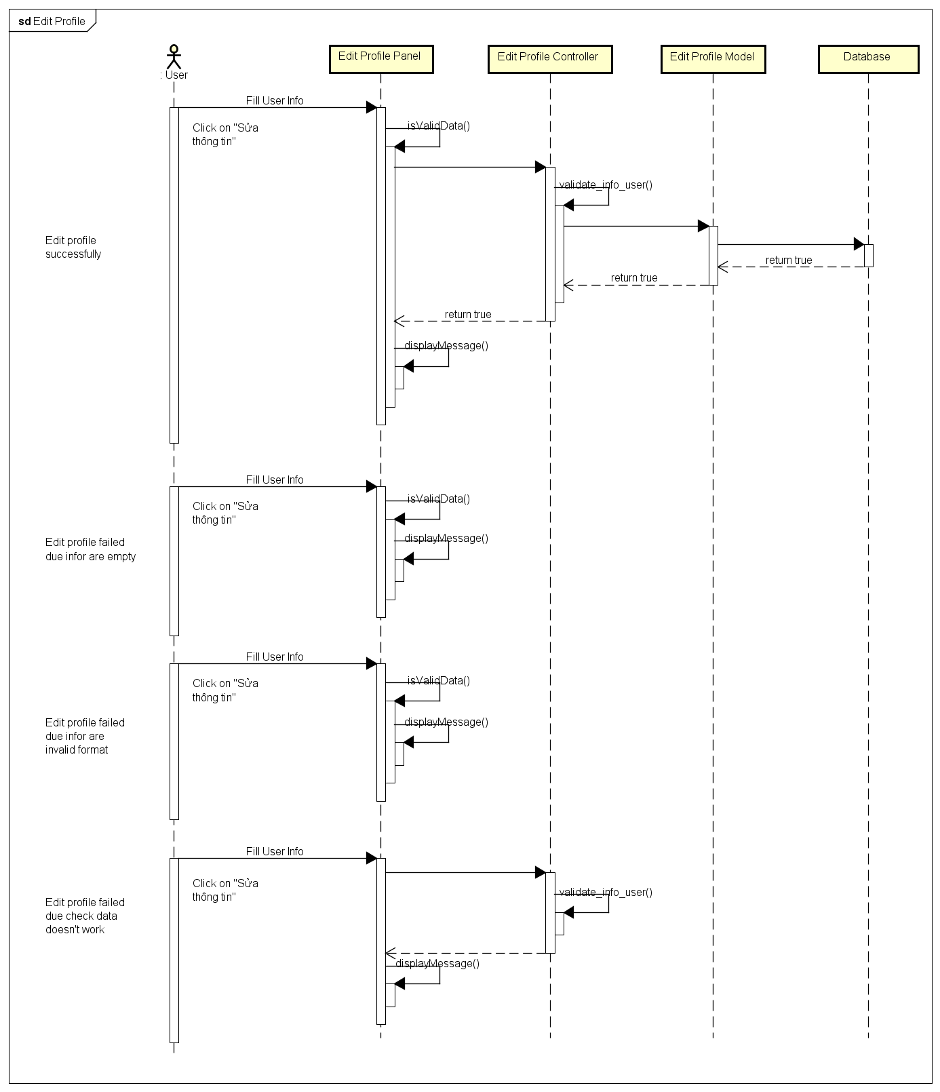

4.4.A.9. History

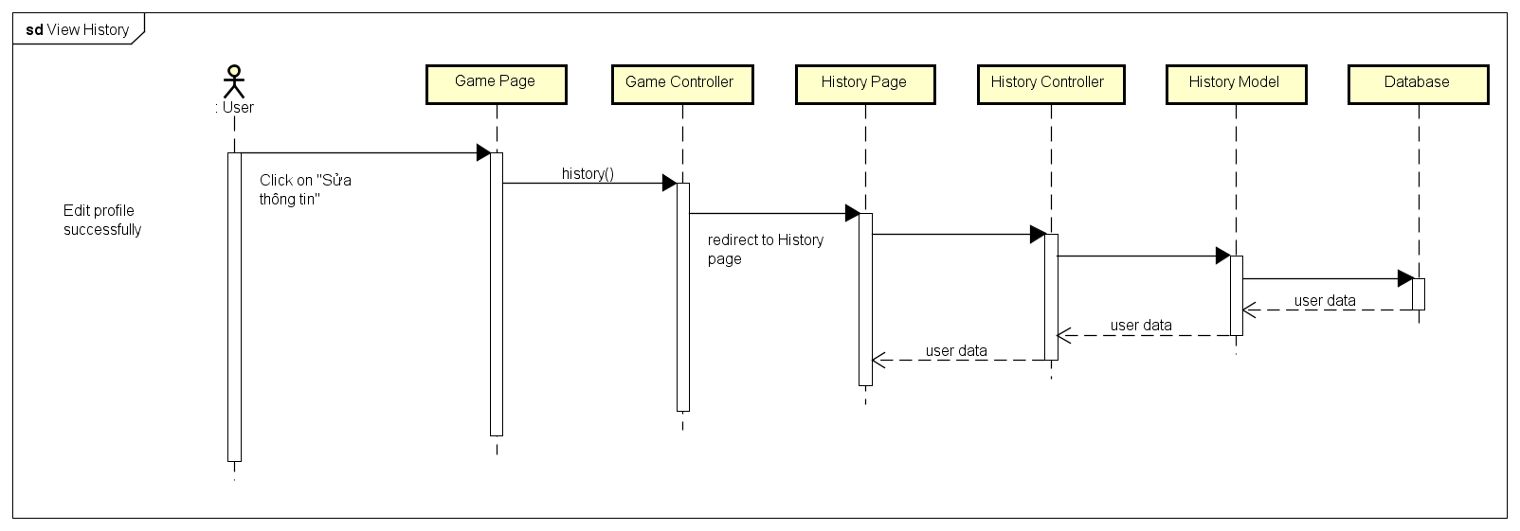

4.4.A.10. Notification

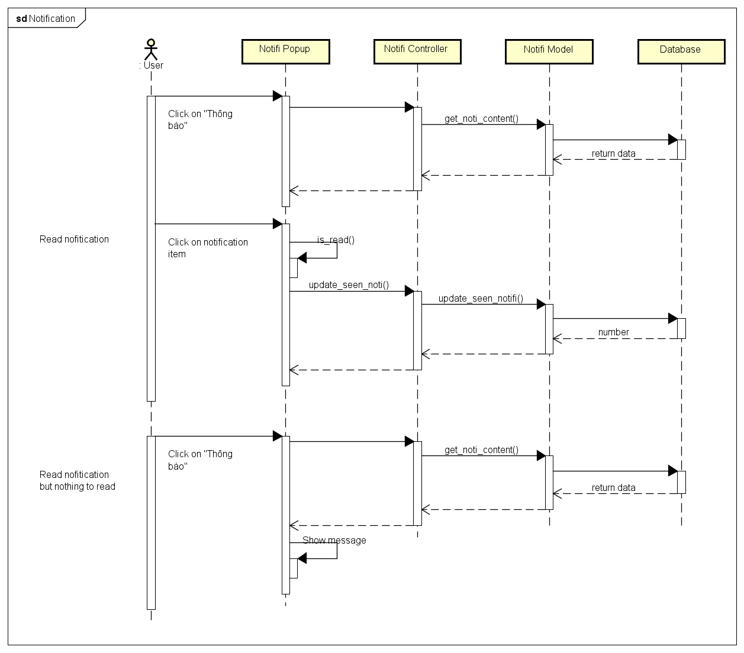

4.4.A.11. User Rankings

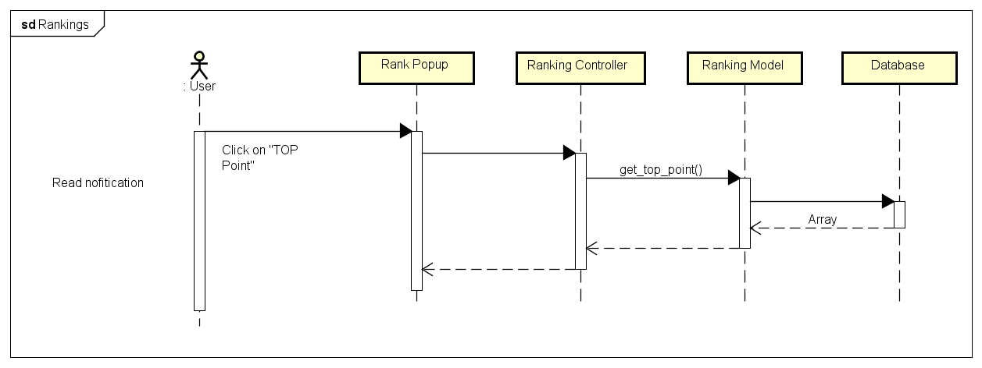

4.4.A.12. Create Challenges

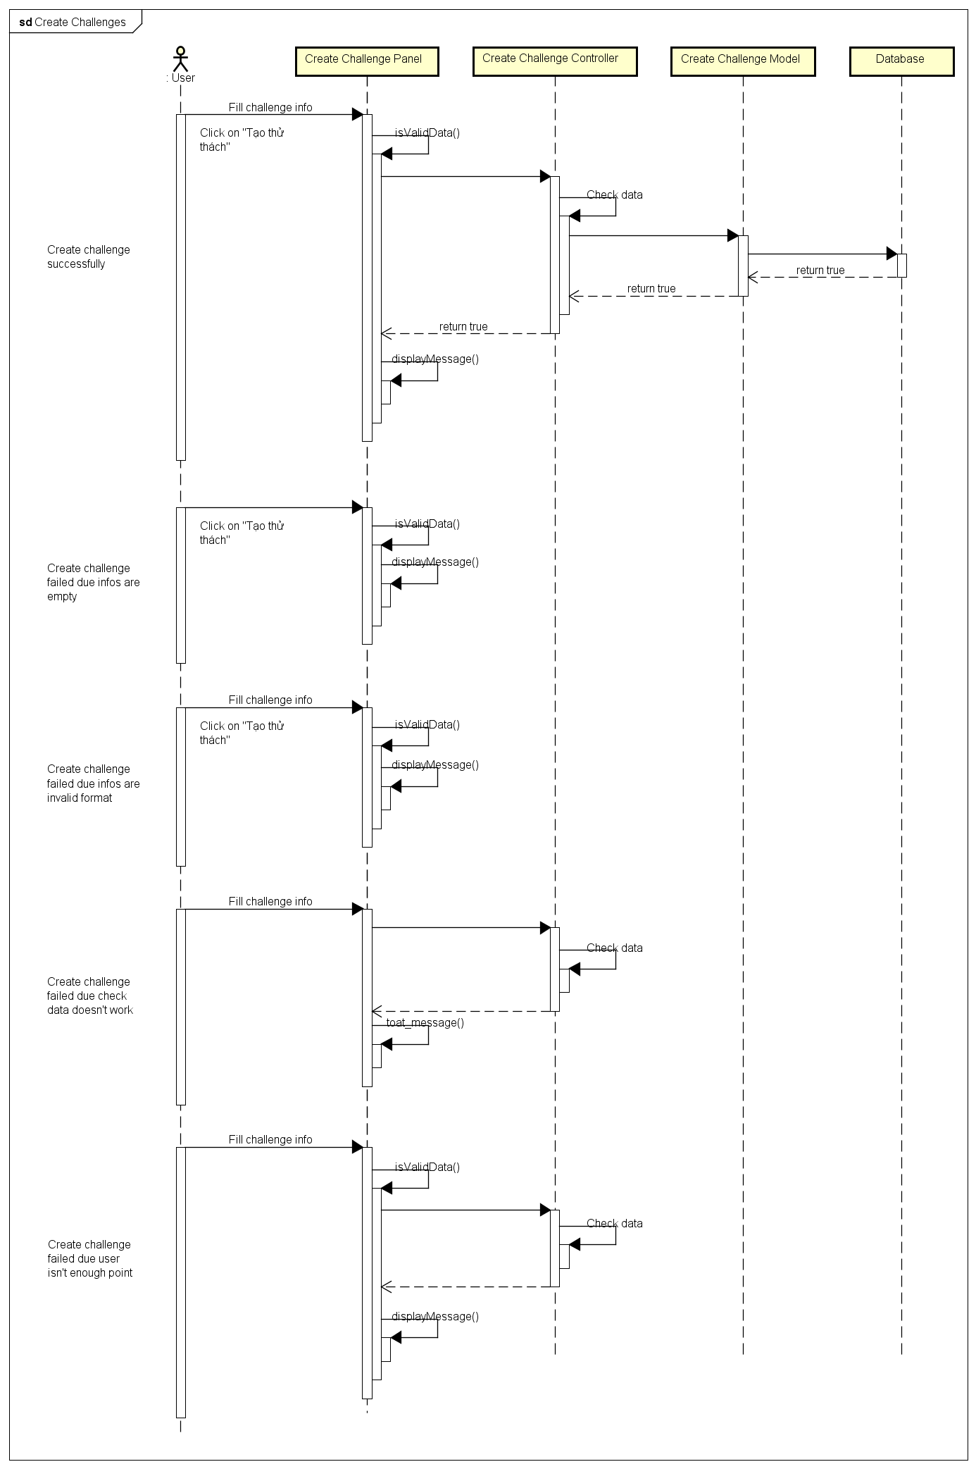

4.4.A.13. Bet On Traditional Game

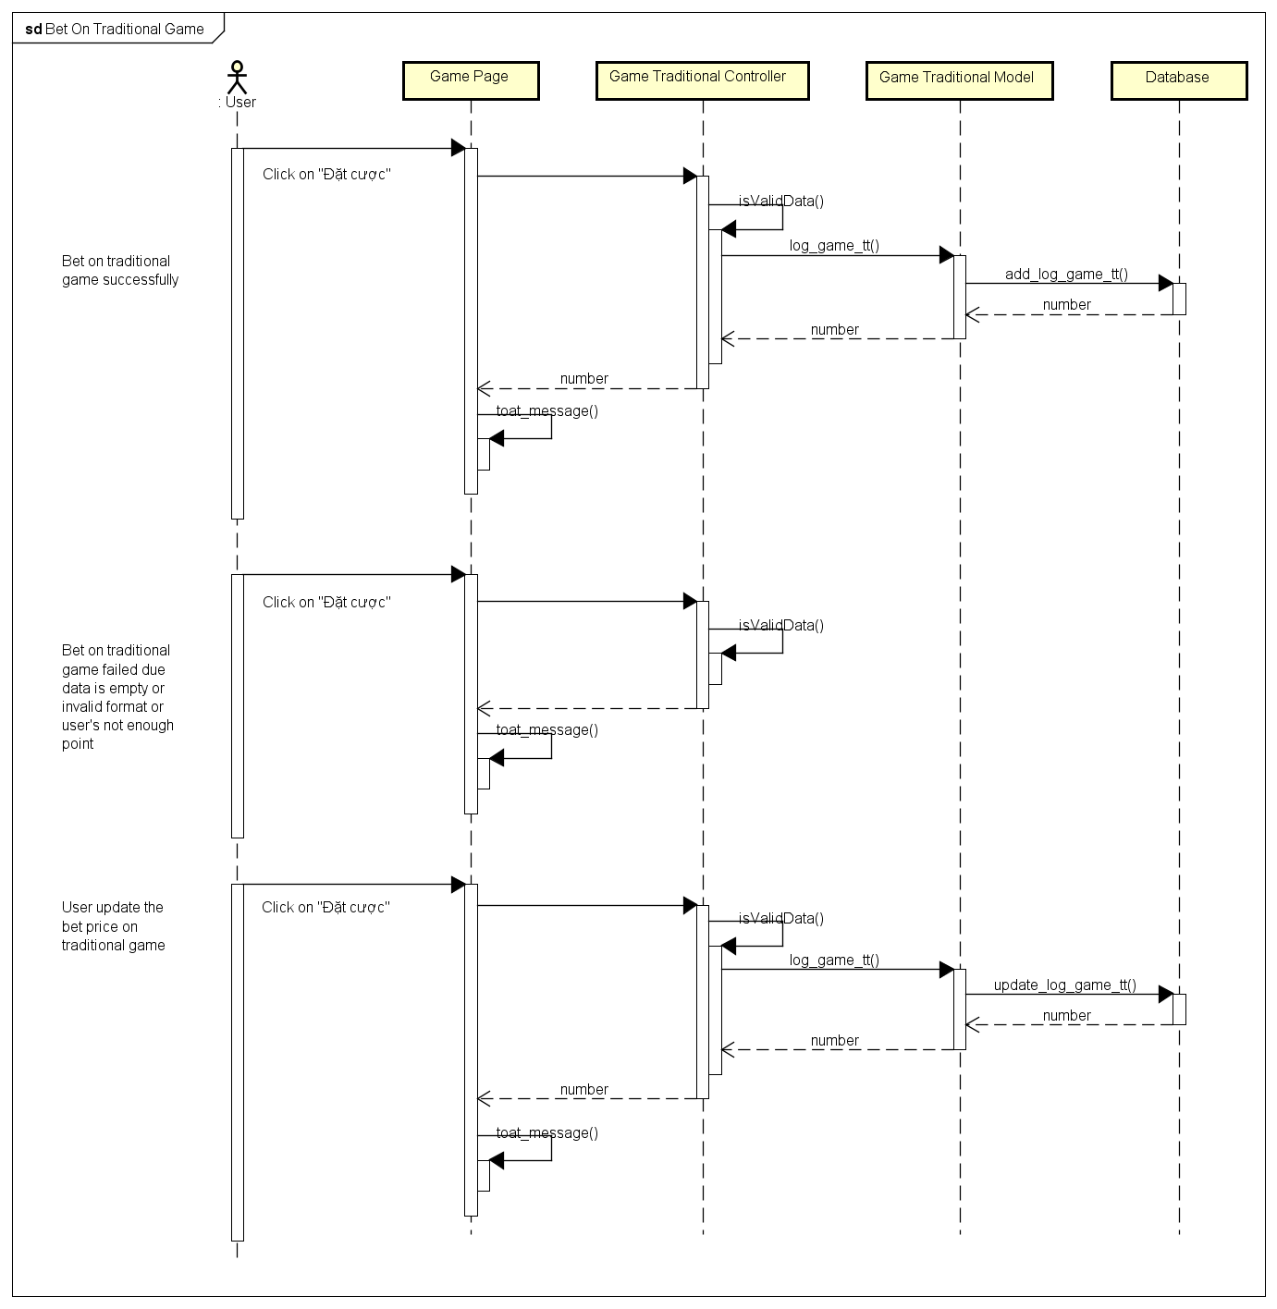

4.4.A.14. Bet On Challenge Game

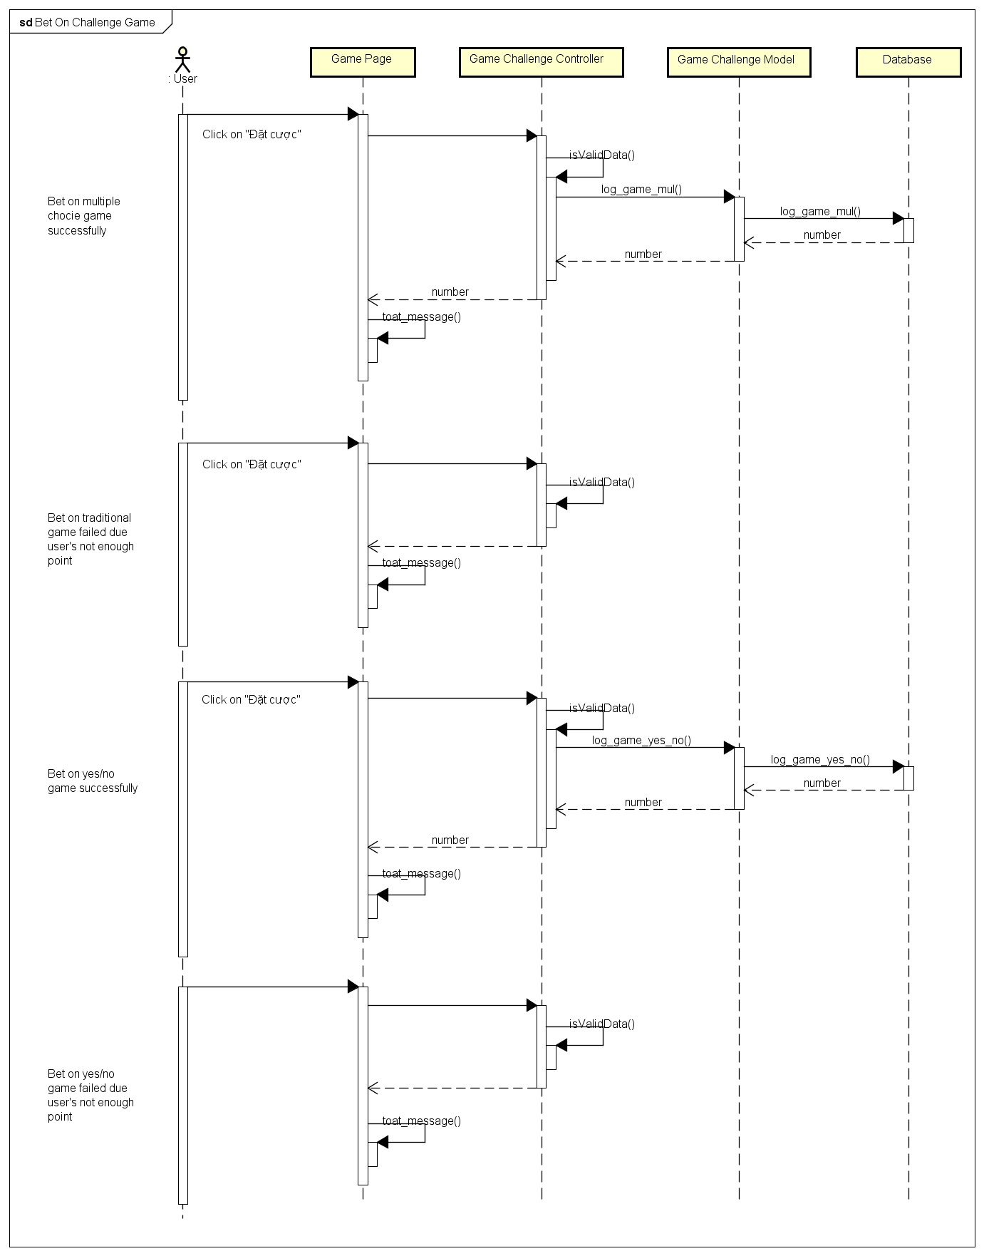

4.4.B. Admin Sequence Diagram

4.4.B.1. Login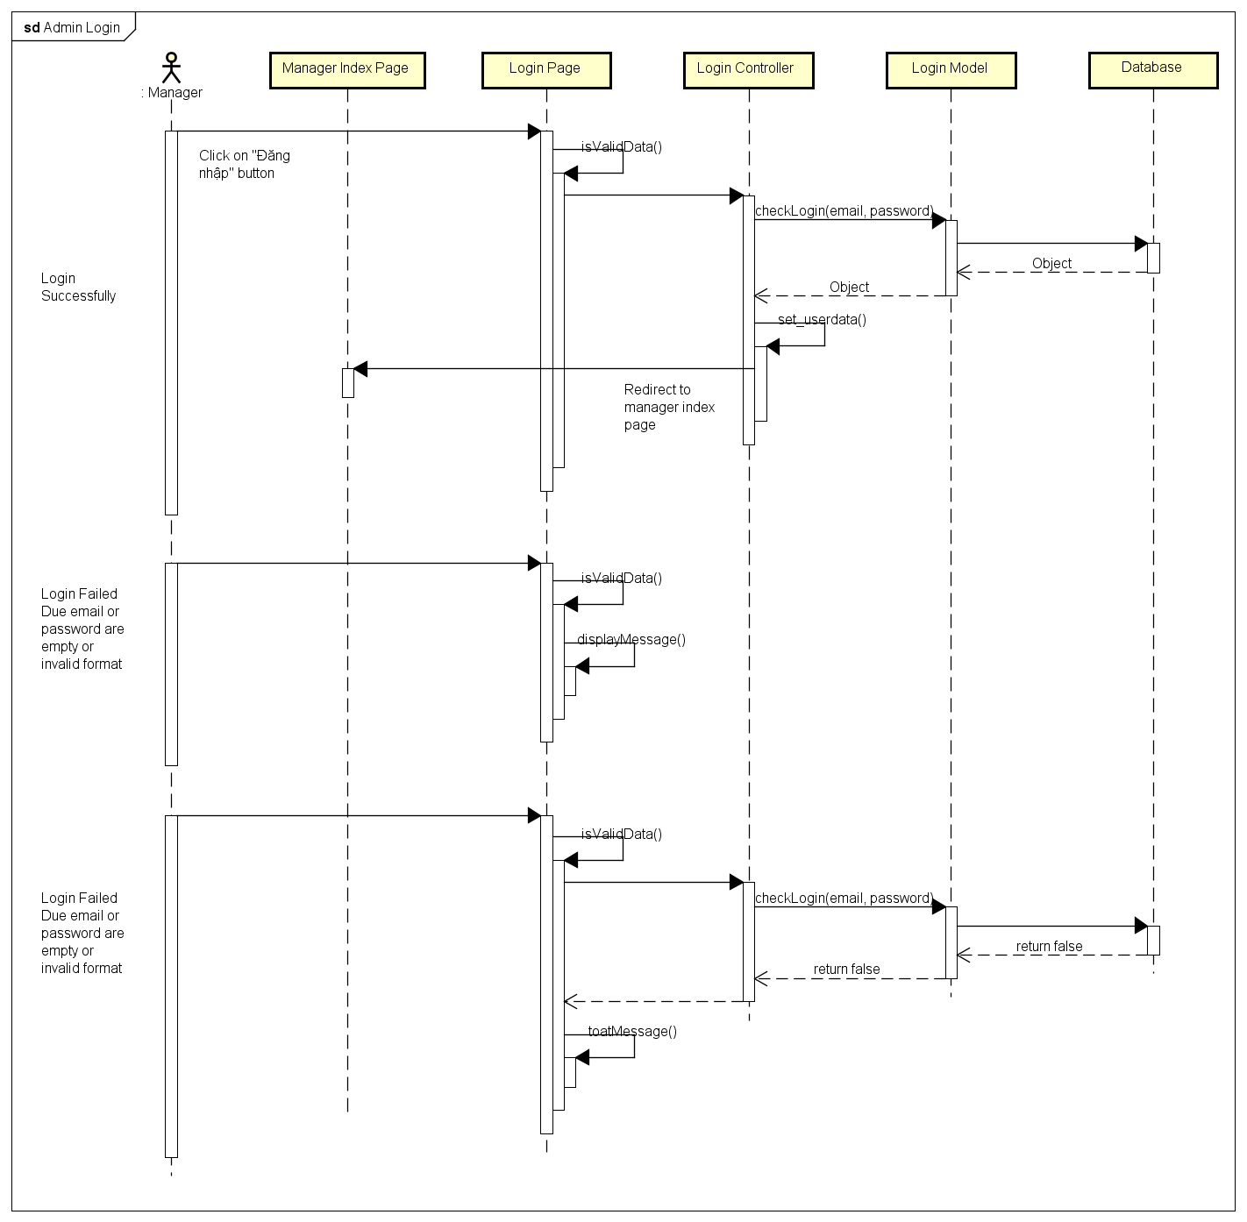

4.4.B.2. Notification

4.4.B.3. Send Notification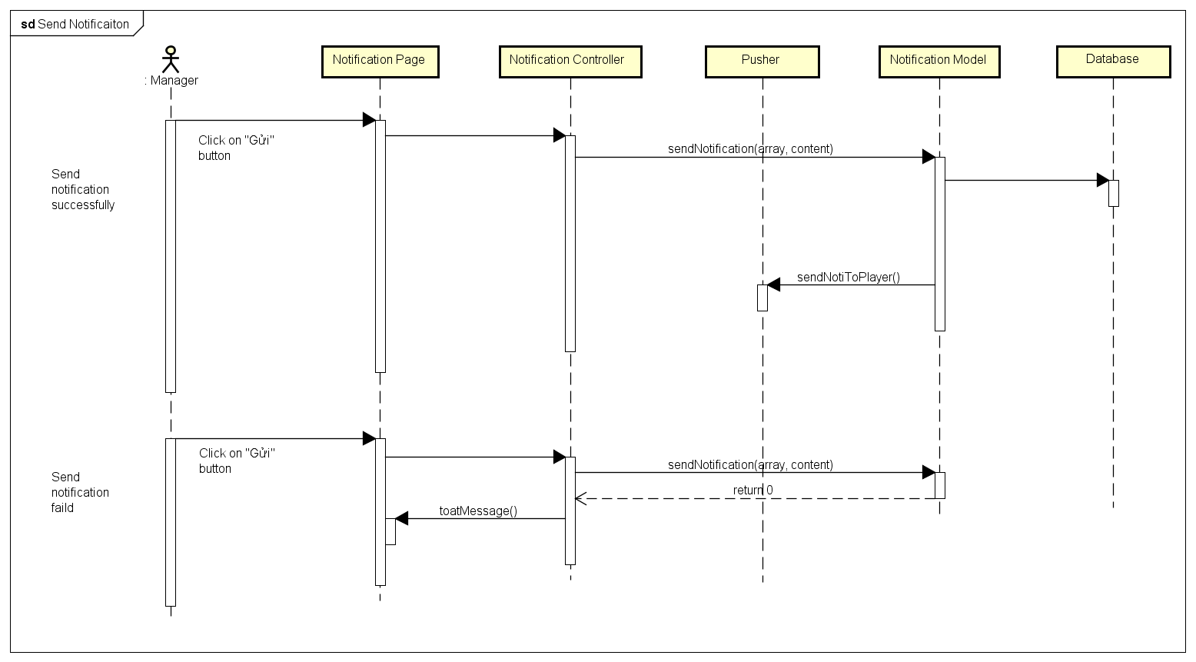

4.4.B.4. Delete Notification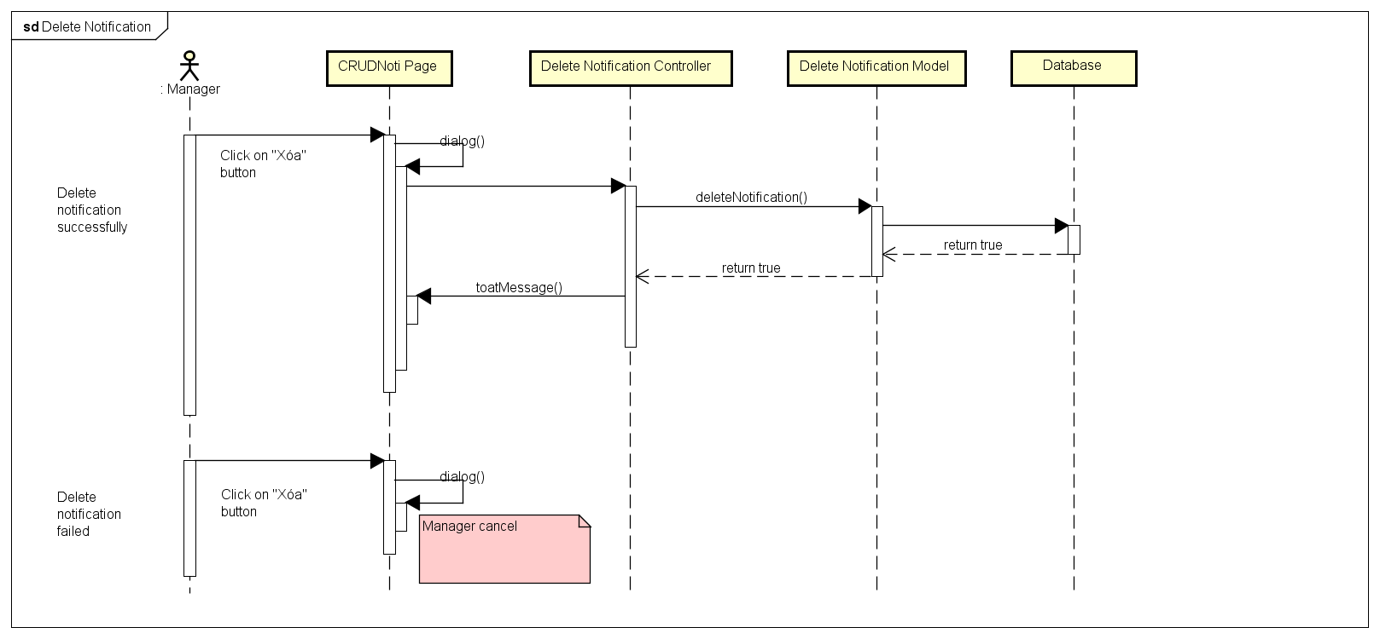

4.4.B.5. Edit Notification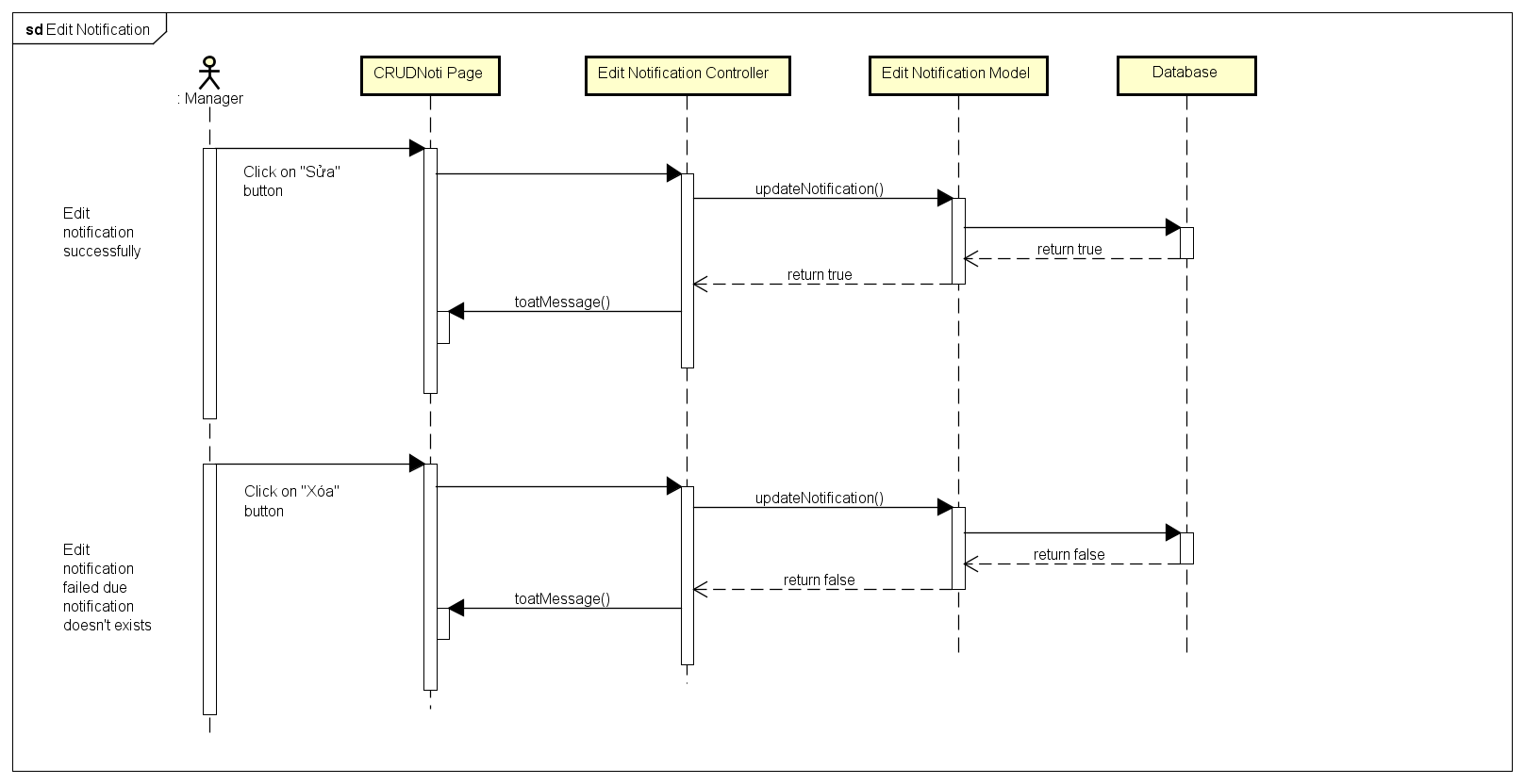

4.4.B.6. Search Game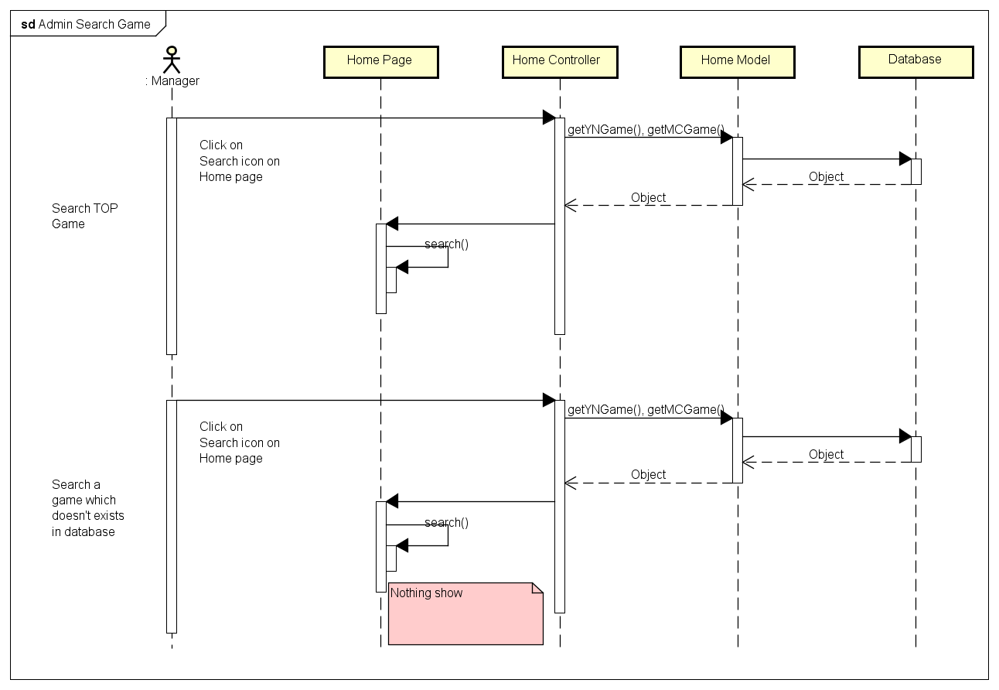

4.4.B.7. Search Member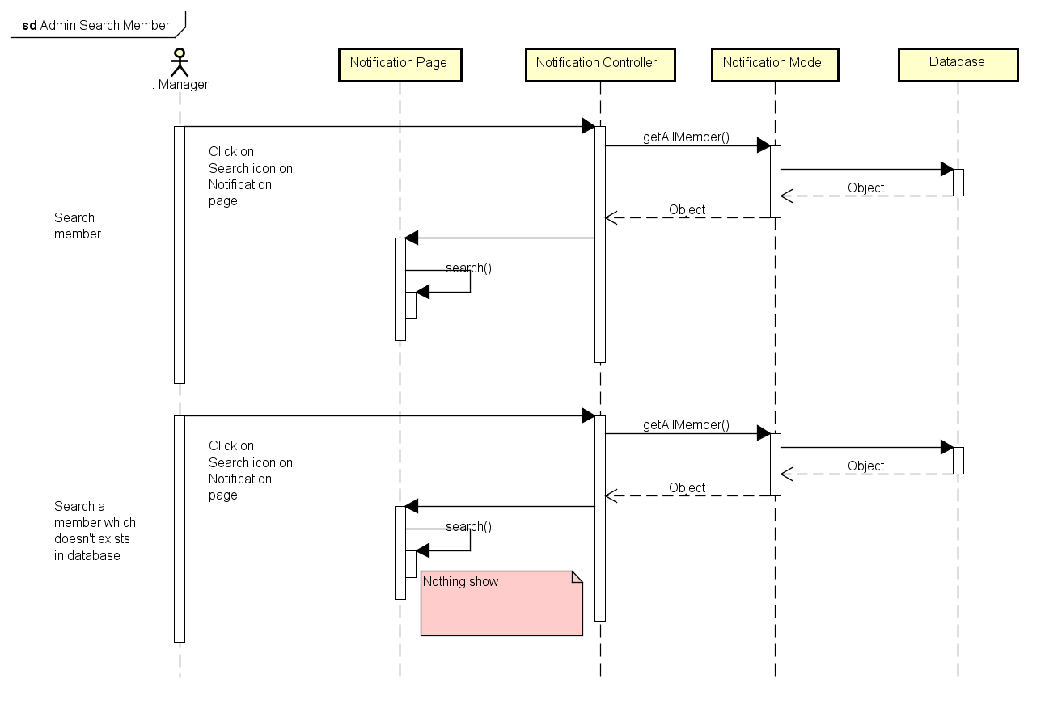

4.4.B.8. Block Manager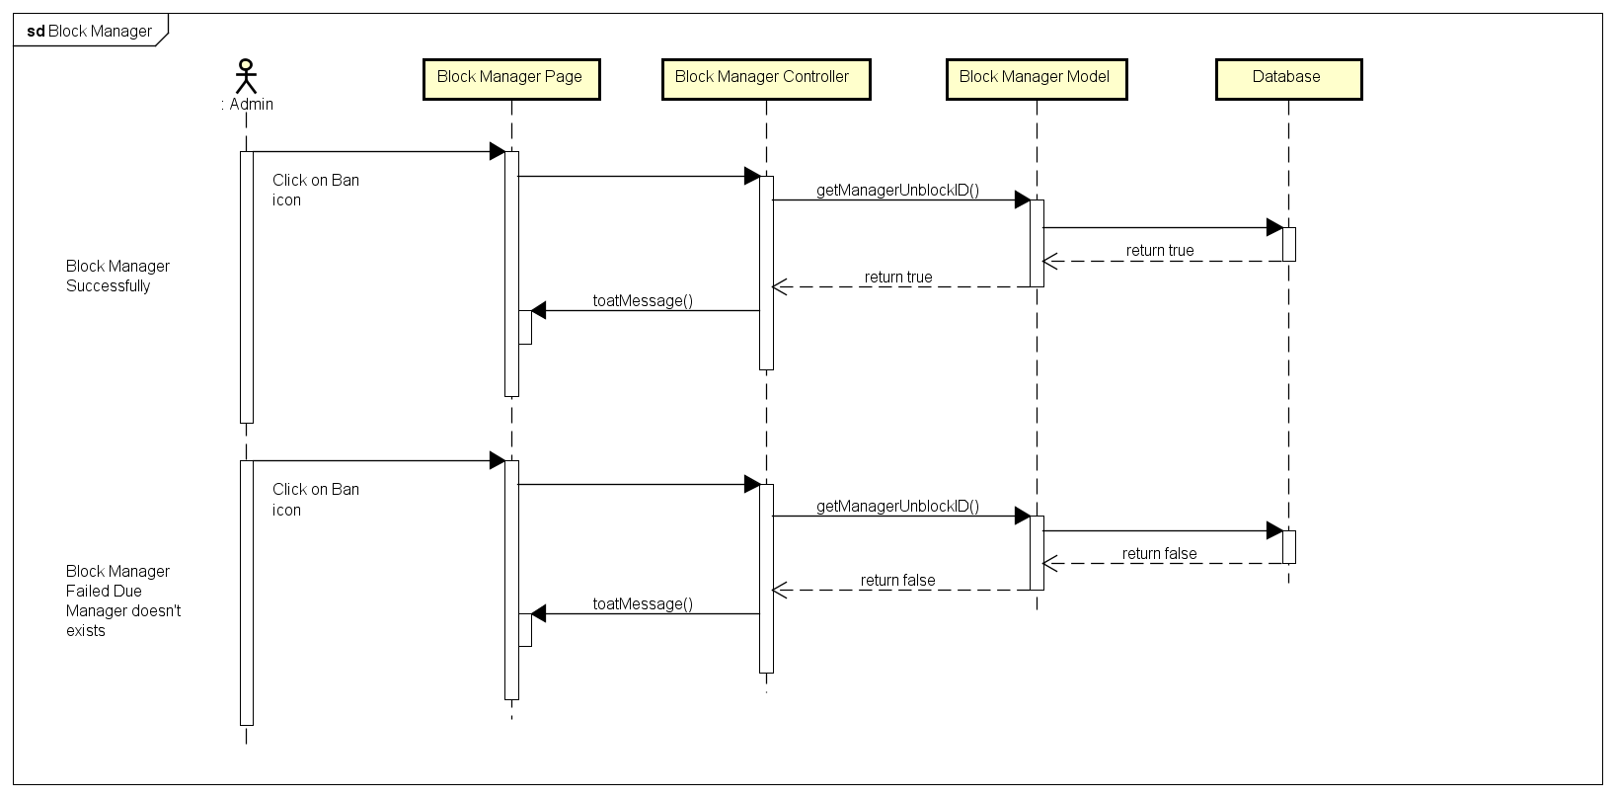

4.4.B.9. Unblock Manager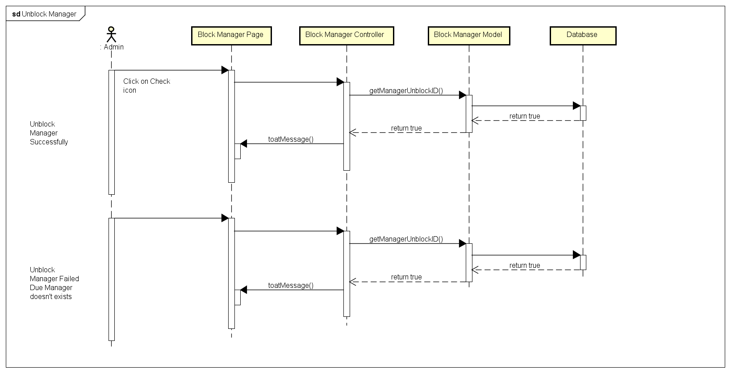

4.4.B.10. Change Gift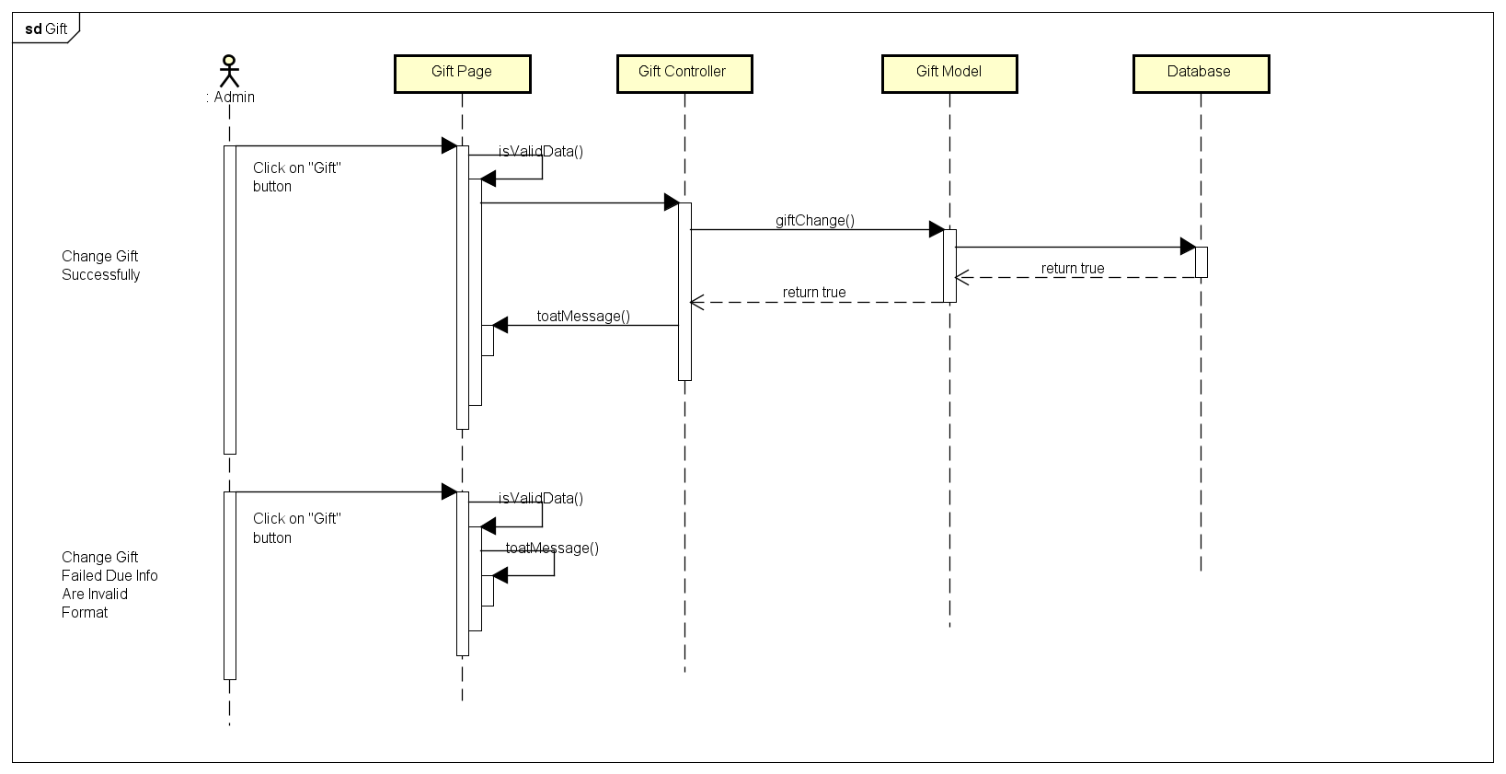

4.4.B.11. History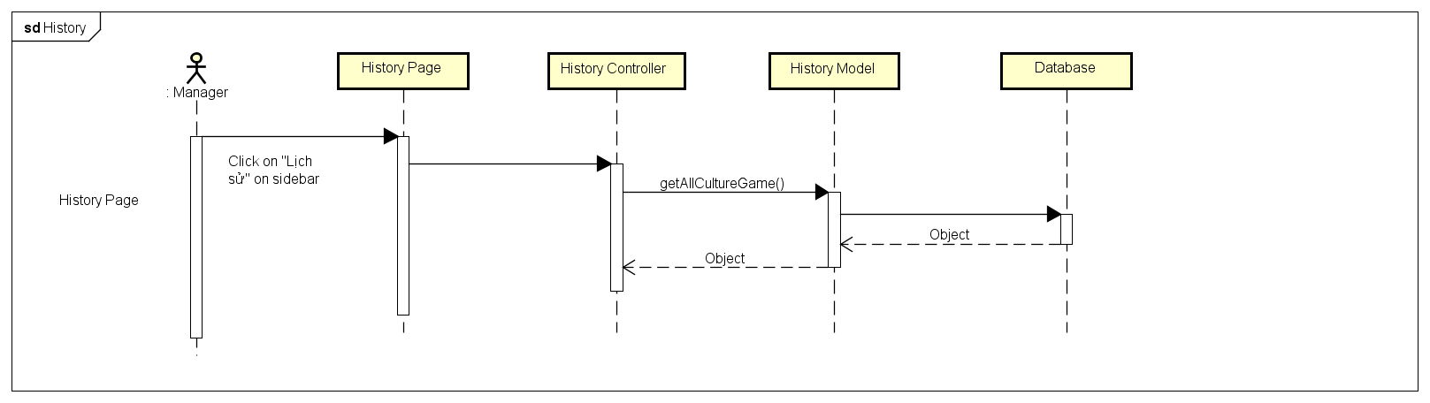

4.4.B.12. Create Game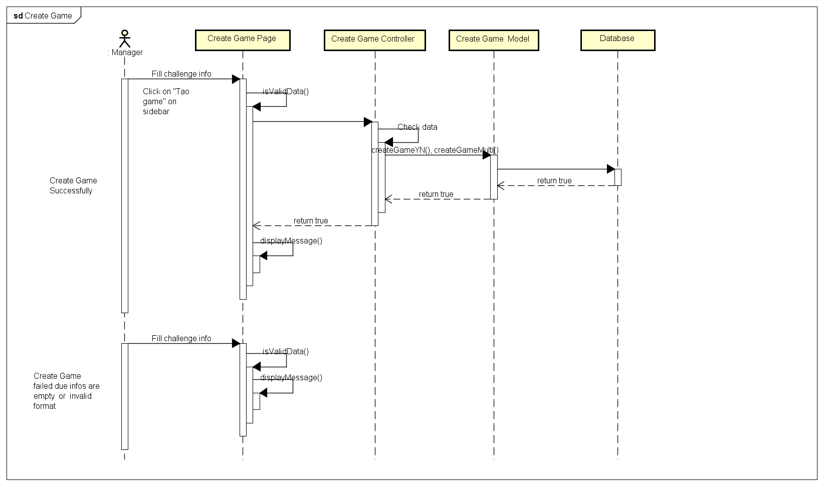

4.4.B.13. Edit Manager Information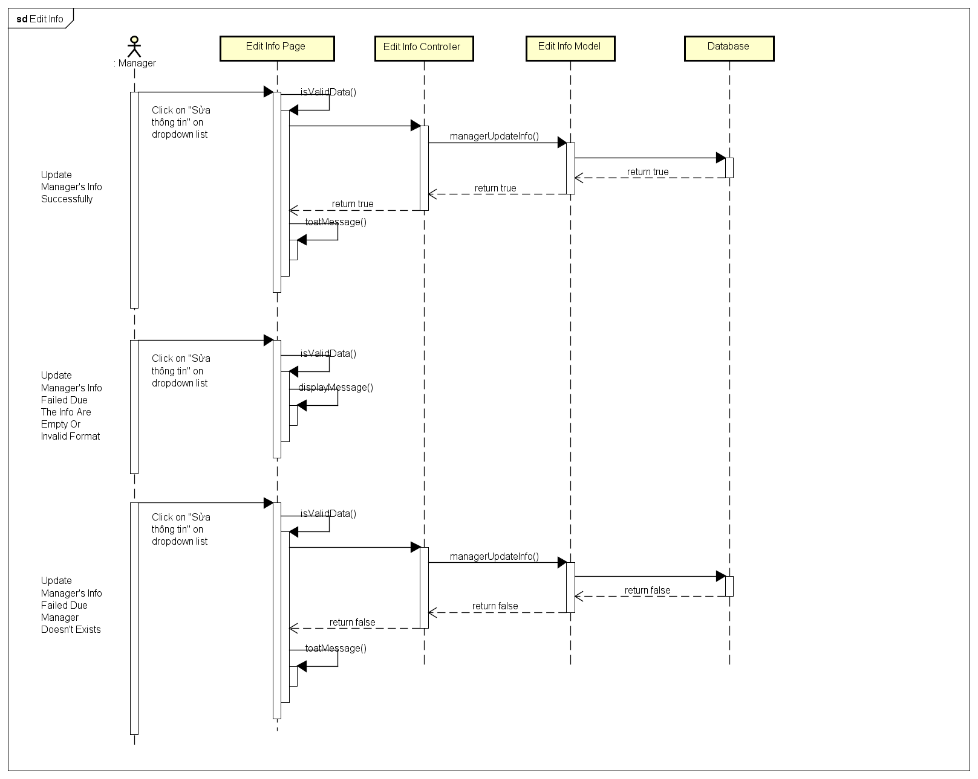

4.4.B.14. View Manager Information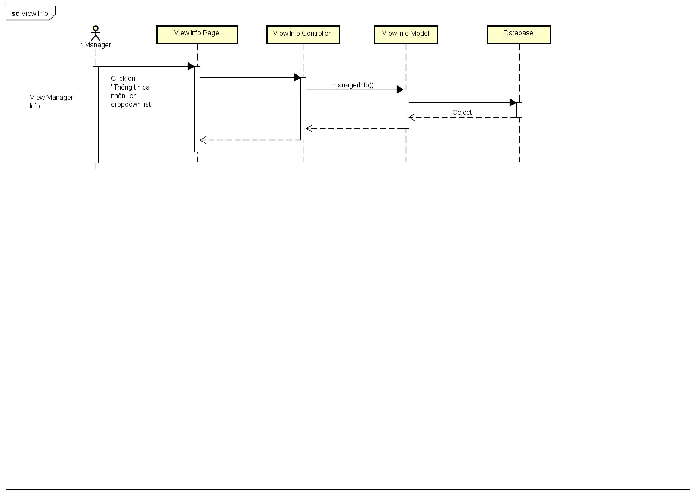

4.4.B.15. Change Password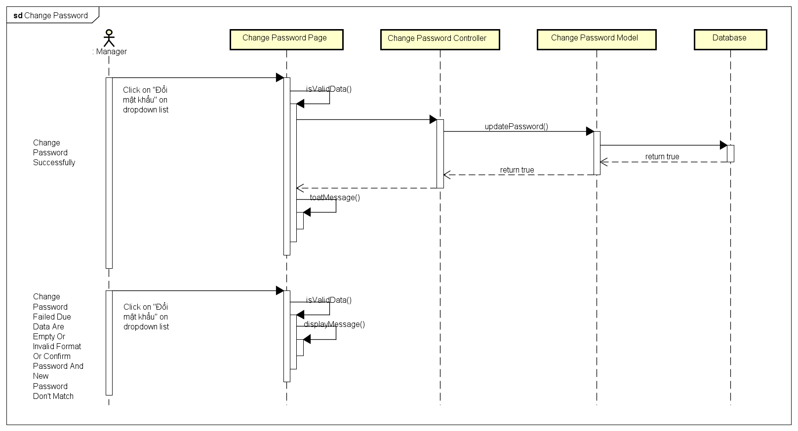

4.4.B.16. Forgot Password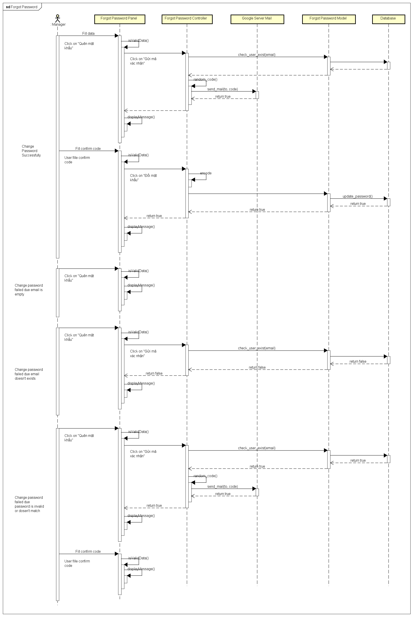

4.5.A. Activities Diagram

4.5.A.1. Register and Login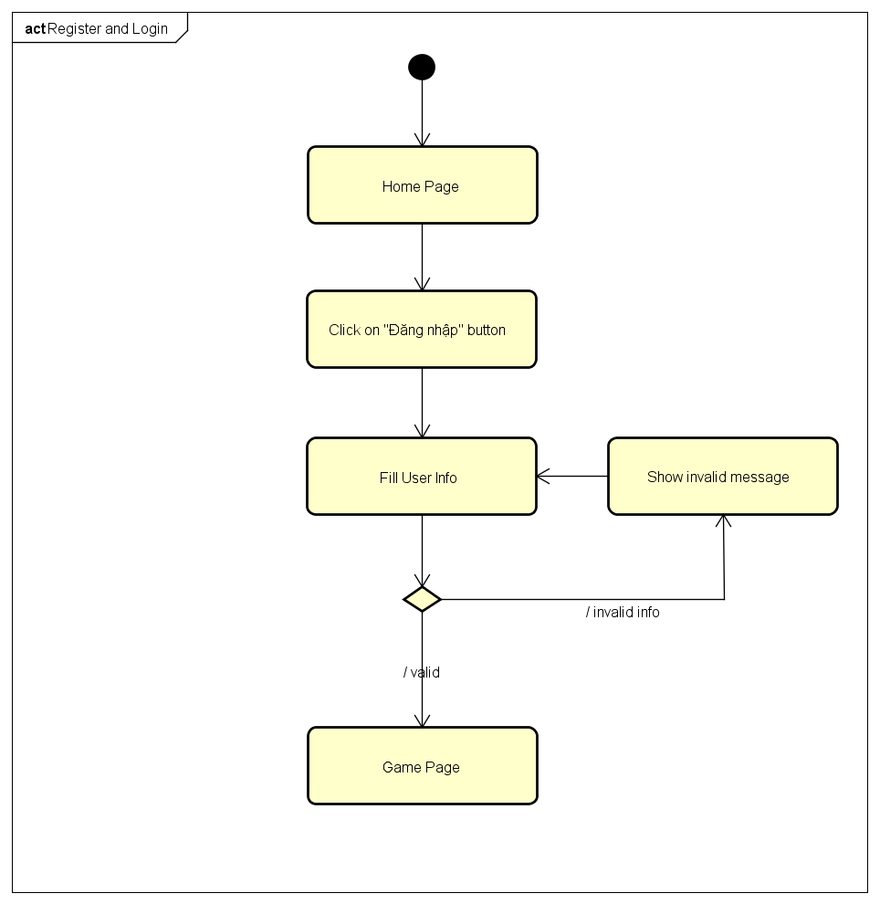

4.5.A.2. Login Using Facebook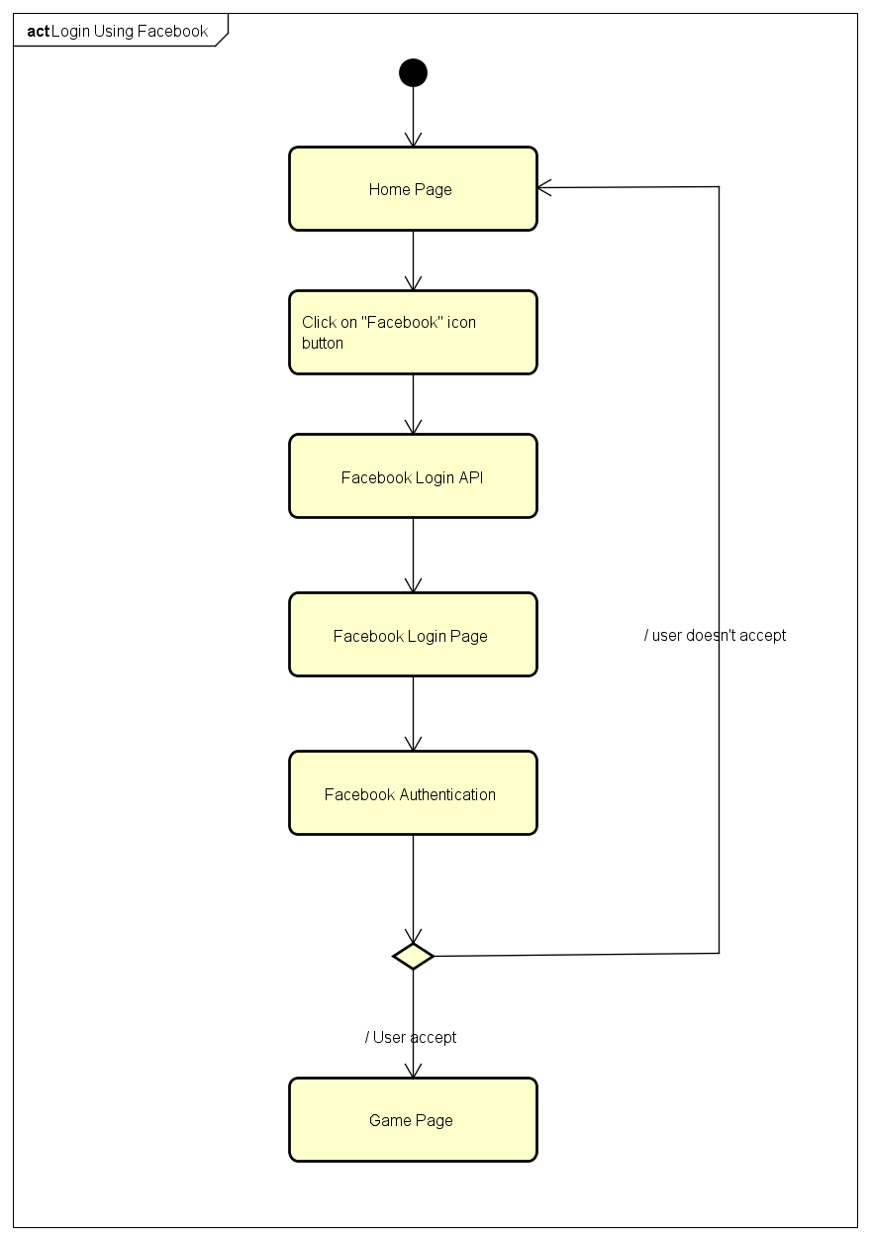

4.5.A.3. Login Using Google Plus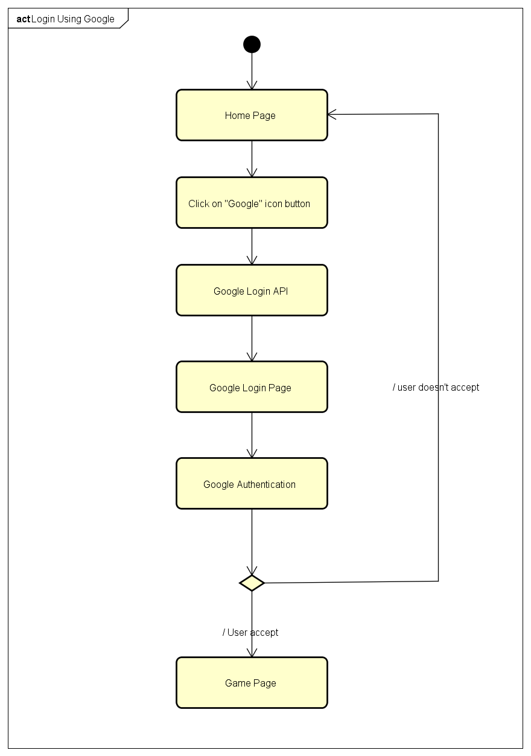

4.5.A.4. Logout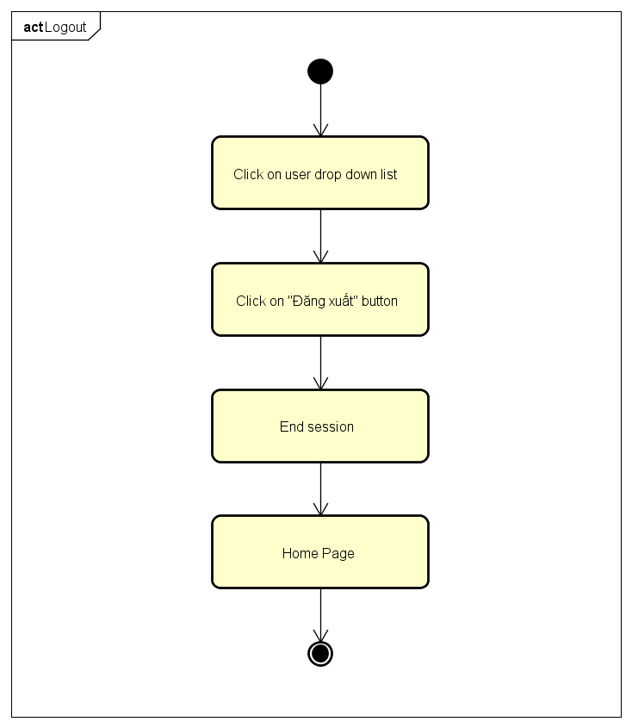

4.5.A.5. Change Password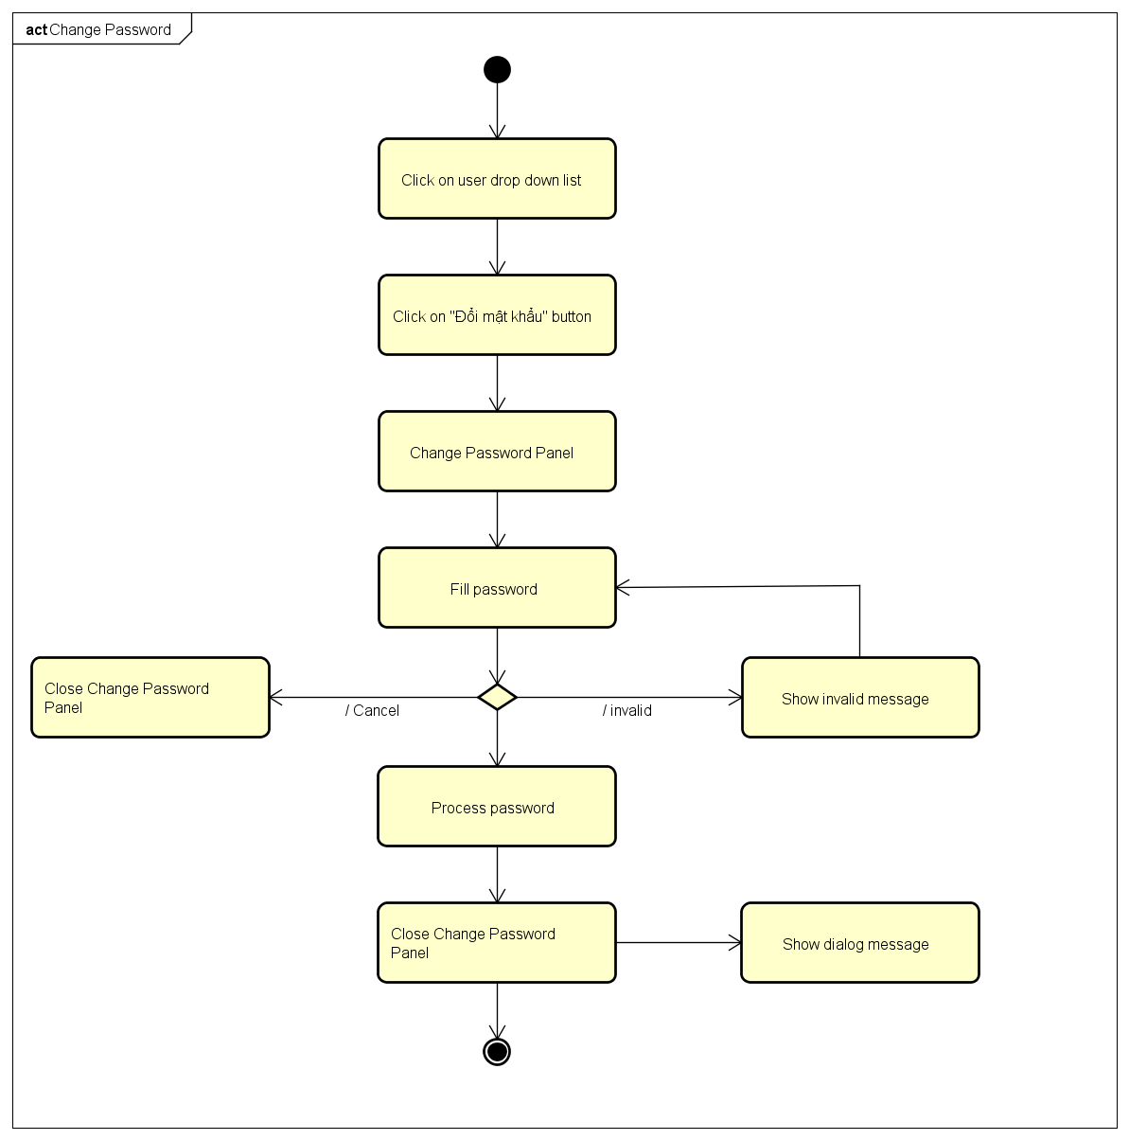

4.5.A.6. Forgot Password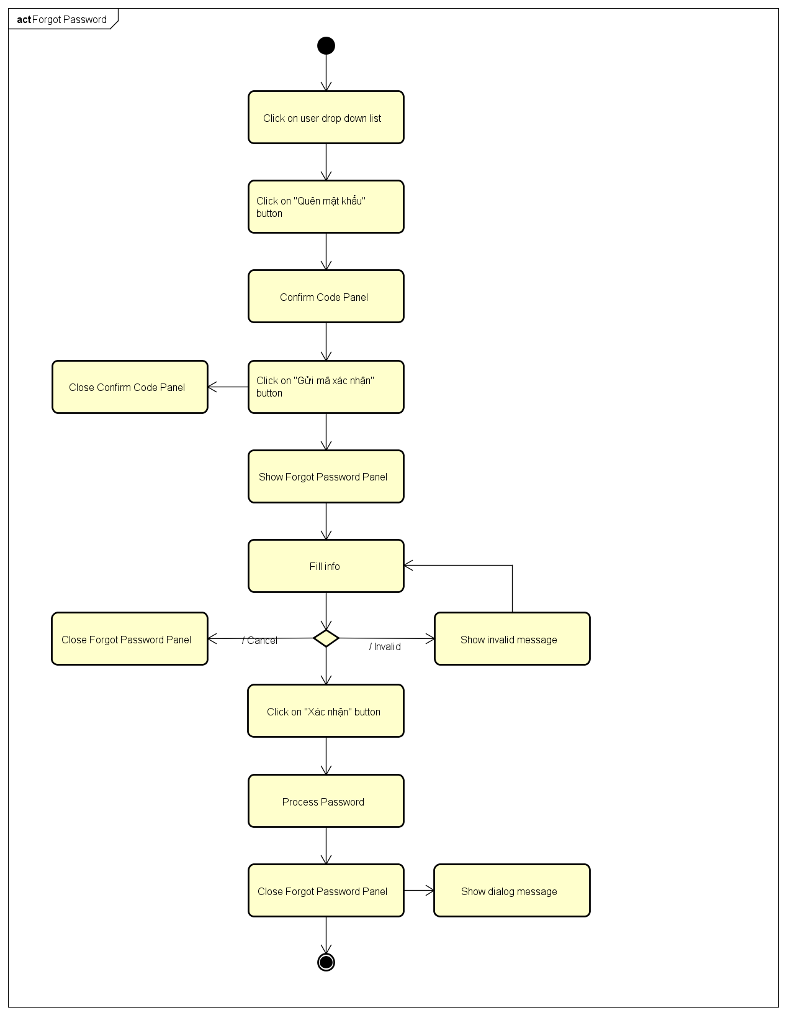

4.5.A.7. Edit Profile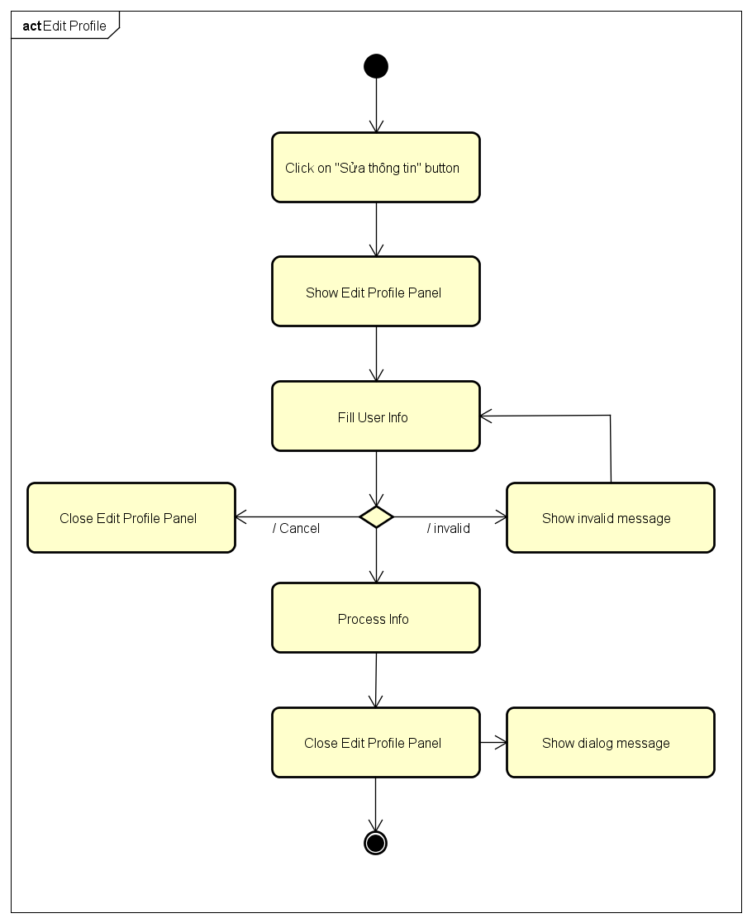

4.5.A.8. History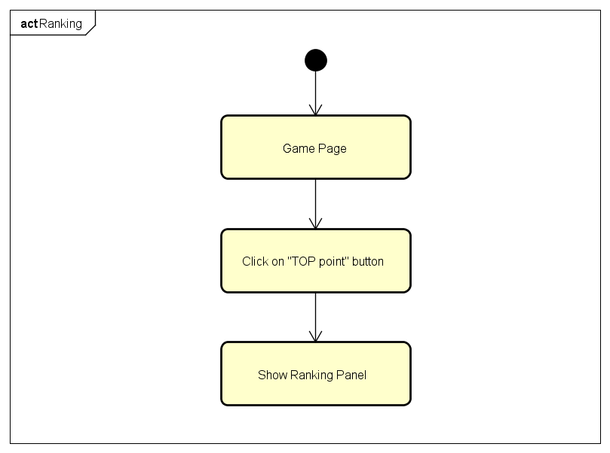

4.5.A.9. Notification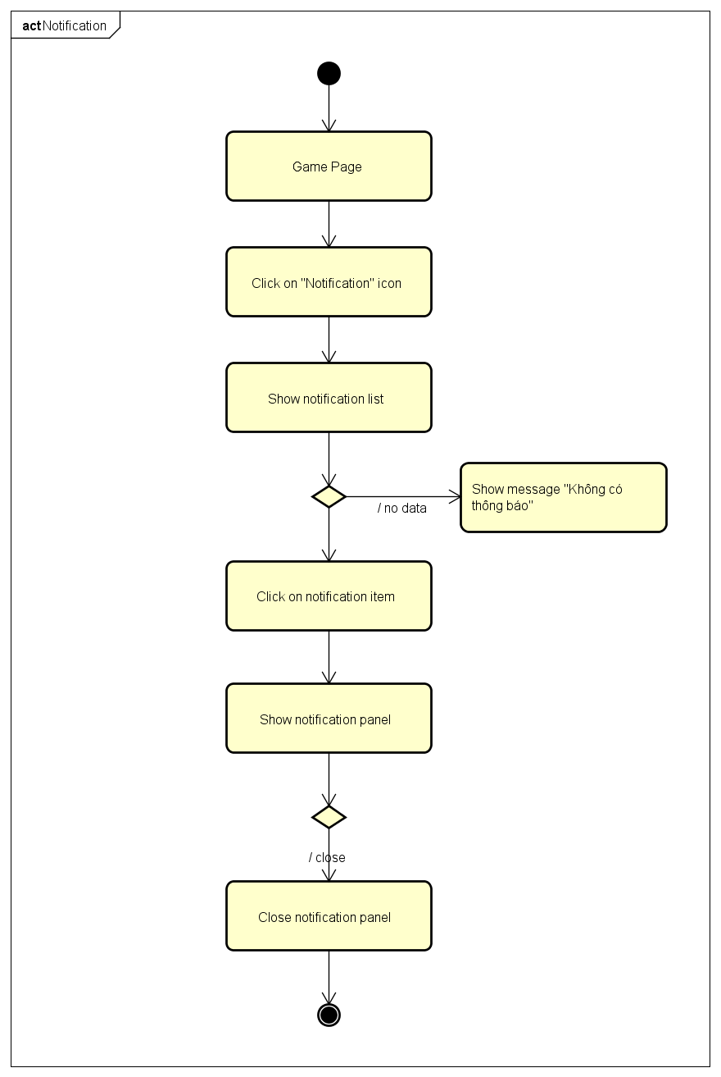

4.5.A.10. Ranking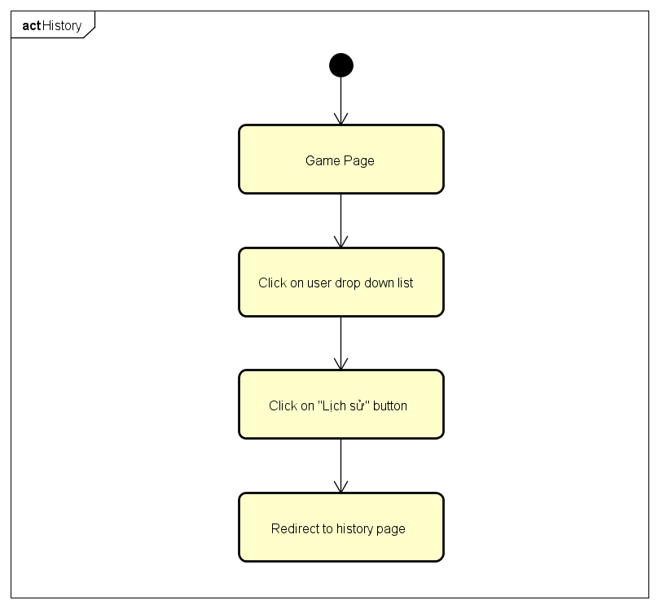

4.5.A.11. Create Challenges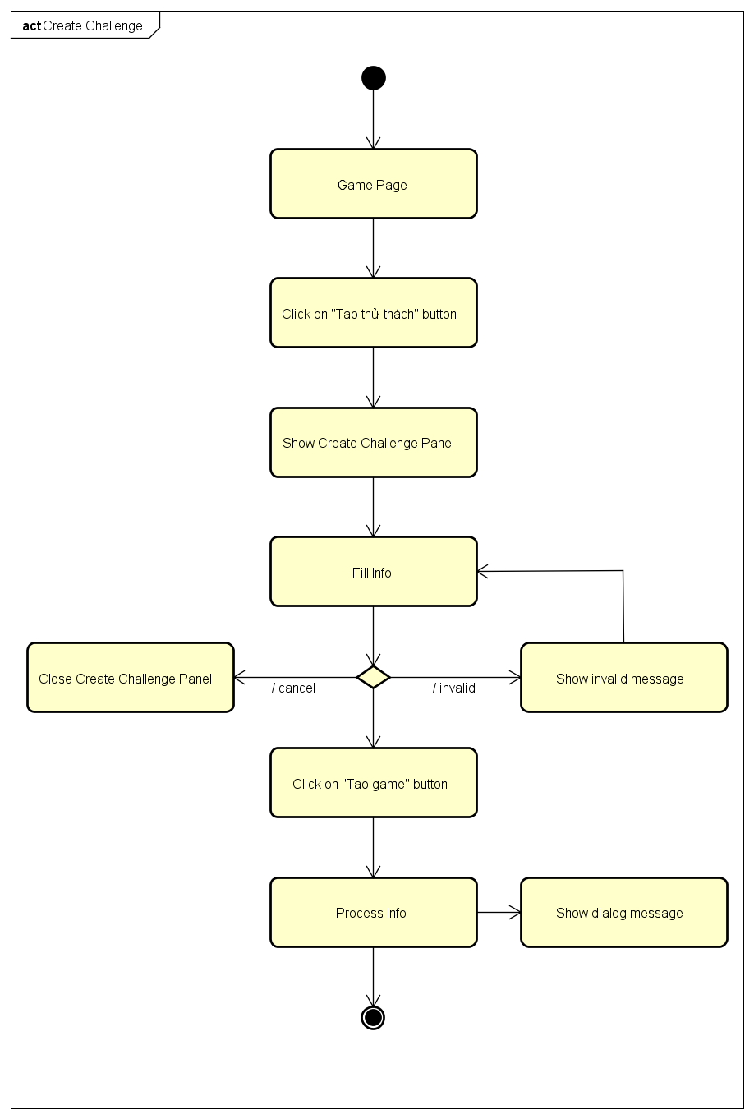

4.5.A.12. Bet On Traditional Game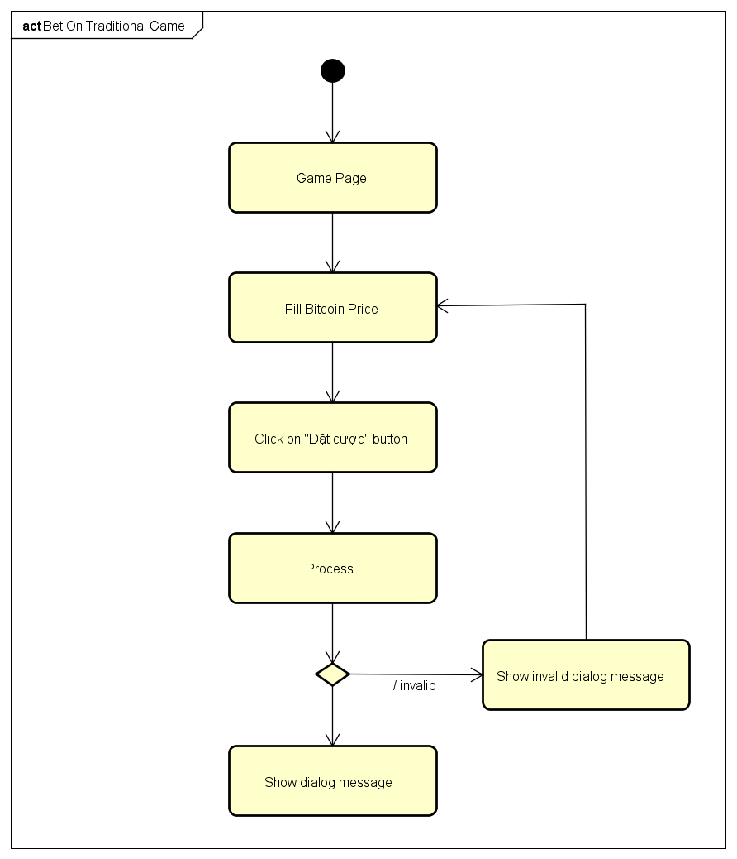

4.5.A.13. Bet On Challenge Game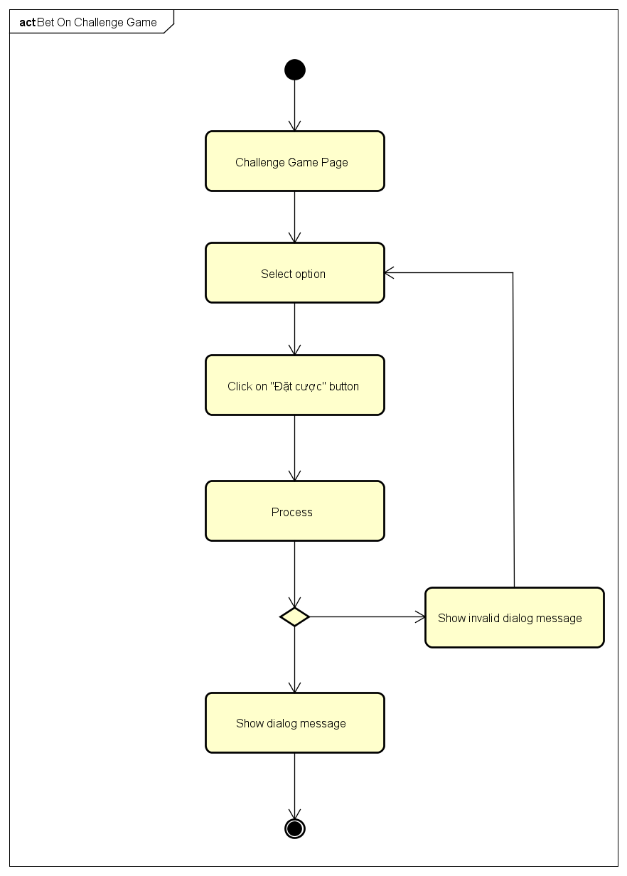

4.5.B. Admin Activities Diagram

4.5.B.1. Login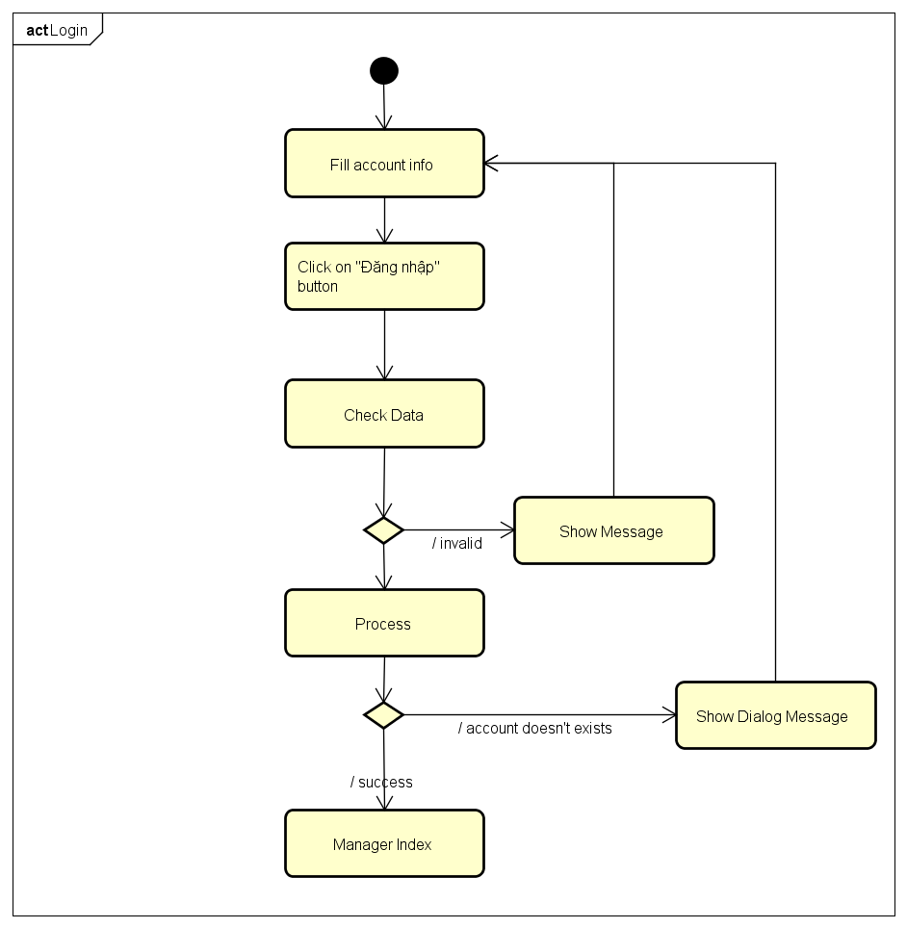

4.5.B.2.Send Notification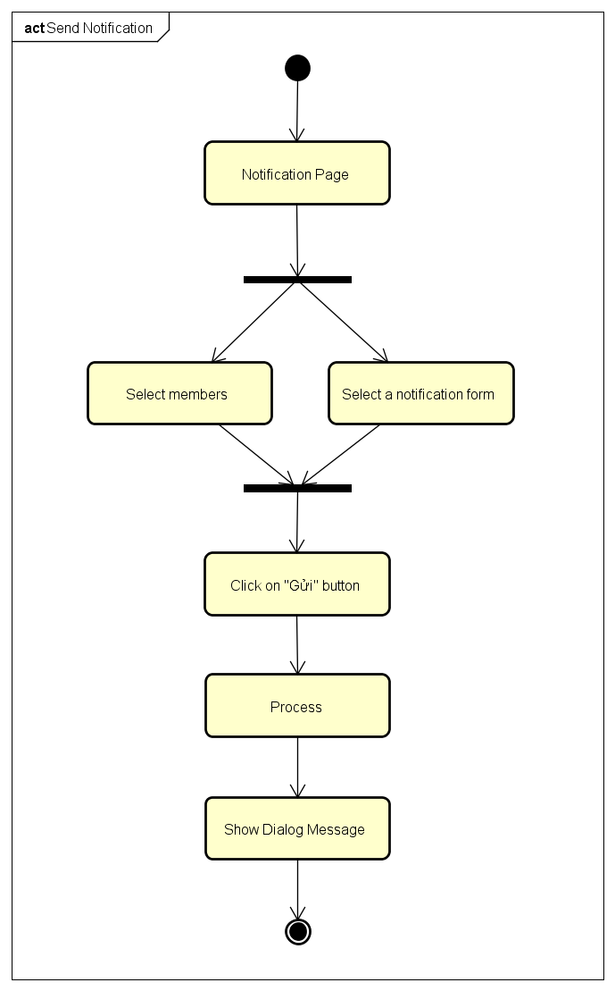

4.5.B.3.Add Notification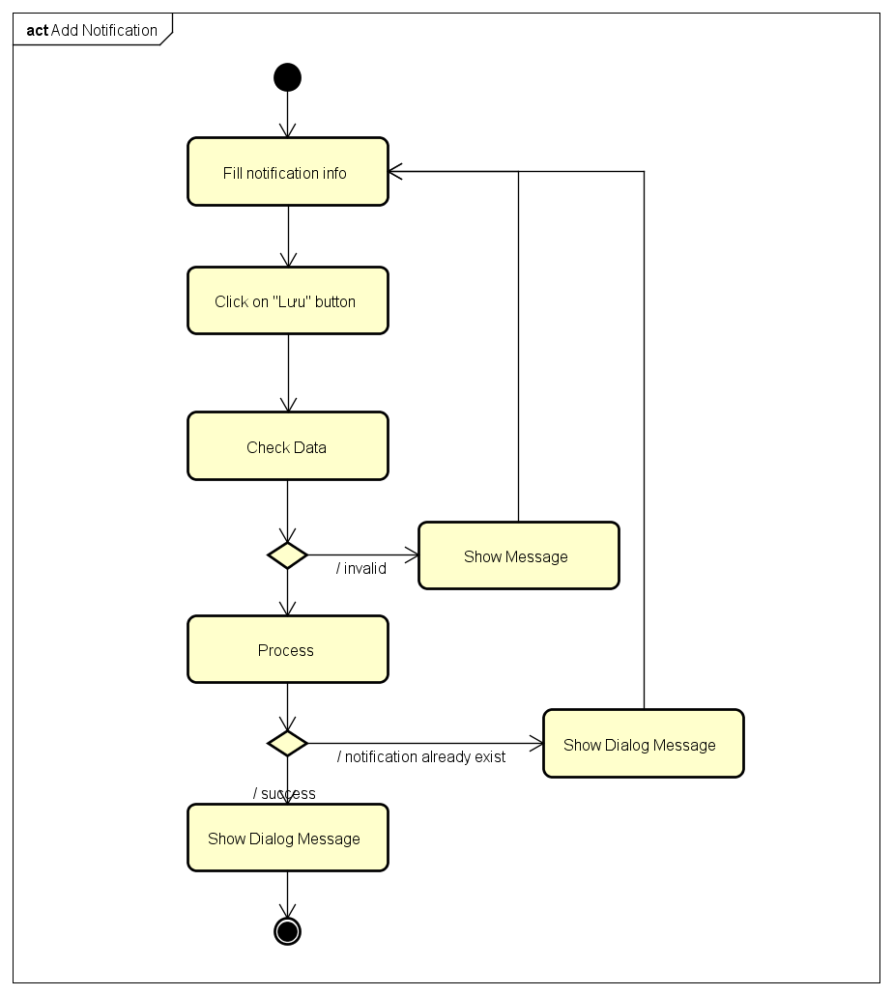

4.5.B.4.Delete Notification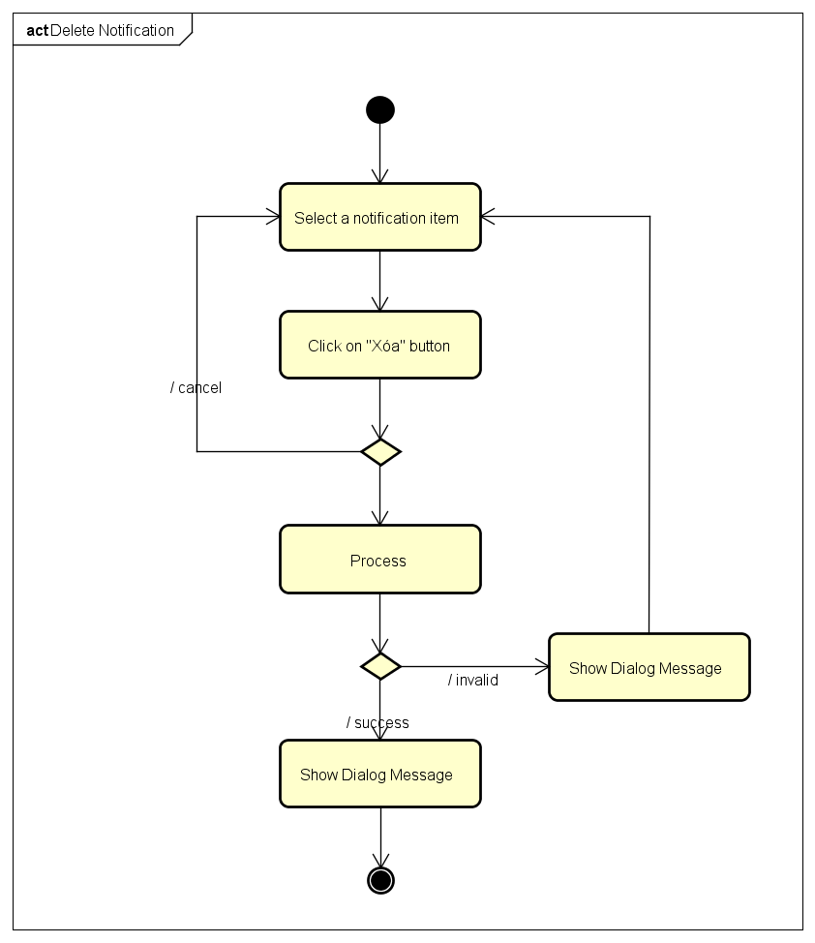

4.5.B.5.Edit Notification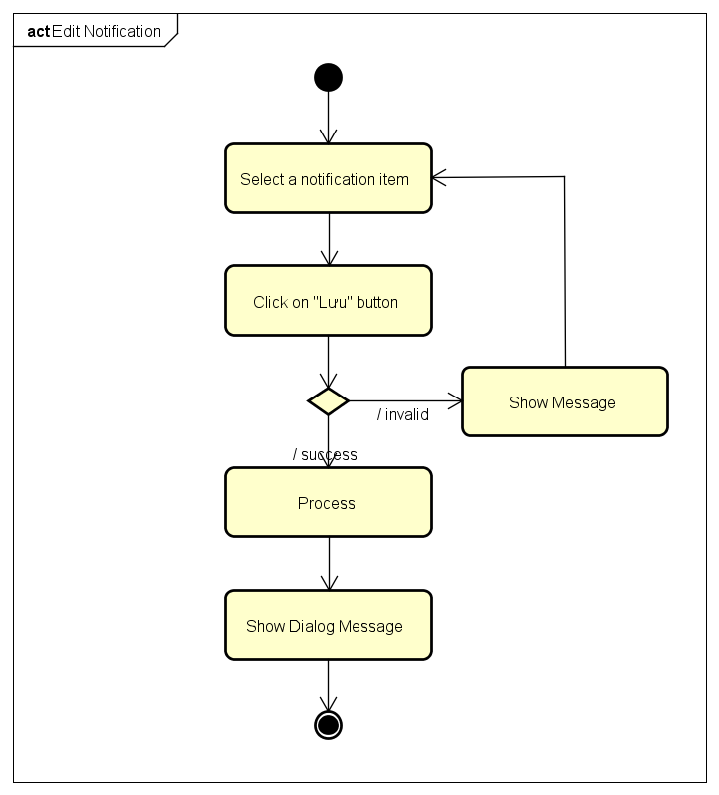

4.5.B.6.Search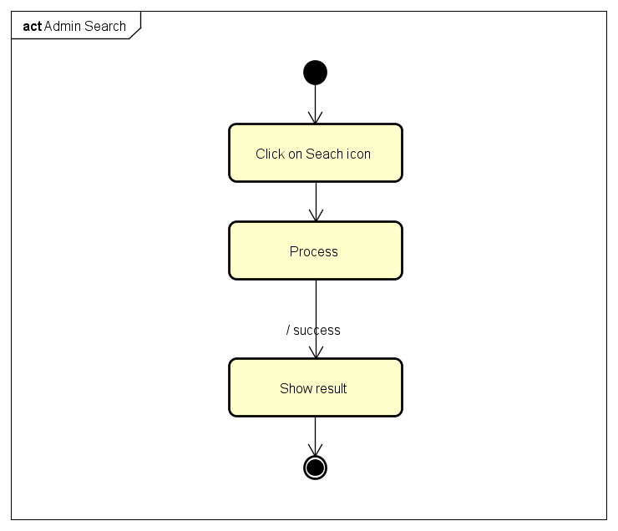

4.5.B.7.Block Manager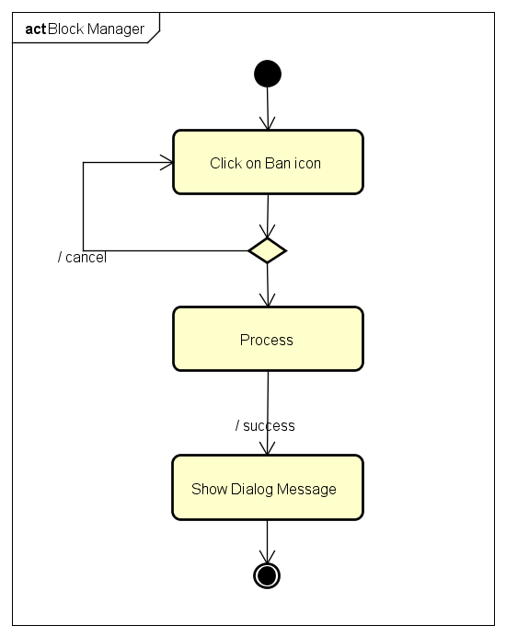

4.5.B.8.Unblock Manager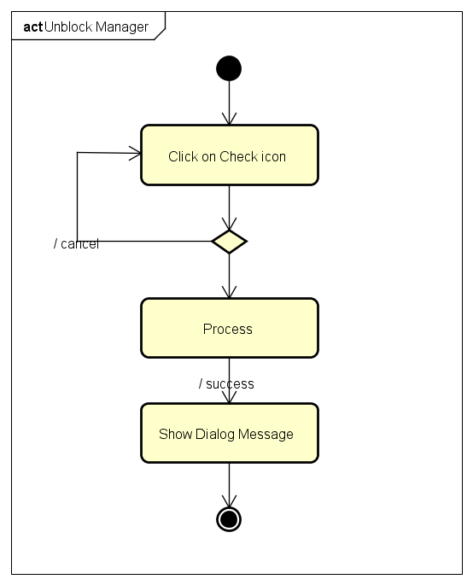

4.5.B.9.Change Gift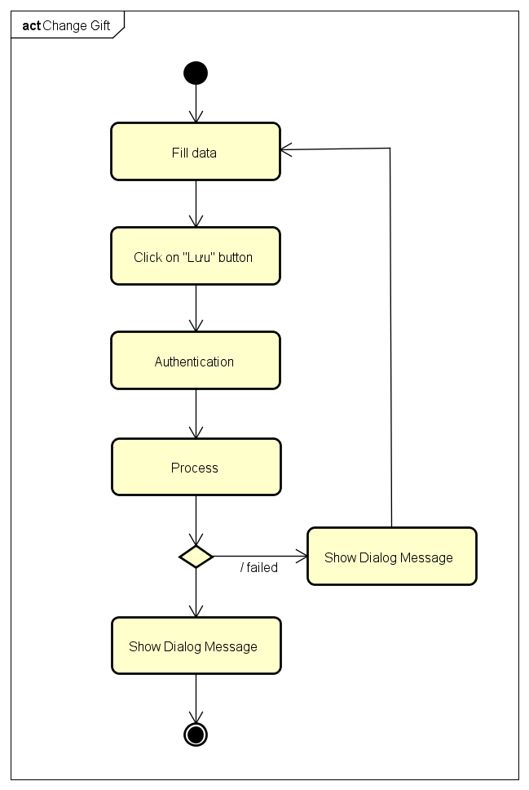

4.5.B.10.History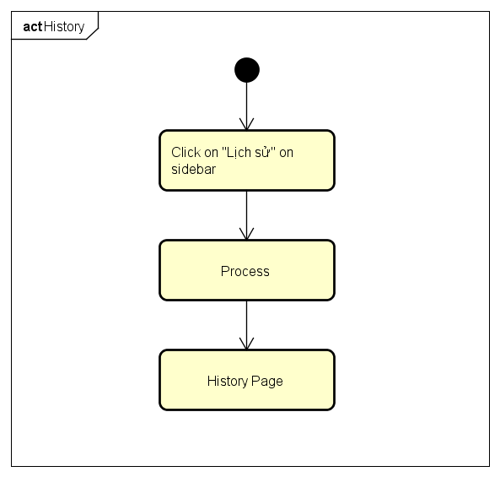

4.5.B.11.Create Game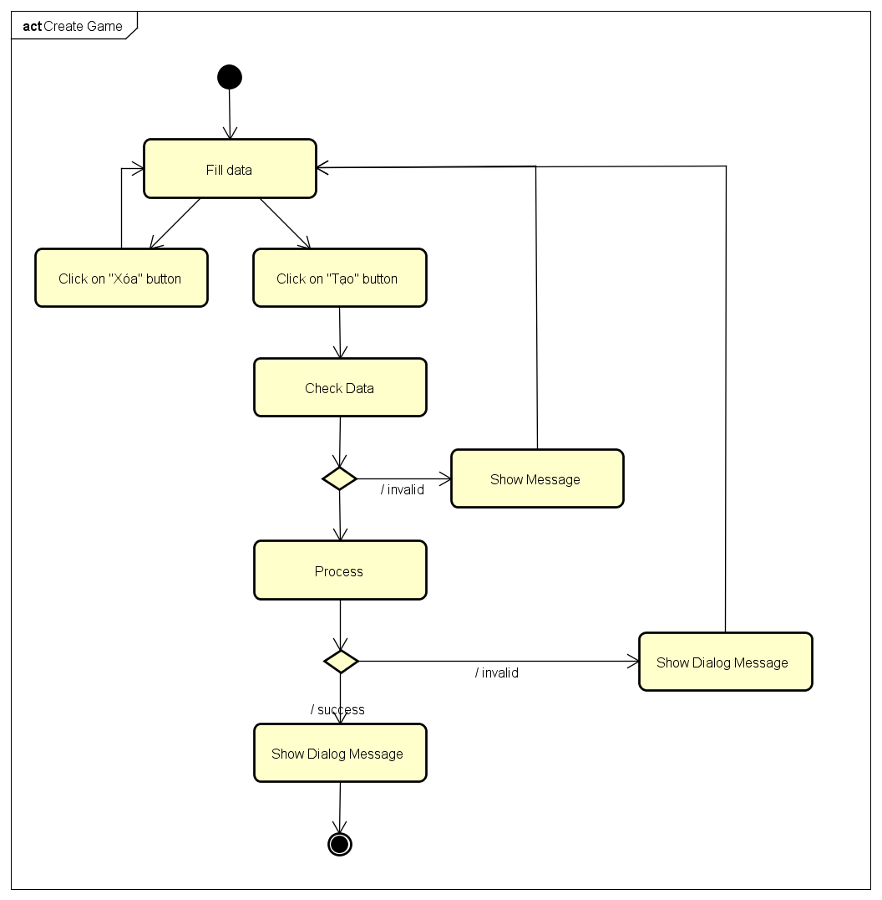

4.5.B.12.Edit Manager Information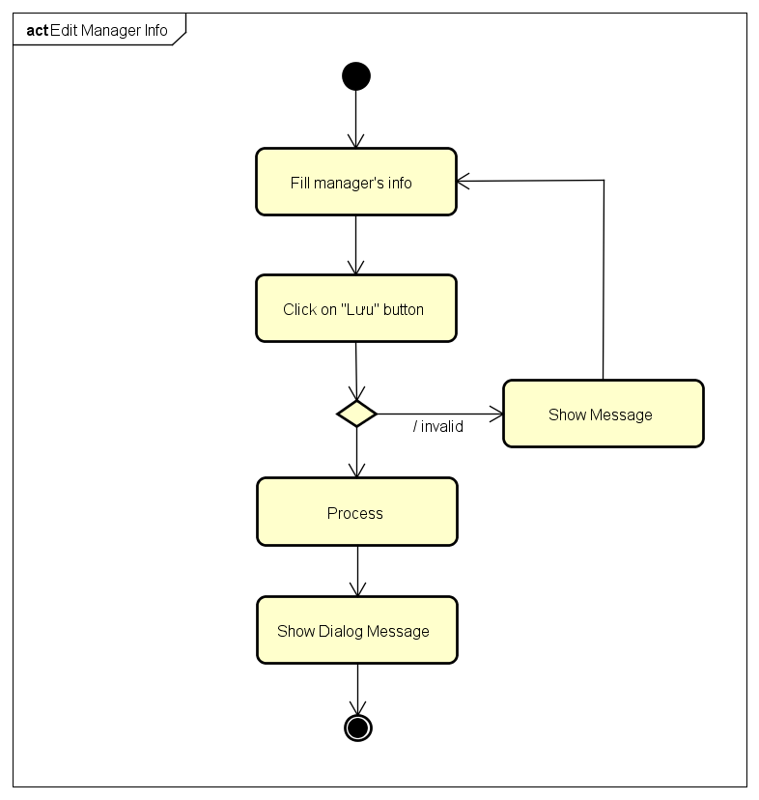

4.5.B.13.View Manager Information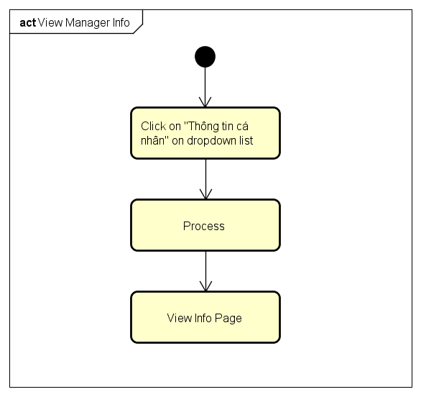

4.5.B.14.Change Password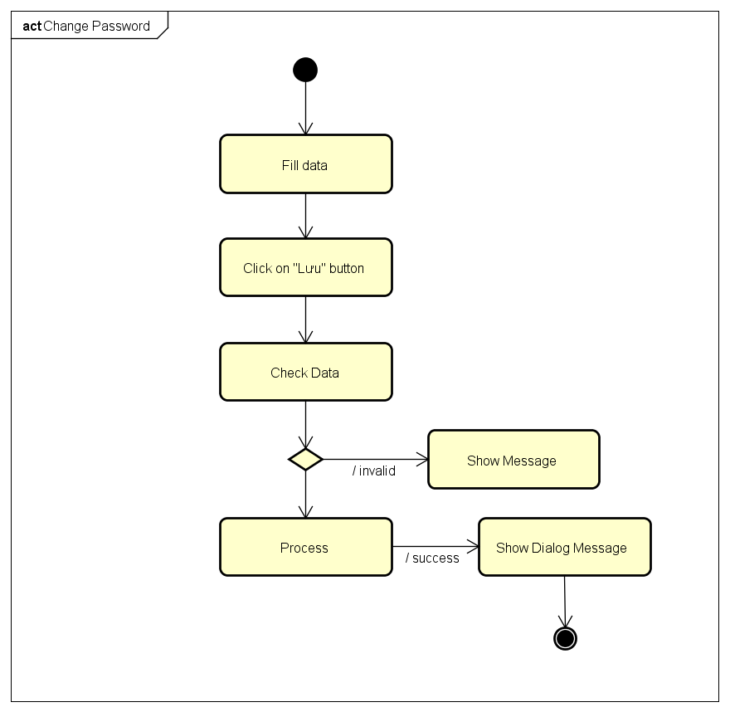

4.5.B.15.Forgot Password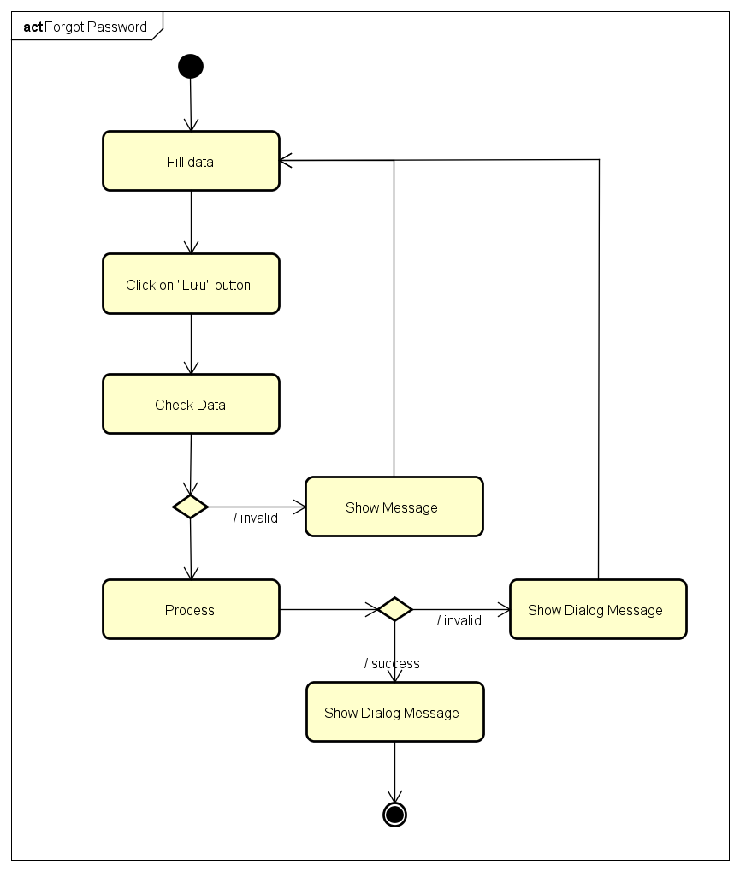

4.6. CRC Cards and Class Diagram

4.6.1. CRC Cards

4.6.2. Class Diagram

4.7.A. User Interface Design

4.7.A.1. Register and Login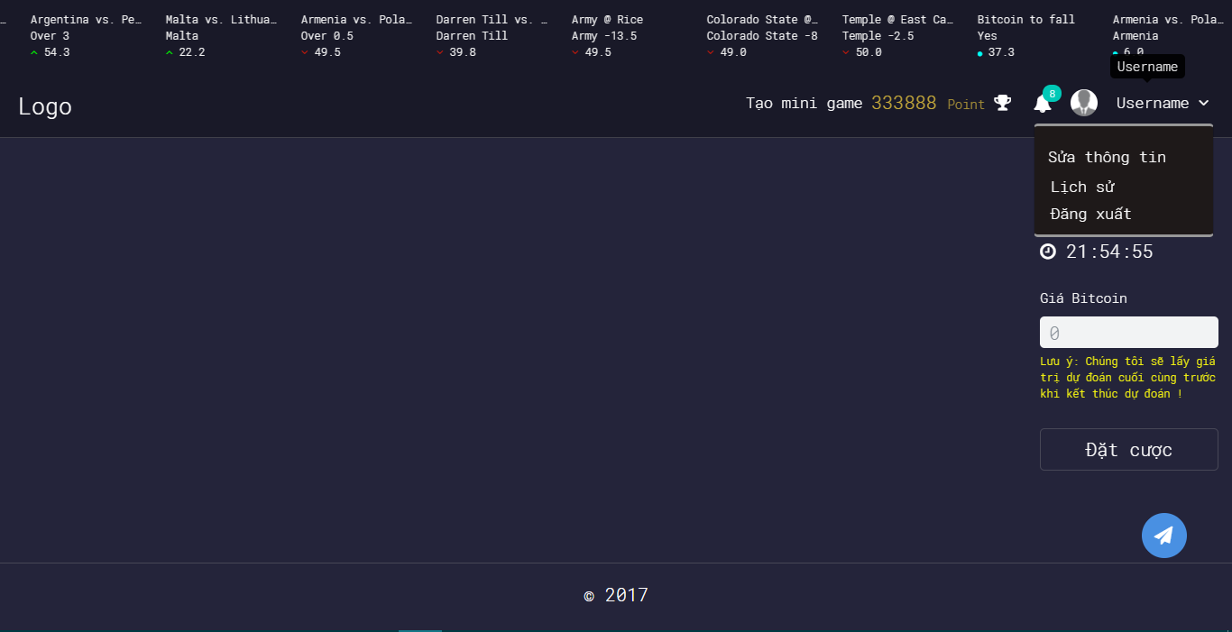

4.7.A.2. Login Using Facebook

4.7.A.3. Login Using Google Plus

4.7.A.4. Logout

4.7.A.5. Change Password

4.7.A.6. Forgot Password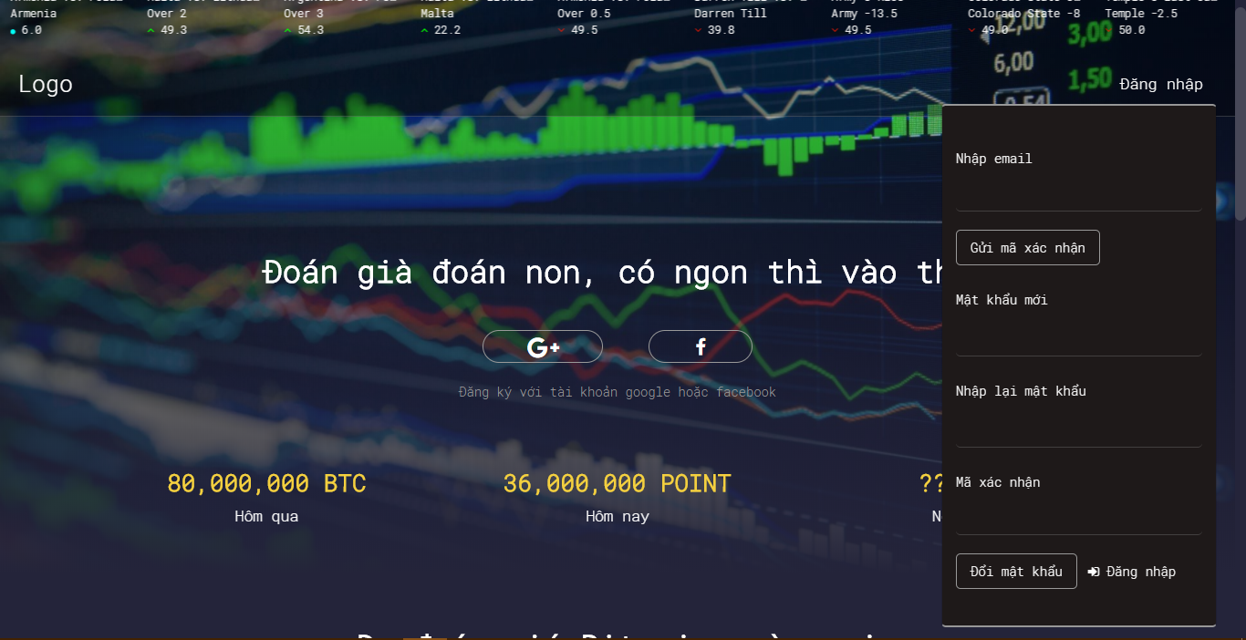

4.7.A.7. Edit Profile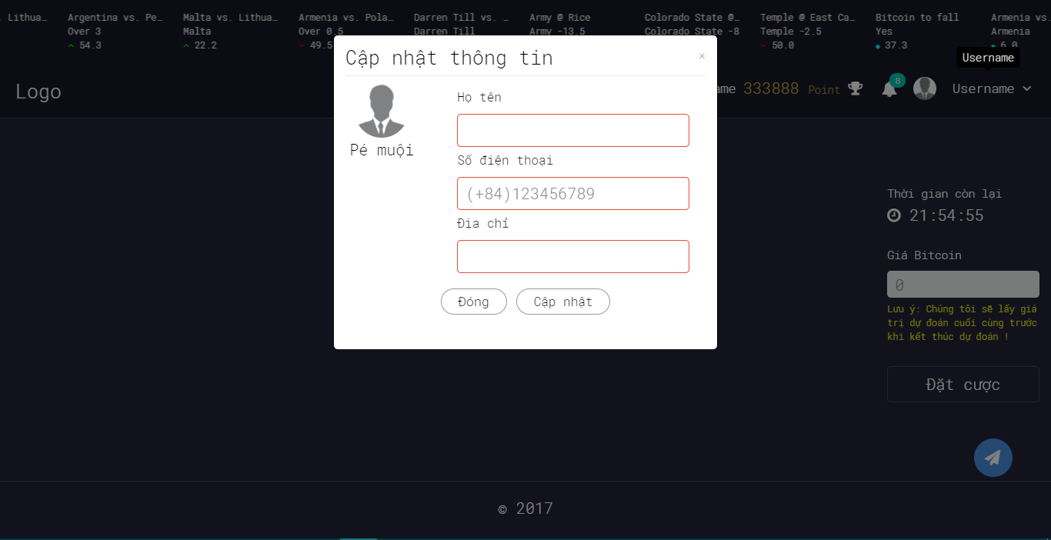

4.7.A.8. History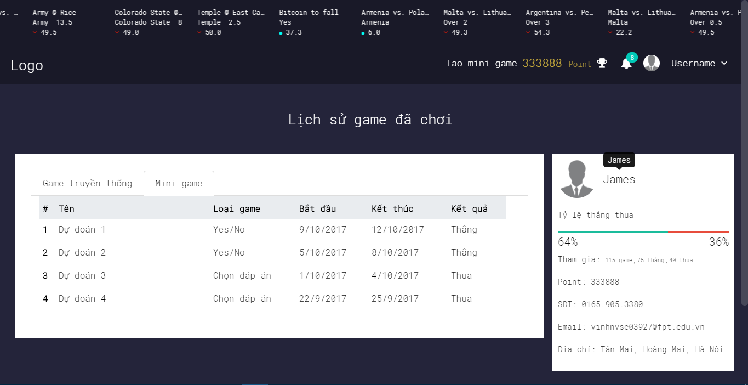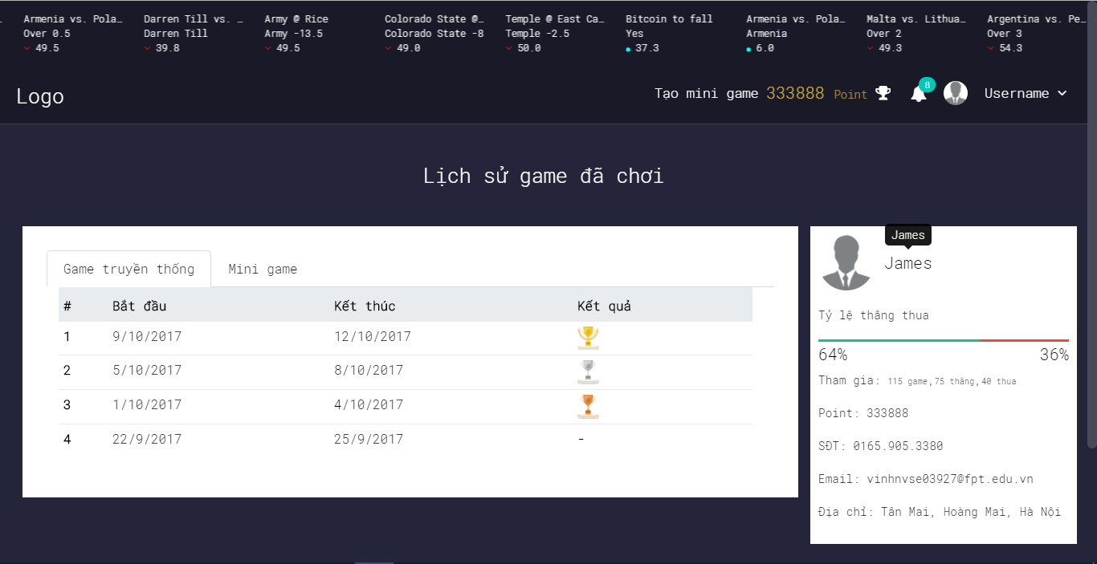

4.7.A.9. Notification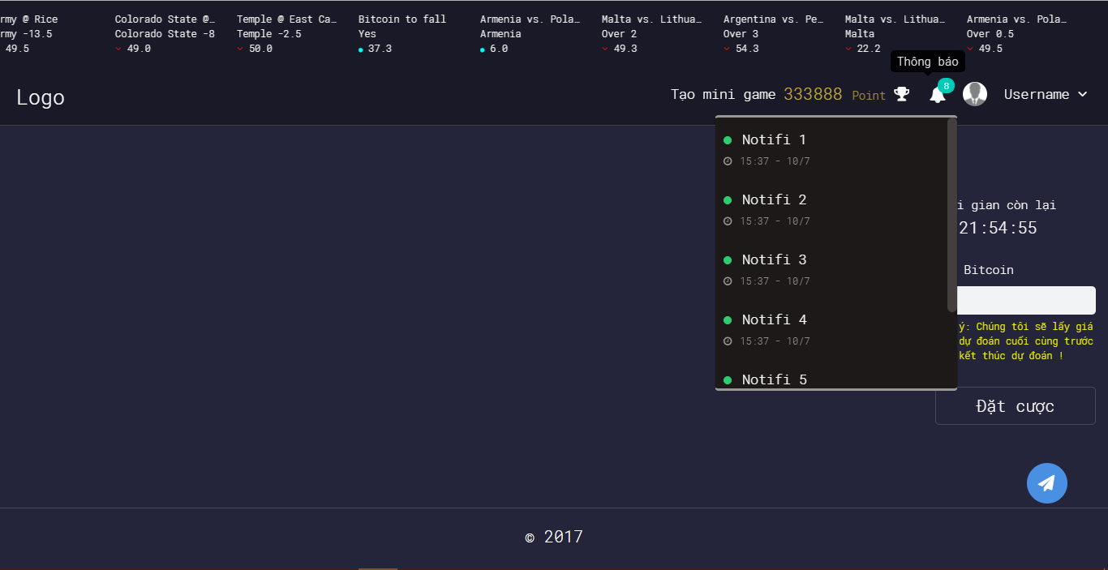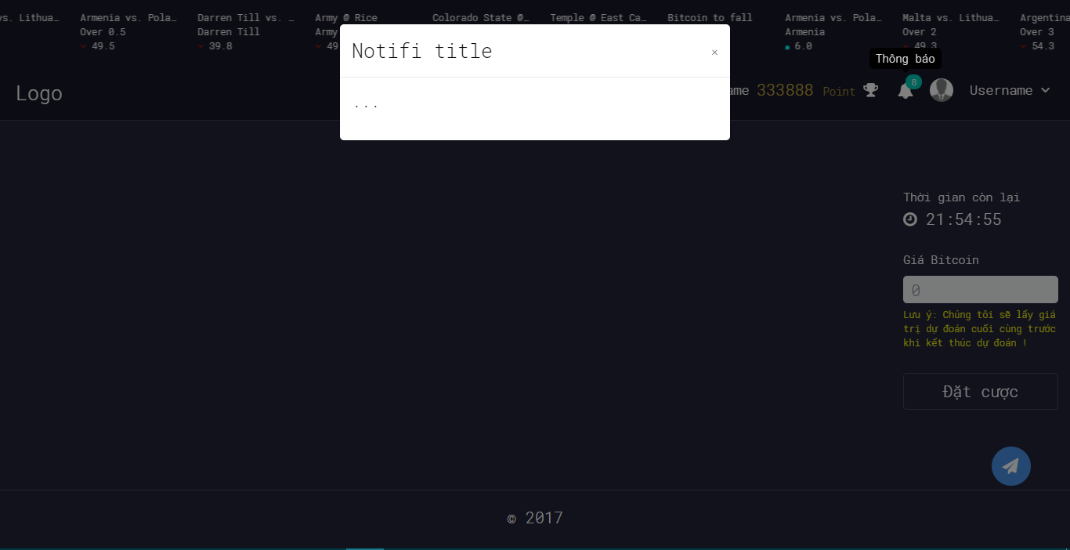

4.7.A.10. Ranking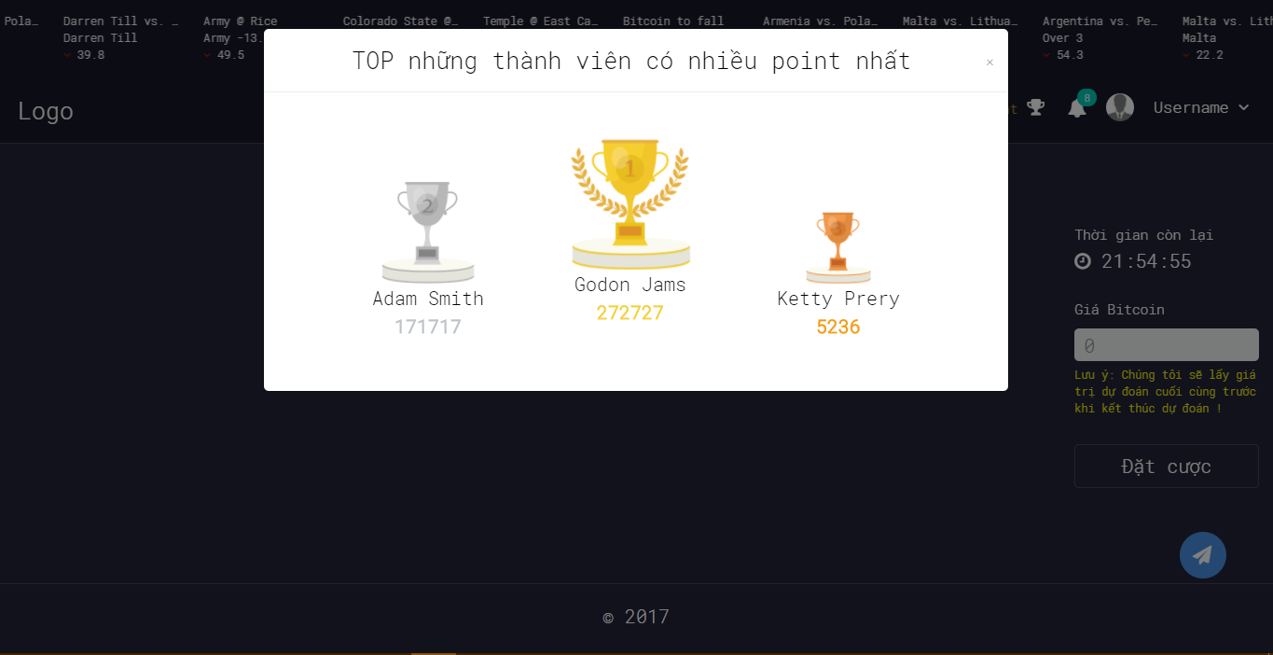

4.7.A.11. Create Yes/No Game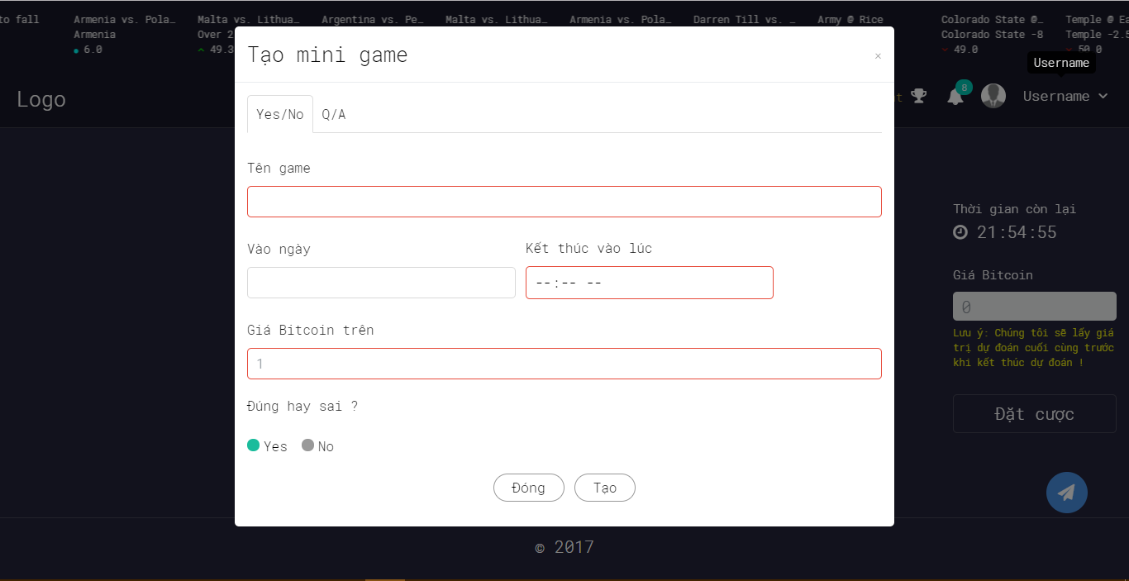

4.7.A.12. Create Multiple Choice Game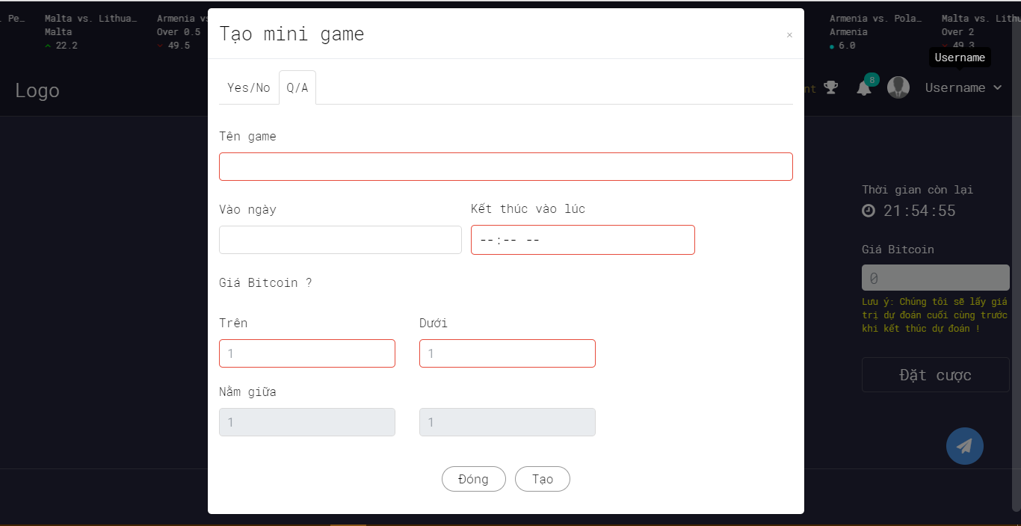

4.7.A.13. Bet On Traditional Game

4.7.A.14. Bet On Yes/No Game

4.7.A.15. Bet On Multiple Choice Game

4.7.A.16. YES/No Game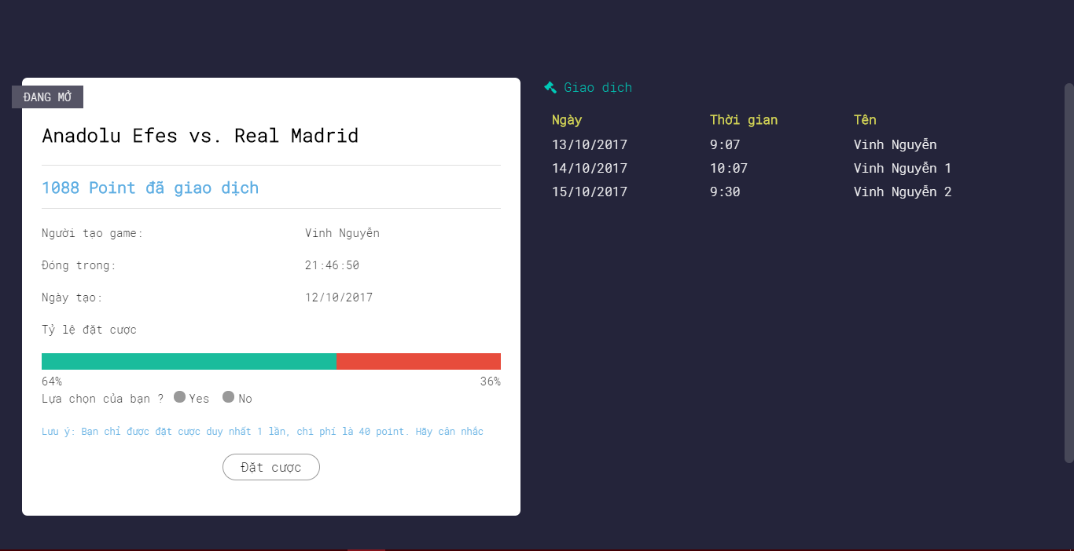

4.7.A.17. Multiple Choice Game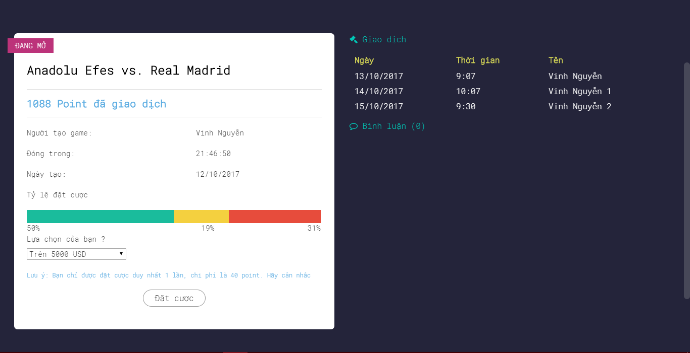

4.8. Database Design

4.8.1. Overview

Figure Database Design Screen

4.8.2. ROLE table

ROLE table store users’ role information

|  |  |  |  |  |  |
| --- | --- | --- | --- | --- | --- |
| **No.** | **Field Name** | **Type** | **Size** | **Description** | **Not Null** |
| 1 | ROLE_ID (Primary key) | int | 11 | The unique identity field for role | X |
| 2 | ROLE_NAME | varchar | 30 | Name of the role | X |

4.8.3. USERS table

|  |  |  |  |  |  |
| --- | --- | --- | --- | --- | --- |
| **No.** | **Field Name** | **Type** | **Size** | **Description** | **Not Null** |
| 1 | USER_ID  (Primary key) | int | 11 | The unique identity field for user | X |
| 2 | ROLE_ID | int | 11 | The unique identity field for role  REFERENCES ROLE(ROLE_ID) | X |
| 3 | USER_CIF | varchar | 50 | The user’s id is returned from facebook or google while login with these providers |  |
| 4 | USER_NAME | nvarchar | 100 | Name of user | X |
| 5 | PASSWORD | varchar | 100 | Password to login |  |
| 6 | USER_POINT | int | 11 | The point to join the created by system or users | X |
| 7 | EMAIL | varchar | 100 | Email of user | X |
| 8 | PHONE_NUMBER | varchar | 30 | Phone number of user |  |
| 9 | ADDRESS | nvarchar | 255 | Address of user |  |
| 10 | CREATE_DATE | date |  | The day that user join us | X |
| 11 | ATTENDANCE | bool |  | This field to check if user use service daily | X |
| 12 | ACTIVE | bool |  | To block or active user | X |

4.8.4. NOTIFICATION table

NOTIFICATION table store the message sent to user when necessary

|  |  |  |  |  |  |
| --- | --- | --- | --- | --- | --- |
| **No.** | **Field Name** | **Type** | **Size** | **Description** | **Not Null** |
| 1 | NOTICE_ID  (PRIMARY KEY) | int | 11 | The unique identity field for message | X |
| 2 | TITLE | nvarchar | 255 | Title of message | X |
| 3 | CONTENT | text |  | Content of message | X |
| 4 | CREATE_DATE | datetime |  | Date when message is created | X |

4.8.5. NOTIFICATION_TYPE table

NOTIFICATION_TYPE table store type of notice

|  |  |  |  |  |  |
| --- | --- | --- | --- | --- | --- |
| **No.** | **Field Name** | **Type** | **Size** | **Description** | **Not Null** |
| 1 | TYPE_ID  (PRIMARY KEY) | int | 11 | The unique identity field for message type | X |
| 2 | TYPE_NAME | varchar | 20 | Name of type | X |

4.8.6. NOTIFICATION_DETAILS table

NOTIFICATION_DETAILS table store logs when messages sent to users

|  |  |  |  |  |  |
| --- | --- | --- | --- | --- | --- |
| **No.** | **Field Name** | **Type** | **Size** | **Description** | **Not Null** |
| 1 | NOTICE_ID  references NOTIFICATION(NOTICE_ID) | int | 11 | The unique identity field for message | X |
| 2 | USER_ID  references USERS(USER_ID) | int | 11 | The unique identity field for user | X |
| 3 | TYPE_ID  references NOTIFICATION_TYPE(TYPE_ID) | int | 2 | The unique identity field for type | X |
| 4 | GAME_ID | int | 11 | To determine what game message responsible for | X |
| 5 | SEND_DATE | datetime |  | Date that message was sent to user | X |
| 6 | SEEN | bool |  | Status of message when received by user | X |

4.8.7. CHAT_ROOMS table

CHAT_ROOMS table store the channel that message’s sent to

|  |  |  |  |  |  |
| --- | --- | --- | --- | --- | --- |
| **No.** | **Field Name** | **Type** | **Size** | **Description** | **Not Null** |
| 1 | ROOM_ID  (Primary key) | int | 11 | The unique identity field for channel | X |
| 2 | GAME_ID  references SYSTEM_GAMES (GAME_ID) | int | 11 | Game that chat channel is created for | X |
| 3 | ROOM_NAME | varchar | 100 | The name of channel | X |
| 4 | CREATE_DATE | datetime |  | The day that room is created | X |

4.8.9. CHAT_MESSAGES table

CHAT_MESSAGES table store message that is commented by user to system game

|  |  |  |  |  |  |
| --- | --- | --- | --- | --- | --- |
| **No.** | **Field Name** | **Type** | **Size** | **Description** | **Not Null** |
| 1 | MESSAGE_ID  (Primary key) | int | 11 | The unique identity field for comment | X |
| 2 | USER_ID  references USERS(USER_ID) | int | 11 | The owner of comment | X |
| 3 | ROOM_ID  references CHAT_ROOMS(ROOM_ID) | int | 11 | The channel that comment in | X |
| 4 | CONTENT | nvarchar | 255 | Content of comment | X |
| 5 | SEND_DATE | dateitme |  | Date that user leave their comment | X |

4.8.10. CATEGORIES table

CATEGORIES table store currency category information

|  |  |  |  |  |  |
| --- | --- | --- | --- | --- | --- |
| **No.** | **Field Name** | **Type** | **Size** | **Description** | **Not Null** |
| 1 | CATEGORY_ID  (Primary key) | int | 11 | The unique identity field for category | X |
| 2 | CATEGORY_NAME | varchar | 30 | Category name | X |

4.8.11. CURRENCY_TYPE table

CURRENCY_TYPE table store currency type

|  |  |  |  |  |  |
| --- | --- | --- | --- | --- | --- |
| **No.** | **Field Name** | **Type** | **Size** | **Description** | **Not Null** |
| 1 | TYPE_ID  (Primary key) | int | 11 | The unique identity field for type | X |
| 2 | TYPE_NAME | varchar | 20 | Type name | X |
| 3 | CATEGORY_ID  references CATEGORIES(CATEGORY_ID) | int | 11 | Category of type | X |

4.8.12. CURRENCY_DETAILS table

CURRENCY_DETAILS table store information about a specificed currency unit at a time

|  |  |  |  |  |  |
| --- | --- | --- | --- | --- | --- |
| **No.** | **Field Name** | **Type** | **Size** | **Description** | **Not Null** |
| 1 | CURRENCY_ID  (Primary key) | int | 11 | The unique identity field for currency | X |
| 2 | PRICE | double |  | Price of currency unit at a time | X |
| 3 | UPDATE_AT | datetime |  | The time that currency is to be value at | X |
| 4 | TYPE_ID  references CURRENCY_TYPE(TYPE_ID) | int |  | Type of currency | X |

4.8.13. SYSTEM_GAMES table

SYSTEM_GAMES table store the game automatically created by system

|  |  |  |  |  |  |
| --- | --- | --- | --- | --- | --- |
| **No.** | **Field Name** | **Type** | **Size** | **Description** | **Not Null** |
| 1 | GAME_ID  (Primary key) | int | 11 | The unique identity field for game | X |
| 2 | TITLE | nvarchar | 255 | Game title | X |
| 3 | CONTENT | nvarchar | 255 | Game content | X |
| 4 | START_DATE | datetime |  | Time that game starts | X |
| 5 | END_DATE | datetime |  | Time that game ends | X |
| 6 | ACTIVE | bool |  | Status of game | X |
| 7 | POINT_TO_BET | double |  | Point spent to join game | X |
| 8 | RESULT | double |  | Result of game |  |
| 9 | CUR_TYPE_ID  references CURRENCY_TYPE(TYPE_ID) | int | 11 | Type of game corresponding to type of currency | X |

4.8.14. SYSTEM_GAME_LOGS table

SYSTEM_GAME_LOGS store history of system game

|  |  |  |  |  |  |
| --- | --- | --- | --- | --- | --- |
| **No.** | **Field Name** | **Type** | **Size** | **Description** | **Not Null** |
| 1 | USER_ID  references USERS(USER_ID) | int | 11 | Game’s player | X |
| 2 | GAME_ID  references SYSTEM_GAMES(GAME_ID) | int | 11 | Game that logs belong to | X |
| 3 | PRICE_GUESS | double |  | Value of currency unit user guess | X |
| 4 | DATE_GUESS | datetime |  | Time user leave their prediction | X |

4.8.15. AWARD table

AWARD table store gift for the 3 first prizes of system game

|  |  |  |  |  |  |
| --- | --- | --- | --- | --- | --- |
| **No.** | **Field Name** | **Type** | **Size** | **Description** | **Not Null** |
| 1 | AWARD_ID  (Primary key) | int | 11 | The unique identity field for award | X |
| 2 | PRIZE | int | 1 | The prize that the gift belongs to | X |
| 3 | AWARD_NAME | nvarchar | 100 | Name | X |
| 4 | PRICE | double |  | Value of gift | X |
| 5 | IMAGE_URL | varchar | 255 | Image of gift | X |
| 6 | ACTIVE | bool |  | Status of gift | X |

4.8.16. ACHIEVEMENT table

ACHIEVEMENT table store winners of system game

|  |  |  |  |  |  |
| --- | --- | --- | --- | --- | --- |
| **No.** | **Field Name** | **Type** | **Size** | **Description** | **Not Null** |
| 1 | A_ID | int | 11 | The unique identity field for achievement | X |
| 2 | USER_ID  references USERS(USER_ID) | int | 11 | User get achievement | X |
| 3 | AWARD_ID  references AWARD(AWARD_ID) | int | 11 | The ward for winner | X |
| 4 | GAME_ID  references SYSTEM_GAMES(GAME_ID) | int | 11 | Game that user get achievement | X |
| 5 | GET_AT | datetime |  | Time that user get achievement | X |

4.8.17. YN_GAMES table

YN_GAMES table store binary option game (true/faslse) created by users

|  |  |  |  |  |  |
| --- | --- | --- | --- | --- | --- |
| **No.** | **Field Name** | **Type** | **Size** | **Description** | **Not Null** |
| 1 | GAME_ID  (Primary key) | int | 11 | The unique identify field for game | X |
| 2 | OWNER_ID  references USERS(USER_ID) | int | 11 | The owner of game | X |
| 3 | CUR_TYPE_ID  references CURRENCY_TYPE(TYPE_ID) | int | 11 | The currency unit that game use to bet | X |
| 4 | TITLE | nvarchar | 255 | Game title | X |
| 5 | CONTENT | nvarchar | 255 | Game content | X |
| 6 | START_DATE | datetime |  | Time to start game | X |
| 7 | END_DATE | datetime |  | Time to end game | X |
| 8 | POINT_TO_BET | int | 5 | Point to join game | X |
| 9 | PRICE_BET | double |  | Value of currency unit that user raise to bet | X |
| 10 | RESULT | double |  | Result of game |  |
| 11 | PLAYER_COUNT | int | 2 | Number of players join game.  (<= 40) | X |
| 12 | ACTIVE | bool |  | Status of game. It’s set to false if game end | X |
| 13 | TOTAL_AMOUNT | int | 11 | Total point get from players  (PLAYER_COUNT*POINT_TO_BET) | X |

4.8.18. YN_GAME_LOGS table

YN_GAME_LOGS table store history of yn_game

|  |  |  |  |  |  |
| --- | --- | --- | --- | --- | --- |
| **No.** | **Field Name** | **Type** | **Size** | **Description** | **Not Null** |
| 1 | USER_ID  references USERS(USER_ID) | int | 11 | Players in game | X |
| 2 | GAME_ID  references YN_GAMES(GAME_ID) | int | 11 | The unique identify field for game that log is saved | X |
| 3 | ANSWER | bool |  | The answer players choose | X |
| 4 | ANS_TIME | datetime |  | Date that user join game | X |
| 5 | IS_WINNER | bool |  | Result of game that point out who is winner or looser |  |

4.8.19. MULTI_CHOICE_GAMES table

MULTI_CHOICE_GAMES table store multichoice game created by user

|  |  |  |  |  |  |
| --- | --- | --- | --- | --- | --- |
| **No.** | **Field Name** | **Type** | **Size** | **Description** | **Not Null** |
| 1 | GAME_ID  (Primary key) | int | 11 | The unique identify field for game | X |
| 2 | OWNER_ID | int | 11 | The owner of game | X |
| 3 | CUR_TYPE_ID | int | 11 | The currency unit that game use to bet | X |
| 4 | TITLE | nvarchar | 255 | Game title | X |
| 5 | CONTENT | nvarchar | 255 | Game content | X |
| 6 | START_DATE | datetime |  | Time to start game | X |
| 7 | END_DATE | datetime |  | Time to end game | X |
| 8 | POINT_TO_BET | int | 5 | Point to join game | X |
| 9 | PRICE_BELOW | double |  | Minimum value of currency unit that user raise to bet | X |
| 10 | PRICE_ABOVE | double |  | Maximum value of currency unit that user raise to bet | X |
| 11 | RESULT | double |  | Value of currency unit when game ends |  |
| 12 | PLAYER_COUNT | int | 2 | Number of players join game.  (<= 40) | X |
| 13 | ACTIVE | bool |  | Status of game. It’s set to false if game end | X |
| 14 | TOTAL_AMOUNT | int | 11 | Total point get from players  (PLAYER_COUNT*POINT_TO_BET) |  |

4.8.20. MULTI_CHOICE_GAME_LOGS table

MULTI_CHOICE_GAME_LOGS table store history of multi choice game

|  |  |  |  |  |  |
| --- | --- | --- | --- | --- | --- |
| **No.** | **Field Name** | **Type** | **Size** | **Description** | **Not Null** |
| 1 | USER_ID  references USERS(USER_ID) | int | 11 | Players in game | X |
| 2 | GAME_ID  references YN_GAMES(GAME_ID) | int | 11 | The unique identify field for game that log is saved | X |
| 3 | PRICE_BELOW | bool |  | Option that player choose. True if the real price < MULTI_CHOICE_GAMES (PRICE_BELOW) | X |
| 4 | PRICE_BETWEEN | bool |  | Option that player choose. True if the MULTI_CHOICE_GAMES (PRICE_BELOW) <= real price <= MULTI_CHOICE_GAMES (PRICE_ABOVE) | X |
| 5 | PRICE_ABOVE | bool |  | Option that player choose. True if the real price > MULTI_CHOICE_GAMES (PRICE_ABOVE) | X |
| 6 | ANS_TIME | datetime |  | Date that user join game | X |
| 7 | IS_WINNER | bool |  | Result of game that point out who is winner or looser |  |

|  |  |  |  |  |  |
| --- | --- | --- | --- | --- | --- |
| **No.** | **Field Name** | **Type** | **Size** | **Description** | **Not Null** |
| 1 | USER_ID  (Primary key) | int | 11 | The unique identity field for user | X |
| 2 | ROLE_ID | int | 11 | The unique identity field for role  REFERENCES ROLE(ROLE_ID) | X |
| 3 | USER_CIF | varchar | 50 | The user’s id is returned from facebook or google while login with these providers |  |
| 4 | USER_NAME | nvarchar | 100 | Name of user | X |
| 5 | PASSWORD | varchar | 100 | Password to login |  |
| 6 | USER_POINT | int | 11 | The point to join the created by system or users | X |
| 7 | EMAIL | varchar | 100 | Email of user | X |
| 8 | PHONE_NUMBER | varchar | 30 | Phone number of user |  |
| 9 | ADDRESS | nvarchar | 255 | Address of user |  |
| 10 | CREATE_DATE | date |  | The day that user join us | X |
| 11 | ATTENDANCE | bool |  | This field to check if user use service daily | X |
| 12 | ACTIVE | bool |  | To block or active user | X |

Register login

|  |  |  |  |  |
| --- | --- | --- | --- | --- |
| **Field Name** | **Description** | **Control type** | **Data type** | **Length** |
| Infinity slide show | Show mini games have been created. | Link |  |  |
| Logo | Title of website | Link |  |  |
| Login facebook, google | click on “Login facebook” or “Login goggle” to login website | Button |  |  |
| Game navbar | Include list all games, games are open or close. | Link |  |  |
| Button “Đăng nhâp” | Click on “đăng nhập” to login if user has an account.  Users don’t have an account, user click “đăng nhâp” to register. | Button |  |  |
| Form login or register | Include name of email, password.  If user forget password, click on “quên mật khẩu” to get new password | Text field,  Button, Link |  |  |

Forget password

|  |  |  |  |  |
| --- | --- | --- | --- | --- |
| **Field Name** | **Description** | **Control type** | **Data type** | **Length** |
| Form Forget password | Include form to get new password | Text field,  Button, Link | Text |  |

Traditional game

|  |  |  |  |  |
| --- | --- | --- | --- | --- |
| **Field Name** | **Description** | **Control type** | **Data type** | **Length** |
| Infinity slide show | Email  Button gui ma  New password  Confirm password  Ma xac nhan | Link |  |  |
| Logo | Title of website | Link |  |  |
| Navigation bar | Include Create challenge, Point, Rank, Notification, Profile, Icon profile. | Link |  |  |
| Option tag | Contain 3 items: View profile, History, Logout. | Link |  |  |
| Chart | Chart updates bitcoin prices per minute |  |  |  |
| Time | Fill estimating bitcoin prices then player wait time of game over. | Text field | double |  |
| Button “Đặt cược” | Click on “Đặt cược” to bet traditional betting game | Button |  |  |
| Chat button | Click on “chat” to chat | Button |  |  |
| Form Profile | Contain 3 items: Full name, phone number, Address  Button Close.  - Click on button “Cập nhật” to update profile. | Text field, button | Text, number |  |

Yes no game

|  |  |  |  |  |  |
| --- | --- | --- | --- | --- | --- |
| **Field Name** | | **Description** | **Control type** | **Data type** | **Length** |
| Infinity slide show | | Show mini games have been created. | Link |  |  |
| Logo | | Title of website | Link |  |  |
| Navigation bar | | Include Create challenge, Point, Rank, Notification, Profile, Icon profile. | Link |  |  |
| Option tag | | Contain 3 items: View profile, History, Logout. | Link |  |  |
| Form play yes_no betting game | name of game | Name of game is created by player. |  | Text |  |
| Date create | Date create yes_no betting game. |  | date |  |
| Close game | Date time close this game. |  | datetime |  |
| Information of creator | name’s creator game |  | Text |  |
| Radio button Yes or No | select “Yes” or “No” based on question of game | button |  |  |
| Button “Đặt cược” | Click on button” đặt cươc” to bet | Button |  |  |
| Transaction table | | Show date, time and name of players who participated in game. | Table |  |  |

Multichoice

|  |  |  |  |  |  |
| --- | --- | --- | --- | --- | --- |
| **Field Name** | | **Description** | **Control type** | **Data type** | **Length** |
| Infinity slide show | | Show mini games have been created. | Link |  |  |
| Logo | | Title of website | Link |  |  |
| Navigation bar | | Include Create challenge, Point, Rank, Notification, Profile, Icon profile. | Link |  |  |
| Option tag | | Contain 3 items: View profile, History, Logout. | Link |  |  |
| Form play yes_no betting game | name of game | Name of game is created by player. |  | Text |  |
| Date create | Date create yes_no betting game. |  | date |  |
| Close game | Date time close this game. |  | datetime |  |
| Information of creator | name’s creator game |  | Text |  |
| Option | Select “under” or “upper” or “between” based on question of this game. |  |  |  |
| Button “Đặt cược” | Click on button” đặt cươc” to bet | Button |  |  |
| Transaction table | | Show date, time and name of players who participated in game. | Table |  |  |

Create yes_no betting game

|  |  |  |  |  |  |
| --- | --- | --- | --- | --- | --- |
| **Field Name** | | **Description** | **Control type** | **Data type** | **Length** |
| Infinity slide show | | Show mini games have been created. | Link |  |  |
| Logo | | Title of website | Link |  |  |
| Navigation bar | | Include Create challenge, Point, Rank, Notification, Profile, Icon profile. | Link |  |  |
| Option tag | | Contain 3 items: View profile, History, Logout. | Link |  |  |
| Form create yes_no betting game | name of game | Name of game is created by player. |  | Text |  |
| Start Date | Start date of game | Text field | date |  |
| End time | End time of game | Text field | date |  |
| Bitcoin prices? | The question’s creator of game | Text field | Text |  |
| Radio button | Select “yes” of “ no”. | button |  |  |
| Button “Tạo” | Click on button” Tạo” to create game | Button |  |  |

Create multichoice game

|  |  |  |  |  |  |
| --- | --- | --- | --- | --- | --- |
| **Field Name** | | **Description** | **Control type** | **Data type** | **Length** |
| Infinity slide show | | Show mini games have been created. | Link |  |  |
| Logo | | Title of website | Link |  |  |
| Navigation bar | | Include Create challenge, Point, Rank, Notification, Profile, Icon profile. | Link |  |  |
| Option tag | | Contain 3 items: View profile, History, Logout. | Link |  |  |
| Form create yes_no betting game | name of game | Name of game is created by player. |  | Text |  |
| Start Date | Start date of game | Text field | date |  |
| End time | End time of game | Text field | date |  |
| Bitcoin prices? | The question’s creator of game | Text field | Text |  |
| option | Fill “under”, “upper” or “between” bitcoin prices based on creator | button |  |  |
| Button “Tạo” | Click on button” Tạo” to create game | Button |  |  |

View history

|  |  |  |  |  |
| --- | --- | --- | --- | --- |
| **Field Name** | **Description** | **Control type** | **Data type** | **Length** |
| Infinity slide show | Show mini games have been created. | Link |  |  |
| Logo | Title of website | Link |  |  |
| Navigation bar | Include Create challenge, Point, Rank, Notification, Profile, Icon profile. | Link |  |  |
| Option tag | Contain 3 items: View profile, History, Logout. | Link |  |  |
| History table | Show history of challenges games were played by player. | Table |  |  |
| Information of player | Show information of player. |  |  |  |

View notification

|  |  |  |  |  |
| --- | --- | --- | --- | --- |
| **Field Name** | **Description** | **Control type** | **Data type** | **Length** |
| Infinity slide show | Show mini games have been created. | Link |  |  |
| Logo | Title of website | Link |  |  |
| Navigation bar | Include Create challenge, Point, Rank, Notification, Profile, Icon profile. | Link |  |  |
| Option tag | Contain 3 items: View profile, History, Logout. | Link |  |  |
| Option notification | Show list of notification’s player |  |  |  |
| Chart | Chart updates bitcoin prices per minute |  |  |  |
| Time | Fill estimating bitcoin prices then player wait time of game over. | Text field | double |  |
| Button “Đặt cược” | Click on “Đặt cược” to bet traditional betting game | Button |  |  |
| Chat button | Click on “chat” to chat | Button |  |  |

View top point

|  |  |  |  |  |
| --- | --- | --- | --- | --- |
| **Field Name** | **Description** | **Control type** | **Data type** | **Length** |
| Infinity slide show | Show mini games have been created. | Link |  |  |
| Logo | Title of website | Link |  |  |
| Navigation bar | Include Create challenge, Point, Rank, Notification, Profile, Icon profile. | Link |  |  |
| Option tag | Contain 3 items: View profile, History, Logout. | Link |  |  |
| Option notification | Show list of notification’s player |  |  |  |
| Popup Top point | Show top of players have the most point with rank 1, 2 and 3. | Popup |  |  |

Send notification

|  |  |  |  |  |
| --- | --- | --- | --- | --- |
| **Field Name** | **Description** | **Control type** | **Data type** | **Length** |
| Sidebar | The list of main menu | Sidebar |  |  |
| Number of Member Panel | Click on panel to show list of members | Panel |  |  |
| List of Winners Panel | Click on panel to show list of winners | Panel |  |  |
| History game Panel | Show list of traditional betting games. | Panel |  |  |
| Number of members Chart | The chart shows the number of members by month | Chart |  |  |
| Top 10 Of Player Panel | Show top 10 of player have the highest point in month | Panel |  |  |
| Search top challenge games | Search challenge games | Button Search | Text |  |
| Top challenge games Panel | Show challenge games | Panel |  |  |

|  |  |  |  |  |
| --- | --- | --- | --- | --- |
| **Field Name** | **Description** | **Control type** | **Data type** | **Length** |
| Sidebar | The list of main menu | Sidebar |  |  |
| Search list of members | Search members. | Button search | Text |  |
| Detail information Panel | Show Detail information of members | Panel |  |  |
| Text Area | Fill a notification to send | Text area | Text |  |
| Notification Option | Select a notification to send | Option |  |  |
| Radio box | Choose a type ( email, thông báo, cả 2) to send | Radio |  |  |
| Button “Gửi” | Click on button “Gửi” to send notification | Button |  |  |
| Button”Thêm thông báo” | Click on to add new notification | Button |  |  |