Final Exercises

The deadline is 20 August ‘2018.
You have to send your answer file to aoki@tokyo-ct.ac.jp in pdf format.
These exercises are worth 40% of your final grade.

Exercise 1

Read the color image ‘P1030975.JPG’ as shown below and resize it to a 300×400 matrix using imresize( ) function. Detect edges in the picture and extract only the shape of the red car from it. You should apply all of things you have learned in this class. Give me your final result and the MATLAB program to get it.
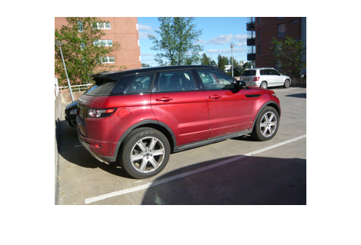

Exercise 2

(1) Type the following MATLAB program that I made and named distance(M, N), and save it as distance.m. This function generates an array whose size is specified by M and N. Then, try to use the function and examine what array it generates. You can check, for example, Ds=distance(8, 8) at the command line, and find what array is generated. Then, think about how you can apply this function to making a low-pass filter.
function Ds = distance( M, N )

u = 0 : (M-1) ;
v = 0 : (N-1) ;

idy = find(u>=M/2) ;
u(idy) = u(idy) - M ;
idx = find(v>=N/2) ;
v(idx) = v(idx) - N ;

U = u' * ones(1, N) ;
V = ones(M, 1) * v ;

Us = fftshift(U) ;
Vs = fftshift(V) ;
Ds = ( Us.^2+Vs.^2 ).^0.5 ;

end

(2) Make the low-pass filter function g = lpfilter(f, r), where f is an input image, g is an output image, and r is a parameter to control the effect of filtering. Complete the following program by filling in the blank, probably, 4-line commands are necessary to complete the program). Investigate the effect of the low-pass filter g = lpfilter(f, r) for a grayscale image, showing filtered images with at least three different values of r.

function [ g ] = lpfilter( f, r )

[M, N] = size( f ) ;

F = fft2(double( f )) ;
Ds = distance(M, N) ;
Hlp = (Ds<=r) ;

figure, imshow(g,[ ])

end

[Additional explanation]

The function g = lpfilter( f, r ) has the transfer function:

Hlp( v, u) = 1 if Ds(v, u) <= r
= 0 if Ds(v, u) > r ,

where the M x N array Ds is given by the function distance(M, N). This filter is called an ideal low-pass filter (ILPF), because all components of F (or Fourier transform of an image) are cut off (multiplied by 0) outside the circle and all components on or inside the circle are unchanged (multiplied by 1).

On the other hand, we can obtain a high-pass filter by using the simple relation:

Hhp( v, u) = 1 – Hlp( v, u) .

The transfer functions of low-pass and high-pass filter are shown below, respectively.

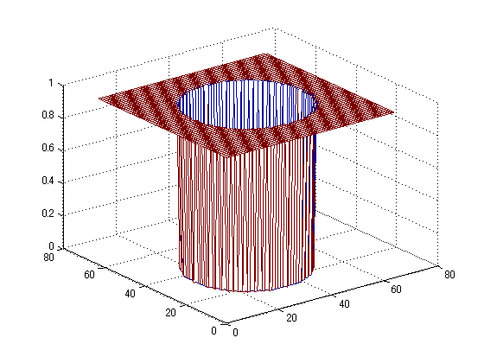
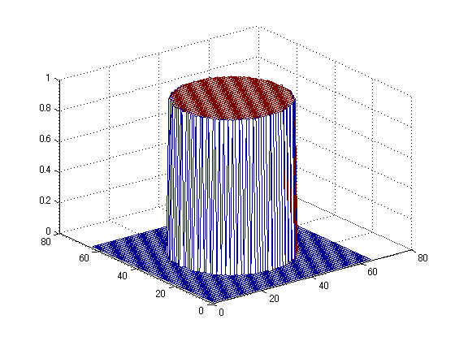

Low-pass filter
High-pass filter

