Part1 Exercises

Exercise1.1 MATLAB supports a number of powerful indexing schemes that simplify array manipulation. Read and display the 256×256 ‘lenna.bmp’ image using the MATLAB function imread() and imshow(). Using array indexing, generate images specified by the following, and display them, respectively.
(1): Generate 128×256 images subsampled from the upper part of the original image.
(2): Generate 256×128 images subsampled from the right part of the original image.
(3): Generate a 128×128 image subsampled from the upper and right part of the original image.
(4): Generate a 128×128 image subsampled from the lower and right part of the original image.
(5): Generate a 150×150 image clipped from a center part of the original image.
(6): Generate a 256×256 image flipped vertically.
(7): Generate a 256×256 image flipped horizontally.
(8): Generate a 128×128 image reduced from the original image using the notation 1:2:end.
(9): Generate a 86×86 image reduced from the original image using the notation 1:3:end.

Exercise 1.2 Generate 256×256 images as shown below, and display them, respectively.

50
50
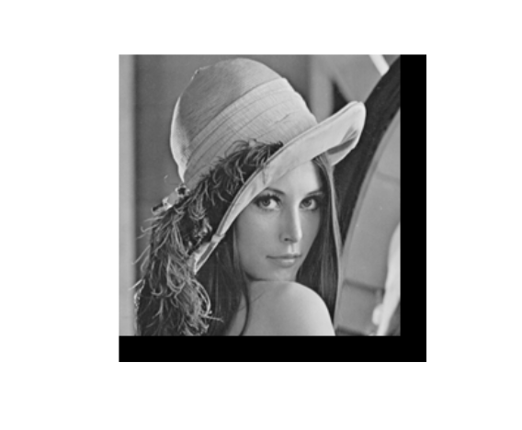
50
50
20
20

Exercise 1.3 Read the color image ‘c_mandrill.bmp’ and display it. Then, extract the red, green and blue component images and display them, respectively. And convert the color image to gray-scale image using the MATLAB function rgb2gray(). And convert it to an array of class double scaled to the range [0, 1] using the function mat2gray(), then display it.

Exercise 1.4 Generate the 2-valued images from the [0, 1] gray-scale image you generated in Exercise 1.3. You should generate three 2-valued images with different threshold values 0.4, 0.6 and 0.8, and display them, respectively.

Exercise 1.5 Draw graphs of the functions g=f^gamma with gamma= 0.333, 0.5, 3, respectively, when the value of f changes from 0 to 1. You can use the MATLAB function plot() when drawing graphs. Then, transform the intensity of the pixels in the [0, 1] gray-scale image you generated in Exercise 1.3 using power-law (gamma) transform. You should transform three cases in which gamma=0.333, 0.5, 3, and display them, respectively. Then check the difference between them.

Exercise 1.6 Investigate how a contrast-stretching transformation function g = T(f) changes by drawing graphs with different parameter values of m=0.5 and E=5, 10, 20. Then, perform the contrast-stretching transformation for the gray-scale image you generated in Exercise 1.3. You should transform three cases and display their transformed images, respectively.

Exercise 1.7 Read the ‘lenna.bmp’ image and examine it using the MATLAB function imtool(). For example, type the MATLAB commands as the following:
>>f=imread(‘lenna.bmp’);
>>imtool(f)
The function imtool() allow us to perform a number of interactive operations upon it. Investigate what kind of functions imtool() has.

Exercise 1.8 Firstly, read and display the color image ‘P1000786.JPG’ and resize it to a 300×400 matrix as shown below using the function imresize(). (You can check how to use imresize() by typing ‘help imresize’ at the command line system prompt.) Secondly, convert it to gray-scale image. Finally, generate a 2-valued image so that a building can be distinguished from other parts using power-law (gamma) transformation. (A Metropolia signboard should be removed.)

You can use MATLAB function imread(), imresize(), rgb2gray(), imtool(), and so on.
