7
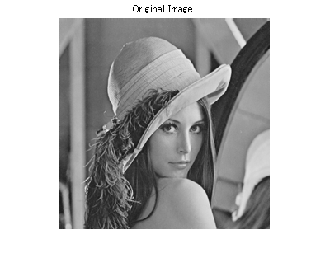
Exercise1.1 Answer

>> clear
>> close all
>>
>> f=imread('lenna.bmp') ;
>> figure,imshow(f)
>> figure(1), imshow(f), title('Original Image')
>>

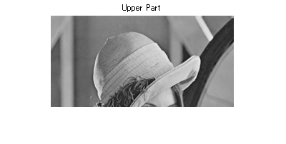
(1)
>> f1=f(1:128 , :) ;
>> figure(2), imshow(f1), title('Upper Part')
>>

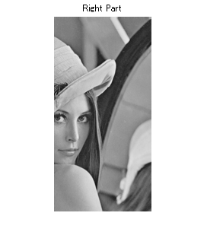
(2)
>> f2=f(:, 129:256) ;
>> figure(3), imshow(f2), title('Right Part')
>>

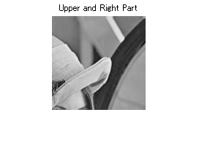
(3)
>> f3=f(1:128, 129:256) ;
>> figure(4), imshow(f3), title('Upper and Right Part')
>>

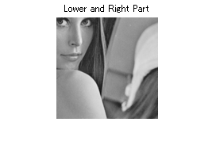
(4)
>> f4=f(129:256, 129:256) ;
>> figure(5), imshow(f4), title('Lower and Right Part')
>>

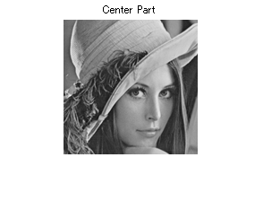
(5)
>> f5=f(53:53+149, 53:53+149) ;
>> figure(6), imshow(f5), title('Center Part')
>>

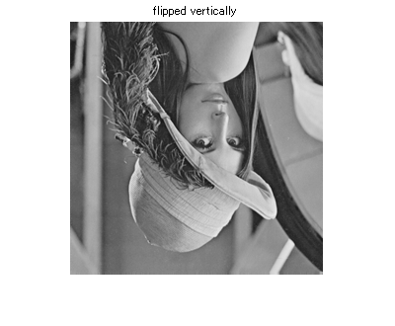
(6)
>> f6=f(end:-1:1, :) ;
>> figure(7), imshow(f6), title('flipped vertically')
>>

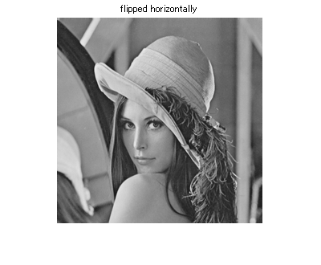
(7)
>> f7=f(:, end:-1:1) ;
>> figure(8), imshow(f7), title('flipped horizontally')
>>

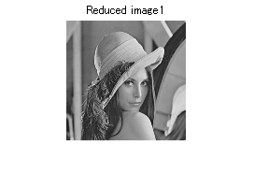
(8)
>> f8=f(1:2:end, 1:2:end) ;
>> figure(9), imshow(f8), title('Reduced image1')
>>
>> whos f8
Name Size Bytes Class Attributes
f8 128x128 16384 uint8

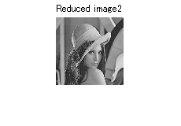
(9)
>> f9=f(1:3:end, 1:3:end) ;
>> figure(10), imshow(f9), title('Reduced image2')
>>
>> whos f9
Name Size Bytes Class Attributes
f9 86x86 7396 uint8

Exercise1.2 Answer

>> clear
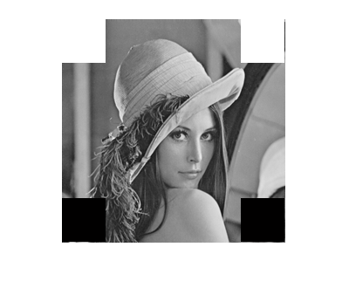
>> close all
>>
>> f=imread('lenna.bmp') ;
>> f1=f;
>> f1(1:50, 1:50)=255;
>> f1(1:50, 207:256)=255;
>> f1(207:256, 1:50)=0;
>> f1(207:256, 207:256)=0;
>> figure(2), imshow(f1)
>>

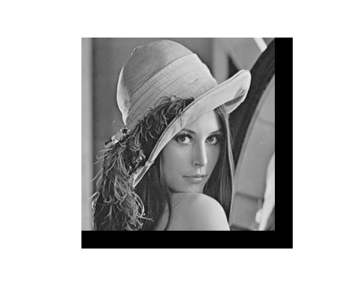
>>
>> f2=f;
>> f2(1:20, :)=255 ;
>> f2(:, 1:20)=255 ;
>> f2(end-19:end, 21:end)=0 ;
>> f2(21:end, end-19:end)=0 ;
>> figure(3), imshow(f2)
>>

Exercise1.3 Answer

>> clear
>> close all
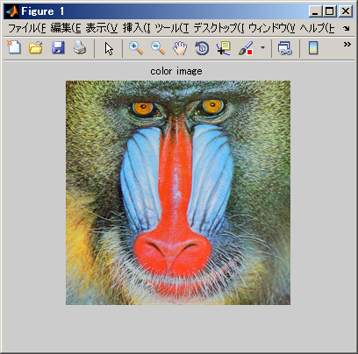
>>
>> f=imread('c_Mandrill.bmp') ;
>> f_r=f(:,:, 1) ;
>> f_g=f(:,:, 2) ;
>> f_b=f(:,:, 3) ;
>> figure(1), imshow(f), title('color image')
>> figure(2), imshow(f_r), title('red component')
>> figure(3), imshow(f_g), title('green component')
>> figure(4), imshow(f_b), title('blue component')
>>
>> ff=rgb2gray(f) ;
>> ff0=mat2gray(ff) ;

>> whos
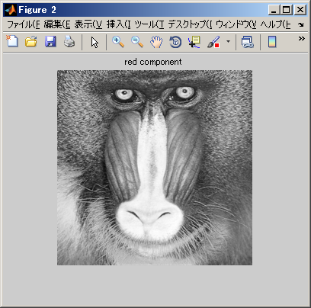
Name Size Bytes Class Attributes
f 256x256x3 196608 uint8
f_b 256x256 65536 uint8
f_g 256x256 65536 uint8
f_r 256x256 65536 uint8
ff 256x256 65536 uint8
ff0 256x256 524288 double

>> figure(10), imshow(ff0)

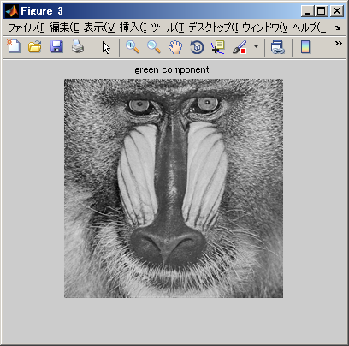
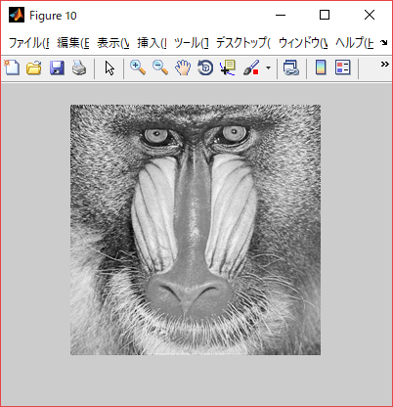

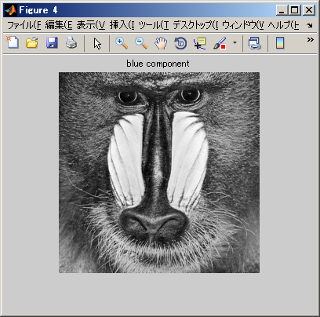

********* display using subplot( ) function **********

>> figure(5)
>> subplot(1, 5, 1), imshow(f), title('color image')
>> subplot(1, 5, 2), imshow(f_r), title('red component')
>> subplot(1, 5, 3), imshow(f_g), title('green component')
>> subplot(1, 5, 4), imshow(f_b), title('blue component')
>> subplot(1, 5, 5), imshow(ff0), title('gray scale image')
>>

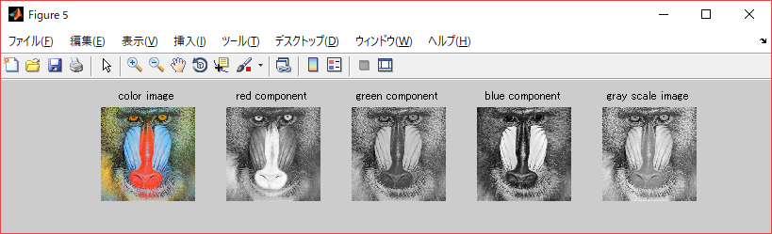

>> figure(11)
>> subplot(2, 2, 1), imshow(f), title('color image')
>> subplot(2, 2, 2), imshow(f_r), title('red component')
>> subplot(2, 2, 3), imshow(f_g), title('green component')
>> subplot(2, 2, 4), imshow(f_b), title('blue component')
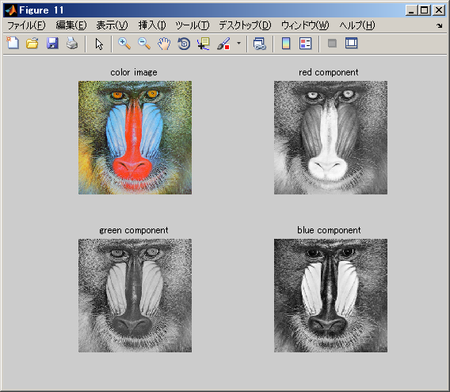
>>

Exercise1.4 Answer

>> ff04=ff0>0.4 ;
>> ff06=ff0>0.6 ;
>> ff08=ff0>0.8 ;
>> figure(7)
>> subplot(1,4,1), imshow(ff0), title('gray scale image')
>> subplot(1,4,2), imshow(ff04), title('2-valued Th=0.4')
>> subplot(1,4,3), imshow(ff06), title('2-valued Th=0.6')
>> subplot(1,4,4), imshow(ff08), title('2-valued Th=0.8')
>>
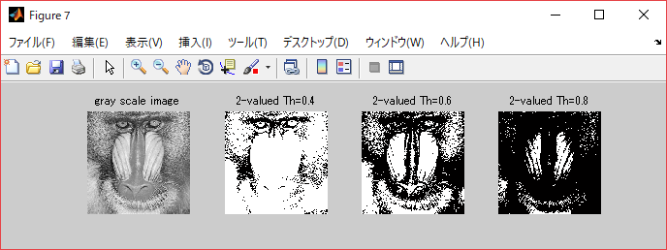

Exercise1.5 Answer

********** Generate a graph of the function g=f ^{gamma} **********

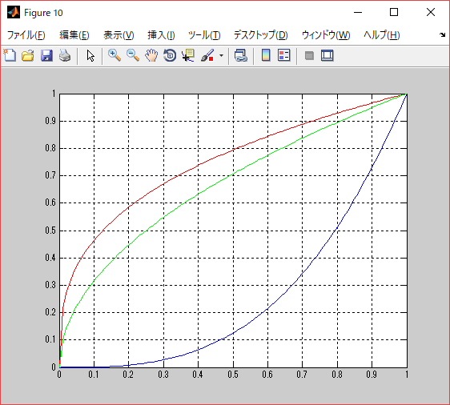
>> f=0:0.01:1 ;
>> g1=f.^0.333 ;
>> g2=f.^0.5 ;
>> g3=f.^3 ;
>>
>> figure(10)
>> plot(f, g1, 'r')
>> hold on
>> plot(f, g2, 'g')
>> plot(f, g3, 'b')
>> grid on
>>

>> gg1=ff0.^0.333 ;
>> gg2=ff0.^0.5 ;
>> gg3=ff0.^3 ;
>> figure(11)
>> subplot(1,4,1), imshow(ff0), title('Original image')
>> subplot(1,4,2), imshow(gg1), title('gamma=0.333')
>> subplot(1,4,3), imshow(gg2), title('gamma=0.5')
>> subplot(1,4,4), imshow(gg3), title('gamma=3')
>>

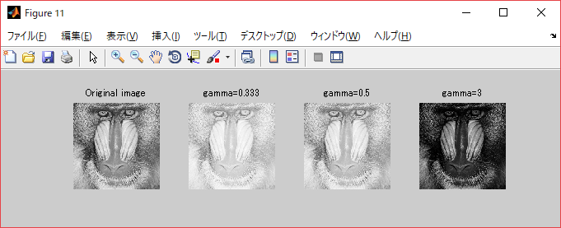

Exercise1.6 Answer

>> f=0:0.01:1 ;
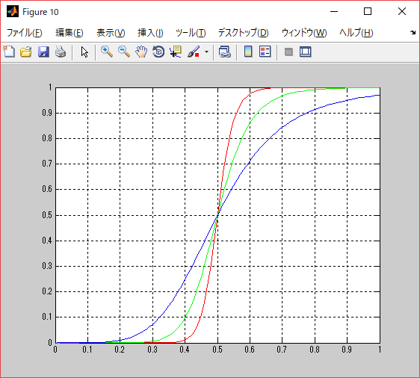
>> m=0.5 ;
>> E=20 ;
>> g1= 1./(1+ (m./f).^ E) ;
>> E=10 ;
>> g2= 1./(1+ (m./f).^ E) ;
>> E=5 ;
>> g3= 1./(1+ (m./f).^ E) ;
>> figure(10)
>> figure(10)
>> plot(f, g1, 'r')
>> hold on
>> plot(f, g2, 'g')
>> plot(f, g3, 'b')
>> hold off
>> grid on
>>
>>
>> m=0.5 ;
>> E=5 ;
>> g0505= 1./(1+ (m./ff0).^ E) ;
>> E=10 ;
>> g0510= 1./(1+ (m./ff0).^ E) ;
>> E=20 ;
>> g0520= 1./(1+ (m./ff0).^ E) ;
>> figure(12)
>> subplot(1,4,1),imshow(ff0,[]),title('Original image')
>> subplot(1,4,2),imshow(g0505,[]),title('Output m=0.5, E=5')
>> subplot(1,4,3),imshow(g0510,[]),title('Output m=0.5, E=10')
>> subplot(1,4,4),imshow(g0520,[]),title('Output m=0.5, E=20')
>>
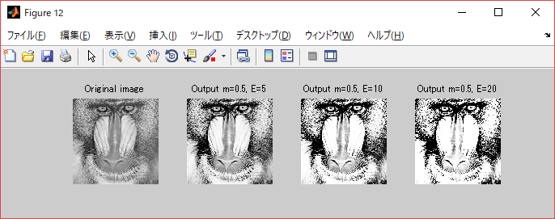

Exercise1.7 Answer

>> f=imread('lenna.bmp') ;
>> imtool(f)
>>
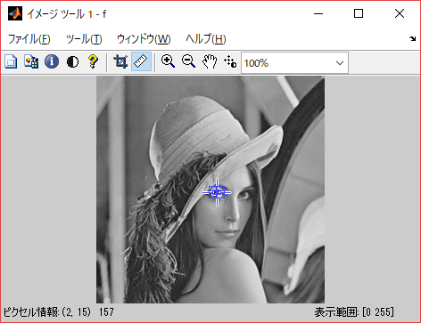
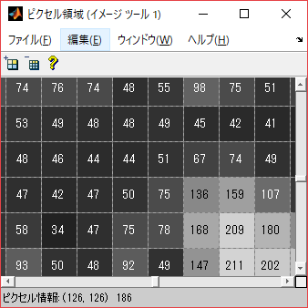
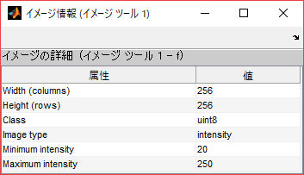
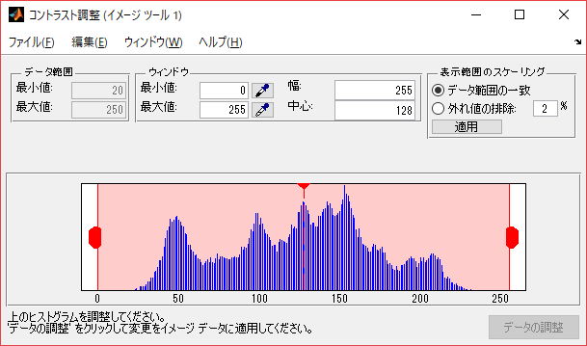

Exercise 1.8 Answer

>> fcolor=imread('P1000786.JPG') ;
>> fsmall=imresize(fcolor, 0.1) ;
>> f=rgb2gray(fsmall) ;
>> ff=mat2gray(f) ;
>> whos
Name Size Bytes Class Attributes
f 300x400 120000 uint8
fcolor 3000x4000x3 36000000 uint8
ff 300x400 960000 double
fsmall 300x400x3 360000 uint8
>> ff1=ff.^4 ;
>> imtool(ff1) % chek the threshold value using imtool()
>> b1=ff1>0.6 ;
>> figure, imshow(b1)
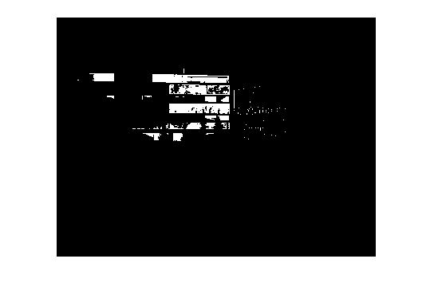
>>

***** about the function of mat2gray() *****
>> A=[1 2 3 4; 3 4 5 6; 6 5 4 3; 5 4 3 2]
A =
1 2 3 4
3 4 5 6
6 5 4 3
5 4 3 2
>> aa=mat2gray(A)
aa =
0 0.2000 0.4000 0.6000
0.4000 0.6000 0.8000 1.0000
1.0000 0.8000 0.6000 0.4000
0.8000 0.6000 0.4000 0.2000

max

