Learning activity 3 / Actividad de aprendizaje 3

Evidence: Cell phones for sale / Evidencia: Celulares a la venta

Read the description of the two cell phones that are for sale. Then write ten comparisons. / Lea la descripción de dos teléfonos celulares. Luego escriba diez comparaciones entre ellos.

Silver X100 | Titanium Z1
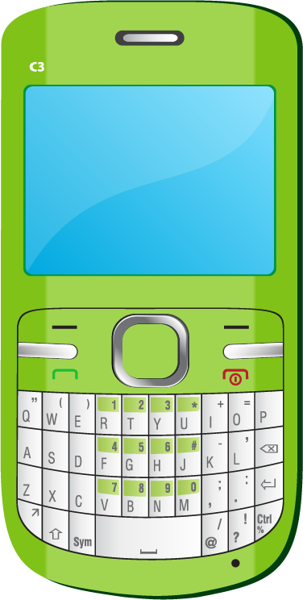 | 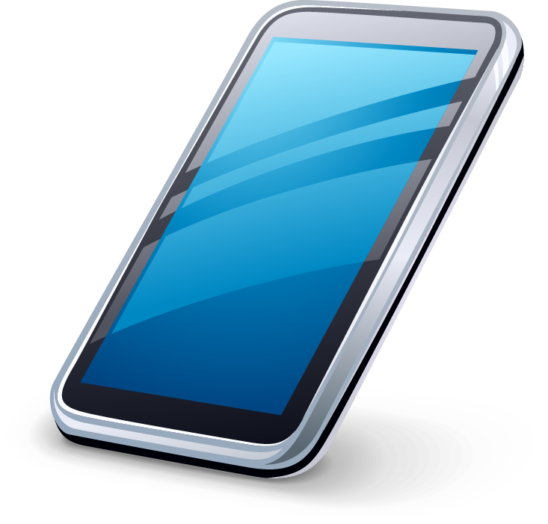
This new smartphone weighs 145 grams. It is 14 cm wide and 7.5 centimeters long. It has an Android operating system. It is water and dust resistant. The screen is 5.1 inches wide and the resolution is 1060 x 1900 pixels. It has a multi-touch screen. It has a light sensor, proximity sensor, and scratch-resistant glass. It has a 16 megapixel camera. The system memory has 2048 MB RAM and the built-in storage memory is 32 GB. You can talk for 20 hours and the battery stays charged. | The Titanium Z1 weighs 135 grams. It is 10 cm wide and 13 centimeters long. It has an Android operating system. It is water resistant. The screen is 3.8 inches wide and the resolution is 860 x 1200 pixels. It has a multi-touch screen. It has a light sensor and scratch-resistant glass. It has a 13 megapixel camera. The system memory has 1048 MB RAM and the built-in storage memory is 32 GB. You can talk for 10 hours and the battery stays charged.

Fuente de imágenes: SENA

Example / Ejemplo:

Titanium Z1 is not as heavy as Silver X100. / Titanium Z1 no es tan pesado como el Silver X100.

As … as
1. The titanium Z is not as wide as the Silver X1000.
2. Titanium Z is not dust resistant like the Silver X1000.
3. The Silver X1000 has more inches than the Titanium Z1.
4. The Silver X1000 does not have as much resolution as the Titanium Z1.
5. The Titanium Z1 does not have a proximity sensor as the Silver X1000.
Less … than - not as … as
1. The Silver X1000 has a better camera than the Titanium z1.
2. Titanium Z1 has less RAM storage than Silver X1000
3. The Titanium Z1 has the same integrated storage memory as the Silver X1000.
4. The Silver X1000 has a battery that lasts twice as long as the Titanium Z1.
5. The Silver X1000 tiene el mismo sistema operativo que el Titanium Z1

When you finish your work, send the file to your instructor through the platform as follows:

- Click “Ver Evidencia”.
- Attach the file which must be previously saved on the computer.
- Leave a comment for the instructor (optional).

Una vez finalice la evidencia envíe al instructor el archivo a través de la plataforma, así:

- Dé clic en “Ver Evidencia”.
- Adjuntar el archivo el cual debe estar previamente guardado en el equipo.
- Dejar un comentario al instructor (opcional).

Note: This evidence is an individual activity. Remember to check the learning guide in order to know if you have done all the assigned activities, know how to develop them and deliver them correctly.

Nota: Esta evidencia es de carácter individual. Recuerde revisar la guía de aprendizaje con el fin de verificar que ha realizado todas las actividades propuestas, saber cómo desarrollarlas y entregarlas correctamente.

Criterios de evaluación
Compara aparatos tecnológicos teniendo en cuenta la estructura gramatical, vocabulario y contexto requerido.

