**ENG207 DISCRETE MATHEMATICS**

**PRACTICE**

|  |  |  |
| --- | --- | --- |
| **Topic Name** | **:** | **Exam Scheduler** |
| **Group Number** | **:** | **7** |
| **Semester** | **:** | **IV** |
| **Academic Year** | **:** | **2020-21** |
| **Program** | **:** | **Computer Science Engineering** |
| **Degree** | **:** | **Bachelor of Technology** |



**School of Engineering**

**Ajeenkya DY Patil University, Pune**

DY Patil Knowledge City Road Via Lohegaon,

Airport Rd, Charholi Budruk, Pune, Maharashtra 412105



**DATE: April 11, 2021**

**CERTIFICATE**

This is to certify that **Mr. Arpit Singh** bearing University Registration No. **2019-B-28092001C** of B.Tech, 2ndyear **Computer Science Engineering Div. A** has successfully completed **Discrete Mathematics** practice session as per the university requirements during the academic year 2020-21.

**Dr. Biswajeet Champaty**

**Head-School of Engineering**

**Prof. Shital Solanki**

**Faculty-in-charge**

Date: Internal Examiner External Examiner



**DATE: April 11, 2021**

**CERTIFICATE**

This is to certify that Mr. **Jaineel Petiwale** bearing University Registration No. **2019-B-21032001** of B.Tech, 2ndyear **Computer Science Engineering Div. A** has successfully completed **Discrete Mathematics** practice session as per the university requirements during the academic year 2020-21.

**Dr. Biswajeet Champaty**

**Head-School of Engineering**

**Prof. Shital Solanki**

**Faculty-in-charge**

Date: Internal Examiner External Examiner



**DATE: April 11, 2021**

**CERTIFICATE**

This is to certify that **Mr. Jainil Gajjar** bearing University Registration No. **2019-B-28092001A** of B.Tech, 2ndyear **Computer Science Engineering Div. A** has successfully completed **Discrete Mathematics** practice session as per the university requirements during the academic year 2020-21.

**Dr. Biswajeet Champaty**

**Head-School of Engineering**

**Prof. Shital Solanki**

**Faculty-in-charge**

Date: Internal Examiner External Examiner



**DATE: April 11, 2021**

**CERTIFICATE**

This is to certify that **Miss Janhavi Ghogle** bearing University Registration No. **2019-B-28092001** of B.Tech, 2ndyear **Computer Science Engineering Div. A** has successfully completed **Discrete Mathematics** practice session as per the university requirements during the academic year 2020-21.

**Dr. Biswajeet Champaty**

**Head-School of Engineering**

**Prof. Shital Solanki**

**Faculty-in-charge**

Date: Internal Examiner External Examiner

**INDEX**

|  |  |  |  |
| --- | --- | --- | --- |
| **Sr. No.** | **Context** | **Page NO.** | **Sign** |
| 1 | Introduction | 1 |  |
| 2 | Objective | 1 |  |
| 3 | Software Requirement | 1 |  |
| 4 | Working of Project | 1 |  |
| 5 | Code | 2 |  |
| 6 | Graph Colouring: Discrete Mathematics Concept | 3 |  |
| 7 | Other Application | 5 |  |
| 8 | Result | 6 |  |
| 9 | Conclusion | 6 |  |
| 10 | How to Improve? | 6 |  |
| 11 | References | 7 |  |
| 12 | Implementation | 8 |  |

**Shital D. Solanki**

Assistant Professor

**INTRODUCTION**

Our team has developed a program that allows you to conveniently schedule exams without having to worry about scheduling conflicts. The programme is written in the Java programming language. The project is based on the graph colouring theory, a part of discrete mathematics.

**OBJECTIVE**

To schedule the examination subjects in such a way that students taking any combination of subjects have no conflict.

**SOFTWARE REQUIREMENT**

The code in this Project were test using BlueJ with Windows 10. We can use other java compiler like IntelliJ, Codeblock, Visual Studio Code and etc. Java is a class-based, object-oriented programming language that is designed to have as few implementation dependencies as possible.

**WORKING OF PROJECT**

* Print the no. of branches we have
* Request user to select one of the above branches
* Request user to input no. of subject they have
* Request user to enter name of subject
* Print all the dates allotted for the examination
* Request user to select any one date to assign the subject
* Print all the slots in a day
* Request user to select any one slot for the subject.
* If the slot is empty, assign the subject to the slot
* Else, Print “Slot not available”.
* Print Time Table with all the subjects assigned and print “Your exams are assigned successfully”.
* Request user to type 1 to continue or 2 to exit.
* If user types 1, the whole process will restart.
* Else, Exit the terminal.

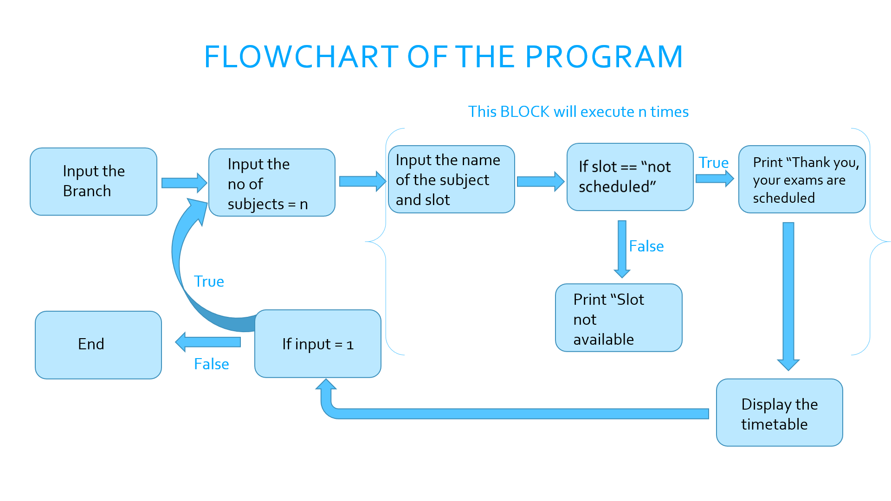

**LINK TO THE CODE**

<https://github.com/JPetiwale/Exam_Scheduler>

**GRAPH COLOURING: DISCRETE MATHEMATICS CONCEPT**

Graph colouring is the procedure of assignment of colours to each vertex of a graph G such that no adjacent vertices get same colour. The objective is to minimize the number of colours while colouring a graph.

The **chromatic number** *χ*(*G*) of a graph *G* is the minimal number of colours for which such an assignment is possible.

***Vertex colouring*** is the most common graph colouring problem.  The other graph colouring problems like ***Edge Colouring*** (No vertex is incident to two edges of same colour) and ***Face Colouring***(Geographical Map Colouring) can be transformed into vertex colouring.

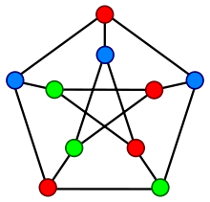 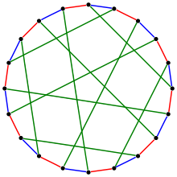 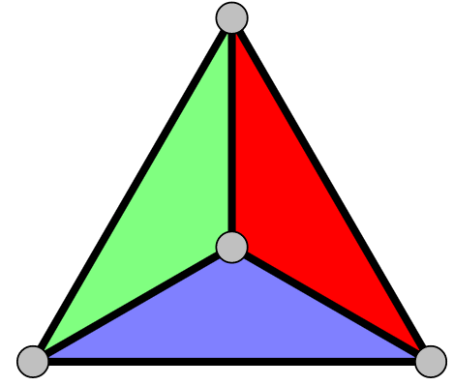

Edge Colouring Graph

Face Colouring Graph

Vertex Colouring Graph

**Method to Colour a Graph**

The steps required to colour a graph G with n number of vertices are as follows −

**Step 1** − Arrange the vertices of the graph in some order.

**Step 2** − Choose the first vertex and colour it with the first colour.

**Step 3** − Choose the next vertex and colour it with the lowest numbered colour that has not been coloured on any vertices adjacent to it. If all the adjacent vertices are coloured with this colour, assign a new colour to it. Repeat this step until all the vertices are coloured.

**Example**

In the figure, at first vertex a is coloured red. As the adjacent vertices of vertex, a are again adjacent, vertex b and vertex d are coloured with different colour, green and blue respectively. Then vertex c is coloured as red as no adjacent vertex of c is coloured red. Hence, we could colour the graph by 3 colours. Hence, the chromatic number of the graph is 3.

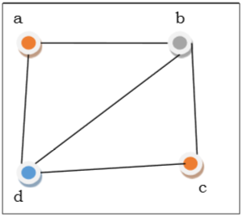

**OTHER APPLICATION**

* ***Mobile Radio Frequency Assignment:*** When frequencies are assigned to towers, frequencies assigned to all towers at the same location must be different. This problem is also an instance of graph colouring problem where every tower represents a vertex and an edge between two towers represents that they are in range of each other.
* ***Sudoku:***Sudoku is also a variation of Graph colouring problem where every cell represents a vertex. There is an edge between two vertices if they are in same row or same column or same block.
* ***Register Allocation:***In compiler optimization, register allocation is the process of assigning a large number of target program variables onto a small number of CPU registers. This problem is also a graph colouring problem.
* ***Bipartite Graphs:***We can check if a graph is Bipartite or not by colouring the graph using two colours. If a given graph is 2-colourable, then it is Bipartite, otherwise not.
* ***Map Colouring:***Geographical maps of countries or states where no two adjacent cities cannot be assigned same colour. Four colours are sufficient to colour any map

**RESULT**

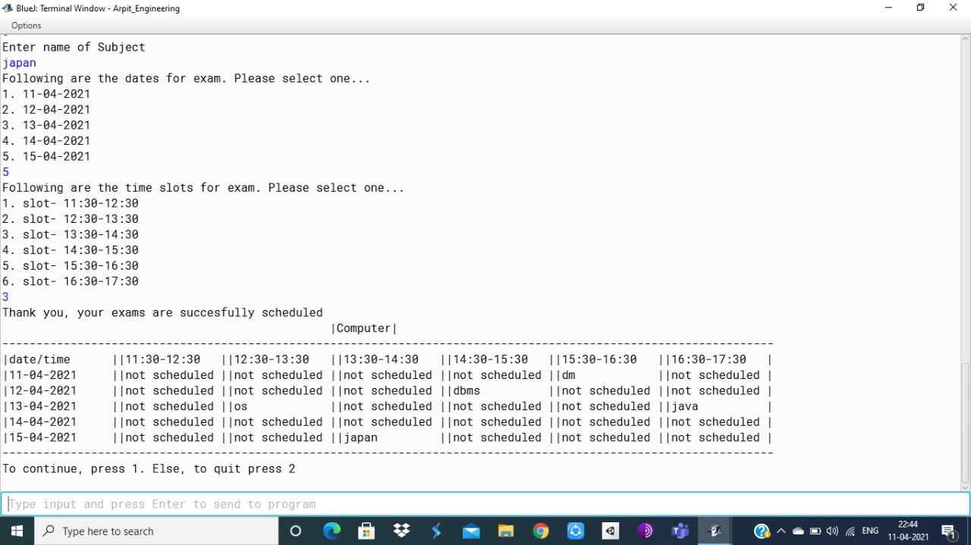

**CONCLUSION**

This program can be used by universities and colleges to schedule their exams in an effective and effortless way. It saves time of the faculty to schedule exam which can be utilised elsewhere. It also sets an example of use of mathematics in day-to-day life. If altered and modulated correctly, this code snippet can be used to schedule various entities.

**HOW TO IMPROVE?**

* This program has limit of 30 subjects
* We can use GUI to create more readable timetable
* We can also schedule teachers to invigilate for the exam
* We can create a code with database so we don't have to enter all details again and again, and all Faculty have access to it and directly book time slot.

**REFERENCES**

* <https://www.geeksforgeeks.org/graph-coloring-applications/>
* <https://www.tutorialspoint.com/the-graph-coloring>
* <https://brilliant.org/wiki/graph-coloring-and-chromatic-numbers/>
* <https://en.wikipedia.org/wiki/Graph_coloring#:~:text=In%20its%20simplest%20form%2C%20it,is%20called%20a%20vertex%20coloring.&text=Vertex%20coloring%20is%20usually%20used,into%20a%20vertex%20coloring%20instance>.

**Implementation**

**EXAM SCHEDULER**

*Project report submitted*

*By*

|  |  |  |
| --- | --- | --- |
| **Name** | **URN** | **Branch** |
| Mr. Arpit Singh | 2019-B-28092001C | Computer Science |
| Mr. Jaineel Petiwale | 2019-B-21032001 | Computer Science |
| Mr. Jainil Gajjar | 2019-B-28092001A | Computer Science |
| Ms. Janhavi Ghogle | 2019-B-28092001 | Computer Science |

**Under the guidance of**

**Shital D. Solanki**

Assistant Professor



**Feb, 2021**

**School of Engineering**

**Ajeenkya D Y Patil University   
D Y Patil Knowledge City, Charoli Bk.Via Lohegaon,  
Pune - 412105, Maharashtra, India**