**Design ER Diagram**

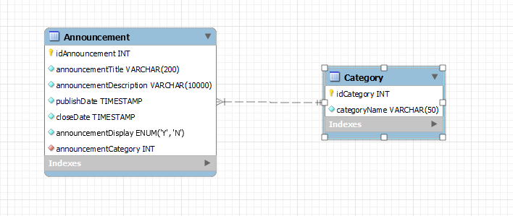

**DB Script**

*-- MySQL Workbench Forward Engineering*

*SET @OLD_UNIQUE_CHECKS=@@UNIQUE_CHECKS, UNIQUE_CHECKS=0;*

*SET @OLD_FOREIGN_KEY_CHECKS=@@FOREIGN_KEY_CHECKS, FOREIGN_KEY_CHECKS=0;*

*SET @OLD_SQL_MODE=@@SQL_MODE, SQL_MODE='ONLY_FULL_GROUP_BY,STRICT_TRANS_TABLES,NO_ZERO_IN_DATE,NO_ZERO_DATE,ERROR_FOR_DIVISION_BY_ZERO,NO_ENGINE_SUBSTITUTION';*

*-- -----------------------------------------------------*

*-- Schema announcement*

*-- -----------------------------------------------------*

*-- -----------------------------------------------------*

*-- Schema announcement*

*-- -----------------------------------------------------*

*CREATE SCHEMA IF NOT EXISTS `announcement` DEFAULT CHARACTER SET utf8 ;*

*USE `announcement` ;*

*-- -----------------------------------------------------*

*-- Table `mydb`.`Category`*

*-- -----------------------------------------------------*

*DROP TABLE IF EXISTS `announcement`.`Category` ;*

*CREATE TABLE IF NOT EXISTS `announcement`.`Category` (*

*`idCategory` INT NOT NULL,*

*`categoryName` VARCHAR(50) NOT NULL,*

*PRIMARY KEY (`idCategory`))*

*ENGINE = InnoDB;*

*-- -----------------------------------------------------*

*-- Table `announcement`.`Announcement`*

*-- -----------------------------------------------------*

*DROP TABLE IF EXISTS `announcement`.`Announcement` ;*

*CREATE TABLE IF NOT EXISTS `announcement`.`Announcement` (*

*`idAnnouncement` INT NOT NULL,*

*`announcementTitle` VARCHAR(200) NOT NULL,*

*`announcementDescription` VARCHAR(10000) NOT NULL,*

*`publishDate` TIMESTAMP NOT NULL,*

*`closeDate` TIMESTAMP NOT NULL,*

*`announcementDisplay` ENUM('Y', 'N') NOT NULL DEFAULT 'N',*

*`announcementCategory` INT NOT NULL DEFAULT 001,*

*PRIMARY KEY (`idAnnouncement`),*

*INDEX `fk_Announcement_Category_idx` (`announcementCategory` ASC) VISIBLE,*

*CONSTRAINT `fk_Announcement_Category`*

*FOREIGN KEY (`announcementCategory`)*

*REFERENCES `announcement`.`Category` (`idCategory`)*

*ON DELETE NO ACTION*

*ON UPDATE NO ACTION)*

*ENGINE = InnoDB;*

*SET SQL_MODE=@OLD_SQL_MODE;*

*SET FOREIGN_KEY_CHECKS=@OLD_FOREIGN_KEY_CHECKS;*

*SET UNIQUE_CHECKS=@OLD_UNIQUE_CHECKS;*

*-- -----------------------------------------------------*

*-- Data for table `announcement`.`Category`*

*-- -----------------------------------------------------*

*START TRANSACTION;*

*USE `announcement`;*

*INSERT INTO `announcement`.`Category` (`idCategory`, `categoryName`) VALUES (001, 'General');*

*INSERT INTO `announcement`.`Category` (`idCategory`, `categoryName`) VALUES (002, 'Grant');*

*INSERT INTO `announcement`.`Category` (`idCategory`, `categoryName`) VALUES (003, 'Job');*

*COMMIT;*

**Infrastructure Architecture**

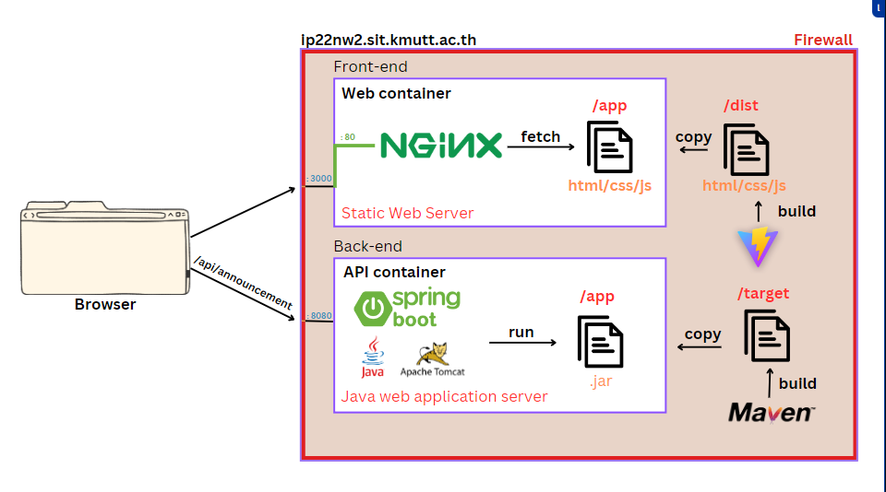

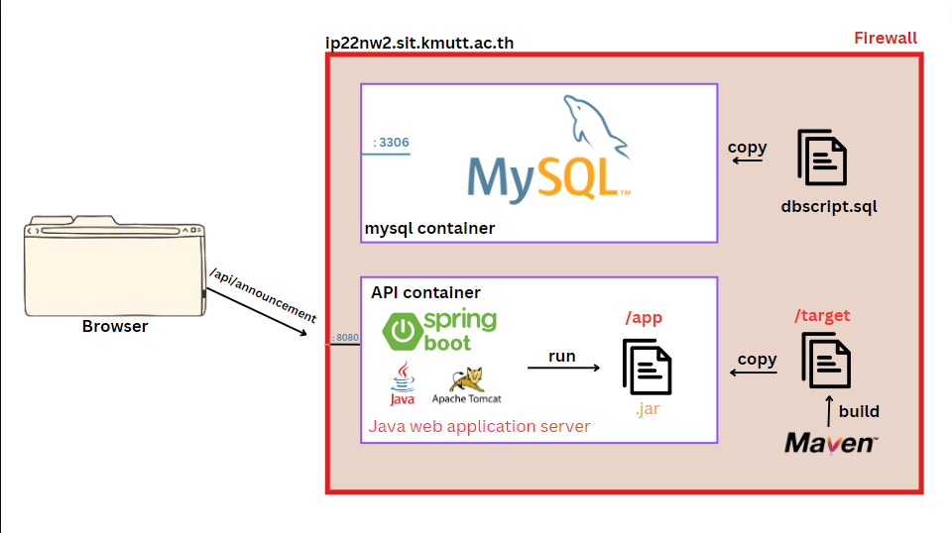

**API endpoints**

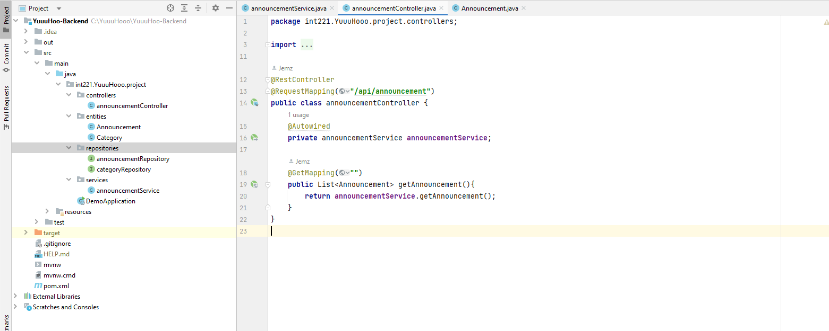

**ลอง test method GET ใน postman**

