Ion-Ion
Same as an Ionic Bond
Melting KCl breaks these
Dissolving KCl breaks these
Freezing (solidifying) NaCl makes these
Strength of attraction depends upon the charge and, then, the size of the ion (Smaller is stronger!)
The only interparticle that IS a BOND.
600 – 4,000 kJ/mol released
when formed

Ion-dipole
When a salt dissolves in water, these are formed
Strength of attraction depends upon the charge and, then, size of the ion (Smaller is stronger!) and how polar the molecule is
These exist in a hydrate such as CuSO₄ 5 H₂O
40 – 600 kJ/mol are released when formed
an ion attracted to a polar molecule
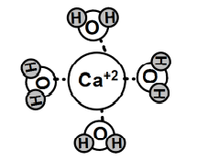
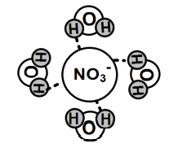
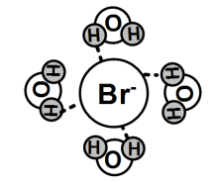

Dipole-dipole
Strength of attraction depends on how polar both molecules are
Polar molecule attracted to a polar molecule
Hydrogen chloride gas particles stick together with this IMF
When acetonitrile (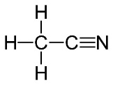) condenses, these are formed
5 – 25 kJ/mol are released when formed
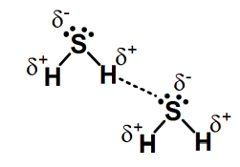

Hydrogen bonding
When an H bonded to F, O, N is attracted to a very electronegative atom in a polar bond
10 – 40 kJ/mol are released when formed
When water freezes, these are formed
When ethanol boils, these are broken
When ethanol dissolves in water, these are formed
Formed when ammonia is dissolved in water to make ammonia cleaner
The strongest type of dipole-dipole IMFs, according to some
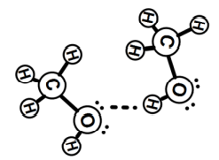
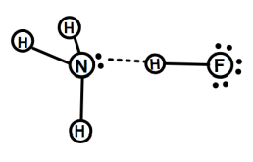
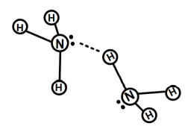

Dipole-Induced Dipole
When iodine dissolves in ethanol, these are formed
Strength of attraction depends upon how polar one molecule is and how polarizable the other molecule is
Formed when carbon dioxide is dissolved in water to make a carbonated beverage
Forms when a polar molecule induces a temporary polarity on a nonpolar molecule
2 – 10 kJ/mol are released when formed, typically
Polar molecule attracted to nonpolar molecule
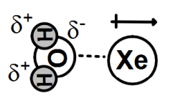

Induced dipole – Induced dipole
When iodine sublimes, these are broken
Strength of attraction depends upon size of the electron cloud only
Broken when dry ice sublimes
Formed when oxygen gas is liquefied
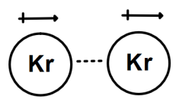
Also called a dispersion force
Also called a London force
0.05- 40 kJ/mol are released when formed, typically
The only significant force between a nonpolar molecule attracted to a nonpolar molecule
Found between any 2 attracted particles
Attraction created when the random motion of electrons in one atom or molecule induces a temporary dipole in a neighboring atom or molecule
Strength of attraction depends on how polarizable both molecules/atoms are.

