**ONLINE LEAVE APPLICATION**

**FOR**

**DEPED BAYUGAN CITY**

A Capstone Project

Presented to the Faculty of the

Computer Studies Department

College of Information Technology

Mindanao State University

In Partial Fulfillment of the Requirements

For the degree Bachelor of Science in Information Technology

By

Christian Luceño Garillo

Ms. Jasmine Jeanette C. Mama

Adviser

October, 2017

**Table of Contents**

List of Figures.............................................................................................................................................. iv

List of Tables .............................................................................................................................................. v

**Chapter 1 Introduction............................................................................................................................... 1**

1.1 Project Context........................................................................................................................................ 2

1.2 Purpose and Description.......................................................................................................................... 4

1.3 Objectives................................................................................................................................................ 5

1.4 Scope and Limitations............................................................................................................................. 6

**Chapter 2 Review of Related Literature................................................................................................... 8**

2.1 Related Theories and Concepts............................................................................................................... 8

2.1.1 Progressive Web Applications................................................................................................ 8

2.1.2 Responsive Web Design.......................................................................................................... 8

2.1.3 Micro Web Services................................................................................................................ 9

2.1.4 Database Per Service............................................................................................................. 11

2.1.5 Leave of Absence….............................................................................................................. 14

2.2 Related Existing Systems...................................................................................................................... 17

2.2.1 University of Louisville........................................................................................................ 17

2.2.2 PhilHealth Electronic Registration System........................................................................... 19

2.2.3 BIR eREGISTRATION (eREG) System.............................................................................. 22

**Chapter 3 Technical Background............................................................................................................ 23**

3.1 Organizational Chart............................................................................................................................. 24

3.2 Workflow.............................................................................................................................................. 25

3.2.1 Existing Workflow……........................................................................................................ 17

3.2.2 Proposed Workflow….......................................................................................................... 17

**Chapter 4 Methodology…………………………..................................................................................... 26**

4.1 Requirements Analysis.......................................................................................................................... 26

4.1.1 PIECES Evaluation Framework............................................................................................ 26

4.1.2 Cause and Effect Analysis..................................................................................................... 27

4.1.3 Gantt Chart……………………………………...…………………………………………. 28

4.2 Design................................................................................................................................................... 28

4.2.1 Hierarchical Input-Process-Output....................................................................................... 29

4.2.2 Input-Process-Output……………………………………….……………………………... 29

4.2.3 Use Case Diagram…………………………………………………………….…………… 30

4.2.4 Entity-Relationship Diagram……………………………………………………………… 31

4.2.5 Architectural Design………………………………………………………………………. 32

4.3 Development and Testing……………………………………………………………………………. 33

4.3.1 Software Specification…………………………………………………………..............… 33

4.3.2 Hardware Specification……………………………………………………………………. 34

4.3.3 Deployment Diagram……………………………………………………………………… 35

4.3.4 Usability Test Plan……...…...……………………………………………………...……... 36

4.3.4.1 Problem Statement.…...….........…………………………………….…...……... 36

4.3.4.2 Procedure………...…...….........………………………………….……...……... 36

4.3.4.3 Roles………….….…...….........……………………………….………...……... 37

4.3.4.4 Error Classification.......….........…………………………………….…...……... 37

**Chapter 5 Presentation and Interpretation of Results........................................................................... 38**

5.1 Techniques and Algorithms………….…………….….……………………………….….…….......... 38

5.1.1 Offline Web……….……......…………………………………………….……….….......... 38

5.2.1 Image Submission………......…………………………………………….……….….......... 42

5.2 Usability Test for Leave Applicants……………….….……………………………….….…….......... 41

5.3 Usability Test for Principal/HR/SDS.….………….….………………………….………….….......... 42

5.4 Usability Test for Administrator……….………….….……………………………….….…….......... 43

5.5 Summary…………………………....….………….….………………………………........................ 43

**Chapter 6 Implementation Plan…………………………...................................................................... 44**

6.1 Implementation Milestones………………………………………………………………….….......... 44

6.2 Implementation Contingency….…………………………………………………………….….......... 45

6.3 Infrastructure/Deployment.………………………………………………………………….….......... 45

6.3.1 Support…………………......…………………………………………….……….….......... 45

6.3.1.1 Hardware.……......……………………………………………….…….….......... 45

6.3.1.2 Network and Services…………………………………………….……….......... 45

6.3.1.3 Software.……......……………………………………….………........................ 46

6.3.1.4 Personnel.……......………………………………………….…….……….......... 46

**Chapter 7 Summary, Conclusion, and Recommendations…................................................................ 47**

7.1 Summary….………………….…………………………………….….…………….….......... 47

7.2 Conclusion………………….…………………………………….….…………….…............ 47

7.1 Recommendations...………….………………………….….………………………….......... 47

**Bibliography……………………………………………………………………………………......….... 49**

**List of Figures**

Figure 2.1 Database Per Service Sample.………………….……………….………………….…………. 11

Figure 2.2 University of Louisville Leave Request Form ………………….……………………………. 18

Figure 2.3 PhilHealth Electronic Registration System Form.…….…….….……………………...…...… 19

Figure 2.4 BIR eREGISTRATION (eREG) System*...*…………….….…..……………………….……... 22

Figure 3.1 The DepED Bayugan City Division Organizational Chart………………………………...…. 24

Figure 3.2 Application for Leave Existing Workflow……………….………………………………....… 25

Figure 3.3 Application for Leave Proposed Workflow.…………….……….………………………….… 25

Figure 4.1 Hierarchical Input-Process-Output……………………....……………………………………. 29

Figure 4.2 Input-Process-Output…………….….……………….….….…….…………………………… 29

Figure 4.3 Use Case Diagram ………………………………….…………….….….………………….… 30

Figure 4.4 Entity Relationship Diagram ……….…………………………….………………….….….… 31

Figure 4.5 Entity Relationship diagram (Database per service) ……………….………………………… 31

Figure 4.6 Architectural Design of Online Leave Application.………………….….……………………. 32

Figure 4.7 Deployment Diagram ………………………………….….…………….……………………. 35

Figure 5.1 Normal HTTP request-response …….………………….….…………….……………………. 39

Figure 5.2 HTTP request-response with service worker ………….….…………….……………………. 39

Figure 5.3 Submission of chunk from IDB to server API ….…….….…………….……………….……. 41

**List of Tables**

Table 4.1 PIECES Evaluation of the current system ……….……………………………………….…. 26

Table 4.2 Cause and Effect Analysis of the Current System….….……………………………….….… 27

Table 4.3 Developer Software Requirements……………...….….……………………………….….… 33

Table 4.4 User Software Requirements ……………...….….…………………………………….….… 34

Table 4.5 Developer Hardware Requirements ……………...….….….….……………………….….… 34

Table 4.6 User Hardware Requirements….….……………...….….….….……………………….….… 34

Table 5.1 Summary of errors encountered by the leave applicants.….….……….……………….….… 41

Table 5.2 Summary of errors encountered by the Principal/HR/SDS.….………………………. …..… 42

Table 5.3 Summary of errors encountered by the Administrator……….………………………. …..… 43

Table 5.4 Summary of the errors, severity, causes, and action taken…...………………………. …..… 43

Table 6.1 Milestones in the implementation of Online Leave Application….……….…………. …..… 44

Table 6.2 Implementation Contingency Specifications………………….….…….….…………. …..… 45

**Chapter 1**

**Introduction**

A **leave of absence** is a period of time that one must be away from one's primary [job](https://en.wikipedia.org/wiki/Job_(role)), while maintaining the status of [employee](https://en.wikipedia.org/wiki/Employment). It is a right granted to employees not to report for work with or without pay as may be provided by law. The term may be used more restrictively to exclude other periods away from the workplace (e.g., [vacations](https://en.wikipedia.org/wiki/Vacation), [paid time off](https://en.wikipedia.org/wiki/Paid_time_off), [holidays](https://en.wikipedia.org/wiki/Holiday), hiatuses, [sabbaticals](https://en.wikipedia.org/wiki/Sabbatical), [working from home](https://en.wikipedia.org/wiki/Working_from_home) programs), with leave of absence used for exceptional circumstances; generally, such an arrangement has a predefined termination at a particular date or after a certain event has occurred.

Bayugan City is a small but a very mountainous city, a place where a division office of DepED resides. When teachers apply for a leave, they need to go to their division office in order to submit the form. It could not be submitted online because it is not yet available. Some teachers may only need to reach the division office thru one ride of a tricycle, but, other teachers will need to take a bus, a habal-habal or a single motor. Some teachers need to walk for miles in order to be able to ride a bus, some needs to take all the rides in order to reach the division office. This method of submitting their leave of absence is very time consuming and very hard.

Today’s workers use many different technological tools to work together. For many organizations, email is still the primary method of communication but this could change in the near future. Workers have learned to adapt the use of technology ranging from smartphones to personal computers. Offices who are not using computers are very hard to find if not impossible. Computers have become their number one tool in solving their everyday office problems.

The World Wide Web is what most people think of as the Internet. It is all the Web pages, pictures, videos and other online content that can be accessed via a Web browser. It is the information space in today’s era. The Internet, in contrast, is the underlying network connection that allows us to send email and access the World Wide Web. Nowadays. Almost everyone has their own internet connection which gives them access to the world wide web.

With the current problems the applicants encounter when applying for a leave, with them having their own technological tools (smartphones, pc, tablet, laptops, etc.), with the world wide web being available in the internet, the researcher decided to automate the application for leave and put it in the world wide web. This will make the application for leave easier and more convenient, it will be available 24/7 anytime, and anywhere.

* 1. **Project Context**

This capstone project entitled “Online Leave Application for DepED Bayugan City” is a software development project focused on the creation and implementation of Application for Leave which will be accessible online. This project was started last October 2017 and is expected to be finished until the end of July 2018.

DepED Bayugan City Division is composed of 66 schools, 56 primary and 10 secondary, in which the majority are hard to access because of the challenging terrain. Some schools will cost you considerable amount of money if you travel from the division office. Some schools will require you to walk couple of kilometres just to be there. And when they apply for a leave, they need to go to the division office to fill-up and submit the form 6 of the Civil Service Commission, submitting the form to the division office is required. Every time they apply for a leave, either they themselves submit the form or they ask someone to submit it for them. The thing is, they have internet connection, some may not be very fast but it is enough to browse the web.

According to the Bayugan City Division Schools Division Superintendent, Doctor Imelda N. Sabornido; It will be a great benefit for the teachers if they will have an Application for Leave which can be accessed anytime anywhere. From the statement of the superintendent, the researcher decided to create the Online Leave Application, which will cater the teacher’s Application for Leave Online and will be accessible anytime, anywhere.

Application for leave has been done manually by filling up a form and submitting it directly to the division office. Papers can be submitted by anyone as long as the paper has been filled up correctly with the proper signature of the applicant. It’s a fast and easy process. And over the years, it has been successful. But for the teachers, living far, it may not be easy.

The employees inside the division office have been using computers since the beginning. They have been using it for everyday processes they do, from accounting to human resources. While they have computers, they still not have utilized the technology’s true power. The power to make things available to the teachers even if they are at work or at home. By the use of technology, it is possible. And thus, the creation of Online Leave Application.

Online Leave Application is a project designed to let teachers apply for leave without needing to go to the division office to submit their application forms by making the process available online. Which will be accessible to the teachers anytime, anywhere.

The following are the types of leaves:

**Sick Leave** is granted on account of sickness or disability of the employees or any member of their family (parents, brothers, sisters, children, spouse and even house help who are living with the employees) [1].

**Vacation Leave** isgranted to employee for personal reasons, the approval of which is contingent upon the necessities of the service [1].

**Special Privilege Leave** is aleave of absence which may be availed of for a maximum of three (3) days annually to mark special milestones and/or attend to filial and domestic emergencies such as birthday, anniversary, mourning, PTA meetings, etc [1].

**Maternity Leave** means that Every woman in the government service who has rendered an aggregate of two (2) or more years of service, shall in addition to the vacation and sick leave granted her, be entitled to maternity leave of sixty (60) calendar days with full pay [1].

**Paternity Leave** means that **e**very married male employee is entitled to paternity leave of seven (7) working days for each of the first four (4) deliveries of his legitimate spouse. It is non-cumulative and non-convertible to cash [1].

**Parental Leave (Solo Parent Act)** is seven (7) days leave of absence granted to a parent who has the sole custody and responsibility of the child and who has rendered at least one (1) year of service regardless of employment status [1].

**Rehabilitation Leave** isgranted to employees for disability on account of injuries sustained while in the performance of duty [1].

**Ten (10) Days Leave (Violence against women and their children act of 2004)** means that any woman employee in the government service, regardless of employment status and/or whose child is a victim of violence and whose age is below eighteen (18) or above eighteen (18), but unable to care of oneself, is entitled to avail of the ten (10) days leave [1].

**Gynaecological Disorder** refers to disorders that would require surgical procedures such as, but not limited to dilatation and curettage and those involving female reproductive organs such as the vagina, cervix, uterus, fallopian tubes, ovaries, breast, adnexa and pelvic floor, as certified by a competent physician [1].

**Study Leave** isa time-off from work not exceeding six (6) months with pay for the purpose of assisting qualified employees to prepare for their bar or board examinations to complete their master’s degree [1].

**Terminal Leave** refers to the money value of the total accumulated leave credits of an employee based on the highest salary rate received prior to or upon retirement date/voluntary separation [1].

**Special Emergency Leave** is a5-day leave granted to those employees directly affected by natural  
calamities and disasters. (Office Order No. 2012-02).

The users of this project are the following:

The **teachers** which will be the main users of the software. They will be the one to fill up the form on leave application. They can submit the form and wait for the response. And they can check for the history of their application.

The **principal** will accept the application to be submitted to the HR.

The **human resource office personnel** assigned for checking the leave credits, will be the recipient of the leave applications. They will check for the leave credits available, check that the credits applied for are possible, and check if the application is valid or not.

The **division superintendent** Will receive the checked applications and will approve or reject them.

* 1. **Purpose and Description**

Online Leave Application aims to eliminate the difficult process of applying for a leave. The researcher aims to lessen the hassle when a teacher, far from the division office, applies for a leave. The creation of the system is the way the researcher will resolve the distance difficulty in the application for leave.

**The following are the beneficiaries of the project:**

**Teachers:**

The current process of application for leave is not beneficial for the teachers living far from the division office, and in order to help them, the researcher will make the application for leave available online and accessible anytime, anywhere. This makes the teacher the main target beneficiary on this research.

This project is intended to help teachers in DepED Bayugan City Division for an easy online application for leave. It will make the process of application easier for the teachers living far from the division office. Through this project, the researcher aims to eliminate the problems in the process of applying for leave, which is distance and accessibility to division office. The teachers will not need to submit their filled-up form to the division office physically. Thru this, the life of teachers will be easier when it comes to applying for a leave.

**Human Resource Office**:

From the beginning of the division office, the HR compiles the application forms, records the leaves that has been used, and crawl upon them when a new application arrived to verify the leave credits available. This process will be no more, because the project will make crawling history of applications easier.

D**ivision Superintendent**:

Piles of papers to sign for, lots of personnel coming in and out of the office. This will be lessened, by the help of OLA, papers and personnel coming in and out of the superintendent’s office will be lesser.

D**ivision office**:

Online Leave Application is one of the few steps to realizing the organization’s dream, the dream to be a less paper office.

* 1. **Objectives**

The primary objective is to make the application for leave available online.

Specifically, the project shall accomplish the following:

1. Design and develop a responsive web application.
2. Design and implement a micro web service that opens access to the organization’s database.
3. Design our own database independent to the organization’s database.
4. Test and evaluate the performance of the created system.
   1. **Scope and Limitations**

The following define the scope of the Project:

This project shall be concerned with the development of the OLA for DepED Bayugan City division only. It is expected to work in any Division office but will be designed only for Bayugan City Division Office.

This project will not connect directly to the database the organization currently have, instead, the researcher will only connect to the organization’s database using micro services only.

This project will support the following leave applications: Sick leave (SL), Vacation Leave (VL), Special Leave Privilege (SPL), Maternity Leave (ML), Paternal Leave (PL), Parental Leave (Solo Parent Act), Rehabilitation Leave, ten (10) Days Leave (Violence Against Women and Their Children Act of 2004), Special Leave Benefits for Women, Study Leave, Terminal Leave and Special Emergency Leave.

Some users will be expected to be using their mobile phones when applying for a leave, so this app must be adjusted to work on mobile devices. Some users also will use desktop computers, and desktop version of the app is the default view of the app. The applicant must be able to apply for a leave even if there is no internet connection. And submit the application if the device is connected to the internet again.

The following define the limitations of the project:

The offline version of the project will not be available for the principal, human resource office and superintendent modules. It will only be available for the teacher’s module or the application for leave module.

Automatic calculations of leave credits will not be included in this project, because it is not possible to trace the leave credits due to some factors; attendance, in order to calculate leave credits attendance must be checked.

Signatures are essential part of the application. The applicant must sign, the Human Resource Personnel must sign, and the Superintendent must sign. But in order to make it electronic and make it available online, signatures must be removed. The superintendent has agreed to the removal of the signatures in the system. Removing the signatures will make the system an approval based system. The Superintendent will not receive the application if it will not be approved by the Human Resource Office. The HRO will only receive the application if approved by the principal. And the applicant will know if the application has been approved or rejected with the corresponding reasons why.

**Chapter 2**

**Related Literature**

This chapter discusses the relevant concepts and existing similar projects that the researchers had taken into account and studied rigorously in order to accomplish the desired output of this research. The sections that follow describes some related concept about the technology paradigm the researcher will stumble and the concept about leave application. The following sections will be the foundation of the research.

**2.1 Related Theories and Concept**

**2.1.1 Progressive Web Applications**

**Progressive Web Apps** (**PWAs**) are [web applications](https://en.wikipedia.org/wiki/Web_application) that are regular [web pages](https://en.wikipedia.org/wiki/Web_page) or [websites](https://en.wikipedia.org/wiki/Website), but can appear to the user like traditional [applications](https://en.wikipedia.org/wiki/Application_software) or native [mobile applications](https://en.wikipedia.org/wiki/Mobile_app). The application type attempts to combine features offered by most modern [browsers](https://en.wikipedia.org/wiki/Web_browser) with the benefits of a [mobile](https://en.wikipedia.org/wiki/Mobile_device) experience.

Although development practices for apps have matured,cross-platform development remains a prominent topic. Typically, apps should always support both Android and iOS devices. They ought to run smoothly on various hardware, and be compatible with a host of platform versions. Additionally, device categories beyond smartphone and tablets have emerged, which makes multi-platform support even trickier. Truly developing an app once and serving the multitude of possible targets remains an issue despite having cross platform frameworks that are acknowledged by practice and research. The technology unifier remains to be found, but Progressive Web Apps (PWA) might be a step towards it [4].

In an area where the connection offers only 2g, which have the maximum speed of 250Kbs, refreshing the web page every request will not be a good idea. Progressive web applications might be the key to giving services to the areas that can only have 2g connections.

In this project, the researcher will use the idea of not needing to reload a page in order to process a data. This technique is very important because some of the key proponents can only have 2g connection, making it really hard for them to browse a website that always reloads whenever the user do an action.

**2.1.2 Responsive Web Design**

Traditionally websites were designed with a fixed grid layout. This design paradigm of a fixed grid layout was popularized by graphic designers with fixed rows and columns, which create modules where web content could be placed. The inflexibility of these fixed designed layout led to problems because websites were also browsed from a mobile device where user experience was poor compared to desktop browsing. To address the need of a mobile-friendly website, different versions of the same website were created based on the user’s device. The solution for delivering a website based on the device request is done by redirecting to a separately designed mobile websites for mobiles, tablet websites for tablets and desktop websites for desktops. However, the solution is not appropriate for the latest context, where smartphones have gained much popularity as devices to browse websites. Different smartphones have different screen resolutions. Browsing a website that is designed for a particular device leads to poor user experiences. This new circumstance makes it difficult to design websites for all the devices whose resolution and screen sizes are predetermined by the developer [8]. The need of today’s websites or web applications should be adaptive and accessible regardless of the device used. This approach of developing websites is popularly known as responsive website design.

One of the most popular CSS framework in the web today for designing a responsive web application is bootstrap, it is very easy to use, you just need to add some classes to your divisions and your application will be responsive in just a few tweaks, it works like magic. The only disadvantage that you will encounter in the researcher’s perspective is having to include all of the resources that bootstrap provides that you probably won’t be using in your project. Since the researcher does not like including a resources that won’t be used in a project, so the researcher decided to manually apply responsive web design using CSS.

**2.1.3 Micro Web Services**

Microservice is a service-based application development methodology. In this methodology, big applications will be divided into smallest independent service units. Microservice is the process of implementing Service-oriented Architecture (SOA) by dividing the entire application as a collection of interconnected services, where each service will serve only one business need [9].

In a service-oriented architecture, entire software packages will be sub-divided into small, interconnected business units. Each of these small business units will communicate to each other using different protocols to deliver successful business to the client. Now the question is, how Microservice Architecture (MSA) differs from SOA? In one word, SOA is a designing pattern and Microservice is an implementation methodology to implement SOA or we can say Microservice is a type of SOA [9].

Following are some rules that we need to keep in mind while developing a Microservice-oriented application [9].

**Independent**: Each microservice should be independently deployable.**Coupling**: All microservices should be loosely coupled with one another such that changes in one will not affect the other.**Business Goal**: Each service unit of the entire application should be the smallest and capableof delivering one specific business goal.

Microservices, just like any other development paradigm also have advantages and disadvantages, those are the following:

**Advantages:**

**Small in size**: Microservices is an implementation of SOA design pattern. It is recommended to keep your service as much as you can. Basically, a service should not perform more than one business task, hence it will be obviously small in size and easy to maintain than any othermonolithic application.

**Focused**: As mentioned earlier, each microservice is designed to deliver only one business task. While designing a microservice, the architect should be concerned about the focal point of the service, which is its deliverable. By definition, one microservice should be full stack in nature and should be committed to delivering only one business property.

**Autonomous**: Each microservice should be an autonomous business unit of the entireapplication. Hence, the application becomes more loosely coupled, which helps to reduce themaintenance cost.

**Technology heterogeneity**: Microservice supports different technologies to communicate witheach other in one business unit, which helps the developers to use the correct technology at the correct place. By implementing a heterogeneous system, one can obtain maximum security, speed and a scalable system.

**Resilience**: Resilience is a property of isolating a software unit. Microservice follows high level of resilience in building methodology, hence whenever one unit fails it does not impact the entire business. Resilience is another property which implements highly scalable and less coupled system.

**Ease of deployment**: As the entire application is sub-divided into small piece of units, everycomponent should be full stack in nature. All of them can be deployed in any environment very easily with less time complexity unlike other monolithic applications of the same kind.Following are some points on the disadvantages of microservice architecture.

**Disadvantages:**

**Distributed system**: Due to technical heterogeneity, different technologies will be used todevelop different parts of a microservice. A huge set of skilled professionals are required tosupport this big heterogeneous distributed software. Hence, distributed and heterogeneitystands as a number one disadvantage of using microservice.

**Cost**: Microservice is costly, as you have to maintain different server space for different business tasks.

**Enterprise readiness**: Microservice architecture can be considered as a conglomerate ofdifferent technologies, as technology is evolving day-by-day. Hence, it is quite difficult to make a microservice application enterprise ready to compare to conventional software development model.

In order for the project to use the progressive web app design which does not need to reload the page, the project must make the business transactions available in a web service (API), and the javascript will then be able to fetch the data available in the web server. JavaScript is an scripting language designed to be run in the background of a website.

**2.1.4 Database per service**

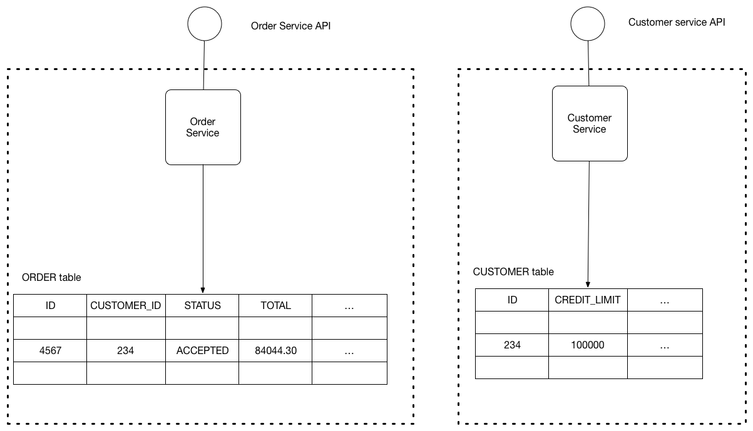Let’s imagine you are developing an online store application using the [Microservice architecture pattern](http://microservices.io/patterns/microservices.html). Most services need to persist data in some kind of database. For example, the Order Service stores information about orders and the Customer Service stores information about customers [10].

Figure 2.1 Database Per Service Sample

The service’s database is effectively part of the implementation of that service. It cannot be accessed directly by other services.

There are a few different ways to keep a service’s persistent data private. You do not need to provision a database server for each service. For example, if you are using a relational database then the options are:

* Private-tables-per-service – each service owns a set of tables that must only be accessed by that service
* Schema-per-service – each service has a database schema that’s private to that service
* Database-server-per-service – each service has its own database server.

Private-tables-per-service and schema-per-service have the lowest overhead. Using a schema per service is appealing since it makes ownership clearer. Some high throughput services might need their own database server.

It is a good idea to create barriers that enforce this modularity. You could, for example, assign a different database user id to each service and use a database access control mechanism such as grants. Without some kind of barrier to enforce encapsulation, developers will always be tempted to bypass a service’s API and access it’s data directly.

Using a database per service has the following benefits:

* Helps ensure that the services are loosely coupled. Changes to one service’s database does not impact any other services.
* Each service can use the type of database that is best suited to its needs. For example, a service that does text searches could use Elastic Search. A service that manipulates a social graph could use Neo4j.

Using a database per service has the following drawbacks:

* Implementing business transactions that span multiple services is not straightforward. Distributed transactions are best avoided because of the CAP theorem. Moreover, many modern (NoSQL) databases don’t support them. The best solution is to use the [Saga pattern](http://microservices.io/patterns/data/saga.html). Services publish events when they update data. Other services subscribe to events and update their data in response.
* Implementing queries that join data that is now in multiple databases is challenging.

There are various solutions:

* API Composition - the application performs the join rather than the database. For example, a service (or the API gateway) could retrieve a customer and their orders by first retrieving the customer from the customer service and then querying the order service to return the customer’s most recent orders.
* Command Query Responsibility Segregation (CQRS) - maintain one or more materialized views that contain data from multiple services. The views are kept by services that subscribe to events that each services publishes when it updates its data. For example, the online store could implement a query that finds customers in a particular region and their recent orders by maintaining a view that joins customers and orders. The view is updated by a service that subscribes to customer and order events.
* Complexity of managing multiple SQL and NoSQL databases

Base on this project, the database of the division office which have all the list of the employees and the list of the schools will be needed. These tables already exist and the division office is already updating these tables every now and then. So the researcher will make use of that tables and instead of copying the tables to the online leave application database, the researcher will use the idea of database per service which uses the micro web services design. The researcher will then gain access to the updated employees and schools tables from the database of the division office.

**2.1.5 Leave of Absence**

It is the right granted to employees not to report with or without pay as may be provided by law and as the rules prescribe in Rule XVI of Executive Order No. 292 [1].

The following are the procedures in the filling, processing, and approval of leave applications:

1. Employees are required to file their leave applications using CSC Form No. 6 which should be fully accomplished in duplicate original copies, wherever they go on leave of absence.
2. The supervisor recommends the approval or disapproval of the application.
3. The authorized official approves the application following the rules on delineation of functions/delegation of authority.
4. The Personnel Division processes the application, including certification as to leave balance.
5. A copy of the processed application is released to the employee concerned every end of the month and the other one is retained at the Personnel Division for file.

**Leave administration:**

* Employees who render work during the prescribed hours are entitled to 15 days vacation leave and 15 days sick leave credits annually or 1.25 days vacation and sick leave credits monthly, with full pay.
* Application for leave of absence except for emergency sick leave shall be filed in advance, whenever possible, five (5) days before the effectivity of leave.
* Application for leave for thirty (30) calendar days or more shall be accompanied by an Office Clearance from money and property accountabilities.
* Employees who are absent without approved leave shall not be entitled to receive their salary corresponding to the period of their unauthorized leave of absence.
* Employees who are continuously absent without approved leave for at least thirty (30) working days shall be considered AWOL and shall be separated from service or dropped from the rolls without prior notice.

They shall, however, be informed at their last known address appearing on their 201 files of their separation from the service, not later than five (5) days from its effectivity.

* If the number of unauthorized absences is less than thirty (30) days, a written Return-to-work order shall be served to them at their last known written address on record.

Failure on their part to report for work within the period stated in the order shall be a valid ground for dropping them from the rolls.

**Types of leave:**

**Sick Leave** – granted on account of sickness or disability of the employees or any member of their family (parents, brothers, sisters, children, spouse and even house help who are living with the employees).

* Application for sick leave shall be filed upon return to work.
* Application for sick leave filed in advance, or exceeding five (5) days shall be accompanied by a medical certificate.
* Approved Sick leave submitted to the Personnel Division later than the 6th working day after the leave of absence shall be deducted from the employee’s salary.

**Vacation Leave –** granted to employee for personal reasons, the approval of which is contingent upon the necessities of the service.

* Vacation leave without pay is considered a gap in the service.

**Five (5) days forced/mandatory Leave (FL)**

* Employees with ten (10) days or more vacation leave shall be required to go on vacation leave whether continuous or intermittent for a minimum of five (5) working days annually.
* Forced leave shall be forfeited if not taken during the year. However, if the secretary cancelled the scheduled leave in the exigency of the service, the same shall no longer be deducted from the total accumulated vacation leave.
* Those with accumulated vacation leave of less than ten (10) days shall have the option to go on forced leave or not. However, officials and employees with accumulated vacation leave of fifteen (15) days who availed of monetization for ten (10) days resulting in five (5) days vacation leave, shall still be required to go on forced leave.

**Special Privilege Leave –** leave of absence which may be availed of for a maximum of three (3) days annually to mark special milestones and/or attend to filial and domestic emergencies such as birthday, anniversary, mourning, PTA meetings, etc.

* SPL is non-cumulative and non-convertible to cash.
* SPL on emergency cases shall be files within the day upon return to work, and the supervisor/office should be informed of the reason of availing such leave.

**Maternity Leave –** Every woman in the government service who has rendered an aggregate of two (2) or more years of service, shall in addition to the vacation and sick leave granted her, be entitled to maternity leave of sixty (60) calendar days with full pay.

**Paternity Leave**

* Every married male employee is entitled to paternity leave of seven (7) working days for each of the first four (4) deliveries of his legitimate spouse.
* It is non-cumulative and non-convertible to cash.

**Parental Leave (Solo Parent Act) –** seven (7) days leave of absence granted to a parent who has the sole custody and responsibility of the child and who has rendered at least one (1) year of service regardless of employment status.

* In order to avail of the Parental Leave, the solo parent shall submit to the Personnel Division the Solo Parent Identification Card or Certification issued/validated by the DSWD within the month of January every year.

**Rehabilitation Leave –** granted to employees for disability on account of injuries sustained while in the performance of duty.

* The duration, frequency and terms of availing this leave shall be based on the recommendation of the medical authority i.e. may be half day basis, intermittent schedule or less than six (6) months, but not to exceed six (6) months and their absences shall not be deducted from the sick and vacation leave credits.

**Ten (10) Days Leave (Violence against women and their children act of 2004) –** Any woman  
 employee in the government service, regardless of employment status and/or whose child is a victim of violence and whose age is below eighteen (18) or above eighteen (18), but unable to care of oneself, is entitled to avail of the ten (10) days leave.

* The special leave may be availed for every instance of gynaecological disorder requiring surgery

**Gynaecological Disorder –** refers to disorders that would require surgical procedures such as, but not limited to dilatation and curettage and those involving female reproductive organs such as the vagina, cervix, uterus, fallopian tubes, ovaries, breast, adnexa and pelvic floor, as certified by a competent physician.

**Study Leave –** a time-off from work not exceeding six (6) months with pay for the purpose of assisting qualified employees to prepare for their bar or board examinations to complete their master’s degree.

**Terminal Leave –** refers to the money value of the total accumulated leave credits of an employee based on the highest salary rate received prior to or upon retirement date/voluntary separation.

**Special Emergency Leave –** 5-day leave granted to those employees directly affected by natural  
 calamities and disasters. (Office Order No. 2012-02).

**2.2 Related Existing Systems**

**2.2.1 University of Louisville**

University of Louisville website can be found at (<https://louisville.edu/>). It is the official website of University of Louisville. In the deeper part of their official website, they have a form which offers an application for leave request.

A form can be found at (<https://louisville.edu/hr/forms/leave-request>) is very similar to the form that the researcher will be using in this project (Civil Service Commission Form No. 6). The form consists of the following information that must be filled; Name, Employee ID, Employee Title, Department, E-mail Address, Supervisor Email Address, Type of leave, Total Number of Hours, Begin Date, Start Time, End Date, End Time and Explanation.

This Online Leave Request Form from is helping employees of the University of Louisville apply for leave request without needing to go to the physical office, fill out the form and submit the filled-up form. All the employees need to do is fill out the form and the right personnel will process the request.

This Leave Request Form caters all types of leave in which are (Vacation, Sick, Bereavement, Jury Duty). Employees may apply for leave request by presenting themselves in the human resource office or thru filling-up and submitting the form online.

This system is very closely related to the project the researcher will be doing. The forms might not be that the same, but it is very close. The form in this system is not smart enough to adjust the form depending in the type of leave the applicant will choose. Smart form will be a goal the researcher wants to apply in the project output.

Human Resource Online Leave Request form from University of Louisville is show in figure 2.3 Below.

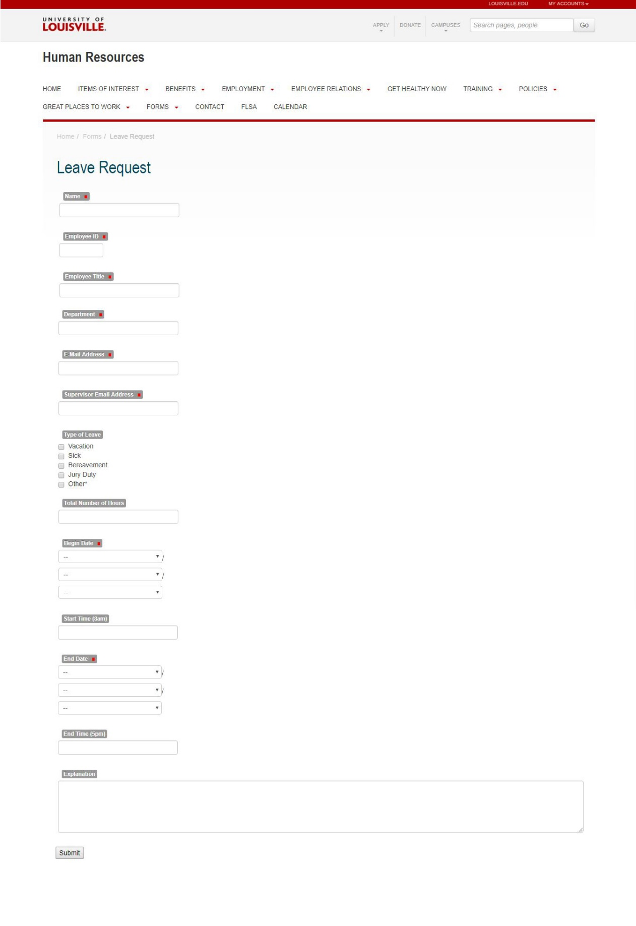Figure 2.2 University of Louisville Leave Request Form

Figure 2.2 Shows the application form format being used for their online leave request. Here we can see how amazing it is to be able to access the application form from the comfort of our places.

**2.2.2 PhilHealth Electronic Registration System**

Offered to the public for individual registration of members in the formal and informal sector.

This system shows some functionalities like availability of file uploads that the researcher will apply in the output project. Here we can see that we should avoid overwhelming the users with massive numbers of input fields.

The system is used by individuals belonging to the following category:

* Employed Members
* Self-employed members
* Overseas Filipino Worker
* Retirees in the Government and Private Sector

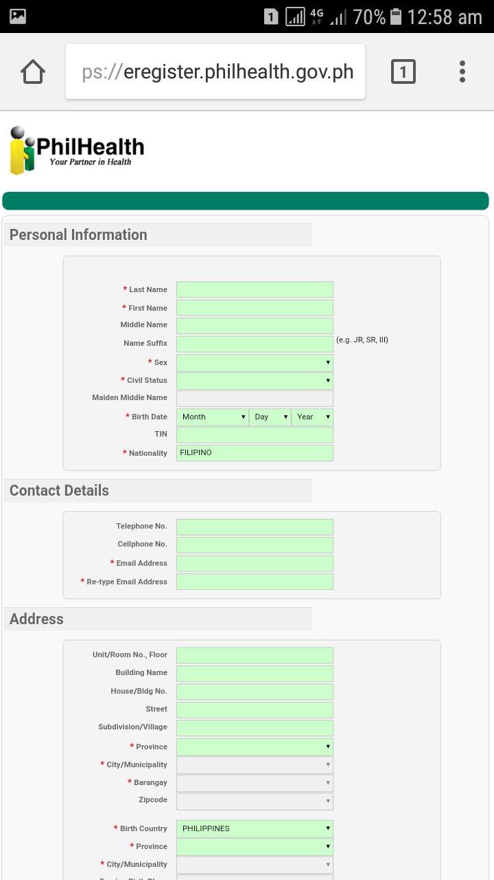

*Figure 2.3 PhilHealth Electronic Registration System Form*

Figure 2.3 Shows PhilHealth Registration system form. This is not the same with the leave application but it is the same idea, it’s about application.

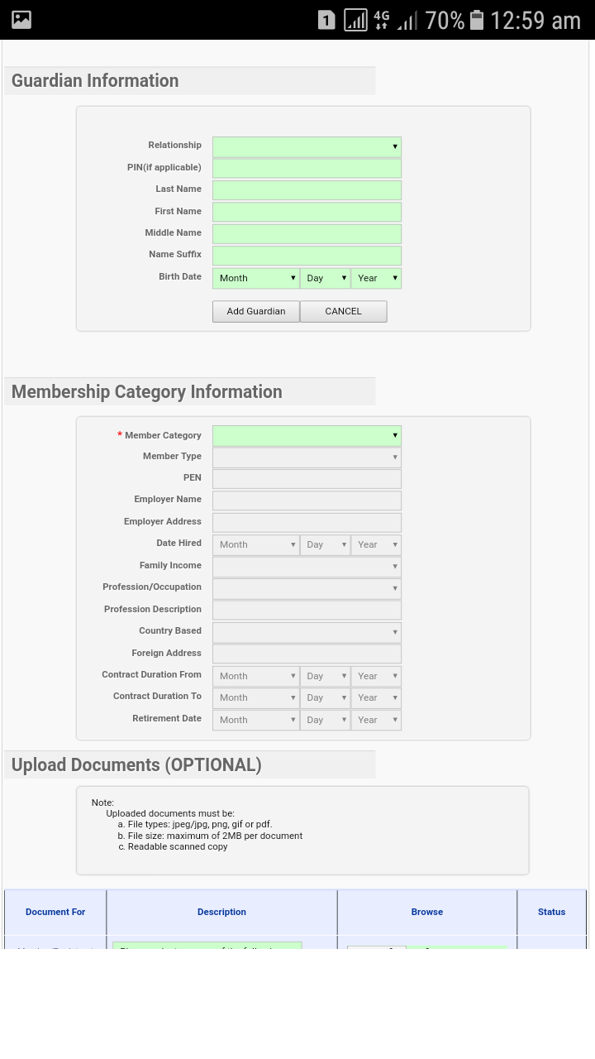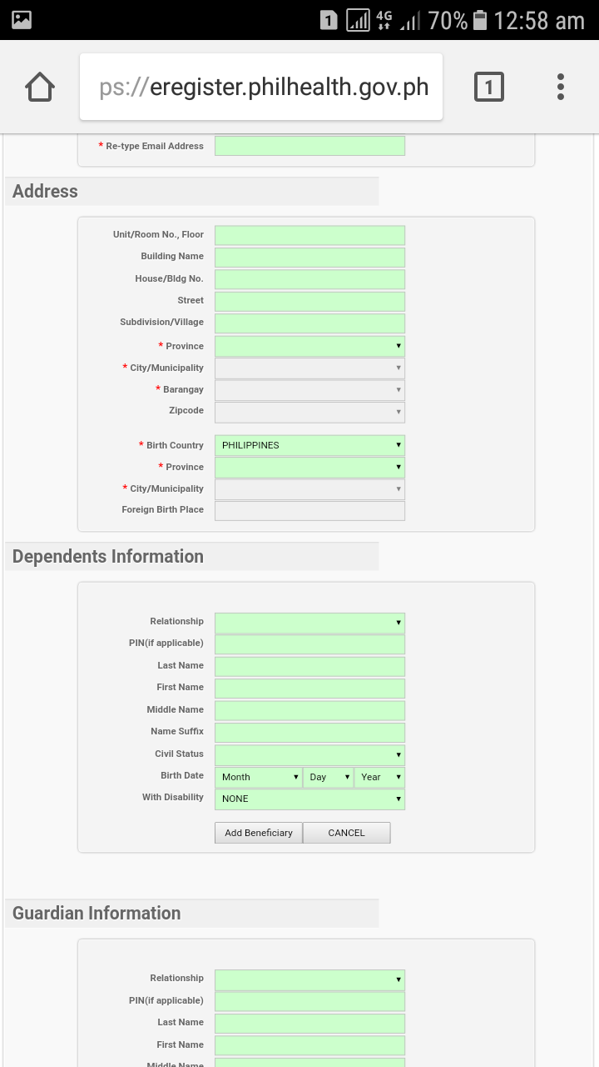 *Figure 2.3 (Continuation) PhilHealth Electronic Registration System Form*

Figure 2.3 (Cont.) Is the continuation of the form from figure 2.4.1. It shows the idea of putting red asterisk in every required field in the form.

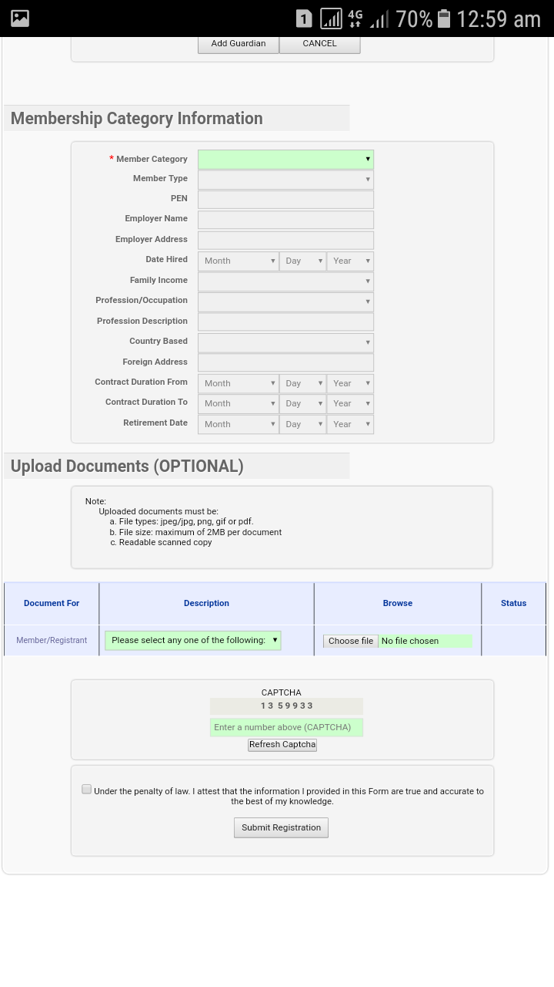

*Figure 2.3 (Continuation) PhilHealth Electronic Registration System Form*

Figure 2.3 (Cont.) Is the continuation of the form from figures above. It shows the ability to attach a file in the form.

**2.2.3 BIR eREGISTRATION (eREG) System**

The eREGISTRATION (eREG) System is a web application system for various taxpayers registration services, such as TIN Issuance, payment of registration fee and Issuance of Certificate of Registration.

You can see that this is a captcha type of form submission since the applicant will need to type the captcha in order to submit the form. This idea is very useful in the project output of this researcher. But since the researcher will be using user bases form submission, captcha might not be necessary.

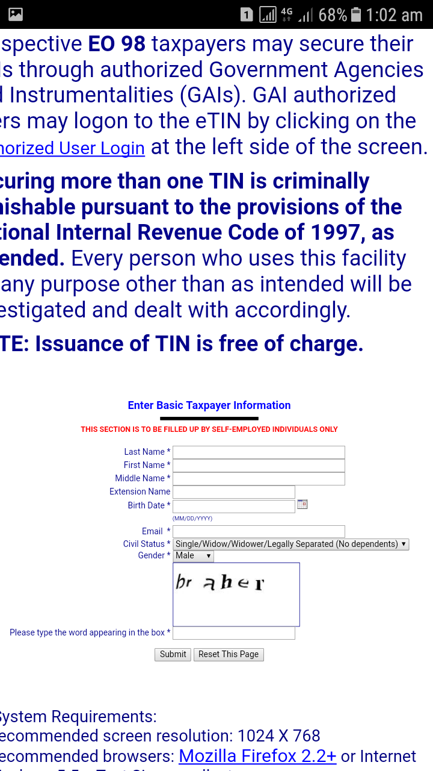 If you try to see the birthdate input. They can select a date using a date GUI, but that might be harder to navigate compare to just separating the day, month, year input fields. So the researcher will follow to just separate the day, month, year fields.

*Figure 2.4* BIR eREGISTRATION (eREG) System

Figure 2.4 shows a form with captcha which is very effective in screening the bots and screening brute force attacks.

**Chapter 3**

**Technical Background**

DepED Bayugan City Division is composed of 66 schools, 56 primary and 10 secondary and all amounts to more or less 1,300 employees in the year 2017. Employees under this division office when applying for a Leave will need to go to the division office and pass the requirements 5 days before the effectivity of the leave, if it is an emergency sick leave, then the employee can apply on the same day the employee resumes to work.

When an employee applies for a leave, filing must be done inside the division office and submit to the personnel in charge in Human Resource Department. The right personnel will then process the request, calculate the total leave credits the employee can spend. If the filed application has been prepared by the HR Department and has been validated, it will then be submitted to the division superintendent who will approve the request.

Employees that comes to the division office filing for a leave comes from different places, assigned to different schools, and travels to different distances. And the main problem that the researcher is solving in the research is the distance problem. Let’s see this; If a teacher is alone with his son, and one day his son got sick for only a day, and the teacher will apply for a leave of one (1) day, and he is assigned in a school with rough terrain which is 10 kilometres away from the division office. The teacher will need to do his filling in the division office so he will need to travel just to be with his son for a day to ensure his son’s safety. We have the technology and the internet, let’s make the world a better place using the current technology that we have.

The division superintendent was once a teacher, and knows this situation very well. She is very kind hearted enough to think of this project thinking only what are the best for the employees under her supervision. The creation of Online Leave Application will give the employees direct access to the leave application online anytime anywhere.

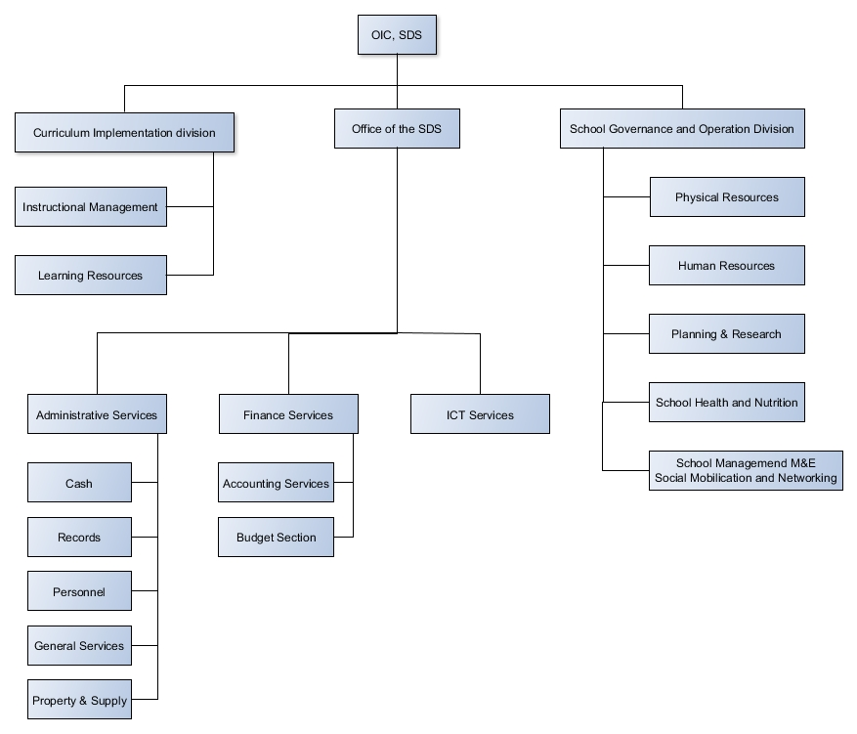**3.1 Organizational Chart**

*Figure 3.1 The DepED Bayugan City Division Organizational Chart*

Direct access to the application’s administration page will not be available to all personnel of the division office. It will be granted only to the following offices:

* **ICT Office** – Will act as the administrator of the database and the application.
* **Human Resource Office –** Will process the filed applications and accepts it to be submitted to the superintendent.
* **OIC, SDS –** Will approve the filed application.

**3.2 Workflow**

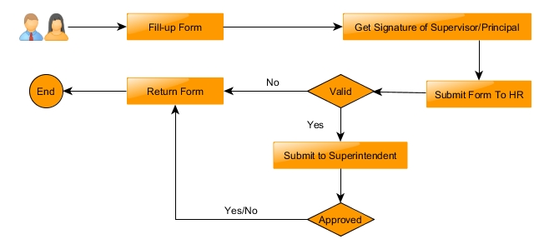**3.2.1 Existing Workflow**

*Figure 3.2 Application for Leave Existing Workflow*

In figure 3.2 the user fills up the form, gets signature of principal then submit to HR. If application is valid, submits to division superintendent then the division superintendent approves/disapproves the form and returns it.

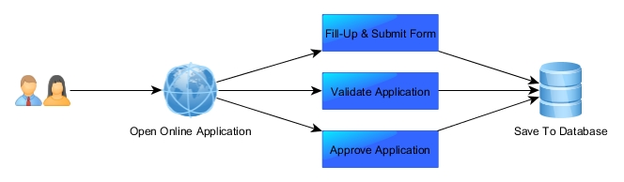**3.2.2 Proposed Workflow**

*Figure 3.3 Application for Leave Proposed Workflow*

In figure 3.3 the user will apply for leave in the web, then waits for the reply. If the application is approved or rejected the user will know immediately in the web.

**Chapter 4**

**Methodology**

This chapter discusses the methodology of the research project. It includes the development phase of the project and the diagrams of the different processes.

**4.1 Requirement Analysis**

The current workflow was evaluated to provide a detailed analysis of its problems. The following sections describe in detail the result of the analysis.

**4.1.1 PIECES Evaluation Framework**

Using the PIECES Evaluation Framework, we have identified the problems that we have in the current system. Table 4.1 Shows the result of evaluation using PIECES Evaluation Framework.

*Table 4.1 PIECES Evaluation of the current system*

|  |  |
| --- | --- |
| **Performance** | **Throughput** – Passing the Application Form manually from office to office lessens the maximum rate of production in applying for a leave. It takes time to pass the application form from school principal to human resource office to division superintendent. |
| **Response Time** – Each office has their own works, so, sometimes, if too busy, the applicant might wait a couple of minutes to get their application form back. There is even a possibility that when the applicant submits the application, the assigned personnel will not be there to entertain the application. |
| **Information** | **Stored Data** – Stored Data is not well organized because it is paper based. It could be lost anytime. |
| **Economics** | **Costs** – Money is needed for transportation to get to the division office. It ranges from 16php to 150php depending on the location of the applicant. |
| **Control** |  |
| **Efficiency** | **People, Machines, or Computers waste materials and suppliers –** Effort required for task is excessive, just by going to the division office, it needs a lot of effort. |
| **Service** | **The system is inflexible to new or exceptional situations –** What if the applicant is injured? The Applicant will still need to make the same amount of effort to apply for a leave. |

**4.1.2 Cause and Effect Analysis**

After the evaluation using the PIECES Evaluation Framework, we performed an evaluation of the causes and effects of the problems in the current system. Table 4.2 Summarizes the cause and effect of each problem identified using PIECES Framework with the proposed solutions to be provided with the system and its corresponding constraints.

*Table 4.2 Cause and Effect Analysis of the Current System*

|  |  |  |  |  |
| --- | --- | --- | --- | --- |
|  | **Problems / Opportunities** | **Cause and Effect** | **System Objectives** | **System Constraints** |
| **Performance** | Throughput and Response Time | **Cause:** Process needs effort and time  **Effect:** Longer response time and lesser throughput. | Increase response time and throughput with faster and more accessible application | Needs internet connection to submit the application. |
| **Information** | Stored Data Could be Lost Anytime | **Cause:** The data is paper based.  **Effect:** Could be lost anytime if not kept in an organized manner. | Make a more efficient storage system (database). | Old data will not be included in the new database. |
| **Economy** | Cost of Transportation to submit Application | **Cause:** Long distance to travel.  **Effect:** Teachers will need to spend money for transportation. | Make the application submission available in the world wide web. | Application will not be submitted if there is no internet connection. |
| **Control/Security** |  |  |  |  |
| **Efficiency** | Excessive work for a simple task | **Cause:** Passing the application form from office to office.  **Effect:** Process needs effort and time to be finished. | Make the project like a document tracking system. | The user needs to check the application to know its current status. |
| **Service** | Inflexible System | **Cause:** Effort and time needed is still the same even if the applicant is busy or he’s/she’s somewhere far.  **Effect:** Harder application for the applicant’s side. | Make the leave application available online. | Needs internet connection to successfully submit the leave. |

**4.1.3 Gantt Chart**

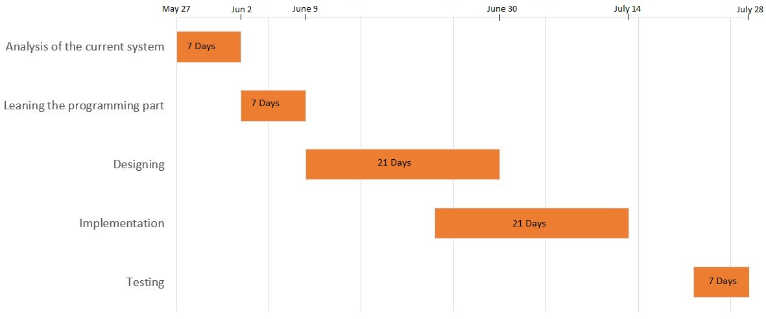

The actual development started in May 27. Learning the programming part is only 7 days for the researcher already have background on the technology that will be using. Designing took time because the system has been through a lot of versions.

**4.2 Design**

This section provides modelling tools that describe the system and its processes including developer and user specifications and software testing plans.

**4.2.1 Hierarchical Input-Process-Output**

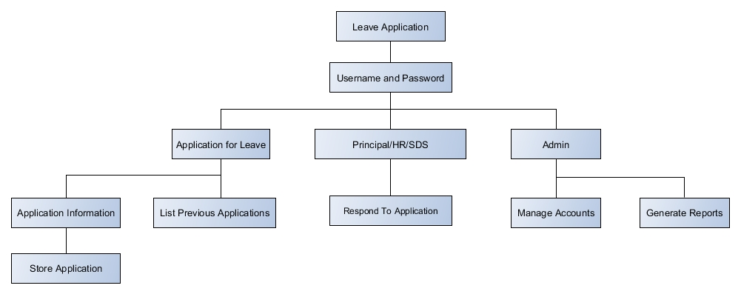

*Figure 4.1* Hierarchical Input-Process-Output

When opening the leave application, a login page will appear which will then need username and password to be able to login. Application for leave is a module where users can apply for leave. Applying for leave or storing the leave application will need the user to supply the needed information in the form. The user then can be able to list previous Applications. If the username and password belongs to Principal or Human Resource or SDS, they will be redirected to a module where they will respond to leave applications made by the users. If the account is admin, it will be able to manage the accounts and generate reports.

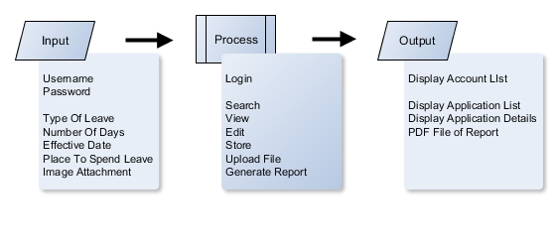**4.2.2 Input-Process-Output**

*Figure 4.2* Input-Process-Output

Using username and password, the user will be able to login. If the account is the account manager, account list will be displayed. In order to search, view, edit, store, upload file, generate report we need to have the input for the application for leave form. The output of the following processes will be the display of the list of the applications, modules might do different functions but the output will still be the same, outputting the application list or application details. If the admin wants to generate a report, a PDF File or a direct printing will be provided.

**4.2.2 Use Case Diagram**

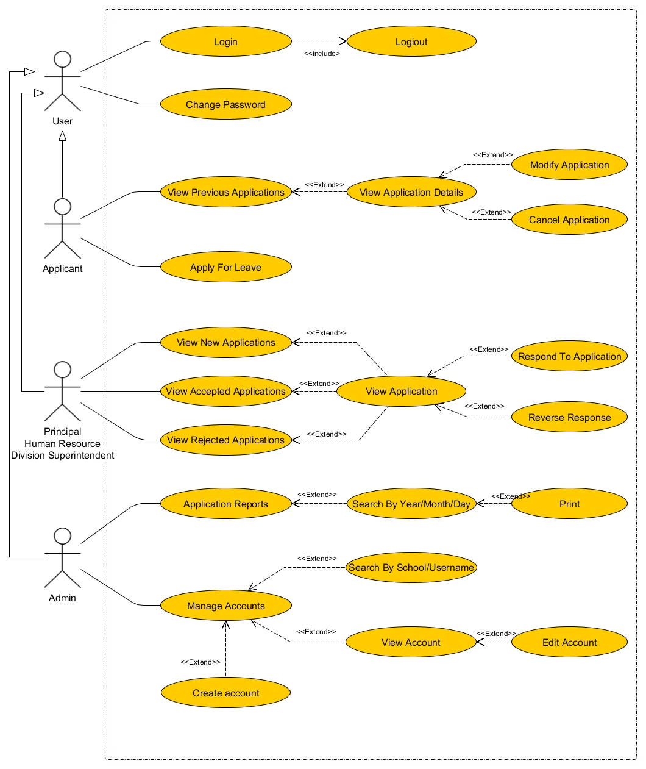

*Figure 4.3* Use Case Diagram

In figure 4.3, all of the account types will inherit the user’s privileges. The applicant can apply for leave and view previous applications. After viewing previous applications, the applicant can now view application details then modify and cancel application. The principal, human resource and superintendent have all same page that will be presented. They will be responsible for responding to the leave applications. The admin will be responsible for managing accounts and printing the application reports.

**4.2.4 Entity-Relationship Diagram**

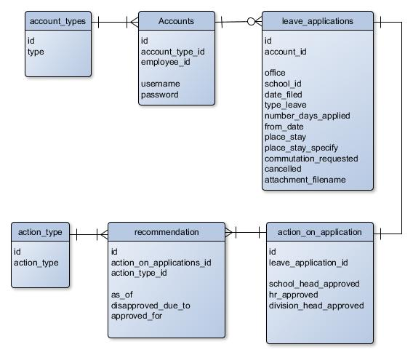

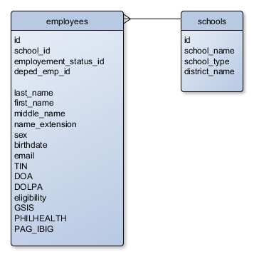*Figure 4.4* Entity Relationship Diagram

*Figure 4.5* Entity Relationship diagram (Database per service)

ERD in figure 4.4 shows 2 columns from the database of the Human Resource Office (Bayugan Division) which is not in the project’s database but connected in the tables (Figure 4.3) using a web service. Accounts table in this project’s database (Figure 4.3) is connected in the employee table from the database per service (Figure 4.4). The second table (schools, Figure 4.4) is used in the search by school functionality of the project.

**4.2.5 Architectural design**

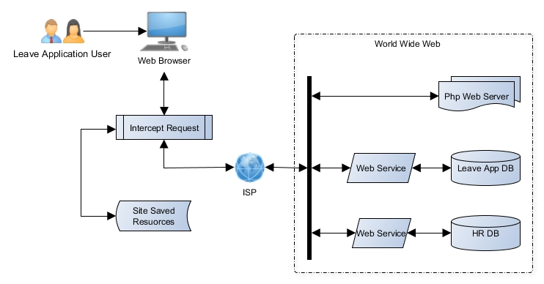

*Figure 4.6* Architectural Design of Online Leave Application

Since Online Leave Application is web based, the user must use a browser in order to use the app. There is a new technology called service worker that is programmable to run in the background of the browser. The service worker can also intercept any incoming request and be able to respond to the request. When the user accesses the leave application, the service worker will intercept the incoming request and reply it with the site resources requested that is already in the cache. When the user first access the website, the service worker will be installed and it will only run in the next time the user accesses the site.

Internet will be needed in the first run of the program. The next time internet will be needed, it will be about accessing the web services of leave application.

The browser will request for some resources from PHP web server, the web server will then respond with the files requested. The application will then be served in the browser with empty data. Scripting will then be used to request data from the database using the web service (micro services). If the script request resources about the employees, it will need to access the Employee API (micro service). The API will then get the data from the database and send it back to the script requesting it.

**4.3 Development and Testing**

**4.3.1 Software Specification**

*Table 4.3 Developer Software Requirements*

|  |  |
| --- | --- |
| Programming Language | PHP, Go, Javascript, HTML5, CSS |
| Development Environment | PhpStorm |
| Text Editor | Notepad++ |
| Web Browser | Mozilla Firefox 44.0+ |
|  | Google Chrome 40.0+ |
|  | Opera 27+ |
|  | Samsung Internet 4+ |
|  | Safari 11.1+ |
|  | Edge 17+ |
| Web server | Apache httpd 2.4 (for testing) |
| Version Control | Git 2.13.2 |
| Database | MySQL 14.12, |

*Table 4.4 User Software Requirements*

|  |  |
| --- | --- |
| Operating System | Windows, Mac OS, Linux, Android, IOS |
| Web browser | Mozilla Firefox 44.0+ |
|  | Google Chrome 40.0+ |
|  | Opera 27+ |
|  | Samsung Internet 4+ |
|  | Safari 11.1+ |
|  | Edge 17+ |

**4.3.2 Hardware Specification**

*Table 4.5 Developer Hardware Requirements*

|  |  |
| --- | --- |
| Development Device | Laptop |
| Screen Resolution | 1366 x 768 |
| Processor | 2GHz or better |
| Memory (RAM) | 4GB or better |
| Keyboard | Standard, US layout |

*Table 4.6 User Hardware Requirements*

|  |
| --- |
| Office Computer |
| Screen Resolution | Min: 1024x600, Recommended: 1366x768 |
| Processor | 1GHz or better |
| Memory | 1GB RAM or better |
| Keyboard | Standard, US layout |

|  |
| --- |
| Smartphone |
| Processor | 1GHz or better |
| Memory | 1GB RAM or better |

**4.3.3 Deployment Diagram**

*Figure 4.7* 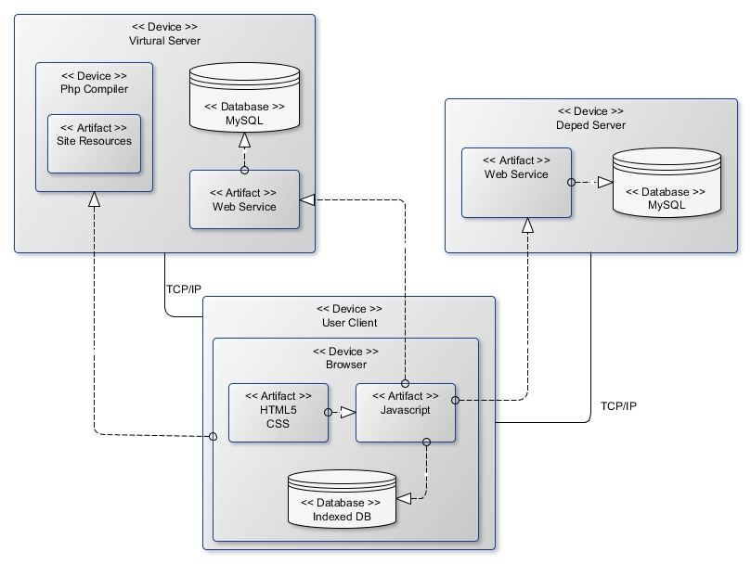Deployment Diagram

Figure 4.6 illustrates the deployment scheme to be used in the project deployment stage. This design complies with the system architecture design but gives a more in-depth view of the interactions between each of the interfaces of each node instead of just their connections. Base on this deployment scheme, the leave application virtual server is completely independent with the server of DepED Bayugan. The application static media files will be able to connect to the databases from both server and the database is loosely coupled with the PHP application.

**4.3.4 Usability Test Plan**

This section describes the usability test plan for heuristically evaluating the usability of the Online Leave Application. This test is designed to evaluate whether potential users will be able to perform a set of common tasks that can be performed on the site. The test aims to provide user-centered reviews and not expert reviews of the site. The format of the usability test plan can be found in Appendix C of this document.

**4.3.4.1 Problem Statement**

Based on the current features of the website and the analysis of the site implementation, the following assumptions are made about the general user who will use the site:

* They will be applying for a leave.
* They will update their leave request.
* They will be checking the status of their leave request.
* They will be updating their account password.

Furthermore, upon conducting interviews during the design and development of the site, the researcher assumes the following of the potential staff and principals of Bayugan City DepED that will use the site:

* They will be responsible for responding to the leave requests.
* They will be responsible for managing the accounts.
* They will be responsible for printing the leave requests applied.

Thus, with these assumptions, the researcher will focus the test on these concerns:

* Can the user identify what each button does, or where each link leads to?
* Can the user distinguish interactive content (i.e. which buttons are clickable or fields that are editable?)
* Can they efficiently perform the task they intend to perform?

**4.3.4.2 Procedure**

For testing stations, the user can user any device he has with web a browser installed and a casual network connectivity. The researcher’s laptop will serve as the testing server.

The participants were provided a copy of the task list and the evaluation sheet. The researcher will then open the web site using the device of the participant. Then the participants can start doing the task list. After each task, the participant will rate the difficulty of the task. If problems arise, the participant must take note of it and notify the facilitator for appropriate classification of the problem.

**4.3.4.3 Roles**

Participant – the tester who will rate the usability of the software.

Facilitator – responsible for administering the test. Facilitator interaction with the participants must be kept to a minimum.

**4.3.4.4 Error Classification**

Two types of error must be taken note of:

1. Critical errors – these are the “brick walls” in the software. These are errors where the participant is brought to a complete stop in the performance of a task and simply cannot complete it.
2. Non-critical errors – these are errors that the participant encounters but are able to overcome and the task is still completed.

To examine the severity of the impact of the errors encountered, the following measures the effects of the errors encountered:

**High** – the participants was not able to complete the task.

**Moderate** – the participants had a hard time performing the task but nevertheless was able to complete it.

**Low** – the participants was able to complete the task and wasn’t significantly disturbed by any problem that occurred.

**Chapter 5**

**Presentation and Interpretation of Results**

This section contains the results of the tests and evaluations conducted to assess the performance and functionalities of the system. The test was conducted with 5 teachers and a staff from DepED Bayugan.

**5.1 Techniques and Algorithms**

In this section, the researcher discusses the algorithms and techniques used in conquering the biggest problems encountered and solutions provided in the creation of the project.

**5.1.1 Offline Web**

Currently, if you will ask a programmer if it is possible to access a URL via a browser without an internet connection, generally they would answer, it is impossible. Because web applications traditionally assume that the network is reachable. HTML documents are loaded over HTTP and traditionally fetch all of their sub-resources via subsequent HTTP requests. This places web content at a disadvantage versus other technology stacks. But luckily, service worker was born.

The [service worker](https://www.w3.org/TR/service-workers-1/#dfn-service-worker) is designed first to redress this balance by providing a Web Worker context, which can be started by a runtime when navigations are about to occur. This event-driven worker is registered against an origin and a path (or pattern), meaning it can be consulted when navigations occur to that location. Events that correspond to network requests are dispatched to the worker and the responses generated by the worker may override default network stack behavior. This puts the [service worker](https://www.w3.org/TR/service-workers-1/#dfn-service-worker), conceptually, between the network and a document renderer, allowing the [service worker](https://www.w3.org/TR/service-workers-1/#dfn-service-worker) to provide content for documents, even while offline.

[Service workers](https://www.w3.org/TR/service-workers-1/#dfn-service-worker) are generic, event-driven, time-limited script contexts that run at an origin. These properties make them natural endpoints for a range of runtime services that may outlive the context of a particular document, e.g. handling push notifications, background data synchronization, responding to resource requests from other origins, or receiving centralized updates to expensive-to-calculate data (e.g., geolocation).

*Figure 5.1* Normal HTTP request-response

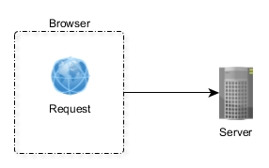

Figure 5.1 shows how HTTP request-response normally happens. When the user accesses a browser, it types a URL and press enter, that URL will then become a request which the browser will try to do. The browser will then be able to receive the response. If the connection does not exist, the browser will simply show a “No internet connection” message.

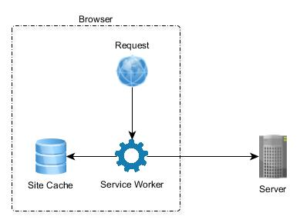

*Figure 5.2* HTTP request-response with service worker

Figure 5.2 shows how HTTP request-response happens with the user of service workers. When you try to type a URL in the browser and press enter, the browser will try to check if a service worker exists that controls that domain (URL). If it exists, the service worker will check if the resources are available offline and returns them. If the resources need to be accessed online, the service worker will fetch the resources and return them to the browser.

Service workers are just JavaScript you programmed, the amazing part is the word “you programmed”, since it means you can do all sorts of things with service worker. And you will have a request interceptor running in the background that you yourself programmed freely.

**5.1.2 Image Submission**

During the time when the researcher uploaded the project to the world wide web, some problems occurred. One of those problems is the submission of the images. When an applicant submits an application with image attachment in it, if the image is less than 200kb, the image will always fail to upload. The researcher found out that it was the same with Facebook and Google Mail. When trying to upload a file that is too big in a slow internet connection, the upload will fail. So the researcher decided to create a solution to this problem.

The first step is to resize the image to smaller resolution for smaller size. When you resize an image, its storage size will be smaller too. But image resize is not very uncommon in JavaScript. Using canvas element, the researcher resized the image to 50% of its original height and width.

Second is to divide the image into smaller chunks. There are lots of more complicated solutions that exists. One solution is divide the images with canvas tiling. But there is a simpler solution, the image Base64 conversion. Base64 is Binary-to-text encoding scheme which can be used to convert data into text format so it can be easily transmitted via any mean i.e. email. Base64 converts data into a URL friendly string consist of the “standard” alphabet uses A-Z, a-z, 0-9 and /,+ with = as a padding character. After conversion, you need to embed the code into your img tag or CSS to display the image.

Now that the image is converted to a URL friendly string, it can now be used anywhere. Since it is basically a string, it will be read from left to right to get the value of the image. The string result can now be divided into parts. The researcher divided the string into per 50,000 character, which is approximately equivalent to 50kb in size. So if the image is 1mb, it is possible that it will be divided into 20 chunks.

We need a local database to save the chunked result of the string to be saved so that when the uploader comes back, the file will still be available. There are 2 choices for local database, IndexedDB (IDB) or Web Storage, there are both useful and powerful, if simplicity will play a role in the choice, Web Storage will clearly win the stage. The researcher used IndexedDB in some part of this project but this time, IDB will step in. The chunks will be saved in IDB for later uses.

The last step is to make sure all of the chunks are sent to the server. Starting from the first chunk, it will be sent to the server, one by one. If fails to submit, the program will retry to submit the chunk until it will success and proceed to the next chunk. If all the chunks have been submitted, show a notification to the uploader that the files have been successfully uploaded. The server will receive the chunks and stack them accordingly to the filename that has been set.

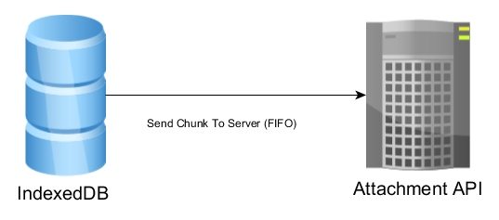

*Figure 5.3* Submission of chunk from IDB to server API

In figure 5.3, using the Queueing (FIFO), the image chunk will be sent to the server API which will then stack the chunks into a single image.

**5.2 Usability Test for Leave Applicants**

With the assumptions of the activities to be undertaken by potential users outlined in section 4.3.4.1 of Chapter 4 of this document, the features available for the main users (leave applicants) of this application has been tested. Five (5) applicants participated in this test.

The following table summarizes the results of the test for each of the task on the non-administrative features of the site.

*Table 5.1 Summary of errors encountered by the leave applicants*

|  |  |
| --- | --- |
| **Task** | **Errors Encountered** |
| **Login** | No error |
| **Apply a Leave** | No error |
| **View Previous Leave Applications** | No error |
| **Print Previous Applications** | No error |
| **Cancel a Leave** | No error |
| **Edit A Leave** | No error |
| **Change Password** | No error |
| **Logout** | No error |

Table 5.1 shows that the applicants did not encounter any errors. However, this does not mean that the system is fool proof as the researcher found some technical problems with the system during the testing.

**5.3 Usability Test for Principal/HR/SDS**

Usability test for Principal/HR/SDS. The three users have only one participant for the testing since all of their functionalities are the same.

*Table 5.2 Summary of errors encountered by the Principal/HR/SDS*

|  |  |
| --- | --- |
| **Task** | **Errors Encountered** |
| **View New Applications** | Cancelled Applications are still shown in the list |
| **View Accepted Applications** | No error |
| **View Rejected Applications** | No error |
| **Respond to a new Application** | No error |
| **Reverse Action** | No error |

Table 5.2 shows the results of the evaluation and testing for Principal/HR/SDS users. The error encountered in View New Applications task only appeared in Principal Module. It was not really an error but a bug which has been fixed after its discovery.

**5.4 Usability Test for Administrator**

The administrator of the system is an HR staff. In this test, we have one participant conducting the test, an HR staff from division office.

*Table 5.3 Summary of errors encountered by the Administrator*

|  |  |
| --- | --- |
| **Task** | **Errors Encountered** |
| **Create an Account** | No error |
| **Search accounts by school** | No error |
| **Search accounts by username** | No error |
| **Edit an Account** | No error |
| **View Application Report by Month** | No error |
| **View Application Report by Day** | No error |
| **Print a report** | No error |

Table 5.3 shows the result of the evaluation and testing for the Administrator. Although no errors were found, the administrator had a hard time figuring out where the print functionality is because it will only show when there is a record found.

**5.5 Summary**

The test conducted on the web application provided reliable data regarding the performance of the Online Leave Application. Even though errors were met, potential users gave a positive feedback about the system. The errors that was met in the testing were due to the developer not testing the site thoroughly and were note related to the performance of the technologies used. All errors were immediately resolved and considered.

*Table 5.4 Summary of the errors, severity, causes, and action taken*

|  |  |  |  |  |
| --- | --- | --- | --- | --- |
| **Test** | **Error** | **Severity** | **Cause** | **Action Taken** |
| View new Applications | Cancelled Applications appears in the new applications list | Low | Developer/Development | Resolved |

Table 5.4 Summarizes the errors encountered during the test, the severity levels, causes, and action taken.

**Chapter 6**

**Implementation Plan**

This chapter discusses the details of the implementation plan of the project.

**6.1 Implementation Milestones**

Table 6.1 summarizes the major tasks to be performed during the implementation.

*Table 6.1 Milestones in the implementation of Online Leave Application*

|  |  |  |  |
| --- | --- | --- | --- |
| **Task** | **Resources Required** | **Key Personnel** | **Success Measures** |
| **Acquire project implementation approval** | Project Presentation, Project Prototype, Pertinent Documents | Proponent | Approved Implementation,  On-going project |
| **Provide overall planning and coordination of implementation** | Requirement Analysis | DepED Bayugan  Proponent | Budget Plan,  action plan,  defined roles and tasks |
| **Provide and Implement alpha and beta tests for each build** | Working project build | Proponent  Tester | Project build must be ready for release |
| **Provide User Manual** | User Manual | Proponent | User manuals are readily available for support |
| **Acquire required hardware, software, and connectivity and support services** | Hardware, software, and network specifications | DepED Bayugan | Hardware and software requirements are met |

**6.2 Implementation Contingency**

Although the implementation milestones are clearly set, some variability still remains and must also be considered in planning. Table 6.2 describes possible problems that might arise in implementation with the corresponding contingency plans.

*Table 6.2 Implementation Contingency Specifications*

|  |  |
| --- | --- |
| **Problem** | **Contingency** |
| Web hosting service costs rise above the budget | Expand Budget  Host Locally |
| Proponent cannot handle load on need for technical support. | Acquire personnel for technical support |
| Software Encounters performance bottlenecks | Review code to reduce bottlenecks |
| Software Encounters errors | Review code and reduce errors |

**6.3 Infrastructure/Deployment**

**6.3.1 Support**

This section describes the infrastructure support for the deployment of the project.

**6.3.1.1 Hardware**

For DepED Bayugan, any device with web browser will do the work, but they must meet the system requirements specified below to improve the system throughput.

* Memory At least 1.5GB RAM
* Processor At least 2GHz clock speed

**6.3.1.2 Network and Services**

A web-hosting service must be paid by the office and an SSL certificate must be bought. This will make sure the uptime of Online Leave Application will be 99.99%.

**6.3.1.3 Software**

The only software needed to use the program is a web browser. Any device with a web browser and internet connection will be ready to use the Online Leave Application.

**6.3.1.4 Personnel**

Each of the staff must be computer literate. The staff that will use the system must be trained in order to efficiently use the system. Training will not take that much time because the system has been designed to be usable even without trainings. They must be familiar with the features of the system and must be able to type using a standard keyboard.

**Chapter 7**

**Summary, Conclusion, and Recommendations**

**7.1 Summary**

This project entitled “Online Leave Application for DepED Bayugan City” aims to address the problems of DepED Bayugan when it comes to efficiency and availability of the application for leave. The more distance a school from the division office is, the more it will be harder to apply for a leave. Since world wide web is accessible everywhere, the project output (Online Leave Application) will open a more accessible and efficient leave application.

An initial study of the current system was conducted to design and implement a leave application that will be available in the world wide web. Leave application processes were then assessed to identify which can be applied in the online leave application.

**7.2 Conclusion**

The system requirements and specifications met with high satisfaction on the requirements of the stakeholders. In the analysis of the software and the initial communication with an HR staff from Bayugan DepED, the software solution provided has satisfied their office. These software specifications were approved by the stakeholders.

Considering the requirement analysis, implementation milestones summary, hardware and software, usability test result, the system is now error free. The project now complete and ready for further additional functionalities and recommendations.

**7.3 Recommendations**

In order for the project to become more efficient, the developer recommend the following functionalities:

* Automatic calculation of remaining leave credits.
* Add a more advanced searching algorithm
* Pack the web application and deploy as Mobile app
* Pack the web application and deploy as Desktop app
* Add a real time chat app for convenience

It will be possible that some researcher will recreate the project. For the project to be more successful, the following could be applied:

* Service workers will only work on a secured connection, so do not use ajax style fetching as HTTPS requires multiple handshakes making it slower than normal ajax fetch. Instead, use web sockets, it will only open a connection once and be used unlimitedly.

**Bibliography**

[1] Department of Transportation and Communications (2011). *EMPLOYEE GUIDE ON LEAVE OF ABSENCE*. Office Order No. 2011-20

[2] Civil Service Commission (CSC) Memorandum Circular No. 14, s. 1999

[3] Gunjan Samtani, Dimple Sadhwani. *Web Services and Application Frameworks (.NET and J2EE)*, TECT publishing, Chicago Illinois USA.

[4] Tim A. Majchrzak (2008), *Progressive Web Apps: the Definite Approach to Cross-Platform Development,* 51st Hawaii International Conference on System Sciences,

[6] *Google Docs, Sheets, and Slides* [Online]. Available: <https://en.wikipedia.org/wiki/Google_Docs,_Sheets,_and_Slides>. [Accessed 06 November 2017]

[7] *Technology and Globalization*, SUNY LEVIN Institute.

[8] Chandra Aryal (2014), *Design Principles for Responsive Web,* Helsinki Metropolia University of Applied Science.

[9] *Microservice Architecture,* Tutorials Points (I) Pvt. Ltd.

[10] Pattern: Database per service [Online]. Available: <http://microservices.io/patterns/data/database-per-service.html>. [Accessed 14 July 2018]