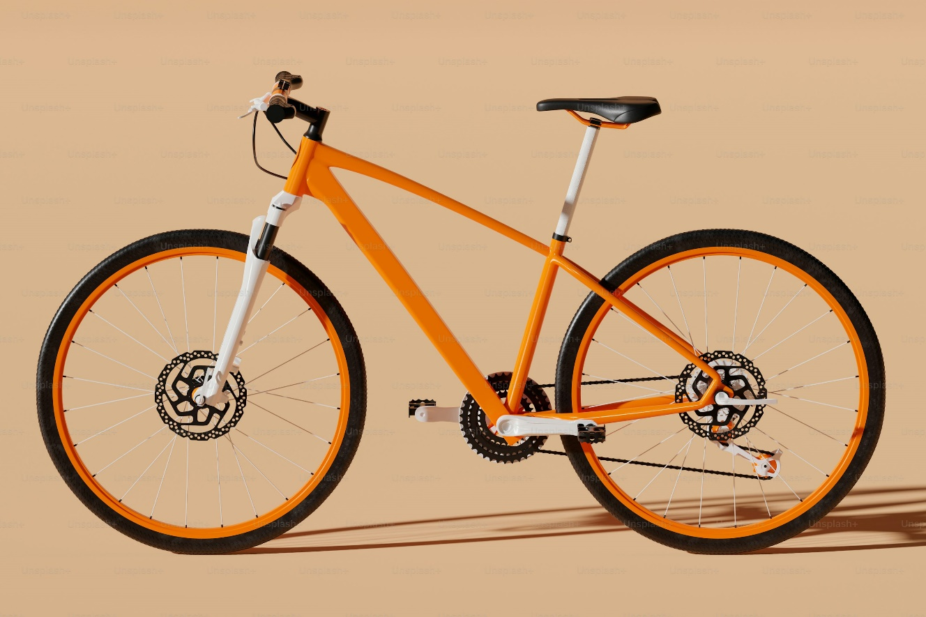

**Contents**

ELABORATE A CAMPUS BICYCLE PLAN 2

Coordinate Actions with Local Authorities 2

CREATE BIKE LANES 2

PLAN FOR SIGNAGE 2

Secure Bicycle Parking 2

Maintaining Bicycles 2

Evaluate and Supervise the Program 3

PROGRAMS IN OTHER UNIVERSITIES 3

# ELABORATE A CAMPUS BICYCLE PLAN

## Coordinate Actions with Local Authorities

Universities should collaborate with local authorities to develop a coherent bicycle plan. This includes aligning infrastructure with city-wide cycling routes, promoting safe travel across campus borders, and encouraging local policy support for student cyclists.  
  
By working closely with municipal partners, universities can also address shared safety concerns and integrate with larger transportation networks.

## CREATE BIKE LANES

Dedicated bicycle lanes should be constructed to ensure safe travel within the campus. These lanes must be clearly marked and physically separated from motor vehicle traffic wherever possible.  
  
The placement of these lanes should consider the most traveled paths between dormitories, classrooms, dining halls, and recreational areas.

## PLAN FOR SIGNAGE

Proper signage is essential to guide cyclists and alert other road users. Signs should indicate the location of bike lanes, parking areas, repair stations, and pedestrian crossings.  
Additionally, clear markings on the road surface should complement vertical signs to enhance visibility and compliance.

## Secure Bicycle Parking

Universities must provide adequate, safe, and convenient parking facilities for bicycles. These areas should be well-lit, located near main buildings, and, if possible, covered to protect from weather damage.  
  
Installing surveillance cameras and using secure racks can reduce theft and vandalism.

## Maintaining Bicycles

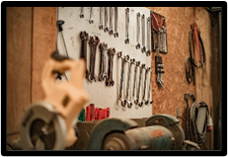The well-being of students relies on the regular upkeep of their bicycles. In areas where seasons are clearly defined and the temperature shift between day and night is notable, the tire pressure of bikes can fluctuate significantly. Additionally, students might harm their bicycles due to misuse or carelessness during an accident.

Universities should set up a bicycle repair facility for students or guarantee that local communities offer one at reasonable costs.

Universities opting to establish their own repair facility must confirm it is furnished with essential tools and maintains a supply of spare parts (tires, inner tubes, etc.).

## Evaluate and Supervise the Program

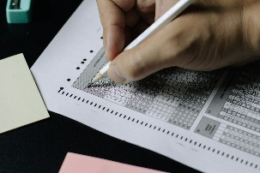 Universities should evaluate the effectiveness of their initiatives aimed at promoting bicycle use. Additionally, universities may wish to analyze the link between increased bicycle use and the rise in the number of bikes or accidents.

Universities should collect data on bicycle sales, the number and type of fixs performed (for universities with a campus bike repair workshop), the occupancy of bike parking areas, the volume of bike traffic, and the number of accidents.

Universities may also consider surveying students and faculty to assess their level of satisfaction with the new program.

Universities may also consider surveying students and faculty to assess their level of satisfaction with the new program.

# PROGRAMS IN OTHER UNIVERSITIES

Other universities have already developed programs aimed at encouraging bicycle use.

|  |  |  |
| --- | --- | --- |
| PROGRAMS IN OTHER UNIVERSITIES |  |  |
| University | **Enrollment** | **Program** |
| vanArsdel | 12,945 | * Course on bicycle safety |
|  |  | * Course on bicycle maintenance |
|  |  | * Bicycle repair workshop |
| Institut Bellows | 38,734 | * Bicycle sharing program |
|  |  | * Bicycle repair workshop on campus |
| Graphic Design Institute | 2,843 | * Course on bicycle safety |
|  |  | * Discounts on helmets |
| School of Fine Arts | 7,452 | * Videos on bicycle safety |
|  |  | * Bike shelters and parks |
|  |  | * Bicycle repair workshop on campus |