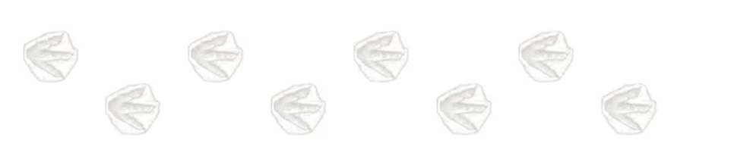

Dinosaurs

# A New Product

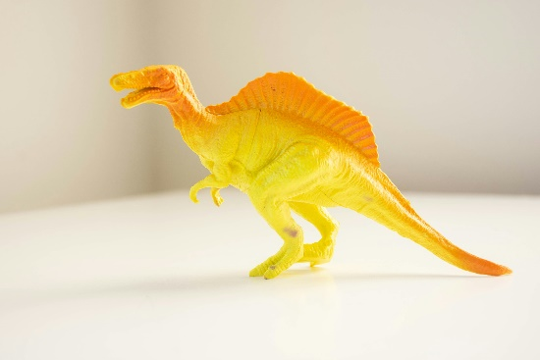DinoWorld Toys is pleased to announce the launch of a new product line: dinosaurs!

Each plastic toy has been designed taking into account the latest scientific discoveries. Each toy comes with an informational card that details the size, diet, geographical region, and geological period of the dinosaur.

# Children Love Dinosaurs

Children love talking about subjects that interest them and enjoy deepening their knowledge. Consequently, dinosaurs and children are a perfect combination. Some children collect dinosaur cards just like our parents or grandparents once collected stamps.

**Parents and educators don't always know how to support children in their passion for dinosaurs. Dinosaur names are difficult to pronounce and scientists continue to discover new dinosaur species.**

# Your Mission

DinoWorld Toys asks all their store employees to become dinosaur experts!

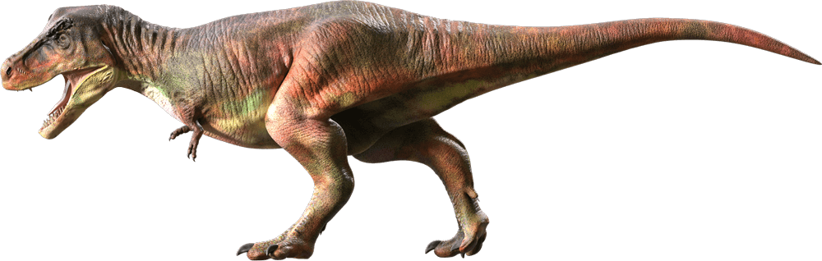Children greatly influence how their parents spend their money. We must make children want to come to our stores. When children have fun, they can start to take ownership of a brand and ask to return to their parents.

Our wish is that you develop some knowledge about dinosaurs. You should be able to help these children who collect dinosaur cards.

## Other Important Points About Dinosaurs

It is wise to choose two or three dinosaurs and memorize several points that characterize them. You will find some examples below. Dinosaurs are classified by geological period. We recommend choosing dinosaurs from the same period to understand their interdependence.

* Upper Cretaceous Period
  + Carnivores (meat eaters)
    - Tyrannosaurus rex
      * Meaning: tyrant lizard king
      * Size: up to 14 m long and 5 m high
      * Weight: up to 5 tons
  + Velociraptor
    - * Meaning: swift thief
      * Size: up to 2 m long and 1 m high
      * Weight: up to 15 kg
  + Omnivores (plant and meat eaters)
    - Triceratops
      * Meaning: three-horned face
      * Size: up to 9 m long and 3 m high
      * Weight: up to 6 tons
* Geological Time Periods

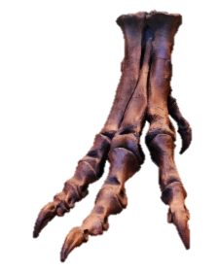

1. **Triassic:** from -251 to -201 million years
2. **Jurassic:** from -201 to -145 million years
3. **Cretaceous:** from -145 to -66 million years
4. **Cenozoic:** from -66 million years to present day

When you study the facts about dinosaurs, you must also know the geological period during which they lived.

|  |  |
| --- | --- |
| Dinosaur | Geological Period |
| Tyrannosaurus rex | 3. Cretaceous |
| Triceratops | 3. Cretaceous |
| Apatosaurus | 2. Jurassic |
| Pterodactyl | 2. Jurassic |
| Coelophysis | 1. Triassic |
| Stegosaurus | 2. Jurassic |
| Ankylosaurus | 3. Cretaceous |
| Allosaurus | 2. Jurassic |
| Plateosaurus | 1. Triassic |

# Favorite Dinosaurs

Children who love dinosaurs may have a long list of favorite species. We recommend that you prepare by creating your own list. You can really spark a child's interest if your list includes lesser-known dinosaurs. This will be an opportunity for children to make discoveries or to tell you about what they already know.

Try to have fun when creating your list!