Planned Family Orchard

# Brief overview:

Ensuring access for all people to their preferred contraceptive methods advances several human rights including the right to life and liberty, freedom of opinion and expression and the right to work and education, as well as bringing significant health and other benefits.

Use of contraception prevents pregnancy-related health risks for women, especially for adolescent girls, and when births are separated by less than two years, the infant mortality rate is 45% higher than it is when births are 2-3 years and 60% higher than it is when births are four or more years apart.

It offers a range of potential non-health benefits that encompass expanded education opportunities and empowerment for women, and sustainable population growth and economic development for countries.

Modern contraceptive prevalence among Married women of reproductive age (MWRA) increased worldwide between 2000 and 2019 by 2.1 percentage points from 55.0% (95% UI 53.7%–56.3%) to 57.1% (95% UI 54.6%–59.5%).

Reasons for this slow increase include: limited choice of methods; limited access to services, particularly among young, poorer and unmarried people; fear or experience of side-effects; cultural or religious opposition; poor quality of available services; users’ and providers’ bias against some methods; and gender-based barriers to accessing services.

# Apple

**Honeycrisp**: A new variety that is large, crisp, and juicy. Good for eating and baking. If kept cool, this variety can be stored for several months.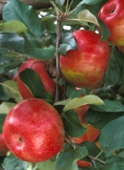

**Harvest Time:** Early September.

**Golden Delicious**: A large, crisp, juicy, all purpose apple. Self-fertile, but produces best if allowed to cross pollinate with another mid-late apple.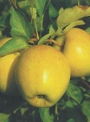

**Harvest Time:** Late October.

# Cherry

**BlackTartarian**: Medium-size fruit, purple-black color, juicy, rich and sweet. A good pollinizer for Bing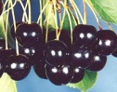 cherries.

**Harvest Time:** Mid-June thru Early July

**Bing**: Large fruit that is juicy and sweet. Good for canning. Vigorous producer. Needs Rainier or Black Tartarian for pollination.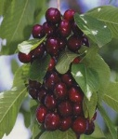

**Harvest Time:** Early thru Mid-July

# Peach

**Early Elberta**: Large, juicy, fruit with rich flavor. Freestone. Frost hardy. Good for eating, canning or freezing. Self-fertile.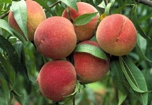

**Harvest Time:** Early July

# Plum

**Brooks**: Sweet. Good for eating, canning and drying. Brooks is the Oregon refinement of the Italian prune-plum. Self-fertile.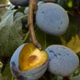

**Harvest Time:** September