

***July 22, 2020***

***Vol 5 Issue 1***

**Fishing Adventures**

**Laketown, Oregon Newsletter**

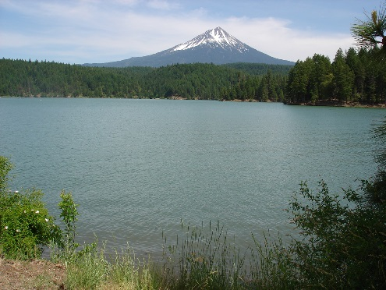

# Fishing Derby a Success

The annual Laketown Fishing Derby concluded this past weekend with great success! This year we enjoyed the addition of an Aquaculture Workshop taught by graduate students from Oregon State University Department of Fisheries and Wildlife. Approximately 30 high school and college students attended the workshop. The students learned about the life cycle of hatchery Steelhead.

The Fishing Derby concluded with a special Kids Day involving 75 fifth grade students from our local Laketown Elementary School who were taught how to fish for trout.

The general public was invited to assist the Oregon Department of Fish and Wildlife in releasing approximately 1000 legal sized trout for the kids to catch. The students received jet boat rides and lunch was provided. The Fishing Derby raised approximately $60,000.00 which will be used for local fish enhancement.

.

# Don’t Forget Your License

Have you renewed your fishing license for this year? Be aware that troopers of the Oregon State Police Fish and Wildlife Division are patrolling our area. A truck was recently stopped with four subjects who were seen angling in a closed area of the creek flowing into the lake. While approaching the vehicle the trooper noticed a salmon in the bed and a cooler. Subsequent checks revealed several steelhead were in the cooler. The subjects confessed that the salmon and steelhead had been caught from the creek. Neither the steelhead nor salmon were on the harvest cards. Two of the four subjects were cited for Failure to Validate Harvest Card. All subjects were warned for angling in a closed area. Don’t let this happen to you! Make sure to renew your license and validate your harvest cards with your catch.



# Fishing All Year

The weather is beautiful all year and the water at the lake is surprisingly warm for most of seasons. Average water temperatures fluctuate from a chilly 46 degrees F in February to an inviting 80 degrees F in August. Don't let cold weather at home scare you away, because fishing on our lake is fabulous all year!

*My family spent a week fishing on the lake this past summer. It was so much fun!*

*~ Justin Campbell, Salt Lake City, UT*

|  |  |  |  |
| --- | --- | --- | --- |
| Month | High | Low | Water |
| January | 45 | 24 | 47 |
| February | 53 | 31 | 46 |
| March | 61 | 36 | 52 |
| April | 72 | 46 | 54 |
| May | 82 | 53 | 62 |
| June | 90 | 62 | 70 |
| July | 97 | 71 | 76 |
| August | 94 | 69 | 80 |
| September | 88 | 60 | 76 |
| October | 77 | 46 | 69 |
| November | 59 | 36 | 62 |
| December | 45 | 25 | 53 |
| Fishing All Year |  |  |  |

Table 1 Average Temperatures

# Plan a Trip

If you haven’t planned your trip to the lake this year, don’t wait another minute. Fishing Adventures is here to help you. It’s easy. Simply give us a call and we’ll help you.

For more information, telephone Fishing Adventures at (541) 123-9875