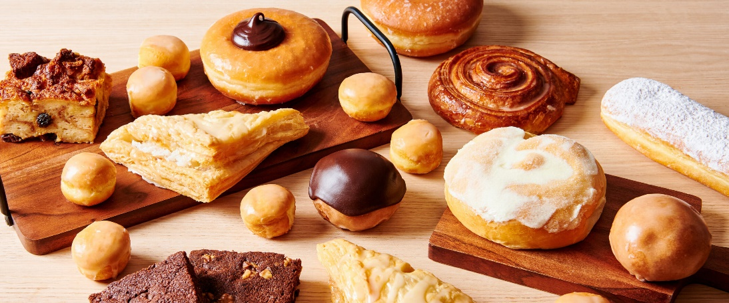MainStreet Bakery

# Our Mission Statement

The MainStreet Bakery’s mission is to be one of the finest producers of unique baked goods in the industry, while modeling excellence in how to treat employees and consumers. Our motto is: “If you want it, we can probably bake it!”

“We love the unique flavors available from MainStreet Bakery. It makes parties and social events much more fun!” ~ Campbell’s Catering in Medford, Oregon

# Black muffinRequest Your Own Flavors

Have you ever wanted a bread or cake flavor no one makes? Like, Jalapeno flavor. Or, watermelon? How about a simple combination of popular flavors that are difficult to find, such as peanut butter and pecans? The MainStreet Bakery specializes in creating unique flavors.

# Customize in Almost No Time

Need a special flavor for a special party next week? We can do it! Most of our flavors can be created and available for pickup in just 72 hours. Rush orders are also possible and can be picked up in only 24 hours for an additional fee. Give us a try. We promise you won’t be disappointed. Our company is family owned and has been baking breads and cakes for three generations. We know our business and we love our customers. And we especially love baking!

# Our Customers

Our customers range from direct consumers to resellers, corporations to caterers. Our consumers buy ready-made baked goods from our retail store. Our resellers place custom orders which they provide to their customers. We do it all!

# Removing from the Pan

 Caution: the baking tray remains hot after removal. Protect your hands with oven mitts or a dry cloth when handling the tray. Let the muffins cool for a few minutes before removing them to help them set.

Carefully slide a knife or spatula around each muffin to loosen the edges. Turn the tray upside down and gently tap or press the bottoms to release the muffins. If you used paper liners, they should come out easily. Let the muffins cool completely before serving.

# Best Sellers

|  |
| --- |
| 1. Blueberry & streusel |
| 1. Apple |
| 1. Whole wheat & banana |

Every day, we bake the six varieties of muffins that have been the most popular over the past quarter, along with a special muffin called the "Muffin of the Week." Our current best sellers are:

|  |
| --- |
| 1. Corn, bacon & cheddar |
| 1. Socola |
| 1. Cream |

## Key Clients

Our breads and cakes are so good, our customers come back over and over again.

Below is a list of our biggest clients.

# Our Location

MainStreet Bakery

5432 Center Street  
Medford, OR 97501

(541) 123-4578