# How to Plant Seedlings for Reforestation

Correct handling and care of seedlings from the nursery to planting is essential for successful reforestation. The seedlings should be kept cool, but not allowed to freeze. Ideally, they should be stored at 33–35°F. Minimize the length of time that boxes or bags of trees are out of cold storage. On the planting site, place the boxes or bags in a cool, shady place, and keep root systems moist. Dip them in water if necessary to prevent drying after they are removed from the storage boxes or bags. Proper planting is necessary for plantation success. 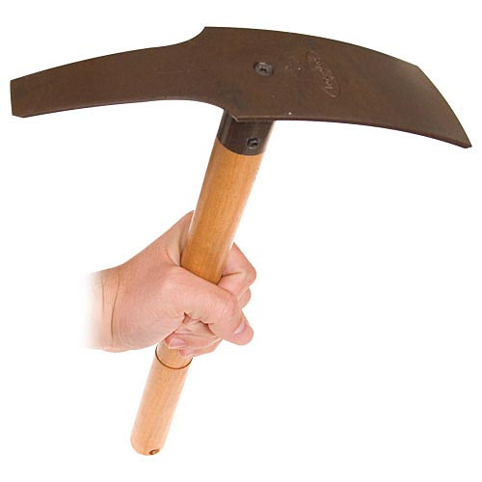You may have to cut a scalp with the planting tool to clear away weeds or debris at the planting spot. The planting hole should be deep enough and wide enough to allow the seedling root system to hang down naturally. You can plant seedlings using any planting tool – we recommend a hoedad. The hole should be large enough so the roots hang straight down. Pack soil firmly around the root system, leaving no air pockets. Don’t let duff, grass, snow, or debris fall in around the root system. Plant the trees at least as deep as they were in the nursery beds. It is acceptable to plant as deep as the first branch, and that is acceptable. However, don’t bury green branches. Shallow planting is not acceptable and no roots should ever stick up out of the hole. When properly planted, the seedling will be able to withstand a firm tug on the stem and should stand straight.

# Five Steps:

1. Insert blade deeply and pull back to open hole.
2. Insert seedling.
3. Backfill gently around roots.
4. Firm soil with planting tool.
5. Pack soil firmly around seedling.

# Tool to Plant Tree Seedlings

Forests in the Greater La Pine Basin managed to reduce wildland fires & ensure high quality water in the upper Deschutes Basin.

After timber harvest or a forest fire, reforestation is essential for a productive working landscape and healthy ecosystem. When replanting you need to decide where you will get tree seeds or seedlings. To help you and other forest land managers, reforestation scientists at the USDA Forest Service Pacific Northwest Research Station, Oregon State University, and the

# The Seedlot Selection Tool.

Forests are made up of trees, shrubs, and herbs that are suited to grow well in the local environment. When comparing plants from different forests, scientists have found that plants are genetically different among populations and groupings of related individuals in the same location, and that these differences allow plants to grow well in the local climate. If you plant tree seedlings on your property and they are not suited for the environment on your land, they will not survive or may not grow well.

In order to achieve productive forests with quality timber that promotes a healthy ecosystem, forest landowners and natural resource managers must acquire tree seeds or seedlings that match the local climate in which they are planting. In the past, this has been accomplished by using defined zones (e.g. seed zones or breeding zones) or seed transfer rules that specify an area by geography or climate from which seeds can be moved and will likely grow well. These zones assume that climate will not change over the long-term, which is not likely given current predictions by climate scientists. Future climate predictions indicate changes in local environments will result in the health and productivity of forests declining as climate changes.

The Seedlot Selection Tool uses climate models to define zones based on current and projected climate rather than geography alone. With this tool, forest land owners and natural resource managers can explore options for responding to climate change by determining where seeds or seedlings should be sourced so that they are suited to grow well in the projected future climate. The Seedlot Selection Tool is a web-based mapping application that can be used to map current or future climates based on different climate change scenarios. It is tailored for matching seedlots and planting sites, but can be used by anyone interested in mapping climates defined by temperature and water availability. The Seedlot Selection Tool allows the user to control various input parameters, and can be customized for the management practices, climate change assumptions, and risk tolerance of the user.

Currently, the Seedlot Selection Tool maps the northeastern and western United States including Alaska and work is underway to expand the tool to the southeastern U.S.