|  |  |
| --- | --- |
| Exploring  rock art | Ancient Cultures of Utah |

Contents

History of Utah 2

The Great Salt Lake 2

Ancient Rock Art 3

Newspaper Rock 3

Potash Road, Moab (Arches National Park) 4

Sego Canyon 4

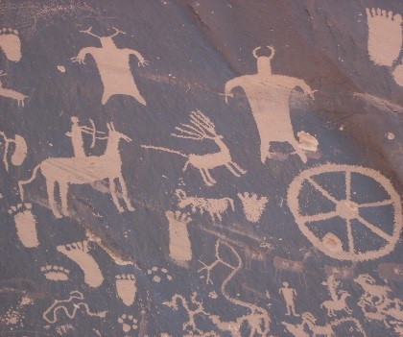

Newspaper Rock

Visitors come from around the world to visit Utah's many Rock Art sites.

A Few Popular Sites

* 9-Mile Canyon
* Newspaper Rock
* Sego Canyon

Facts About Utah:

* **Area:** 84,990 sq. miles
* **Neighboring States:** Nevada, Arizona, Wyoming, Colorado, New Mexico, Idaho
* **Population:** 2,233,169
* **Capital:** Salt Lake City

Ancient Settlers of Utah:

* Archiac
* Fremont
* Anasazi
* Utes, Goshute, Paiute, Shoshone

# History of Utah

Utah has been the home of many people. Early culture groups include the Desert Archiac, Anasazi, and Fremont. Then a thousand years ago, such Numic-speaking hunter-gatherers as the Shoshones, Utes, Southern Paiutes, and Goshutes began moving into Utah. They were joined by an Athapaskan group called, the Navajos.

White men came along much later. Their first significant incursion came in 1776 as a party of Spanish explorers traveled much of the length of present-day Utah. Led by Franciscan friars Dominguez and Escalante. Fifty years later, mountain men searching for beaver explored, trapped and befriended the Indians living here. Such men as Jim Bridger, Etienne Provost, Miles Goodyear, and Jedediah Smith gave names to many of the area's distinctive geographical features.

Finally, in 1847 came the Mormon settlers questing for a religious sanctuary in the remote West. Immigrating in large numbers, they laid out communities, built homes and churches, established farms, and achieved statehood in 1896.

## The Great Salt Lake

Utah is home to the largest U.S. lake west of the Mississippi River. The Great Salt Lake is a remnant of ancient Lake Bonneville, a prehistoric freshwater lake that was 10 times larger than the Great Salt Lake is today. The current lake is 75 miles long and 28 miles wide, and covers 1,700 square miles. It has a maximum depth of about 35 feet and is typically 3 to 5 times saltier than the ocean. Due to the high salinity, the lake is fish free. The largest aquatic critters are brine shrimp and brine flies. The Great Salt Lake is one of the largest migratory bird magnets in Western North America

The first white person known to have visited the Great Salt Lake was Jim Bridger in 1825.

# Ancient Rock Art

The quality and quantity of Utah's prehistoric rock art is unmatched anywhere. This rock art takes two forms: those that are pecked into the surface of the rock are called “petroglyphs”; painted designs are called ‘pictographs’.

The earliest rock art is attributed to the Archiac Culture. The Archiacs were hunters and gatherers. Scholars generally agree that this form of rock art is at least 2,000 years old. Much of Utah's rock art is credited to the Fremont Indians who occupied most of the state between 800 and 1,500 years ago. The Anasazi also produced rock art, from slightly before the time of Christ to 700 years ago. More recent groups, such as the Numic-speaking Ute, Paiute, Shoshone, and Goshute, who replaced the Fremont Indians, also created rock art.

# Where to Find Rock Art

Below is a list of popular sites in Utah.

# Newspaper Rock

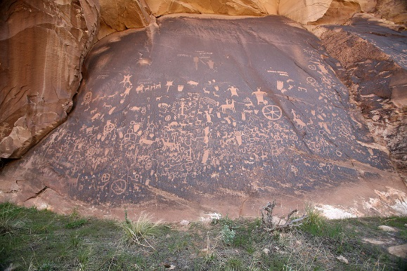This famous site is along a well-traveled access road into the Needles district of Canyonlands National Park, 12 miles from US 191 and 30 miles from the park boundary. The 200-square-foot rock is covered by hundreds of petroglyphs—one of the largest, best preserved panels in the Southwest. The petroglyphs feature a mix of human forms, animals, and abstract artwork. Newspaper Rock was designated a State Historical Monument in 1961

# Nine Mile Canyon

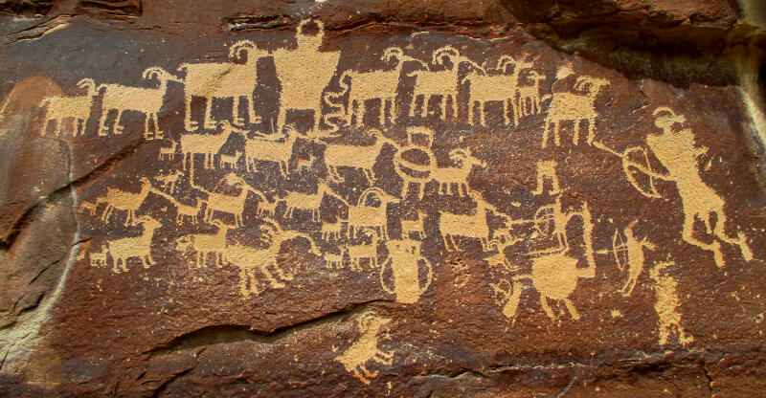Some of the most spectacular rock art in Utah is in Nine Mile Canyon northeast of Price. The canyon is actually 40 miles long, do not let the name deceive you. Nine Mile Canyon is remote, hostile, unblemished and roughly beautiful. Called "the world's longest art gallery" it is home to numerous rock art panels, including the famous "Hunter Panel". Most of the rock art  was created by the Fremont Indians who occupied this area some 1,000 years ago.

# Potash Road, Moab (Arches National Park)

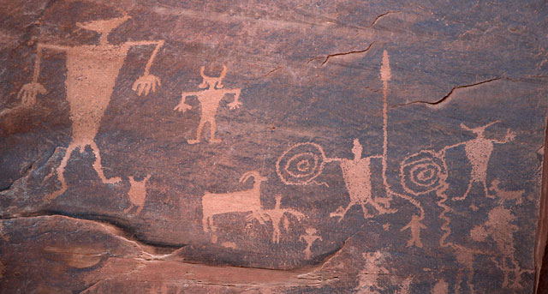The entrance to Arches is located 5 miles north of Moab, UT along Highway 191. Opposite the entrance to the park is the beginning of Potash Road. Potash Road has many wonderful sites you can view from your car – no major hiking required! You won’t even need a GPS to locate the rock art because they are clearly marked with highway signs.

Some of the best attractions are two large panels of petroglyphs and several dinosaur tracks. This is an adventure everyone can enjoy.

# Sego Canyon

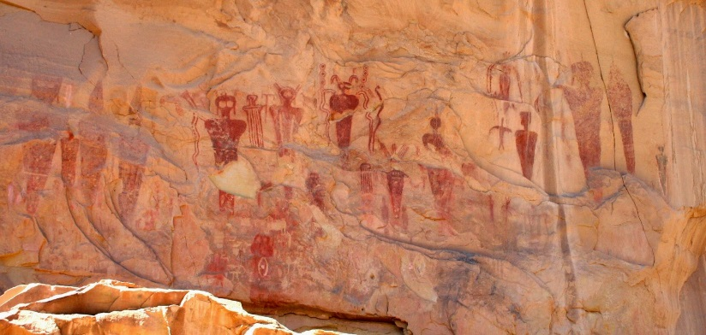The sandstone cliffs of Sego Canyon are a spectacular outdoor art gallery of petroglyphs painted and carved by Native Americans peoples over a period of around 8,000 years. They are characterized by more than 80 haunting life-sized figures with hollowed eyes or missing eyes and the frequent absence of arms and legs. Some claim that the mysterious figures are evidence of alien visitation in our ancient past, while scholars maintain that the strange beings represent shamanistic visions produced in trance-like states.