**Margie's Travel Adventures**

You are cordially invited to discover an exclusive preview of the finest river cruise experience available.

This preview event will be hosted by our highly experienced guide and travel enthusiast Pascaline Overeem, who will share compelling highlights from last year's tourism season and provide an enticing glimpse of the journeys she has planned for this year.

She will offer you practical advice to make the most of your travel experience, including tips for capturing memorable photographs and creating a blog to document your adventures, recommendations regarding essential items to pack, how to pack your luggage efficiently, how to better experience a new culture, and much more.

We hope to count you among us during this informative and enjoyable event that will give you a preview of this extraordinary journey and allow you to meet some of your fellow travelers even before the trip begins.

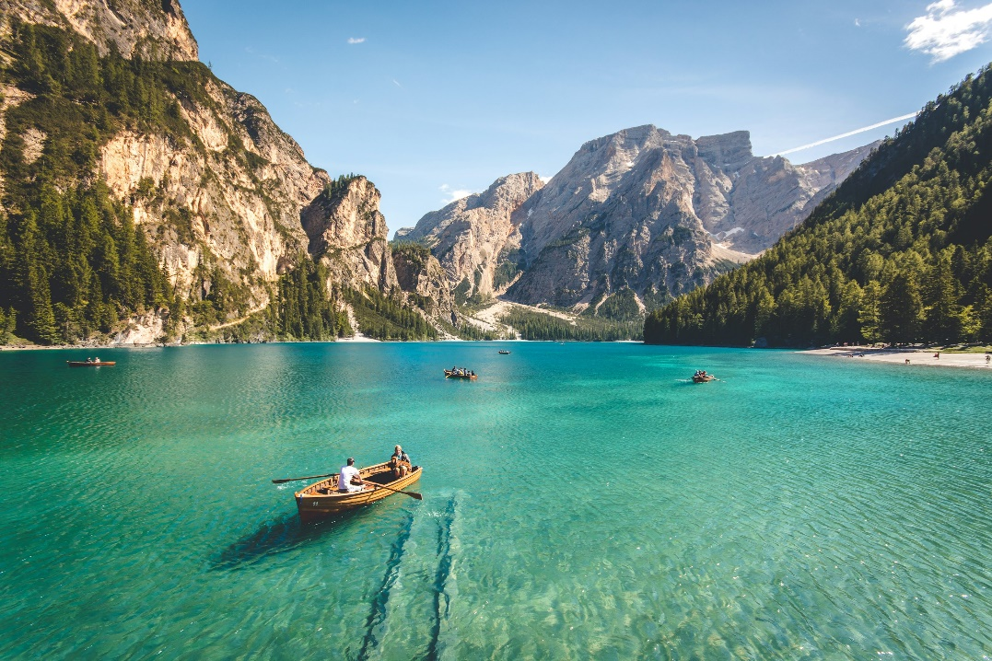

This event will take place on January 16th starting at 7:00 PM. Please confirm your attendance to:

**Margie's Travel Adventures**

margie@margiestravel.com