Sofiane Ferrani and Joshua Jiang

**Skipping a stone: what is the optimal angle of attack at which we can possibly skip a stone a maximum number of times?**

Goals of the simulation

The goals of our simulation are to first, calculate the maximum number of skips possibly done when skipping a stone in a lake given initial conditions, and second, find the optimal angle of attack at which we can maximize the number of skips produced, assuming we have the means to throw at any initial velocity. A tertiary objective also involves graphing the trajectory of the stone on the lake in a coordinate system of x with respect to y (with y = 0 at water level). More extensive analyses of the data will be implemented once we are familiarized with the final program.

Theory and equations

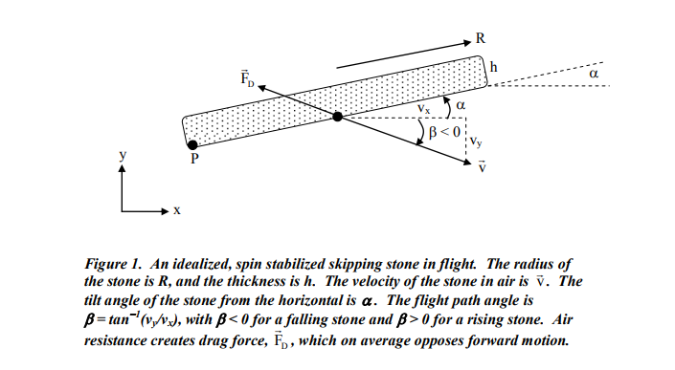

There are two major stages of the trajectory of the stones. There is first the “projectile” stage, where the stone’s acceleration is only affected by gravity and drag. It occurs when the stone is above water level (y > 0). Second, there is the “collisional” stage. It occurs when the stone is at or below water level (y =< 0).

1. Equation of motion for “projectile” stage (when y > 0)

Along the x direction, the stone’s motion is affected by drag. Considering the force acting on the center of mass, we have:

Along the y direction, the acceleration is affected by both the drag force and by gravity:

It is to be noted that, assuming a high spin velocity, the stone’s tilt angle (that we will also call angle of attack) is stabilized during the impact, thanks to the gyroscopic effect (counteracting against precession). Indeed, a throw that gives a high velocity to the center of mass of the stone will most likely have a high angular velocity about its own center (high spin). Therefore, we will assume it will not change with respect to the initial condition. However, the angle does change constantly and must be updated through:

1. Equation of motion for “collisional” stage (when y =< 0)

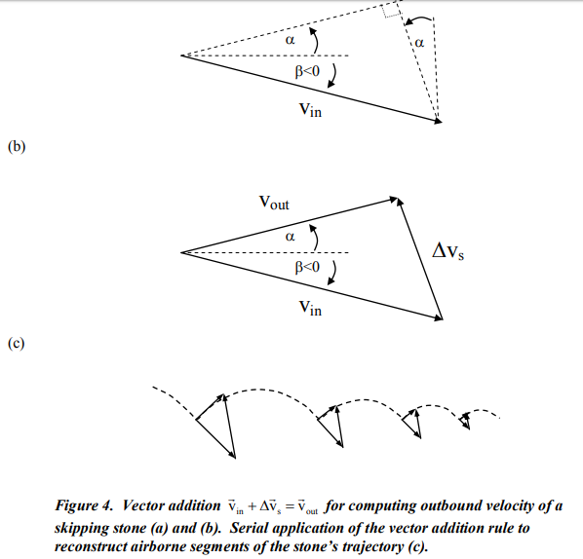During the collisional process, Newton’s third law of action and reaction applies: the force water exerts on the stone will be equal to the force of the stone on the water. The reaction force of water possesses both a lift and friction component. The work of the friction component of this reactive force is what dissipates the energy of the stone progressively throughout each collision of the trajectory. The dissipation of energy results in a gradual decrease in the flight path angle , and consequent decrease in velocity , that can be deduced from the following illustration:

If we approximate the collision to be instantaneous, then the acceleration caused by the reaction force throughout the collision results in the following change in velocity:

Since friction acts mainly on the x component, we consider the x component of the velocity:

And so, energy will progressively be dissipated in the form of friction through the trajectory, until the final collision occurs ― not enough kinetic energy is generated to counter balance the work of friction throughout the collision. Thus, the stopping criterion of the motion is when the velocity in x is smaller than 0.

For the y component, the lift force can be estimated using conservation of energy, since most of the thermal energy lost through friction is lost on the x component. We must also include gravity during the collisional process. Setting y = 0 to be water level, and the height of the stone being deduced trigonometrically, we have:

In the above equation, we realize that This is the stopping criterion of the y component: when the velocity squared (kinetic energy) of the stone is not sufficient to counteract the vertical effect of gravity.

It is important to note that the effects of the spin on the angular motion as well as on the consequent variation of the angle has been neglected. In fact, most of the papers we have come across either do not even mention the spin, or do not include it in their own calculation of their data. Furthermore, it is shown that the decrease in angular momentum (caused by the spin) throughout the trajectory is negligible relative to the decrease in speed of the center of mass.

Algorithm

Our program will first set initial conditions for the drag coefficient of air, air density, radius of the stone, height of the stone (or width), gravitational acceleration, initial y position, initial x position of 0, initial angle of attack , initial flight path angle (not really, but it will be calculated using initial velocities in x and y), initial velocity in x given to the stone (we will only refer to that value when we mention initial velocity in the report) and initial velocity in y of 0.

Then, we will define methods for acceleration in x and y for the projectile stage.

Arrays of time, angle , acceleration (two types), position x, position y, velocity in x and velocity in y will be defined. A condition referring to the value of y (bigger or smaller than 0) will determine whether the motion is in the projectile or in the collisional phase.

If we’re in the projectile phase, meaning y is bigger than 0 (0 being water level), every variable stored in an array is incremented using Euler’s method as shown in the equations of motion in the “projectile stage” earlier in the paper. We chose Euler’s method because the propagation of error on the x and y values due to its very approximate equation (upgrades using velocity only) will not be too high since the projectile motion doesn’t last too long as the stone quickly reaches water for the collisional process.

If we’re in the collisional process (y smaller or equal to zero), then acceleration is not used for updating of velocity. We, once again, use Euler’s method to increment velocities in x and y using the equations of motion of the collisional phase shown above. The consequent errors on the values of x and y will be very slight since the phase lasts but a few fractions of seconds. It is to be noted that the angle as well as the acceleration values must still be incremented in this stage, because they are both dependent on velocity (which changes during the collisional phase).

The stopping criteria must also be implemented: the plotting of the graph of the x position versus y position of the stone (using the math.plot library) is initiated only when the stopping criteria for the x component or the y component occur (see theory). A message that the rock has stopped moving is displayed on the output, as well as the values of the arrays accounting for position, velocity and acceleration. The count of skips is also displayed. The latter is incremented throughout the trajectory whenever a change in phase is detected. A Boolean value determines the current state and the previous state of the stone. “True” means that the rock is underwater, whereas “false” means it is in the air.

Unfortunately, optimization methods such as the bisection method or the golden ration won’t be used to find the optimal angle of attack, initial velocity or initial position of y because there are too many parameters to take into account in the functions that we are willing to optimize. Furthermore, finding these functions is complicated in itself, as we would have the code run multiple times to count the number of skips (which is already a couple thousands of steps) for each given initial angle, height or velocity. Excel will be of much more practical use to plot relevant graphs.

Code validation

When running our simulation, the principal model we used was a study entitled “The theoretical limits of stone skipping”, led by Charles F. Babbs from Perdue University. It was only natural for us to compare our results to the study, using the exact same initial conditions of the stone throw as it did. The “standard model” of the study let the density of air to be 0.00122 g/cm^3, the mass density of the stone = 1 g/cm^3; drag coefficient of air to be 0.5, the stone thickness to be 1 cm, the gravitational acceleration to be 980 cm/s^2, the radius of the stone to be 4 cm, the initial height of the throw to be 50 cm, the tilt angle (alpha) to be 17° (0.3 radians), the x-component of the initial velocity to be 10 000 cm/s and the y-component to be 0 (with a consequent angle of attack beta to be 0° with respect the horizon initially). As a result, the trajectory theoretically obtained 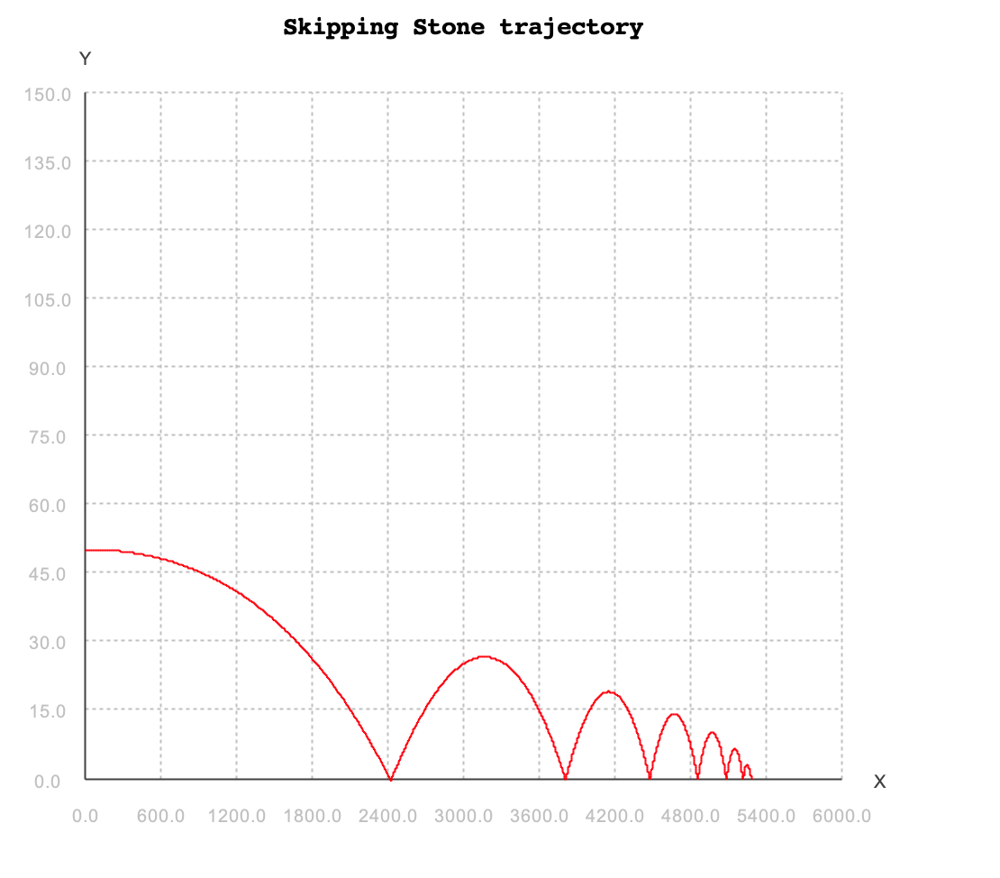gave 9 total skips. Our simulation, similarly, resulted in 7 skips:

Since all initial physical conditions were the same, this slight discrepancy probably has something to do with the numerical method. More specifically, it is probable that our time step, which was 0.001 for reasons of practicality in computation (lots of data had to be gathered), was not low enough. Nevertheless, since the final skips cover a very low distance each, as we will see at higher velocities of the throw, a difference in two skips is negligible for our purposes. Further validation of the code include the results obtained when the program takes as input either an angle of inclination alpha of 90° (PI/2 in radians) ― the stone flops at the first contact with water. This makes physical sense, since the lift force of water on the stone is proportional to the area of contact, whereas the area of contact is inversely proportional to the tilt angle. Finally, inputting an initial velocity (in x) of the throw as 0 cm/s gives “NaN” (a.k.a. not a number) as output. This is due to the dependence of the angle of the flight path angle beta in . It also makes sense that nothing happens when no initial velocity is given.

Results and data analysis

According to our methodology, there are three initial conditions that play a key role in the number of skips obtained after a throw: the angle of attack, the velocity and the height at which the stone was thrown. Although the present study aims at optimizing the angle of attack exclusively, one cannot simply disregard the effects of velocity and height on the optimal number of skips possible.

And so, the first part of our analysis focused on the initial velocity given to the stone, since it was observable, through experimentation, that it affected the number of skips more than changes in initial height. Using the same initial conditions as the study referred to earlier, changes in initial angles (angle ranging from 0 to PI/2, with intervals varying according to observable changes in number of skips between two consecutive angles) for various initial velocities resulted in the following graph:

For an initial height of 50 cm, the graph then shows that the optimal throw is given an initial velocity of 50 000 cm/s at an angle of 0.03 degrees, resulting in 35 skips. From this graph, three dependences can be observed. For one, the optimal angle of attack is inversely proportional to the initial velocity given to the stone:

This makes sense because the reaction force of water on the stone has a lift component that is proportional to the velocity of the stone squared as well as the sinus function of the angle alpha (in the y component of acceleration). For a given acceleration on the mass, higher velocities require lower angles of attack. Furthermore, in order to respect the condition for the stopping criterion in the y direction , lower angles allow for higher velocities (kinetic energy) to act against gravity. Second, the number of skips, for any given velocity, peaks at a specific angle and then decreases asymptotically with increasing angles. This means that there is an angle at which the loss of kinetic energy through friction during the collisional process is minimal. Third, surprisingly, for the same initial conditions, the optimal number of skips does not always increase with respect to the initial velocity ― in fact, the peak observed is found at 50 000 cm/s (35 skips). 100 000 cm/s only allows for 34 skips to be executed. In other words, there is an optimal speed that can allow for an optimal number of skips, and exceeding that speed results in a decrease in optimal skips:

This is due to the mathematical dependence of the velocity in x of the stone to the cosine function of the angle of attack minus the angle beta (which is dependent on ). With extremely high velocities, the argument of the cosine becomes negative, and therefore the velocity in x decreases to 0 (limit at which our program stops).

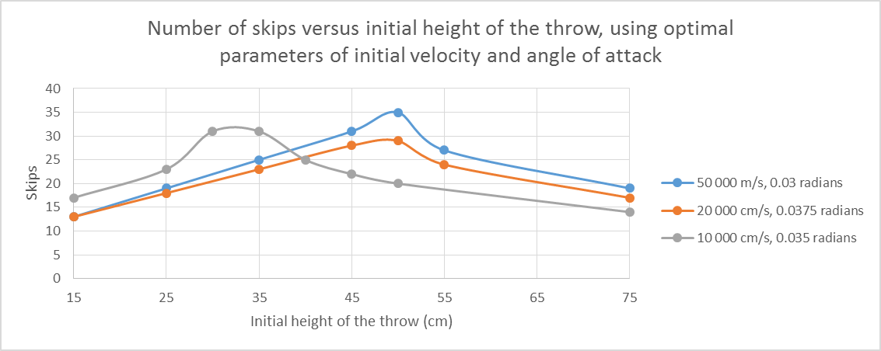Second, it possible to analyze the effects of changes in initial height on the maximal number of skips of the stone. To proceed, we selected the optimal angles of attack found in the first graph, and set them as our initial conditions in order to determine whether it was possible to further optimize the number of skips obtained using the “initial height” parameter. The following trends were obtained for velocities of 50 000, 20 000 and 10 000 cm/s:

The first observation is that the number of skips does depend on the initial height of the throw. For each throw, there is an optimal initial height at which one can maximize the number of skips. At high velocities ranging from 20 000 cm/s to 50 000 cm/s with optimal angle of attacks of 0.0375 and 0.03 radians respectively, 50 cm appears to stay constantly the peak initial height. The number of skips found in the first graph, then, will stay the same. However, at lower velocities, the peak shifts to lower heights: 30 to 35 cm give 31 skips for a velocity of 10 000 cm/s, which is a lot higher than the 20 skips found for 50 cm of height. This peak found makes sense, because the initial height influences the magnitude of angle beta at which the stone will first hit the lake, since gravity will pull the stone down for more or less time depending on the initial height. Once again, due to the cosine function of the angle of attack *minus* the angle beta used in the calculation of the velocity in x, it is only normal to observe a peak in number of skips at some specific initial height, and an asymptotic decrease past that peak.

Conclusion

In conclusion, the maximum number of skips that is physically possible to obtain is 35, at a velocity of 500 m/s, at a height of 50 cm and at an angle of attack of 1.7°. Its trajectory looks like the following graph:

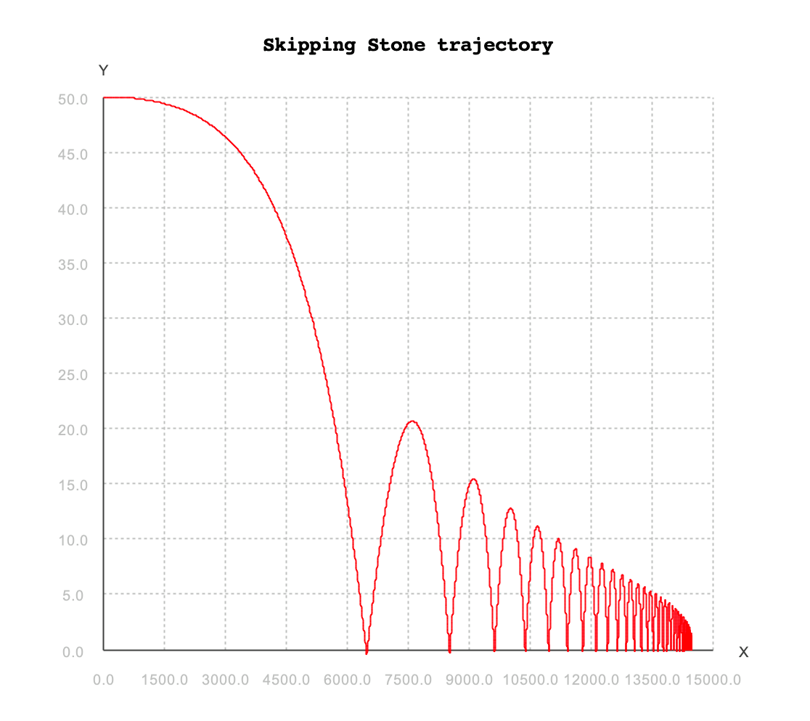

The present study has proven multiple dependences between initial conditions involved in skipping stones, and the most relevant conclusions include the existence of a maximal velocity at which we can throw the stone for a maximal number of skips, the inversely proportional dependence of the peak angle of attack with respect to the initial velocity of the throw, and the peak of number of skips at lower initial heights for lower velocities. Concerning the latter, there is a clear possibility that we can attain close to 35 skips at lower initial velocities and at lower heights of the throw. An interesting extension to the current study would include analysis of throws that involve more tangible velocities (lower than the speed of sound, at the very least), to find the peak number of skips at which humans can throw a stone in a lake.

Sources:

https://docs.lib.purdue.edu/cgi/viewcontent.cgi?referer=https%3A%2F%2Fwww.google.com%2F&httpsredir=1&article=1016&context=bmewp&fbclid=IwAR0jwuS1KdO9G8pxvco5c0EH29ZbBg20jMXi7JrxsYPMk7OrOE63als3Rl4