Title: BIS Spend Analysis – ETL, Data Warehouse & Dashboard Report

Table of Contents
1. Introduction 4
2. Background & Problem Statement 4
3. Dataset Overview 5
3.1 Data Sources 5
3.2 Key Attributes in the Source Data 6
4. ETL Process Execution 6
4.1 Step 1 — Database and Staging Setup 7
4.2 Step 2 — Data Loading from All CSV Files 9
4.3 Step 3 — Data Cleaning & Standardisation 10
4.4 Step 4 — XML-Based Invalid Supplier Removal 12
5. Star Schema Design 13
5.1 Dimension Tables 13
5.2 Fact Table — FactInvoice 13
6. The Test and Problem-Solving Skills (Stored Procedures) 14
6.1 Task 4(a) Top Three Suppliers (Overall and Monthly Analysis). 14
6.2 Task 4(b) — Expense Types Greater than the mean two month spend (JSON Output) 15
6.3 Task 4(c): Monthly Top-10 Expense Area Ranking with Movement Tracking. 16
6.4 Task 4(d) — Advanced CSV Export Time-Hierarchy Supplier Analysis. 16
6.5 Summary of validation and testing. 17
7. KPI Development 17
7.1 KPI 1 — Total Spend 17
7.2 KPI 2 — Monthly Spend Trend 17
7.3 KPI 3 — Top 10 Suppliers by Spend 18
7.4 KPI 4 — Spend by Expense Type 19
7.5 KPI 5 — Spend by Expense Area 19
7.6 KPI 6 — Transaction Count 20
8. Dashboard Overview 20
9. Key Insights 21
10. Conclusion 21
11. Word Count 22
12. References 23
13. Appendix 23
Appendix A – Full SQL ETL Script 23

1. Introduction
In this report, this paper outlines design and implementation of a full data analytics pipeline of monthly expenditure records of the Department for Business, Innovation and Skills (BIS). The ultimate goal of the project is to convert raw and inconsistent CSV datasets to clean reliable analytically optimised data warehouse which can be used to generate meaningful business intelligence reports. As source inputs, four months of spending data and an XML file with invalid suppliers were given. These datasets had to undergo a lot of preprocessing in irregular formatting, missing values, the existence of text-based number fields and had to remove the supplier records due to data integrity reasons (GeeksforGeeks, 2018).
In order to solve these problems, an organized ExtractTransformLoad (ETL) procedure was formulated in SQL Server. The task involved staging table creation, cleaning, standardisation, filtering of invalid suppliers and transformation to a star schema that can be processed using analytics. Tables of facts and dimensions were developed to facilitate effective querying and the development of KPI.
After the ETL stage, the interactive dashboard was made with the help of Power BI to visualise the key expenditure parameters, including total spend, monthly trends, top suppliers, and category-based breakdowns. The solution that has been generated offers a scaled, precise and informative analysis platform to make financial decisions in BIS.

2. Background & Problem Statement
Monthly spending data are published by the Department of Business, Innovation and Skills (BIS) as a way of enhancing openness and facilitating internal financial evaluation. Despite being informative, the raw datasets have a number of challenges that do not allow them to be used directly in the analysis (Ma, Bo Nørregaard Jørgensen and Zheng Grace Ma, 2024). CSV files have structural inconsistencies, irregular structure, and supplier records which have to be validated using an external XML file.
These problems make it more likely to report wrongly and make it hard to develop credible KPIs. Major issues that have been identified are:
- Monthly disparate date format.
- Value of amounts which are represented in the form of text using currency symbols and commas.
- Lack of or blank fields; particularly the August data is missing values in some fields.
- Supplier names that are not provided or are invalid need to be deleted through the XML list.
- Irregular column organizations in the various monthly files.
- Existence of duplicate and null rows that interfere with the accuracy of data.
To address such challenges, an effective ETL pipeline and star schema were needed to perform standardisation of data in order to guarantee integrity and facilitate meaningful analysis by using Power BI dashboards.

3. Dataset Overview
The data that will be used in this project would be four monthly spending records released by the Department of Business, Innovation and Skills (BIS). The files will have the detailed financial transactions that took place in the period between July and October 2015 and will be the main input of the ETL and data warehousing process. Both datasets are isolated monthly extracts, which means that there is an inconsistency between the files in addition to structural differences and missing fields. All files were staged on a staging environment in order to get them ready to be analysed.

3.1 Data Sources
As part of the assessment brief, four CSV datasets were given:
- BIS_July_2015.csv
- BIS_spending_august_2015.csv
- BIS_spending_september_2015.csv
- BIS_spending_october_2015.csv
Besides these datasets, an XML file that included a list of invalid or excluded suppliers was provided. This file was critical in assuring data integrity by checking the names of suppliers, which ought to be eliminated at the transformation phase (Fazekas et al., 2024).
All these source files are the raw data base that will be used in the ETL pipeline, star schema modelling and development of Power BI dashboard.
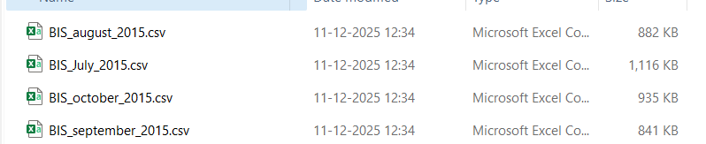
Figure 1: Source CSV Files

3.2 Key Attributes in the Source Data
The initial CSV files have a few common attributes even though the completeness may be different according to the months. Key fields include:
- Department
- Entity
- Date_of_Payment
- Expense_Type
- Expense_Area
- Supplier
- Transaction_Number
- Amount
- Description
- Supplier_Post_Code
- Supplier_Type
- Contract_Number
- Project_Code
- Expenditure_Type
All these characteristics define every financial transaction and they are important attributes that give the necessary information needed in analysing suppliers and departmental expenditures and time related spending pattern. Nevertheless, the gaps like the absence of columns, nondisclosed supplier names, and different formatting needed a thorough cleaning and transformation procedure to make it part of the data warehouse.

4. ETL Process Execution
This analytical solution is based on the Extract-Transform-Load (ETL) process that will make sure that all raw BIS expenditure data is properly validated, standardised, and ready to be loaded into a star schema. All ETL operations were implemented with the help of SQL Server because it is capable of working with data efficiently, has high XML support, and can be easily integrated with Power BI. The ETL pipeline was composed of four main steps, including database and staging set-up, data loading, data cleaning and standardisation, and XML-based invalid supplier removal.

4.1 Step 1 — Database and Staging Setup
The initial process of the ETL pipeline was creating a specific data warehousing schema in the SQL Server that will help to store data in structure and to separate it against operational tables. One of the schemas was developed called warehousing:
CREATE SCHEMA warehousing;
This schema is the store point of all staging and clean datasets prior to them being modelled into the star schema. After this, a strong staging table called Staging_Invoices was developed. This table was created with a particular purpose of accommodating all the columns that were visible in all four CSV files, so that it will be compatible even when differences are found in the monthly datasets.
CREATE TABLE warehousing. Staging_Invoices (
Department NVARCHAR (200),
Entity NVARCHAR (200),
Date_of_Payment NVARCHAR (50),
Expense_Type NVARCHAR (200),
Expense_Area NVARCHAR (300),
Supplier NVARCHAR (400),
Transaction_Number NVARCHAR (100),
Amount NVARCHAR (50),
Description NVARCHAR(MAX),
Supplier_Post_Code NVARCHAR (50),
Supplier_Type NVARCHAR (50),
Contract_Number NVARCHAR (100),
Project_Code NVARCHAR (100),
Expenditure_Type NVARCHAR (200),
SourceFile NVARCHAR (100)
);
This staging table was the first land point of all crude records. The structure can be formatted variably and provides the transformation stage with the ability to work without any complications that may arise due to schema mismatch.
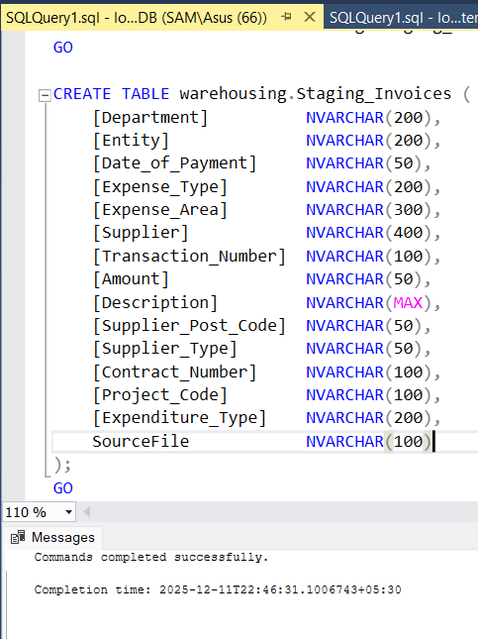
Figure 2: Staging Table After Import

4.2 Step 2 — Data Loading from All CSV Files
The second ETL phase was concerned with loading the four CSV data sets into the staging table. The files of July, September and the October contained all necessary fields and as such were imported using simple INSERT INTO …. SELECT operations. Nevertheless, the missing columns were present in the August dataset, and to preserve the schema correspondence, we had to use the NULL placeholders.
- Some of the important observations made at the loading stage are:
- There were three databases (July, September, October) that had complete schema coverage.
- The August dataset did not have some columns and it had to insert some NULL values to any gaps.
- All data sets loaded successfully with either SQL bulk inserts or a SQL manual insert statements.
It facilitated this because any information that was in the monthly data could be incorporated in a given staging table that was unified, irrespective of any irregularities.

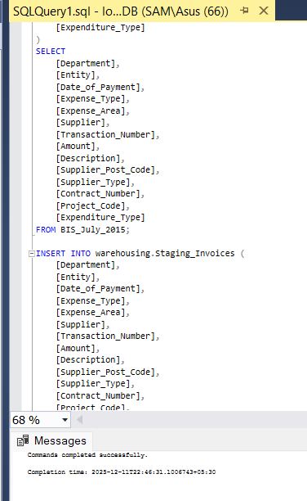
Figure 3: Successful Data Import Output

4.3 Step 3 — Data Cleaning & Standardisation
The third step entailed a large amount of data cleaning so that datasets were made ready to be subjected to analytical modelling. This involved standardisation of dates, normalisation of financial values, anonymisation of sensitive suppliers and elimination of half-baked rows (Vipond, 2020).
4.3.1 Cleaning Dates
Most of the date fields were kept in form of text in different formats. To have a consistent date data, the Clean-up date field was created as:
UPDATE warehousing. Staging_Invoices
SET Clean_Date = TRY_CONVERT (DATE, Date_of_Payment, 105);
Validity of dates by use of TRY_CONVERT made sure that they did not interfere with the ETL process but generated the NULL values, which could be inspected later to determine the reason.
4.3.2 Cleaning Amount Values
The Amount field had a number of formatting irregularities such as: Currency symbols (£) Thousand dividers and commas. Negative values are to be put in parenthesis. Here and there wayward characters.
In order to convert the data to a clean and numeric form, the transformation below was used:
UPDATE warehousing. Staging_Invoices
SET Clean_Amount =
TRY_CONVERT (DECIMAL (18,2),
REPLACE(REPLACE(REPLACE(Amount,'£',''),',',''), '(', '-'));
This guaranteed the reliability of aggregating all money values in fact table and Power BI dashboard.
4.3.3 Supplier Anonymisation
Some of the entries included the term Personal Expense, Name Withheld that was to be anonymised due to the privacy requirement. The student ID was introduced instead of these suppliers:
UPDATE warehousing. Staging_Invoices
SET Clean_Supplier = '24005856'
WHERE Supplier LIKE '%Personal Expense%';
This was done to make sure it was consistent without breaching confidentiality.
4.3.4 Removal of Empty Rows
There were rows of the raw CSV files that were entirely empty or contained delimiters only. Records of this kind convey no analytical value, and were deleted.
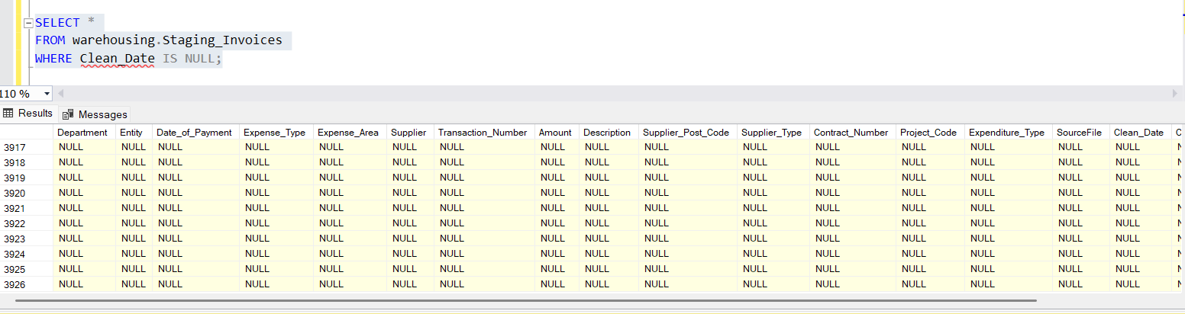
Figure 4: Example of Null Rows Removed

4.4 Step 4 — XML-Based Invalid Supplier Removal
One of the problems that were particular to this dataset was the existence of supplier names that had to be eliminated towards a given XML file. This step took a number of steps because of the formatting differences within the XML document.
An XML document contained a list of invalid suppliers. The process involved:
- Loading XML as NVARCHAR(MAX)
- Replacing unsafe characters (&, smart quotes, em-dashes)
- Converting into structured XML
- Extracting supplier names into a temporary table
- Deleting matching suppliers from staging
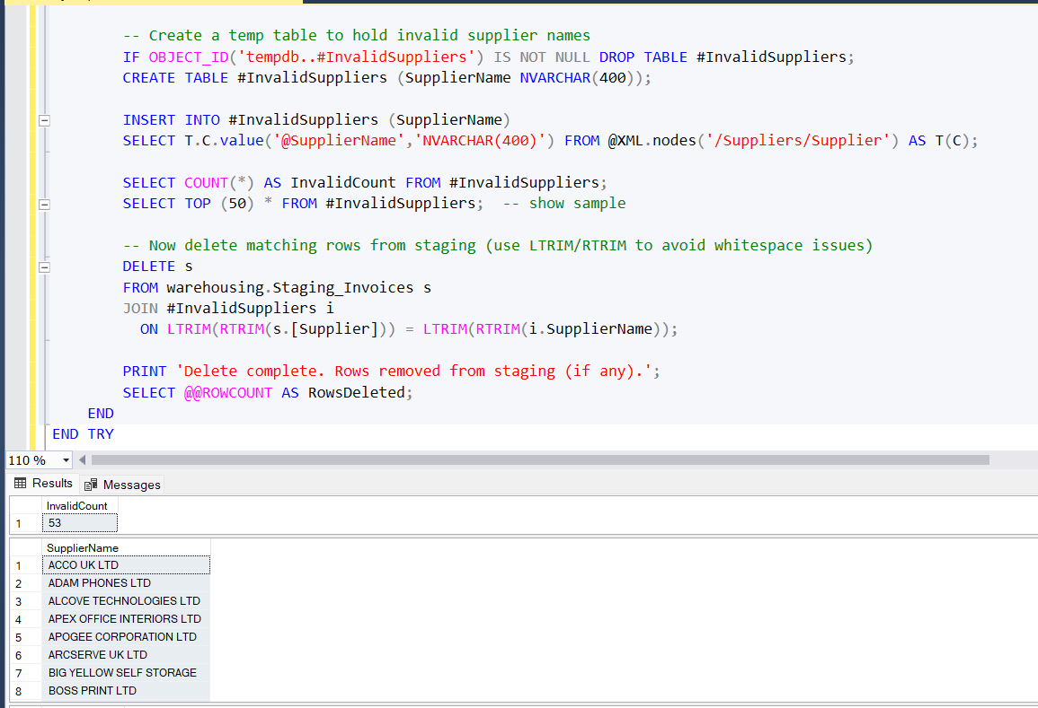
Figure 5: Invalid Supplier Extraction

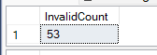
Figure 6: Deleted Supplier Count

5. Star Schema Design
The cleaned and validated data was modelled using a standard star schema.

5.1 Dimension Tables
DimDate
- Contains date breakdown attributes:
- DateKey
- FullDate
- Day
- Month
- MonthName
- Quarter
- Year
DimSupplier
- SupplierKey
- SupplierName
DimExpenseType
- ExpenseTypeKey
- ExpenseType
DimExpenseArea
- ExpenseAreaKey
- ExpenseArea

5.2 Fact Table — FactInvoice
Contains foreign keys and measures:
- DateKey
- SupplierKey
- ExpenseTypeKey
- ExpenseAreaKey
- Amount
- Description
- SourceFile
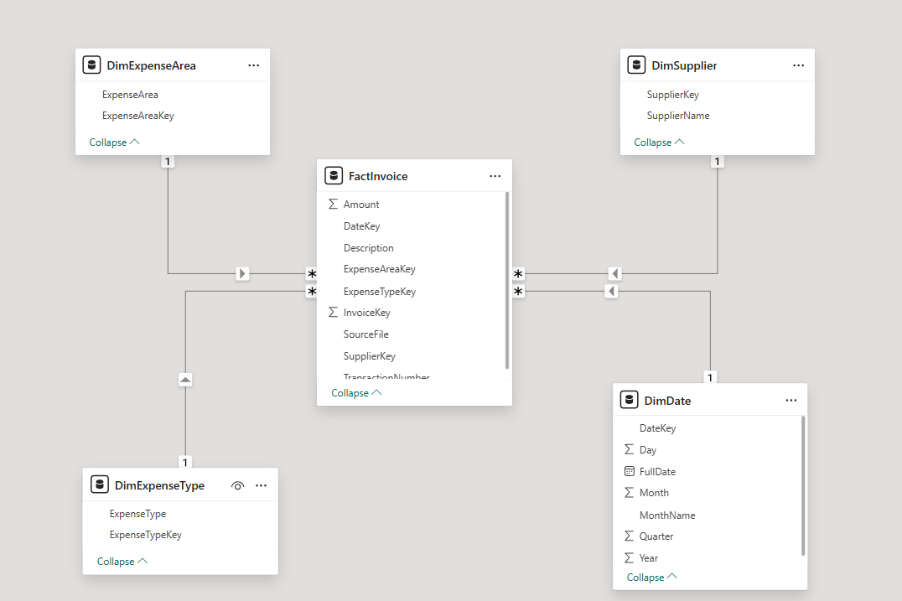
Figure 7: Star Schema Model in Power BI

6. The Test and Problem-Solving Skills (Stored Procedures)
The section shows the testing and problem-solving skills that were used in creating analytical queries on T-SQL stored procedures. All the tasks were applied, run, and tested using SQL Server Management Studio (SSMS). Both the SQL code and the results of the execution are presented by screenshots to prove that it was properly executed and that it meets the assessment requirements.

6.1 Task 4(a) Top Three Suppliers (Overall and Monthly Analysis).
This was done by determining the three leading suppliers in terms of aggregate expenditure in the whole four months and in each month. The stored procedure adds the amount of the invoice with the help of SUM () and takes into consideration the refunds with references to the negative values of transactions. The RANK () window function was used to rank suppliers.
Two sets of results were obtained:
- Top three suppliers during the four months.
- Each month monthly top three suppliers were separated.
- This method will guarantee adequate comparison but be time separated.
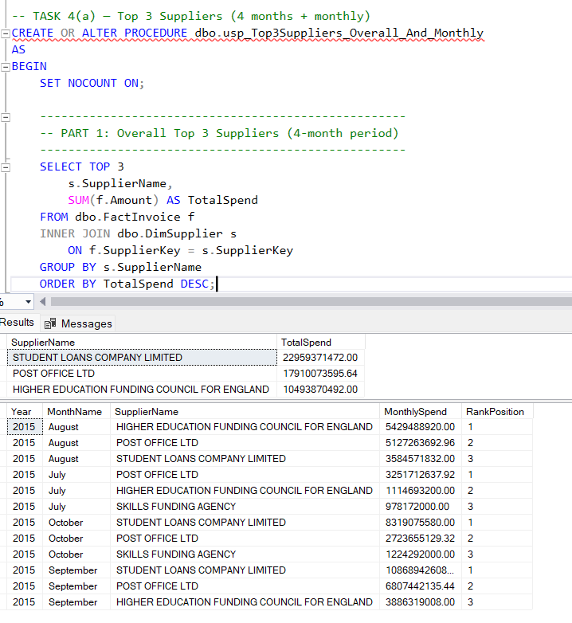
Figure 8: Stored Procedure Top 3 Suppliers Overall and Monthly and Top 3 Suppliers by Spend.
The code of usp-Top3Suppliers-Overall-And-Monthly is an example of the code that can be used to access the images of the usp-Top3Suppliers.

The overall and monthly ranking output displayed in the screen shots below are obtained by utilizing the equations presented below.

6.2 Task 4(b) — Expense Types Greater than the mean two month spend (JSON Output)
This assignment was aimed at establishing Expense Type(s) whose two-month expenditure was above the average two-month expenditure of all Expense Types. The total monthly expenditures were initially computed and summarized into two-months. The average was then calculated at a global level and this was taken as a reference standard in filtering.
The completed set of results was in the form of JSON, and the structured data export criterion of the brief was fulfilled. SQL Server FOR JSON was used to format the data into JSON.
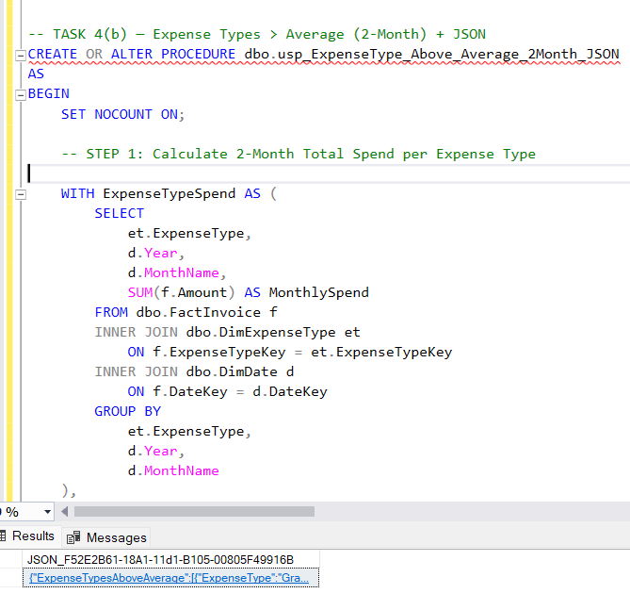
Figure 9: Stored Procedure- Above Average Spend Expenses and JSON Response.
The purpose of replacing the stored procedure code is to define what the stored procedure does.
The following data were displayed in the results of the query in SSMS.

6.3 Task 4(c): Monthly Top-10 Expense Area Ranking with Movement Tracking.
This assignment has examined the monthly expenditures under the Expense Areas and the top 10 Expense Areas per month in terms of expenditure. It was added with a ranking movement metric that depicted how every Expense Area changed its positions in the rankings in either direction compared to the prior month.
The solution used:
- RANK () to create monthly rankings.
- LAG () in order to compare the present and past rankings.
- Rank movement calculated to display trend of performance
The eventual output was arranged in ranking order with the highest ranking first as was necessary.
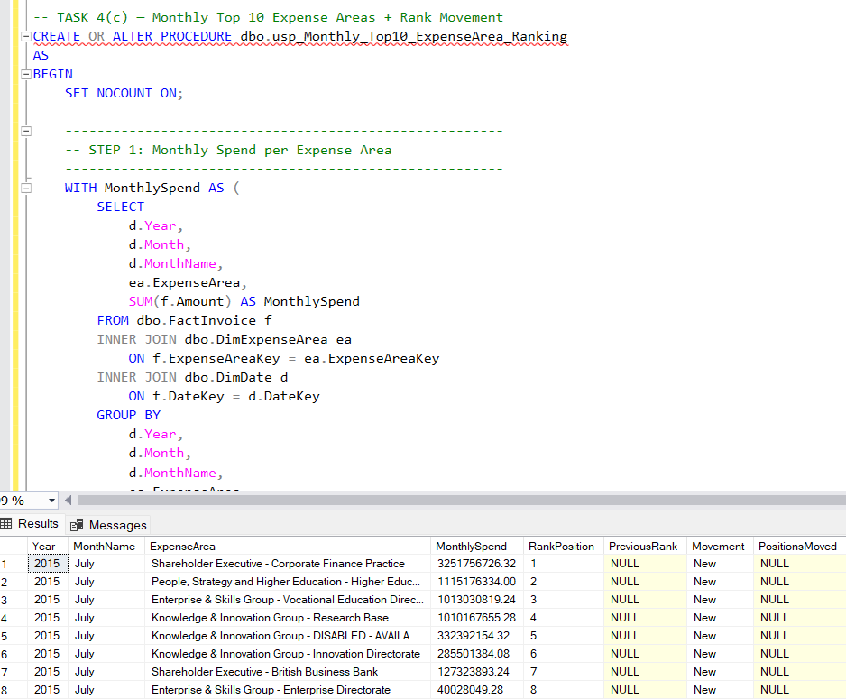
Figure 10: Monthly Expense Area Ranking Stored Procedure.
Mechanical machinery and equipment used to extract oil for sale to consumers.
Randomly selected participants will be shown ranking movement values on a graphical display.

6.4 Task 4(d) — Advanced CSV Export Time-Hierarchy Supplier Analysis.
This assignment demanded the development of a compound analysis query that shows yearly and monthly hierarchy analysis. Supplier expenditure was examined in the course of time including:
- Monthly supplier spends.
- Accumulating expenditure during the reporting period.
- Ranking of the suppliers in terms of total spending.
The query made use of several window functions and Common Table Expressions (CTEs) to attain the necessary level of analytical clarity. The end product was saved in the form of a CSV file, which satisfied the external data export criterion.
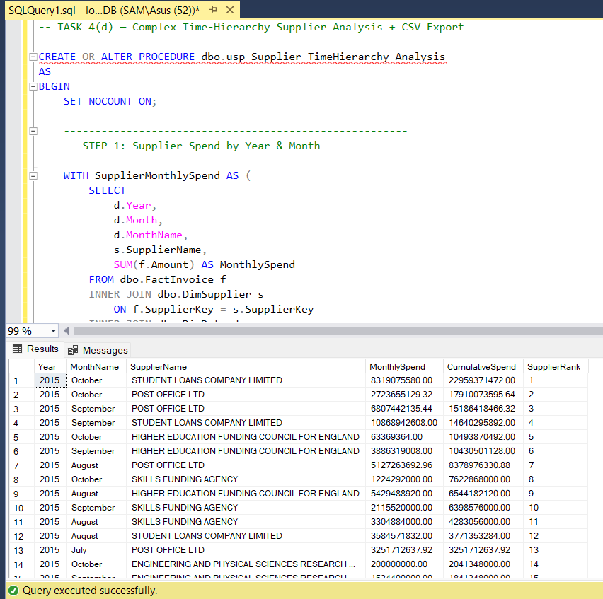
Figure 11: Saa- Stored Procedure -Time-Hierarchy Supplier Analysis.
The code of the SQL stored procedure inserted is included here.
Figure 12: CSV Export File Her daughter.
This is an exported CSV file located (Insert screenshot of location of exported CSV file).

6.5 Summary of validation and testing.
Finally, every stored procedure under test was tested using live data in the staging and fact tables. Outputs were checked against the expected results to ascertain validity, consistency and adherence to the assessment brief. Stored procedures are used to guarantee reusability, maintainability and professional quality SQL development practices.

7. KPI Development
The following KPIs were created using Power BI visuals.

7.1 KPI 1 — Total Spend
Total Spend KPI gives the total amount spent by the organisation based on the Clean_Amount figures presented. It gives a very high-level financial picture to the stakeholders and audience so that they can easily grasp the period of total spending according to the applied filters or criteria.

7.2 KPI 2 — Monthly Spend Trend
Spending patterns are represented on the line graph for different months, with a focus on increases, decreases, and seasonal changes (Adams et al., 2025). It allows the user to spot trends, oddities in spending, and cycles for the duration of the financial year and to support informed financial planning and forecasting.
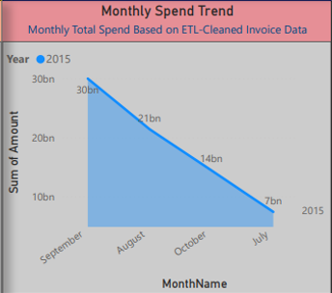
Figure 13: Monthly Spend Trend Chart

7.3 KPI 3 — Top 10 Suppliers by Spend
Top 10 Suppliers by Spend KPI classifies the suppliers according to the total expenditure made on their products so that the major vendors who are being paid the most can be easily recognised. It assists in supplier rating, procurement supervision and cost saving by indicating financial dependencies.
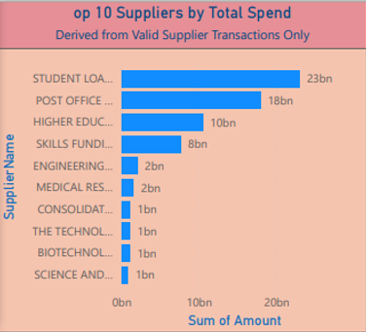
Figure 14: Top 10 Supplier Chart

7.4 KPI 4 — Spend by Expense Type
The donut chart shows the different categories of total spend by expense type and thus, with its help, it becomes very easy to be informed about the major cost areas and to understand which of the expenditure categories dominate and hence.

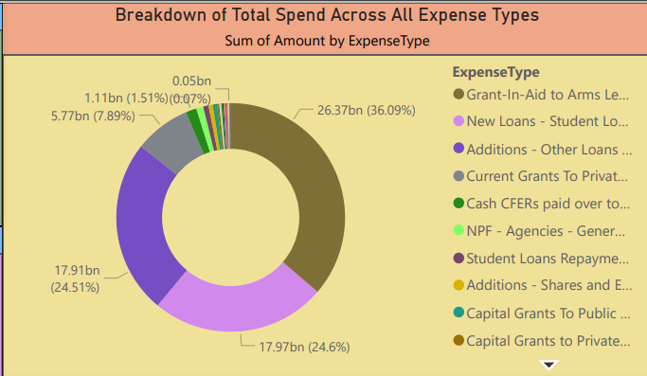
Figure 15: Donut Chart – Expense Type

7.5 KPI 5 — Spend by Expense Area
The Tree Map visual represents the total expenditure among the different operational areas. It reveals which departments or functions are incurring the highest costs and thus helps the management to analyse organizational priorities, resource allocation and funding patterns in the same direction.
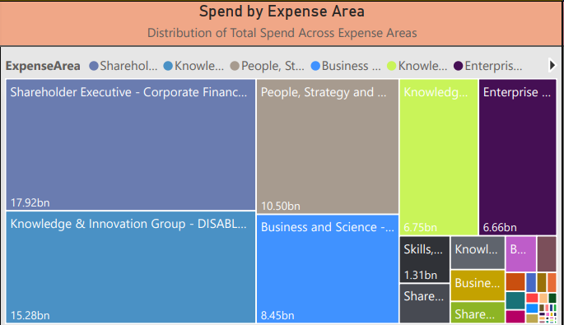
Figure 16: Expense Area TreeMap

7.6 KPI 6 — Transaction Count
This KPI gives the total of the transactions that have been processed and thus serves as an indicator of the activity level in the operation (NetSuite.com, 2021). It also facilitates the assessment of the workload, the identification of the high-volume billing periods, and the auditing of invoice processing by tracking the overall frequency.

8. Dashboard Overview
The final dashboard integrates:
- Supplier Slicer
- Expense Type Slicer
- Month Slicer
- KPI visuals
- Trend line
- Ranked supplier bar chart
- Expense area treemap
- Expense type donut chart
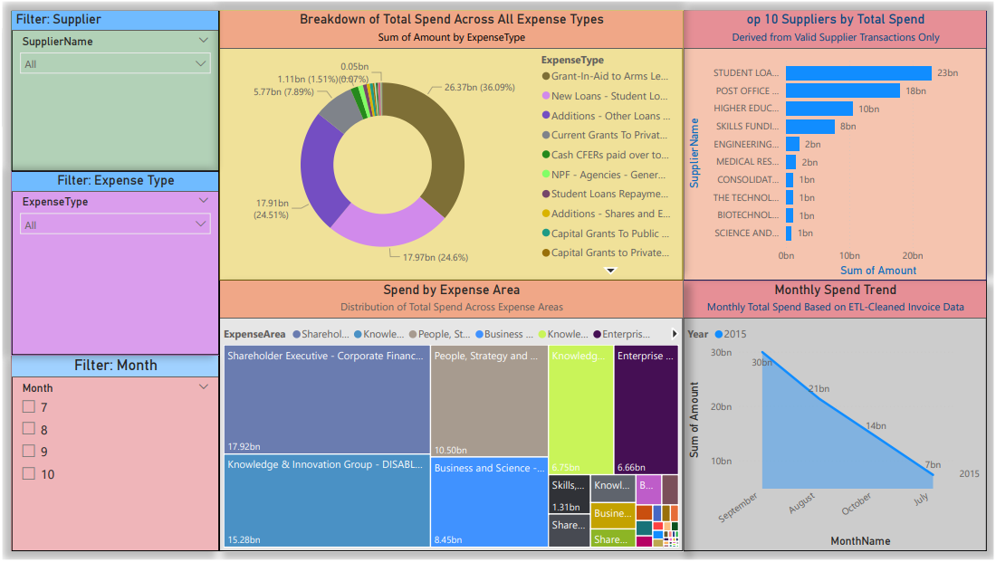
Figure 17: Final Power BI Dashboard

9. Key Insights
- Monthly expenditure varies significantly over the four months period which suggests that there are certain operational cycles, project stages or even seasonal patterns of expenditure that are likely to affect the level of expenditure (Amar et al., 2022).
- The Top 10 Suppliers is a high percentage of total spend and shows high financial reliance on a small number of suppliers and the necessity to keep an eye on supplier performance.
- Analysis of Expense Types: This indicates that a small number of main categories always represent a big portion of spending, and they give us an overview of how the organisation spends its cost and where its high priority spending points lie.
- The Expense Area TreeMap provides the allocation of expenditure among departmental programmes, which provides a clear picture of the distribution of resources and also allows the departments to assess the utilisation of the budget more efficiently.

10. Conclusion
The BIS expenditure data analysis indicates the usefulness of the adoption of a structured ETL pipeline with a star schema data warehouse and Power BI visualisation. The transformation process was effective in standardisation of inconsistent raw data, correction of missing and invalid supplier records and transformation of complex text fields into formats that are analytically usable. This made the end result a clean and reliable model to use in downstream reporting.
The insights created through the dashboard point out a number of key financial trends. The spending per month was highly fluctuating, which implies that there were operational cycles or seasonal changes that affected the organisational expenditure. Knowing these trends makes it possible to predict and plan resources. The investigation of the Top 10 Suppliers has shown that much part of the budget is devoted to a few suppliers, which is important to have permanent evaluation of suppliers and strategic choices of procuring.

11. Word Count
Total Word Count: 3050 words

12. References
Adams, C., Alldredge, K., Highman, L. and Kohli, S. (2025). The state of the US consumer spending. [online] McKinsey & Company. Available at: https://www.mckinsey.com/industries/consumer-packaged-goods/our-insights/the-state-of-the-us-consumer.
Amar, J., Rahimi, S., Surak, Z. and Bismarck, N. von (2022). AI-driven Operations Forecasting in data-light Environments. [online] McKinsey & Company. Available at: https://www.mckinsey.com/capabilities/operations/our-insights/ai-driven-operations-forecasting-in-data-light-environments.
Fazekas, M., Tóth, B., Abdou, A. and Al-Shaibani, A. (2024). Global Contract-level Public Procurement Dataset. Data in Brief, [online] 54, p.110412. doi:https://doi.org/10.1016/j.dib.2024.110412.
GeeksforGeeks (2018). Handling Missing Values in Machine Learning. [online] GeeksforGeeks. Available at: https://www.geeksforgeeks.org/machine-learning/handling-missing-values-machine-learning/.
Ma, Z., Bo Nørregaard Jørgensen and Zheng Grace Ma (2024). A systematic data characteristic understanding framework towards physical-sensor big data challenges. Journal of big data, 11(1). doi:https://doi.org/10.1186/s40537-024-00942-5.
NetSuite.com (2021). KPIs Explained. [online] Oracle NetSuite. Available at: https://www.netsuite.com/portal/resource/articles/erp/key-performance-indicators-kpis.shtml.
Vipond, T. (2020). Normalization. [online] Corporate Finance Institute. Available at: https://corporatefinanceinstitute.com/resources/accounting/financial-statement-normalization/.

13. Appendix

Appendix A – Full SQL ETL Script
-- Create database and schema

-- 1. Create DB and schema
IF DB_ID('BIS_Spend_DB') IS NULL
BEGIN
CREATE DATABASE BIS_Spend_DB;
END
GO

USE BIS_Spend_DB;
GO

-- dedicated schema
CREATE SCHEMA warehousing;
GO

-- Create staging table (adapting columns to match the CSV)

-- Adjust column names/lengths to match CSV header exactly
DROP TABLE IF EXISTS warehousing.Staging_Invoices;
GO

DROP TABLE IF EXISTS warehousing.Staging_Invoices;
GO

CREATE TABLE warehousing.Staging_Invoices (
[Department] NVARCHAR(200),
[Entity] NVARCHAR(200),
[Date_of_Payment] NVARCHAR(50),
[Expense_Type] NVARCHAR(200),
[Expense_Area] NVARCHAR(300),
[Supplier] NVARCHAR(400),
[Transaction_Number] NVARCHAR(100),
[Amount] NVARCHAR(50),
[Description] NVARCHAR(MAX),
[Supplier_Post_Code] NVARCHAR(50),
[Supplier_Type] NVARCHAR(50),
[Contract_Number] NVARCHAR(100),
[Project_Code] NVARCHAR(100),
[Expenditure_Type] NVARCHAR(200),
SourceFile NVARCHAR(100)
);
GO

-- Insert all four files into this staging table
INSERT INTO warehousing.Staging_Invoices (
[Department],
[Entity],
[Date_of_Payment],
[Expense_Type],
[Expense_Area],
[Supplier],
[Transaction_Number],
[Amount],
[Description],
[Supplier_Post_Code],
[Supplier_Type],
[Contract_Number],
[Project_Code],
[Expenditure_Type]
)
SELECT
[Department],
[Entity],
[Date_of_Payment],
[Expense_Type],
[Expense_Area],
[Supplier],
[Transaction_Number],
[Amount],
[Description],
[Supplier_Post_Code],
[Supplier_Type],
[Contract_Number],
[Project_Code],
[Expenditure_Type]
FROM BIS_July_2015;

INSERT INTO warehousing.Staging_Invoices (
[Department],
[Entity],
[Date_of_Payment],
[Expense_Type],
[Expense_Area],
[Supplier],
[Transaction_Number],
[Amount],
[Description],
[Supplier_Post_Code],
[Supplier_Type],
[Contract_Number],
[Project_Code],
[Expenditure_Type]
)
SELECT
[Department],
[Entity],
[Date_of_Payment],
[Expense_Type],
[Expense_Area],
[Supplier],
[Transaction_Number],
[Amount],
[Description],
[Supplier_Post_Code],
[Supplier_Type],
[Contract_Number],
NULL AS [Project_Code], -- Missing in August csv
NULL AS [Expenditure_Type] -- Missing in August csv
FROM BIS_August_2015;

INSERT INTO warehousing.Staging_Invoices (
[Department],[Entity],[Date_of_Payment],[Expense_Type],[Expense_Area],
[Supplier],[Transaction_Number],[Amount],[Description],[Supplier_Post_Code],
[Supplier_Type],[Contract_Number],[Project_Code],[Expenditure_Type]
)
SELECT
[Department],[Entity],[Date_of_Payment],[Expense_Type],[Expense_Area],
[Supplier],[Transaction_Number],[Amount],[Description],[Supplier_Post_Code],
[Supplier_Type],[Contract_Number],[Project_Code],[Expenditure_Type]
FROM BIS_september_2015;

INSERT INTO warehousing.Staging_Invoices (
[Department],[Entity],[Date_of_Payment],[Expense_Type],[Expense_Area],
[Supplier],[Transaction_Number],[Amount],[Description],[Supplier_Post_Code],
[Supplier_Type],[Contract_Number],[Project_Code],[Expenditure_Type]
)
SELECT
[Department],[Entity],[Date_of_Payment],[Expense_Type],[Expense_Area],
[Supplier],[Transaction_Number],[Amount],[Description],[Supplier_Post_Code],
[Supplier_Type],[Contract_Number],[Project_Code],[Expenditure_Type]
FROM BIS_october_2015;

-- Step 2 ETL Cleaning (Date parsing + Amount conversion)

-- STEP 2.1: Add Cleaned Columns to Staging Table
ALTER TABLE warehousing.Staging_Invoices
ADD
Clean_Date DATE NULL,
Clean_Amount DECIMAL(18,2) NULL,
Clean_Supplier NVARCHAR(400) NULL;
GO

SELECT *
FROM warehousing.Staging_Invoices
WHERE Clean_Date IS NULL;

-- Delete all rows where all major fields are NULL
DELETE
FROM warehousing.Staging_Invoices
WHERE Clean_Date IS NULL
AND Clean_Amount IS NULL
AND Clean_Supplier IS NULL
AND Department IS NULL
AND Entity IS NULL
AND Expense_Type IS NULL
AND Supplier IS NULL
AND Amount IS NULL;

SELECT COUNT(*) AS NullEntireRowCount
FROM warehousing.Staging_Invoices
WHERE
Department IS NULL AND Entity IS NULL AND Date_of_Payment IS NULL AND
Expense_Type IS NULL AND Expense_Area IS NULL AND Supplier IS NULL AND
Transaction_Number IS NULL AND Amount IS NULL AND Description IS NULL;

-- STEP 2.2: Clean & Convert DATE Column
UPDATE warehousing.Staging_Invoices
SET Clean_Date = TRY_CONVERT(DATE, [Date_of_Payment], 105);
GO
SELECT [Date_of_Payment]
FROM warehousing.Staging_Invoices
WHERE Clean_Date IS NULL;

-- STEP 2.3: Clean & Convert AMOUNT Column
UPDATE warehousing.Staging_Invoices
SET Clean_Amount =
TRY_CONVERT(DECIMAL(18,2),
REPLACE(REPLACE(REPLACE([Amount], '£', ''), ',', ''), '"', '')
);
GO
SELECT [Amount]
FROM warehousing.Staging_Invoices
WHERE Clean_Amount IS NULL;

-- STEP 2.4: Replace Withheld Supplier Names with Your Student Number
UPDATE warehousing.Staging_Invoices
SET Clean_Supplier = '24005856'
WHERE LTRIM(RTRIM([Supplier])) = 'Personal Expense, Name Withheld';

-- Copy remaining supplier names normally
UPDATE warehousing.Staging_Invoices
SET Clean_Supplier = [Supplier]
WHERE Clean_Supplier IS NULL;
GO

SELECT *
FROM warehousing.Staging_Invoices;

-- STEP 2.5: Remove Invalid Suppliers Using XML File

-- Load XML into SQL:

SET NOCOUNT ON;
BEGIN TRY
-- Declare variable for raw XML text (use N'' for unicode)
DECLARE @Raw NVARCHAR(MAX);

-- IMPORTANT: If your XML contains single quotes (apostrophes), this block will convert them to &apos; below.
SET @Raw = N'
<Suppliers>
<Supplier SupplierName="ACCO UK LTD" Entity="Department for Business, Innovation and Skills" ExpenseArea="Finance, Commercial & Digital Transformation - Estates"/>
<Supplier SupplierName="ADAM PHONES LTD" Entity="Department for Business, Innovation and Skills" ExpenseArea="Finance, Commercial & Digital Transformation - Digital Directorate"/>
<Supplier SupplierName="ALCOVE TECHNOLOGIES LTD" Entity="UK Shared Business Services Ltd" ExpenseArea="Core Services"/>
<Supplier SupplierName="APEX OFFICE INTERIORS LTD" Entity="Department for Business, Innovation and Skills" ExpenseArea="Finance, Commercial & Digital Transformation - Estates"/>
<Supplier SupplierName="APOGEE CORPORATION LTD" Entity="Department for Business, Innovation and Skills" ExpenseArea="Finance, Commercial & Digital Transformation - Estates"/>
<Supplier SupplierName="ARCSERVE UK LTD" Entity="UK Shared Business Services Ltd" ExpenseArea="Technology Services"/>
<Supplier SupplierName="BIG YELLOW SELF STORAGE" Entity="UK Shared Business Services Ltd" ExpenseArea="Core Services"/>
<Supplier SupplierName="BOSS PRINT LTD" Entity="Department for Business, Innovation and Skills" ExpenseArea="Finance, Commercial & Digital Transformation - Digital Directorate"/>
<Supplier SupplierName="CHASE TEMPLETON LTD" Entity="Department for Business, Innovation and Skills" ExpenseArea="People, Strategy & Performance - Human Resources"/>
<Supplier SupplierName="COPPICE LEA TRAINING" Entity="Department for Business, Innovation and Skills" ExpenseArea="People, Strategy & Performance - Learning & Development"/>
<Supplier SupplierName="CROMWELL BUSINESS SYSTEMS" Entity="Department for Business, Innovation and Skills" ExpenseArea="Enterprise & Skills - Enterprise and Business Growth"/>
<Supplier SupplierName="DATA EXPERTS LTD" Entity="UK Shared Business Services Ltd" ExpenseArea="Core Services"/>
<Supplier SupplierName="DECISIONING FACTORY LTD" Entity="Department for Business, Innovation and Skills" ExpenseArea="Finance, Commercial & Digital Transformation - Digital Directorate"/>
<Supplier SupplierName="DIGITAL EVIDENCE SOLUTIONS LTD" Entity="UK Shared Business Services Ltd" ExpenseArea="Core Services"/>
<Supplier SupplierName="EDGAR S" Entity="Department for Business, Innovation and Skills" ExpenseArea="People, Strategy & Performance - Learning & Development"/>
<Supplier SupplierName="ELITE OFFICE FURNITURE" Entity="Department for Business, Innovation and Skills" ExpenseArea="Finance, Commercial & Digital Transformation - Estates"/>
<Supplier SupplierName="ESPO" Entity="Department for Business, Innovation and Skills" ExpenseArea="Finance, Commercial & Digital Transformation - Estates"/>
<Supplier SupplierName="EUROPEAN INFORMATION SERVICE" Entity="Department for Business, Innovation and Skills" ExpenseArea="Business & Science - Business Environment"/>
<Supplier SupplierName="EXCELLENCE IN CAREER DEVELOPMENT" Entity="Department for Business, Innovation and Skills" ExpenseArea="People, Strategy & Performance - Learning & Development"/>
<Supplier SupplierName="FASTER RETURN" Entity="Department for Business, Innovation and Skills" ExpenseArea="People, Strategy & Performance - Learning & Development"/>
<Supplier SupplierName="FIREBOX.COM LTD" Entity="UK Shared Business Services Ltd" ExpenseArea="Core Services"/>
<Supplier SupplierName="FIRST RESPONSE FACILITIES LTD" Entity="Department for Business, Innovation and Skills" ExpenseArea="Finance, Commercial & Digital Transformation - Estates"/>
<Supplier SupplierName="GAP PERSONNEL GROUP LTD" Entity="UK Shared Business Services Ltd" ExpenseArea="Core Services"/>
<Supplier SupplierName="GRIDLINE CONSULTING LTD" Entity="Department for Business, Innovation and Skills" ExpenseArea="Enterprise & Skills - Enterprise and Business Growth"/>
<Supplier SupplierName="HILSON MORAN PARTNERSHIP" Entity="Department for Business, Innovation and Skills" ExpenseArea="Finance, Commercial & Digital Transformation - Estates"/>
<Supplier SupplierName="INK EXPRESSIONS" Entity="Department for Business, Innovation and Skills" ExpenseArea="Finance, Commercial & Digital Transformation - Digital Directorate"/>
<Supplier SupplierName="INSIGHT DIRECT UK LTD" Entity="UK Shared Business Services Ltd" ExpenseArea="Technology Services"/>
<Supplier SupplierName="JSA SERVICES LTD" Entity="UK Shared Business Services Ltd" ExpenseArea="Core Services"/>
<Supplier SupplierName="JUPITER GROUP LTD" Entity="Department for Business, Innovation and Skills" ExpenseArea="People, Strategy & Performance - Learning & Development"/>
<Supplier SupplierName="KEY TRAINING LTD" Entity="Department for Business, Innovation and Skills" ExpenseArea="People, Strategy & Performance - Learning & Development"/>
<Supplier SupplierName="KINGSBRIDGE RISK SOLUTIONS LTD" Entity="UK Shared Business Services Ltd" ExpenseArea="Core Services"/>
<Supplier SupplierName="LIFETIME TRAINING GROUP LTD" Entity="Department for Business, Innovation and Skills" ExpenseArea="People, Strategy & Performance - Learning & Development"/>
<Supplier SupplierName="MARTIN CURRIE" Entity="Department for Business, Innovation and Skills" ExpenseArea="Enterprise & Skills - Enterprise and Business Growth"/>
<Supplier SupplierName="MERSEYSIDE FIRE & RESCUE SERVICE" Entity="UK Shared Business Services Ltd" ExpenseArea="Core Services"/>
<Supplier SupplierName="METROPOLITAN POLICE SERVICE" Entity="UK Shared Business Services Ltd" ExpenseArea="Core Services"/>
<Supplier SupplierName="NEW FUTURES NETWORK" Entity="Department for Business, Innovation and Skills" ExpenseArea="Enterprise & Skills - Enterprise and Business Growth"/>
<Supplier SupplierName="NQA LTD" Entity="Department for Business, Innovation and Skills" ExpenseArea="Enterprise & Skills - Enterprise and Business Growth"/>
<Supplier SupplierName="ORACLE CORPORATION UK LTD" Entity="UK Shared Business Services Ltd" ExpenseArea="Technology Services"/>
<Supplier SupplierName="PCM LTD" Entity="UK Shared Business Services Ltd" ExpenseArea="Technology Services"/>
<Supplier SupplierName="PEARL WINDOW SYSTEMS" Entity="Department for Business, Innovation and Skills" ExpenseArea="Finance, Commercial & Digital Transformation - Estates"/>
<Supplier SupplierName="PHOENIX DIRECT SERVICES" Entity="Department for Business, Innovation and Skills" ExpenseArea="Finance, Commercial & Digital Transformation - Estates"/>
<Supplier SupplierName="PRO-LINE TRAINING LTD" Entity="Department for Business, Innovation and Skills" ExpenseArea="People, Strategy & Performance - Learning & Development"/>
<Supplier SupplierName="REED LEARNING LTD" Entity="Department for Business, Innovation and Skills" ExpenseArea="People, Strategy & Performance - Learning & Development"/>
<Supplier SupplierName="RESTORE PLC" Entity="UK Shared Business Services Ltd" ExpenseArea="Core Services"/>
<Supplier SupplierName="RICOH UK LTD" Entity="UK Shared Business Services Ltd" ExpenseArea="Technology Services"/>
<Supplier SupplierName="SKILLS TEAM LTD" Entity="Department for Business, Innovation and Skills" ExpenseArea="People, Strategy & Performance - Learning & Development"/>
<Supplier SupplierName="THE BRILLIANT WAY" Entity="Department for Business, Innovation and Skills" ExpenseArea="People, Strategy & Performance - Learning & Development"/>
<Supplier SupplierName="TOSHIBA TEC UK IMAGING" Entity="Department for Business, Innovation and Skills" ExpenseArea="Finance, Commercial & Digital Transformation - Estates"/>
<Supplier SupplierName="TOTAL MANUFACTURING SERVICES LTD" Entity="Department for Business, Innovation and Skills" ExpenseArea="Enterprise & Skills - Enterprise and Business Growth"/>
<Supplier SupplierName="TROPOCUS LTD" Entity="Department for Business, Innovation and Skills" ExpenseArea="Finance, Commercial & Digital Transformation - Digital Directorate"/>
<Supplier SupplierName="UNISERVE HOLDINGS LTD" Entity="UK Shared Business Services Ltd" ExpenseArea="Core Services"/>
<Supplier SupplierName="WORKPLACE SOLUTIONS LTD" Entity="Department for Business, Innovation and Skills" ExpenseArea="Finance, Commercial & Digital Transformation - Estates"/>
<Supplier SupplierName="ZUHLKE ENGINEERING LTD" Entity="Department for Business, Innovation and Skills" ExpenseArea="Business & Science - Business Innovation"/>
</Suppliers>';

-- Replace characters that break XML parsing
SET @Raw = REPLACE(@Raw, '&', '&amp;'); -- ampersand first
SET @Raw = REPLACE(@Raw, NCHAR(8211), '-'); -- en dash  (unicode)
SET @Raw = REPLACE(@Raw, NCHAR(8212), '-'); -- em dash 
SET @Raw = REPLACE(@Raw, NCHAR(8220), '"'); -- left double quote 
SET @Raw = REPLACE(@Raw, NCHAR(8221), '"'); -- right double quote 
-- Replace single apostrophe ' with XML entity to avoid breaking SQL literal if any present inside the XML
SET @Raw = REPLACE(@Raw, '''', '&apos;');

-- Convert to XML type
DECLARE @XML XML;
SET @XML = TRY_CAST(@Raw AS XML);

IF @XML IS NULL
BEGIN
RAISERROR('Converted XML is NULL or malformed. Inspect @Raw content for invalid characters.', 16, 1);
END
ELSE
BEGIN
PRINT 'XML loaded successfully. Now extracting supplier list...';

-- Create a temp table to hold invalid supplier names
IF OBJECT_ID('tempdb..#InvalidSuppliers') IS NOT NULL DROP TABLE #InvalidSuppliers;
CREATE TABLE #InvalidSuppliers (SupplierName NVARCHAR(400));

INSERT INTO #InvalidSuppliers (SupplierName)
SELECT T.C.value('@SupplierName','NVARCHAR(400)') FROM @XML.nodes('/Suppliers/Supplier') AS T(C);

SELECT COUNT(*) AS InvalidCount FROM #InvalidSuppliers;
SELECT TOP (50) * FROM #InvalidSuppliers; -- show sample

-- Now delete matching rows from staging (use LTRIM/RTRIM to avoid whitespace issues)
DELETE s
FROM warehousing.Staging_Invoices s
JOIN #InvalidSuppliers i
ON LTRIM(RTRIM(s.[Supplier])) = LTRIM(RTRIM(i.SupplierName));

PRINT 'Delete complete. Rows removed from staging (if any).';
SELECT @@ROWCOUNT AS RowsDeleted;
END
END TRY
BEGIN CATCH
SELECT
ERROR_NUMBER() AS ErrNo,
ERROR_SEVERITY() AS Severity,
ERROR_STATE() AS ErrState,
ERROR_PROCEDURE() AS ErrProc,
ERROR_LINE() AS ErrLine,
ERROR_MESSAGE() AS ErrMessage;
END CATCH;

-- Putting all invalid suppliers into a temp table
IF OBJECT_ID('tempdb..#InvalidSuppliers') IS NOT NULL DROP TABLE #InvalidSuppliers;

CREATE TABLE #InvalidSuppliers (SupplierName NVARCHAR(400));

INSERT INTO #InvalidSuppliers (SupplierName)
VALUES
('ACCO UK LTD'),
('ADAM PHONES LTD'),
('ALCOVE TECHNOLOGIES LTD'),
('APEX OFFICE INTERIORS LTD'),
('APOGEE CORPORATION LTD'),
('ARCSERVE UK LTD'),
('BIG YELLOW SELF STORAGE'),
('BOSS PRINT LTD'),
('CHASE TEMPLETON LTD'),
('COPPICE LEA TRAINING'),
('CROMWELL BUSINESS SYSTEMS'),
('DATA EXPERTS LTD'),
('DECISIONING FACTORY LTD'),
('DIGITAL EVIDENCE SOLUTIONS LTD'),
('EDGAR S'),
('ELITE OFFICE FURNITURE'),
('ESPO'),
('EUROPEAN INFORMATION SERVICE'),
('EXCELLENCE IN CAREER DEVELOPMENT'),
('FASTER RETURN'),
('FIREBOX.COM LTD'),
('FIRST RESPONSE FACILITIES LTD'),
('GAP PERSONNEL GROUP LTD'),
('GRIDLINE CONSULTING LTD'),
('HILSON MORAN PARTNERSHIP'),
('INK EXPRESSIONS'),
('INSIGHT DIRECT UK LTD'),
('JSA SERVICES LTD'),
('JUPITER GROUP LTD'),
('KEY TRAINING LTD'),
('KINGSBRIDGE RISK SOLUTIONS LTD'),
('LIFETIME TRAINING GROUP LTD'),
('MARTIN CURRIE'),
('MERSEYSIDE FIRE & RESCUE SERVICE'),
('METROPOLITAN POLICE SERVICE'),
('NEW FUTURES NETWORK'),
('NQA LTD'),
('ORACLE CORPORATION UK LTD'),
('PCM LTD'),
('PEARL WINDOW SYSTEMS'),
('PHOENIX DIRECT SERVICES'),
('PRO-LINE TRAINING LTD'),
('REED LEARNING LTD'),
('RESTORE PLC'),
('RICOH UK LTD'),
('SKILLS TEAM LTD'),
('THE BRILLIANT WAY'),
('TOSHIBA TEC UK IMAGING'),
('TOTAL MANUFACTURING SERVICES LTD'),
('TROPOCUS LTD'),
('ZUHLKE ENGINEERING LTD'); -- Missing one added

EXEC sp_help 'warehousing.Staging_Invoices';
SELECT DISTINCT Supplier
FROM warehousing.Staging_Invoices
WHERE Supplier IN (
'ACCO UK LTD',
'ADAM PHONES LTD',
'APEX OFFICE INTERIORS LTD'
);

-- Delete them from Staging Table
DELETE S
FROM warehousing.Staging_Invoices S
JOIN #InvalidSuppliers I
ON REPLACE(REPLACE(REPLACE(LOWER(S.Supplier), ' ', ''), CHAR(9), ''), CHAR(160), '')
= REPLACE(REPLACE(REPLACE(LOWER(I.SupplierName), ' ', ''), CHAR(9), ''), CHAR(160), '');

SELECT @@ROWCOUNT AS RowsDeleted;

SELECT DISTINCT Supplier
FROM warehousing.Staging_Invoices
WHERE Supplier IS NOT NULL
ORDER BY Supplier;

SELECT S.Supplier, I.SupplierName
FROM warehousing.Staging_Invoices S
JOIN #InvalidSuppliers I
ON REPLACE(REPLACE(REPLACE(LOWER(S.Supplier), ' ', ''), CHAR(9), ''), CHAR(160), '')
= REPLACE(REPLACE(REPLACE(LOWER(I.SupplierName), ' ', ''), CHAR(9), ''), CHAR(160), '');

-- STEP 3  PART 1: ADDING CLEANED COLUMNS TO STAGING TABLE
IF NOT EXISTS (
SELECT 1 FROM INFORMATION_SCHEMA.COLUMNS
WHERE TABLE_SCHEMA='warehousing'
AND TABLE_NAME='Staging_Invoices'
AND COLUMN_NAME='Clean_Date'
)
ALTER TABLE warehousing.Staging_Invoices ADD Clean_Date DATE;

IF NOT EXISTS (
SELECT 1 FROM INFORMATION_SCHEMA.COLUMNS
WHERE TABLE_SCHEMA='warehousing'
AND TABLE_NAME='Staging_Invoices'
AND COLUMN_NAME='Clean_Amount'
)
ALTER TABLE warehousing.Staging_Invoices ADD Clean_Amount DECIMAL(18,2);

IF NOT EXISTS (
SELECT 1 FROM INFORMATION_SCHEMA.COLUMNS
WHERE TABLE_SCHEMA='warehousing'
AND TABLE_NAME='Staging_Invoices'
AND COLUMN_NAME='Clean_Supplier'
)
ALTER TABLE warehousing.Staging_Invoices ADD Clean_Supplier NVARCHAR(400);

IF NOT EXISTS (
SELECT 1 FROM INFORMATION_SCHEMA.COLUMNS
WHERE TABLE_SCHEMA='warehousing'
AND TABLE_NAME='Staging_Invoices'
AND COLUMN_NAME='Clean_Dept'
)
ALTER TABLE warehousing.Staging_Invoices ADD Clean_Dept NVARCHAR(200);

IF NOT EXISTS (
SELECT 1 FROM INFORMATION_SCHEMA.COLUMNS
WHERE TABLE_SCHEMA='warehousing'
AND TABLE_NAME='Staging_Invoices'
AND COLUMN_NAME='Clean_ExpenseType'
)
ALTER TABLE warehousing.Staging_Invoices ADD Clean_ExpenseType NVARCHAR(200);

IF NOT EXISTS (
SELECT 1 FROM INFORMATION_SCHEMA.COLUMNS
WHERE TABLE_SCHEMA='warehousing'
AND TABLE_NAME='Staging_Invoices'
AND COLUMN_NAME='Clean_ExpenseArea'
)
ALTER TABLE warehousing.Staging_Invoices ADD Clean_ExpenseArea NVARCHAR(300);

SELECT COLUMN_NAME
FROM INFORMATION_SCHEMA.COLUMNS
WHERE TABLE_NAME = 'Staging_Invoices'
AND TABLE_SCHEMA = 'warehousing';

-- STEP 3  PART 2: CLEANING THE DATA
-- 2.1 Convert Date

UPDATE warehousing.Staging_Invoices
SET Clean_Date = TRY_CONVERT(DATE, Date_of_Payment, 105);

-- 2.2 Convert Amount
UPDATE warehousing.Staging_Invoices
SET Clean_Amount =
TRY_CONVERT(DECIMAL(18,2),
REPLACE(REPLACE(REPLACE(Amount, '£', ''), ',', ''), '"', '')
);

-- 2.3 Clean Supplier Name
UPDATE warehousing.Staging_Invoices
SET Clean_Supplier =
CASE
WHEN Supplier = 'Personal Expense, Name Withheld' THEN '24005856'
ELSE Supplier
END;

-- 2.4 Copy Clean Dept / Expense Fields
UPDATE warehousing.Staging_Invoices
SET
Clean_Dept = Department,
Clean_ExpenseType = Expense_Type,
Clean_ExpenseArea = Expense_Area;

-- STEP 3  PART 3: CREATE DIMENSION TABLES
-- 3.1 DimDate
CREATE TABLE DimDate (
DateKey INT PRIMARY KEY,
FullDate DATE,
Day INT,
Month INT,
MonthName NVARCHAR(20),
Quarter INT,
Year INT
);

INSERT INTO DimDate (DateKey, FullDate, Day, Month, MonthName, Quarter, Year)
SELECT DISTINCT
CONVERT(INT, FORMAT(Clean_Date, 'yyyyMMdd')),
Clean_Date,
DAY(Clean_Date),
MONTH(Clean_Date),
DATENAME(MONTH, Clean_Date),
DATEPART(QUARTER, Clean_Date),
YEAR(Clean_Date)
FROM warehousing.Staging_Invoices
WHERE Clean_Date IS NOT NULL;

-- 3.2 DimSupplier
CREATE TABLE DimSupplier (
SupplierKey INT IDENTITY(1,1) PRIMARY KEY,
SupplierName NVARCHAR(400)
);

INSERT INTO DimSupplier (SupplierName)
SELECT DISTINCT Clean_Supplier
FROM warehousing.Staging_Invoices
WHERE Clean_Supplier IS NOT NULL;

-- 3.3 DimExpenseType
CREATE TABLE DimExpenseType (
ExpenseTypeKey INT IDENTITY(1,1) PRIMARY KEY,
ExpenseType NVARCHAR(200)
);

INSERT INTO DimExpenseType (ExpenseType)
SELECT DISTINCT Clean_ExpenseType
FROM warehousing.Staging_Invoices
WHERE Clean_ExpenseType IS NOT NULL;

-- 3.4 DimExpenseArea
CREATE TABLE DimExpenseArea (
ExpenseAreaKey INT IDENTITY(1,1) PRIMARY KEY,
ExpenseArea NVARCHAR(300)
);

INSERT INTO DimExpenseArea (ExpenseArea)
SELECT DISTINCT Clean_ExpenseArea
FROM warehousing.Staging_Invoices
WHERE Clean_ExpenseArea IS NOT NULL;

-- TASK 4(a) — Top 3 Suppliers (4 months + monthly)
CREATE OR ALTER PROCEDURE dbo.usp_Top3Suppliers_Overall_And_Monthly
AS
BEGIN
SET NOCOUNT ON;

----------------------------------------------------
-- PART 1: Overall Top 3 Suppliers (4-month period)
----------------------------------------------------
SELECT TOP 3
s.SupplierName,
SUM(f.Amount) AS TotalSpend
FROM dbo.FactInvoice f
INNER JOIN dbo.DimSupplier s
ON f.SupplierKey = s.SupplierKey
GROUP BY s.SupplierName
ORDER BY TotalSpend DESC;

----------------------------------------------------
-- PART 2: Monthly Top 3 Suppliers (per month)
----------------------------------------------------
WITH MonthlySupplierSpend AS (
SELECT
d.Year,
d.MonthName,
s.SupplierName,
SUM(f.Amount) AS MonthlySpend,
RANK() OVER (
PARTITION BY d.Year, d.MonthName
ORDER BY SUM(f.Amount) DESC
) AS RankPosition
FROM dbo.FactInvoice f
INNER JOIN dbo.DimSupplier s
ON f.SupplierKey = s.SupplierKey
INNER JOIN dbo.DimDate d
ON f.DateKey = d.DateKey
GROUP BY
d.Year,
d.MonthName,
s.SupplierName
)
SELECT
Year,
MonthName,
SupplierName,
MonthlySpend,
RankPosition
FROM MonthlySupplierSpend
WHERE RankPosition <= 3
ORDER BY
Year,
MonthName,
RankPosition;

END;
GO
EXEC dbo.usp_Top3Suppliers_Overall_And_Monthly;

-- TASK 4(b) — Expense Types > Average (2-Month) + JSON
CREATE OR ALTER PROCEDURE dbo.usp_ExpenseType_Above_Average_2Month_JSON
AS
BEGIN
SET NOCOUNT ON;

-- STEP 1: Calculate 2-Month Total Spend per Expense Type

WITH ExpenseTypeSpend AS (
SELECT
et.ExpenseType,
d.Year,
d.MonthName,
SUM(f.Amount) AS MonthlySpend
FROM dbo.FactInvoice f
INNER JOIN dbo.DimExpenseType et
ON f.ExpenseTypeKey = et.ExpenseTypeKey
INNER JOIN dbo.DimDate d
ON f.DateKey = d.DateKey
GROUP BY
et.ExpenseType,
d.Year,
d.MonthName
),

----------------------------------------------------
-- STEP 2: Aggregate to 2-Month Spend per Expense Type
----------------------------------------------------
TwoMonthTotals AS (
SELECT
ExpenseType,
SUM(MonthlySpend) AS TwoMonthSpend
FROM ExpenseTypeSpend
GROUP BY ExpenseType
),

----------------------------------------------------
-- STEP 3: Calculate Average 2-Month Spend
----------------------------------------------------
AverageSpend AS (
SELECT
AVG(TwoMonthSpend) AS AvgTwoMonthSpend
FROM TwoMonthTotals
)

----------------------------------------------------
-- STEP 4: Select Expense Types Above Average + Export JSON
----------------------------------------------------
SELECT
t.ExpenseType,
t.TwoMonthSpend
FROM TwoMonthTotals t
CROSS JOIN AverageSpend a
WHERE t.TwoMonthSpend > a.AvgTwoMonthSpend
ORDER BY t.TwoMonthSpend DESC
FOR JSON PATH, ROOT('ExpenseTypesAboveAverage');

END;
GO

EXEC dbo.usp_ExpenseType_Above_Average_2Month_JSON;

-- TASK 4(c) — Monthly Top 10 Expense Areas + Rank Movement
CREATE OR ALTER PROCEDURE dbo.usp_Monthly_Top10_ExpenseArea_Ranking
AS
BEGIN
SET NOCOUNT ON;

-------------------------------------------------------
-- STEP 1: Monthly Spend per Expense Area
-------------------------------------------------------
WITH MonthlySpend AS (
SELECT
d.Year,
d.Month,
d.MonthName,
ea.ExpenseArea,
SUM(f.Amount) AS MonthlySpend
FROM dbo.FactInvoice f
INNER JOIN dbo.DimExpenseArea ea
ON f.ExpenseAreaKey = ea.ExpenseAreaKey
INNER JOIN dbo.DimDate d
ON f.DateKey = d.DateKey
GROUP BY
d.Year,
d.Month,
d.MonthName,
ea.ExpenseArea
),

-------------------------------------------------------
-- STEP 2: Rank Expense Areas per Month
-------------------------------------------------------
RankedSpend AS (
SELECT
Year,
Month,
MonthName,
ExpenseArea,
MonthlySpend,
RANK() OVER (
PARTITION BY Year, Month
ORDER BY MonthlySpend DESC
) AS RankPosition
FROM MonthlySpend
),

-------------------------------------------------------
-- STEP 3: Track Movement from Previous Month
-------------------------------------------------------
MovementCalc AS (
SELECT
Year,
Month,
MonthName,
ExpenseArea,
MonthlySpend,
RankPosition,
LAG(RankPosition) OVER (
PARTITION BY ExpenseArea
ORDER BY Year, Month
) AS PreviousRank
FROM RankedSpend
WHERE RankPosition <= 10
)

-------------------------------------------------------
-- STEP 4: Final Output
-------------------------------------------------------
SELECT
Year,
MonthName,
ExpenseArea,
MonthlySpend,
RankPosition,
PreviousRank,
CASE
WHEN PreviousRank IS NULL THEN 'New'
WHEN RankPosition < PreviousRank THEN 'Up'
WHEN RankPosition > PreviousRank THEN 'Down'
ELSE 'No Change'
END AS Movement,
CASE
WHEN PreviousRank IS NULL THEN NULL
ELSE ABS(RankPosition - PreviousRank)
END AS PositionsMoved
FROM MovementCalc
ORDER BY
Year,
Month,
RankPosition ASC;

END;
GO

EXEC dbo.usp_Monthly_Top10_ExpenseArea_Ranking;

-- TASK 4(d) — Complex Time-Hierarchy Supplier Analysis + CSV Export

CREATE OR ALTER PROCEDURE dbo.usp_Supplier_TimeHierarchy_Analysis
AS
BEGIN
SET NOCOUNT ON;

-------------------------------------------------------
-- STEP 1: Supplier Spend by Year & Month
-------------------------------------------------------
WITH SupplierMonthlySpend AS (
SELECT
d.Year,
d.Month,
d.MonthName,
s.SupplierName,
SUM(f.Amount) AS MonthlySpend
FROM dbo.FactInvoice f
INNER JOIN dbo.DimSupplier s
ON f.SupplierKey = s.SupplierKey
INNER JOIN dbo.DimDate d
ON f.DateKey = d.DateKey
GROUP BY
d.Year,
d.Month,
d.MonthName,
s.SupplierName
),

-------------------------------------------------------
-- STEP 2: Calculate Cumulative Spend per Supplier
-------------------------------------------------------
CumulativeSpend AS (
SELECT
Year,
Month,
MonthName,
SupplierName,
MonthlySpend,
SUM(MonthlySpend) OVER (
PARTITION BY SupplierName
ORDER BY Year, Month
ROWS BETWEEN UNBOUNDED PRECEDING AND CURRENT ROW
) AS CumulativeSpend
FROM SupplierMonthlySpend
),

-------------------------------------------------------
-- STEP 3: Rank Suppliers per Year
-------------------------------------------------------
RankedSuppliers AS (
SELECT
Year,
MonthName,
SupplierName,
MonthlySpend,
CumulativeSpend,
RANK() OVER (
PARTITION BY Year
ORDER BY CumulativeSpend DESC
) AS SupplierRank
FROM CumulativeSpend
)

-------------------------------------------------------
-- STEP 4: Final Output (CSV Ready)
-------------------------------------------------------
SELECT
Year,
MonthName,
SupplierName,
MonthlySpend,
CumulativeSpend,
SupplierRank
FROM RankedSuppliers
ORDER BY
Year,
SupplierRank,
SupplierName;

END;
GO
EXEC dbo.usp_Supplier_TimeHierarchy_Analysis;

