ARTI 502
Deep Learning: 2nd Assignment
Training-Testing CNN with CIFAR Dataset using Pytorch
Year 2026 Term 1

Group # 1
Group Members:
# | Member Name | Member Academic ID
1 | Khalid Waleed Alhilal (Group Leader) | 2230000788
2 | Ali Khalid Albinali | 2230003813
3 | Mishary Waleed AlAwadh | 2230006217
4 | Nawaf Alsabr | 2230004159
5 | Yasir Saleh Alghamdi | 2230004157
6 | Ibrahim Alkuwaiz | 2230002878
7 | Meshal Alrubaie | 2230005991
GitHub repository: https://github.com/ImSleepingHere/DL-Assignment2-CNN-CIFAR

Overview
In this assignment we train convolutional neural networks on the CIFAR-10 dataset (60,000 colour images of 32×32 pixels in 10 classes: 50,000 for training and 10,000 for testing) with PyTorch. We build a CNN out of the two core building blocks, convolution layers and max-pooling layers, write the training and test functions, look at the data, try every suggested data augmentation, record and plot train loss, test loss and test accuracy, and then keep improving the design (deeper networks and pretrained models) to push the test accuracy as close to 100 % as we could.
Objective
Implement two core building blocks of deep learning:
- Convolution layers
- Max-pooling layers
Summary of our results
All numbers below are copied from the executed notebooks in the repository (nothing is rounded up or estimated). Train loss and test loss include label smoothing 0.1, so they cannot go below about 0.5.
Model | Epochs | Final train loss | Final test loss | Test acc
Task 2 CNN: 6 conv + BN + MaxPool, GAP head (from scratch) | 40 | 0.6620 | 0.7079 | 92.94 %
ResNet-18 + AutoAugment + CutMix (from scratch) | 200 | – | – | 96.83 %
ViT-B/16 pretrained, full fine-tune | 10 | – | – | 97.80 %
ViT-L/16 pretrained, frozen + linear classifier | 30 | – | – | 98.05 %
RegNetY-32GF pretrained CNN, LP-FT (val-selected) | 1 + 5 | 0.5213 | 0.5351 | 98.62 %
ViT-L/16 pretrained, LP-FT with layer-wise LR decay (best) | 1 + 5 | 0.5039 | 0.5221 | 99.31 %

Best design: a ViT-L/16 pretrained on 3.6 billion images (SWAG), trained in two stages (linear probe, then fine-tuning of the whole network with layer-wise learning-rate decay): 99.31 % test accuracy (69 errors out of 10,000). The best pure CNN is RegNetY-32GF with the same recipe: 98.62 %. The best network trained from scratch is ResNet-18 (96.83 %), and the plain Task 2 CNN reaches 92.94 %.
Environment: Windows 11, VS Code + Jupyter, Python 3.14.4, PyTorch 2.14.0+cu130, torchvision 0.29.0. The Task 1–5 notebook and RegNet run were executed on an NVIDIA GeForce RTX 5080 (16 GB); the ViT runs were executed by our group member on an NVIDIA GeForce RTX 4080 SUPER (16 GB).
Source code: https://github.com/ImSleepingHere/DL-Assignment2-CNN-CIFAR

Tasks (with PyTorch)
Task 1: Getting the CIFAR Dataset
Instructions:
- Download the dataset first. Since PyTorch hosts the CIFAR dataset, you can load it using their helper function later.
- You need to change DATA_PATH to an empty directory to download the dataset to.
Deliverable:
- Screenshot showing the dataset loaded successfully.
Our Work & Results
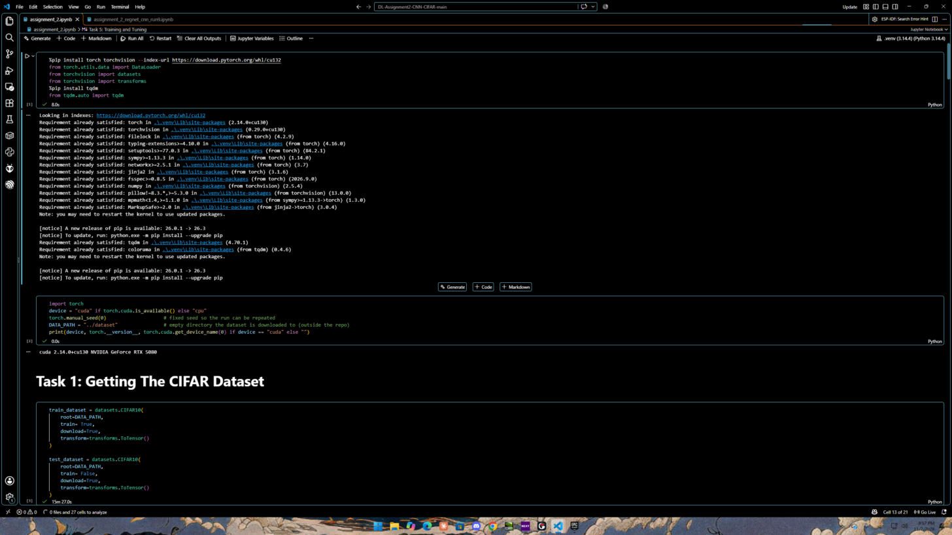
Figure 1: Imports, fixed seed, DATA_PATH and the GPU check (cuda, PyTorch 2.14.0+cu130, NVIDIA GeForce RTX 5080)
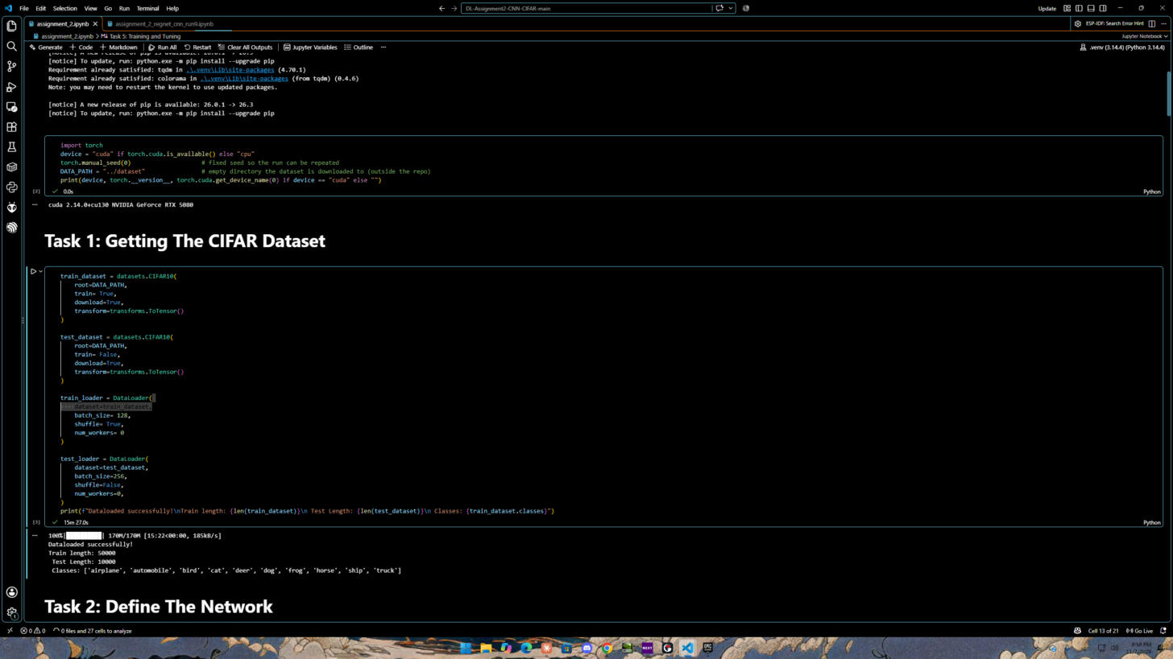
Figure 2: CIFAR-10 downloaded into the empty DATA_PATH directory (../dataset) and loaded successfully
Result: DATA_PATH = "../dataset" points to an empty directory outside the repository, so the 170 MB archive is not committed to GitHub. datasets.CIFAR10(root=DATA_PATH, download=True) downloaded and loaded the data: 50,000 training images and 10,000 test images in the 10 classes airplane, automobile, bird, cat, deer, dog, frog, horse, ship and truck.
Task 2: Defining the Network
Instructions:
- Just like with MNIST in the first assignment you need to define your network architecture. This time you will be using convolutional layers and maxpooling to extract features from our images before you feed those features into your final classifier.
- Check out the documentation for nn.Conv2d.
- So the first parameter is the number of channels in the input. Second is the number of filters we'll use (AKA number of channels in the output). Third is kernel size. Next is stride and padding which are optional and have default values.
- Create your training and test functions.
Deliverable:
- Provide screenshots of your code to define your network.
- Show screenshots of your training and test functions.
Our Work & Results
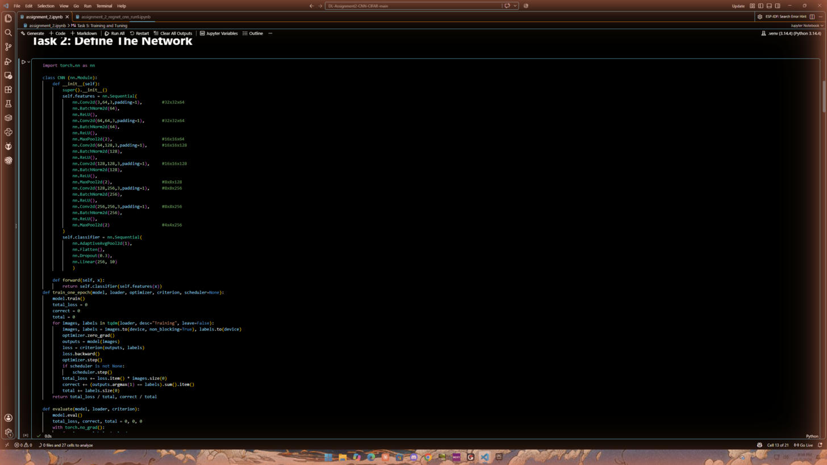
Figure 3: The CNN: three blocks of [Conv2d-BatchNorm-ReLU] × 2 + MaxPool2d, then global average pooling, dropout and a linear classifier
Architecture: every nn.Conv2d(in_channels, out_channels, kernel_size=3, padding=1) keeps the spatial size, and every nn.MaxPool2d(2) halves it: 3×32×32 → 64×32×32 → 64×16×16 → 128×16×16 → 128×8×8 → 256×8×8 → 256×4×4. BatchNorm after each convolution stabilises training. The classifier is AdaptiveAvgPool2d(1) → Flatten → Dropout(0.3) → Linear(256, 10); averaging each feature map instead of flattening 4,096 values removes about 1 M parameters that would overfit.
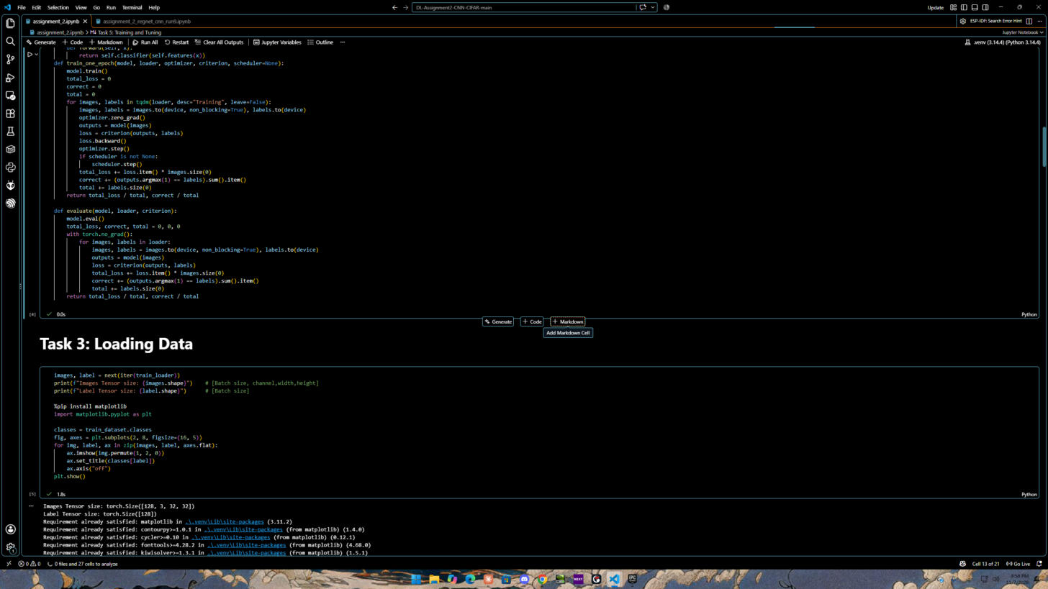
Figure 4: Training function train_one_epoch() and test function evaluate()
Training function train_one_epoch(): puts the model in training mode and, for every mini-batch, moves the images to the GPU, runs the forward pass, computes the loss, back-propagates (loss.backward()), updates the weights (optimizer.step()) and steps the learning-rate scheduler. It returns the average loss and the accuracy. Test function evaluate(): puts the model in eval mode (BatchNorm uses its running statistics, dropout is off) and computes loss and accuracy without gradients (torch.no_grad()).
Task 3: Loading Data
Instructions:
- It's worthwhile to check out how the dataloader loads the images into tensors. You can print out the size of the loaded data in the images tensors. Also you can use matplotlib to see the visualization of the images data.
Deliverable:
- Provide screenshots how to find:
- Images tensor size
- Data images visualization using matplotlib
Our Work & Results
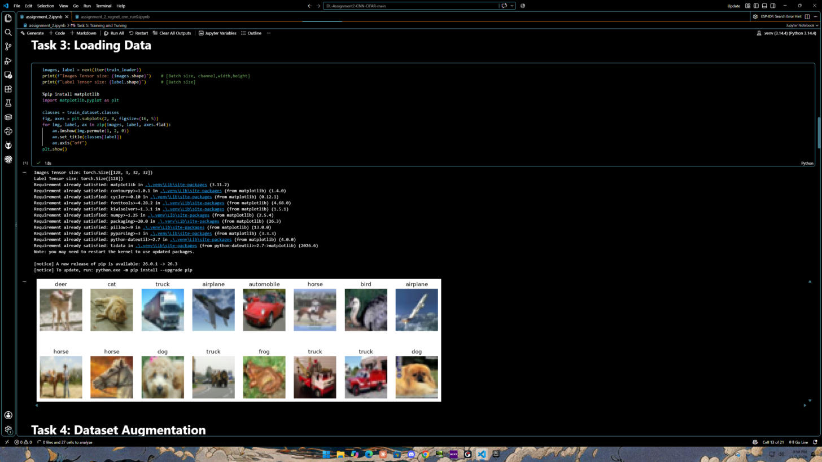
Figure 5: Tensor size of one mini-batch and 16 training images visualised with matplotlib
1. Images tensor size = [128, 3, 32, 32] = batch size × channels (RGB) × height × width; the label tensor is [128]. 2. Visualisation: img.permute(1, 2, 0) changes C×H×W into H×W×C, the layout matplotlib's imshow expects; each image is titled with its class name.
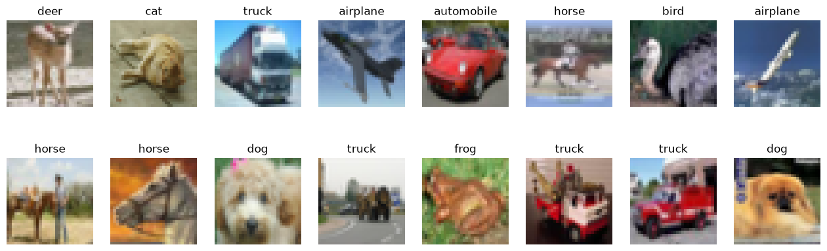
Figure 6: One mini-batch of training images with their labels
Task 4: Dataset Augmentation
Instructions:
- In this assignment, you may find that data augmentation helps you a lot (or possibly hurts your performance).
- Play around with various data augmentations we will suggest some: ToPILImage, RandomHorizontalFlip, RandomResizedCrop, ColorJitter, RandomRotation, Normalize, adding various types of noise, ToTensor.
- Note: You should be careful about which of these you apply to the test data. You usually don't want to apply noise to the test data, but you do want to normalize it the same way for example.
Deliverables:
- Apply your code with various Dataset Augmentation as mentioned above.
Our Work & Results
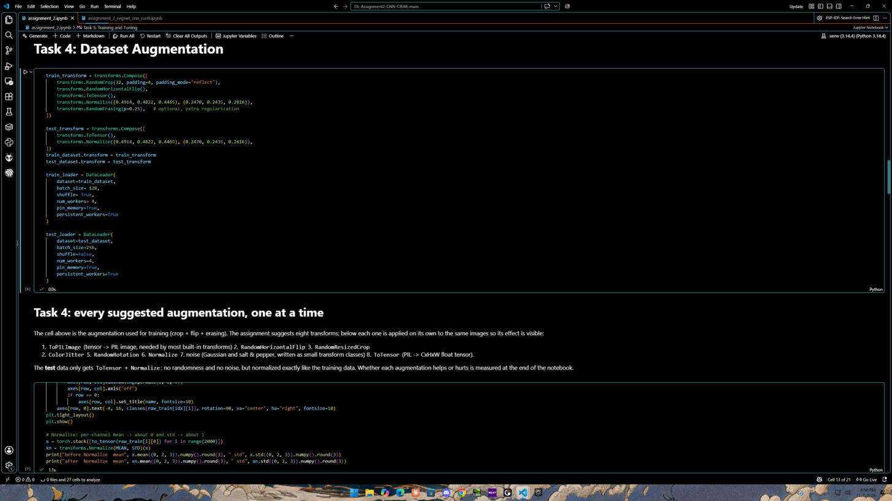
Figure 7: Training transform (random crop, flip, normalize, random erasing) and test transform (ToTensor + Normalize only)
Train vs. test: the training data gets random crop with 4-pixel reflect padding, horizontal flip, ToTensor, Normalize with the CIFAR-10 channel mean/std and RandomErasing. The test data only gets ToTensor and the same Normalize, with no randomness and no noise, exactly as the note in the instructions says.
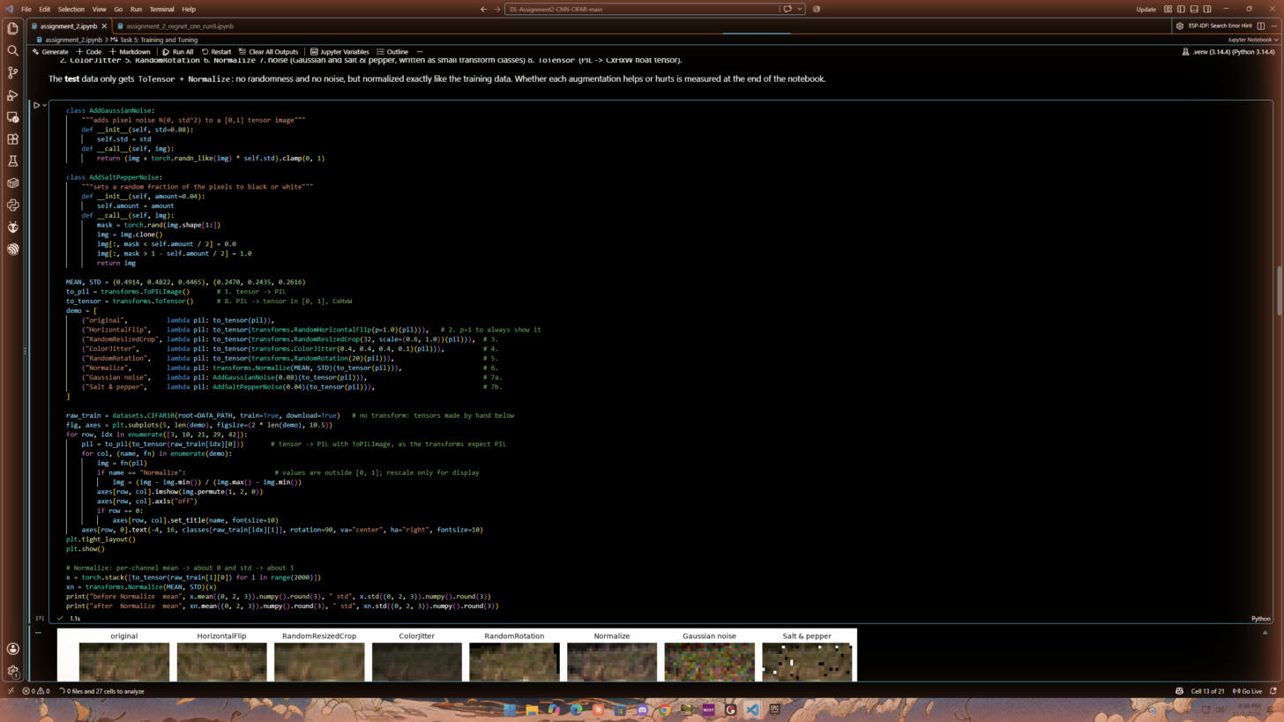
Figure 8: All eight suggested augmentations, including two noise transforms we wrote (Gaussian and salt & pepper)
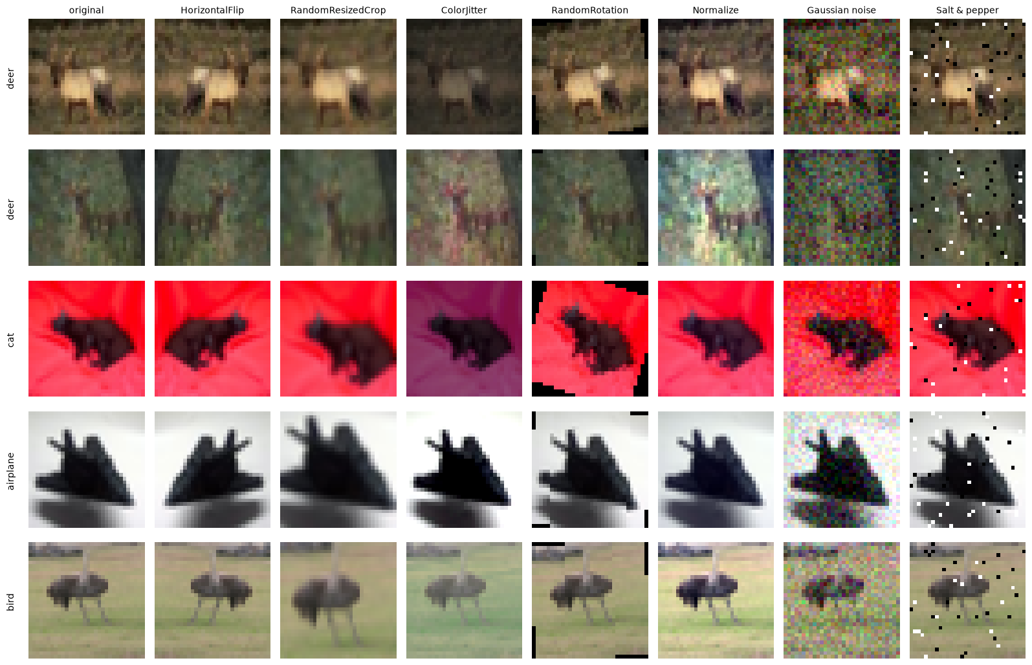
Figure 9: The same five training images under each augmentation
All eight suggestions are implemented: (1) ToPILImage converts the tensor to a PIL image, which the built-in transforms expect; (2) RandomHorizontalFlip; (3) RandomResizedCrop; (4) ColorJitter (brightness, contrast, saturation, hue); (5) RandomRotation; (6) Normalize; (7) noise: our own AddGaussianNoise (std 0.08) and AddSaltPepperNoise (4 % of pixels) classes; (8) ToTensor returns a C×H×W float tensor in [0, 1]. Normalize was checked numerically on 2,000 images: per-channel mean goes from [0.491, 0.484, 0.447] to [0.000, 0.006, 0.001] and std from [0.245, 0.242, 0.261] to [0.992, 0.995, 0.997].
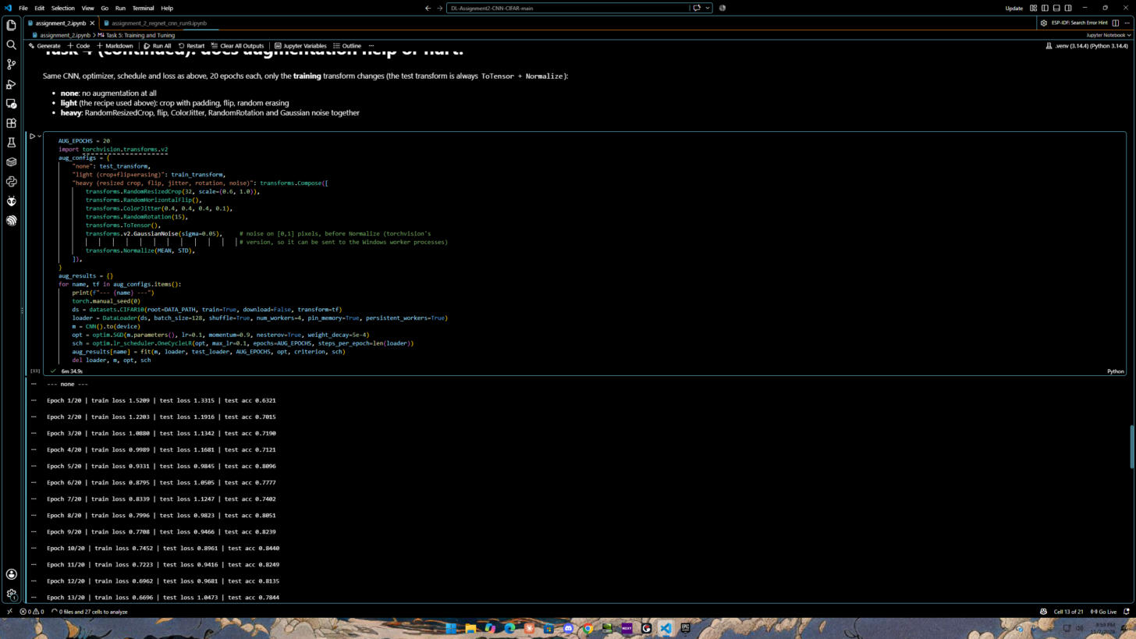
Figure 10: Does augmentation help or hurt? The same CNN is trained for 20 epochs with three different training transforms
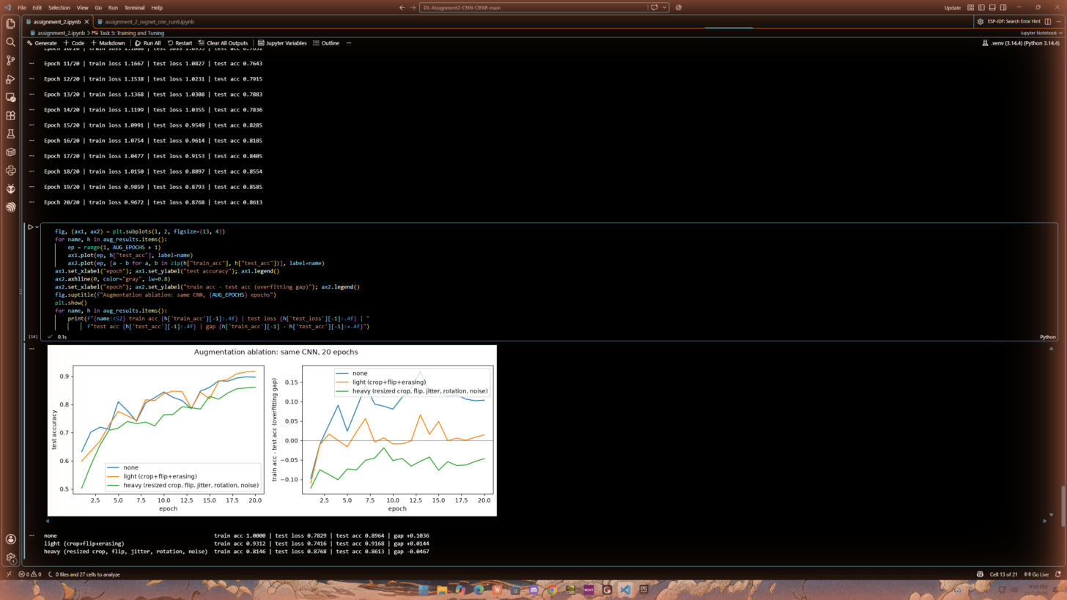
Figure 11: Test accuracy and overfitting gap (train acc − test acc) for each augmentation setting
Training augmentation (20 epochs, same CNN) | Train acc | Test loss | Test acc | Gap
None | 100.00 % | 0.7829 | 89.64 % | +10.36
Light: random crop + flip + random erasing | 93.12 % | 0.7416 | 91.68 % | +1.44
Heavy: resized crop + flip + jitter + rotation + Gaussian noise | 81.46 % | 0.8768 | 86.13 % | −4.67

Conclusion: augmentation can both help and hurt, as the assignment says. Without augmentation the network memorises the training set (100 % train accuracy, 10.4-point gap). Light augmentation closes the gap and gives the best test accuracy (+2.04 points). Heavy augmentation is too strong for this small CNN in 20 epochs: it under-fits (train accuracy below test accuracy) and test accuracy drops by 3.5 points. We therefore kept the light augmentation for the CNN.
Task 5: Training Function and Tuning hyperparameters
Instructions:
- Generally, it is useful to see how your training is going. Often people print their loss to make sure it goes down and their accuracy to make sure it goes up. But pictures are better than words. So for this part, you should record and plot the training loss, test loss, and test accuracy (and whatever else you want).
- Try different network architectures and experiment with hyperparameters.
Deliverables:
- Screenshot of your python source code that contains your training function with above requirements.
- What design that you tried worked the best? This includes things like network design, learning rate, batch size, number of epochs, and other optimization parameters, data augmentation etc.
- What was the final train loss? Test loss? Test Accuracy? Provide the plots for train loss, test loss, and test accuracy.
Our Work & Results
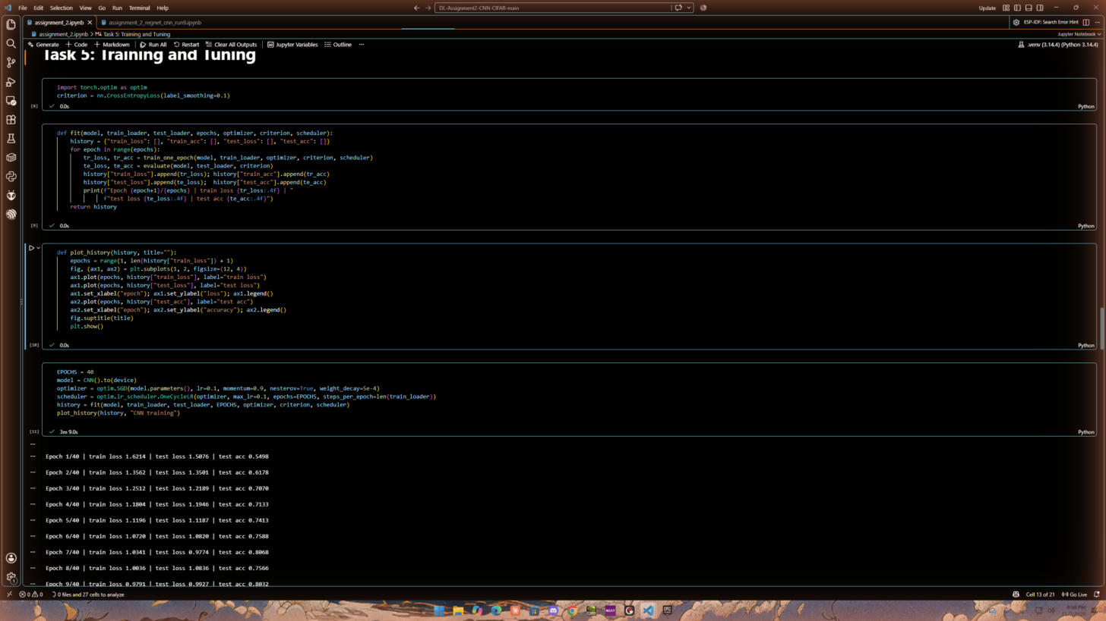
Figure 12: fit() records train loss, train accuracy, test loss and test accuracy every epoch; plot_history() plots them
fit() calls the training and test functions every epoch, stores the four values in a history dictionary and prints one debug line per epoch. plot_history() draws train loss vs. test loss and the test accuracy. Hyper-parameters for the CNN: SGD with Nesterov momentum 0.9, weight decay 5e-4, OneCycle learning-rate schedule with peak 0.1, batch size 128, 40 epochs, cross-entropy loss with label smoothing 0.1.
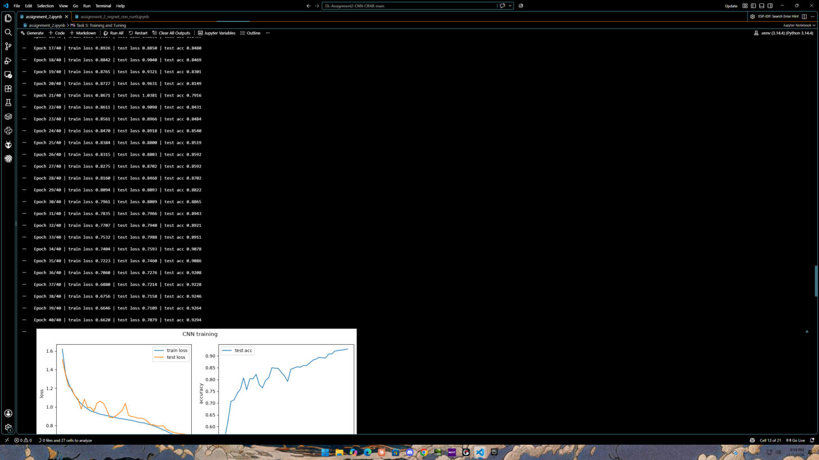
Figure 13: Training log of the CNN (40 epochs)
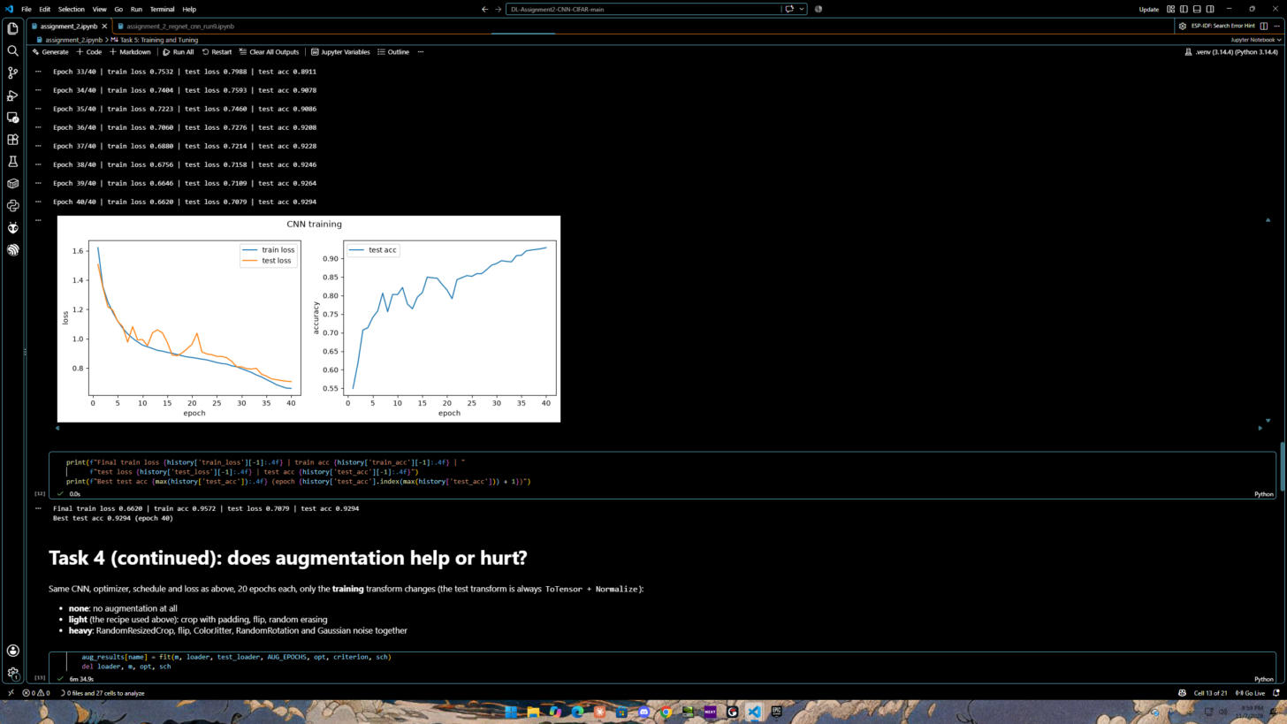
Figure 14: Train loss, test loss and test accuracy of the Task 2 CNN, and the final numbers
CNN result: final train loss 0.6620, test loss 0.7079, test accuracy 92.94 % (the best epoch is the last one, epoch 40; 40 epochs took 3 min 9 s on the RTX 5080). Train and test loss stay close, so with light augmentation the CNN does not overfit.
Different architectures and hyper-parameters we tried
The full log with the reason for every change is in EXPERIMENTS.md in the repository. Each run kept what worked in the previous one:
Run | What changed | Test acc
1 | Baseline CNN, Flatten + FC head, Adam lr 1e-3 constant, 30 epochs | 88.21 %
2 | SGD + Nesterov + weight decay, OneCycle LR, crop/flip/erasing, label smoothing, GAP head, 40 epochs (our Task 2–5 CNN) | 92.94 %
3 | ResNet-18 (skip connections), bf16 + channels_last, flip test-time augmentation (TTA), 60 epochs | 95.74 %
4 | ResNet-18 + AutoAugment + CutMix, 200 epochs (best from scratch) | 96.83 %
5 | ViT-B/16 pretrained (SWAG), full fine-tune, AdamW lr 5e-5, 10 epochs | 97.80 %
6 | ViT-L/16 pretrained, backbone frozen, only a linear classifier trained | 98.05 %
7 | ViT-L/16, linear probe 1 epoch, then fine-tune 3 epochs with layer-wise LR decay | 99.28 %
8 | Same as Run 7 with 5 fine-tune epochs (best) | 99.31 %
9 | RegNetY-32GF pretrained CNN, same LP-FT recipe, 45k/5k train/validation split | 98.62 %

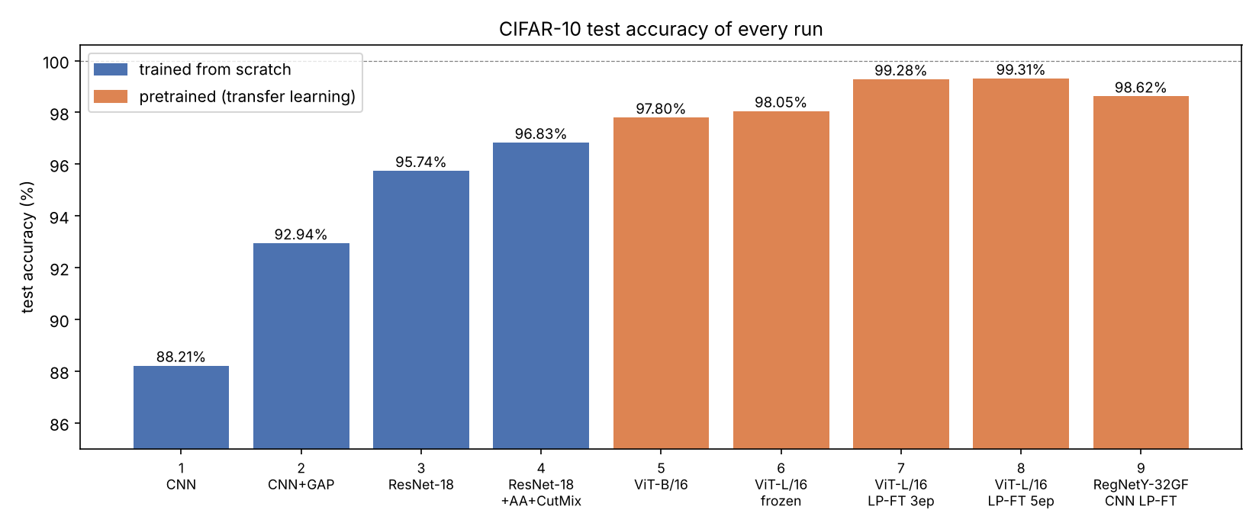
Figure 15: Test accuracy of every run
The design that worked best
- Network: ViT-L/16 (304 M parameters) with SWAG weights pretrained on 3.6 billion images, and a new zero-initialised 10-class linear head.
- Data: CIFAR images up-scaled 32 → 224 px (bicubic, on the GPU) and normalised with the ImageNet mean/std; augmentation = random crop + horizontal flip (light augmentation again worked best); flip TTA at test time.
- Stage 1, linear probe: backbone frozen, 1 epoch training only the head (AdamW lr 1e-3) → 97.79 %. A good head before touching the backbone avoids destroying the pretrained features (this is what went wrong in Run 5).
- Stage 2, fine-tuning: all layers, 5 epochs, AdamW, base LR 2e-5 for the head and top block, layer-wise LR decay 0.8 per block (patch embedding gets 7.6e-8), weight decay 0.05, OneCycle with 10 % warm-up, gradient clipping 1.0, label smoothing 0.1, bf16 mixed precision.
- Batch size: 32, processed as 2 chunks of 16 with gradient accumulation to fit in 16 GB of GPU memory.
Final numbers of the best design: final train loss 0.5039, test loss 0.5221, test accuracy 99.31 % with flip TTA (99.30 % without), i.e. 69 mistakes on the 10,000 test images. Per class: airplane 99.5, automobile 99.6, bird 99.4, cat 98.5, deer 99.3, dog 98.4, frog 99.8, horse 99.8, ship 99.8, truck 99.0 %. Cat and dog stay the hardest classes, as in every run.
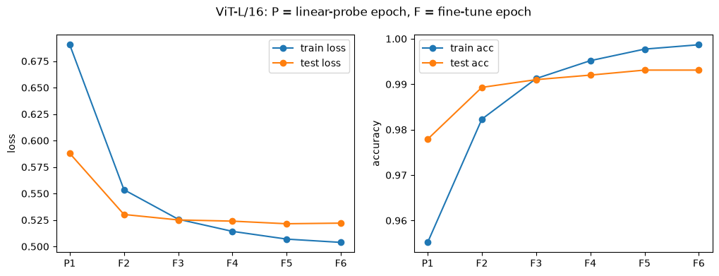
Figure 16: Best design (ViT-L/16 LP-FT): train loss, test loss and test accuracy for every epoch (P = linear-probe epoch, F = fine-tune epoch)
Best CNN: RegNetY-32GF (Run 9)
Because the assignment is about convolutional networks, we also applied the same two-stage recipe to the strongest pretrained CNN in torchvision, RegNetY-32GF (SWAG weights). This run holds out 5,000 training images as a validation set: the epoch is chosen on validation accuracy and the test set is only used to report the result, so this number is not tuned on the test set. Stage-wise LR decay 0.5 (stem → head), base LR 1e-4, 5 fine-tune epochs.
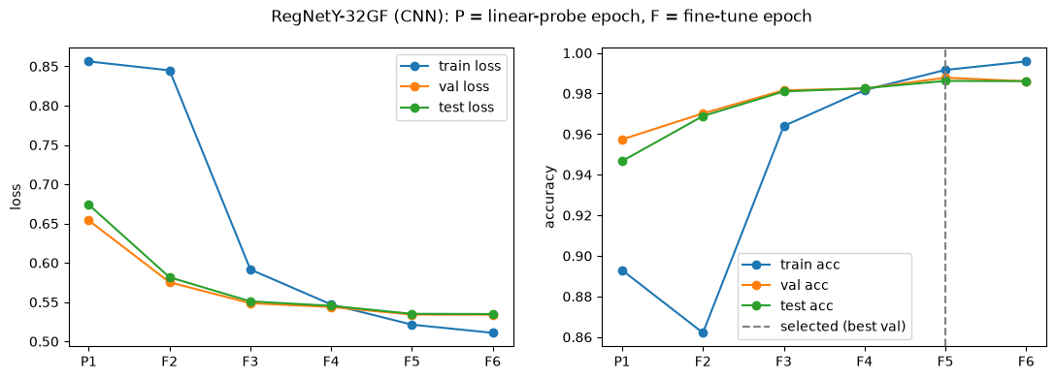
Figure 17: RegNetY-32GF: loss and accuracy per epoch on train, validation and test
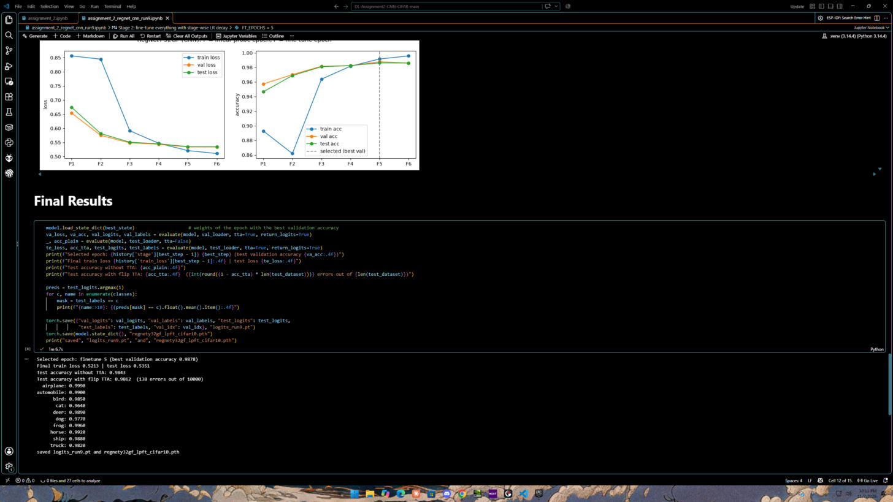
Figure 18: RegNetY-32GF final results on the test set
Run 9 result: selected epoch 5 of 6 (the 4th fine-tune epoch) (validation accuracy 98.78 %); final train loss 0.5213, test loss 0.5351, test accuracy 98.62 % with flip TTA (98.43 % without), 138 errors out of 10,000.
Why not exactly 100 %? The best published CIFAR-10 results are around 99.5 %. A few test images are ambiguous or wrongly labelled, so 100 % is not a realistic target; our 99.31 % is close to that limit.
Task 6: Save your source code
Instructions:
- Save your python source code.
Deliverable:
- Submit your Github link of your source code along with this document, which includes all screenshots via Blackboard.
Our Work & Results
GitHub repository: https://github.com/ImSleepingHere/DL-Assignment2-CNN-CIFAR
The whole project is Jupyter notebooks:
- assignment_2.ipynb: Tasks 1–5 (dataset, CNN, train/test functions, data visualisation, all augmentations and the augmentation experiment, training with plots).
- assignment_2_resnet_run3.ipynb, assignment_2_resnet_run4.ipynb: ResNet-18 from scratch.
- assignment_2_vit_run5.ipynb, assignment_2_vitl_linear_run6.ipynb, assignment_2_vitl_finetune_run7.ipynb, assignment_2_vitl_finetune_run8.ipynb: pretrained vision transformers (Run 8 is the best design).
- assignment_2_regnet_cnn_run9.ipynb: RegNetY-32GF pretrained CNN with a validation split.
- EXPERIMENTS.md (what was changed between runs and why), README.md, requirements.txt, and this report with all screenshots in report/.
The dataset (../dataset) and the trained weights (*.pth, hundreds of MB to GBs) are excluded with .gitignore; the notebooks download the data and recreate the weights.

Grading Rubric
Criterion | Excellent | Good | Developing | Poor | Marks
Task 1: Getting the CIFAR Dataset | Dataset loaded correctly with clear screenshot showing successful execution | Loaded correctly but screenshot is unclear | Dataset loaded with issues or incomplete evidence | Not loaded / missing screenshot | 0.5
Task 2: Defining the Network | All clear screenshots | Minor mistakes or missing small details | Several missing description or unclear screenshots | Not answered / incorrect / missing evidence | 2
Task 3: Loading Data | All clear screenshots | Minor mistakes or missing small details | Several missing description or unclear screenshots | Not loaded / missing screenshot | 0.5
Task 4: Dataset Augmentation | All datasets augmentation implemented | Major datasets augmentation implemented | Minor datasets augmentation implemented | Not done | 2
Task 5: Training Function and Tuning parameters | Tuning parameters and model architecture created, screenshot included, and results description explained accurately | Tuning parameters and model architecture correct but results description is weak | Tuning parameters and model architecture correct but incorrect results description | Not done | 2
Task 6: Save your source code | Source code saved successfully | Source code saved successfully but minor missing item | Source code save incomplete or file format incorrect | Not submitted / missing | 0.5
Total |  |  |  |  | 7.5

