**Explain each of the following**

**1. man**

**2. ls, echo, read**

**3. more, less, cat,**

**4. cd, mkdir, pwd, find**

**5. mv, cp, rm ,tar**

**6. wc, cut, paste**

**7. head, tail, grep, expr**

**8 chmod, chown**

**9. Redirections & Piping**

**10. useradd, usermod, userdel, passwd**

**11. df,top, ps**

**12 ssh, scp, ssh-keygen, ssh-copy-id**

**man**

Explanation: The man command is used to display the manual pages of other commands in Unix-like operating systems. These manual pages provide detailed information about command usage, options, syntax, and examples.

* Options:
  + -f: Display a one-line description of a command.
  + -k: Search for a keyword in the manual page descriptions.
  + -l: Specify the language for the manual page.
  + -w: Show the location of the manual page file.

**ls**

* Explanation: The ls command is used to list files and directories in the current directory.
* Options:
  + -a: Include hidden files in the listing.
  + -l: Use a long listing format to display detailed information.
  + -h: Display file sizes in human-readable format.
  + -t: Sort files by modification time.

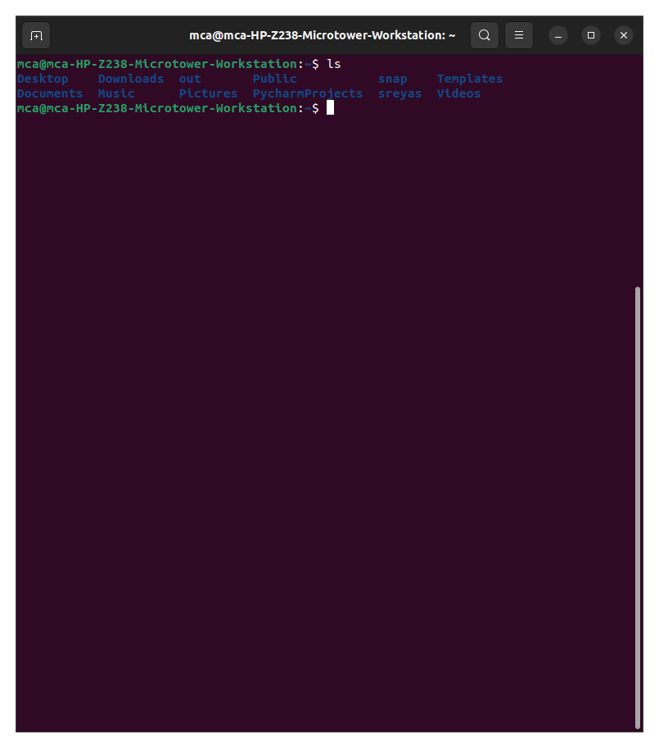

**echo**

* Explanation: The echo command is used to print text or variables to the terminal.
* Options: None significant.

Example: **echo "Hello, world!"**

**read**

* Explanation: The read command is used to read input from the user or from a file.
* Options: None significant.

Example**: read var_name**

**more**

* Explanation: The more command is used to display the contents of a file one screen at a time.
* Options: None significant.

Example: **more filename.txt**

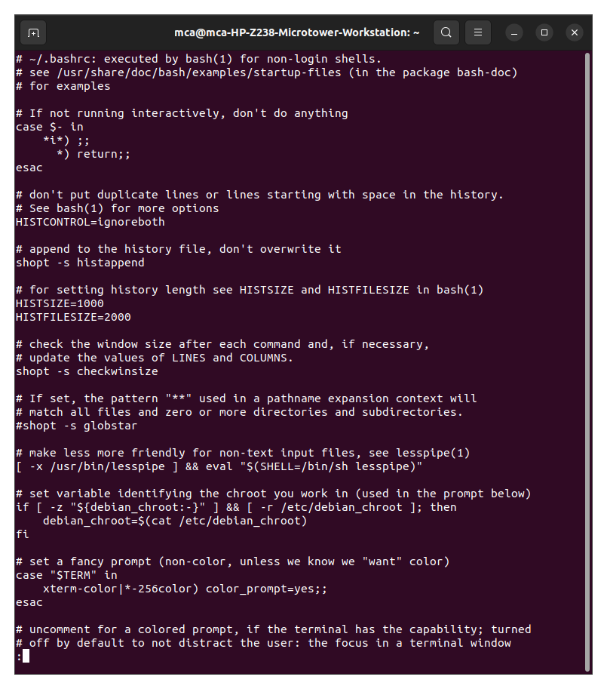

**less**

* Explanation: The less command is similar to more but allows backward scrolling and searching.
* Options:
  + -N: Display line numbers.
  + -i: Ignore case when searching.

Example: **less -N filename.txt**

**cat**

* Explanation: The cat command is used to concatenate and display the contents of files.
* Options:
  + **--show-all, -A:** It is the same as -vET.
  + **--number-nonblank, -b:** It shows the total non-empty output lines. Also, it overrides -n.
  + **-e:** It is the same as -vE.
  + **--show-ends, -E:** It shows the $ symbol at the completion of all lines.
  + **--number, -n:** It gives the total of every output line.
  + **--squeeze-blank, -s:** It suppresses redundant empty output lines.
  + **-t:** It is the same as -vT.
  + **--show-tabs, -T:** It shows TAB characters as ^|.
  + **-u:** ignored.
  + **--show-nonprinting, -v:** It uses M- and ^ notation, except TAB and LFD.
  + **--version:** It displays the information of the output version and exit.
  + **--help:** It shows the help menu and exit.

Example: **cat file1.txt**

**cd**

* Explanation: The cd command is used to change the current directory.
* Options:
  + -: This option allows switching to the previous directory.
  + ~ or --: These options switch to the user's home directory.
  + <directory>: This option specifies the directory to change to.
  + .. : To move to the parent directory.

Example: **cd /path/to/directory**

**mkdir**

* **Explanation:** The mkdir command is employed to create directories in Unix-like operating systems. It allows users to generate one or more directories at the specified location.
* **Options:**
  + -m, --mode=MODE: Sets the permissions (mode) of the created directory to the specified mode.
  + -p, --parents: Creates parent directories as needed.
  + -v, --verbose: Displays a message for each directory created.
  + --help: Displays help information about the mkdir command.
  + --version: Displays version information about the mkdir command.

Example: **mkdir documents**

**pwd**

* **Explanation**: The pwd command stands for "print working directory" and is used to print the current working directory.
* **Options**:
  + -L: Display the logical current working directory.
  + -P: Display the physical current working directory.
  + -h: Display help information about the pwd command.
  + -V: Display version information about the pwd command.

Example: **pwd**

Output: **/home/user/documents**

**find**

* **Explanation**: The find command is used to search for files and directories in a directory hierarchy based on various criteria.
* **Options**:
  + -name: Search for files with a specific name.
  + -type: Search for files of a specific type (e.g., directories, regular files).
  + -exec: Execute a command on each file found.

Example: **find /path/to/directory -name "*.txt"**

This command searches for all files with a ".txt" extension in the specified directory.

**mv**

* **Explanation**: The mv command is used to move or rename files and directories.
* **Options**:
  + -i: Prompt before overwriting existing files.
  + -u: Update the destination file only if it is older than the source file.

Example: **mv file1.txt directory/**

This command moves the file "file1.txt" to the "directory" directory.

**cp**

* **Explanation**: The cp command is used to copy files and directories.
* **Options**:
  + -r: Recursively copy directories and their contents.
  + -i: Prompt before overwriting existing files.

Example: **cp file1.txt file2.txt**

This command copies the contents of "file1.txt" to "file2.txt".

**rm**

* **Explanation**: The rm command is used to remove (delete) files and directories.
* **Options**:
  + -r: Recursively remove directories and their contents.
  + -f: Force removal without prompting for confirmation.

Example: **rm file1.txt**

This command removes the file "file1.txt".

**tar**

* **Explanation**: The tar command is used to create, list, extract, or update compressed archive files.
* **Options**:
  + -c: Create a new archive.
  + -x: Extract files from an archive.
  + -z: Compress or decompress the archive using gzip.

Example: tar -czvf archive.tar.gz directory/

This command creates a gzipped tar archive of the "directory" directory.

**wc**

* **Explanation**: The wc command is used to count lines, words, and characters in files.
* **Options**:
  + -l: Count lines.
  + -w: Count words.
  + -c: Count characters.

Example: **wc -l file.txt**

This command counts the number of lines in the file "file.txt".

**cut**

* **Explanation**: The cut command is used to extract sections from each line of files.
* **Options**:
  + -f: Select fields to extract.
  + -d: Specify a delimiter character.

Example: **cut -d',' -f1 file.csv**

This command extracts the first field from each line of a CSV file using a comma as the delimiter.

**paste**

* **Explanation**: The paste command is used to merge lines of files.
* **Options**:
  + -d: Specify a delimiter character.

Example: **paste file1.txt file2.txt**

This command merges corresponding lines from "file1.txt" and "file2.txt".

**head**

* Explanation: The head command is used to display the beginning of files.
* **Options**:
  + -n: Specify the number of lines to display.

Example: **head -n 10 file.txt**

This command displays the first 10 lines of the file "file.txt".

**tail**

* **Explanation**: The tail command is used to display the end of files.
* **Options**:
  + -n: Specify the number of lines to display.

Example: **tail -n 10 file.txt**

This command displays the last 10 lines of the file "file.txt".

**grep**

* **Explanation**: The grep command is used to search for text patterns in files.
* **Options**:
  + -i: Ignore case distinctions in the pattern and input files.
  + -r: Recursively search subdirectories.

Example: **grep -i "pattern" file.txt**

This command searches for the pattern "pattern" in the file "file.txt", ignoring case distinctions.

**expr**

* **Explanation**: The expr command evaluates expressions.
* **Options**:

Example: **expr 5 + 3**

This command evaluates the expression and outputs the result.

**chmod**

* **Explanation**: The chmod command is used to change the permissions of files and directories.
* **Options**:
  + u, g, o, a: Specify permissions for user, group, other, or all.
  + +, -, =: Add, remove, or set permissions.

Example: **chmod u+x file.sh**

This command adds execute permission for the owner of the file "file.sh".

**chown**

* Explanation: The chown command is used to change the owner and group of files and directories.
* Options:

Example: **chown user:group file.txt**

This command changes the owner and group of the file "file.txt" to "user" and "group".

**Redirections & Piping**

* **Explanation**: Redirections and piping are not standalone commands but rather features of the shell that allow users to control input and output streams of commands.
* **Concepts**:
  + >: Redirects output to a file, overwriting existing content.
  + >>: Redirects output to a file, appending to existing content.
  + <: Redirects input from a file.
  + |: Pipes the output of one command as input to another command.

Example: **cat file.txt | grep "pattern" > output.txt**

This command reads the contents of "file.txt", searches for the pattern "pattern", and writes the output to "output.txt".

**useradd**

* **Explanation**: The useradd command is used to create new user accounts.
* **Options**:
  + -m: Create the user's home directory.
  + -G: Add the user to supplementary groups.

Example: **useradd -m -G sudo newuser**

This command creates a new user "newuser" with a home directory and adds them to the "sudo" group.

**usermod**

* **Explanation**: The usermod command is used to modify user account settings.
* **Options**:
  + -aG: Add the user to additional groups.
  + -l: Change the username.

Example: **usermod -aG wheel newuser**

This command adds the user "newuser" to the "wheel" group.

**userdel**

* **Explanation**: The userdel command is used to delete user accounts.
* **Options**:
  + -r: Remove the user's home directory and mail spool.

Example: **userdel -r olduser**

This command deletes the user "olduser" and removes their home directory.

**passwd**

* **Explanation**: The passwd command is used to change user passwords.
* **Options**:

Example: **passwd username**

This command prompts the user to enter a new password for the specified username.

**df**

* **Explanation**: The df command is used to display disk space usage.
* **Options**:
  + -h: Display sizes in human-readable format.
  + -T: Display file system types.

Example: **df -h**

This command displays disk space usage in a human-readable format.

**top**

* Explanation: The top command is used to display system resource usage.
* Options: None significant.

Example: **top**

This command displays real-time information about system resource usage.

**ps**

* **Explanation**: The ps command is used to display information about active processes.
* **Options**:
  + -e: Display information about all processes.
  + -f: Display full-format listing.

Example: **ps -ef**

This command displays detailed information about all processes running on the system.

**ssh**

* **Explanation**: The ssh command is used to securely connect to remote servers.
* **Options**:
  + -p: Specify the port to connect to on the remote server.
  + -i: Specify the identity file (private key) for authentication.

Example: **ssh user@example.com**

This command establishes a secure shell connection to the remote server "example.com" as the user "user".

**scp**

* **Explanation**: The scp command is used to securely copy files between hosts.
* **Options**:
  + -r: Recursively copy directories and their contents.
  + -P: Specify the port to connect to on the remote server.

Example: **scp file.txt user@example.com:/path/to/destination/**

This command securely copies the file "file.txt" to the remote server "example.com" at the specified destination.

**ssh-keygen**

* **Explanation**: The ssh-keygen command is used to generate SSH key pairs.
* **Options**:
  + -t: Specify the type of key to generate (e.g., RSA, DSA, ECDSA).
  + -f: Specify the filename of the key pair.

Example: **ssh-keygen -t rsa -b 4096**

This command generates a 4096-bit RSA SSH key pair.

**ssh-copy-id**

* **Explanation**: The ssh-copy-id command is used to copy SSH public keys to remote hosts for passwordless authentication.
* **Options**:
  + None significant.

Example: **ssh-copy-id user@example.com**

This command copies the local SSH public key to the "authorized_keys" file on the remote server "example.com", enabling passwordless authentication.