**1. Prepare a short note on the following hardware components.**

a. Motherboard

b. Internal storage devices

i. RAM- different types

ii. ROM

iii. Hard Disk

c. SMPS

d. daughter cards

e. Bus slots

f. Interfacing ports

**Motherboard**

A motherboard is the central printed circuit board (PCB) in a computer that holds many of the crucial components of the system, including the CPU (Central Processing Unit), memory modules, expansion slots, connectors for peripherals, and other essential circuitry. It serves as the backbone of the computer, facilitating communication between all components. The motherboard determines the compatibility of various hardware components and influences the overall performance and capabilities of the system. It comes in various form factors, such as ATX, microATX, and Mini-ITX, to accommodate different sizes of computer cases and configurations. In summary, the motherboard is like the foundation of a computer, providing the necessary connections and infrastructure for all other components to function together harmoniously.

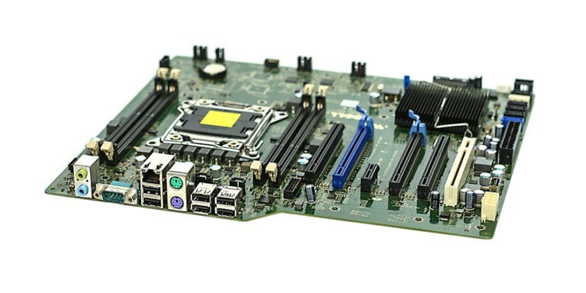

**Internal storage devices**

**i. RAM (Random Access Memory) - Different Types:**

RAM, or Random Access Memory, is a type of volatile memory used by computers to temporarily store data and instructions that the CPU (Central Processing Unit) needs to access quickly.

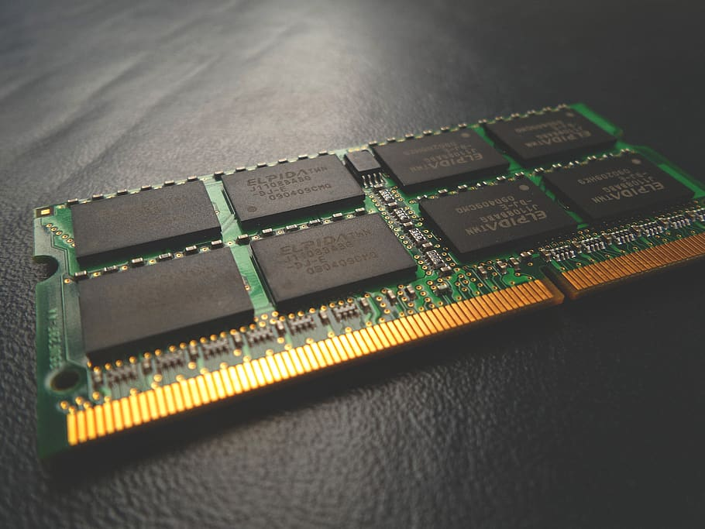

**DRAM (Dynamic RAM):**

- DRAM is the most common type of RAM used in modern computers.

- It requires periodic refreshing to maintain data integrity.

- DRAM is relatively inexpensive but has higher latency compared to other types.

**SRAM (Static RAM):**

- SRAM is faster and more expensive than DRAM.

- It does not require refreshing like DRAM, which makes it faster but also more power-hungry.

- SRAM is often used in cache memory due to its speed.

**DDR SDRAM (Double Data Rate Synchronous DRAM):**

- DDR SDRAM synchronizes data transfers to the rising and falling edges of the clock signal, effectively doubling the data transfer rate compared to traditional SDRAM.

- Different generations of DDR SDRAM (e.g., DDR, DDR2, DDR3, DDR4, DDR5) offer improvements in speed and efficiency.

**ii. ROM (Read-Only Memory):**

ROM, or Read-Only Memory, is a type of non-volatile memory used in computers and other electronic devices to store data that is essential for their operation.

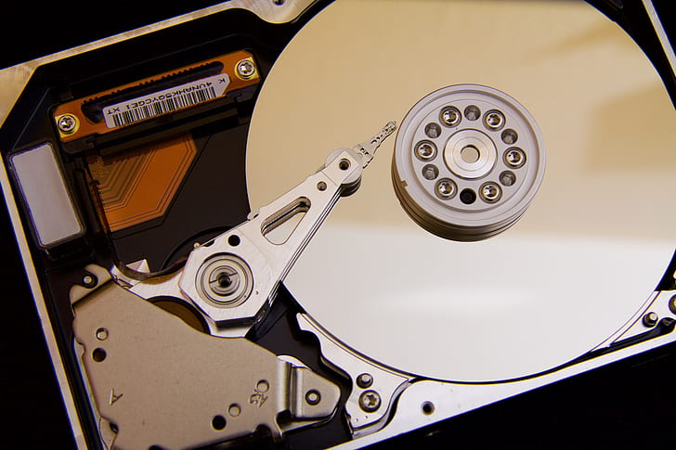

**Mask ROM (MROM):**

- Mask ROM is programmed during the manufacturing process and cannot be modified afterward.

- It is commonly used to store firmware and essential system software in devices like embedded systems, gaming consoles, and appliances.

**EPROM (Erasable Programmable Read-Only Memory):**

- EPROM can be programmed and erased multiple times using ultraviolet light.

- To program an EPROM, a special device called a EPROM programmer is used to burn data onto the chip.

- Once programmed, an EPROM retains its data even when the power is turned off.

- EPROMs were commonly used in early computers and electronic devices but have been largely replaced by EEPROM and flash memory.

**EEPROM (Electrically Erasable Programmable Read-Only Memory):**

- EEPROM can be programmed and erased electrically, making it more convenient than EPROM.

- Unlike EPROM, EEPROM does not require exposure to ultraviolet light for erasure.

- EEPROM is commonly used to store BIOS settings, firmware updates, and other configuration data in computers, smartphones, and other electronic devices.

**Flash Memory:**

- Flash memory is a type of EEPROM that can be erased and reprogrammed in blocks instead of one byte at a time.

- It is widely used in USB flash drives, memory cards, SSDs (Solid State Drives), and other storage devices.

- Flash memory is non-volatile, meaning it retains data even when the power is turned off.

- There are different types of flash memory, including NAND flash and NOR flash, each with its own characteristics and applications.

**iii. Hard Disk:**

A hard disk, commonly known as a hard disk drive (HDD), is a type of data storage device used in computers and other electronic devices. It consists of one or more rigid magnetic disks (platters) coated with a magnetic material, which store data in binary form (0s and 1s). An HDD also includes read/write heads that move across the spinning platters to read and write data.

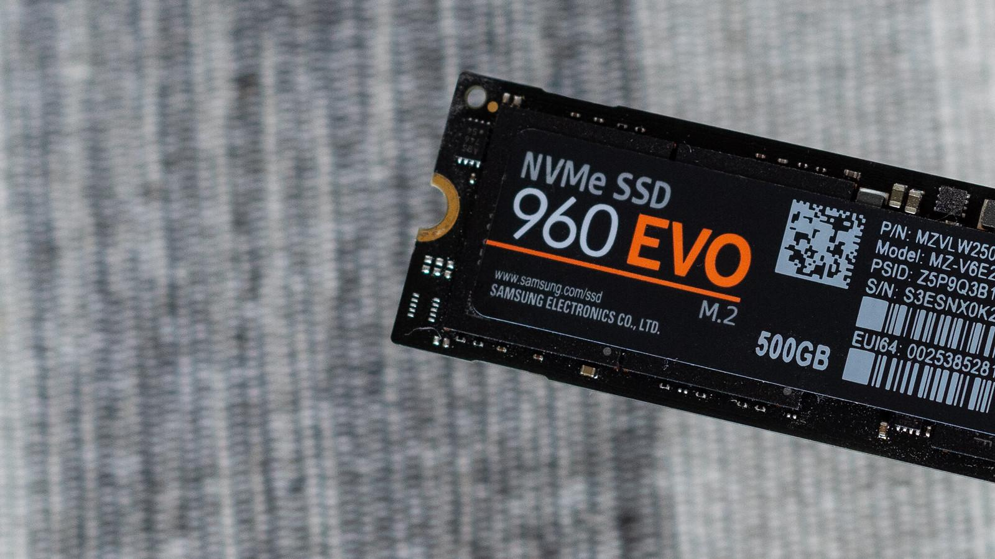

**Hard Disk Drive (HDD):**

- HDDs use spinning magnetic disks (platters) to store data.

- They offer high storage capacities at relatively low costs per gigabyte.

- HDDs are commonly used for storing large amounts of data, such as multimedia files and software installations.

**Solid State Drive (SSD):**

- SSDs use flash memory to store data, offering much faster read and write speeds compared to HDDs.

- They have no moving parts, making them more durable and energy-efficient.

- SSDs are commonly used as boot drives and for storing frequently accessed files and applications due to their speed.

**NVMe SSD (Non-Volatile Memory Express SSD):**

- NVMe SSDs are a type of SSD that connects to the computer via the PCIe (Peripheral Component Interconnect Express) interface.

- They offer even higher speeds compared to traditional SSDs, making them ideal for demanding tasks such as gaming and video editing.

**SMPS (Switched-Mode Power Supply) in Computers**

SMPS, or Switched-Mode Power Supply, is a crucial component in modern computers responsible for converting AC (Alternating Current) power from the mains electricity into DC (Direct Current) power required by the computer's internal components.

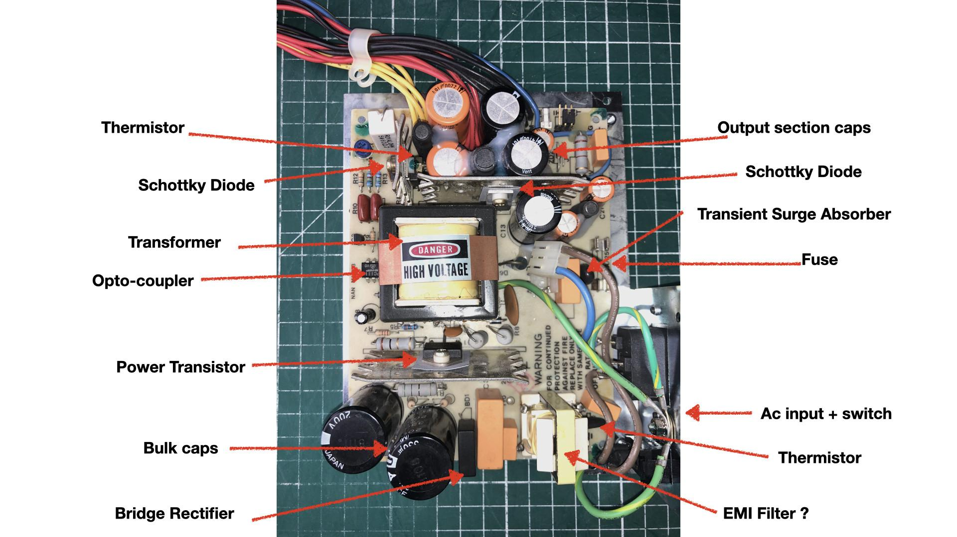

**Functionality:**

- SMPS efficiently converts the high-voltage AC power from the electrical outlet into lower-voltage DC power suitable for the computer's operation.

- It regulates the output voltage and current to ensure stable and consistent power delivery to the computer's components, including the motherboard, CPU, GPU, and drives.

**Design:**

- SMPS uses high-frequency switching circuits, such as buck, boost, and flyback converters, to convert AC to DC power efficiently.

- It typically consists of various components, including transformers, rectifiers, capacitors, and transistors, to perform the voltage conversion and regulation processes.

**Advantages:**

- Efficiency: SMPS operates at high efficiency levels, resulting in reduced power consumption and heat generation compared to traditional linear power supplies.

- Size and Weight: SMPS are generally smaller and lighter than linear power supplies, making them suitable for compact computer designs.

- Flexibility: SMPS can support a wide range of input voltages and frequencies, allowing computers to operate in different regions with varying electrical standards.

**Importance in Computers:**

- SMPS is a critical component in computers, providing stable and reliable power to ensure the proper functioning of all internal components.

- It protects sensitive electronics from voltage fluctuations and power surges, preventing potential damage to the computer hardware.

- SMPS plays a significant role in overall system stability, performance, and longevity.

**Daughter Cards**

Daughter cards, also known as expansion cards or daughterboards, are additional circuit boards that are connected to the mainboard (motherboard) of a computer or electronic device.

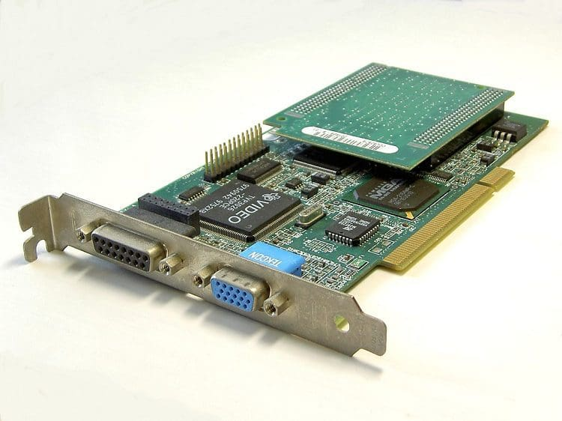

**Function:**

- Daughter cards serve various purposes, such as adding functionality, expanding capabilities, or providing additional interfaces to the mainboard.

- They can include components such as integrated circuits, connectors, and ports to perform specific tasks or connect to external devices.

**Types:**

- Expansion Cards: Daughter cards used to add new features or functionality to a system, such as graphics cards (GPU), network interface cards (NIC), sound cards, and USB/FireWire expansion cards.

- Interface Cards: Daughter cards that provide additional ports or connectors for connecting peripherals or external devices, such as USB expansion cards, SATA expansion cards, and serial/parallel port cards.

- Modem Cards: Daughter cards that contain modem components for connecting to a telephone line for data communication.

- RAID Cards: Daughter cards used to add RAID (Redundant Array of Independent Disks) functionality to a system for data storage and redundancy.

**Installation:**

- Daughter cards are typically inserted into expansion slots on the mainboard, such as PCI (Peripheral Component Interconnect), PCIe (PCI Express), or AGP (Accelerated Graphics Port) slots.

- They are securely connected to the mainboard using screws or clips and may require additional power connections depending on their power requirements.

**Benefits:**

- Daughter cards allow for customization and expansion of a system's capabilities without the need to replace the entire mainboard.

- They provide flexibility and scalability, allowing users to add or upgrade specific features as needed.

- Daughter cards can enhance system performance, connectivity, and functionality to meet specific requirements or user preferences.

**Limitations**:

- The number and type of expansion slots available on the mainboard may limit the number and compatibility of daughter cards that can be installed.

- Some daughter cards may require additional drivers or software installation to function properly, depending on the operating system and hardware compatibility.

**Bus Slots**

In computing, bus slots are physical or electrical interfaces on a computer's motherboard or expansion cards that allow for the connection of various peripheral devices

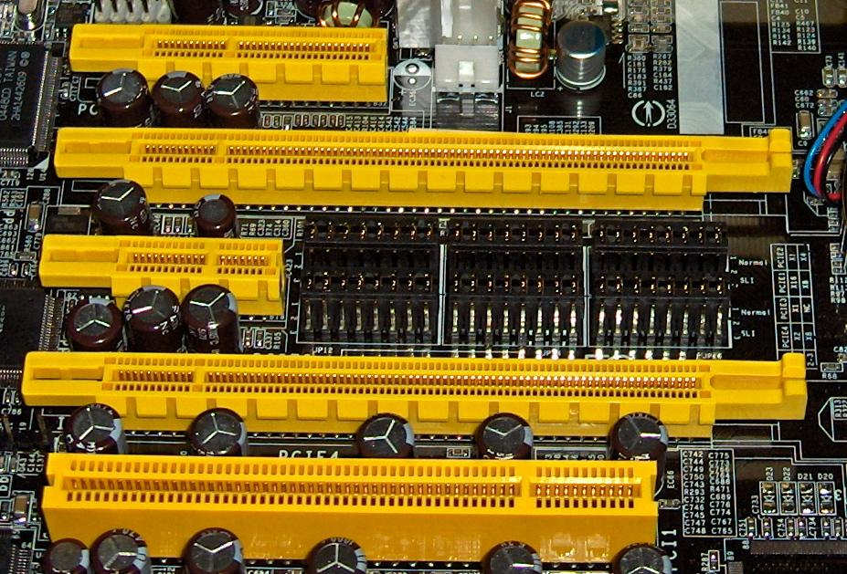

Functionality:

* + Bus slots provide a means for expansion and connectivity within a computer system. They allow peripheral devices, such as expansion cards, to communicate with the CPU and other components on the motherboard.
  + Different types of bus slots support different data transfer rates, protocols, and form factors, catering to various types of expansion cards and peripherals.
* Types:
  + PCI (Peripheral Component Interconnect): PCI slots were one of the earliest types of bus slots and were widely used for connecting expansion cards such as sound cards, network cards, and graphics cards. They come in various versions, including PCI, PCI-X, and PCI Express (PCIe).
  + PCI Express (PCIe): PCIe is the most common type of bus slot in modern computers. It offers higher data transfer rates and improved performance compared to traditional PCI slots. PCIe slots come in different sizes, including x1, x4, x8, and x16, referring to the number of data lanes available for communication.
  + AGP (Accelerated Graphics Port): AGP slots were specifically designed for connecting graphics cards and providing high-speed data transfer between the GPU and CPU. However, AGP has been largely replaced by PCIe for modern graphics cards.
  + ISA (Industry Standard Architecture): ISA slots were prevalent in older computer systems but are now obsolete. They were used for connecting expansion cards such as sound cards, modems, and network adapters.
  + Other Interfaces: Other bus slot interfaces include USB (Universal Serial Bus), SATA (Serial ATA), and M.2 slots for connecting storage devices, network adapters, and other peripherals.
* Installation:
  + Expansion cards are inserted into the corresponding bus slots on the motherboard. Each slot has a specific shape and size to accommodate compatible expansion cards.
  + Once inserted, expansion cards are secured in place using screws or clips to ensure proper connectivity and stability.

Usage:

* + Bus slots are used to expand the functionality of a computer system by adding additional features or connectivity options. Common expansion cards include graphics cards, sound cards, network adapters, storage controllers, and USB expansion cards.

**Interfacing Ports**

Interfacing ports, also known as input/output (I/O) ports, are physical connectors on a computer or electronic device that allow for communication with external devices

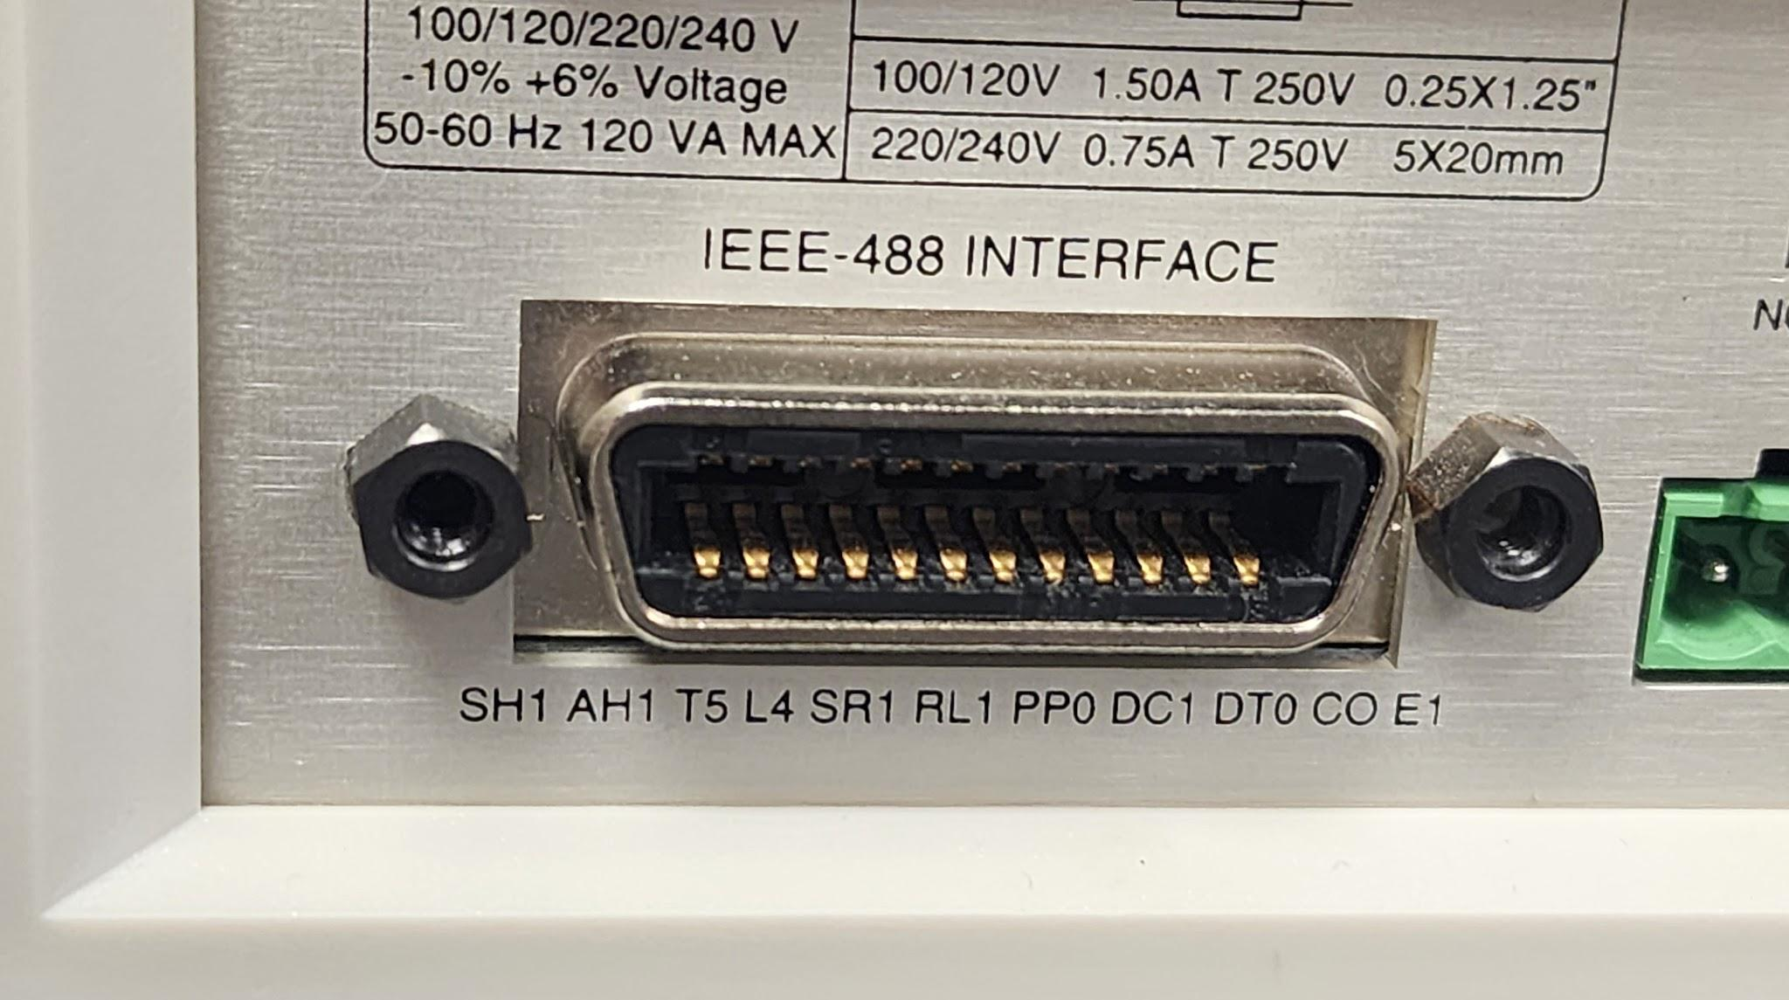

Functionality:

* + Interfacing ports facilitate the transfer of data, signals, and power between a computer or device and external peripherals or accessories.
  + They serve as interfaces for connecting input devices (such as keyboards, mice, and scanners), output devices (such as monitors, printers, and speakers), storage devices (such as USB drives and external hard drives), and networking devices (such as Ethernet cables and Wi-Fi adapters).
* Types:
  + USB (Universal Serial Bus): USB ports are versatile and widely used for connecting a variety of peripherals, including keyboards, mice, printers, external storage devices, and smartphones. They support hot-swapping and provide power for charging devices.
  + HDMI (High-Definition Multimedia Interface): HDMI ports transmit high-definition audio and video signals between a computer or device and an external display, such as a monitor or television.
  + VGA (Video Graphics Array): VGA ports are older analog video ports used for connecting monitors and projectors to computers. They are gradually being replaced by digital interfaces like HDMI and DisplayPort.
  + Ethernet (RJ45): Ethernet ports enable wired network connectivity, allowing computers to connect to local area networks (LANs), routers, switches, and modems for internet access.
  + Audio Jacks: Audio ports, including headphone jacks and microphone jacks, allow for audio input and output, facilitating connections with headphones, speakers, microphones, and audio recording devices.
  + Thunderbolt: Thunderbolt ports provide high-speed data transfer and video output capabilities, often found on Mac computers and high-end PCs. They support daisy-chaining and can connect to various peripherals, including displays, external storage, and docking stations.
  + Serial and Parallel Ports: These older ports were used for connecting serial devices (e.g., mice, modems) and parallel devices (e.g., printers, scanners) but are less common in modern computers due to the prevalence of USB and other interfaces.
* Installation and Use:
  + Peripherals are connected to interfacing ports by inserting compatible cables or connectors into the corresponding ports on the computer or device.
  + Each port type has a specific shape and size to ensure proper connectivity, with some ports featuring keyed connectors or locking mechanisms for secure attachment.
  + Once connected, devices can communicate with the computer or device, allowing for data transfer, input/output operations, and device control.

**2. Write the specification for a desktop computer**

**Processor (CPU):**

- Type: Multi-core processor (e.g., Intel Core i5, AMD Ryzen 5)

- Clock Speed: Minimum of 2.5 GHz base frequency

- Cache: L3 cache size of at least 6 MB

**Memory (RAM):**

- Type: DDR4

- Capacity: 8 GB (expandable to 16 GB or more)

- Speed: Minimum of 2400 MHz

**Storage:**

- Primary Storage: Solid State Drive (SSD)

- Capacity: 256 GB (or higher for increased storage needs)

- Interface: SATA or NVMe PCIe for faster performance

- Secondary Storage: Hard Disk Drive (HDD)

- Capacity: 1 TB (or higher for additional storage)

- Speed: 7200 RPM (for faster data access)

**Graphics Processing Unit (GPU):**

- Integrated GPU (for basic tasks):

- Intel UHD Graphics 630 (or equivalent)

- Discrete GPU (for gaming or graphics-intensive tasks):

- NVIDIA GeForce GTX 1650 (or equivalent)

- Dedicated Video Memory: Minimum of 2 GB GDDR5

**Motherboard:**

- Form Factor: ATX or Micro ATX

- Expansion Slots: PCIe x16, PCIe x1

- Connectivity: USB 3.0/3.1, HDMI, DisplayPort, Ethernet

**Operating System:**

- Windows 10 Home (64-bit) or Fedora Linux (Fedora workstation 39)

**Networking:**

- Ethernet: Gigabit Ethernet (10/100/1000 Mbps)

- Wireless: Wi-Fi 802.11ac (dual-band) or Wi-Fi 6 (optional)

**Ports:**

- USB Ports: Minimum of 4 USB 3.0/3.1 ports, 2 USB 2.0 ports

- Audio Ports: Headphone jack, microphone jack

- Video Ports: HDMI, DisplayPort

**Optical Drive:**

- DVD-RW drive (optional)

**Power Supply:**

- Wattage: 450W (or higher) 80 Plus Bronze certified for efficiency

**Case:**

- Form Factor: Mid Tower

- Cooling: Front and rear fans for airflow, optional liquid cooling support

**Keyboard and Mouse:**

- Wired or wireless keyboard and mouse combo included

**Monitor:**

- Size: 24 inches (or larger) LED monitor with Full HD resolution (1920 x 1080)

**3. Write the specification for a server computer.**

**Processor (CPU):**

- Type: Dual or Multi-core server-grade processor (e.g., Intel Xeon, AMD EPYC)

- Clock Speed: Minimum of 2.0 GHz base frequency

- Cores/Threads: Multiple cores per CPU for parallel processing

**Memory (RAM):**

- Type: ECC (Error-Correcting Code) Registered DDR4

- Capacity: 32 GB (expandable to several terabytes)

- Speed: Minimum of 2666 MHz

**Storage:**

- Primary Storage: Solid State Drive (SSD) or NVMe SSD (for OS and critical applications)

- Capacity: 500 GB (or higher for increased performance)

- Secondary Storage: Hard Disk Drives (HDDs) or SSDs (for data storage and backups)

- Capacity: Multiple drives, totaling several terabytes or more

- RAID Configuration: RAID 5 or RAID 10 for data redundancy and performance

**Networking:**

- Ethernet: Gigabit Ethernet (10/100/1000 Mbps) or 10 Gigabit Ethernet (10GbE)

- Dual NICs (Network Interface Controllers) for redundancy and load balancing

- Support for network protocols such as TCP/IP, DHCP, DNS, and SNMP

**Expansion Slots:**

- PCIe Slots: Multiple PCIe x16 or x8 slots for additional network cards, storage controllers, or specialized hardware

**Operating System:**

- Server Operating System: Windows Server, Linux (e.g., Ubuntu Server, CentOS), or FreeBSD

- Hypervisor: Optional support for virtualization platforms like VMware ESXi, Microsoft Hyper-V, or KVM

**Remote Management:**

- Integrated Lights-Out (iLO) or Intelligent Platform Management Interface (IPMI) for remote server management and monitoring

- Remote Console Access: Remote Desktop Protocol (RDP) or Virtual Network Computing (VNC)

**Power Supply:**

- Redundant Power Supplies: Dual or more for high availability

- Wattage: Sufficient wattage to handle peak loads, with support for redundant power sources and hot-swappable components

**RAID Controller:**

- Hardware RAID controller with battery backup or flash-backed cache for data protection and performance optimization

**Form Factor:**

- Rackmountable: 1U, 2U, or 4U form factor for installation in server racks

**Cooling:**

- Redundant cooling fans with hot-swappable design for continuous operation and thermal management

**Security:**

- Trusted Platform Module (TPM) for hardware-based security features

- Secure Boot support to prevent unauthorized software execution

**Backup and Disaster Recovery:**

- Support for automated backup solutions, including cloud-based and on-premises backups

- Disaster recovery planning and implementation, including redundant data centers and failover mechanisms

**4. Write a short note on the following.**

**a. Operating System**

**b. Linux**

**c. Ubuntu**

**d. Virtual Machine**

**e. Kernel**

**f. Shell**

**g. Terminal**

**h. Bash**

**i. Shell scripting**

**Operating System (OS)**

An operating system is software that manages computer hardware and provides services for computer programs. It acts as an intermediary between users and the computer hardware, facilitating communication and interaction. The OS manages tasks such as memory allocation, process scheduling, file management, and device control. Examples of popular operating systems include Windows, macOS, and Linux.

**Linux**

Linux is a family of open-source Unix-like operating systems based on the Linux kernel. It was developed by Linus Torvalds in 1991 and has since become widely adopted for various purposes, including servers, desktops, embedded systems, and mobile devices. Linux distributions, or "distros," package the Linux kernel with additional software components and tools to create complete operating systems tailored for specific use cases.

**Ubuntu**

Ubuntu is a popular Linux distribution based on Debian. It is known for its ease of use, stability, and extensive software repositories. Ubuntu comes with a variety of desktop environments, including GNOME, KDE, and Xfce, catering to different user preferences. It is widely used for both desktop and server environments and is supported by a large community of developers and users.

**Virtual Machine (VM)**

A virtual machine is a software emulation of a physical computer that runs an operating system and applications as if they were installed on real hardware. VMs are created using virtualization software such as VirtualBox, VMware, or KVM/QEMU. They provide benefits such as hardware abstraction, isolation, and flexibility, allowing users to run multiple operating systems or instances on a single physical machine.

**Kernel**

The kernel is the core component of an operating system that manages hardware resources and provides essential services to other software components. It acts as an intermediary between the hardware and software layers, handling tasks such as process management, memory management, device drivers, and system calls. The Linux kernel, for example, is responsible for managing hardware resources in Linux-based operating systems.

**Shell**

A shell is a command-line interface that allows users to interact with the operating system by entering commands and executing scripts. It interprets user input and executes commands or programs accordingly. Examples of popular shells include Bash (Bourne Again Shell), Zsh (Z Shell), and PowerShell (for Windows). Shells provide features such as scripting, command history, and environment customization.

**Terminal**

A terminal is a text-based interface used to access the shell and run commands on a computer system. It provides a window or console where users can type commands and view the output. Terminals are commonly used on Unix-like operating systems, including Linux and macOS, although they are also available on Windows through applications like Command Prompt and PowerShell.

**Bash**

Bash, or Bourne Again Shell, is a widely used command-line shell and scripting language for Unix-like operating systems. It is the default shell for many Linux distributions and macOS. Bash provides features such as command-line editing, job control, and shell scripting capabilities, making it a powerful tool for system administration and automation tasks.

**Shell Scripting**

Shell scripting refers to writing scripts or programs in a shell language (such as Bash) to automate tasks, perform system administration, or execute commands sequentially. Shell scripts can contain commands, control structures (e.g., loops, conditionals), variables, and functions. They are commonly used to automate repetitive tasks, configure system settings, and create custom utilities on Unix-like operating systems.

**5. Steps to create a Shell Script in linux.**

1. **Choose a Text Editor**

Select a text editor to write your shell script. Common choices include nano, vi, vim, or gedit. You can use any text editor you're comfortable with.

1. **Open the Text Editor**

Open the chosen text editor in the terminal. For example, to open the nano editor, you can type `nano` followed by the name of your script file. If the file doesn't exist, it will be created.

**nano myscript.sh**

1. **Write Your Script**

Write your shell script in the text editor. Start by adding the necessary shebang line at the top of the file to specify the interpreter to use (e.g., Bash).

**#!/bin/bash**

**# Your shell script commands go here**

**echo "Hello, world!"**

1. **Save the Script**

Save your script by pressing `Ctrl` + `O` (for nano) or following the editor's save instructions. Provide a filename with the `.sh` extension to indicate that it's a shell script.

1. **Set Execution Permissions (Optional)**

If you want to execute your script directly, you need to give it execute permissions. You can do this using the `chmod` command.

**chmod +x myscript.sh**

1. **Execute the Script**

Run your script by typing its filename preceded by `./` in the terminal.

**./myscript.sh**

Alternatively, you can run the script by specifying the shell interpreter followed by the script filename.

**bash myscript.sh**

1. **Review Output**

After executing the script, review the output in the terminal to ensure it behaves as expected. If there are any errors, you may need to edit and modify your script accordingly.

1. **Edit and Iterate (If Necessary)**

If your script doesn't produce the desired results, you can edit and modify it in the text editor, then save the changes and rerun the script to test the modifications.

**6. What is the extension of shell script.**

The extension commonly used for shell scripts is "**.sh**".

For example, if you have a shell script named "**myscript**", the full filename with the extension would be "**myscript.sh**".

The presence of the ".sh" extension is not mandatory for a shell script to function. The extension primarily serves as a convention to indicate that the file contains a script written in a shell language (such as Bash) and may help users identify the type of file and its purpose.

**7. What is shebang ?**

The shebang, also known as a hashbang or pound-bang, is a special character sequence at the beginning of a script file that specifies the path to the interpreter for executing the script. In Unix-like operating systems, including Linux and macOS, the shebang is denoted by the characters "#!" followed by the path to the interpreter.

For example, in a shell script written in Bash, the shebang line typically looks like this

**#!/bin/bash**

This line indicates that the script should be executed using the Bash shell interpreter located at /bin/bash**.**

**8. How to put your comments in your script.**

To add comments to your script in a Unix-like shell (such as Bash), you can use the # symbol.

Example:

#This is a comment in the shell script.

**9. How to execute a shell script.**

To execute a shell script in a Unix-like operating system (such as Linux or macOS), you need to follow these steps:

Navigate to the Directory Containing the Script:

* Open a terminal window and use the cd command to navigate to the directory where your shell script is located. For example:

**cd /path/to/directory**

Ensure the Script Has Execution Permissions (Optional):

* If the script file does not already have execution permissions, you need to grant them using the chmod command. Replace script.sh with the name of your script file.

**chmod +x script.sh**

Execute the Script:

* Once you're in the directory containing the script, you can execute it by typing its name preceded by ./. Replace script.sh with the name of your script file.

**./script.sh**

* If the script is located in a different directory, you can specify the full path to the script instead of navigating to its directory. For example:

**/path/to/script.sh**

Review the Output:

* After executing the script, review the output in the terminal. The script may produce output, display messages, or perform tasks depending on its functionality.
* Troubleshooting:
  + If you encounter any errors, review the script for syntax errors or logical mistakes.
  + Ensure that the script file has the correct permissions for execution. If not, use the chmod command to grant execution permissions.
  + Check that the shebang line (#!/bin/bash for a Bash script) is correctly specified at the beginning of the script file.

**10. Write a shell script to display your name .**

Open a Text Editor:

* Open a text editor of your choice, such as Nano, Vim, or Gedit. You can use the following command to open Nano:

nano display_name.sh

Write the Script:

* In the text editor, write the following lines to create the script:

**#!/bin/bash**

**# Displaying name**

**echo "My name is Sreyas"**

* This script starts with a shebang line #!/bin/bash to specify the Bash interpreter, followed by a comment indicating that the script displays your name using the echo command.

Save the Script:

* Save the script by pressing Ctrl + O (to write out) and then Enter in Nano. Provide a filename for the script, such as display_name.sh, and confirm the save operation by pressing Enter.

Exit the Text Editor:

* After saving the script, exit the text editor by pressing Ctrl + X in Nano.

Grant Execution Permissions (If Necessary):

* If the script file does not have execution permissions, grant them using the following command:

**chmod +x display_name.sh**

Execute the Script:

* Finally, execute the script by running the following command:

**./display_name.sh**

* This command runs the script, and you should see the output:

My name is Sreyas