**10. Area of different shapes using overloaded functions.**

**Code :**

import java.util.Scanner;

class Area{

float area(float radius){

return (float)Math.PI*(radius*radius);

}

float area(float base, float height){

return (float)0.5*base*height;

}

float area(float length, float breadth, float height){

return length*breadth*height;

}

}

class AreaFunctionOverload{

public static void main(String[] args){

System.out.println("Name : Sreyas Satheesh\nRoll.no : 53\nTitle : Area of Shapes using Function Overloading\nDate : 13/02/2024\n");

Scanner scanner = new Scanner(System.in);

float radius, base, length, breadth, height;

Area area = new Area();

System.out.println("Enter the details of the circle");

System.out.print("Radius : ");

radius = scanner.nextFloat();

float areaOfCircle = area.area(radius);

System.out.println("Enter the details of the Triangle");

System.out.print("Base : ");

base = scanner.nextFloat();

System.out.print("Height : ");

height = scanner.nextFloat();

float areaOfTriangle = area.area(base, height);

System.out.println("Enter the details of the Box");

System.out.print("Length : ");

length = scanner.nextFloat();

System.out.print("Breadth : ");

breadth = scanner.nextFloat();

System.out.print("Height : ");

height = scanner.nextFloat();

float areaOfBox = area.area(length, breadth, height);

System.out.println("\nArea of Circle is " + areaOfCircle);

System.out.println("Area of Triangle is " + areaOfTriangle);

System.out.println("Area of Box is " + areaOfBox);

scanner.close();

}

}

**Output :**

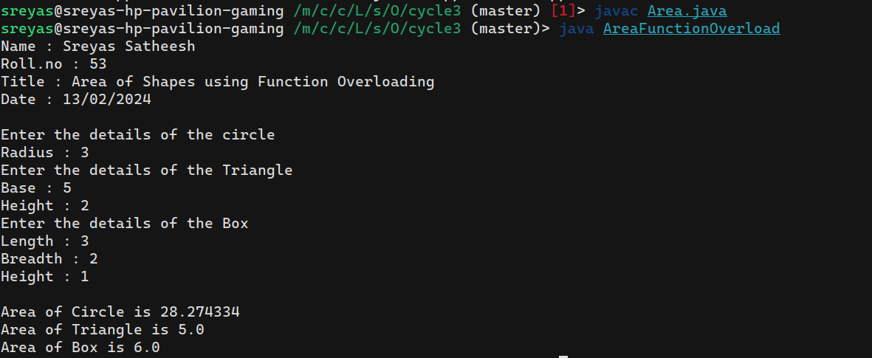

**11. Create a class ‘Employee’ with data members Empid, Name, Salary, Address and constructors to initialize the data members. Create another class ‘Teacher’ that inherit the properties of class employee and contain its own data members department, Subjects taught and constructors to initialize these data members and also include display function to display all the data members. Use array of objects to display details of N teachers.**

**Code :**

import java.util.Scanner;

class Employee {

public int Empid, Salary;

public String Name, Address;

public Employee(int Empid, String Name, int Salary, String Address) {

this.Empid = Empid;

this.Name = Name;

this.Salary = Salary;

this.Address = Address;

}

}

class Teacher extends Employee {

String Department, Subject;

public Teacher(int Empid, String Name, int Salary, String Address, String Department, String Subject) {

super(Empid, Name, Salary, Address);

this.Department = Department;

this.Subject = Subject;

}

void Display(){

System.out.println("\nEmpolyee id : " + super.Empid);

System.out.println("Empolyee name : " + super.Name);

System.out.println("Empolyee salary : " + super.Salary);

System.out.println("Empolyee address : " + super.Address);

System.out.println("Department : " + this.Department);

System.out.println("Subject taught : " + this.Subject);

}

}

class Main {

public static void main(String args[]){

System.out.println("Name : Sreyas Satheesh\nRoll.no : 53\nTitle : Details of Employee.\nDate : 06/04/2024\n");

Scanner scanner = new Scanner(System.in);

System.out.print("Enter the no.of Teachers : ");

int n = scanner.nextInt();

Teacher []arr = new Teacher[n];

System.out.println("Enter the details ");

for(int i=0; i< n; i++){

System.out.println("Enter the details of Teacher " + i+1 + " : ");

System.out.print("id : ");

int id = scanner.nextInt();

System.out.print("name : ");

scanner.nextLine();

String name = scanner.nextLine();

System.out.print("salary : ");

int salary = scanner.nextInt();

System.out.print("Address : ");

scanner.nextLine();

String address = scanner.nextLine();

System.out.print("Department : ");

String department = scanner.nextLine();

System.out.print("Subject : ");

String subject = scanner.nextLine();

arr[i] = new Teacher(id, name, salary, address, department, subject);

}

System.out.println("\nDetials\n");

for(int i =0; i< n; i++){

arr[i].Display();

}

scanner.close();

}

}

**Output :**

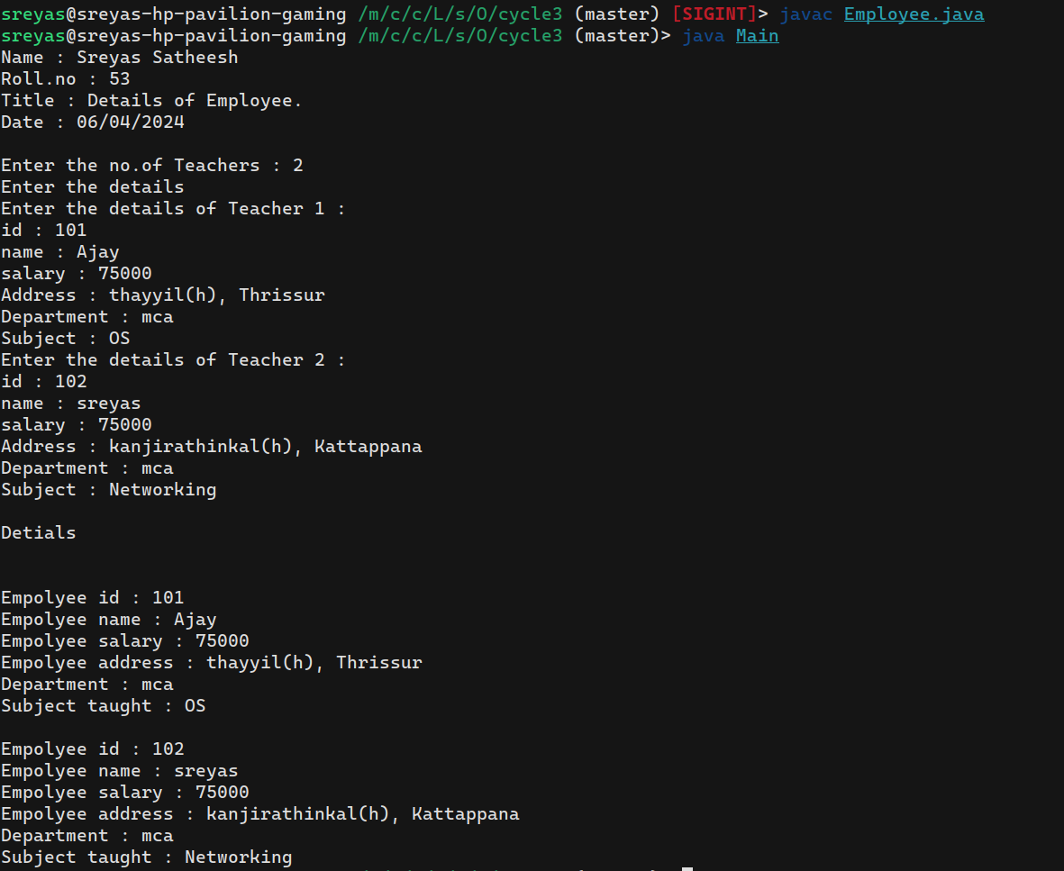

**12. Create a class ‘Person’ with data members Name, Gender, Address, Age and a constructor to initialize the data members and another class ‘Employee’ that inherits the properties of class Person and also contains its own data members like Empid, Company_name, Qualification, Salary and its own constructor. Create another class ‘Teacher’ that inherits the properties of class Employee and contains its own data members like Subject, Department, Teacherid and also contain constructors and methods to display the data**

**members. Use array of objects to display details of N teachers.**

**Code :**

import java.util.Scanner;

class Person {

String name, gender, address;

int age;

public Person(String name, String gender, String address, int age){

this.name = name;

this.gender = gender;

this.address = address;

this.age = age;

}

void display(){

System.out.println("Name: " + name + "\nGender: " + gender + "\nAddress: " + address + "\nAge: " + age);

}

}

class Employee extends Person {

int empId, salary;

String companyName, qualification;

public Employee(int empId, String companyName, String qualification, int salary, String name, String gender, String address, int age){

super(name, gender, address, age);

this.empId = empId;

this.companyName = companyName;

this.qualification = qualification;

this.salary = salary;

}

void display(){

System.out.println("Employee Id : " + empId + "\nCompany name : " + companyName + "\nQualification : " + qualification + "\nSalary : " + salary);

super.display();

}

}

class Teacher extends Employee {

int teacherId;

String subject, department;

public Teacher (int teacherId, String subject, String department, int empId, String companyName, String qualification, int salary, String name, String gender, String address, int age){

super(empId, companyName, qualification, salary, name, gender, address, age);

this.teacherId = teacherId;

this. subject = subject;

this.department = department;

}

void display(){

System.out.println("Teacher Id : " + teacherId + "\nDepartment : " + department + "\nSubject : " + subject);

super.display();

}

}

class PersonMain {

public static void main(String[] arg){

System.out.println("Name : Sreyas Satheesh\nRoll.no : 53\nTitle : Details of Teachers.\nDate : 06/04/2024\n");

Scanner scanner = new Scanner(System.in);

System.out.print("Enter the no.of Teachers : ");

int TeacherCount = scanner.nextInt();

Teacher [] Teachers = new Teacher[TeacherCount];

for (int i=0; i<TeacherCount; i++) {

System.out.println("\nEnter the Teacher details");

System.out.print("Enter the Teacher id : ");

int id = scanner.nextInt();

System.out.print("Enter the Subject : ");

scanner.nextLine();

String subject = scanner.nextLine();

System.out.print("Enter the Department : ");

String department = scanner.nextLine();

System.out.print("Enter the Employee id : ");

int empId = scanner.nextInt();

System.out.print("Enter the Company name : ");

scanner.nextLine();

String companyName = scanner.nextLine();

System.out.print("Enter the Qualification : ");

String qualification = scanner.nextLine();

System.out.print("Enter the Salary : ");

int salary = scanner.nextInt();

System.out.print("Enter the Name : ");

scanner.nextLine();

String name = scanner.nextLine();

System.out.print("Enter the Gender : ");

String gender = scanner.nextLine();

System.out.print("Enter the Address : ");

String address = scanner.nextLine();

System.out.print("Enter the Age : ");

int age = scanner.nextInt();

Teachers[i] = new Teacher(id, subject, department, empId, companyName, qualification, salary, name, gender, address, age);

}

for (int i=0; i<TeacherCount; i++){

System.out.println("\nDetails of Teacher " + (i+1));

Teachers[i].display();

}

scanner.close();

}

}

**Output :**

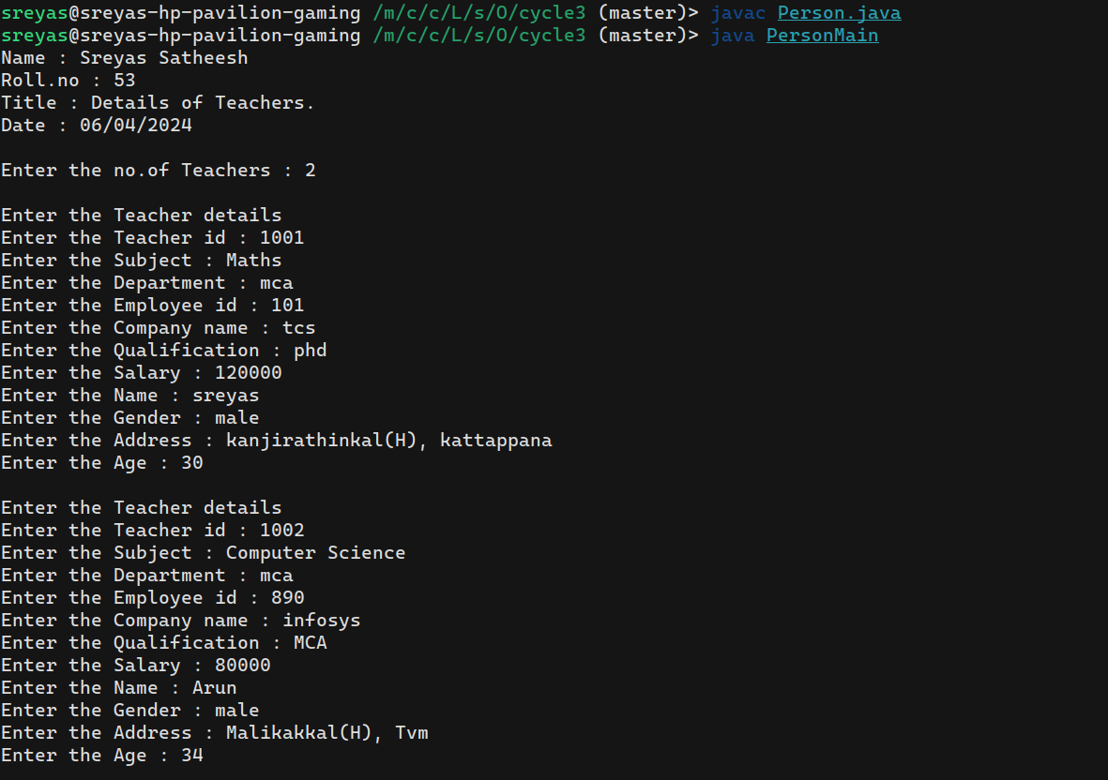

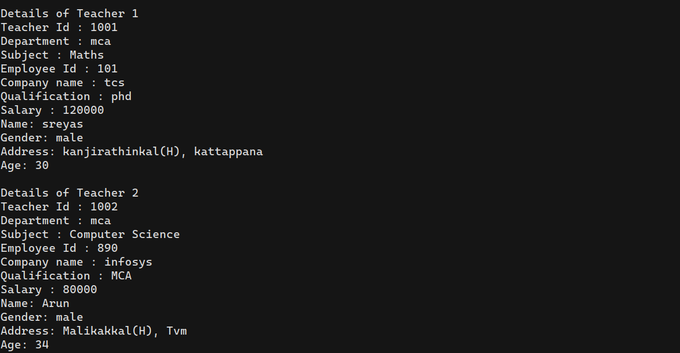

**13. Write a program has class Publisher, Book, Literature and Fiction. Read the information and print the details of books from either the category, using inheritance.**

**Code :**

import java.util.Scanner;

class Publisher {

String author, company, date;

public Publisher(String author, String company, String date){

this.author = author;

this.company = company;

this.date = date;

}

}

class Book extends Publisher {

String name, language;

int price;

public Book(String name, String language, int price, String author, String company, String date){

super(author, company, date);

this.name = name;

this.language = language;

this.price = price;

}

}

class Literature extends Book {

String category = "literature";

String title;

public Literature(String name, String language, int price, String author, String company, String date){

super(name, language, price, author, company, date);

}

void display(){

System.out.println("\nName : " + name + "\nCategory : " + category + "\nLanguage : " + language + "\nPrice : " + price + "\nAuthor : " + author + "\nCompany : " + company + "\nDate : " + date);

}

}

class Fiction extends Book {

String category = "fiction";

String title;

public Fiction(String name, String language, int price, String author, String company, String date){

super(name, language, price, author, company, date);

}

void display(){

System.out.println("\nName : " + name + "\nCategory : " + category + "\nLanguage : " + language + "\nPrice : " + price + "\nAuthor : " + author + "\nCompany : " + company + "\nDate : " + date);

}

}

class BookMain {

public static void main(String[] arg) {

System.out.println("Name : Sreyas Satheesh\nRoll.no : 53\nTitle : Details of Book.\nDate : 06/04/2024\n");

Scanner scanner = new Scanner(System.in);

String name, language, author, company, date;

int price;

System.out.print("Enter the total number of books : ");

int MAX = scanner.nextInt();

Literature arr1[] = new Literature[MAX];

Fiction arr2[] = new Fiction[MAX];

int i = 0, j = 0;

boolean status = true;

while(status && i+j < MAX){

System.out.print("\nCATEGORY\n---------------\n1)Literature\n2)Fiction\n\nOPERATIONS\n---------------\n3)Display\n4)Exit\nChoose one : ");

int choice = scanner.nextInt();

switch(choice){

case 1 :

System.out.println("\nEnter the Details of the book " + (i+j+1));

System.out.print("Name : ");

scanner.nextLine();

name = scanner.nextLine();

System.out.print("Language : ");

language = scanner.nextLine();

System.out.print("Price : ");

price = scanner.nextInt();

System.out.print("Author : ");

scanner.nextLine();

author = scanner.nextLine();

System.out.print("Publishing company : ");

company = scanner.nextLine();

System.out.print("Date : ");

date = scanner.nextLine();

arr1[i++] = new Literature(name, language, price, author, company, date);

break;

case 2 :

System.out.println("\nEnter the Details of the book " + (i+j+1));

System.out.print("Name : ");

scanner.nextLine();

name = scanner.nextLine();

System.out.print("Language : ");

language = scanner.nextLine();

System.out.print("Price : ");

price = scanner.nextInt();

System.out.print("Author : ");

scanner.nextLine();

author = scanner.nextLine();

System.out.print("Publishing company : ");

company = scanner.nextLine();

System.out.print("Date : ");

date = scanner.nextLine();

arr2[j++] = new Fiction(name, language, price, author, company, date);

break;

case 3 :

for(int k=0; k<i; k++){

System.out.println("\nDetials of book " + (k+1));

arr1[k].display();

}

for(int k=0; k<j; k++){

System.out.println("\nDetials of book " + (k+i+1));

arr2[k].display();

}

break;

case 4 :

status = false;

break;

default : System.out.println("Invalid choise.");

}

}

if((i+j) >= MAX){

for(int k=0; k<i; k++){

System.out.println("\nDetials of book " + (k+1));

arr1[k].display();

}

for(int k=0; k<j; k++){

System.out.println("\nDetials of book " + (k+i+1));

arr2[k].display();

}

}

scanner.close();

}

}

**Output :**

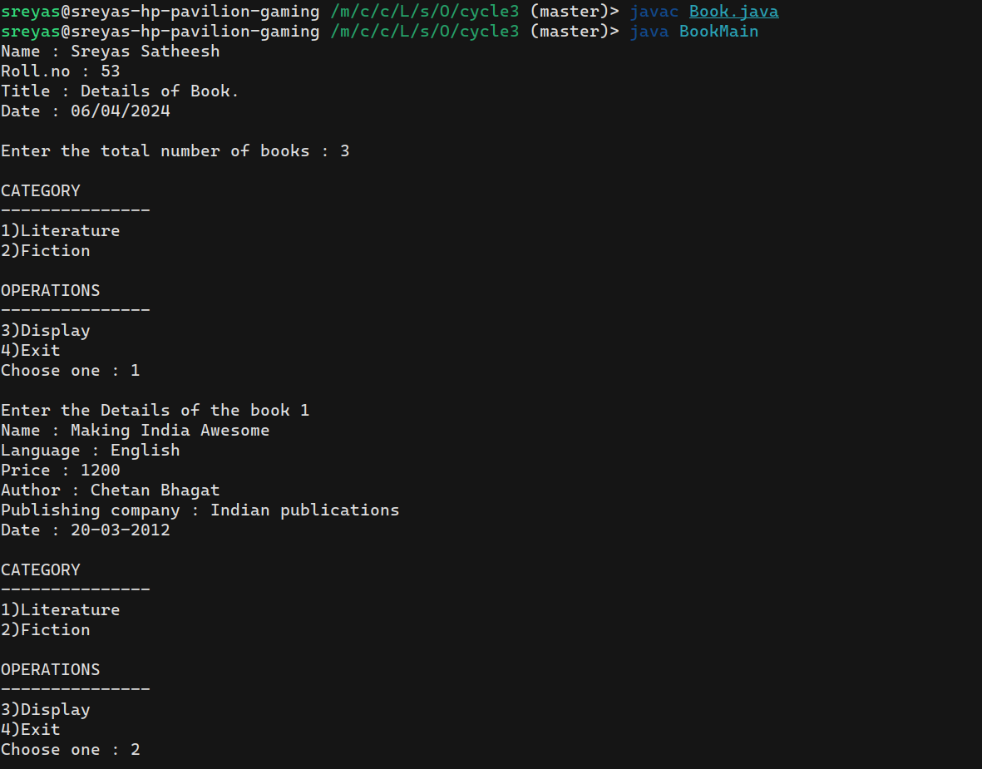

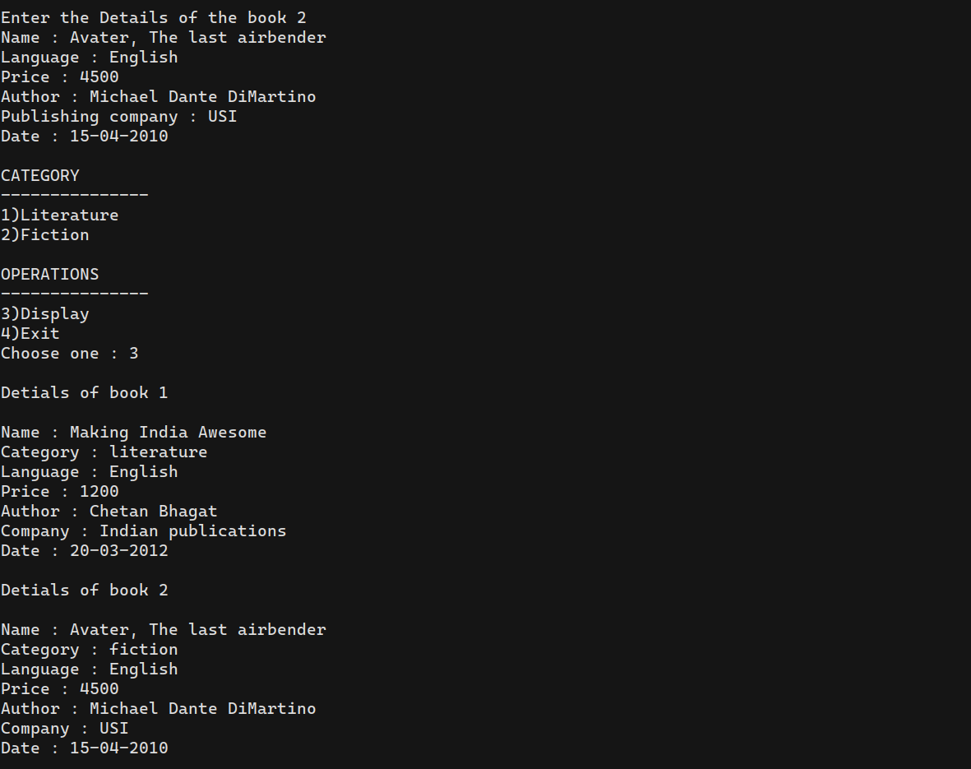

**14. Create classes Student and Sports. Create another class Result inherited from Student and Sports. Display the academic and sports score of a student**

**Code :**

import java.util.Scanner;

class Student {

String name, academicScore;

public Student(String name, String academicScore){

this.name = name;

this.academicScore = academicScore;

}

void display(){

System.out.println("Student name : " + name + "\nAcademic Score : " + academicScore);

}

}

interface Sports {

void displaySportsScore();

}

class Result extends Student implements Sports {

String sportsName, sportsScore;

public Result(String name, String academicScore, String sportsName, String sportsScore){

super(name, academicScore);

this.sportsName = sportsName;

this.sportsScore = sportsScore;

}

public void displaySportsScore(){

System.out.println("Sports name : " + sportsName + "\nSports Score : " + sportsScore);

}

void display(){

System.out.println("\nStudent Details");

super.display();

displaySportsScore();

}

}

class ResultDetails {

public static void main(String [] args){

System.out.println("Name : Sreyas Satheesh\nRoll.no : 53\nTitle : Student academic & sports details.\nDate : 08/04/2024\n");

Scanner scanner = new Scanner(System.in);

System.out.println("Enter the Details of the student");

System.out.print("name : ");

String name = scanner.nextLine();

System.out.print("academic score : ");

String academicScore = scanner.nextLine();

System.out.print("sports name : ");

String sportsName = scanner.nextLine();

System.out.print("sports score : ");

String sportsScore = scanner.nextLine();

Result object = new Result(name, academicScore, sportsName, sportsScore);

object.display();

scanner.close();

}

}

**Output :**

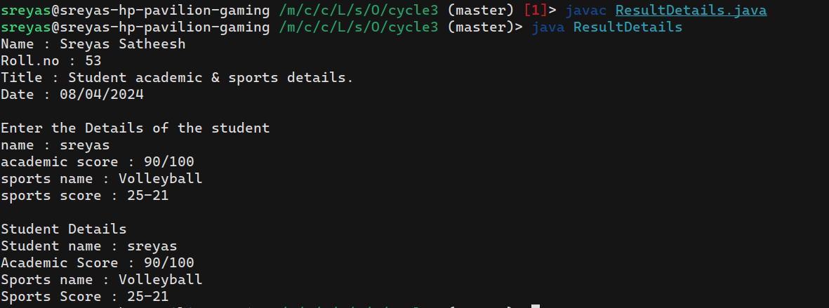

**15. Create an interface having prototypes of functions area() and perimeter(). Create two classes Circle and Rectangle which implements the above interface. Create a menu driven program to find area and perimeter of objects.**

**Code :**

import java.util.Scanner;

interface MathUtils {

void area();

void perimeter();

}

class Circle implements MathUtils {

double pi = 3.141;

double radius;

public Circle(double radius){

this.radius = radius;

}

public void area(){

double area = pi * radius * radius;

System.out.println("\narea of circle : " + area);

}

public void perimeter(){

double perimeter = 2 * pi * radius;

System.out.println("perimeter of circle : " + perimeter);

}

}

class Rectangle implements MathUtils {

double length;

double width;

public Rectangle(double length, double width){

this.length = length;

this.width = width;

}

public void area(){

double area = length * width;

System.out.println("\narea of rectangle : " + area);

}

public void perimeter(){

double perimeter = 2 * (length + width);

System.out.println("perimeter of rectangle : " + perimeter);

}

}

public class AreaAndPerimeter {

public static void main(String [] arg){

System.out.println("Name : Sreyas Satheesh\nRoll.no : 53\nTitle : Area and Perimeter using Interface.\nDate : 08/04/2024\n");

Scanner scanner = new Scanner(System.in);

boolean status = true;

while(status){

System.out.print("\nSHAPES\n------------\n1) Rectangle\n2) Circle\n3) exit\nChoose one : ");

int choice = scanner.nextInt();

switch(choice){

case 1:

System.out.println("\nEnter the details of Rectangle.");

System.out.print("length : ");

double length = scanner.nextInt();

System.out.print("width : ");

double width = scanner.nextInt();

Rectangle rect = new Rectangle(length, width);

rect.area();

rect.perimeter();

break;

case 2:

System.out.println("\nEnter the details of Circle.");

System.out.print("radius : ");

double radius = scanner.nextInt();

Circle cir = new Circle(radius);

cir.area();

cir.perimeter();

break;

case 3:

status = false;

break;

}

}

scanner.close();

}

}

**Output :**

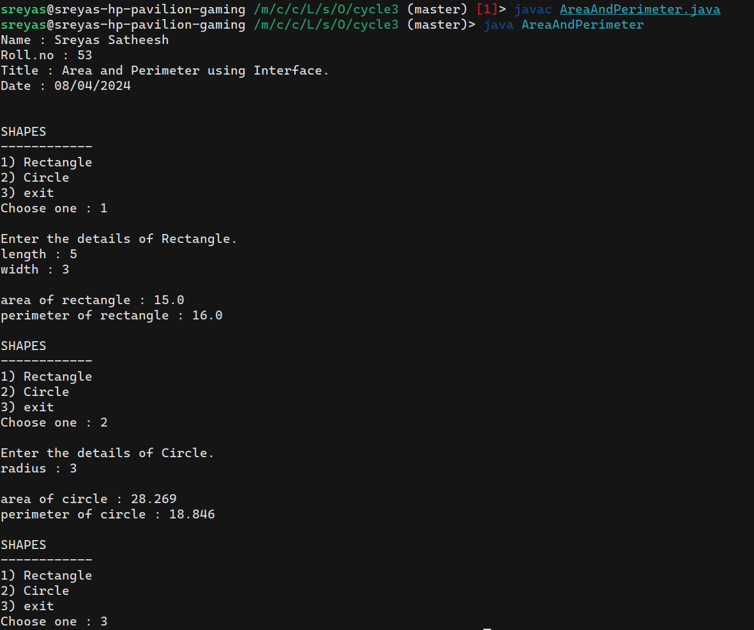

**16. Prepare bill with the given format using calculate method from interface.**

**Order No.**

**Date :**

**Product Id Name Quantity unit price Total**

**-----------------------------------------------------------------**

**101 A 2 25 50**

**102 B 1 100 100**

**-----------------------------------------------------------------**

**Net. Amount 150**

**Code :**

import java.util.Scanner;

interface Calculate {

void calculate();

}

class Product {

int id, quantity, unitPrice, total;

String name;

Product(int id, String name, int quantity, int unitPrice){

this.id = id;

this.name = name;

this.quantity = quantity;

this.unitPrice = unitPrice;

this.total = quantity * unitPrice;

}

}

class Order implements Calculate {

int orderNo;

String orderDate;

int netAmt;

int i = 0;

Product [] list = new Product[20];

Order(int orderNo, String orderDate){

this.orderNo = orderNo;

this.orderDate = orderDate;

}

void add(int id, String name, int quantity, int unitPrice){

list[i++] = new Product(id, name, quantity, unitPrice);

}

public void calculate(){

netAmt = 0;

for(int k=0; k<i; k++){

netAmt += list[k].total;

}

this.display();

}

void display(){

System.out.println("\nOrder no. : " + orderNo + "\nDate : " + orderDate);

System.out.println("Product id Name Quantity Unit price Total\n-------------------------------------------------------");

for(int k=0; k<i; k++){

System.out.println(list[k].id + " " + list[k].name + " " + list[k].quantity + " " + list[k].unitPrice + " " + list[k].total);

}

if(i==0) System.out.println("No product added.");

System.out.println("-------------------------------------------------------\n Net.Amount " + netAmt);

}

}

public class Bill {

public static void main(String [] arg){

System.out.println("Name : Sreyas Satheesh\nRoll.no : 53\nTitle : Calculate bill.\nDate : 08/04/2024\n");

Scanner scanner = new Scanner(System.in);

System.out.print("Enter the order no : ");

int orderNo = scanner.nextInt();

System.out.print("Enter the order date : ");

scanner.nextLine();

String orderDate = scanner.nextLine();

Order order = new Order(orderNo, orderDate);

boolean status = true;

while(status){

System.out.print("\nOPERATIONS\n-------------------\n1) Add product\n2) Calculate total\n3) Exit\n-------------------\nChoose one : ");

int choice = scanner.nextInt();

switch(choice){

case 1:

System.out.print("\nEnter the product id : ");

int id = scanner.nextInt();

System.out.print("Enter the product name : ");

scanner.nextLine();

String name = scanner.nextLine();

System.out.print("Enter the product quantity : ");

int quantity = scanner.nextInt();

System.out.print("Enter the product unit price : ");

int unitPrice = scanner.nextInt();

order.add(id, name, quantity, unitPrice);

break;

case 2:

order.calculate();

break;

case 3:

status = false;

break;

default:

System.out.println("\nInvalid choice.\n");

}

}

scanner.close();

}

}

**Output :**

