**6. Program to Sort strings.**

**Code :**

import java.util.Scanner;

import java.util.Arrays;

public class StringSorting{

public static void main(String arg[]){

Scanner scan = new Scanner(System.in);

System.out.println("Name : Sreyas Satheesh\nRoll.no : 53\nTitle : String sorting\nDate : 13/02/2024\n");

System.out.print("Enter the no.of Strings : ");

int n = scan.nextInt();

System.out.println("Enter the strings");

String[] str = new String[n];

scan.nextLine();

for(int i=0; i<n; i++){

str[i] = scan.nextLine();

}

System.out.println("Array before sorting : " + Arrays.toString(str));

// sorting method 1

// Arrays.sort(str);

// System.out.println(Arrays.toString(str));

// End of method 1

// sorting method 2

for(int i=0; i<n-1; i++){

for(int j=0; j<n-i-1; j++){

if(str[j].compareTo(str[j+1]) > 0){

String temp = str[j];

str[j] = str[j+1];

str[j+1] = temp;

}

}

}

System.out.println("Array after sorting : " + Arrays.toString(str));

// end of method 2

scan.close();

}

}

**Output :**

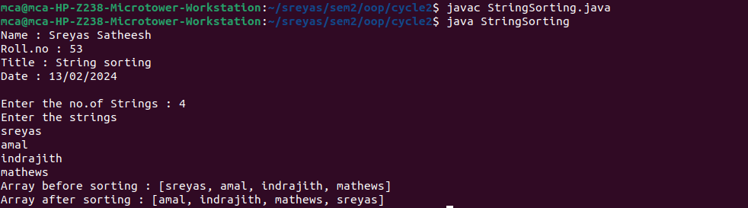

**7. Search an element in an array.**

**Code :**

import java.util.Scanner;

import java.util.Arrays;

class Search{

public static void main(String arg[]){

System.out.println("Name : Sreyas Satheesh\nRoll.no : 53\nTitle : Search element in array\nDate : 13/02/2024\n");

Scanner scanner = new Scanner(System.in);

System.out.print("Enter the size of the array : ");

int n = scanner.nextInt();

int arr[] = new int[n];

System.out.println("Enter the array elements : ");

for(int i=0; i<arr.length; i++){

arr[i] = scanner.nextInt();

}

System.out.println("Array is : " + Arrays.toString(arr));

System.out.print("Enter the value to search : ");

int value = scanner.nextInt();

int flag = 0;

for(int i=0; i<n; i++){

if(value == arr[i]){

flag = 1;

break;

}

}

System.out.println("Element " + value + (flag == 0 ? " not found in the array" : " found in the array"));

scanner.close();

}

}

**Output :**

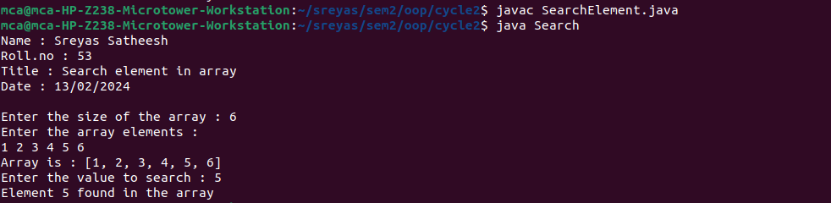

**8. Perform string manipulations.**

**Code :**

import java.util.Scanner;

class Manipulation{

public static void main(String arg[]){

System.out.println("Name : Sreyas Satheesh\nRoll.no : 53\nTitle : String manipulation\nDate : 13/02/2024\n");

Scanner scanner = new Scanner(System.in);

System.out.print("Enter a String : ");

String str = scanner.nextLine();

System.out.println("\nString is : " + str);

System.out.println("Length of the string is : " + str.length());

System.out.println("Character at the position is : " + str.charAt(0));

System.out.println("Lower case : " + str.toLowerCase());

System.out.println("Upper case : " + str.toUpperCase());

System.out.print("Enter a substring to check : ");

String subStr = scanner.nextLine();

if(str.contains(subStr)) System.out.println("String '" + str + "' contains the substring '" + subStr + "'");

else System.out.println("String '" + str + "' not contains the substring '" + subStr + "'");

scanner.close();

}

}

**Output :**

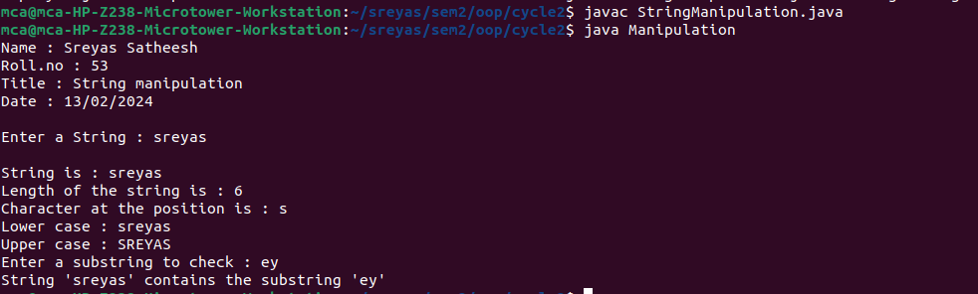

**9. Program to create a class for Employee having attributes eNo, eName eSalary. Read n employ information and Search for an employee given eNo, using the concept of Array of Objects.**

**Code :**

import java.util.Scanner;

class Employee{

int eNo, eSalary;

String eName;

public Employee(int no, String name, int salary) {

this.eNo = no;

this.eName = name;

this.eSalary = salary;

}

}

class Main{

public static void main(String arg[]){

Scanner scanner = new Scanner(System.in);

System.out.print("Enter the no of Employees : ");

int n = scanner.nextInt();

Employee arr[] = new Employee[n];

for(int i=0; i<n; i++){

System.out.println("Enter the details of employee " + Integer.toString(i+1));

System.out.print("Enter the employee id : ");

int no = scanner.nextInt();

System.out.print("Enter the employee name : ");

scanner.nextLine();

String name = scanner.nextLine();

System.out.print("Enter the salary : ");

int salary = scanner.nextInt();

arr[i] = new Employee(no, name, salary);

}

System.out.print("\nEnter the employee id to search : ");

int id = scanner.nextInt();

int flag = 0;

for(int i=0; i<n; i++){

if(arr[i].eNo == id){

System.out.println("Employee found.\nid : " + Integer.toString(id) + "\nname : " + arr[i].eName + "\nsalary : " + Integer.toString(arr[i].eSalary));

flag = 1;

break;

}

}

if(flag == 0) System.out.println("Employee not found");

scanner.close();

}

}

**Output :**

