**24. Program to draw Circle, Rectangle, Line in Applet.**

**Code :**

import java.awt.Color;

import java.awt.Graphics;

import javax.swing.JApplet;

public class shapes extends JApplet {

@Override

public void paint(Graphics g) {

setSize(500, 500);

g.setColor(Color.BLUE);

g.drawLine(100, 50, 400, 50);

g.setColor(Color.RED);

g.fillRect(100, 100, 300, 100);

g.setColor(Color.GREEN);

g.fillOval(100, 250, 100, 100);

}

}

**Output :**

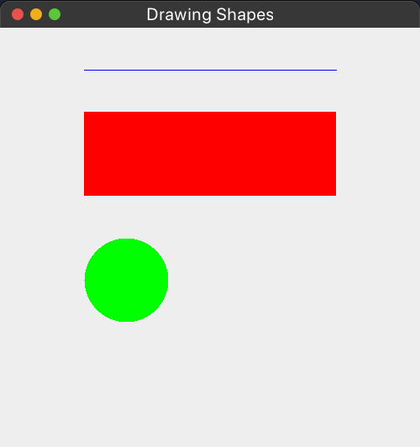

**25. Implement a simple calculator using AWT components.**

**Code :**

import java.awt.*;

import java.awt.event.*;

public class Calculator implements ActionListener {

Frame f = new Frame();

Label l1 = new Label("First Number");

Label l2 = new Label("Second Number");

Label l3 = new Label("Result");

TextField t1 = new TextField();

TextField t2 = new TextField();

TextField t3 = new TextField();

Button b1 = new Button("Add");

Button b2 = new Button("Sub");

Button b3 = new Button("Mul");

Button b4 = new Button("Div");

Button b5 = new Button("Cancel");

Calculator() {

l1.setBounds(50, 100, 100, 20);

l2.setBounds(50, 140, 100, 20);

l3.setBounds(50, 180, 100, 20);

t1.setBounds(200, 100, 100, 20);

t2.setBounds(200, 140, 100, 20);

t3.setBounds(200, 180, 100, 20);

b1.setBounds(50, 250, 50, 20);

b2.setBounds(110, 250, 50, 20);

b3.setBounds(170, 250, 50, 20);

b4.setBounds(230, 250, 50, 20);

b5.setBounds(290, 250, 50, 20);

f.add(l1);

f.add(l2);

f.add(l3);

f.add(t1);

f.add(t2);

f.add(t3);

f.add(b1);

f.add(b2);

f.add(b3);

f.add(b4);

f.add(b5);

b1.addActionListener(this);

b2.addActionListener(this);

b3.addActionListener(this);

b4.addActionListener(this);

b5.addActionListener(this);

f.setLayout(null);

f.setVisible(true);

f.setSize(400, 350);

}

public void actionPerformed(ActionEvent e) {

int n1 = Integer.parseInt(t1.getText());

int n2 = Integer.parseInt(t2.getText());

if (e.getSource() == b1) {

t3.setText(String.valueOf(n1 + n2));

}

if (e.getSource() == b2) {

t3.setText(String.valueOf(n1 - n2));

}

if (e.getSource() == b3) {

t3.setText(String.valueOf(n1 * n2));

}

if (e.getSource() == b4) {

t3.setText(String.valueOf(n1 / n2));

}

if (e.getSource() == b5) {

System.exit(0);

}

}

public static void main(String args[]) {

new Calculator();

}

}

**Output :**

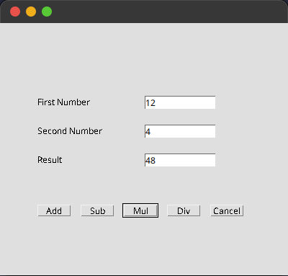

**26. Program to list the sub directories and files in each directory and search for a file name.**

**Code :**

import java.io.File;

import java.util.Scanner;

public class DirectoryExplorer {

public static void main(String[] args) {

System.out.println("Name : Sreyas Satheesh\nRoll.no : 53\nTitle : List the sub directories and files in each directory & search for a file name\nDate : 08/05/2024\n");

Scanner scanner = new Scanner(System.in);

System.out.print("Enter directory path: ");

String directoryPath = scanner.nextLine();

System.out.println("");

exploreDirectory(directoryPath);

scanner.close();

}

private static void exploreDirectory(String directoryPath) {

File directory = new File(directoryPath);

if (!directory.isDirectory()) {

System.out.println(directoryPath + " is not a directory");

return;

}

exploreDirectory(directory, "");

searchFile(directory);

}

private static void exploreDirectory(File directory, String indent) {

File[] files = directory.listFiles();

if (files != null) {

for (File file : files) {

System.out.println(indent + (file.isDirectory() ? "[" + file.getName() + "]" : file.getName()));

if (file.isDirectory()) {

exploreDirectory(file, indent + " ");

}

}

}

}

private static void searchFile(File directory) {

Scanner scanner = new Scanner(System.in);

System.out.print("\nEnter the filename to search: ");

String filename = scanner.nextLine();

boolean found = searchFileInDirectory(directory, filename);

if (!found) {

System.out.println("File not found in the directory or its subdirectories.");

}

scanner.close();

}

private static boolean searchFileInDirectory(File directory, String filename) {

File[] files = directory.listFiles();

if (files != null) {

for (File file : files) {

if (file.getName().equals(filename)) {

System.out.println("** Found file: " + file.getAbsolutePath() + " **");

return true;

}

if (file.isDirectory()) {

boolean foundInSubDir = searchFileInDirectory(file, filename);

if (foundInSubDir) {

return true;

}

}

}

}

return false;

}

}

**Output :**

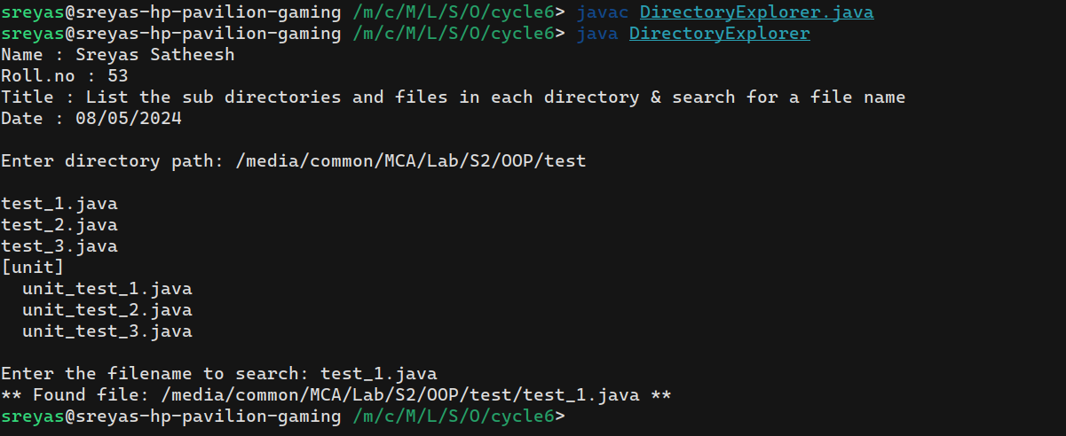

**27. Write a program to write to a file, then read from the file and display the contents on the console.**

**Code :**

import java.io.FileWriter;

import java.io.FileReader;

import java.io.BufferedReader;

import java.io.IOException;

import java.util.Scanner;

public class FileReadWrite {

public static void main(String[] args) {

System.out.println("Name : Sreyas Satheesh\nRoll.no : 53\nTitle : Write to a file, then read from the file & display the contents on the console\nDate : 08/05/2024\n");

Scanner scanner = new Scanner(System.in);

System.out.print("Enter the file name: ");

String filename = scanner.nextLine();

System.out.println("\nEnter the content to write to the file:");

String contentToWrite = scanner.nextLine();

writeFile(filename, contentToWrite);

readFileAndDisplay(filename);

scanner.close();

}

private static void writeFile(String filename, String content) {

try (FileWriter fileWriter = new FileWriter(filename)) {

fileWriter.write(content);

System.out.println("\n** File written successfully. **");

} catch (IOException e) {

System.err.println("\n** An error occurred while writing to the file: " + e.getMessage() + " **");

}

}

private static void readFileAndDisplay(String filename) {

try (FileReader fileReader = new FileReader(filename);

BufferedReader bufferedReader = new BufferedReader(fileReader)) {

String line;

System.out.println("\nFile contents:");

while ((line = bufferedReader.readLine()) != null) {

System.out.println(line);

}

} catch (IOException e) {

System.err.println("\n** An error occurred while reading the file: " + e.getMessage() + " **");

}

}

}

**Output :**

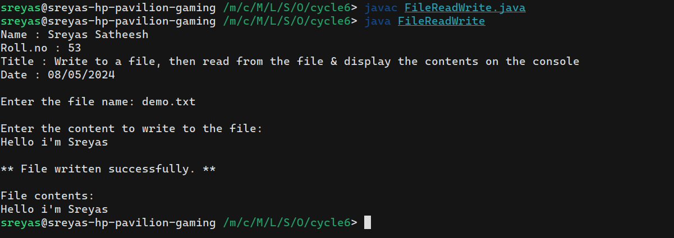

**28. Write a program to copy one file to another.**

**Code :**

import java.io.FileReader;

import java.io.FileWriter;

import java.io.BufferedReader;

import java.io.BufferedWriter;

import java.io.IOException;

import java.util.Scanner;

public class FileCopy {

public static void main(String[] args) {

System.out.println(

"Name : Sreyas Satheesh\nRoll.no : 53\nTitle : Program to copy one file to another\nDate : 08/05/2024\n");

Scanner scanner = new Scanner(System.in);

System.out.print("Enter the source file name: ");

String sourceFileName = scanner.nextLine();

System.out.print("Enter the destination file name: ");

String destinationFileName = scanner.nextLine();

copyFile(sourceFileName, destinationFileName);

scanner.close();

}

private static void copyFile(String sourceFileName, String destinationFileName) {

try (FileReader fileReader = new FileReader(sourceFileName);

BufferedReader bufferedReader = new BufferedReader(fileReader);

FileWriter fileWriter = new FileWriter(destinationFileName);

BufferedWriter bufferedWriter = new BufferedWriter(fileWriter)) {

String line;

while ((line = bufferedReader.readLine()) != null) {

bufferedWriter.write(line);

bufferedWriter.newLine();

}

System.out.println("\n** File copied successfully **");

} catch (IOException e) {

System.err.println("\n** An error occurred while copying the file: " + e.getMessage() + " **");

}

}

}

**Output :**

