**PL/SQL**

1)

DECLARE  
message varchar(20):='Hello world';  
BEGIN  
dbms_output.put_line(message);  
END;  
/

SQL> SET SERVEROUTPUT ON;

SQL> DECLARE

2 message varchar(20):='Hello world';

3 BEGIN

4 dbms_output.put_line(message);

5 END;

6 /

Hello world

PL/SQL procedure successfully completed.

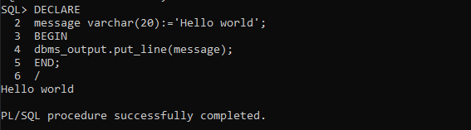

2)

DECLARE  
a number;  
b number;  
c number;  
BEGIN  
a:=&a;  
b:=&b;  
c:=&c;  
if(a>b and a>c)then  
dbms_output.put_line('a is maximum and the value is '||a);  
elsif(b>a and b>c)then  
dbms_output.put_line('b is maximum and the value is '||b);  
else  
dbms_output.put_line('c is maximum and the value is '||c);  
end if;  
END;  
/

SQL> @D:\sreyas\sem2\dbms\sql\2.sql

Enter value for a: 10

old 6: a:=&a;

new 6: a:=10;

Enter value for b: 20

old 7: b:=&b;

new 7: b:=20;

Enter value for c: 5

old 8: c:=&c;

new 8: c:=5;

b is maximum and the value is 20

PL/SQL procedure successfully completed.

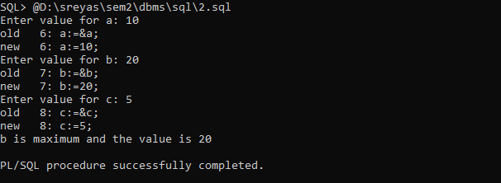

3)

DECLARE  
n NUMBER:=10;  
BEGIN  
FOR i in 1..n LOOP  
dbms_output.put_line(i);  
END LOOP;  
END;  
/

SQL> @D:\sreyas\sem2\dbms\sql\3.sql

1

2

3

4

5

6

7

8

9

10

PL/SQL procedure successfully completed.

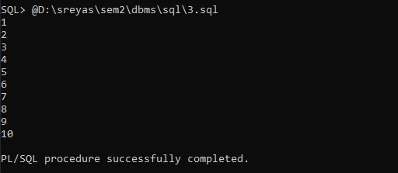

4)

DECLARE  
N NUMBER:=&n;  
S NUMBER:=0;  
R NUMBER:=0;  
BEGIN  
WHILE N!=0  
LOOP  
S:=S+MOD(N, 10);  
N:=TRUNC(N/10);  
END LOOP;  
dbms_output.put_line('sum of digits of given number is '||S)  
END;  
/

5)

declare

a number(2):=&a;

b number(2):=&b;

begin

if a>b then

dbms_output.put_line('Greatest values is '||a);

elsif b>a then

dbms_output.put_line('Greatest values is '||b);

else

dbms_output.put_line('Both are equal');

end if;

end;

/

6)

declare

efname employee.fname%type;

elname employee.lname%type;

esalary employee.salary%type;

begin

select fname,lname,salary

into efname,elname,esalary

from employee

where ssn=102;

dbms_output.put_line(efname||' '||elname||' '||esalary);

end;

/

7)

declare

efname employee.fname%type;

elname employee.lname%type;

esalary employee.salary%type;

begin

select fname,lname,salary

into efname,elname,esalary

from employee

where ssn=102;

dbms_output.put_line(efname||' '||elname||' '||esalary);

end;

/