**Create an employee table ‘EMP’ with following fields**

|  |  |
| --- | --- |
| **Name** | **Type** |
| EID | NUMBER |
| ENAME | VARCHAR2(20) |
| AGE | NUMBER |
| SALARY | NUMBER(10,2) |

SQL> create table emp (eid number primary key,ename varchar(30),age number,salary number(10,2));

Table created.



SQL> insert into emp values(&eid,'&ename',&age,&salary);

Enter value for eid: 101

Enter value for ename: ajay

Enter value for age: 21

Enter value for salary: 25000

old 1: insert into emp values(&eid,'&ename',&age,&salary)

new 1: insert into emp values(101,'ajay',21,25000)

1 row created.

SQL> /

Enter value for eid: 102

Enter value for ename: ajo

Enter value for age: 22

Enter value for salary: 30000

old 1: insert into emp values(&eid,'&ename',&age,&salary)

new 1: insert into emp values(102,'ajo',22,30000)

1 row created.

SQL> /

Enter value for eid: 103

Enter value for ename: akshara

Enter value for age: 21

Enter value for salary: 20000

old 1: insert into emp values(&eid,'&ename',&age,&salary)

new 1: insert into emp values(103,'akshara',21,20000)

1 row created.

SQL> /

Enter value for eid: 104

Enter value for ename: akshay

Enter value for age: 22

Enter value for salary: 35000

old 1: insert into emp values(&eid,'&ename',&age,&salary)

new 1: insert into emp values(104,'akshay',22,35000)

1 row created.

SQL> /

Enter value for eid: 105

Enter value for ename: ananthan

Enter value for age: 23

Enter value for salary: 27500

old 1: insert into emp values(&eid,'&ename',&age,&salary)

new 1: insert into emp values(105,'ananthan',23,27500)

1 row created.

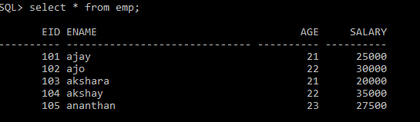

1. **Find the count of employees.**



1. **Find the maximum age.**



1. **Find the minimum age.**

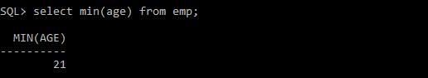

1. **Find the sum of the salary**

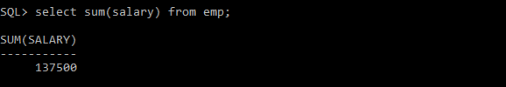

1. **Find the average of age**

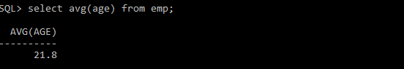

1. **Create a view for age and name**

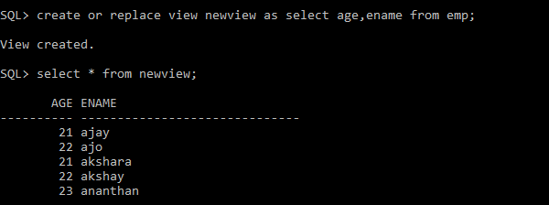

1. **Create a view to store Id, name, salary**

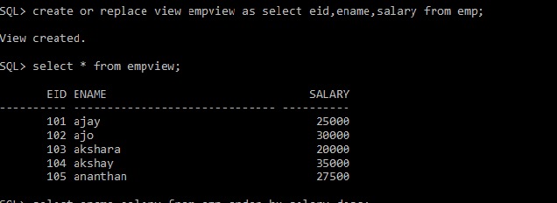

1. **Display name of the employee in descending order of salary**

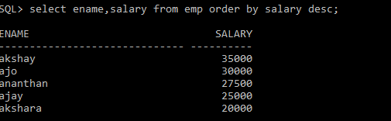

1. **Print the name in ascending order of age**

