**Create an department table ‘DEPARTMENT’ with following fields**

|  |  |
| --- | --- |
| **Name** | **Type** |
| DEPTNO | NUMBER |
| DEPTNAME | VARCHAR2(20) |
| LOCATION | VARCHAR2(20) |

SQL> create table department(deptno number primary key,deptname varchar2(20),location varchar2(20));

Table created.

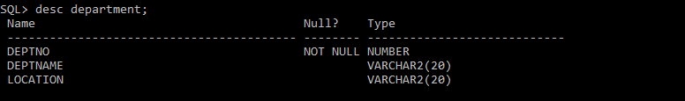

1. **Add column designation to the department table.**

SQL> alter table department add(designation varchar2(20));

Table altered.

1. **Insert values into table.**

SQL> insert into department values(&deptno,'&deptname','&location','&designation');

Enter value for deptno: 1

Enter value for deptname: hr

Enter value for location: kochi

Enter value for designation: manager

old 1: insert into department values(&deptno,'&deptname','&location','&designation')

new 1: insert into department values(1,'hr','kochi','manager')

1 row created.

SQL> /

Enter value for deptno: 2

Enter value for deptname: sales

Enter value for location: thrissur

Enter value for designation: supervisor

old 1: insert into department values(&deptno,'&deptname','&location','&designation')

new 1: insert into department values(2,'sales','thrissur','supervisor')

1 row created.

SQL> /

Enter value for deptno: 3

Enter value for deptname: development

Enter value for location: trivandum

Enter value for designation: developer

old 1: insert into department values(&deptno,'&deptname','&location','&designation')

new 1: insert into department values(3,'development','trivandum','developer')

1 row created.

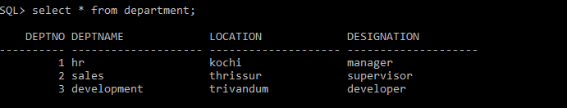

1. **List the records of department table grouped by deptno.**

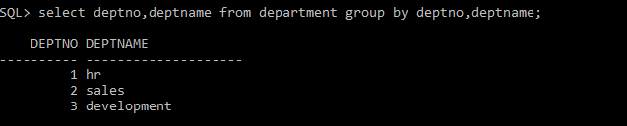

1. **Update the record where deptno is 3.**

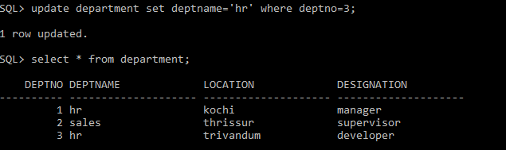

1. **Delete any column data from the tables.**

SQL> alter table department drop(designation);

Table altered.