**Create a table employee**

|  |  |
| --- | --- |
| **Name** | **Type** |
| EMPNO | NUMBER |
| ENAME | VARCHAR2(20) |
| JOB | VARCHAR2(20) |
| MGR | NUMBER |
| SAL | NUMBER |

SQL> create table employee(empno number primary key,ename varchar2(20),job varchar2(20),mgr number,sal number);

Table created.

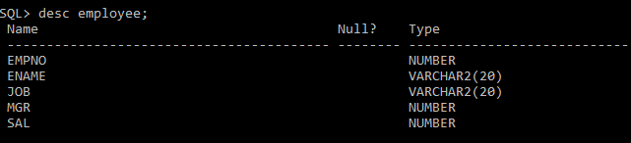

1. **Add a column commission with domain in the employee table.**

SQL> alter table employee add(commission number);

Table altered.

1. **Insert any five records into the table.**

SQL> insert into employee values(&empno,'&ename','&job',&mgr,&sal,&commission);

Enter value for empno: 101

Enter value for ename: ajo

Enter value for job: analyst

Enter value for mgr: 123

Enter value for sal: 30000

Enter value for commission: 2000

old 1: insert into employee values(&empno,'&ename','&job',&mgr,&sal,&commission)

new 1: insert into employee values(101,'ajo','analyst',123,30000,2000)

1 row created.

SQL> /

Enter value for empno: 102

Enter value for ename: akshara

Enter value for job: clerk

Enter value for mgr: 159

Enter value for sal: 15000

Enter value for commission: 1500

old 1: insert into employee values(&empno,'&ename','&job',&mgr,&sal,&commission)

new 1: insert into employee values(102,'akshara','clerk',159,15000,1500)

1 row created.

SQL> /

Enter value for empno: 103

Enter value for ename: ananthan

Enter value for job: professor

Enter value for mgr: 357

Enter value for sal: 30000

Enter value for commission: 2500

old 1: insert into employee values(&empno,'&ename','&job',&mgr,&sal,&commission)

new 1: insert into employee values(103,'ananthan','professor',357,30000,2500)

1 row created.

SQL> /

Enter value for empno: 104

Enter value for ename: akshay

Enter value for job: manager

Enter value for mgr: 546

Enter value for sal: 35000

Enter value for commission: 3000

old 1: insert into employee values(&empno,'&ename','&job',&mgr,&sal,&commission)

new 1: insert into employee values(104,'akshay','manager',546,35000,3000)

1 row created.

SQL> /

Enter value for empno: 105

Enter value for ename: abin

Enter value for job: developer

Enter value for mgr: 987

Enter value for sal: 25000

Enter value for commission: 2000

old 1: insert into employee values(&empno,'&ename','&job',&mgr,&sal,&commission)

new 1: insert into employee values(105,'abin','developer',987,25000,2000)

1 row created.

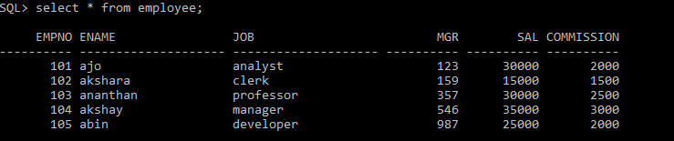

1. **Update the column details of job.**

SQL> update employee set job='trainee' where empno=103;

1 row updated.

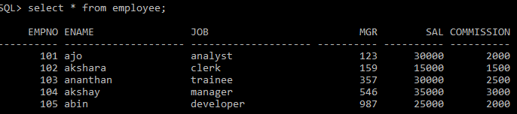

1. **Rename the column of employee table using alter command**

SQL> alter table employee rename column mgr to managerno;

Table altered**.**

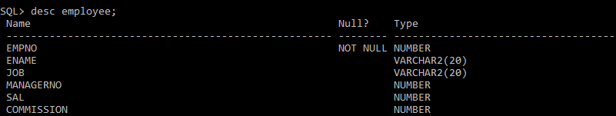

1. **Delete the employee whose is 105.**

SQL> delete employee where empno=105;

1 row deleted.