Set 1

**Sailors table**

CREATE TABLE sailors (sid NUMBER(3) PRIMARY KEY, sname VARCHAR(20), rating NUMBER(3), age NUMBER(3));

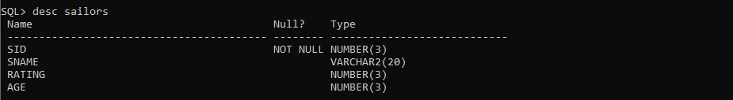

SQL> INSERT INTO sailors VALUES(&sid, '&sname', &rating, &age);

Enter value for sid: 22

Enter value for sname: Dustin

Enter value for rating: 7

Enter value for age: 45

old 1: INSERT INTO sailors VALUES(&sid, '&sname', &rating, &age)

new 1: INSERT INTO sailors VALUES(22, 'Dustin', 7, 45)

1 row created.

SQL> INSERT INTO sailors VALUES(&sid, '&sname', &rating, &age);

Enter value for sid: 29

Enter value for sname: Brutas

Enter value for rating: 1

Enter value for age: 33

old 1: INSERT INTO sailors VALUES(&sid, '&sname', &rating, &age)

new 1: INSERT INTO sailors VALUES(29, 'Brutas', 1, 33)

1 row created.

SQL> INSERT INTO sailors VALUES(&sid, '&sname', &rating, &age);

Enter value for sid: 31

Enter value for sname: Lubber

Enter value for rating: 8

Enter value for age: 55

old 1: INSERT INTO sailors VALUES(&sid, '&sname', &rating, &age)

new 1: INSERT INTO sailors VALUES(31, 'Lubber', 8, 55)

1 row created.

SQL> INSERT INTO sailors VALUES(&sid, '&sname', &rating, &age);

Enter value for sid: 32

Enter value for sname: Andy

Enter value for rating: 8

Enter value for age: 25

old 1: INSERT INTO sailors VALUES(&sid, '&sname', &rating, &age)

new 1: INSERT INTO sailors VALUES(32, 'Andy', 8, 25)

1 row created.

SQL> INSERT INTO sailors VALUES(&sid, '&sname', &rating, &age);

Enter value for sid: 58

Enter value for sname: Rusty

Enter value for rating: 10

Enter value for age: 35

old 1: INSERT INTO sailors VALUES(&sid, '&sname', &rating, &age)

new 1: INSERT INTO sailors VALUES(58, 'Rusty', 10, 35)

1 row created.

SQL> INSERT INTO sailors VALUES(&sid, '&sname', &rating, &age);

Enter value for sid: 64

Enter value for sname: Horatio

Enter value for rating: 7

Enter value for age: 35

old 1: INSERT INTO sailors VALUES(&sid, '&sname', &rating, &age)

new 1: INSERT INTO sailors VALUES(64, 'Horatio', 7, 35)

1 row created.

SQL> INSERT INTO sailors VALUES(&sid, '&sname', &rating, &age);

Enter value for sid: 71

Enter value for sname: Zobra

Enter value for rating: 10

Enter value for age: 16

old 1: INSERT INTO sailors VALUES(&sid, '&sname', &rating, &age)

new 1: INSERT INTO sailors VALUES(71, 'Zobra', 10, 16)

1 row created.

SQL> INSERT INTO sailors VALUES(&sid, '&sname', &rating, &age);

Enter value for sid: 74

Enter value for sname: Horatio

Enter value for rating: 9

Enter value for age: 35

old 1: INSERT INTO sailors VALUES(&sid, '&sname', &rating, &age)

new 1: INSERT INTO sailors VALUES(74, 'Horatio ', 9, 35)

1 row created.

SQL> INSERT INTO sailors VALUES(&sid, '&sname', &rating, &age);

Enter value for sid: 85

Enter value for sname: Art

Enter value for rating: 3

Enter value for age: 26

old 1: INSERT INTO sailors VALUES(&sid, '&sname', &rating, &age)

new 1: INSERT INTO sailors VALUES(85, 'Art', 3, 26)

1 row created.

SQL> INSERT INTO sailors VALUES(&sid, '&sname', &rating, &age);

Enter value for sid: 95

Enter value for sname: Bob

Enter value for rating: 3

Enter value for age: 64

old 1: INSERT INTO sailors VALUES(&sid, '&sname', &rating, &age)

new 1: INSERT INTO sailors VALUES(95, 'Bob', 3, 64)

1 row created.

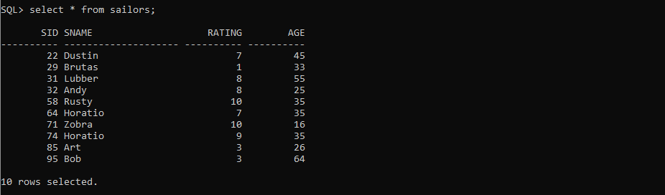

**Boats table**

CREATE TABLE boats(Bid NUMBER(4) PRIMARY KEY, bname varchar(20), color varchar(20));

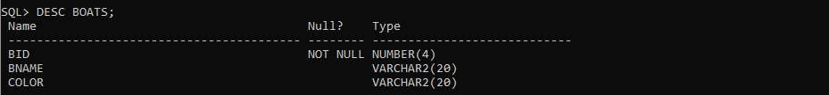

SQL> INSERT INTO boats VALUES(&Bid, '&bname', '&color');

Enter value for bid: 101

Enter value for bname: Interlake

Enter value for color: Blue

old 1: INSERT INTO boats VALUES(&Bid, '&bname', '&color')

new 1: INSERT INTO boats VALUES(101, 'Interlake', 'Blue')

1 row created.

SQL> INSERT INTO boats VALUES(&Bid, '&bname', '&color');

Enter value for bid: 102

Enter value for bname: Interlake

Enter value for color: Red

old 1: INSERT INTO boats VALUES(&Bid, '&bname', '&color')

new 1: INSERT INTO boats VALUES(102, 'Interlake', 'Red')

1 row created.

SQL> INSERT INTO boats VALUES(&Bid, '&bname', '&color');

Enter value for bid: 103

Enter value for bname: Clipper

Enter value for color: Green

old 1: INSERT INTO boats VALUES(&Bid, '&bname', '&color')

new 1: INSERT INTO boats VALUES(103, 'Clipper', 'Green')

1 row created.

SQL> INSERT INTO boats VALUES(&Bid, '&bname', '&color');

Enter value for bid: 104

Enter value for bname: Marine

Enter value for color: Red

old 1: INSERT INTO boats VALUES(&Bid, '&bname', '&color')

new 1: INSERT INTO boats VALUES(104, 'Marine', 'Red')

1 row created.

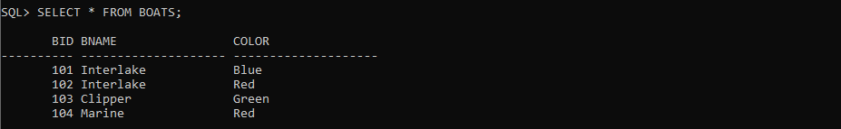

**Reserves table**

CREATE TABLE RESERVES (sid NUMBER, bid NUMBER, day DATE, FOREIGN KEY (sid) REFERENCES sailors(sid), FOREIGN KEY (bid) REFERENCES boats(bid));

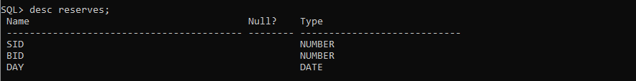

SQL> INSERT INTO reserves VALUES (&sid, &bid, '&day');

Enter value for sid: 22

Enter value for bid: 101

Enter value for day: 10-oct-98

old 1: INSERT INTO reserves VALUES (&sid, &bid, '&day')

new 1: INSERT INTO reserves VALUES (22, 101, '10-oct-98')

1 row created.

SQL> INSERT INTO reserves VALUES (&sid, &bid, '&day');

Enter value for sid: 22

Enter value for bid: 102

Enter value for day: 10-oct-98

old 1: INSERT INTO reserves VALUES (&sid, &bid, '&day')

new 1: INSERT INTO reserves VALUES (22, 102, '10-oct-98')

1 row created.

SQL> INSERT INTO reserves VALUES (&sid, &bid, '&day');

Enter value for sid: 22

Enter value for bid: 103

Enter value for day: 10-aug-98

old 1: INSERT INTO reserves VALUES (&sid, &bid, '&day')

new 1: INSERT INTO reserves VALUES (22, 103, '10-aug-98')

1 row created.

SQL> INSERT INTO reserves VALUES (&sid, &bid, '&day');

Enter value for sid: 22

Enter value for bid: 104

Enter value for day: 10-jul-98

old 1: INSERT INTO reserves VALUES (&sid, &bid, '&day')

new 1: INSERT INTO reserves VALUES (22, 104, '10-jul-98')

1 row created.

SQL> INSERT INTO reserves VALUES (&sid, &bid, '&day');

Enter value for sid: 31

Enter value for bid: 102

Enter value for day: 11-oct-98

old 1: INSERT INTO reserves VALUES (&sid, &bid, '&day')

new 1: INSERT INTO reserves VALUES (31, 102, '11-oct-98')

1 row created.

SQL> INSERT INTO reserves VALUES (&sid, &bid, '&day');

Enter value for sid: 31

Enter value for bid: 103

Enter value for day: 11-jun-98

old 1: INSERT INTO reserves VALUES (&sid, &bid, '&day')

new 1: INSERT INTO reserves VALUES (31, 103, '11-jun-98')

1 row created.

SQL> INSERT INTO reserves VALUES (&sid, &bid, '&day');

Enter value for sid: 31

Enter value for bid: 104

Enter value for day: 11-dec-98

old 1: INSERT INTO reserves VALUES (&sid, &bid, '&day')

new 1: INSERT INTO reserves VALUES (31, 104, '11-dec-98')

1 row created.

SQL> INSERT INTO reserves VALUES (&sid, &bid, '&day');

Enter value for sid: 64

Enter value for bid: 101

Enter value for day: 9-may-98

old 1: INSERT INTO reserves VALUES (&sid, &bid, '&day')

new 1: INSERT INTO reserves VALUES (64, 101, '9-may-98')

1 row created.

SQL> INSERT INTO reserves VALUES (&sid, &bid, '&day');

Enter value for sid: 64

Enter value for bid: 102

Enter value for day: 9-aug-98

old 1: INSERT INTO reserves VALUES (&sid, &bid, '&day')

new 1: INSERT INTO reserves VALUES (64, 102, '9-aug-98')

1 row created.

SQL> INSERT INTO reserves VALUES (&sid, &bid, '&day');

Enter value for sid: 74

Enter value for bid: 103

Enter value for day: 9-aug-98

old 1: INSERT INTO reserves VALUES (&sid, &bid, '&day')

new 1: INSERT INTO reserves VALUES (74, 103, '9-aug-98')

1 row created.

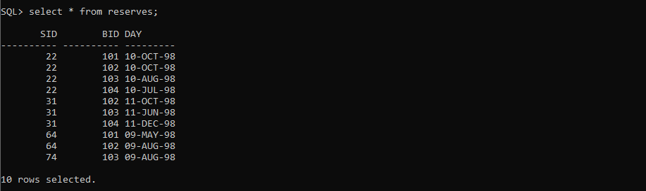

1) Find the names and ages of all sailors

SELECT sname, age FROM sailors;

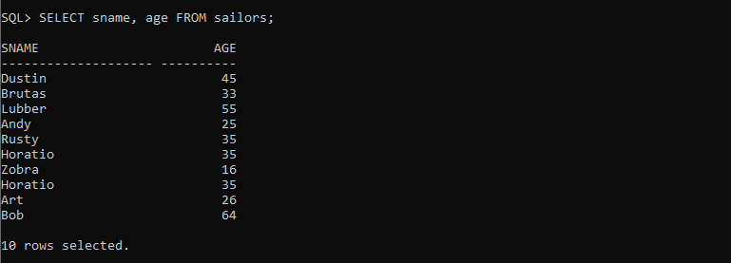

2) Find all information of sailors who have reserved boat number 101.

SELECT * FROM sailors WHERE sid IN (SELECT sid FROM reserves WHERE bid=101);

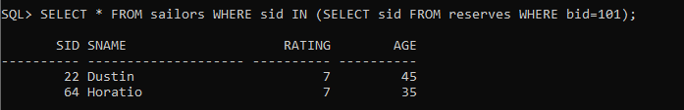

3) Find all sailors with rating above 7

SELECT * FROM sailors WHERE RATING>7;



4) Find the names of sailors who have reserved boat no 103

SELECT sname FROM sailors WHERE sid IN(SELECT sid FROM reserves WHERE bid=103);

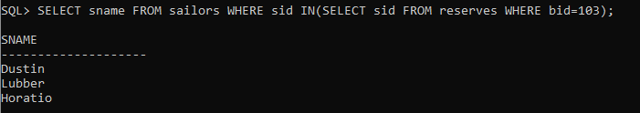

5) Find the names of sailors who have reserved a red boat, and list in the order of age.

SELECT SAILORS.SNAME FROM SAILORS JOIN RESERVES ON SAILORS.SID =RESERVES.SID JOIN BOATS ON RESERVES.BID=BOATS.BID WHERE BOATS.COLOR='Red' ORDER BY SAILORS.AGE;

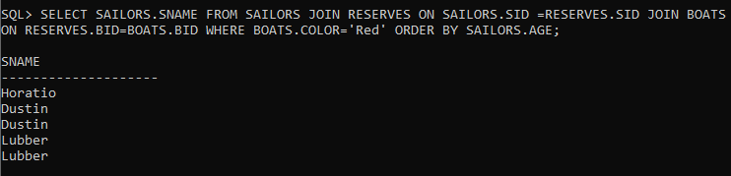

6)