1) Write a Shell program to check the given number is even or odd.

program:

echo -n "Enter a number : "
read n
if [ `expr $n % 2` -eq 0 ]
then
echo "$n is even"
else
echo "$n is odd"
fi

output:

2) Write a Shell program to check a leap year.

program:

echo -n "Enter year : "
read n
if [ `expr $n % 4` -eq 0 ] && [ `expr $n % 100` -ne 0 ] || [ `expr $n % 400` -eq 0 ]; then
echo "$n is leap year"
else
echo "$n is not a leap year"

output:

3) Write a Shell program to find the area and circumference of a circle.

program:

echo "Enter the radius of the circle:"
read radius
area=$(echo "3.1415 * ($radius ^ 2)" | bc)
circumference=$(echo "2 * 3.1415 * $radius" | bc)
echo "The area of the circle is: $area"
echo "The circumference of the circle is: $circumference"

output:

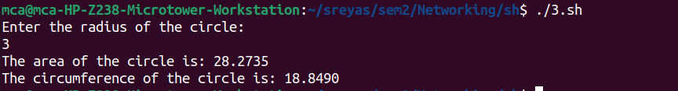

4) Write a Shell program to check the given number and its reverse are same.

program:

echo "Enter a number:"
read number
reverse=$(echo $number | rev)
if [ $number -eq $reverse ]; then
echo "The number and its reverse are the same."
else
echo "The number and its reverse are not the same."
fi

output:

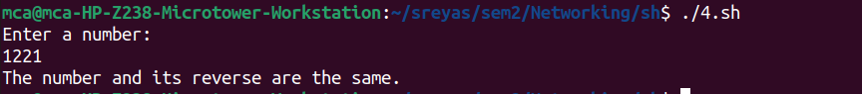

5) Write a Shell program to check the given string is palindrome or not.

program:

echo "Enter a string:"
read string
reverse=$(echo $string | rev)
if [ "$string" == "$reverse" ]; then
echo "The string is a palindrome."
else
echo "The string is not a palindrome."
fi

output:

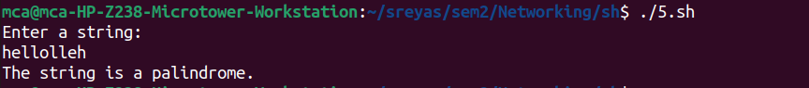

6) Write a Shell program to find the sum of odd and even numbers from a set of numbers.

program:

echo "Enter numbers separated by space:"
read -a numbers
sum_even=0
sum_odd=0
for num in "${numbers[@]}"; do
if [ $((num % 2)) -eq 0 ]; then
sum_even=$((sum_even + num))
else
sum_odd=$((sum_odd + num))
fi
done
echo "Sum of even numbers: $sum_even"
echo "Sum of odd numbers: $sum_odd"

output:

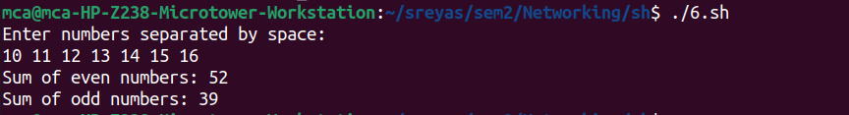

7) Write a Shell program to find the roots of a quadratic equation.

program:

echo "Enter the coefficients (a, b, c) of the quadratic equation (ax^2 + bx + c):"
read a b c
discriminant=$((b * b - 4 * a * c))
if [ $discriminant -gt 0 ]; then
root1=$(echo "(-$b + sqrt($discriminant)) / (2 * $a)" | bc -l)
root2=$(echo "(-$b - sqrt($discriminant)) / (2 * $a)" | bc -l)
echo "The roots are real and different."
echo "Root 1 = $root1, Root 2 = $root2"
elif [ $discriminant -eq 0 ]; then
root=$(echo "-$b / (2 * $a)" | bc -l)
echo "The roots are real and equal."
echo "Root 1 = Root 2 = $root"
else
real_part=$(echo "-$b / (2 * $a)" | bc -l)
imaginary_part=$(echo "sqrt($((-1 * discriminant))) / (2 * $a)" | bc -l)
echo "The roots are complex and different."
echo "Root 1 = $real_part + $imaginary_part i"
echo "Root 2 = $real_part - $imaginary_part i"
fi

output:

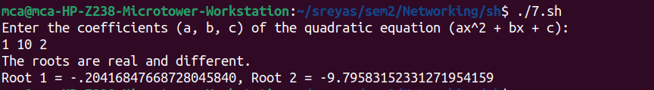

8) Write a Shell program to check the given integer is Armstrong number or not.

program:

echo "Enter a number:"
read number
length=${#number}
sum=0
for ((i=0; i<$length; i++)); do
digit=${number:i:1}
sum=$((sum + digit ** length))
done
if [ $sum -eq $number ]; then
echo "$number is an Armstrong number."
else
echo "$number is not an Armstrong number."
fi

output:

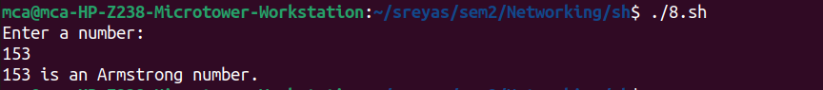

9) Write a Shell program to check the given integer is prime or not.

program:

echo "Enter a number:"
read number
is_prime=true
if [ $number -lt 2 ]; then
is_prime=false
fi
for ((i=2; i<=number/2; i++)); do
if [ $((number % i)) -eq 0 ]; then
is_prime=false
break
fi
done
if $is_prime; then
echo "$number is a prime number."
else
echo "$number is not a prime number."
fi

output:

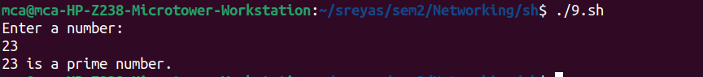

10) Write a Shell program to generate prime numbers between 1 and 50.

program:

echo "Prime numbers between 1 and 50 are:"
for ((i=2; i<=50; i++)); do
is_prime=true
for ((j=2; j<=i/2; j++)); do
if [ $((i % j)) -eq 0 ]; then
is_prime=false
break
fi
done
if $is_prime; then
echo $i
fi
done

output:

