**COMPILER DESIGN**

**(01CE0714)**

**2025-2026**

**STUDENT LAB MANUAL**

**INDEX**

|  |  |  |  |  |
| --- | --- | --- | --- | --- |
| **Sr. No.** | **Title** | **Date** | **Grade** | **Sign** |
| 1 | Write a C Program to remove Left Recursion from grammar |  |  |  |
| 2 | Write a C Program to remove Left Factoring from grammar |  |  |  |
| 3 | Write a C program to implement finite automata and string validation. |  |  |  |
| 4 | Prepare report for Lex and install Lex on Linux/Windows |  |  |  |
| 5 | (a) WALEx Program to count words, characters, lines, Vowels and consonants from given input  (b) WALEx Program to generate string which is ending with zeros. |  |  |  |
| 6 | (a) WALex Program to generate Histogram of words  (b) WALex Program to remove single or multi line comments from C program. |  |  |  |
| 7 | WALex Program to check whether given statement is compound or simple. |  |  |  |
| 8 | WALex Program to extract HTML tags from .html file. |  |  |  |
| 9 | Write a C Program to compute FIRST Set of the given grammar |  |  |  |
| 10 | Write a C Program to compute FOLLOW Set of the given grammar |  |  |  |
| 11 | Write a C Program to implement Operator precedence parser |  |  |  |
| 12 | Write a C Program for constructing LL (1) parsing |  |  |  |
| 13 | Write a C program to implement SLR parsing |  |  |  |
| 14 | Prepare a report on YACC and generate Calculator Program using  YACC. |  |  |  |

**Practical 1**

**Title:** **Write a C Program to remove Left Recursion from the grammar**

**Hint :**Left Recursion in grammar occurs when a non-terminal appears on the left-most side of its own production.  
Example: A → Aα | β  
After removing left recursion:  
A → βA'  
A' → αA' | ε

**Program :**

#include <stdio.h>

#include <string.h>

void main() {

// prod = full input production, like A->Aa|b

// alpha = stores recursive rules (Aa -> a), beta = non-recursive rules

char prod[100], alpha[10][20], beta[10][20], nonTerminal;

int i = 0, m = 0, n = 0;

// ?? Step 1: Get user input

printf("Enter production (e.g., A->Aa|b): ");

scanf("%s", prod); // Input like A->Aa|b

// ?? Step 2: Extract non-terminal from LHS

nonTerminal = prod[0];

// Check format (must be like A->)

if (!(prod[1] == '-' && prod[2] == '>')) {

printf("Invalid production format!\n");

return;

}

i = 3; // Start reading from RHS (skip A->)

// Temporary string to hold each rule between '|'

char temp[20];

int t = 0;

// ?? Step 3: Loop to split RHS rules by '|'

while (1) {

// End of one rule (either '|' or '\0')

if (prod[i] == '|' || prod[i] == '\0') {

temp[t] = '\0'; // End the string

// If rule starts with nonTerminal ? it's left recursive

if (temp[0] == nonTerminal)

strcpy(alpha[m++], temp + 1); // Remove nonTerminal and store in alpha[]

else

strcpy(beta[n++], temp); // Store safe rules in beta[]

t = 0; // Reset temp

if (prod[i] == '\0') break; // End loop if end of string

} else {

temp[t++] = prod[i]; // Add character to temp rule

}

i++;

}

// ?? Step 4: If no left recursion found

if (m == 0) {

printf("No Left Recursion Detected.\n");

return;

}

// ?? Step 5: Output new grammar after removing left recursion

printf("After removing left recursion:\n");

// Print: A -> beta A'

printf("%c -> ", nonTerminal);

for (i = 0; i < n; i++) {

printf("%s%c'", beta[i], nonTerminal); // Add A' to beta

if (i != n - 1) printf(" | ");

}

// Print: A' -> alpha A' | e

printf("\n%c' -> ", nonTerminal); // Proper A' (not B')

for (i = 0; i < m; i++) {

printf("%s%c' | ", alpha[i], nonTerminal); // alpha part + A'

}

printf("e\n"); // Always add epsilon (empty string) to end A' recursion

}

**Output:**

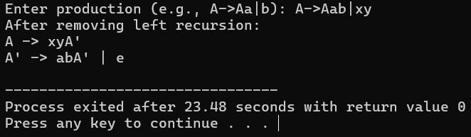

**Practical 2**

**Title:** **Write a C Program to remove Left Factoring from the grammar**

**Hint :**

#include <stdio.h>

#include <string.h>

**Program :**

int main() {

// Declare required strings to store parts of the production

char gram[20]; // Input: the full production RHS, e.g. abcd|abxy

char part1[20], part2[20]; // Two separate alternatives

char modifiedGram[20]; // To hold the factored common part + new NT (e.g. aX)

char newGram[20]; // To hold remaining suffixes (e.g. bcd|bxy)

char tempGram[20]; // (Unused in this code)

int i, j = 0, k = 0, l = 0, pos;

// Input production rule (Only RHS part, assumes LHS is 'A->')

printf("Enter Production : A->");

gets(gram); // deprecated, use fgets() in modern code (but okay for now)

// Step 1: Split into two parts using '|'

for(i = 0; gram[i] != '|'; i++, j++) {

part1[j] = gram[i]; // Copy everything before '|' to part1

}

part1[j] = '\0'; // Null-terminate part1

for(j = ++i, i = 0; gram[j] != '\0'; j++, i++) {

part2[i] = gram[j]; // Copy everything after '|' to part2

}

part2[i] = '\0'; // Null-terminate part2

// Step 2: Find longest common prefix

for(i = 0; i < strlen(part1) || i < strlen(part2); i++) {

if(part1[i] == part2[i]) {

modifiedGram[k++] = part1[i]; // Build the common prefix

pos = i + 1; // Store next index after prefix

}

}

// Step 3: Get remaining suffixes after the prefix in both parts

for(i = pos, j = 0; part1[i] != '\0'; i++, j++) {

newGram[j] = part1[i]; // Remaining part of first production

}

newGram[j++] = '|'; // Add separator between productions

for(i = pos; part2[i] != '\0'; i++, j++) {

newGram[j] = part2[i]; // Remaining part of second production

}

// Step 4: Finalize new grammar strings

modifiedGram[k] = 'X'; // Add new non-terminal (assumes X is safe)

modifiedGram[++k] = '\0'; // Null-terminate

newGram[j] = '\0'; // Null-terminate

// Step 5: Print result

printf("\nGrammar Without Left Factoring : \n");

printf(" A->%s", modifiedGram); // e.g. A->abX

printf("\n X->%s\n", newGram); // e.g. X->cd|xy

return 0;

}

**Output:**

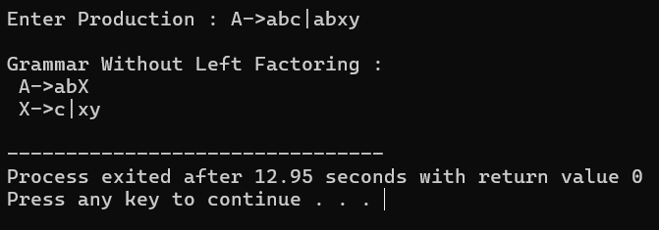

**Practical 3**

**Title:** **Write a C Program to remove Left Factoring from the grammar**

**Hint : DFA for accept “abb”  
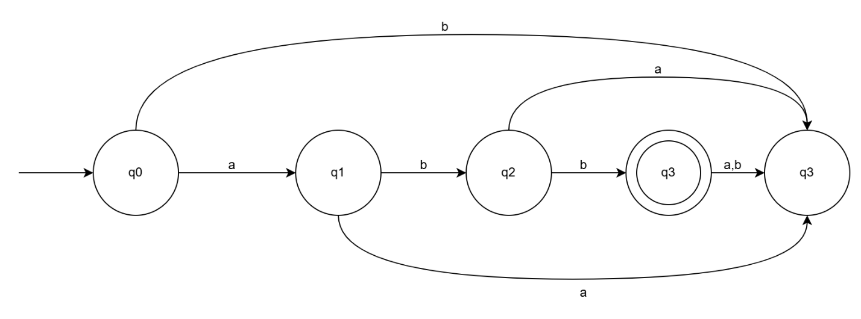**

**Program :**

#include <stdio.h>

#include <string.h>

// Automaton using else-if ladder for accepting "abb"

int main() {

char input[100];

int state = 0, i = 0;

printf("Enter a string: ");

scanf("%s", input);

while (input[i] != '\0') {

if (state == 0 && input[i] == 'a') {

state = 1;

}

else if (state == 1 && input[i] == 'b') {

state = 2;

}

else if (state == 2 && input[i] == 'b') {

state = 3;

}

else {

// Invalid character or unexpected input

state = -1;

break;

}

i++;

}

// Final state must be 3 for valid "abb"

if (state == 3 && input[i] == '\0') {

printf("String ACCEPTED by automaton.\n");

} else {

printf("String REJECTED by automaton.\n");

}

return 0;

}

**Output:**

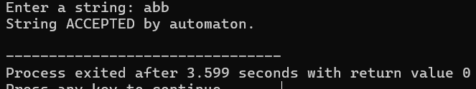

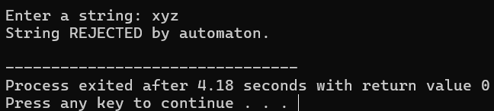

**Practical 4**

**Title: Prepare report for Lex and install Lex on Linux/Windows**

**LEX in Compiler Design:**

Whenever a developer wants to make any software application they write the code in a high-level language. That code is not understood by the machine so it is converted into low-level machine-understandable code by the compiler. Lex is an important part of this compiler and is responsible for the classification of the generated tokens based on their purpose.

**Lexical Analysis**

It is the first step of [compiler design](https://www.geeksforgeeks.org/introduction-of-compiler-design/), it takes the input as a stream of characters and gives the output as tokens also known as tokenization. The tokens can be classified into identifiers, Separators, Keywords, Operators, Constants and Special Characters.

It has three phases:

* Tokenization: It takes the stream of characters and converts it into tokens.
* Error Messages: It gives errors related to lexical analysis such as exceeding length, unmatched string, etc.
* Eliminate Comments: Eliminates all the spaces, blank spaces, new lines, and indentations.

**What is Lex in Compiler Design?**

* Lex is a tool or a computer program that generates Lexical Analyzers (converts the stream of characters into tokens). The Lex tool itself is a compiler. The Lex compiler takes the input and transforms that input into input patterns. It is commonly used with YACC(Yet Another Compiler Compiler). It was written by Mike Lesk and Eric Schmidt.
* Function of Lex
* 1. In the first step the source code which is in the Lex language having the file name 'File.l' gives as input to the Lex Compiler commonly known as Lex to get the output as lex.yy.c.
* 2. After that, the output lex.yy.c will be used as input to the C compiler which gives the output in the form of an 'a.out' file, and finally, the output file a.out will take the stream of character and generates tokens as output.

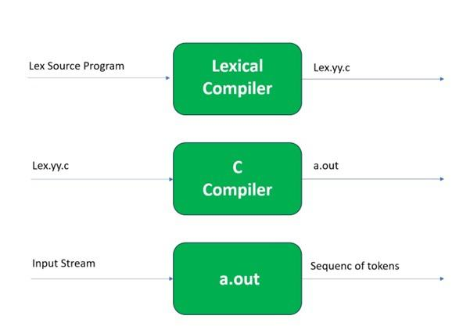

lex.yy.c: It is a C program.  
File.l: It is a Lex source program  
a.out: It is a Lexical analyzer

**Lex File Format:**

A Lex program consists of three parts and is separated by % delimiters: -

Declarations  
%%  
Translation rules  
%%  
Auxiliary procedures

**Declarations:**The declarations include declarations of variables.

**Transition rules:** These rules consist of Pattern and Action.

**Auxiliary procedures:** The Auxiliary section holds auxiliary functions used in the actions.

**For example:**

**declaration**  
number[0-9]  
%%  
**translation**  
if {return (IF);}  
%%  
**auxiliary function**  
int numberSum()

**Steps of installing LEX compiler**

