**Cng 336**

**Lab Final Prework**

**Ulaş Cem Erten - 2256006**

**6.2.3)**

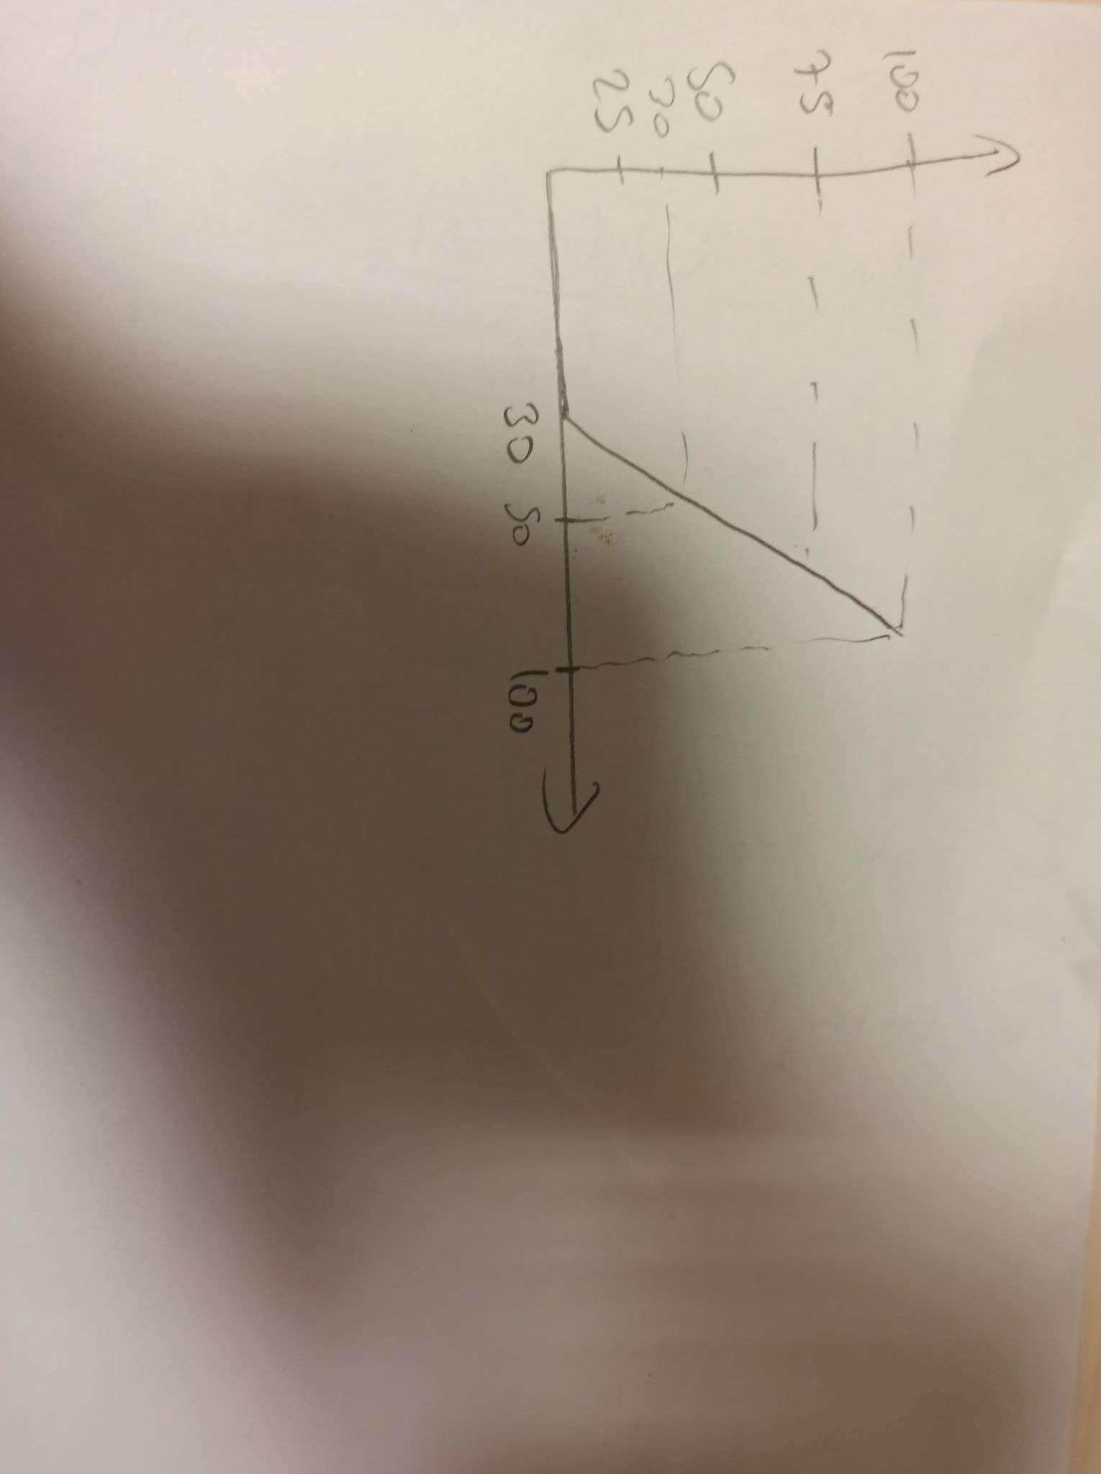

In above picture y axis shows the fan speed, x axis shows the temperature. Under 30 C, fan speed is zero. And Its working with max speed in 100 C with 100 percent fan speed.

**Schematic**

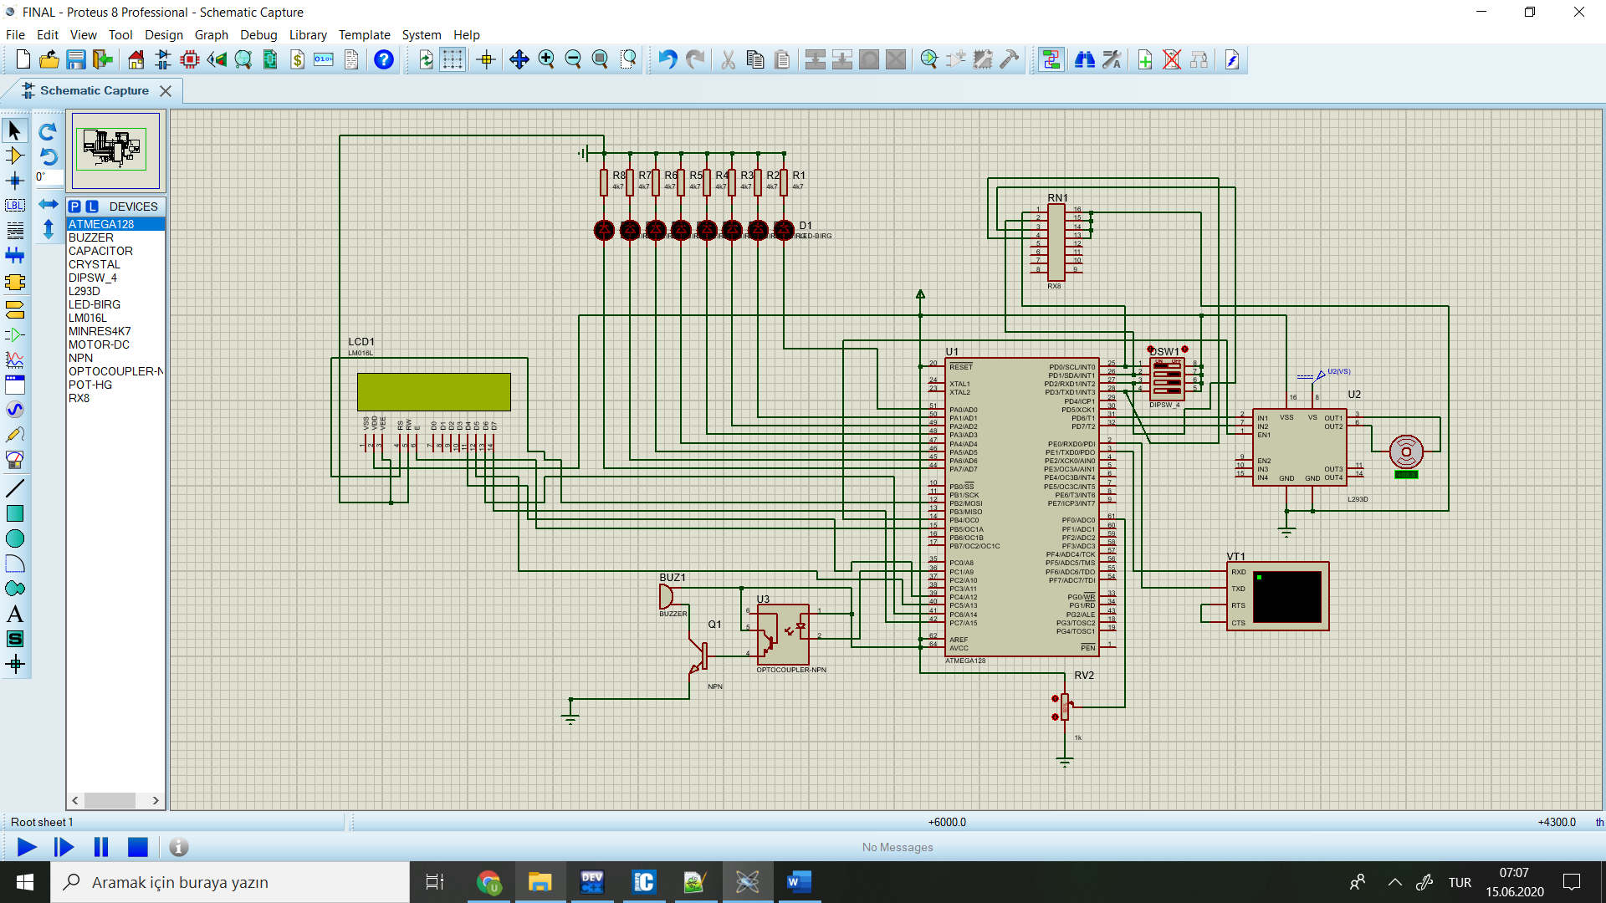

I used PE0 and PE1 to communicate with terminal. I used PD0 for LCD Line 1 select for Temperature display on LCD, PD1 for LCD Line 2 Select for Speed Display on LCD, PD3 for LEDs Display select on PORTA and PD2 for Buzzer noise select. I used PC1 for Buzzer. I used PB4 to deliver PWM signal to the motor driver. I used PB2 for LCD RS, PB5 for LCD En, PC4 to PC7 for LCD Data delivery.

**Flow Diagram**

**Main Module**

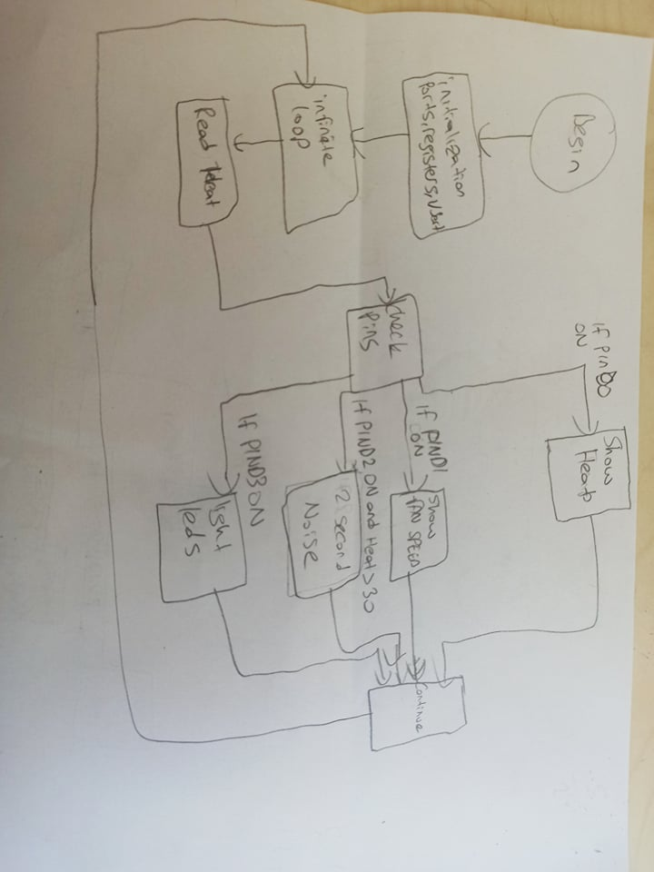

**Usart Module**

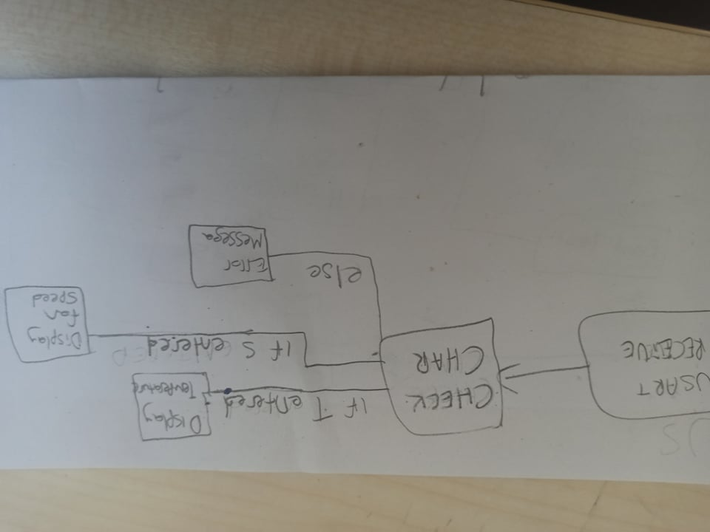

**Source Code**

sbit LCD_RS at PORTB2_bit;

sbit LCD_EN at PORTB5_bit;

sbit LCD_D4 at PORTC4_bit;

sbit LCD_D5 at PORTC5_bit;

sbit LCD_D6 at PORTC6_bit; // lcd init

sbit LCD_D7 at PORTC7_bit;

sbit LCD_RS_Direction at DDB2_bit;

sbit LCD_EN_Direction at DDB5_bit;

sbit LCD_D4_Direction at DDC4_bit;

sbit LCD_D5_Direction at DDC5_bit;

sbit LCD_D6_Direction at DDC6_bit;

sbit LCD_D7_Direction at DDC7_bit;

void send_char(unsigned char my_char){ // send char function

while (!((UCSR0A) & (1 << (UDRE0))));

UDR0 = my_char;

}

void send_string(unsigned char* my_string){ // send string function

while(*my_string)

send_char(*my_string++);

}

unsigned char* my_data = 0x500;

void clear_every_thing(unsigned char* my_data, unsigned int ADDR)

{

int i = 0; // it clears everything in the given adress i used to clear usart

memset(my_data, 0, 0x50);

my_data = ADDR;

}

unsigned char* int_to_String(unsigned int x) { //int to string convertion function

unsigned char converted[4]="";

unsigned int initial_value = x;

char temp_val;

if(initial_value==100){ // look up table for 3 digit number and 1 digit number

return "100";

}

if(initial_value==0){

return "0";

}

if(initial_value==1){

return "1";

}

if(initial_value==2){

return "2";

}

if(initial_value==3){

return "3";

}

if(initial_value==4){

return "4";

}

if(initial_value==5){

return "5";

}

if(initial_value==6){

return "6";

}

if(initial_value==7){

return "7";

}

if(initial_value==8){

return "8";

}

if(initial_value==9){

return "9";

}

if(x==0)

{

*converted = '0';

*(converted + 1) = '\0';

return "";

}

else

{

unsigned int i = 0;

while(x)

{

unsigned char d = x % 10;

x /= 10;

if(d>9)

converted[i++]=(d + 55);// to find its ascii if it is a letter

else

converted[i++]=(d + 48);

}

converted[i] = '\0';

temp_val = converted[0]; //swap operation because now it is in opposite order

converted[0] = converted[1];

converted[1] = temp_val;

return converted;

}

}

unsigned char waves = 0;

void start_noise() iv 0x001E{ // create square wave on portb 4 for making noise if timer 0 compare handle

PORTB.B4 = waves ^ 1;

}

unsigned int sum_twos = 0;

void stop_noise() iv 0x0014 // for stopping noise when timer2 overflow

{++sum_twos; // increment until it becomes 2 sec

}

unsigned char temp;

int my_flag;

unsigned char text_for_usart[0x50];

unsigned char temp_for_usart[4];

unsigned int unit_select;

unsigned int fan_speed = 0;

unsigned int heat_value = 0;

void usart() iv 0x0024{

unsigned int enter = 0;

temp = UDR0;

if(temp == '\n' || temp == '\r') // check if enter is pressed

enter = 1;

else

{if((unsigned int) my_data < 0x530) {

*my_data++ = temp;

*my_data = '\0';}

}

UDR0 = temp;

if(enter)

{my_data = 0x500;

my_flag=1; // flag for adding the unit % or C

if(!(strcmp(my_data,"T"))){ // if equals will return 0

unit_select=1; //choose % or C

strcpy(text_for_usart, "TEMPERATURE: "); // basic copy string

strcpy(temp_for_usart,int_to_String(heat_value));

strcpy(text_for_usart + strlen("TEMPERATURE: "), temp_for_usart);

}

else if(!(strcmp(my_data,"S"))){

unit_select=2;//same as above

strcpy(text_for_usart, "FAN SPEED: ");

strcpy(temp_for_usart,int_to_String(fan_speed));

strcpy(text_for_usart + strlen("FAN SPEED: "), temp_for_usart);

}

else{

send_string("Wrong input entered, Please "); // another input

my_flag=0; // flag will choose wrong input message

}

if(my_flag==1){

if(unit_select==1)

strcpy(text_for_usart + strlen("TEMPERATURE: ") + strlen(temp_for_usart), "C\r"); //explained above

if(unit_select==2)

strcpy(text_for_usart + strlen("FAN SPEED: ") + strlen(temp_for_usart), "%\r"); //explained above

send_string(text_for_usart);

}

clear_every_thing(my_data, 0x500); // clear the data so last data value it wont be seen while asking input

send_string("Enter S for % fan speed and T for temperature:");

}

enter = 0;

}

void active_switches();

unsigned char len_temperature;

unsigned char* lcd_up = 0x300;

unsigned char* lcd_down = 0x320;

unsigned char buzzer_1 = 0;

unsigned char buzzer_2 = 0;

unsigned char motor = 0;

unsigned int second_adc = 0;

unsigned char my_led = 0;

unsigned int first_adc = 0;

void all_calculations() iv 0x002A //adc function

{

second_adc = ADCL;

second_adc += (ADCH & 0x03) << 8; // hence value max 10 bit we should take first 2 bits of high and shift it 8 bits left

if(first_adc != second_adc) // if them changed

{first_adc = second_adc; //store the

heat_value = (second_adc * 0.098); // heat = 5/1023/50 mV * (10 bit value)

if(heat_value < 30) // if new heat value <30

{

buzzer_2 = 0; // buzzer will not sound

fan_speed = 0; //fan speed will be 0

if(motor) // if motor already active

{

((TIMSK) &= ~(1 << (OCIE0))); // enable interrupt for timer0

waves = 0; // make waves variable 0 so when next time interrupt it will create waves on portb4

PORTB.B4 = 0; // but no need because heat < 30

motor = 0; // motor shouldnt work under 30 C

}

if(buzzer_1) //this condition is for high to low temp which means buzzer1 is already set but now we are under 30 C

{((TIMSK) &= ~(1 << (TOIE2))); // enable timer2 interrupt

TCNT2 = 0; //load 0 to timer 2

buzzer_1 = 0; // now buzzer1 should be 0

}

}

else //if heat > 30

{

fan_speed = 100*(heat_value-30)/70; // calculate fan speed

if(!motor) //if low to high

TIMSK |= 1 << (OCIE0); // start timer 0 to make noise

motor = 1; //now motor is active

}

OCR0 = (fan_speed * 255) / 100; // load needed value to ocr0

strcpy(lcd_up, "TEMPERATURE:");

strcpy(temp_for_usart,int_to_String(heat_value));

strcpy(lcd_up + 12, temp_for_usart);

len_temperature = strlen(temp_for_usart);

lcd_up[12 + len_temperature] = 'C';

memset(lcd_up + 13 + len_temperature, ' ', 11 - len_temperature);

strcpy(lcd_down, "FAN SPEED:");

strcpy(temp_for_usart,int_to_String(fan_speed));

strcpy(lcd_down + 10, temp_for_usart);

len_temperature = strlen(temp_for_usart);

lcd_down[10 + strlen(temp_for_usart)] = '%';

memset(lcd_down + 11 + len_temperature, ' ', 11 - len_temperature);

my_led = ((1 << (second_adc / 127)) - 1) & 0xFF; // led values on port a 5V 100 -> 0.625 V for 12.5 for each led

}

active_switches();

}

void active_switches(){ // to check which switches are active

if(PIND.B0==1) //display temperature on first line

Lcd_Out(1, 1, lcd_up);

else

{unsigned char temp[0x10]; // else display empty lines

memset(temp, ' ', 0x10);

Lcd_Out(1, 1, temp);}

if(PIND.B1==1) //same as above

Lcd_Out(2, 1, lcd_down);

else

{unsigned char temp[0x10];

memset(temp, ' ', 0x10);

Lcd_Out(2, 1, temp);}

if(PIND.B2==0) //if buzzer noise switch not active

{

buzzer_2 = 0; // make buzzer2 0 for future

if(buzzer_1) // even if it should have been make noise

{((TIMSK) &= ~(1 << (TOIE2))); // disable timer2

TCNT2 = 0; //load 0 to timer 2

((PORTC) |= (1 << (1))); //portc1 is 1

buzzer_1 = 0;}} //make buzzer1 0 for future

else if(!buzzer_1 && heat_value > 30 && !buzzer_2) //so prev buzzers are 0 and heat > 30

{((TIMSK) |= (1 << (TOIE2))); //enable timer2 overflow interrupt

((PORTC) &= ~(1 << (1)));

buzzer_1 = 1; //made noise become 1

buzzer_2 = 1;}

if(PIND.B3==0) //if led display pin inactive

PORTA = 0; // no display

else

PORTA = my_led; //else display 1 bit for each 12.5 C

}

void restart_timer(){

sum_twos = 0; //make it 0

TIMSK &= ~(1 << TOIE2); // Timer2 overflow interrupt enable

TCNT2 = 0; //timer2 is again 0

PORTC |= 1 << 1; // make PORTC.1 to 1 again

buzzer_1 = 0; // buzzer_1 will become 0 so it will not start

}

void initialize_ports_and_registers(){

DDRA = 0xFF; // A for led outputs

DDRC = 0x02; // C1 connection for buzzer

DDRD = 0xF0; // D7 and D6 for motor connection output

UCSR0C |= (1 << UCSZ01)|(1 << UCSZ00); // UCR0C init

UCSR0B |= (1 << RXEN0)| (1 << RXCIE0) | (1 <<TXEN0) ; // UCSR0B init

DDRB |= 1 << 4; //portb4 will be connected L293D(motor entegre) EN1

PORTD &= ~(1 << (7)); //portd4 will be connected L293D(motor entegre) IN2

PORTD |= 1 << 6; //portd4 will be connected L293D(motor entegre) IN1

PORTC |= 1 << 1; // portc1 will be connected to buzzer

Lcd_Init(); // lcd init

Lcd_Cmd(_LCD_CLEAR); // clear

Lcd_Cmd(_LCD_CURSOR_OFF); // if i dont write this it is seen like cloudy

UBRR0L = 0x40; // baud rate = fclock/(16*UBRR) -1 for async mode, normal speed

UBRR0H = 0; // UBRR = 10^7/(9600*16)-1

TCCR0 |= (1 << CS02) | (1 << CS00) | (1 << WGM00) | (1 << COM01); //prescale 1024 normal mode

OCR0 = fan_speed * 2.55;

TCCR2 |= 1 << CS22; //presecaler 128, normal mode

ADCSRA = 0xEF; // prescelar 64 ,no ADIF and ADPS0, free run mode

}

void enable_interrupt(){//enable interrupt

SREG_I_bit = 1;

}

void main() {

initialize_ports_and_registers(); //call function

enable_interrupt(); // call function

send_string("Enter S for % fan speed and T for temperature:"); // send this to Terminal for 1 time

while(1) {

//just wait

if(sum_twos >= 0x92) { // if it reaches 2 second restart

restart_timer();

}

}

}

**Demonstration**

4C

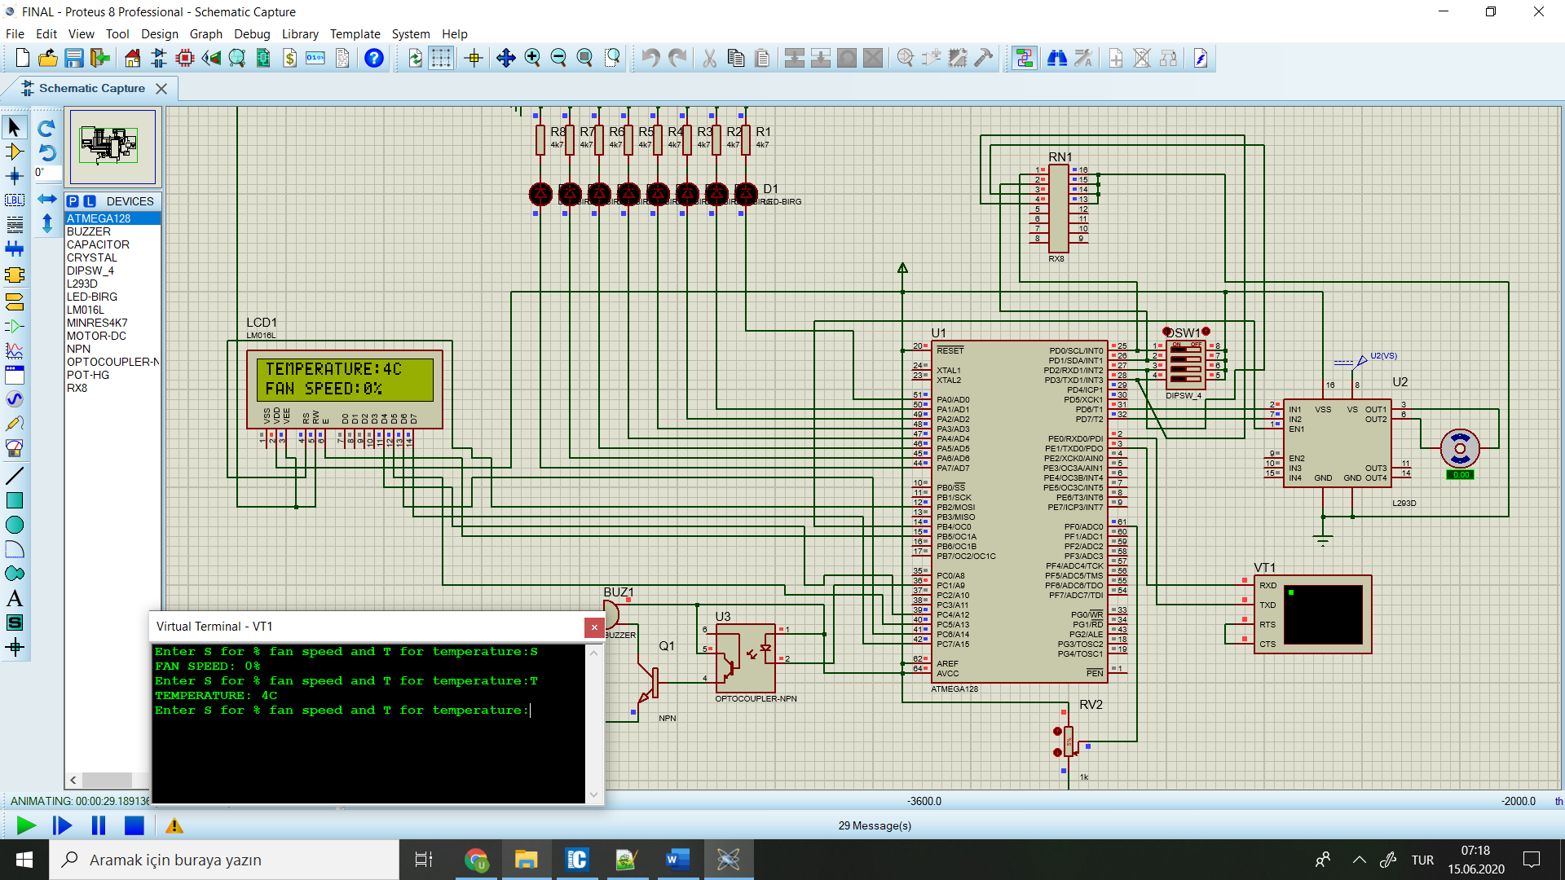

26 C

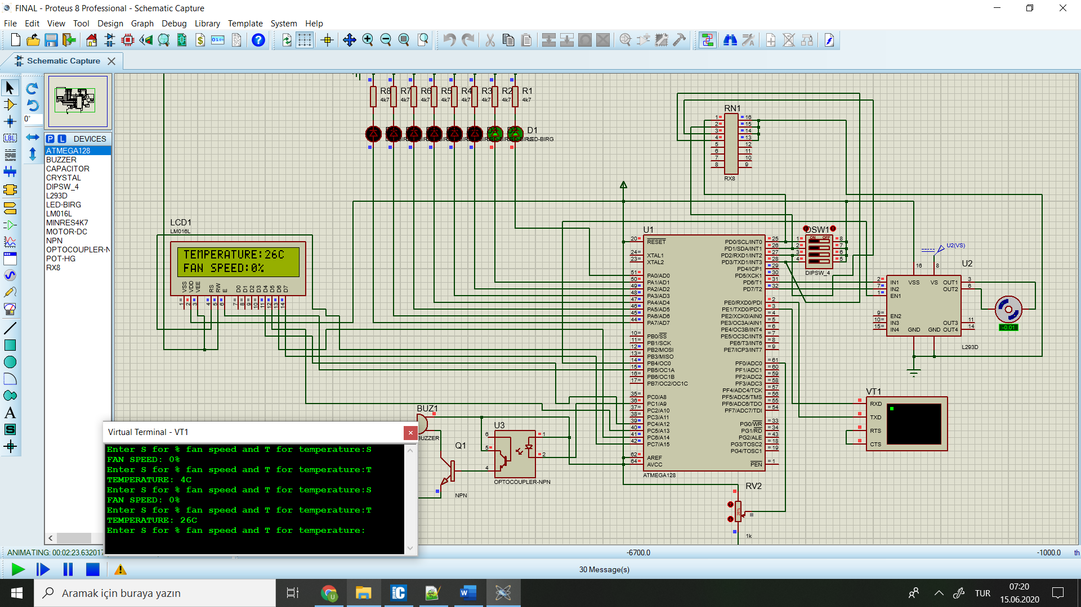

44 C

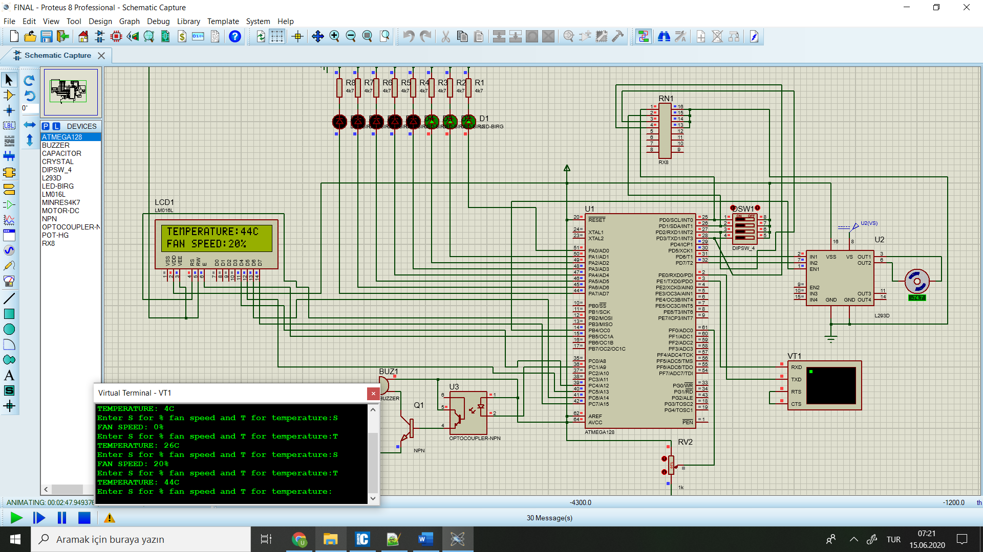

76C

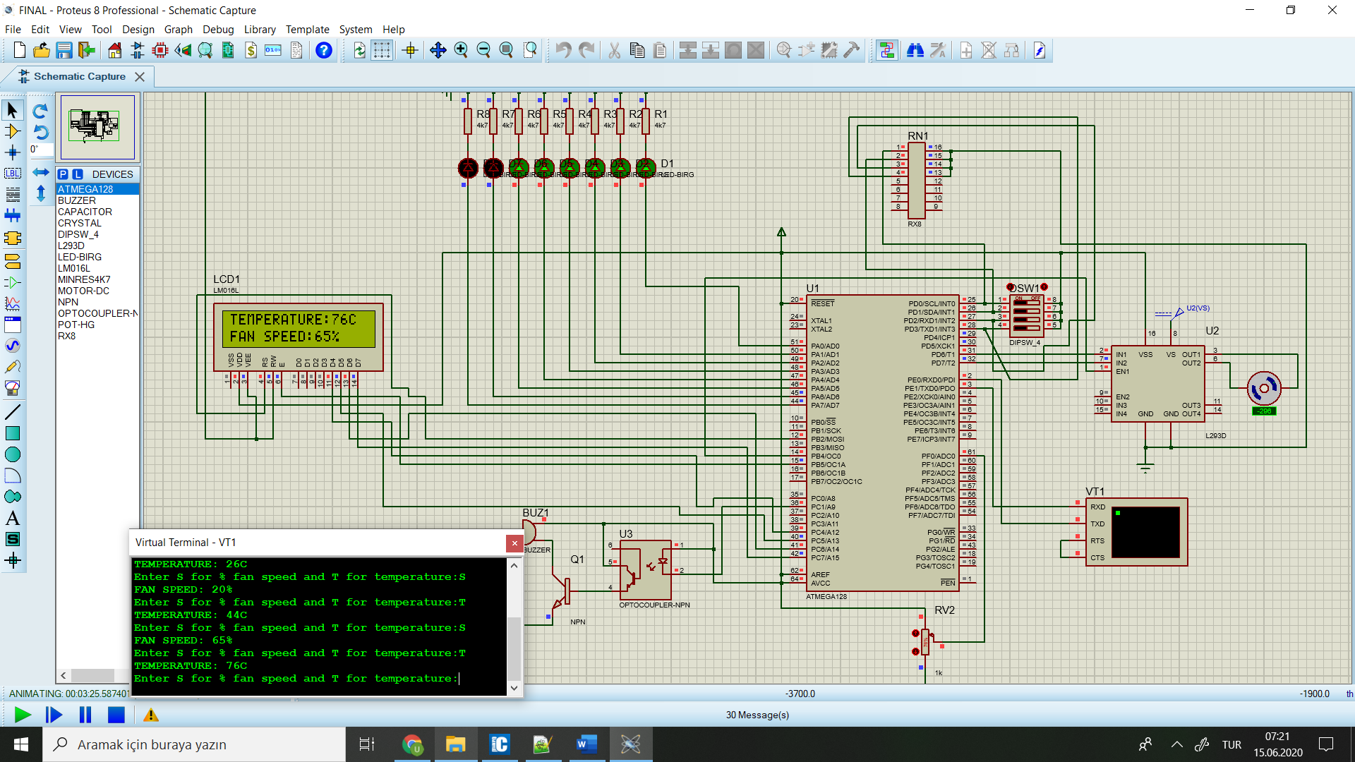

100 C (Highest)

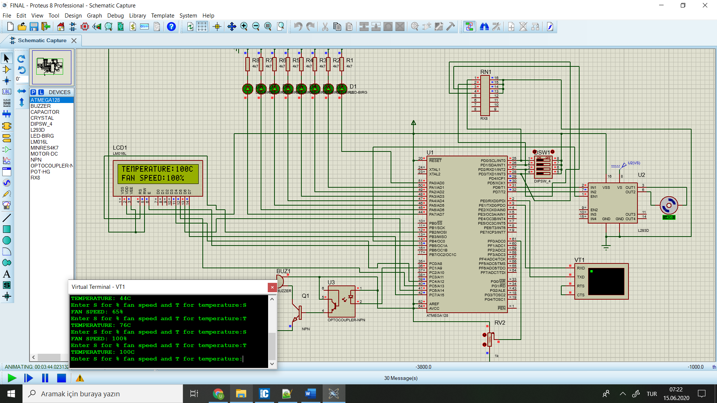

Capture for wrong input in terminal

