THE CIRCLES PROJECT
A possible alternative
The Circles Project is a proposal for an alternative to the way in which we organise collective life today.
It arises from a simple question:
what alternatives do we have?
The project proposes to build a society in which the freedom of the individual and the capacity of the collectivity to cooperate can coexist.
The starting point is the individual.
Every person possesses the same dignity and no person is worth more than another. The collectivity arises from the voluntary coming together of individuals and from the need to accomplish together what no one could accomplish alone.
Each person is as important as the others. No one stands above anyone.
The freedom of each meets that of the others.
My freedom does not end where yours begins: it begins together with yours.
From this principle derives a relationship of reciprocity:
need gives the right to receive; capacity commits one to contribute; usefulness to the community deserves recognition.
Contribution to the collectivity does not constitute superiority over another, just as need does not constitute a condition of inferiority.
Society exists to allow people to live freely together and to pool what is necessary for that freedom to be concrete.

The Circles
The Circles Project organises society through a federated structure of Circles.
A Circle is an organisational and decision-making unit of defined size, constituted around a specific purpose and a specific sphere of responsibility and connected to the other Circles through a federated structure.
Each Circle therefore operates within a determined sphere.
A proximity Circle deals with the matters that directly concern the community in which it operates.
A Competence Circle, by contrast, addresses what requires specific knowledge or responsibilities.
The different levels do not represent a hierarchy of the worth of persons.
They represent a distribution of functions.
No Circle is superior to the individuals who compose it and no sphere of competence should turn automatically into personal power.
The Circles cooperate, coordinate with one another and check one another in accordance with the rules established by the system.
The aim is to allow society to organise itself on a large scale without permanently concentrating power in the hands of a few.
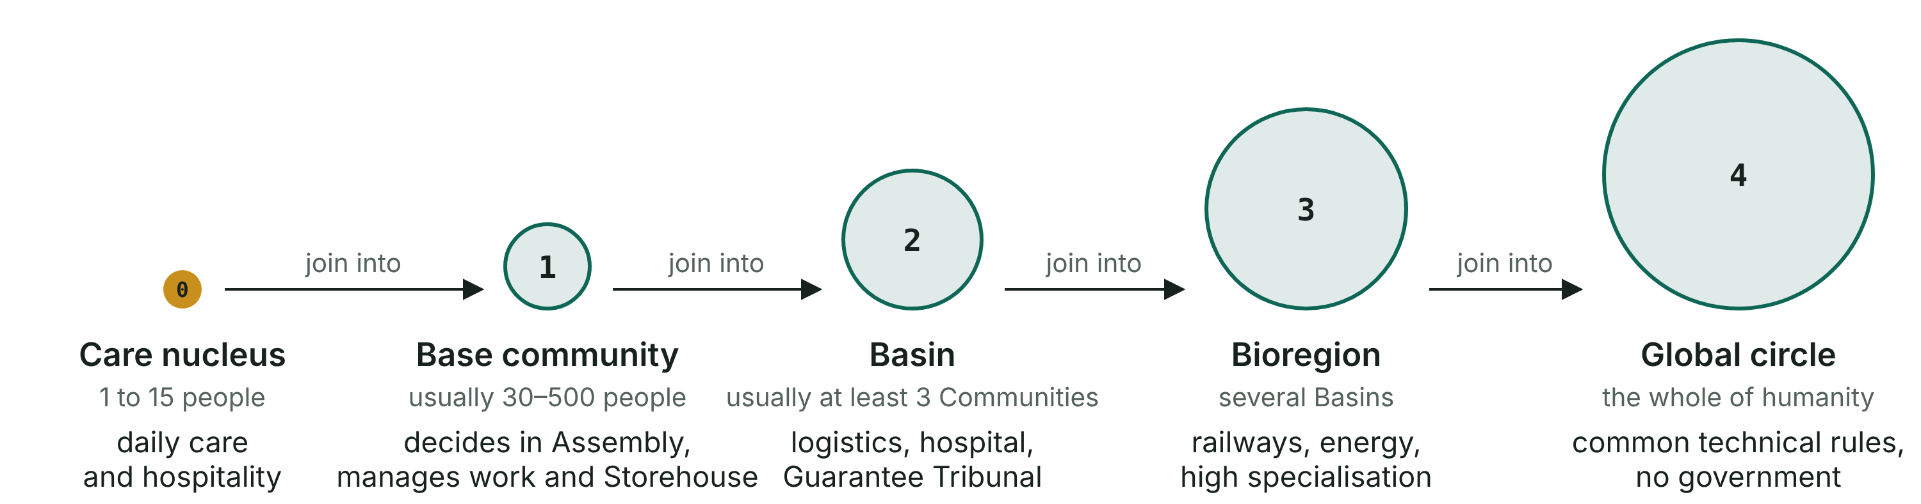
The five levels, from the person to the planet. No level commands the one below: every decision stays at the closest level that can take it.

From need to task
The Circles Project introduces a fundamental principle into the organisation of production and services:
the system does not start from the tasks to be assigned. It starts from the needs to be met.
First, what is needed is identified.
Then, what must be done is determined.
Finally, who will have to do it, and how, is organised.
Work does not determine need. It is need that determines the work necessary.
This changes the way collective organisation is conceived.
An activity is not maintained simply because it exists.
A production is not considered necessary merely because it can be carried out.
A resource is not directed to where there is greater purchasing capacity, but to where there is a necessity that the system must address in accordance with its own rules.
Production, logistics, infrastructure and the contribution of persons must therefore be organised starting from real necessities.
The system must be able to identify needs, understand their scale and transform this information into organisation.
Information tools and artificial intelligence can assist this process, but they remain tools: the gathering and processing of information do not in themselves constitute decision-making power.
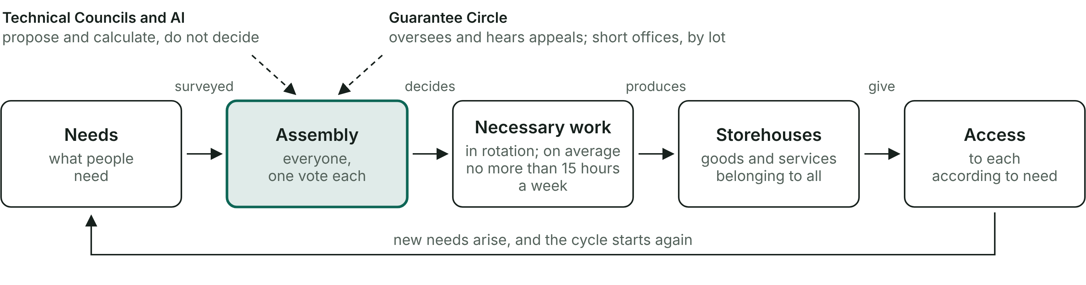
How a Community works: it starts from needs, the Assembly decides, the necessary work fills the Storehouses and everyone has access according to need.

Organising without concentrating power
A complex society needs organisation.
It needs people who produce, care, build, teach, design, transport, maintain infrastructure, manage information and perform thousands of different functions.
Specialisation is therefore necessary.
The problem arises when a necessary function becomes a permanent position of power.
The Circles Project therefore separates, as far as possible, competence, function and personal power.
A person can have a specific competence without becoming the owner of that competence.
A Circle can have a specific responsibility without becoming the owner of the matter it manages.
A function can require continuity without necessarily turning into a permanent authority.
For this reason the system provides for instruments of transparency, verification, challenge, rotation of functions where possible and distribution of responsibilities.
The aim is to build organisation without building a new class of dominators.

The collectivity as an instrument of the individual
The relationship between individual and collectivity constitutes the centre of the project.
The collectivity possesses capacities that the single individual cannot have.
It can build hospitals, energy networks, transport systems, infrastructure, housing, information systems, research facilities and large-scale production.
It can pool knowledge and resources.
It can address problems that exceed the possibilities of a single person.
The Circles Project recognises at the same time the value of individual capacities.
Those who know how to do something useful for others must be able to be recognised for their contribution.
Merit can arise from competence, from commitment, from creativity, from knowledge, from the capacity to solve problems or simply from the willingness to help.
The greatest merit is to be useful to someone. And the greater the usefulness one manages to create for others, the greater the recognition can be.
This recognition concerns the contribution, not the dignity of the person.
All remain equal in their dignity and in their fundamental rights, even when their contributions, competences and responsibilities are different.
Individual capacity thus becomes a resource for the collectivity.
The individual is the starting point. The collectivity is the instrument.

An open source project
The Circles Project is born and is developed as an open source project.
The reason is simple: no individual possesses alone all the knowledge necessary to build a society.
A system of this complexity requires extremely diverse competences.
Law, medicine, engineering, information technology, energy, agriculture, architecture, logistics, economics, science, safety, organisation, communication and a great many other fields must be able to contribute to its construction.
The project must therefore be accessible to those who possess different knowledge and want to make it available.
The Constitution, the Codes, the Annexes, the technical documentation, the infrastructure projects and the results of the experiments must be open to being studied, verified, criticised and improved.
Open source thus becomes part of the very method of construction.
The project is made public so that many people can:
read it → criticise it → verify it → correct it → improve it → develop it.
The knowledge necessary for the construction of the system must not be concentrated in a single author, group or institution.
Those who take part in the construction can leave a verifiable trace of their contribution.
Knowledge remains public and the process of development remains documented.
The aim is to create progressively a system in which the capacity to build belongs to the collectivity without turning into someone’s ownership over the collectivity.

A project that must prove that it works
The Circles Project considers writing the first level of design.
After design come verification, experimentation and concrete experience.
The process must therefore be continuous:
design → verification → experimentation → observation → correction → new version.
It must be possible to subject proposals to criticism.
It must be possible to recognise errors.
It must be possible to document problems.
It must be possible to modify solutions.
A system that cannot be corrected rapidly becomes incapable of adapting to reality.
For this reason the project must remain open to revision even after its eventual application.
Its solidity depends on the capacity to detect its own errors and correct them.

From theory to reality
The Circles Project comprises at the same time a theoretical structure and a material construction.
The Constitution establishes the fundamental principles and the general structure.
The Codes transform those principles into operating rules.
The Technical Annexes develop procedures, criteria and specifications.
The infrastructure makes materially possible what the system establishes.
This means that the construction of the theoretical project and that of the infrastructure must proceed in parallel.
If it is established that a good must be available, there must exist systems capable of producing it, storing it and distributing it.
If transparent management of information is provided for, there must exist information systems capable of making it concretely possible.
Theory defines what the system must make possible.
Infrastructure makes it possible to achieve it.
For this reason the publication of the texts represents the beginning of the construction.

A concrete possibility
The Circles Project starts from the possibility that what we have inherited can be modified.
It proposes to build a structure complete enough to be studied, discussed, verified and, when necessary, corrected.
The question from which it arises remains simple:
what alternatives do we have?
The Circles Project tries to give an answer by building one.
The project begins from the person, organises the collectivity and builds the instruments necessary for both to exist without the one having to dominate the other.

To you who have read this far
I do not know whether the conditions exist today to try a system like this, and I do not know whether they ever will. I am publishing it all the same, because I believe it is valid. If in fifty years someone asks what can be done, here they will find a base to start from.

