《计算机组成原理》实验报告

年级、专业、班级 |  |  |  |  | 姓名
实验题目 | 实验四 简单五级流水线CPU
实验时间 | 2024.5.9-2024.5.23 |  | 实验地点 | DS1410
实验成绩 |  |  | 实验性质 | □验证性 ☑设计性 □综合性
教师评价：
□算法/实验过程正确； □源程序/实验内容提交 □程序结构/实验步骤合理；
□实验结果正确； □语法、语义正确； □报告规范；
其他：
评价教师签名：
一、实验目的
（1）掌握流水线(Pipelined)处理器的思想。
（2）掌握单周期处理中执行阶段的划分。
（3）了解流水线处理器遇到的冒险。
（4）掌握数据前推、流水线暂停等冒险解决方式。
二、实验项目内容
(1) Datapath，所有模块均可由实验三复用，需根据不同阶段，修改mux2 为mux3(三选一选择
器)，以及带有enable(使能)、clear(清除流水线)等信号的触发器，
(2) Controller，其中 main decoder 与 alu decoder 可直接复用，另需增加触发器在不同阶段进行
信号传递
(3) 指令存储器inst_mem(Single Port Ram)，数据存储器 data_mem(Single Port Ram)；同实验三
一致，无需改动，
(4) 参照实验原理，在单周期基础上加入每个阶段所需要的触发器，重新连接部分信号。实验给
出top文件，需兼容top文件端口设定。
(5) 实验给出仿真程序，最终以仿真输出结果判断是否成功实现要求指令。
三、实验过程或算法（源程序）
1 实验设计
1.1 数据通路
1.1.1 功能描述
五级流水线MIPS处理器，支持简单的算术逻辑运算指令与跳转指令。
1.1.2 接口定义
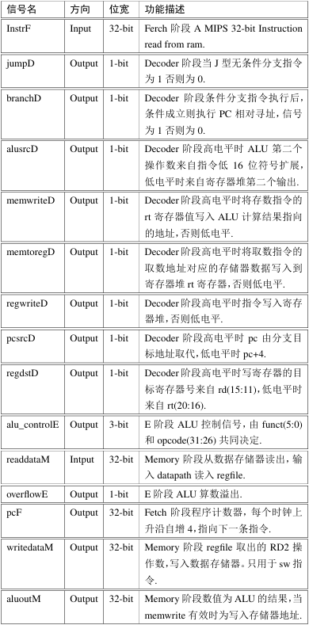
1.2 冒险模块
1.2.1 功能描述
解决分支跳转指令控制冒险，loadword数据冒险以及alu数据冒险
1.2.2 接口定义
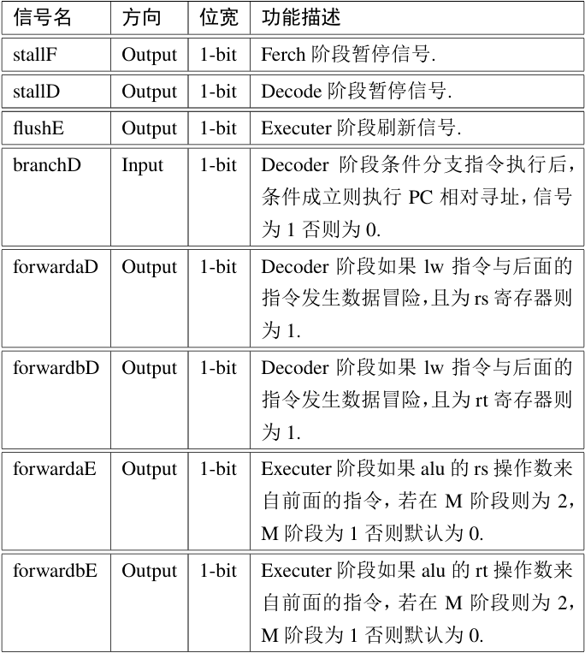
2.1 实验设计
2.1.1 datapath 设计
(1) 在单周期的datapath基础上增加了各级流水线以及相应的信号；
(2) controller 里发出控制信号，都在D阶段，其他信号都在datapath里流动
(3) ALU在E阶段，两个数据存储器和regfile为下降沿有效，数据通路为上升沿有效
2.2 问题以及解决方案
a.问题：
pc两个周期才刷新一次
解决方案：
把修改pcbranch选择模块输入信号正确
b.问题：
regdst不在上升沿时变化而在下降沿时变化，导致后续一系列信号变化错误
解决方案：
修改输入controller模块的instr信号为instrd
c.问题：
rd2输出为x，导致后续一系列信号变化错误
解决方案：
把regfile中的时钟信号改为negedge clk
d.问题：
dataadr信号变化错误
解决方案：
修改alu模块
e.问题：
pc不能正常跳转
解决方案：
发现传入sl2模块的signimme应该为signimm，修改该信号名称
f.问题：
memwrite提前置为1，导致模拟失败
解决方案：
发现将传入datapath的memwrite与传出的memwritem混淆，在top与mips中调整信号名称
3 代码
3.1mips
module mips(
input wire clk,rst,
output wire [31:0] pc,
input wire [31:0] instr,
output wire memwritem,
output wire [31:0] aluoutm,writedatam,
input wire [31:0] readdata
);

wire memwrite,memtoreg,alusrc,regdst,regwrite,branch,jump;
wire[2:0] alucontrol;
wire [31:0] instrd;

controller c(instrd[31:26],instrd[5:0],memtoreg,memwrite,alusrc,regdst,regwrite,branch,jump,alucontrol);
datapath dp(clk,rst,regwrite,memtoreg,memwrite,branch,alusrc,regdst,jump,alucontrol,instr,memwritem,pc,aluoutm,writedatam,instrd,readdata);

endmodule
3.2datapath
module datapath(
input clk,rst,regwrite,memtoreg,memwrite,branch,alusrc,regdst,jump,
input [2:0] alucontrol,
input [31:0] instr,
output memwritem,
output [31:0] pc,aluoutm,writedatam,instrd,
input [31:0] readdata
);
wire regwritee,memtorege,memwritee,alusrce,regdste,regwritem,memtoregm,pcsrcd,regwritew,memtoregw;
wire stallf,stalld,flushe,forwardad,forwardbd,equald;
wire [1:0] forwardae,forwardbe;
wire [2:0] alucontrole;
wire [31:0] signimm,signimme;
wire [4:0] writerege,writeregm,writeregw,rse,rte,rde;
wire [31:0] rd1,rd2,equala,equalb,srcbe,temp,resultw,srcae,rd1e,rd2e,aluout,aluoutw,readdataw,writedatae;
wire [31:0] pc_next,pcplus4f,pcbranchd,pcjump,temp1,pcplus4d;
flop1 flop1(clk,rst,~stalld,pcsrcd,instr,pcplus4f,instrd,pcplus4d);
flop2 flop2(clk,rst,flushe,regwrite,memtoreg,memwrite,alusrc,regdst,instrd[25:21],instrd[20:16],instrd[15:11],alucontrol,signimm,rd1,rd2,regwritee,memtorege,memwritee,alusrce,regdste,rse,rte,rde,alucontrole,signimme,rd1e,rd2e);
flop3 flop3(clk,rst,regwritee,memtorege,memwritee,aluout,writedatae,writerege,regwritem,memtoregm,memwritem,aluoutm,writedatam,writeregm);
flop4 flop4(clk,rst,regwritem,memtoregm,aluoutm,readdata,writeregm,regwritew,memtoregw,aluoutw,readdataw,writeregw);
mux3 mux3_0(forwardae,rd1e,resultw,aluoutm,srcae);
mux3 mux3_1(forwardbe,rd2e,resultw,aluoutm,writedatae);
mux32_2 mux2_4(forwardad,rd1,aluoutm,equala);
mux32_2 mux2_5(forwardbd,rd2,aluoutm,equalb);
assign equald = (equala == equalb);
assign pcsrcd = branch & equald;
hazard_unit hazard(branch,memtorege,memtoregm,regwritee,regwritem,regwritew,instrd[25:21],instrd[20:16],rse,rte,writerege,writeregm,writeregw,forwardad,forwardbd,forwardae,forwardbe,stallf,stalld,flushe);
mux2 mux2_0(regdste,rte,rde,writerege);
regfile regfile(clk,regwritew,instrd[25:21],instrd[20:16],writeregw,resultw,rd1,rd2);
signext sign_extend(instrd[15:0],signimm);
mux32_2 mux2_1(alusrce,writedatae,signimme,srcbe);
ALU ALU0(srcae,srcbe,alucontrole,aluout);
mux32_2 mux2_3(memtoregw,aluoutw,readdataw,resultw);
sl32_2 sl2_0(signimm,temp);
adder adder1(temp,pcplus4d,pcbranchd);
PC PC(clk,rst,~stallf,pc_next,pc);
adder adder0(pc,4,pcplus4f);
mux32_2 mux2_2(pcsrcd,pcplus4f,pcbranchd,temp1);
mux32_2 mux2_6(jump,temp1,{pcplus4d[31:28],instrd[25:0],2'b00},pc_next);
endmodule
3.3flop1
module flop1(
input clk,rst,en,clear,
input [31:0] instr,PCPlus4F,
output reg [31:0] instrD,PCPlus4D
);
always@(posedge clk)begin
if(rst) begin
instrD <= 0;
PCPlus4D <= 0;
end
else if(clear) begin
instrD <= 0;
PCPlus4D <= 0;
end
else if(en) begin
instrD <= instr;
PCPlus4D <= PCPlus4F;
end
end
endmodule
3.4flop2
module flop2(
input clk,rst,clear,
input regwrited,memtoregd,memwrited,alusrcd,regdstd,
input [4:0] rsd,rtd,rdd,
input [2:0] alucontrold,
input [31:0] signimmd,rd1,rd2,
output reg regwritee,memtorege,memwritee,alusrce,regdste,
output reg [4:0] rse,rte,rde,
output reg [2:0] alucontrole,
output reg [31:0] signimme,srcae,rd2e
);
always@(posedge clk,posedge rst)begin
if(rst) begin
regwritee <= 0;
memtorege <= 0;
memwritee <= 0;
alusrce <= 0;
regdste <= 0;
alucontrole <= 0;
rse <= 0;
rte <= 0;
rde <= 0;
signimme <= 0;
srcae <= 0;
rd2e <= 0;
end
else if(clear) begin
regwritee <= 0;
memtorege <= 0;
memwritee <= 0;
alusrce <= 0;
regdste <= 0;
alucontrole <= 0;
rse <= 0;
rte <= 0;
rde <= 0;
signimme <= 0;
srcae <= 0;
rd2e <= 0;
end
else begin
regwritee <= regwrited;
memtorege <= memtoregd;
memwritee <= memwrited;
alusrce <= alusrcd;
regdste <= regdstd;
alucontrole <= alucontrold;
rse <= rsd;
rte <= rtd;
rde <= rdd;
signimme <= signimmd;
srcae <= rd1;
rd2e <= rd2;
end
end
endmodule
3.5flop3
module flop3(
input clk,rst,regwritee,memtorege,memwritee,
input [31:0] aluout,writedatae,
input [4:0] writerege,
output reg regwritem,memtoregm,memwritem,
output reg [31:0] aluoutm,writedatam,
output reg [4:0] writeregm
);
always@(posedge clk,posedge rst)begin
if(rst)begin
regwritem <= 0;
memtoregm <= 0;
memwritem <= 0;
aluoutm <= 0;
writedatam <= 0;
writeregm <= 0;
end
else begin
regwritem <= regwritee;
memtoregm <= memtorege;
memwritem <= memwritee;
aluoutm <= aluout;
writedatam <= writedatae;
writeregm <= writerege;
end
end
endmodule
3.6flop4
module flop1(
input clk,rst,en,clear,
input [31:0] instr,PCPlus4F,
output reg [31:0] instrD,PCPlus4D
);
always@(posedge clk)begin
if(rst) begin
instrD <= 0;
PCPlus4D <= 0;
end
else if(clear) begin
instrD <= 0;
PCPlus4D <= 0;
end
else if(en) begin
instrD <= instr;
PCPlus4D <= PCPlus4F;
end
end
endmodule
3.7hazard_unit
module hazard_unit(
input branchd,memtorege,memtoregm,regwritee,regwritem,regwritew,
input [4:0] rsd,rtd,rse,rte,writerege,writeregm,writeregw,
output forwardad,forwardbd,
output reg [1:0] forwardae,forwardbe,
output stallf,stalld,flushe
);
wire lwstall,branchstall;
assign forwardad = (rsd != 0) & (rsd == writeregm) & regwritem;
assign forwardbd = (rtd != 0) & (rtd == writeregm) & regwritem;
always@(*)begin
if ((rse != 0) & (rse == writeregm) & regwritem)
forwardae = 2'b10;
else if ((rse != 0) & (rse == writeregw) & regwritew)
forwardae = 2'b01;
else
forwardae = 2'b00;
if ((rte != 0) & (rte == writeregm) & regwritem)
forwardbe = 2'b10;
else if ((rte != 0) & (rte == writeregw) & regwritew)
forwardbe = 2'b01;
else
forwardbe = 2'b00;
end
assign #1 lwstall = ((rsd == rte) | (rtd ==rte)) & memtorege;
assign #1 branchstall = branchd &
(regwritee &
(writerege == rsd | writerege == rtd) |
memtoregm &
(writeregm == rsd | writeregm == rtd));
assign #1 stalld = lwstall | branchstall;
assign #1 stallf = stalld;
assign #1 flushe = stalld;

endmodule
3.8controller
module controller(
input wire[5:0] op,
input wire[5:0] funct,
output wire memtoreg,memwrite,alusrc,regdst,regwrite,branch,jump,
output wire[2:0] aluctrl
);
wire[1:0] aluop;
maindec gate1(op,aluop,memtoreg,memwrite,alusrc,regdst,regwrite,branch,jump);
aludec gate2(aluop,funct,aluctrl);
endmodule
四、实验结果及分析和（或）源程序调试过程
4.1仿真图
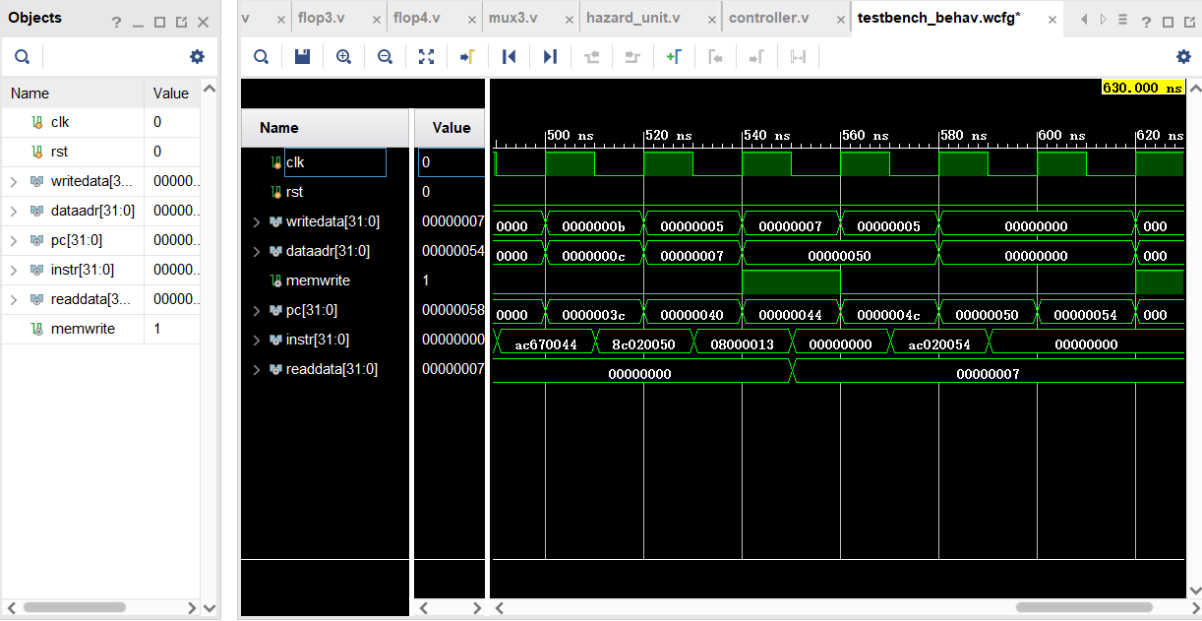
4.2结果
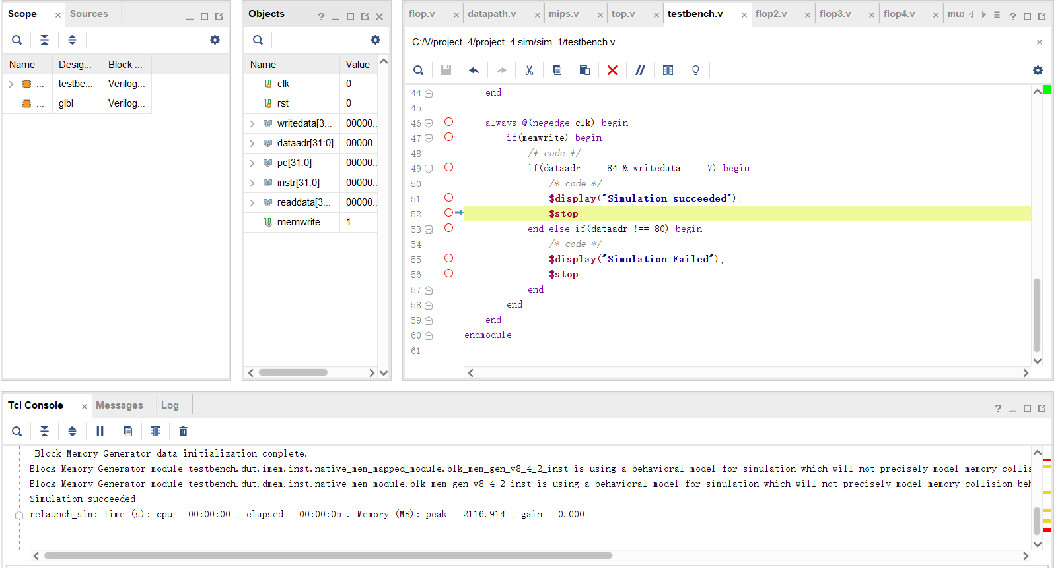

备注：

