project1_03_interpretation_viz

Imaan Ali

2025-08-20

### How does weather impact the sales of each product?

Product 1: Sales for the first product increase slightly with higher temperatures, about 0.07 units per 1°F, while weekends boost sales by roughly 6 units. Rainy days reduce sales by around 2 units, and snowfall has a small negative effect. Among weather variables, rainfall and snowfall have the strongest impact, though the overall model explains only a small portion of variance (Adjusted R² ≈ 0.01). This suggests the product is moderately weather-sensitive, with consumer demand dipping slightly on wet or snowy days.

Product 2: For the second product, temperature negatively affects sales (≈ 0.12 units decrease per 1°F) and snowy days reduce sales sharply by about 9 units. Weekends increase sales by roughly 5.6 units, while rainfall shows minimal effect. Snowfall emerges as the most influential weather factor. The low R² (≈ 0.008) indicates that, while weather impacts are measurable, other factors likely drive most of the sales. In practical terms, extreme snow may deter customers from purchasing this product.

Product 3: The third product is most sensitive to weather. Temperature negatively affects sales (≈ 0.22 units per 1°F), while rain (-3.3 units) and snow (-8 units) strongly reduce demand. Weekends continue to boost sales (≈7 units). Both temperature and precipitation are key drivers, with clear negative relationships. The slightly higher R² (≈ 0.023) indicates weather explains more variation here than for the other products. In a business context, adverse weather directly suppresses sales, highlighting the importance of inventory and promotion planning around extreme weather events.

### # 1.Scatter plot: Temperature vs. Units Sold

# 1. Scatter plot: Temperature vs Units Sold (faceted by product)  
ggplot(df, aes(x = tavg, y = units)) +  
 geom_point(alpha = 0.5, color = "steelblue") +  
 facet_wrap(~item_nbr) +  
 labs(title = "Units Sold vs Average Temperature by Product",  
 x = "Average Temperature (°F)", y = "Units Sold") +  
 theme_minimal()

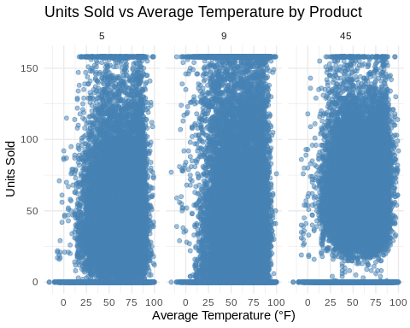

#This scatter plot shows how average daily temperature relates to units sold for each product. For Product 1, sales slightly increase as temperature rises, while Products 2 and 3 show a negative relationship, indicating that colder days tend to have higher sales. This highlights that temperature impacts demand differently depending on the product.

### # 2. Scatter plot: Precipitation vs Units Sold

ggplot(df, aes(x = preciptotal, y = units)) +  
 geom_point(alpha = 0.5, color = "darkgreen") +  
 facet_wrap(~item_nbr) +  
 labs(title = "Units Sold vs Precipitation by Product",  
 x = "Total Precipitation (inches)", y = "Units Sold") +  
 theme_minimal()

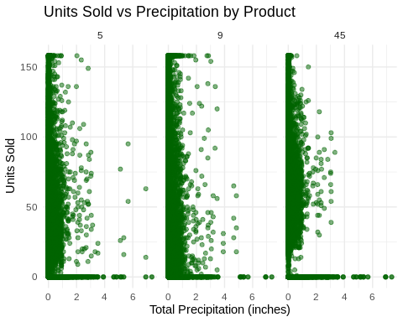

#This scatter plot illustrates the relationship between daily precipitation and units sold for each product. Generally, higher precipitation corresponds to lower sales, especially for Products 1 and 3, suggesting that rainy days may reduce customer demand. Product 2 shows a weaker effect, indicating it is less sensitive to rainfall.

### # 3. Boxplot: Units Sold on Weekends vs Weekdays

ggplot(df, aes(x = factor(is_weekend), y = units)) +  
 geom_boxplot(fill = "orange") +  
 facet_wrap(~item_nbr) +  
 labs(title = "Weekend Effect on Sales",  
 x = "Is Weekend (0=Weekday, 1=Weekend)", y = "Units Sold") +  
 theme_minimal()

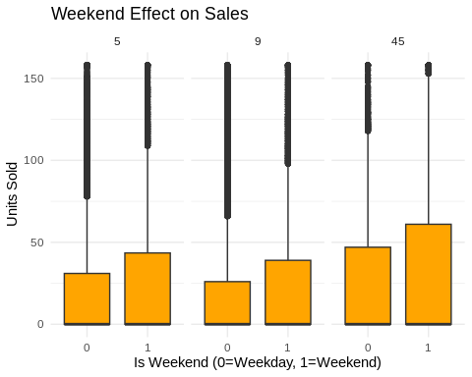

#This box plot compares sales on weekends versus weekdays for each product. All three products show higher median sales on weekends, with Product 3 having the largest weekend boost. This indicates that weekend shopping significantly increases demand, likely due to more customer traffic during leisure days.

### # 4. Bar chart: Average units sold on rainy vs non-rainy days

ggplot(df, aes(x = factor(is_rainy_day), y = units)) +  
 stat_summary(fun = mean, geom = "bar", fill = "purple", position = "dodge") +  
 facet_wrap(~item_nbr) +  
 labs(title = "Average Units Sold: Rainy vs Non-Rainy Days",  
 x = "Rainy Day (0=No, 1=Yes)", y = "Average Units Sold") +  
 theme_minimal()

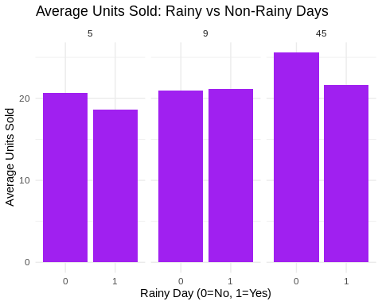

#This plot compares sales on rainy days versus non-rainy days for each product. Products 1 and 3 show noticeably lower sales when it rains, while Product 2 is less affected. This suggests that weather conditions, particularly rainfall, can influence customer purchasing behavior differently across products.

### # 5. Line plot: Monthly trend of sales

ggplot(df, aes(x = month, y = units)) +  
 stat_summary(fun = mean, geom = "line", color = "red", linewidth = 1) +  
 facet_wrap(~item_nbr) +  
 labs(title = "Monthly Sales Trend by Product",  
 x = "Month", y = "Average Units Sold") +  
 theme_minimal()

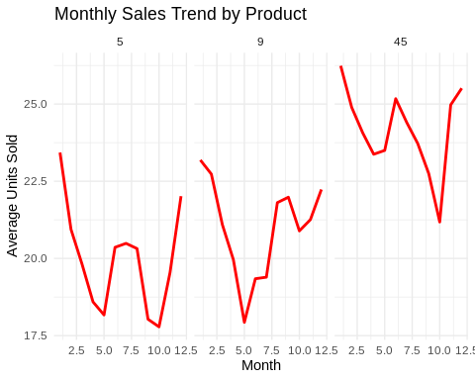

#This plot shows the average monthly sales for each product. Product 1 tends to have relatively stable sales throughout the year with a slight dip in mid-year, Product 2 shows a gradual increase in sales towards the end of the year, and Product 3 experiences clear seasonal peaks around the winter months. This indicates that month and seasonality play a significant role in influencing product sales, with different products responding differently to seasonal trends.

### Business Recommendations

For Product 1, weekend demand is consistently higher, so retailers should prioritize staffing and stock replenishment on Fridays and Saturdays. Snowfall slightly reduces sales, suggesting that businesses can slightly lower inventory during heavy snow periods to avoid excess stock. Temperature has a small positive effect, so mild increases in average temperature may marginally boost demand. Marketing campaigns could highlight availability during weekends and mild weather periods to maximize sales.

For Product 2, cooler temperatures drive higher sales, indicating that retailers should increase stock in winter months and reduce it during warmer periods. Snowy days sharply decrease sales, so offering home delivery options or weather-related promotions could help maintain revenue. Weekend demand is consistently higher, making weekend-focused promotions worthwhile. Retailers could also monitor precipitation forecasts to adjust stock levels in real time and avoid overstocking on rainy days. Targeted email campaigns highlighting winter promotions could further capitalize on seasonal demand patterns.

For Product 3, both rainfall and snowfall strongly suppress sales, suggesting that inventory levels should be adjusted based on short-term weather forecasts. Cold months boost demand, so seasonal promotions and increased stock levels in winter could improve revenue. Weekend effects are significant, so businesses should schedule marketing campaigns and stock replenishments accordingly. Additionally, monthly sales trends highlight seasonal peaks, which can be leveraged for strategic promotions, bundling offers, or loyalty programs to drive higher sales during those periods.