

**PROG6212 POE PART 2**

**ST10021922**

Response to lecturer feedback:

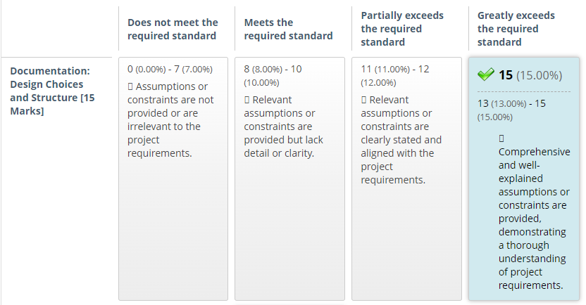I am glad to hear this and will strive to continue the attention to detail.

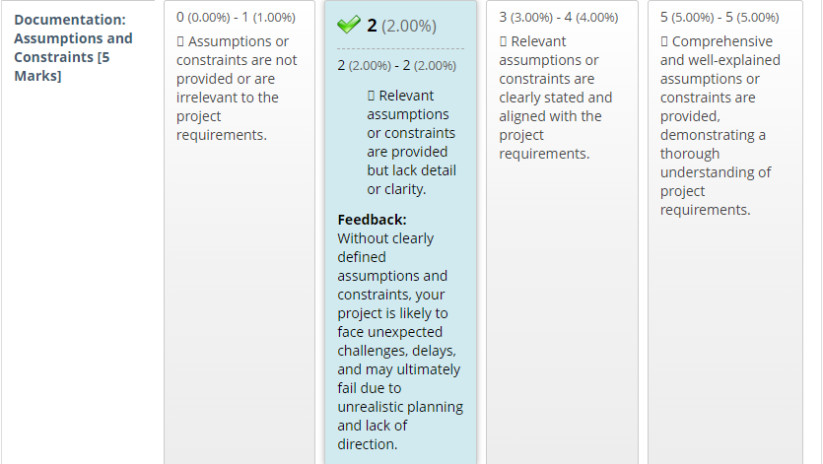I will take this into account in the future and research the constraints thoroughly so that there is no lack of direction and unrealistic planning.

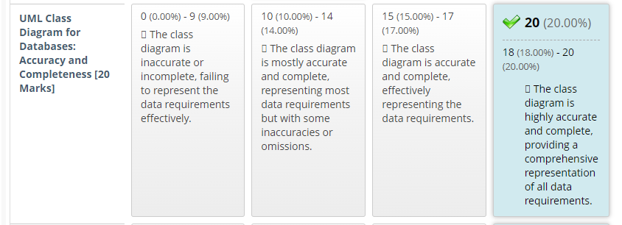Great feedback for me as I generally struggle with UML class diagrams so i am happy to hear that I was accurate in providing one for this assignment.

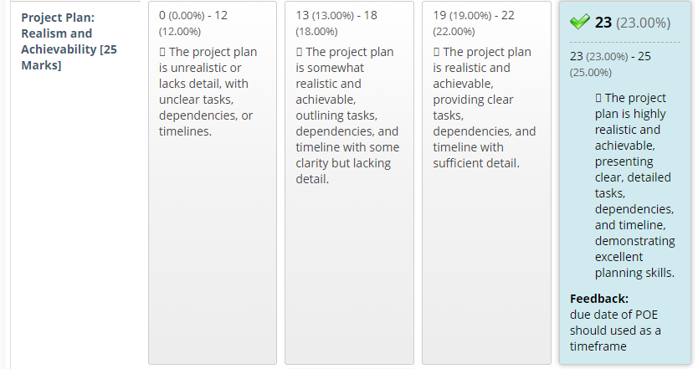Thank you for stating that the due date should be used as a timeframe, it will help with future project plans.

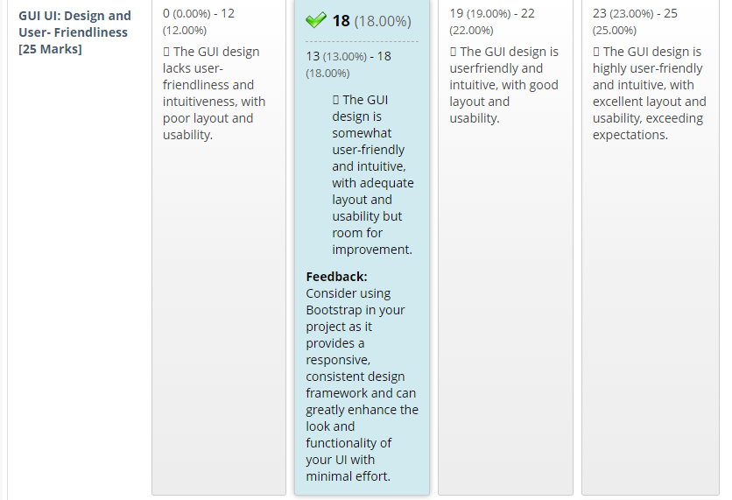Thank for the feedback and I will definitely look into making the UI design better.

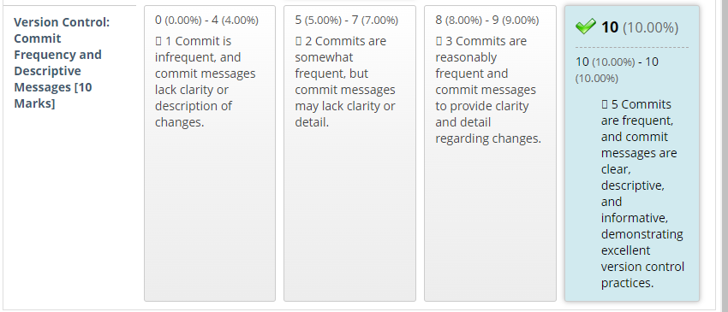I will continue the version control and commit messages.

Screenshots of app

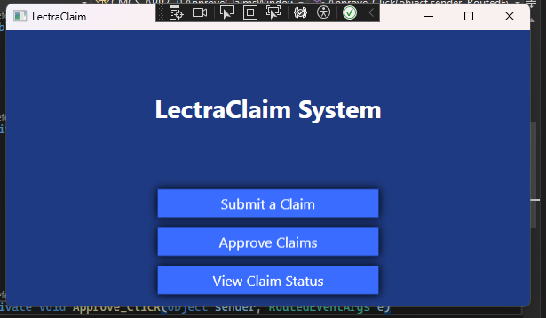

I've made the main window a bit more modern and added a nice blue colour to contrast with the white text, as well as shading around the buttons.

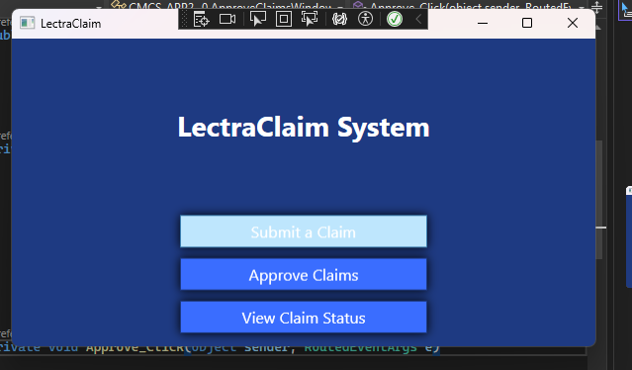

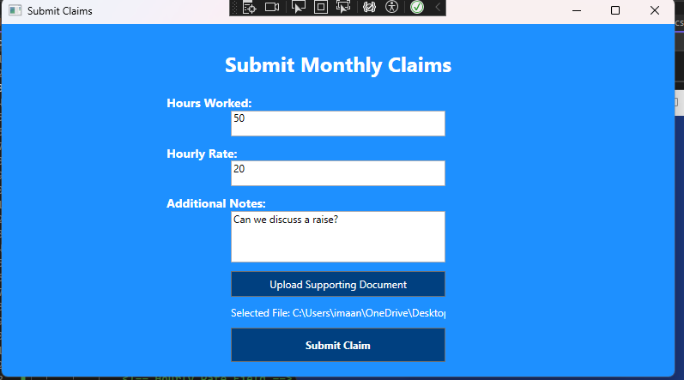

PART 2:

