Pwd – print working directory

ls – list directory contents

ls -l = list as a list

ls -t = show time stamp

ls -tr = order by time reverse

ls -ltr = list as a list with timestamp and revesed

ls -a = show all files (hidden as well)

~ = */ home / user*

*mkdir = make directory*

*rmdir = remove directory (this wont work if directory has contents)*

*rm -r = removes everything in directory and directory itself*

*rm -rf = forcibly delete everything*

*Anything you name with a ‘.’ becomes a hidden file automatically*

*touch “filename” = creates an empty file with the specified Filename*

*cat “filename” = concatenate or read a file*

*mv = this command can be used for moving from source to target or renaming a file*

*man = manual – this command is used to read a manual about anything in Linux*

*w or who = shows who is logged into the system*

*top (table of processes ) =generally shows a table sorted by cpu usage of processes. Also gives an overview of where and how system resources are being utilised*

*PID = process id*

*USER = user*

*PR = Priority – lower is higher priority*

*top -n 10 = exit after running 10 lines*

*load average is broken into three parts – 1min, 5min, 15 mins*

*read for more on top - https://www.redhat.com/sysadmin/interpret-top-output*

*netstat – tupln = show network stats for tcp, udp with numeric information*

*curl ifconfig.me = show public ip*

*TROUBLESHOOT*

*1. ssh connection refused*

* *check ping to server – if successful server is reachable*
* *try telnet on the port you are trying to connect*

*if no – run sudo ufw allow 22*

*sudo ufw reload or sudo ufw enable*

* *you might also need to go to system configuration file for ssh at*

*/ etc / ssh /sshd_config and enable port 22*

*Networking – Linux*

*mac address = your unique address*

*ip address = unique address on network*

*subnet = seperate ip into network and host addresses*

*gateway = connection leading outside or inside of network*

*dns host = translates hostname to ip addr*

*dns domain = lookup domian for host*

*ifconfig and ip addr command gives the same output = information about network*

*nmcli – network manager – used to see ip, mac, default route, dns host, dns domain*

*nmcli d show = shows information for all devices (eth, enps03,lo)*

*ip route show = to show gateway*

*Basic Network Topology*

*Switch = Present inside Local Area Network and used to communicate with hosts within the network*

*Router = Any request from host travels through switch to* ***router*** *to the outside world or internet*

*Following image makes it clear*

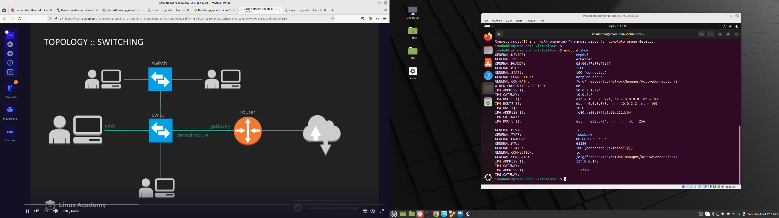

*OSI Layers – (Open System Intercommunication model)*

*The open systems interconnection (OSI) model is a conceptual model created by the International Organization for Standardization which enables diverse communication systems to communicate using standard* [*protocols*](https://www.cloudflare.com/learning/network-layer/what-is-a-protocol/)*. In plain English, the OSI provides a standard for different computer systems to be able to communicate with each other.*

*The OSI Model can be seen as a universal language for computer networking. It is based on the concept of splitting up a communication system into seven abstract layers, each one stacked upon the last.*

*It consists of seven layers*

*1. Application layer : This permits sending and receiving data through applications like web systems*

*protocols: HTTP, SMTP, SOAP*

*Troubleshooting : DNS, curl*

*2. Presentation Layer : Converts request from application to universal format*

*TLS, SSL, JPEG,GIF*

*Rare at this layer*

*3. Session Layer : Manages a session between process and response*

*LDAP, SSL, RPC*

*Rare at this layer*

*4. Transport Layer : defines how data will be sent, performs validation and security*

*This layer breaks TCP packets into manageable portions, labels them and transport them across sessions*

*TCP,UDP*

*verify blocked ports, firewalls, QoS*

*5. Network Layer: Manages IP address path*

*IP*

*Routing, bandwidth, auth*

*6. Data Link Layer : Manages communication between various mac address*

*The packets from network layer are called frames here and these are sent through default gateway*

*Ethernet, MAC, Wifi*

*MAC Addressing, IP Conflicts*

*7. Physical Layer : Manages bit transmission between network nodes . Hardware specific layer*

*Ethernet Physical*

*Verify Physical Componesnts*

*Anatomy of an IP Addresses :*

*IP address is the address of the device on the network. Each IP is unique in a network*

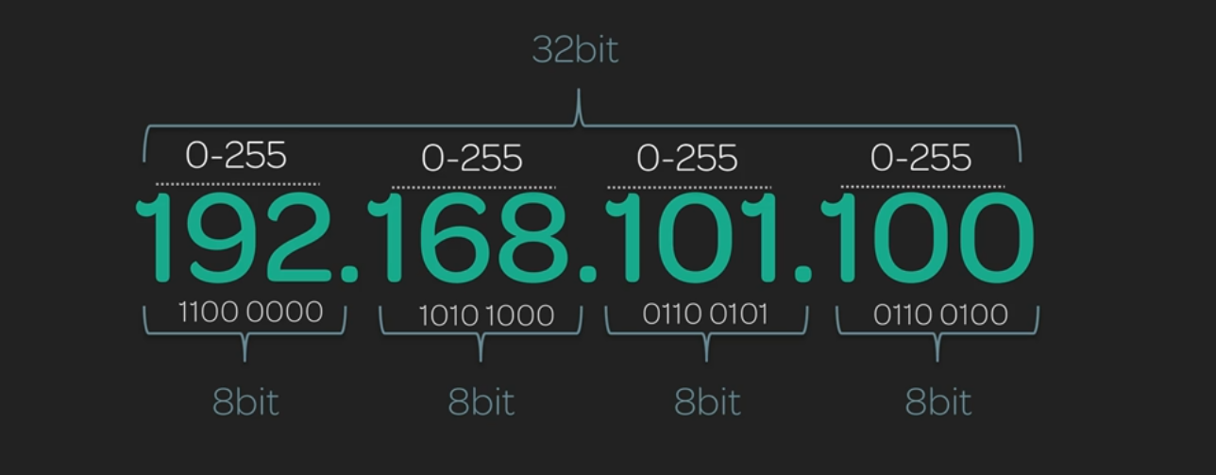

*It is a 32 bit number, made up of four octets, each containing 8 bits.*

*Since 255 is all 1’s in binary, the limit of each octet in decimal is 255*

*Ipv6*

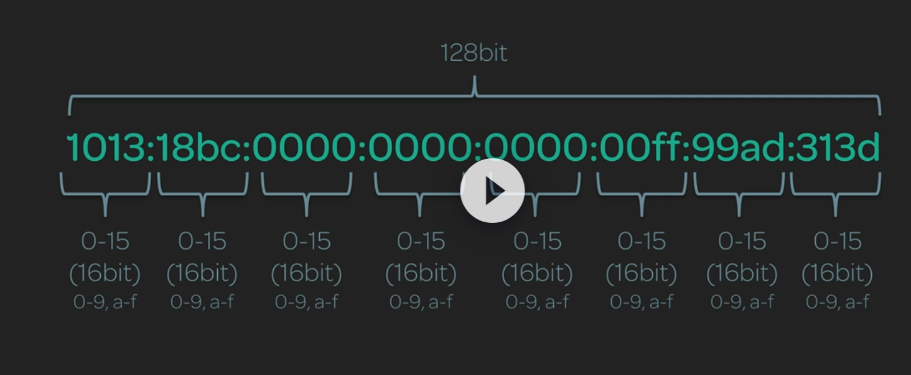

*It is a 128 bit number, broken down to 8 16 bit numbers, represented in HEX as we can 0-9 and a-f for higher numbers*

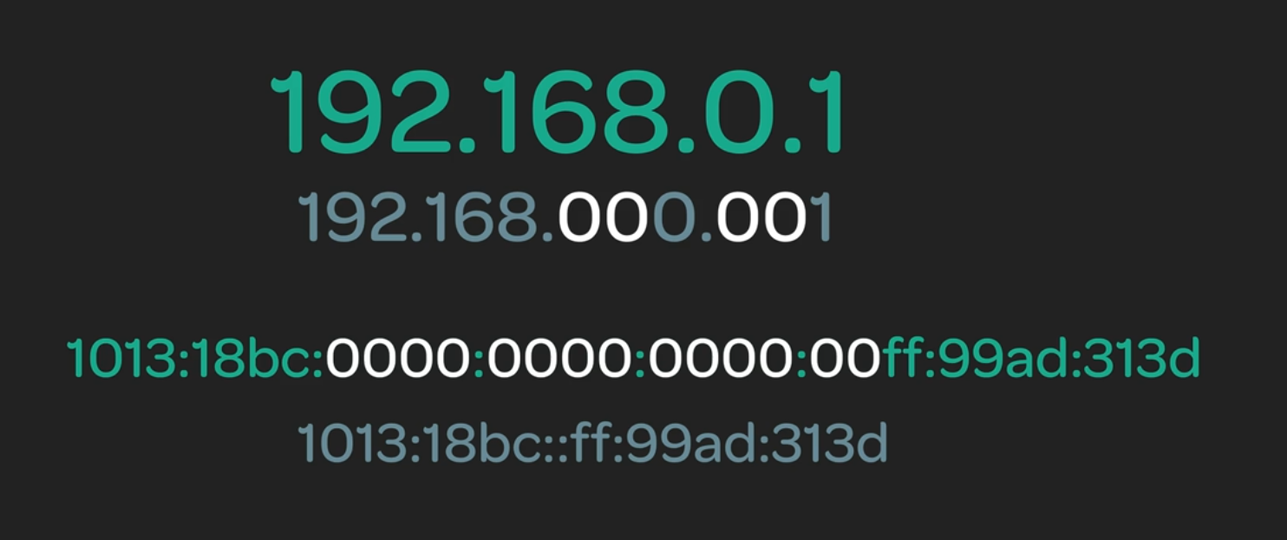

*there is a concept of removing leading zeros to make the ipv6 more readable . Example above can be represented as*



*if all four digits are 0, we skip it and instead and mark it with “:”*

*Classfull Network*

*There are 5 classes of networks in ipv4. We know that each octet is made up of 8 bits. The first 4 bits mark the difference between each class*

*class A : 0--- ---- → range from 0.0.0.0 to 127.255.255.255 -*

*class B :10-- ---- → range from 128.0.0.0 to 191.255.255.255*

*class C :110- ---- → range from 192.0.0.0 to 223.255.255.255*

*class D : 1110 ---- → range from 224.0.0.0 to 239.255.255.255 - multicast*

*class E : 1111 ---- → range from 240.0.0.0 to 255.255.255.255 – used for experimental*

*ip classes and subnets*

*class a reserves first octet for network and remaining for hosts*

*class b reserves first two octets for network*

*class c reserves first 3 octets for network*

*in the last octet – 0 and 255 are reserved and not used for general host allocation*

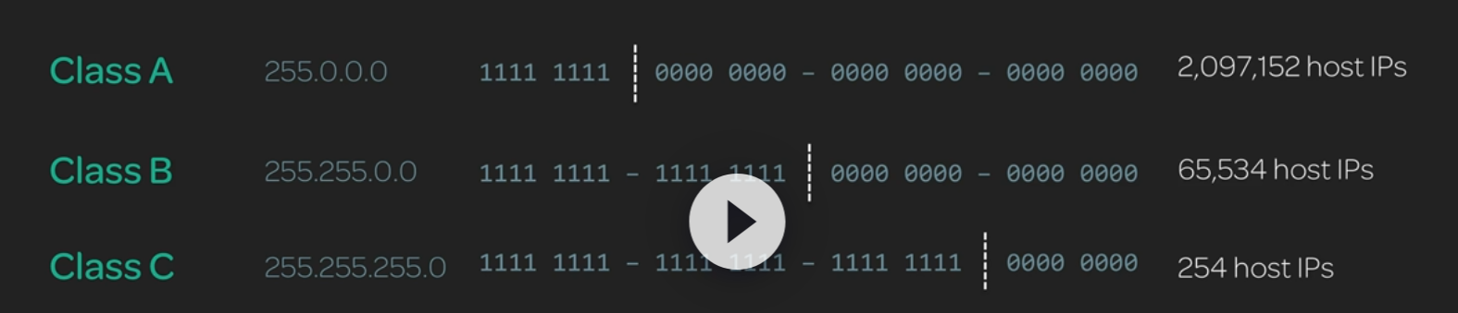

*We have a potential use case where we want for example 500 host IPS.*

*If we use class C then we have scalability problems*

*if we use class B we are wasting around 60000+ IPS*

*To overcome this we use the concept of Classless Inter Domain Routing (CIDR)*

*Before we talk about CIDR, subnetting is the concept of masking network bits using \ notation*

*example. We can write IP as 192.168.101.0/24 to show first 24 bits are masked off and used for network*

*refer below example how we can use CIDR to overcome scalability and wastage*

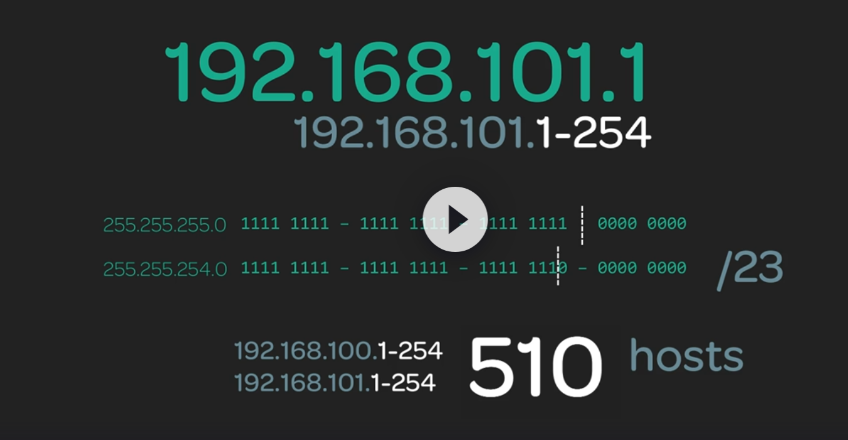

*Sub-netting in ipv6*

*The first 64 bits of Ipv6 is used for network and next 64 is for node*

*the node is defined from MAC address.*

*The first 48 bits of network are for global use and last 16 are for internal transfer*

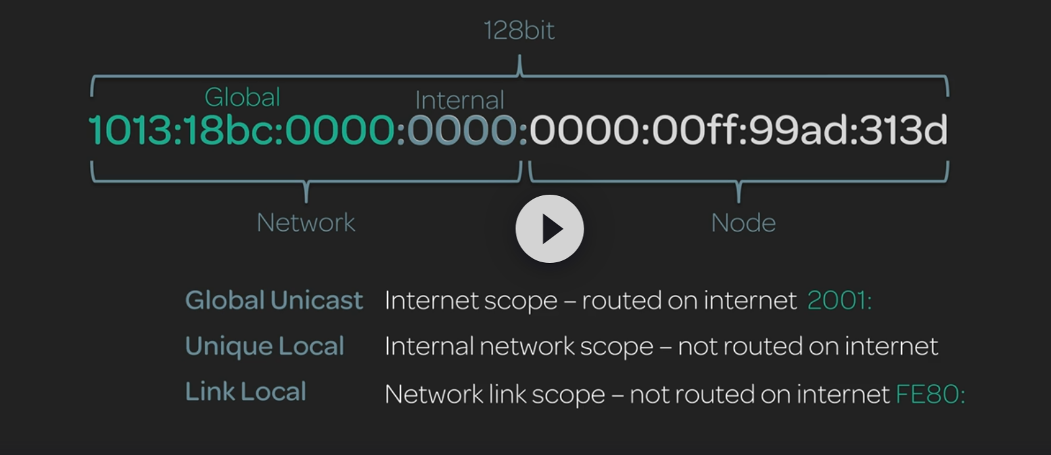

*if ipv6 starts with 2001, it is global uni-cast and the IP is routed over internet*

*if it starts with fe80 it is link local and has network link scope and not routed on internet*

*Network Address Translation:*

*NAT is a method of remapping IP address to another by modifying network address information in the IP head of packets while they are transit across a traffic routing device*

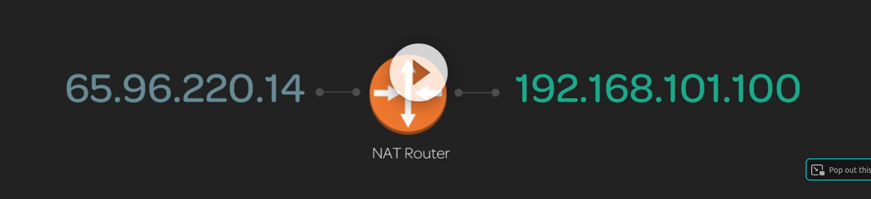

*Routing*

*A router is a layer 3 device. Router forwards data packets between networks*

*It is a static table mapping best path for network destination*

*It lists destinations and gateways for the network the host belongs to.*

