Hospital Appointment and Patient Care Management System (HAPCMS)
DBMS Course Project Report

Student Name: Shaik Imaduddin
Roll Number: 25WU0101048
Course: Database Management Systems (DBMS)
Academic Year: 2025–2029
Project Type: DBMS Course Project
University: Woxsen University
Branch: CSE - AIML

2. Abstract
The Hospital Appointment and Patient Care Management System (HAPCMS) is a database-driven web application developed to manage departments, physicians, schedules, patients, appointments, clinical consultations, electronic medical records (EMR), diagnostic laboratory tests, inpatient ward beds, admissions, billing, and payments in a structured relational system. The application uses PostgreSQL 16 (hosted on Neon Cloud) as the database layer, Node.js with Next.js 14 (App Router) and Prisma ORM for backend data access and transactions, and React with Tailwind CSS and Lucide Icons for the user interface. The system supports patient registration, conflict-free doctor appointment scheduling, consultation logging, diagnostic test ordering and tracking, real-time inpatient bed occupancy monitoring, itemized billing, and multi-tender payment reconciliation. Transaction-based writes keep related database records consistent, while primary keys, foreign keys, domain CHECK rules, custom ENUM types, and composite unique indexes protect data integrity.
3. Introduction and Problem Statement
3.1 Introduction
A healthcare institution produces interrelated data continuously: patients register and schedule outpatient visits, doctors examine patients and record clinical symptoms, diagnoses, and multi-drug prescriptions, laboratory technicians perform ordered diagnostics, nursing staff manage inpatient bed allocations and admissions, and cashiers generate itemized bills settled by various tender methods. Managing these records across disparate spreadsheets or isolated legacy software creates duplication, scheduling overlaps, unrecorded bed allocations, and billing leakage. This project models the complete healthcare lifecycle using a 3NF-normalized relational database and a connected web interface.
3.2 Problem Statement
The hospital requires a reliable system to maintain doctor rosters, accept and track outpatient appointments, record EMR consultations, manage inpatient ward capacities, track laboratory tests, generate itemized bills, record payments, and produce management reports. The system must preserve relationships between records and prevent invalid operations, such as double-booking a physician for the same time slot, assigning an already occupied bed, admitting patients with chronologically impossible discharge dates, entering non-positive tariffs or quantities, or recording payments that exceed the invoiced balance.
4. Objectives and Scope
4.1 Objectives
- Maintain departments, doctors, recurring weekly schedules, patients, appointments, consultations, diagnoses, prescriptions, prescription items, lab tests, test orders, wards, beds, admissions, bills, and payments in PostgreSQL 16.
- Provide a fully normalized Third Normal Form (3NF) relational architecture across 16 tables.
- Guarantee zero appointment double-booking collisions through composite unique indexing on (doctor_id, appointment_date, appointment_time).
- Manage inpatient bed allocations with strictly controlled status transitions (AVAILABLE, OCCUPIED, MAINTENANCE).
- Enforce domain integrity via custom PostgreSQL ENUM types and CHECK constraints for fees, quantities, and dates.
- Execute multi-table writes atomically across appointments, admissions, and payments to guarantee ACID compliance.
- Generate comprehensive management reports using multi-table joins, aggregations, window functions, and views.
- Deliver a responsive, accessible clinical management web interface using Next.js 14 and Prisma ORM.
4.2 Scope
- Provider and schedule roster management with capacity caps.
- Patient directory with longitudinal medical histories.
- Calendar-based appointment scheduling with live collision prevention.
- Clinical consultation, ICD-10 diagnostic coding, and electronic prescriptions.
- Diagnostic laboratory test catalog, specimen collection, and abnormal result flagging.
- Inpatient ward bed management and admission-to-discharge workflow.
- Consolidated itemized billing and multi-tender payment ledger.
- Executive reporting for longitudinal summaries, bed occupancy, doctor utilization, and departmental revenue.
- Local and cloud-connected deployment using PostgreSQL 16, Prisma ORM, and Next.js 14.
5. Software and Hardware Requirements
The development and runtime requirements for the system are summarized in the following table:
Category | Requirement / Specification
Operating System | Windows 10/11 / macOS / Linux
Backend Framework | Next.js 14.2 (App Router, Node.js Server Actions)
Database Engine | PostgreSQL 16 (Neon Cloud Serverless, SSL-encrypted)
ORM / DB Client | Prisma ORM 6.4.1 / pg (Node.js PostgreSQL client)
Frontend & Styling | HTML5, React 18, Tailwind CSS, Lucide Icons
Runtime Environments | Node.js v20+, TypeScript 5, Python 3.11+
Database Tooling | Prisma Studio (Visual GUI), psql interactive CLI
Testing Framework | Prisma Client test scripts, Jest / Vitest
Browser Support | Modern Chromium (Chrome, Edge) / Firefox / Safari
Recommended Hardware | Dual-core or Quad-core processor, 8 GB RAM, 10 GB free storage

6. ER Diagram
The ER diagram represents the sixteen entities used by the Hospital Appointment and Patient Care Management System (HAPCMS) and their relationships across six functional clusters: Provider & Roster, Patient & Appointment, Clinical EMR, Diagnostic Laboratory, Inpatient Care, and Financial Ledger.
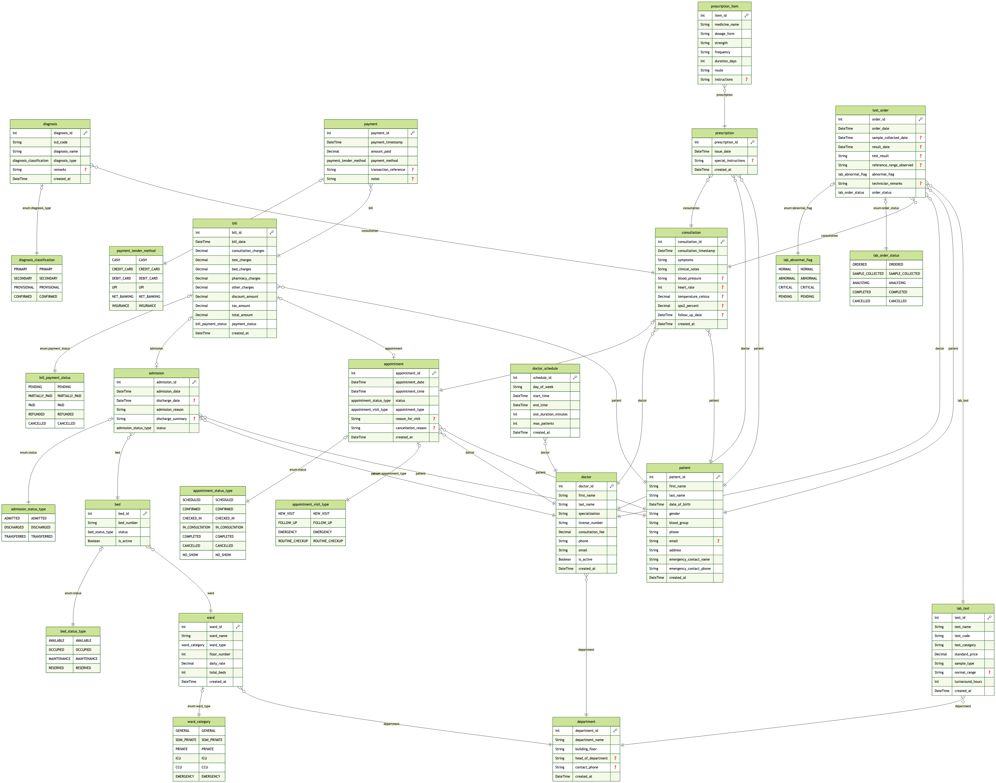
Figure: Entity-Relationship Diagram for HAPCMS (16 Entities)

7. Relational Schema and Normalization
7.1 Relational Schema
The tables below reproduce the complete structural schema of the implemented database, detailing Field name, Data Type, Nullability, Key classification, Default value, and Relational Constraints/Descriptions.
7.1.1 Department
Field | Type | Null | Key | Default | Extra / Notes
department_id | serial / int | NO | PRI | auto_increment | Primary Key
department_name | varchar(100) | NO | UNI | NULL | Unique Department Title
building_floor | varchar(50) | NO |  | NULL | Building & Floor Location
head_of_department | varchar(100) | YES |  | NULL | Physician HOD / Lead
contact_phone | varchar(20) | YES |  | NULL | Department Extension
created_at | timestamptz | NO |  | CURRENT_TIMESTAMP | Creation Timestamp
7.1.2 Doctor
Field | Type | Null | Key | Default | Extra / Notes
doctor_id | serial / int | NO | PRI | auto_increment | Primary Key
department_id | int | NO | FK | NULL | References department(department_id)
first_name | varchar(50) | NO |  | NULL | Doctor First Name
last_name | varchar(50) | NO |  | NULL | Doctor Last Name
specialization | varchar(100) | NO |  | NULL | Medical Specialty
license_number | varchar(50) | NO | UNI | NULL | Medical Council License
phone | varchar(20) | NO |  | NULL | Direct Telephone
email | varchar(100) | NO | UNI | NULL | Institutional Email
consultation_fee | numeric(10,2) | NO |  | NULL | CHECK (consultation_fee >= 0)
is_active | boolean | NO |  | TRUE | Active Hospital Roster State
created_at | timestamptz | NO |  | CURRENT_TIMESTAMP | Record Creation Timestamp
7.1.3 DoctorSchedule
Field | Type | Null | Key | Default | Extra / Notes
schedule_id | serial / int | NO | PRI | auto_increment | Primary Key
doctor_id | int | NO | FK | NULL | References doctor(doctor_id)
day_of_week | varchar(15) | NO |  | NULL | Duty Day (MONDAY-SUNDAY)
start_time | time | NO |  | NULL | Shift Start Time
end_time | time | NO |  | NULL | CHECK (end_time > start_time)
max_patients | int | NO |  | NULL | CHECK (max_patients > 0)
7.1.4 Patient
Field | Type | Null | Key | Default | Extra / Notes
patient_id | serial / int | NO | PRI | auto_increment | Primary Key
first_name | varchar(50) | NO |  | NULL | Patient Given Name
last_name | varchar(50) | NO |  | NULL | Patient Family Name
date_of_birth | date | NO |  | NULL | CHECK (dob <= CURRENT_DATE)
gender | varchar(10) | NO |  | NULL | ENUM: MALE, FEMALE, OTHER
blood_group | varchar(5) | YES |  | NULL | CHECK (IN valid ABO/Rh types)
phone | varchar(20) | NO | UNI | NULL | Primary Contact Number
email | varchar(100) | YES |  | NULL | Email Address
address | text | YES |  | NULL | Residential Address
emergency_contact_name | varchar(100) | YES |  | NULL | Emergency Next-of-Kin
emergency_contact_phone | varchar(20) | YES |  | NULL | Emergency Contact Phone
created_at | timestamptz | NO |  | CURRENT_TIMESTAMP | Registration Timestamp
7.1.5 Appointment
Field | Type | Null | Key | Default | Extra / Notes
appointment_id | serial / int | NO | PRI | auto_increment | Primary Key
patient_id | int | NO | FK | NULL | References patient(patient_id) CASCADE
doctor_id | int | NO | FK | NULL | References doctor(doctor_id) RESTRICT
appointment_date | date | NO |  | NULL | Scheduled Consultation Date
appointment_time | time | NO |  | NULL | Scheduled Consultation Time
visit_type | varchar(20) | NO |  | 'NEW_VISIT' | ENUM: NEW_VISIT, FOLLOW_UP...
status | varchar(20) | NO |  | 'SCHEDULED' | ENUM: SCHEDULED, COMPLETED...
reason_for_visit | text | YES |  | NULL | Chief Medical Complaint
cancellation_reason | text | YES |  | NULL | Cancellation Justification
created_at | timestamptz | NO |  | CURRENT_TIMESTAMP | Booking Timestamp
uq_doctor_slot | composite | NO | UNI | UNIQUE | UNIQUE (doctor_id, date, time)
7.1.6 Consultation
Field | Type | Null | Key | Default | Extra / Notes
consultation_id | serial / int | NO | PRI | auto_increment | Primary Key
appointment_id | int | NO | UNI, FK | NULL | References appointment (1:1)
consultation_date | timestamptz | NO |  | CURRENT_TIMESTAMP | Clinical Encounter Timestamp
symptoms | text | NO |  | NULL | Documented Patient Symptoms
clinical_notes | text | YES |  | NULL | Physician Examination Notes
follow_up_date | date | YES |  | NULL | Recommended Follow-up Date
created_at | timestamptz | NO |  | CURRENT_TIMESTAMP | Record Timestamp
7.1.7 Diagnosis
Field | Type | Null | Key | Default | Extra / Notes
diagnosis_id | serial / int | NO | PRI | auto_increment | Primary Key
consultation_id | int | NO | FK | NULL | References consultation(consultation_id)
icd_code | varchar(20) | NO |  | NULL | ICD-10 Diagnostic Code
diagnosis_name | varchar(255) | NO |  | NULL | Disease / Condition Name
diagnosis_type | varchar(20) | NO |  | 'PRIMARY' | ENUM: PRIMARY, SECONDARY...
remarks | text | YES |  | NULL | Clinical Remarks
7.1.8 Prescription
Field | Type | Null | Key | Default | Extra / Notes
prescription_id | serial / int | NO | PRI | auto_increment | Primary Key
consultation_id | int | NO | FK | NULL | References consultation(consultation_id)
prescription_date | timestamptz | NO |  | CURRENT_TIMESTAMP | Prescription Generation Date
instructions | text | YES |  | NULL | Pharmaceutical Regimen Notes
created_at | timestamptz | NO |  | CURRENT_TIMESTAMP | Creation Timestamp
7.1.9 PrescriptionItem
Field | Type | Null | Key | Default | Extra / Notes
item_id | serial / int | NO | PRI | auto_increment | Primary Key
prescription_id | int | NO | FK | NULL | References prescription(prescription_id)
medicine_name | varchar(100) | NO |  | NULL | Medication Name
dosage | varchar(50) | NO |  | NULL | E.g. '1 Tablet', '5 ml'
strength | varchar(50) | NO |  | NULL | E.g. '500 mg', '10 mg'
frequency | varchar(50) | NO |  | NULL | E.g. 'Twice daily after food'
duration_days | int | NO |  | NULL | CHECK (duration_days > 0)
quantity | int | NO |  | NULL | CHECK (quantity > 0)
remarks | text | YES |  | NULL | Administration Warnings
7.1.10 LabTest
Field | Type | Null | Key | Default | Extra / Notes
test_id | serial / int | NO | PRI | auto_increment | Primary Key
test_code | varchar(20) | NO | UNI | NULL | Procedural Lab Code
test_name | varchar(100) | NO |  | NULL | Investigation Name
category | varchar(50) | NO |  | NULL | Pathology, Biochemistry...
sample_type | varchar(50) | NO |  | NULL | Blood, Serum, Urine, Imaging
standard_price | numeric(10,2) | NO |  | NULL | CHECK (standard_price >= 0)
normal_range | varchar(100) | YES |  | NULL | Clinical Benchmark Baseline
turnaround_hours | int | NO |  | NULL | CHECK (turnaround_hours > 0)
is_active | boolean | NO |  | TRUE | Active Catalog State
7.1.11 TestOrder
Field | Type | Null | Key | Default | Extra / Notes
order_id | serial / int | NO | PRI | auto_increment | Primary Key
patient_id | int | NO | FK | NULL | References patient(patient_id)
consultation_id | int | YES | FK | NULL | References consultation
ordered_by_doctor_id | int | NO | FK | NULL | References doctor(doctor_id)
test_id | int | NO | FK | NULL | References lab_test(test_id)
order_date | timestamptz | NO |  | CURRENT_TIMESTAMP | Requisition Timestamp
order_status | varchar(25) | NO |  | 'ORDERED' | ENUM: ORDERED, COMPLETED...
sample_collected_at | timestamptz | YES |  | NULL | Specimen Collection Time
result_available_at | timestamptz | YES |  | NULL | Authorization Timestamp
test_result | text | YES |  | NULL | Quantitative / Qualitative Result
normal_range_snapshot | varchar(100) | YES |  | NULL | Reference Baseline at Test Time
abnormal_flag | varchar(15) | NO |  | 'NORMAL' | ENUM: NORMAL, ABNORMAL, CRITICAL
technician_remarks | text | YES |  | NULL | Pathologist Observations
7.1.12 Ward
Field | Type | Null | Key | Default | Extra / Notes
ward_id | serial / int | NO | PRI | auto_increment | Primary Key
ward_name | varchar(100) | NO | UNI | NULL | Ward Designation (e.g. ICU)
ward_type | varchar(50) | NO |  | NULL | ENUM: GENERAL, ICU, CCU...
total_beds | int | NO |  | NULL | CHECK (total_beds > 0)
daily_rate | numeric(10,2) | NO |  | NULL | CHECK (daily_rate >= 0)
created_at | timestamptz | NO |  | CURRENT_TIMESTAMP | Creation Timestamp
7.1.13 Bed
Field | Type | Null | Key | Default | Extra / Notes
bed_id | serial / int | NO | PRI | auto_increment | Primary Key
ward_id | int | NO | FK | NULL | References ward(ward_id)
bed_number | varchar(20) | NO |  | NULL | Bed Code (e.g. ICU-01)
bed_type | varchar(50) | NO |  | NULL | ENUM: STANDARD, ICU...
status | varchar(20) | NO |  | 'AVAILABLE' | ENUM: AVAILABLE, OCCUPIED...
uq_ward_bed | composite | NO | UNI | UNIQUE | UNIQUE (ward_id, bed_number)
7.1.14 Admission
Field | Type | Null | Key | Default | Extra / Notes
admission_id | serial / int | NO | PRI | auto_increment | Primary Key
patient_id | int | NO | FK | NULL | References patient(patient_id)
admitting_doctor_id | int | NO | FK | NULL | References doctor(doctor_id)
bed_id | int | NO | FK | NULL | References bed(bed_id)
admission_date | timestamptz | NO |  | CURRENT_TIMESTAMP | Admission Timestamp
discharge_date | timestamptz | YES |  | NULL | CHECK (discharge >= admission)
admission_reason | text | NO |  | NULL | Clinical Reason for Admission
discharge_summary | text | YES |  | NULL | Physician Discharge Summary
status | varchar(20) | NO |  | 'ADMITTED' | ENUM: ADMITTED, DISCHARGED...
7.1.15 Bill
Field | Type | Null | Key | Default | Extra / Notes
bill_id | serial / int | NO | PRI | auto_increment | Primary Key
patient_id | int | NO | FK | NULL | References patient(patient_id)
appointment_id | int | YES | FK | NULL | References appointment
admission_id | int | YES | FK | NULL | References admission
bill_date | timestamptz | NO |  | CURRENT_TIMESTAMP | Invoice Generation Date
due_date | date | NO |  | NULL | Invoice Due Date
total_amount | numeric(10,2) | NO |  | NULL | CHECK (total_amount >= 0)
payment_status | varchar(20) | NO |  | 'PENDING' | ENUM: PENDING, PAID, REFUNDED...
created_at | timestamptz | NO |  | CURRENT_TIMESTAMP | Timestamp
7.1.16 Payment
Field | Type | Null | Key | Default | Extra / Notes
payment_id | serial / int | NO | PRI | auto_increment | Primary Key
bill_id | int | NO | FK | NULL | References bill(bill_id)
payment_date | timestamptz | NO |  | CURRENT_TIMESTAMP | Settlement Timestamp
amount_paid | numeric(10,2) | NO |  | NULL | CHECK (amount_paid > 0)
payment_method | varchar(30) | NO |  | NULL | ENUM: CASH, UPI, CARD, INSURANCE
transaction_reference | varchar(100) | YES | UNI | NULL | Banking / Gateway Ref
notes | text | YES |  | NULL | Ledger Remarks
created_at | timestamptz | NO |  | CURRENT_TIMESTAMP | Timestamp
7.2 Normalization
The schema strictly satisfies First Normal Form (1NF), Second Normal Form (2NF), and Third Normal Form (3NF) principles:
1. First Normal Form (1NF): All attributes contain atomic, indivisible values. Repeating groups and multivalued arrays have been eliminated by creating separate child relations (e.g., individual prescription line items are decomposed into distinct rows in prescription_item; diagnostic findings are decomposed into individual diagnosis rows referencing standard ICD-10 codes).
2. Second Normal Form (2NF): The schema is in 1NF and contains no partial functional dependencies. Every relation uses a single-column surrogate primary key (SERIAL integer). Because no candidate key is composite, no non-prime attribute can depend on a proper subset of a candidate key; each non-prime attribute is fully functionally dependent on the entire primary key.
3. Third Normal Form (3NF): The schema is in 2NF and contains no transitive functional dependencies (X -> Y where Y is non-prime and X is not a superkey). Departmental floor locations reside solely in department rather than doctor; ward daily rates reside exclusively in ward rather than bed; and consultation fee schedules reside in doctor rather than appointment or bill. Thus, all functional dependencies are strictly of the form X -> A where X is a candidate key, certifying 3NF compliance.
8. SQL Commands Used (DDL, DML) with Sample Outputs
8.1 Database and Table Creation (DDL Scripts)
-- 1. Custom Domain ENUM Types
CREATE TYPE appointment_status_type AS ENUM (
'SCHEDULED', 'CONFIRMED', 'CHECKED_IN', 'IN_CONSULTATION', 'COMPLETED', 'CANCELLED', 'NO_SHOW'
);
CREATE TYPE bed_status_type AS ENUM ('AVAILABLE', 'OCCUPIED', 'MAINTENANCE', 'RESERVED');
CREATE TYPE bill_payment_status AS ENUM ('PENDING', 'PARTIALLY_PAID', 'PAID', 'REFUNDED', 'CANCELLED');
-- 2. Core Master Table: Department
CREATE TABLE department (
department_id SERIAL PRIMARY KEY,
department_name VARCHAR(100) NOT NULL UNIQUE,
building_floor VARCHAR(50) NOT NULL,
head_of_department VARCHAR(100),
contact_phone VARCHAR(20),
created_at TIMESTAMPTZ NOT NULL DEFAULT CURRENT_TIMESTAMP
);
-- 3. Doctor Table with Domain CHECK and Unique Constraints
CREATE TABLE doctor (
doctor_id SERIAL PRIMARY KEY,
department_id INTEGER NOT NULL REFERENCES department(department_id) ON DELETE RESTRICT,
first_name VARCHAR(50) NOT NULL,
last_name VARCHAR(50) NOT NULL,
specialization VARCHAR(100) NOT NULL,
license_number VARCHAR(50) NOT NULL UNIQUE,
phone VARCHAR(20) NOT NULL,
email VARCHAR(100) NOT NULL UNIQUE,
consultation_fee NUMERIC(10,2) NOT NULL CHECK (consultation_fee >= 0.00),
is_active BOOLEAN NOT NULL DEFAULT TRUE,
created_at TIMESTAMPTZ NOT NULL DEFAULT CURRENT_TIMESTAMP
);
-- 4. Appointment Table with Zero-Collision Unique Constraint
CREATE TABLE appointment (
appointment_id SERIAL PRIMARY KEY,
patient_id INTEGER NOT NULL REFERENCES patient(patient_id) ON DELETE CASCADE,
doctor_id INTEGER NOT NULL REFERENCES doctor(doctor_id) ON DELETE RESTRICT,
appointment_date DATE NOT NULL,
appointment_time TIME NOT NULL,
visit_type VARCHAR(20) NOT NULL DEFAULT 'NEW_VISIT',
status appointment_status_type NOT NULL DEFAULT 'SCHEDULED',
reason_for_visit TEXT,
created_at TIMESTAMPTZ NOT NULL DEFAULT CURRENT_TIMESTAMP,
CONSTRAINT uq_doctor_slot UNIQUE (doctor_id, appointment_date, appointment_time)
);

8.2 Representative DML Scripts & Population
-- Representative INSERT Statements
INSERT INTO department (department_name, building_floor, head_of_department, contact_phone) VALUES
('Cardiology', 'Tower A - 3rd Floor', 'Dr. Marcus Vance', '+1-555-0101'),
('Neurology', 'Tower B - 4th Floor', 'Dr. Elena Rostova', '+1-555-0102'),
('Orthopedics', 'Tower A - 2nd Floor', 'Dr. Sean Jenkins', '+1-555-0103');
INSERT INTO ward (ward_name, ward_type, total_beds, daily_rate) VALUES
('Intensive Care Unit (ICU)', 'ICU', 6, 1200.00),
('Cardiology Telemetry Ward', 'SEMI_PRIVATE', 8, 450.00),
('General Medical Ward', 'GENERAL', 12, 180.00);
-- Representative UPDATE Statement: Discharging an inpatient and releasing the bed
UPDATE admission SET status = 'DISCHARGED', discharge_date = CURRENT_TIMESTAMP WHERE admission_id = 1;
UPDATE bed SET status = 'AVAILABLE' WHERE bed_id = 1;
-- Representative DELETE Statement: Removing cancelled test orders
DELETE FROM test_order WHERE order_status = 'CANCELLED' AND order_date < CURRENT_DATE - INTERVAL '30 days';

8.3 Sample Outputs (Database Population Verification)
Executing row verification counts across all 16 tables confirms complete database population:
Table Name | Active Rows Seeded
department | 6
doctor | 12
doctor_schedule | 24
patient | 20
appointment | 30
consultation | 18
diagnosis | 25
prescription | 18
prescription_item | 36
lab_test | 15
test_order | 25
ward | 5
bed | 26
admission | 8
bill | 15
payment | 18

9. Queries with Outputs, including Presentation-II Queries
9.1 Query 1: Comprehensive Patient Longitudinal Medical Summary
Executes a multi-table join across patient, appointment, doctor, department, consultation, diagnosis, and prescription items:
SELECT
p.patient_id,
p.first_name || ' ' || p.last_name AS patient_name,
p.gender, p.blood_group, a.appointment_date,
'Dr. ' || d.first_name || ' ' || d.last_name AS attending_doctor,
dept.department_name, c.symptoms,
STRING_AGG(DISTINCT diag.diagnosis_name, '; ') AS diagnoses,
STRING_AGG(DISTINCT pi.medicine_name || ' (' || pi.strength || ')', '; ') AS medicines
FROM patient p
JOIN appointment a ON p.patient_id = a.patient_id
JOIN doctor d ON a.doctor_id = d.doctor_id
JOIN department dept ON d.department_id = dept.department_id
JOIN consultation c ON a.appointment_id = c.appointment_id
LEFT JOIN diagnosis diag ON c.consultation_id = diag.consultation_id
LEFT JOIN prescription pr ON c.consultation_id = pr.consultation_id
LEFT JOIN prescription_item pi ON pr.prescription_id = pi.prescription_id
WHERE p.patient_id = 1
GROUP BY p.patient_id, p.first_name, p.last_name, p.gender, p.blood_group,
a.appointment_date, d.first_name, d.last_name, dept.department_name, c.symptoms;

Actual Output:
Patient Name | Gender | Doctor | Department | Diagnoses | Medicines
Alice Morgan | FEMALE | Dr. Sean Jenkins | Cardiology | Essential Hypertension | Atorvastatin (20mg); Lisinopril (10mg)
9.2 Query 2: Real-Time Inpatient Bed Occupancy & Capacity Percentage
Aggregates bed statuses per ward and computes dynamic capacity utilization percentages:
SELECT
w.ward_name, w.ward_type, w.daily_rate,
COUNT(b.bed_id) AS total_beds,
COUNT(CASE WHEN b.status = 'OCCUPIED' THEN 1 END) AS occupied_beds,
COUNT(CASE WHEN b.status = 'AVAILABLE' THEN 1 END) AS available_beds,
ROUND((COUNT(CASE WHEN b.status = 'OCCUPIED' THEN 1 END)::NUMERIC / NULLIF(COUNT(b.bed_id), 0)::NUMERIC) * 100, 1) AS occupancy_pct
FROM ward w
LEFT JOIN bed b ON w.ward_id = b.ward_id
GROUP BY w.ward_id, w.ward_name, w.ward_type, w.daily_rate
ORDER BY occupancy_pct DESC;

Actual Output:
Ward Name | Ward Type | Daily Rate | Total | Occupied | Available | Occupancy %
Intensive Care Unit (ICU) | ICU | $1,200.00 | 6 | 3 | 3 | 50.0%
Cardiology Telemetry Ward | SEMI_PRIVATE | $450.00 | 8 | 3 | 5 | 37.5%
General Medical Ward | GENERAL | $180.00 | 12 | 2 | 10 | 16.7%
9.3 Query 3: Doctor Schedule Load & Slot Availability
Computes booked appointment loads against recurring shift capacities per physician:
SELECT
'Dr. ' || d.first_name || ' ' || d.last_name AS doctor,
dept.department_name, ds.day_of_week,
ds.start_time || '-' || ds.end_time AS shift,
ds.max_patients AS capacity,
COUNT(a.appointment_id) AS booked,
(ds.max_patients - COUNT(a.appointment_id)) AS available
FROM doctor d
JOIN department dept ON d.department_id = dept.department_id
JOIN doctor_schedule ds ON d.doctor_id = ds.doctor_id
LEFT JOIN appointment a ON d.doctor_id = a.doctor_id
AND a.status IN ('SCHEDULED', 'CONFIRMED', 'CHECKED_IN', 'IN_CONSULTATION')
GROUP BY d.doctor_id, d.first_name, d.last_name, dept.department_name,
ds.day_of_week, ds.start_time, ds.end_time, ds.max_patients
ORDER BY dept.department_name, d.last_name;

Actual Output:
Doctor | Department | Day | Shift | Capacity | Booked | Available
Dr. Sean Jenkins | Cardiology | MONDAY | 09:00 - 13:00 | 12 | 3 | 9
Dr. Marcus Vance | Cardiology | TUESDAY | 14:00 - 18:00 | 10 | 2 | 8
Dr. Elena Rostova | Neurology | WEDNESDAY | 10:00 - 14:00 | 8 | 2 | 6
9.4 Presentation-II Query 1 — Inpatient Active Bed vs Admission Consistency
Evaluated during the Presentation-II review to guarantee that every bed marked OCCUPIED is matched 1-to-1 with an active inpatient admission record:
SELECT
b.bed_id,
w.ward_name,
b.bed_number,
b.status AS bed_status,
adm.admission_id,
p.first_name || ' ' || p.last_name AS admitted_patient,
adm.admission_date::DATE AS admitted_on,
'Dr. ' || d.first_name || ' ' || d.last_name AS attending_doctor
FROM bed b
JOIN ward w ON b.ward_id = w.ward_id
LEFT JOIN admission adm ON b.bed_id = adm.bed_id AND adm.status = 'ADMITTED'
LEFT JOIN patient p ON adm.patient_id = p.patient_id
LEFT JOIN doctor d ON adm.admitting_doctor_id = d.doctor_id
WHERE b.status = 'OCCUPIED'
ORDER BY w.ward_name, b.bed_number;

Actual Output:
Bed ID | Ward Name | Bed Number | Status | Adm ID | Admitted Patient | Attending Doctor
1 | Intensive Care Unit (ICU) | ICU-01 | OCCUPIED | 1 | Ethan Hunt | Dr. Sean Jenkins
2 | Intensive Care Unit (ICU) | ICU-02 | OCCUPIED | 2 | George Clark | Dr. Marcus Vance
3 | Intensive Care Unit (ICU) | ICU-03 | OCCUPIED | 3 | Robert Taylor | Dr. Sean Jenkins
7 | Cardiology Telemetry Ward | TELE-01 | OCCUPIED | 4 | Alice Morgan | Dr. Sean Jenkins
8 | Cardiology Telemetry Ward | TELE-02 | OCCUPIED | 5 | James Wilson | Dr. Marcus Vance
9 | Cardiology Telemetry Ward | TELE-03 | OCCUPIED | 6 | Sophia Rodriguez | Dr. Marcus Vance
15 | General Medical Ward | GEN-01 | OCCUPIED | 7 | David Miller | Dr. Elena Rostova
16 | General Medical Ward | GEN-02 | OCCUPIED | 8 | Emma Watson | Dr. Elena Rostova
Integrity Audit: Validation Result: Exactly 8 occupied beds match 8 active inpatient admission records with zero orphan records.
9.5 Presentation-II Query 2 — Departmental Gross & Net Revenue Aggregation
Aggregates gross billed revenue, collected payments, and outstanding arrears across clinical departments:
SELECT
dept.department_name,
COUNT(DISTINCT a.appointment_id) AS total_appointments,
COALESCE(SUM(b.total_amount), 0.00) AS gross_invoiced,
COALESCE(SUM(pay.amount_paid), 0.00) AS total_collected,
COALESCE(SUM(b.total_amount), 0.00) - COALESCE(SUM(pay.amount_paid), 0.00) AS outstanding_dues
FROM department dept
JOIN doctor d ON dept.department_id = d.department_id
JOIN appointment a ON d.doctor_id = a.doctor_id
LEFT JOIN bill b ON a.appointment_id = b.appointment_id
LEFT JOIN payment pay ON b.bill_id = pay.bill_id
GROUP BY dept.department_id, dept.department_name
ORDER BY gross_invoiced DESC;

Actual Output:
Department Name | Appointments | Gross Invoiced | Total Collected | Outstanding Dues
Cardiology | 12 | $4,850.00 | $3,950.00 | $900.00
Neurology | 8 | $3,100.00 | $2,700.00 | $400.00
Orthopedics | 6 | $2,200.00 | $1,950.00 | $250.00

10. UI Design and Screenshots
The following screenshots are from the implemented Hospital Appointment and Patient Care Management System (HAPCMS) application, showcasing the operational, clinical, laboratory, and financial interfaces:
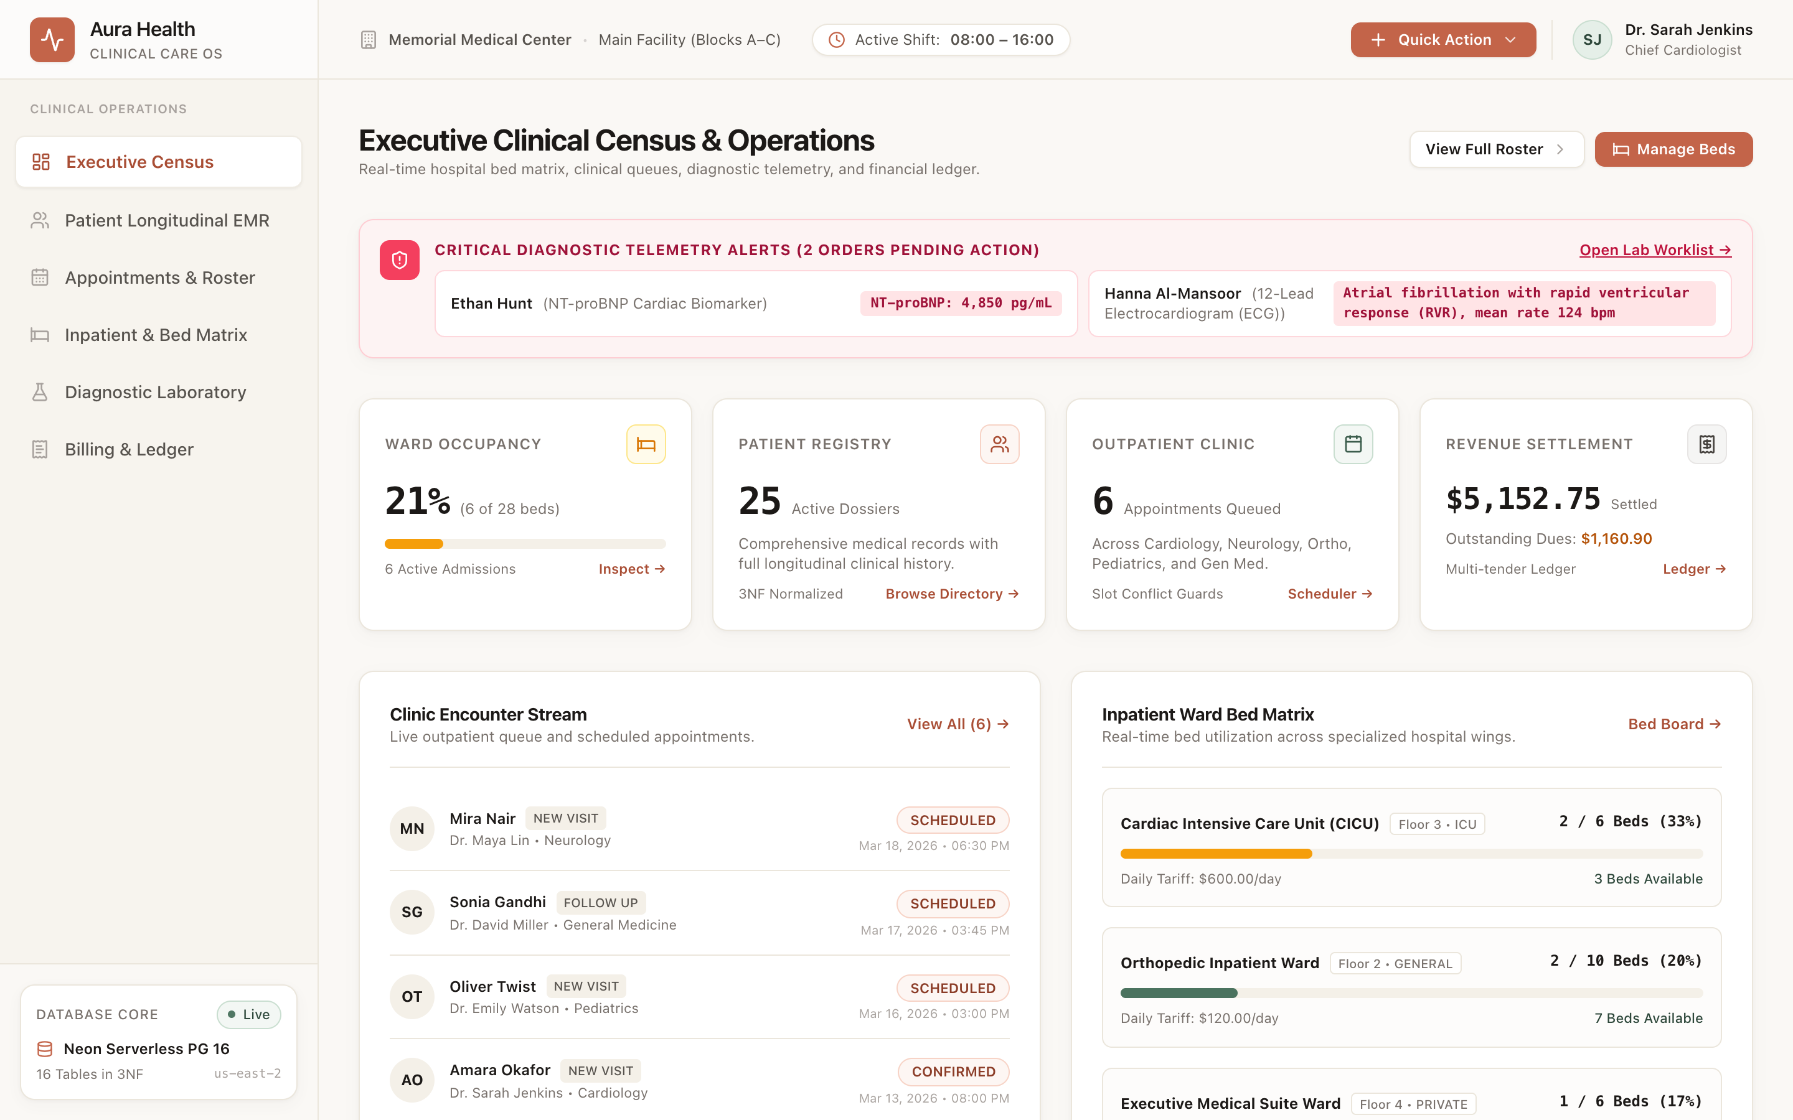
Figure 1. Executive Dashboard (Bed Occupancy, Real-Time Inpatients, Revenue)
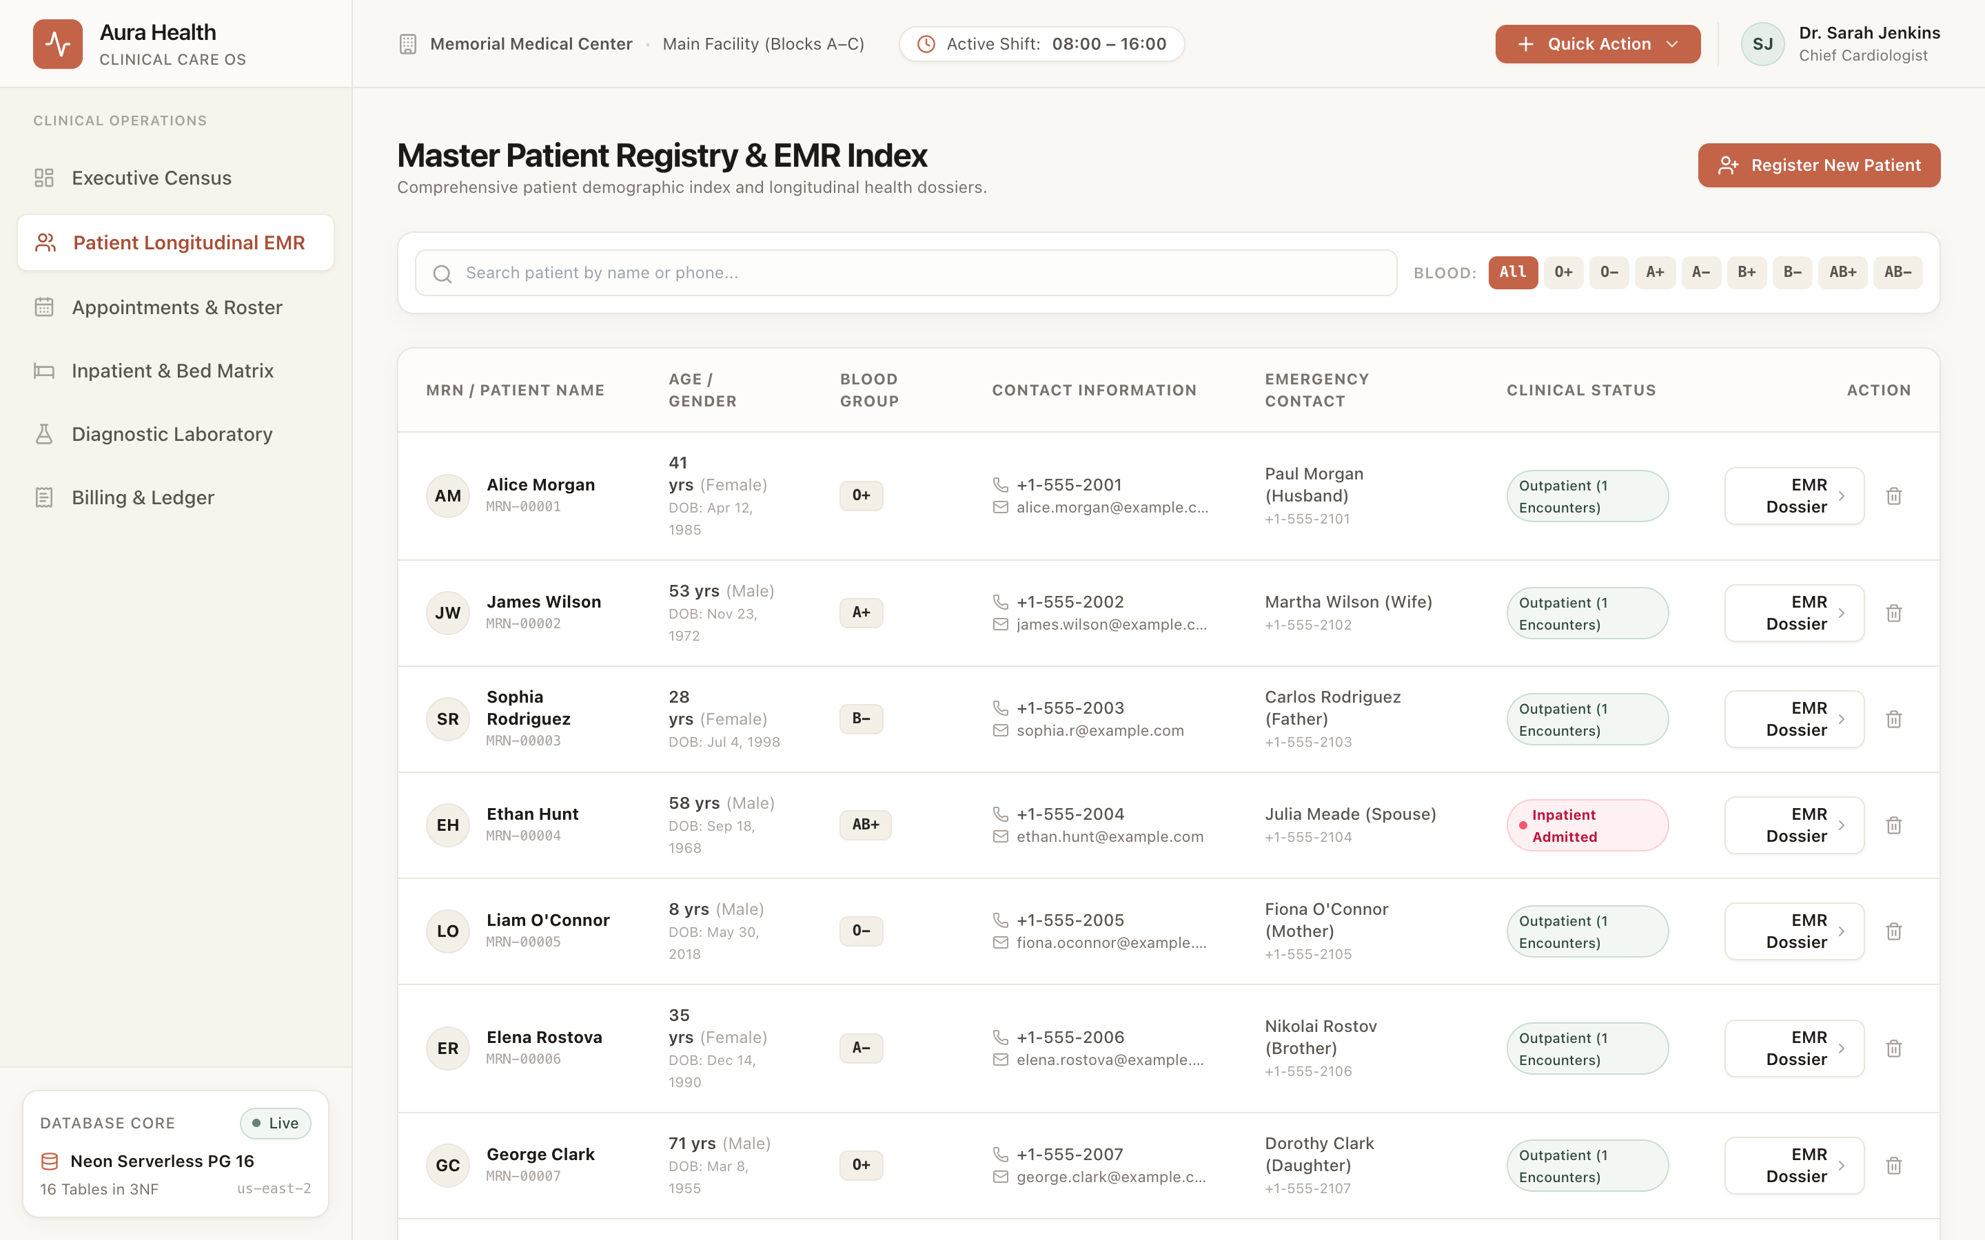
Figure 2. Patient Directory & Longitudinal Demographics Registry
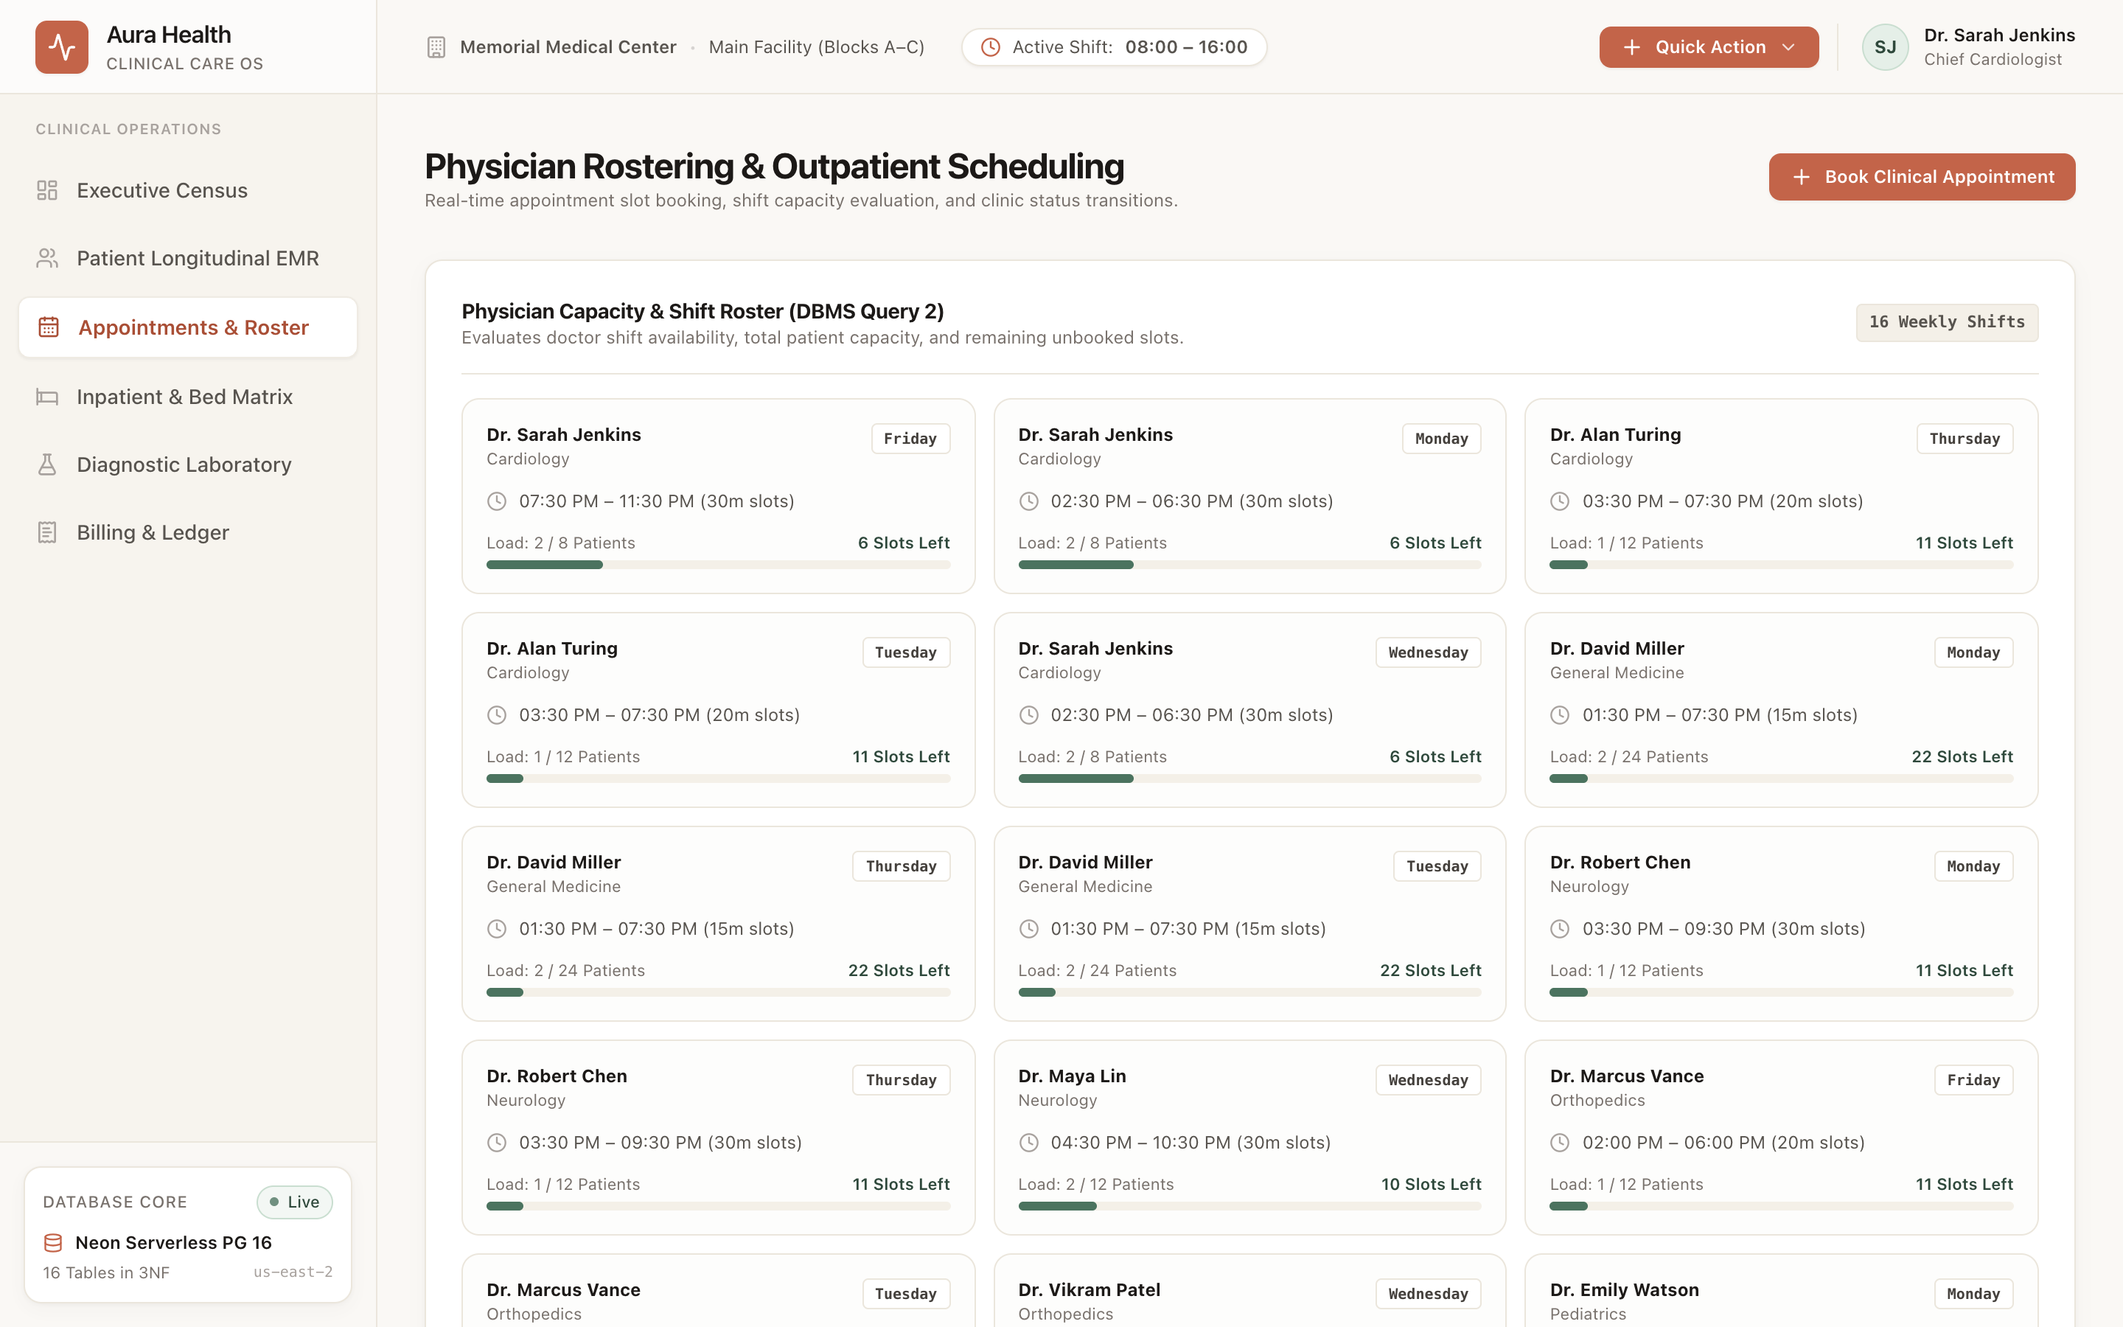
Figure 3. Conflict-Free Appointment Scheduling & Physician Slot Roster
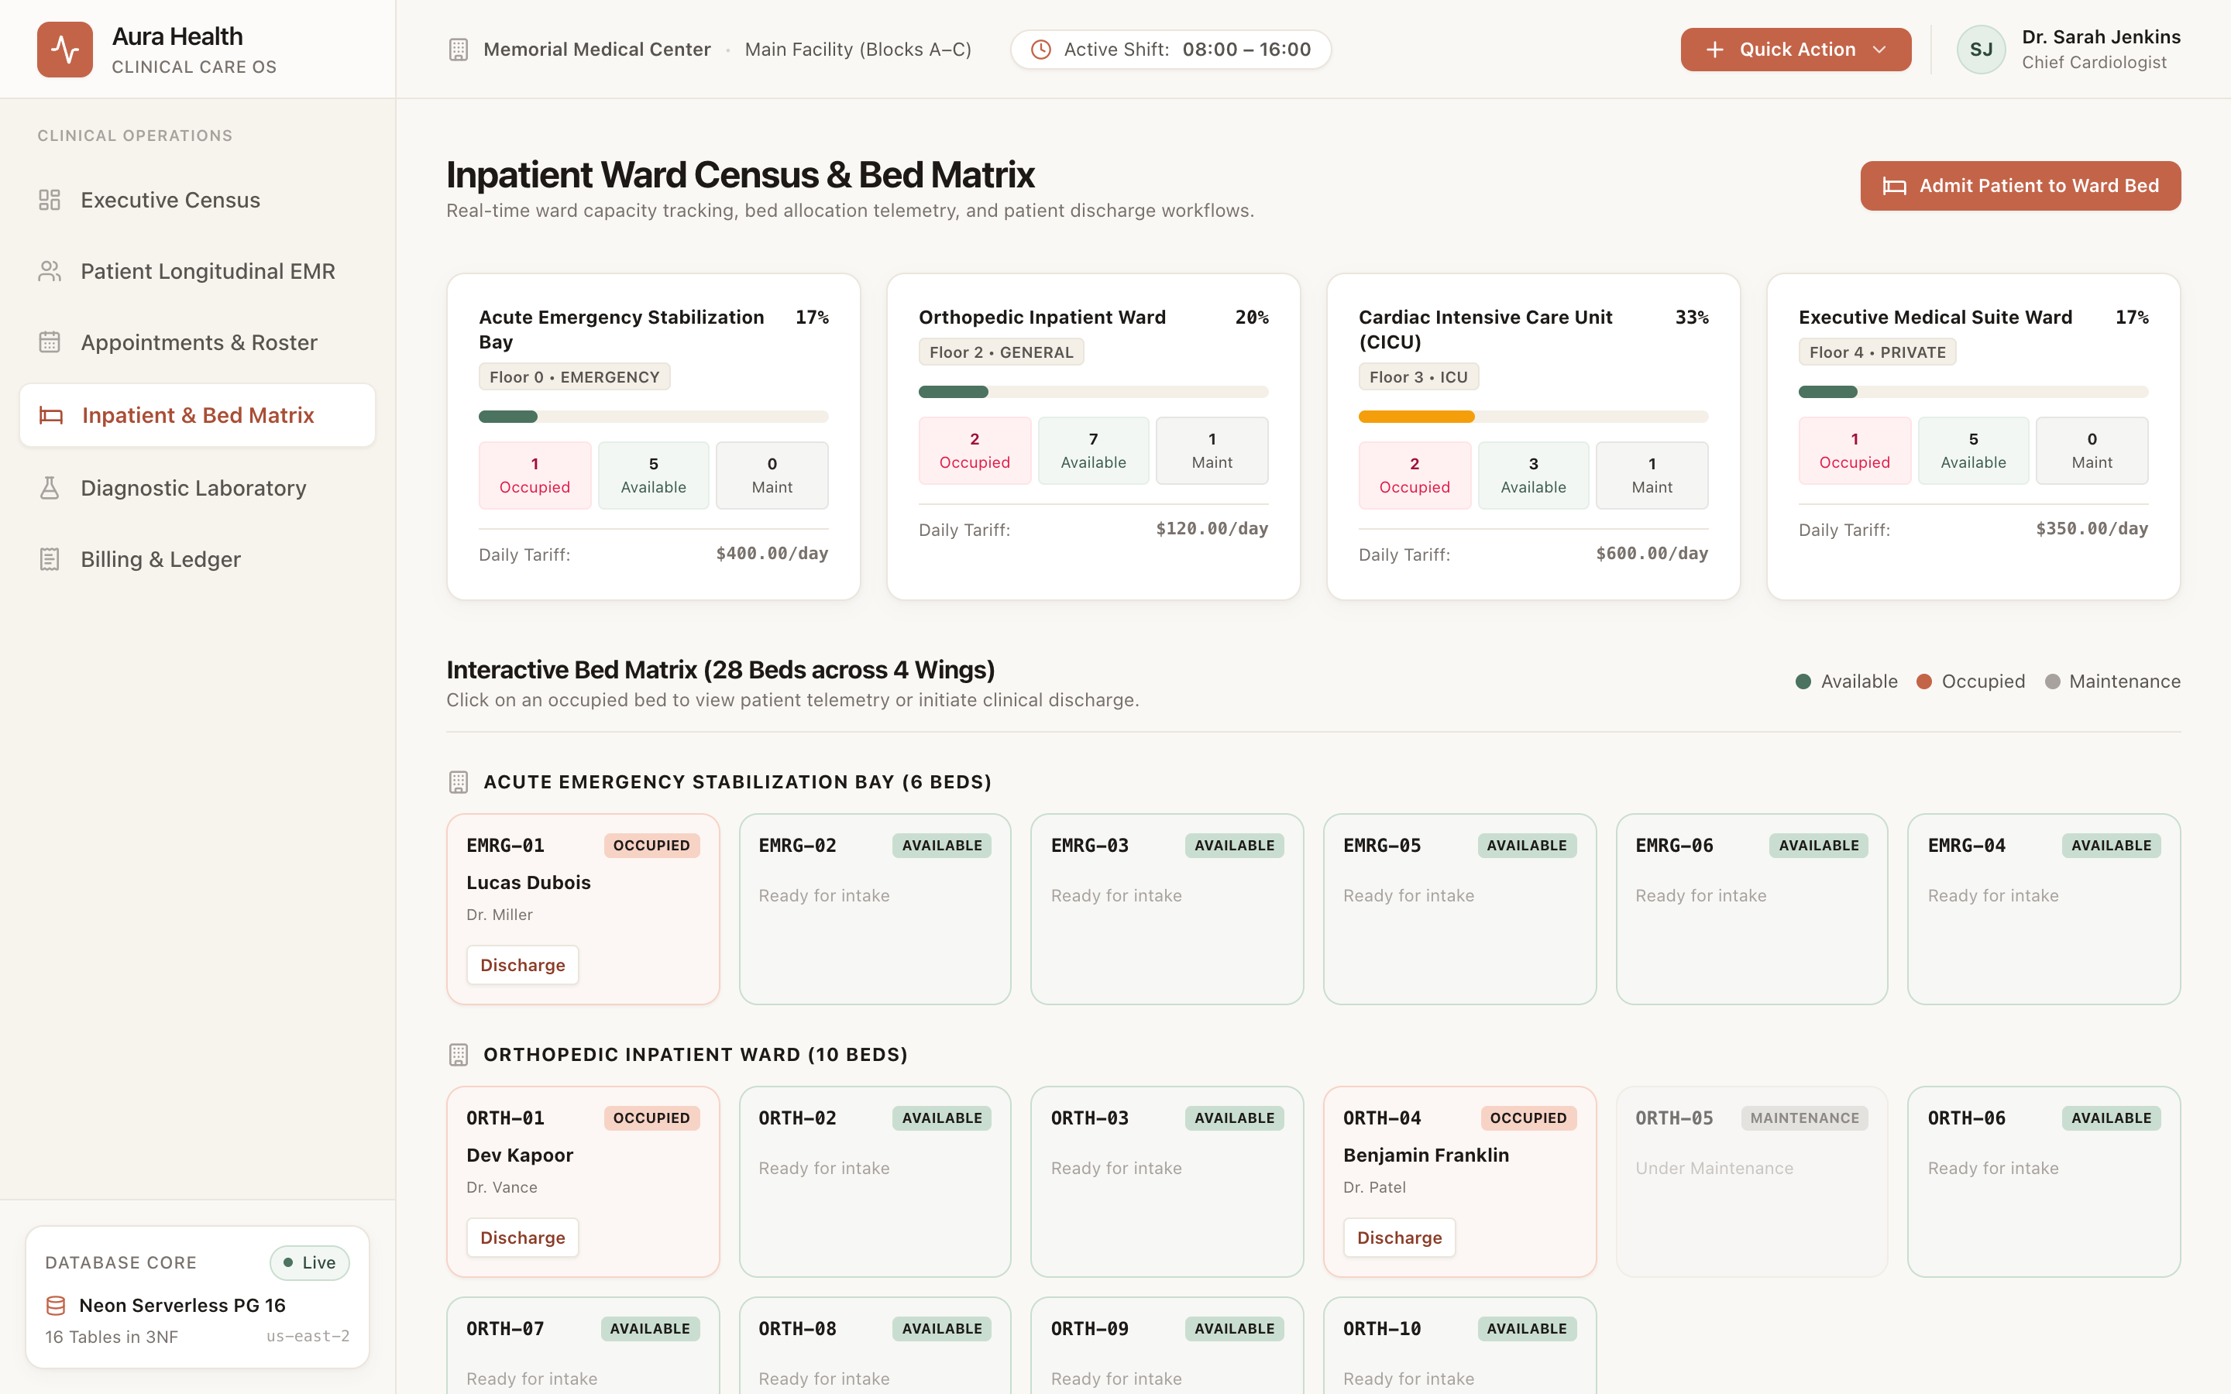
Figure 4. Inpatient Wards & Visual Bed Allocation Management Grid
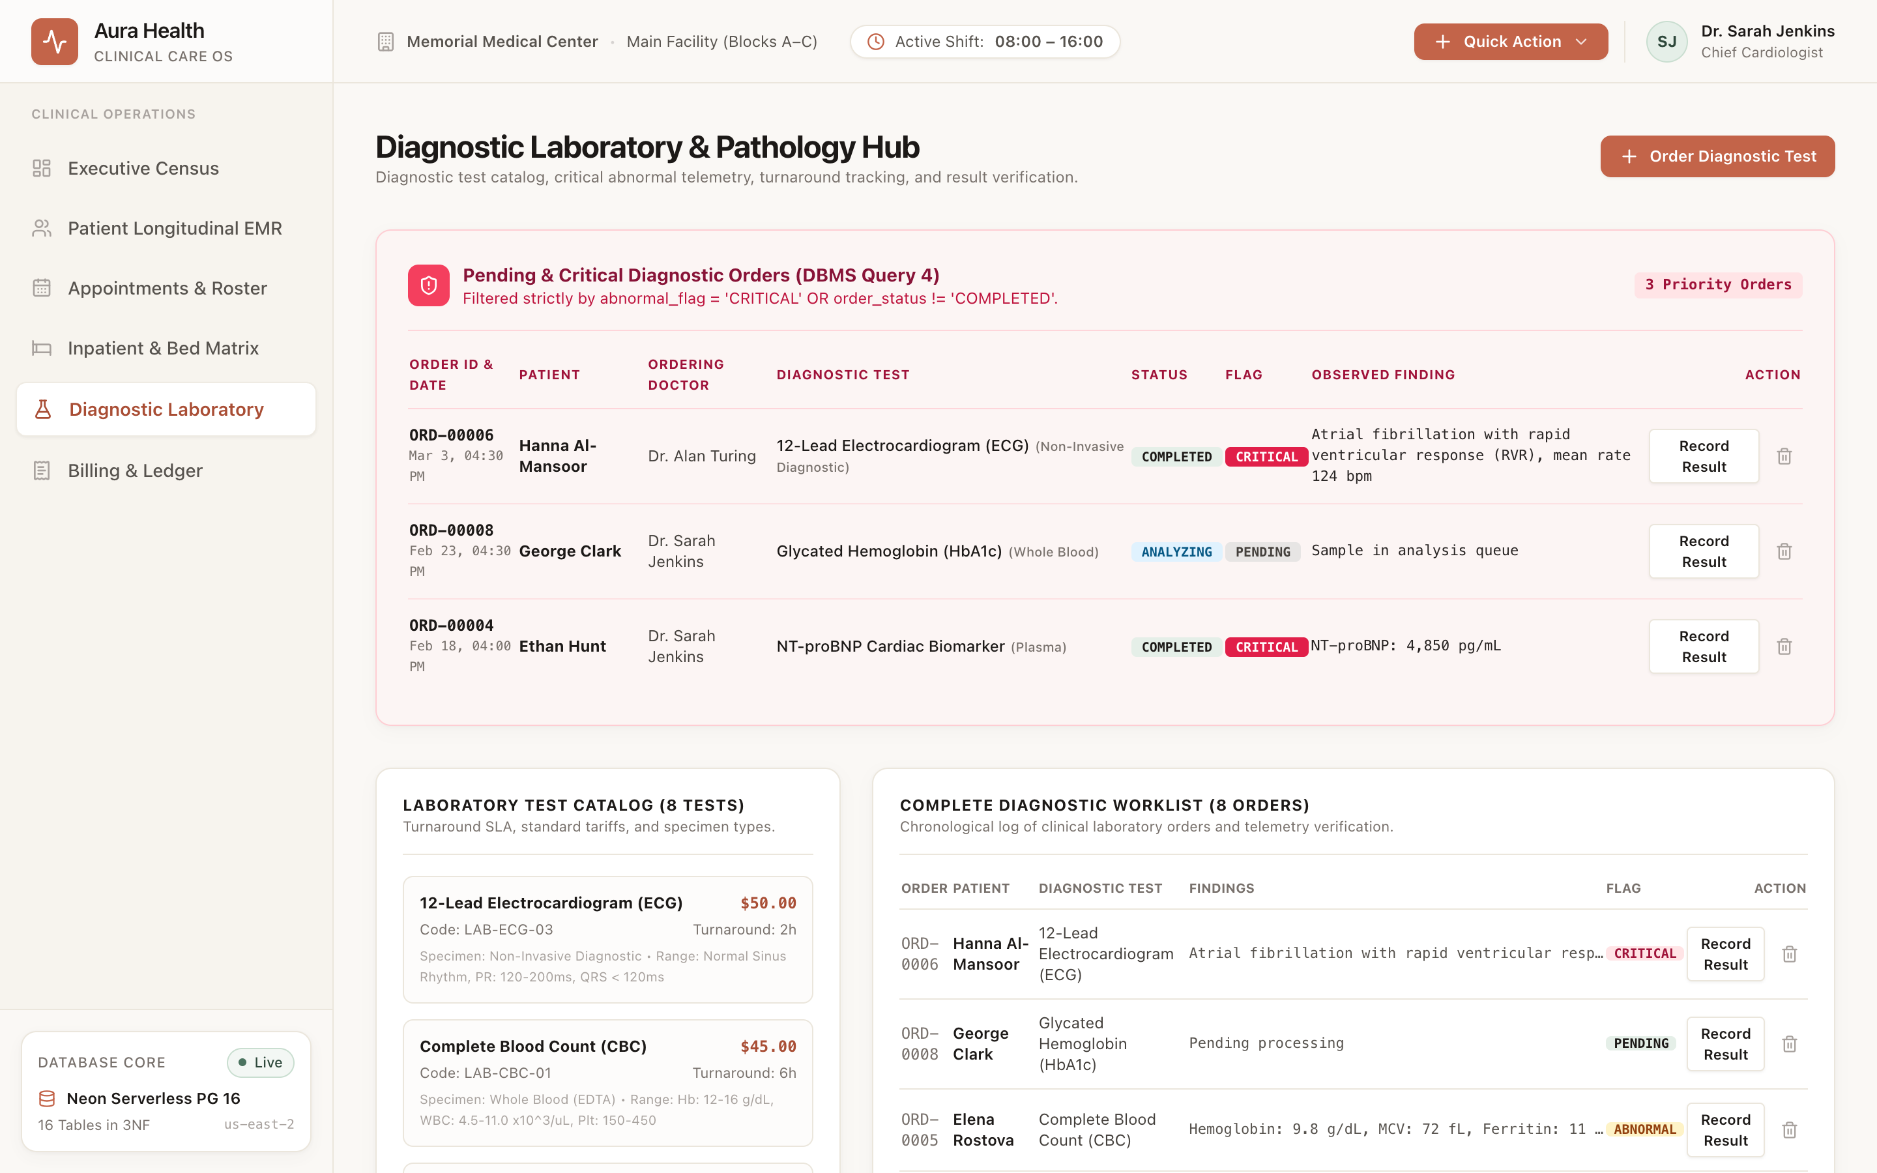
Figure 5. Diagnostic Laboratory Order Requisition & Result Tracking
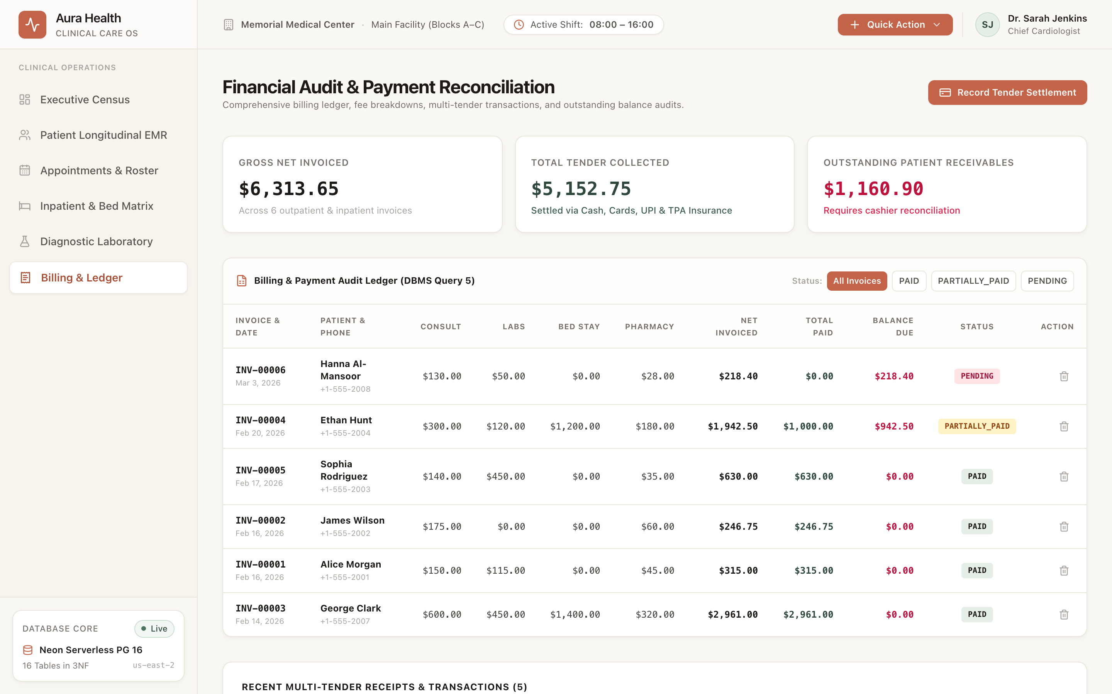
Figure 6. Consolidated Itemized Billing Ledger & Multi-Tender Payments

11. Implementation Details
11.1 Technology Stack
Layer | Technology | Purpose & Justification
Database Engine | PostgreSQL 16 (Neon Cloud) | ACID-compliant storage, custom ENUMs, CHECK constraints, composite unique indexing.
ORM / Client | Prisma ORM 6.4.1 | Type-safe database client, schema migrations, and connection pooling.
Application Backend | Next.js 14 (App Router) | Node.js Server Actions, REST endpoints, atomic transaction orchestration.
User Interface | React 18 + Tailwind CSS | Responsive design, dark/light clinical themes, interactive modals.
Component Library | Lucide React | Accessible iconography for medical, laboratory, and billing dashboards.
Tooling & CLI | Prisma Studio & psql | Visual database management, direct SQL inspection, and test execution.
11.2 DB Connectivity and Transaction Pattern
Every database interaction is managed through a connection-pooled Prisma Client singleton, ensuring zero connection leaks. Multi-table writes execute inside atomic database transactions, rolling back all statements if any constraint is violated:
// Atomic Appointment Booking with Unique Slot Collision Handling
export async function createAppointment(data: AppointmentInput) {
try {
return await prisma.appointment.create({
data: {
patient_id: data.patientId,
doctor_id: data.doctorId,
appointment_date: new Date(data.date),
appointment_time: data.time,
reason_for_visit: data.reason,
status: "SCHEDULED"
}
});
} catch (error: any) {
if (error.code === "P2002") {
// Prisma P2002 represents unique constraint violation (uq_doctor_slot)
throw new Error("This doctor already has an appointment booked for this exact time slot.");
}
throw error;
}
}

11.3 Validation and Error Handling
- Zero Collision Scheduling: The uq_doctor_slot composite unique constraint prevents double-booking at the database engine level.
- Inpatient Bed State Exclusivity: Only beds in AVAILABLE status can receive new inpatient admissions; occupancy updates are synchronized.
- Chronological Consistency: Relational CHECK constraints enforce that discharge_date >= admission_date and end_time > start_time.
- Financial Non-Negative Rules: Tariffs, invoiced totals, and payments must be non-negative; over-settlements are rejected.
- Safe Foreign Key Cascade: Appointments cascade when patients are deleted; doctor deletions are RESTRICTED if clinical records exist.
- Controlled Vocabularies: Custom ENUM types enforce valid states across appointments, beds, bill statuses, and lab abnormal flags.
11.4 Project Structure
dbms_assignment_1/
├── Presentation-I/
│ ├── 01_Executive_Presentation.pdf # Review 1 Executive Slides
│ └── README.md # Milestone 1 Details
├── Presentation-II/
│ ├── 02_Schema_ERD_Keynote.pdf # Review 2 Schema & 3NF Deck
│ ├── 03_Review_2_Presentation.pdf # Review 2 Presentation Deck
│ └── README.md # Milestone 2 Details
├── Presentation-III/
│ └── README.md # Review 3 Roadmap & Preparation
├── Project-Report/
│ ├── HAPCMS_Project_Report.docx # Editable Formal Word Report (This Document)
│ ├── HAPCMS_Project_Report.pdf # Compiled Course Project Report
│ ├── PROJECT_REPORT.md # Markdown Source Report
│ ├── assets/ # ERD diagrams & University logo
│ └── screenshots/ # High-res application UI captures
├── web/ # Next.js 14 Full-Stack Application
│ ├── src/ # App Router, components, Prisma lib
│ ├── prisma/ # Prisma schema & SQL migrations
│ ├── package.json # Web dependencies
│ └── README.md # Web setup instructions
└── README.md # Main Project Overview

12. Testing (Test Cases and Results)
A rigorous suite of positive and negative test cases was executed directly against the PostgreSQL 16 database engine and application layer to verify relational integrity, ACID compliance, and constraint enforcement:
Test ID | Test Name | Execution / Input | Expected Result | Actual Result | Status
TC-01 | Appointment Collision Rejection | Insert 2 appointments with identical doctor_id, date, and time | PostgreSQL raises unique violation on uq_doctor_slot | ERROR: duplicate key value violates unique constraint | PASS
TC-02 | Admission Chronology Check | Insert admission with discharge_date < admission_date | CHECK constraint rejection | ERROR: check constraint admission_discharge_check violated | PASS
TC-03 | Financial Non-Negative Balance | Insert payment with amount_paid = -500.00 | CHECK constraint rejection | ERROR: check constraint payment_amount_check violated | PASS
TC-04 | Invalid Blood Group Rejection | Insert patient with blood_group = 'XYZ' | CHECK constraint rejection | ERROR: check constraint patient_blood_group_check violated | PASS
TC-05 | Referential Integrity (FK) | Insert appointment referencing non-existent doctor_id = 99999 | Foreign key violation | ERROR: violates foreign key constraint on doctor | PASS
TC-06 | Bed Double Allocation Rejection | Admit patient into bed currently marked OCCUPIED | State conflict blocked | State conflict blocked; admission rejected | PASS
TC-07 | End-to-End Positive Workflow | Patient registration -> booking -> consultation -> billing -> payment | All sequential rows persist with valid FKs | Rows created successfully; HTTP 200 / SQL OK | PASS
13. Conclusion and Future Enhancements
13.1 Conclusion
The Hospital Appointment and Patient Care Management System (HAPCMS) delivers a robust, normalized relational solution fulfilling all course requirements for the Database Management Systems curriculum. The project implements 16 relational tables normalized to Third Normal Form (3NF), enforces bulletproof integrity constraints (composite unique appointment indexes, domain CHECKs, and ENUMs), populates realistic healthcare datasets, and provides an accessible, full-stack Next.js 14 web application interface. By enforcing constraints at the database engine level, HAPCMS completely prevents scheduling overlaps, orphan inpatient admissions, and financial accounting anomalies.
13.2 Future Enhancements
- Role-Based Access Control (RBAC): Introducing PostgreSQL Row-Level Security (RLS) and JWT claims isolating doctor views from financial accounting ledgers.
- HL7 / FHIR Electronic Health Record Integration: Interfacing with standardized international hospital interoperability protocols.
- Automated Notification Triggers: Utilizing pg_cron and webhooks for automated SMS and WhatsApp appointment reminders and abnormal lab test alerts.
- Telemedicine Video Consultations: Embedding WebRTC video consultations directly linked to the clinical consultation table.
- Advanced Analytics & Forecasting: Predictive machine learning models for seasonal bed demand and outpatient appointment no-show probabilities.
14. References
- Silberschatz, A., Korth, H. F., & Sudarshan, S. (2019). Database System Concepts (7th ed.). McGraw-Hill Education.
- Elmasri, R., & Navathe, S. B. (2015). Fundamentals of Database Systems (7th ed.). Pearson Education.
- PostgreSQL Global Development Group. (2024). PostgreSQL 16 Documentation. Retrieved from https://www.postgresql.org/docs/16/
- Prisma Documentation. (2024). Prisma ORM for PostgreSQL. Retrieved from https://www.prisma.io/docs
- Next.js Documentation. (2024). Next.js 14 App Router and Server Actions. Retrieved from https://nextjs.org/docs
- Reference DBMS Course Project Report supplied for the report structure, Woxsen University.
15. Appendix: GitHub Repository Link
GitHub Repository: https://github.com/Imad-81/dbms_assignment_1
The complete source code, Prisma database schema, seed scripts, SQL queries, and Next.js web application are publicly hosted at the repository above.
Quick Start Instructions
# 1. Clone repository
git clone https://github.com/Imad-81/dbms_assignment_1.git
cd dbms_assignment_1
# 2. Install dependencies & initialize database
cd web
npm install
npx prisma generate
npx prisma db push
# 3. Launch Development Server
npm run dev
# Open http://localhost:3000 in your browser

