VISUAL DESIGN SYSTEM
Iconography, Typography & Color-in-Use
How the style guide actually shows up screen by screen and step by step

1. Iconography
The icon set carries the product's core idea on its own: an icon starts as an outline and only becomes filled once the thing it represents is actually finished. That single rule does more communicating than any amount of copy — unfinished work looks unfinished, on purpose, everywhere in the interface.
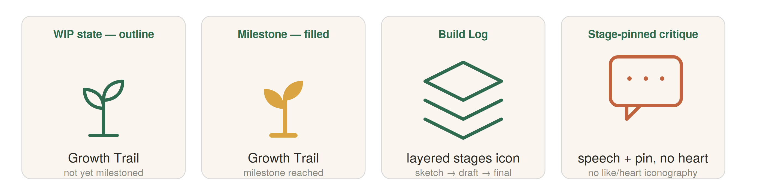
Fig. 1 — The core iconography rule: outline while in progress, filled once a milestone or final stage is reached. No heart or thumbs-up shape appears anywhere in the system.

Style rules
- 2px stroke, rounded joins — consistent line weight across the set, corners soft rather than sharp, closer to pen-and-paper linework than geometric tech icons.
- Outline = in progress, filled = complete — applies to any icon with a lifecycle (Growth Trail markers, Build Log stage indicators, WIP tags), not just decoration.
- No heart, thumbs-up, or star glyph anywhere — a direct, deliberate exclusion — those shapes are the visual language of the like-count culture this product is designed against.
- One color per icon, drawn from the palette — Moss for process/growth icons, Clay for action icons, never a rainbow of icon colors on one screen.

Icon-to-feature mapping
Icon concept | Represents | Color / state rule
Sprout | Growth Trail | Outline Moss by default; fills solid Ochre only at a milestone
Layered diamonds | Build Log / stages | Outline Moss, always — a log is never “done,” only added to
Speech bubble + dots, with a pin | Stage-pinned critique | Outline Clay — the pin is what distinguishes it from a generic comment icon
Hash / tag chip | Interest tags & channels | Outline gray by default; fills Moss once selected
Dashed-outline circle + pencil | WIP status tag | Always outline, always Sage — this icon never has a “filled” state
Compass | Discover / search | Neutral charcoal outline, no accent color — a utility icon, not a feature icon

2. Typography
Two typefaces, each doing a different job. A humanist sans carries the interface itself — buttons, navigation, timestamps — so the product stays legible and gets out of the way. A warm serif is reserved for the moments where a person's own words or reflections appear: stage captions, critique comments, and Growth Trail milestone text. The split marks the difference between the app talking and a person talking.
Role | Typeface | Size / weight | Used for
Display | Serif | 28px / 500 | Growth Trail milestone headlines, profile intro
Section title | Sans (humanist) | 22px / 600 | Screen titles, Build Log names
Body / UI | Sans (humanist) | 16px / 400 | Buttons, navigation, structured feedback prompts
Process narration | Serif, regular | 17px / 400 | Stage captions, critique comments — a maker's or critic's own words
Caption / meta | Sans (humanist) | 13px / 400, muted | Timestamps, stage counters, tag labels

Why the serif is rationed
The serif only appears where a real person wrote something — never in chrome, buttons, or system copy. That keeps it meaningful: seeing serif type is a signal to the reader that they're about to read someone's actual thinking, not interface text. Two weights only (400 regular, 500 medium) across both typefaces keeps the system calm — no bold-everywhere hierarchy competing with the color palette for attention.

3. Where Each Color Shows Up, Screen by Screen
This is a budget, not a suggestion — most screens use one accent color at most, and Ochre is withheld from every screen except Profile. That scarcity is what keeps it meaning something.
Screen | Dominant | Accent / CTA | Ochre? | Why
Home / Process Feed | Paper | Moss (nav only) | Never | The feed has to stay visually calm — giving individual posts bright accent colors would recreate a “which post is winning” read.
Discover (tags, search) | Paper | Moss (selected chip) | Never | A selected tag reads as a positive choice, not a “trending/hot” heat-colored signal.
Create / Build Log editor | Paper canvas | Clay (Add stage, Publish) | Never | Clay marks “do something” — chrome stays quiet so the uploaded work is the visual focus.
Feedback / critique threads | Paper | Moss (prompts), Clay (Request feedback) | Rare — “most helpful” flag only | Every comment gets the same Moss framing regardless of content — no red/green sentiment-coding that would reintroduce judgment.
Profile / Growth Trail | Paper | Moss | Concentrated here | The one screen designed to celebrate progress — deliberately, so it stays rare everywhere else.
Notifications & settings | Paper / neutral gray | Clay dot, actionable items only | Never | Utility screens stay quiet on purpose — no red badge counting every event, only a dot for things that actually need a response.

4. The Palette Across the User Flow
Mapped against the “share a work-in-progress and get feedback” user flow, the pattern becomes explicit: Ochre appears exactly once in the entire journey.
Flow step | Color present | Why
Open app | Neutral (Charcoal on Paper) | A calm entry — no color pressure at the door.
Home / Process Feed | Sage (WIP badges only) | Sets the expectation immediately that unfinished work belongs here, at low visual stakes.
New vs. existing decision | Clay | A real decision point — Clay marks it as an action, not a passive read.
Upload stage / Add WIP tag | Sage | Marking something WIP should feel safe, not like flagging a problem.
Publish stage | Clay | Action completed.
Request feedback decision | Moss-toned copy and buttons | Feedback is framed as an invitation to grow, not an evaluation — kept out of red/orange territory entirely.
Receive structured feedback | Moss / neutral | No per-comment red/green sentiment coding — consistent with the research finding that what matters is whether feedback supports growth, not whether it reads as praise or criticism.
Revise further decision | Clay | Another action point, same visual language as the first decision.
Mark final → Growth Trail updates | Ochre | The single reward moment in the entire flow — deliberately the only place this color appears.

The point of counting this
A palette can say the same thing a feature list says, just faster. Ochre showing up once — at reflection, after a person chooses to mark something final — and nowhere near publishing, browsing, or checking back, is the color system making the same argument as the Growth Trail feature itself: progress gets recognized when the person decides it's worth recognizing, not on the platform's schedule.

