

|  |
| --- |
| Projet de fin d’année  « i-Mark » |
|  |
| 21 avril  Scrum Master :  CHRAIBI Mohamed Bader |

# Contexte général du projet

|  |
| --- |
| **Description du projet** i-Mark est une application qui fournit un moyen de créer des jeux de données d'images pouvant être utilisés dans des algorithmes de vision par ordinateur intelligents pour résoudre différents problèmes tels que la classification, la détection ou la segmentation d'images. **Objectif du projet** |

Notre projet propose une platform web et une application mobile qui vise à optimiser/automatiser la maintenance des infrastructures route/rail/bâtiments.

## **Chart du projet**

|  |  |  |  |  |  |
| --- | --- | --- | --- | --- | --- |
| PROJECT CHARTER | | | | | |
| Name | i-Mark | | | | |
| Date | April 10, 2022 |  | Scrum master | | CHRAIBI Mohamed Bader |
|  |  |  |  | |  |
| Project Description | | | | | |
| i-mark is an application that provides a means of creating image datasets that can be used in intelligent computer vision algorithms to solve different problems like image classification, detection, or segmentation. i-mark is part of an ambitious project that aims to optimize/automate the maintenance of road/rails/buildings infrastructures. | | | | | |
|  |  |  |  | |  |
| Business Case (Besoins / Justifications) | | | | | |
| In the era of DL/ML and big data, having quality data with the right volumes is key for any business to thrive and keep up with the never-ending competition. With all the advances in the computer vision field, one particular use case that has so many applications and benefits from a business standpoint is image segmentation, which allows dividing the image into subgroups called segments or regions of interest (ROI could be a car, person, damage in building column, crack/hole in a highway...). To train and apply deep learning to solve image segmentation problems (e.g., used in smart vehicles, tumor detection, concrete damage detection...) having a dataset of images related to the ROI (car, person, crack/hole, etc.) to be recognized or detected using DL, is now, more than ever, important and key to be able to produce reliable models that could be productized as part of the business tech stack. This is where i-mark plays the first step to build a dataset of images with its metadata and annotations. In this case, i-mark must allow a user to select/draw a region/polygon surrounding an object of interest, in this case, images of some civil engineering structures that contain damages (pathologies) will be provided after the process of selection is done, the application must save the coordinates of the pixels that form the polygon in a convenient format (JSON, XML, database) along with any metadata that could be obtained from the image, like the width, height, GPS coordinates where the picture was taken (mostly, maintenance is done in the field, so mobiles have access to GPS data and i-mark must be able to get that information in the moment of capture). Along with the metadata, i-mark must allow the user to add one or more tags related to the image and a description text. All these data must be stored as previously mentioned. i-mark is intended to be integrated into the ERP of the company, in this case, SAP, so the framework to be used for the web application frontend is OpenUI5 (https://openui5.org/), which is an enterprise-grade frontend framework, used as the core technology that powers the new SAP UI named SAP Fiori (https://www.sap.com/products/fiori.html). | | | | | |
|  |  |  |  | |  |
| Scope | | | | | |
| Deliverables:  2 Applications (Mobile and Web) stocking the metadata in a back End using NoSQL database MVP: get the bounding box of the drawing | |  | Objectives (Validations conditions):  -Time: Deadline 19/05/2022  -Budget: XX DHs  -Scope: Fully functional and deployed Web + obile Application | | |
|  |  |  |  | |  |
| Project Team | | | | | |
| CHRAIBI Mohamed Bader | | | | | |
| ELOUAJI Soukaina | | | | | |
| ETTANI Zakaria | | | | | |
| BEN ALI Imad | | | | | |
| BENHADDOUCH Abdelmonaim | | | | | |
|  |  |  |  | |  |
| Platforms and frameworks | |  | Constraints | | |
| * OpenUI5, OpenCV, HTML 5 canevas ……. | |  | * Fully functional and deployed Web + Mobile   Application | | |
| Risks | | | | | |
| * Product is not ready in time for the launch | | | | | |
|  |  |  |  | |  |
| Milestones | | | | | |
| Project milestone | From | | | To | |
| Milestone 1 | 4/8/2022 | | | 4/28/2022 | |
| Milestone 2 | 4/29/2022 | | | 5/19/2022 | |

# Analyse du besoin

## **Etude benchmark :**

|  |  |
| --- | --- |
| Logiciel | Caractéristiques |
| Label Studio | * Prend en charge un large éventail d’annotations, y compris la classification d’images, la détection d’objets, la segmentation sémantique * Fonctionne avec tous les types de données (audio, image, texte…) * Annotation par polygone |
| **Diffgram** | * Il dispose également de diverses capacités de gestion des jeux de données et des flux de travail * Annotation spatiale par des cadres et des cuboïdes. |
| **LabeIImg** | * Il prend les boîtes englobantes comme méthode d’étiquetage * Annotation enregistrée sous forme XML, format YOLO … |
| **COCO Annotator** | * Il s’agit d’un outil de segmentation d’images basé sur le Web visant à développer et à former des modèles de détection d’objets, de localisation et de détection de points clés * Les jeux de données d’étiquetage peuvent être effectués avec des courbes de forme libre, des polygones et des points clés. * Il offre également un système d’authentification des utilisateurs |

* Notre application doit comprendre un système d’authentification
* Notre application fonctionne avec les types images seulement (PNG, JPEG)
* Notre application implémentera dans un 1er lieu des annotation étiquetés en 2 points (rectangle).
* Notre application détecte la localisation des points clés

# Gestion du projet :

## **Planning prévisionnel :**

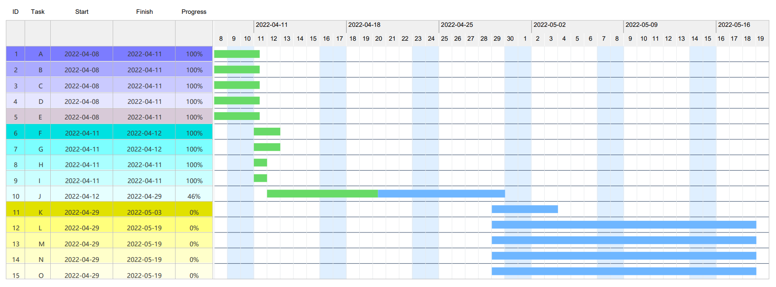



## **Architecture technique :**

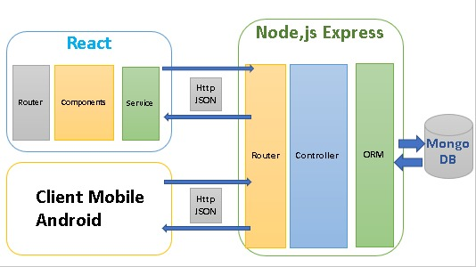

## **Etat d’avancement :**

### Kanban board :

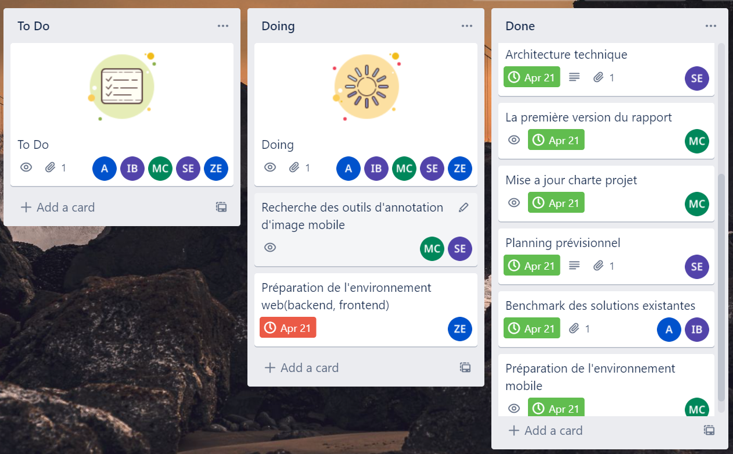

### User story fonctionnelle :

Une interface mobile qui permet de capturer une image pour l’annotation.