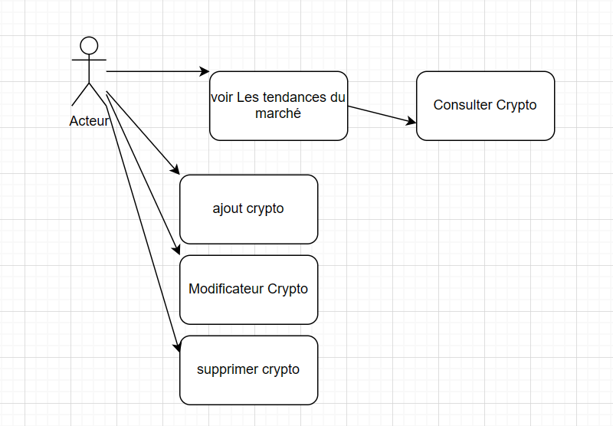
Usecase :
MCD initial:

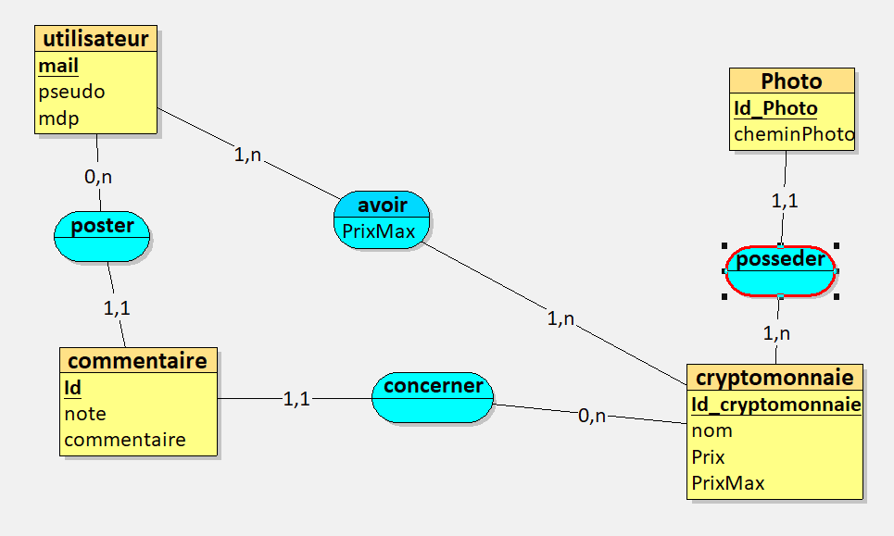
MCD Final :

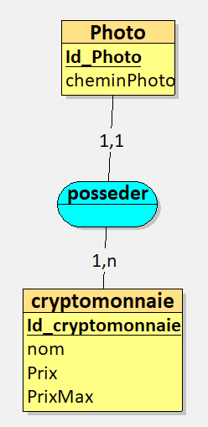

Github → → https://github.com/Imadpro129430/CoinDeLaH
aws → → coin de la hess / 34.201.41.227

