**BENG 219 Control Systems**

Laboratory experiment #2:

***PLC: Programming and Control***

**CompLab Section:** 3

**Professor:** Md Ali

**Team members:** Khoyashov Nurgabyl 201416358

Kondratyuk Dina 201464970

Kukpayev Aibek 201596125

Kuntubek Aldiyar 201590665

**Date of experiment:** 06.02.2018

**Date of submission:** 13.02.2018

**Table of contents**

1. Objectives…………………………………………………………………………………2
2. List of equipment………………………………………………………………………….2
3. Introduction………………………………………………………………………………..2
4. Procedure………………………………………………………………………………….4
5. Results and Discussion………...………….………………………………………………5
6. Conclusion………………………………………………………………………………...5
7. References...………………………………………………………………………………5

**1. Objectives**

1) Be familiar with different combinations of mechanisms and PLC

2) To explore the function of the ladder logic programmes applying CX-ONE software

**2. List of equipment**

1. PLC
2. Motor
3. Terminal I/O Box MM­VC300
4. Pneumatic cylinder MM­V A210
5. Photo Sensor
6. PC with CX-ONE software
7. Conveyor
8. Additional wires

**3. Introduction**

A PLC which stands for PROGRAMMABLE LOGIC CONTROLLER is a prevalent computer control system that can be programmed to demonstrate the state of input devices and perform various logic functions for controlling the output devices. The main aim of the controller in industry is to control the output of the plant by tracking the input and appying the programm in the process of the decision-making. Different types of machine functions and processes can be improved by using this type of control system. For convenient using and easy creation of a sequence in the logical functions it is necessary to apply the ladder diagram. “Ladder diagram’’ is a type of a pattern with horizontal and vertical lines which demonstrates rails and rungs. Each symbol has own meaning. The overall diagram usually explored from left to right and from top to bottom. The representations of these lines are below:

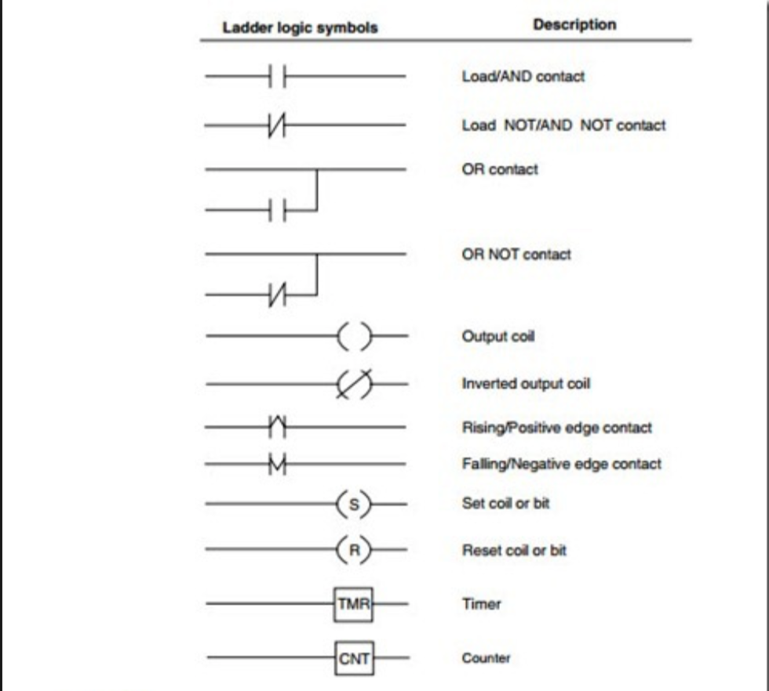

*Figure 1.* *The commonly used ladder logic programm symbols and their meaning.*

In addition, during the laboratory experiment for constructing ladder diagrams of the logic programm the particular software called CX­ONE was used for this purpose. Every stage in the programm is entered just one time. After that, the software will execute the problem in accordance with assigned objective.

The equipment called the terminal I/O box is a board with the several output and input connections, and buttons of on and off. The conventional motor is used to get a signal and depending on connections, it begins to rotate a disk of a toothed form in clockwise or anti­clockwise direction. The next type of the equipment called conveyor is dedicated to perform a delivery of little objects from one side to another of the set during the rotation of the toothed disk. The photo sensor is sensitive to an obstacle in the distance of approximately 40-45 cm and transmit a particular signal of coming object to the terminal box. The pneumatic cylinder is suitable for pushing some details as long as it gets the signal. After that, it come back to its original position.

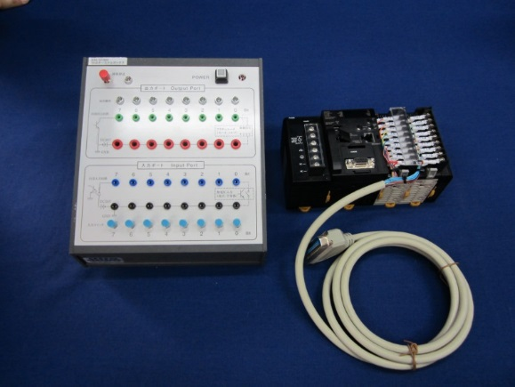

*Figure 2.* The picture of the terminal I/O box

In addition, the significant advantage in usage of a PLC is the feature to modify and duplicate the process of the operation during receiving vital information. Also, it is worth noting that PLC system is modular. It means, that it is possible to combine different types of Input and Output devices for optimal result.

**4. Procedure**

At the beginning of the experiment, terminal box and PLC were wired. Experimental procedure started from setting of USB connection between computer and PLC. CX-Programmer was opened, new CX-window appeared, and appropriate PLC type and network type were selected. From settings of CPU, CPU31 was selected, which was sufficient for this control system. Connection between PLC and computer software was changed to online by choosing “work online”. To control process through certain algorithm, operating mode was changed to program mode. To start programming, I/O table and unit setup were selected, and PLC Ladder program drawing was started. Work online was changed to work offline, and ladder diagram was constructed. In Experiment 1, where motor is controlled by switch, PLC ladder diagram consisted of input relay and output coil as shown in the Figure 1.

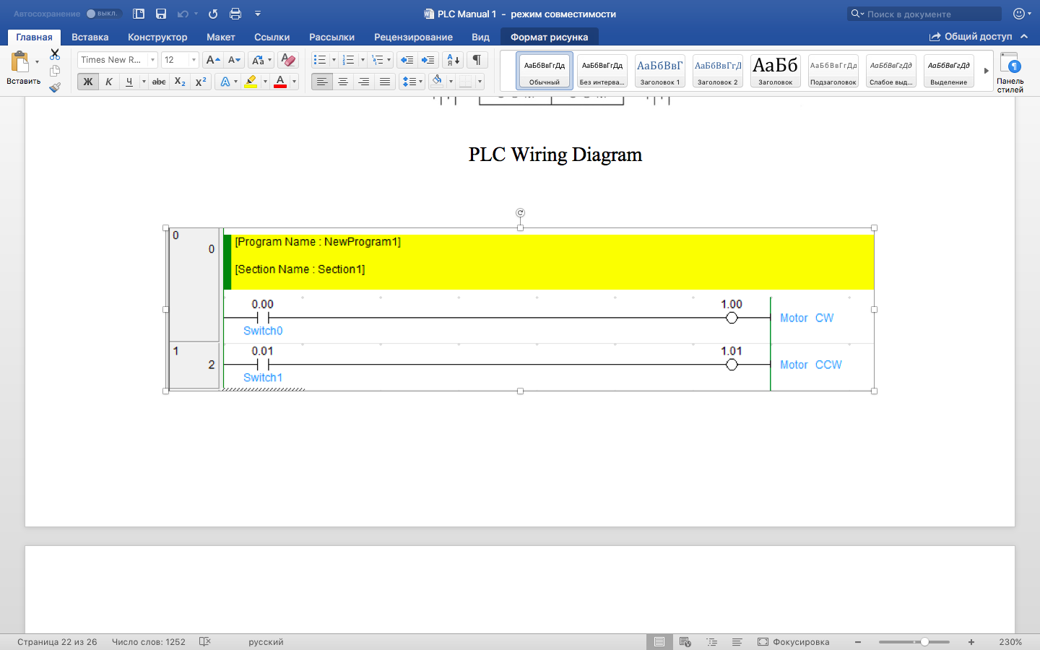

*Figure 3.* PLC ladder diagram for the first experiment.

Certain numbers were assigned to each relay and two-line ladder diagram was constructed, where first line was responsible for clockwise rotation of motor, whereas the second line was for counterclockwise rotation. “Work online” was selected to transfer ladder program to PLC. Program downloading window appeared, which means that PLC could start its work. By using green and red wires, PLC was connected to motor. As a result of program running, motor started to rotate, which can be controlled by switch in PLC. In the second experiment, conveyer was controlled by photo-sensor.

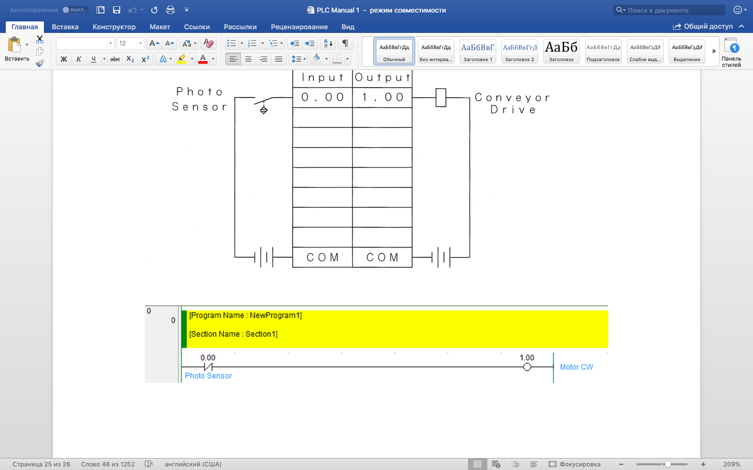

*Figure 4.* PLC ladder diagram for the second experiment.

Ladder program constructed by putting photo sensor relay and output coil. Conveyer was connected to the motor, while running program, conveyer came to motion by sensor.

**5. Results and Discussion**

After running the program and adjusting the switches, the motor rotation was observed during the Experiment 1. The rotation was either clockwise or counter-clockwise according to which switch was used. Moreover, the simultaneous adjustment of switches did not result in anything, which could be the result of contradiction between opposite directions of motion.

During the Experiment 2, the photo sensor was added to the PLC ladder logic program, which resulted in the motion of conveyor, if the light is caught by the sensor.

**6. Conclusion**

The main aim of this experiment was to learn the basic features of PLC by setting and synchronising data throough the CX Software with constructing various logic sequences. Simultaneously, basic concepts of PLC motors were tested and observed. In part 1, by transfering logic program through CX, PLC motor rotated in one direction (counterclockwise) without stopping. In second part, we tested the Photo Sensor by constrcting analogical sequence and observes its work principle of photo sensor (by obstacles).

1. **References**

Wordpress. 2015. Devices, symbols, and circuits: Reading and understanding ladder logic. http://machineryequipmentonline.com/electric-equipment/devices-symbols-and-circuitsreading-and-understanding-ladder-logic/