**Appendix**

Evaluating the clinical utility of images depends on a wide range of factors that are often user dependent, especially for scans of real patients where no ground truth is available. In this manuscript we implemented STO imaging in the specific application of 4DCBCT imaging for radiation therapy, where the typical use case is to verify that the tumor remains within the treatment beam across the respiratory cycle while highly radiosensitive structures such as the heart are avoided.

We have chosen to include this appendix so that readers can make their own qualitative assessment of the images. Note that in this trial the patients receive the conventional 4DCBCT scan, are aligned and treated as in typical clinical practice, then the STO600 scan is acquired, and then the STO200 scan is acquired. We therefore expect to see a rigid translation between the conventional and adaptive images. As explained in the text of the manuscript, it is also common for the patients respiratory motion to qualitatively change over this time, with up to 60% change in the motion amplitude [37]. The considerations should be kept in mind when evaluating the impact of STO acquisition and adaptive reconstruction on the observed motion in 4D images.

Another consideration in assessing CBCT images is that the distribution of attenuation values changes significantly depending on the acquisition type and reconstruction algorithm. A consequence is CBCT images are usually manually windowed to increase contrast of the relevant tissues. The images presented have been manually windowed to give the highest qualitative similarity. Animated forms of these figures are available on reasonable request.

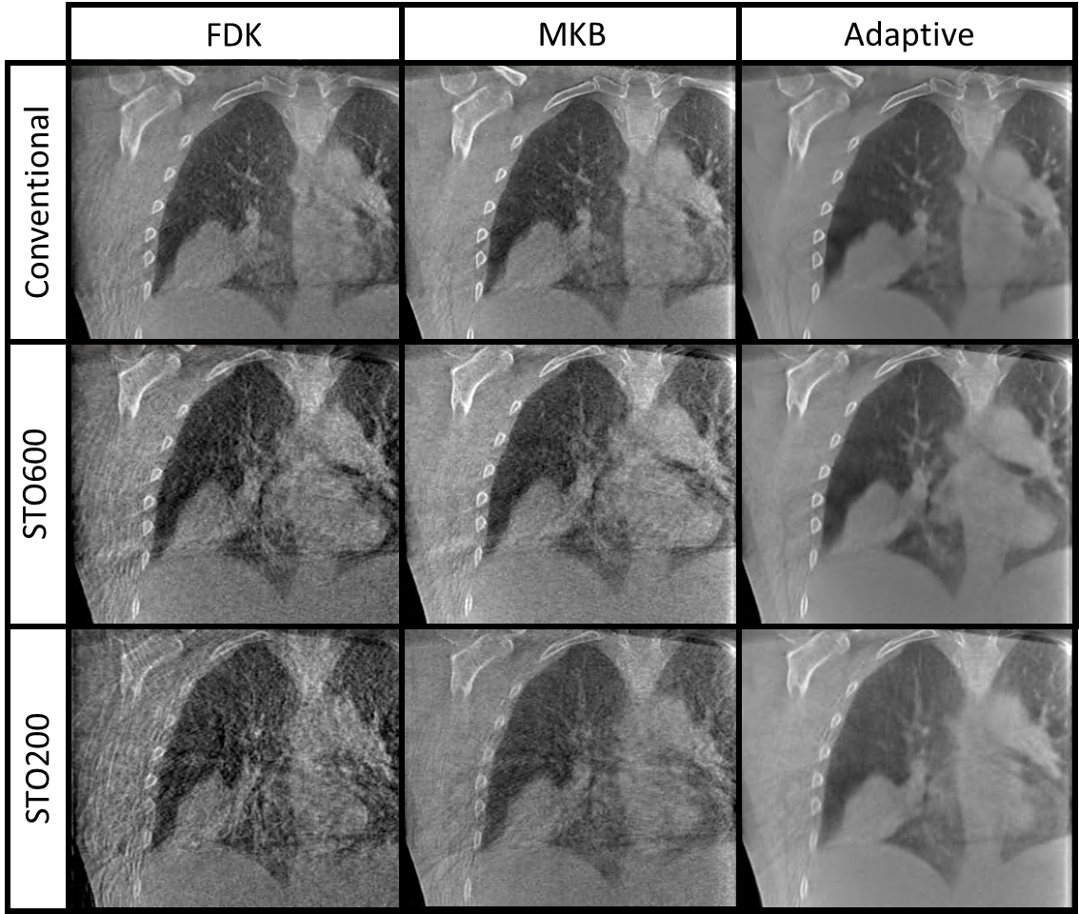

Appendix Figure 1: Comparison of acquisitions and reconstructions for an example patient. Note that all the conventional acquisition images appear to have similar image quality, likely due to filtered backprojection reconstruction quality saturating at this high number of projections. The impact of different reconstruction algorithms is most pronounced in the STO200 scan, where conventional FDK reconstruction image quality is noticeably low.

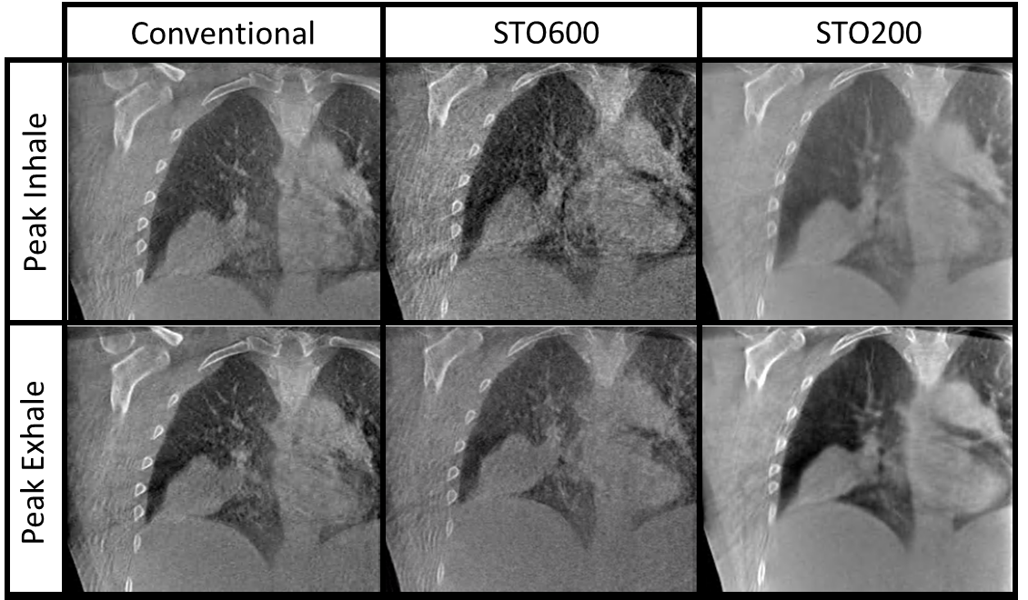

Appendix Figure 2: Comparison of conventional acquisition conventional reconstruction, STO600 acquisition conventional reconstruction, and STO200 acquisition adaptive reconstruction scans at peak inhale and peak exhale for an example patient. We can observe the approximate tumor shape and motion is preserved across the respiratory cycle for each scan, but note that the patients respiratory motion is expected to change somewhat over this timeframe and the patient has been moved after the conventional acquisition as part of regular treatment.

Appendix Figure 3: Comparison of conventional acquisition with conventional (FDK), McKinnon-Bates (MKB) and Adaptive reconstruction at peak exhale and inhale for an example patient. This figure is simply to illustrate that the different reconstruction algorithms have minimal impact on conventional acquisition data, with image quality likely limited by the assumptions of filtered backprojection reconstruction rather than the available number of projections.

Appendix Figure 4: Example of a patient observed to take shallower breaths over the course of treatment. Observe the diaphragm location, noting that these images are of the peak inhale state. Changes in motion of several millimeters over the course of treatment have been widely observed [37].

Appendix Figure 5: Patient with worst STO200 CNR relative to conventional scan. Observe that all scans have the same FOV so this is a relatively large patient, so we expect in general a lower CNR for a fixed kVp and mAs per projection as in our setup. The relative poor CNR of the STO200 image relative to the conventional image may be due to simple variation in CNR at low values, or the projection weighting during the filtered backprojection process not calculating accurately for the low available signal across few projections in the STO200 scan.