Assignment 2

Question 1:
See Image_question1.pdf. It’s a handwritten work.

Question 2:

- The activation function that I will choose for the output layer is linear activation because the given problem is a regression problem.

- The number of neurons in the output layer should be 1 because we are predicting only 1 output value.

- The MSE loss that I incurred while training with sigmoid function was 0.099. After testing, the cost was calculated to be 79.328.

- The plot for loss and accuracy for the number of iterations is given below:

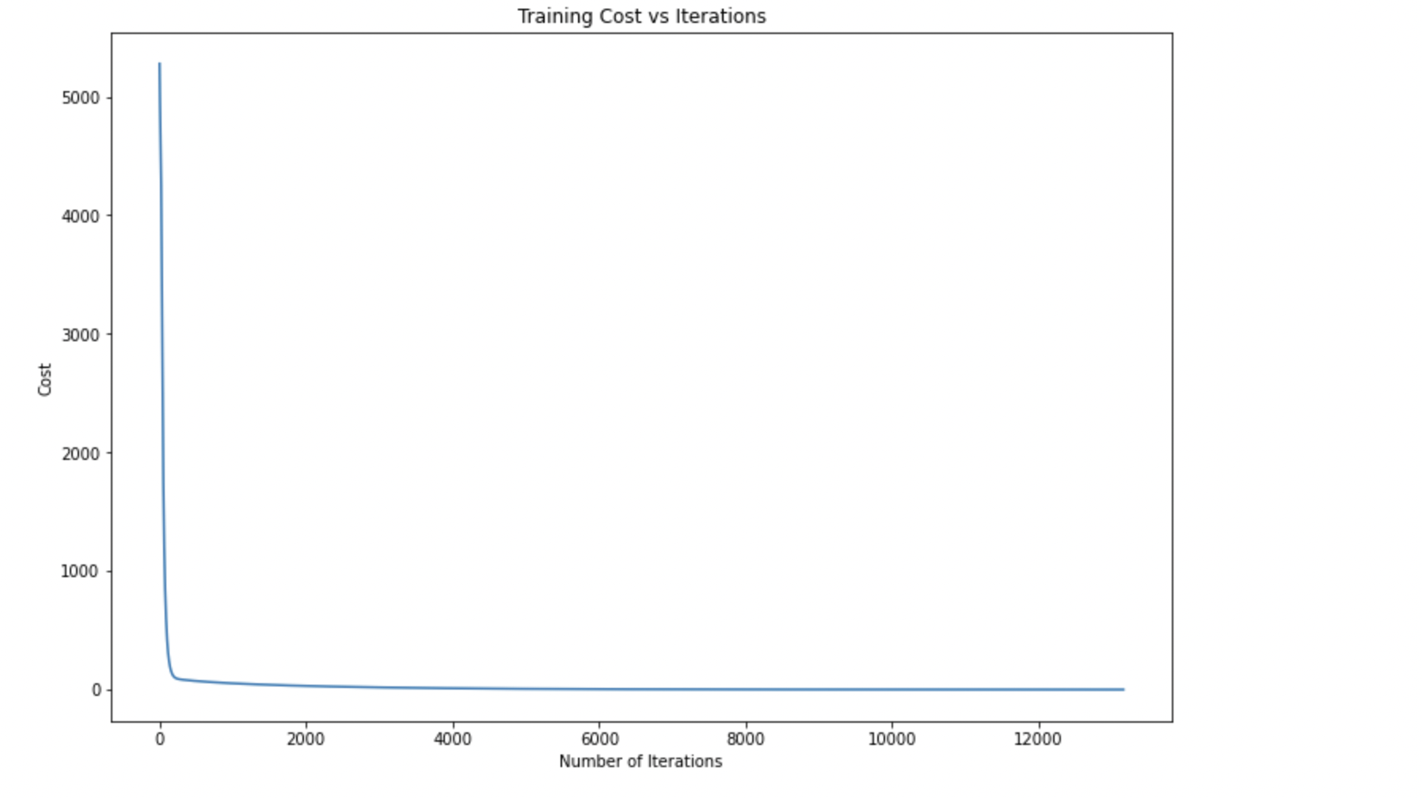

- The learning rate affects the cost, and also the rate at which it converges. I observed that the lesser the learning rate, the lower the cost, as you can see from the plot below:
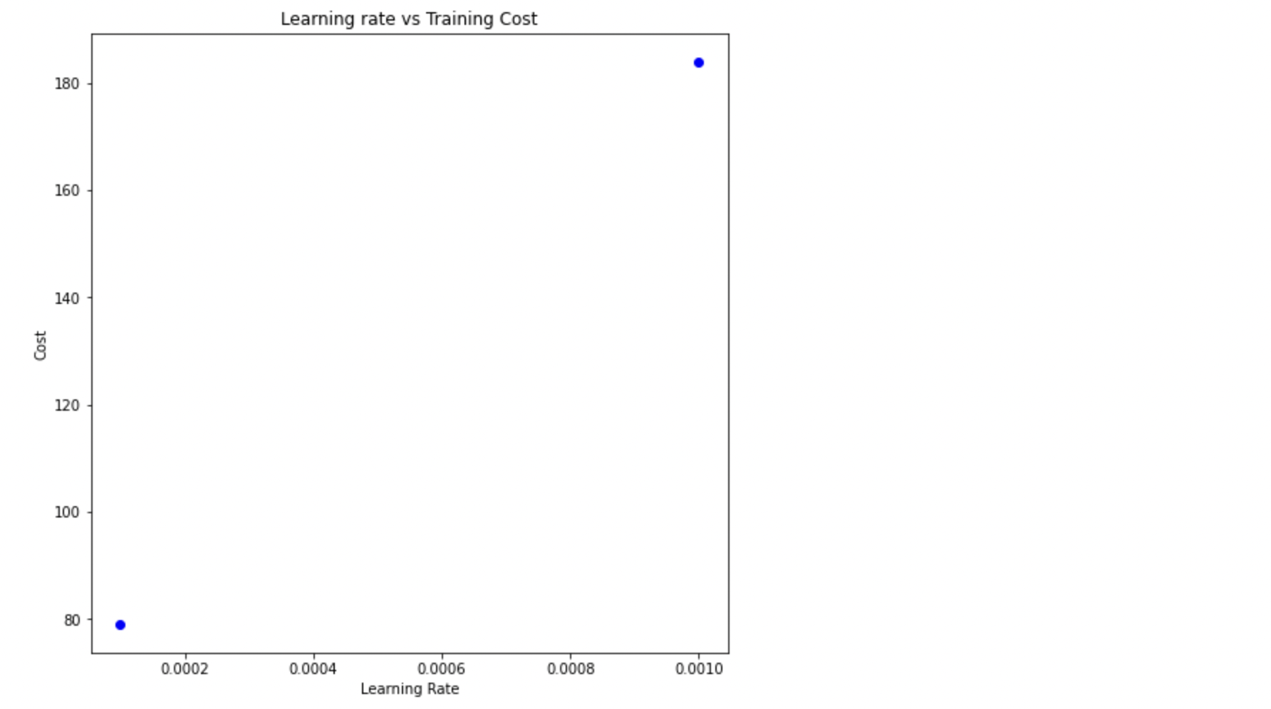

- The number of neurons affect the cost. I observed that when I increased the number of neurons, the cost started going down. The plot for the cost, and the number of neurons is given below. It shows the graphical representation between number of neurons (1 to 10) and cost.

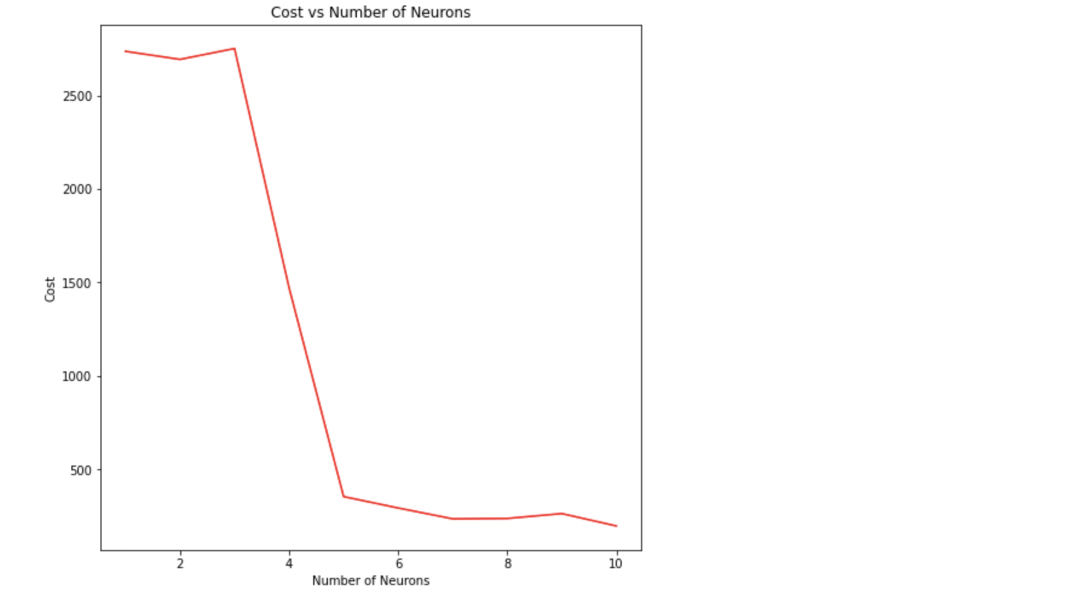
- The update rule does not need to be changed, as we are following a similar approach for all activation functions. i.e. finding the gradient, multiplying it by the learning rate, and subtracting it from its weight.
- The training cost while using sigmoid was calculated to be 0.009.
Likewise, after testing, the test model cost for sigmoid activation was 79.329.
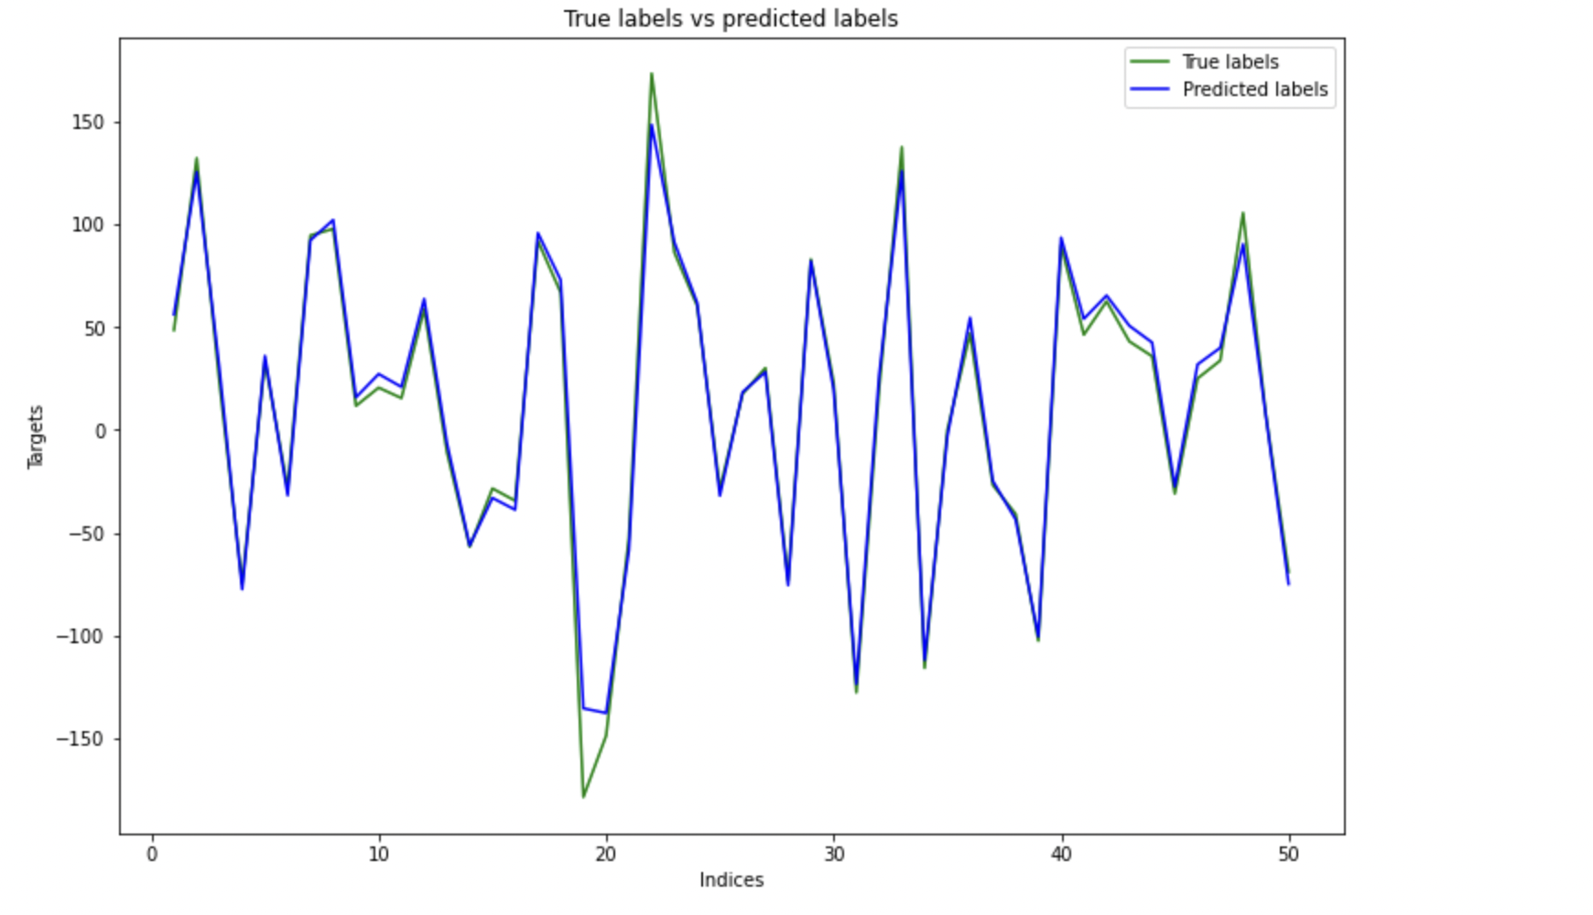

- The activation function is important in a neural network because it essentially decides whether a neuron is active or not, and if it’s transferred to the next layer. The two activation functions that I have used are Linear activation, and Tanh activation functions.
- The update rule does not need to be changed, as we are following a similar approach for all activation functions. i.e. finding the gradient, multiplying it by the learning rate, and subtracting it from its weight.
- To achieve this experiment, we have to define an activation function for tanh, and linear, followed by functions for forward and backward propagation.
- Linear activation:
The training cost while using linear activation was calculated to be 0.855.
Likewise, after testing, the test model cost for linear activation was 50.567.
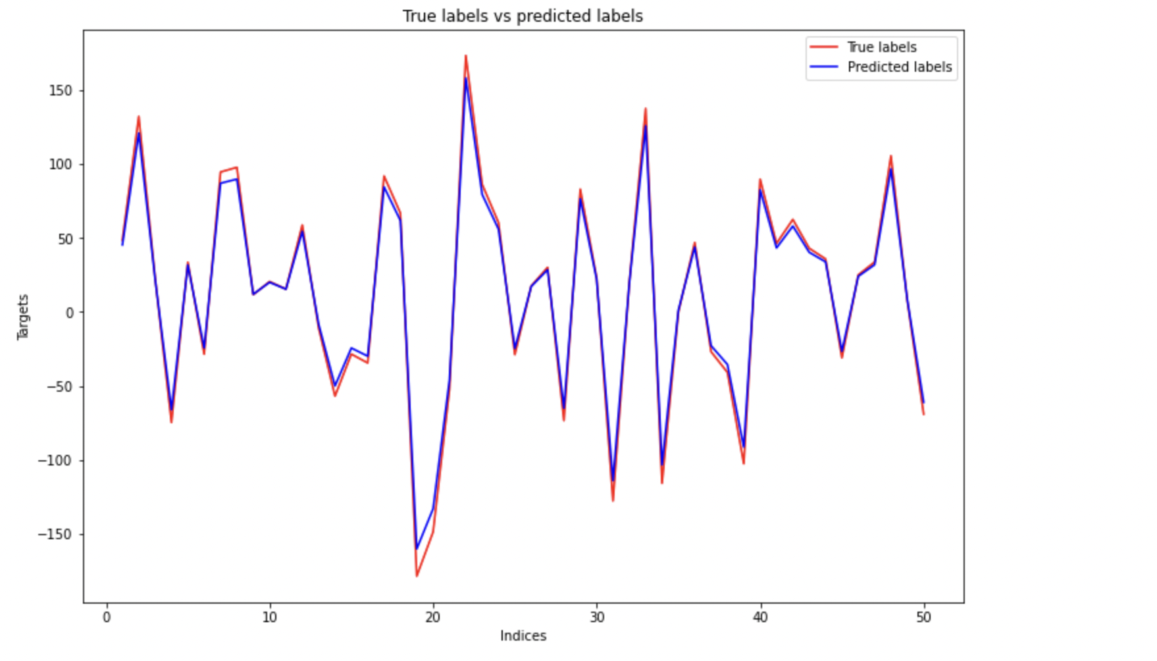
Tanh activation:
The training cost while using tanh activation was calculated to be 0.099.
After testing, the test model cost for tanh activation was calculated to be 197.83
