Exercise 6A: Analyzing Websites with CRAP

Your Name: Kat Hanlon

# Overview

So, you've been web surfing for quite some time now, and you've undoubtedly found some pages that you like and others that you don't like. Sometimes, it's not so easy to really explain why. You now have a new vocabulary with which to describe your thoughts on the matter.

# Part 1: Group Evaluations

1. Follow this link using the browser of your choice.

**http://www.rochesterfirst.com/**

1. Examine this site… at least the first page and a couple of links to sub-pages (pages that are part of the same site).
2. Summarize your opinions and why you came to them here:
   1. Alignment:

They had a decent start on alignment by sorting it into two columns well within the page bounds. However, the left column then switches between using the full width of it as a single column, and breaking it up into another separate column as well. Also, the ads break a lot of the alignment and although the different pages follow a general similar alignment, not all of them do completely. Also, things are so close they tend to overlap at times.

* 1. Proximity:

For the amount of space that they have available, with having the initial header go all the way across the screen, I feel that they could have spaced out the main content a bit more, and separate the columns, so that it is not as cramped and hard to read.

* 1. Repetition:

The header makes for a good use of repetition for keeping their site together. However, they also repeat things that they do not need, such as having the sections menu along with the broken down sections in a separate horizontal menu. They also do seem to have picked a blue and white theme to stick to and implement, however, most of their content breaks and distracts from that repeated color scheme.

* 1. Contrast:

As mentioned previously, the content that they have breaks the blue and white color scheme that they have, and creates a harsh contrast. It hurts my eyes to look at as there is an overload of information and colors all fighting each other. The weather in the header is also hard to read because of the white text on the light and dark blue pictured background in the header. The darker blue box with the white text, such as the section in the header, is more of a decent attempt at one.

* 1. Use of color

I am glad they tried to have a blue/white color scheme, however, the content that they have breaks all of that by implementing and bringing a bunch of other colors onto the page without anything containing them, and breaking them off to show they are different. Since they do it this way, the other colors bleed into the rest of their design and are placed all over the page enough it takes away from the page’s visuals.

* 1. Use of typography

They do make good/decent use of having multiple different level headings and normal text, however, the style of the text is a problem. Because of all the different brought in content, the page is filled with many different text fonts and styles, which could potentially lead to confusion and be distracting for the user.

1. Now go into myCourses, into the **Design Principles** discussion, and tell the class your opinions on the design of **http:// rochesterhomepage.net/**.(HINT: You just wrote them in step 3). Each of you should post your thoughts individually – not as a group.
2. After you post your review, read the other student comments about this site. Choose one other student review and summarize below:
   1. Author of message you’re summarizing: Mychal Hunt
   2. Alignment:
      * The alignment is a hit or miss, good in some places, but not in others. A bar on the “community” page under “Don’t Miss” transitions into something that is the same size just about. But not so bad.
   3. Proximity:
      * Generally, the proximity is good, similar things are together, but the ads makes it kind of weird and breaks the proximity at times.
   4. Repetition:
      * It is effective, but not productive. The site looks the same in terms of boxes and information but it has no flair and is not pleasing.
   5. Contrast:
      * The contrast is bad. It is an unfocused mass of information as everything is pretty much the same color and size without much difference between elements. It all jumbles together.
   6. Use of color:
      * The color is unified, but the endless shades of blue is boring, but not necessarily bad, but not great. It’s good they do not have too many colors on one page though.
   7. Typography
      * The typography is bad. There is lots of text everywhere, and nothing is interesting, just bland boring masses of text.
3. Do you agree or disagree with this person about the design elements of the page in question (Why?)

I agree and disagree. I agree that the alignment is a hit or miss and that the ads ruin the page. I also I agree that the repetition and ugly contrast is pretty much there. However, I disagree on the use of color and typography. I think they needed more colors to match the videos and other content or find a way to contain/separate those content/colors to keep it separated from their blue/white theme. Also, while the clutter of text may be a problem, I also had a problem with so many different styles of text that the videos/articles/ads all brought in and created a confusing mess that was quite frankly distracting and disorienting.

1. Reply to their post (politely) to discuss your agreements and disagreements.

# Part 2: Design Critiques

Pick a web site ***you don’t like*** (in terms of design), and a web site you ***do***, and describe/critique each using the forms attached to this handout. If you are having trouble finding a bad site, try using a random link generator such as:

http://www.uroulette.com/ or   
http://www.randomwebsite.com/

# Part 3: Individual Critiques

Pick a color scheme for your own class page and describe it below. (Describe your color scheme in terms of what color(s) you will use for each element.) Feel free to make these determinations as a team.



I will use the red for the navigation/footer backgrounds, the tan for the main background color, black for plain text and boxes, and the light purple/blue/green for spices of pastel colors in different places all around as well as for text links and used in the header.  
  
  
Now, use the space below to sketch an improved layout for your page. Again, work with your neighbors to come up with something really great! A simple wireframe drawn up in the app of your choice, or a hand sketch either scanned or photographed with a phone would be fine.

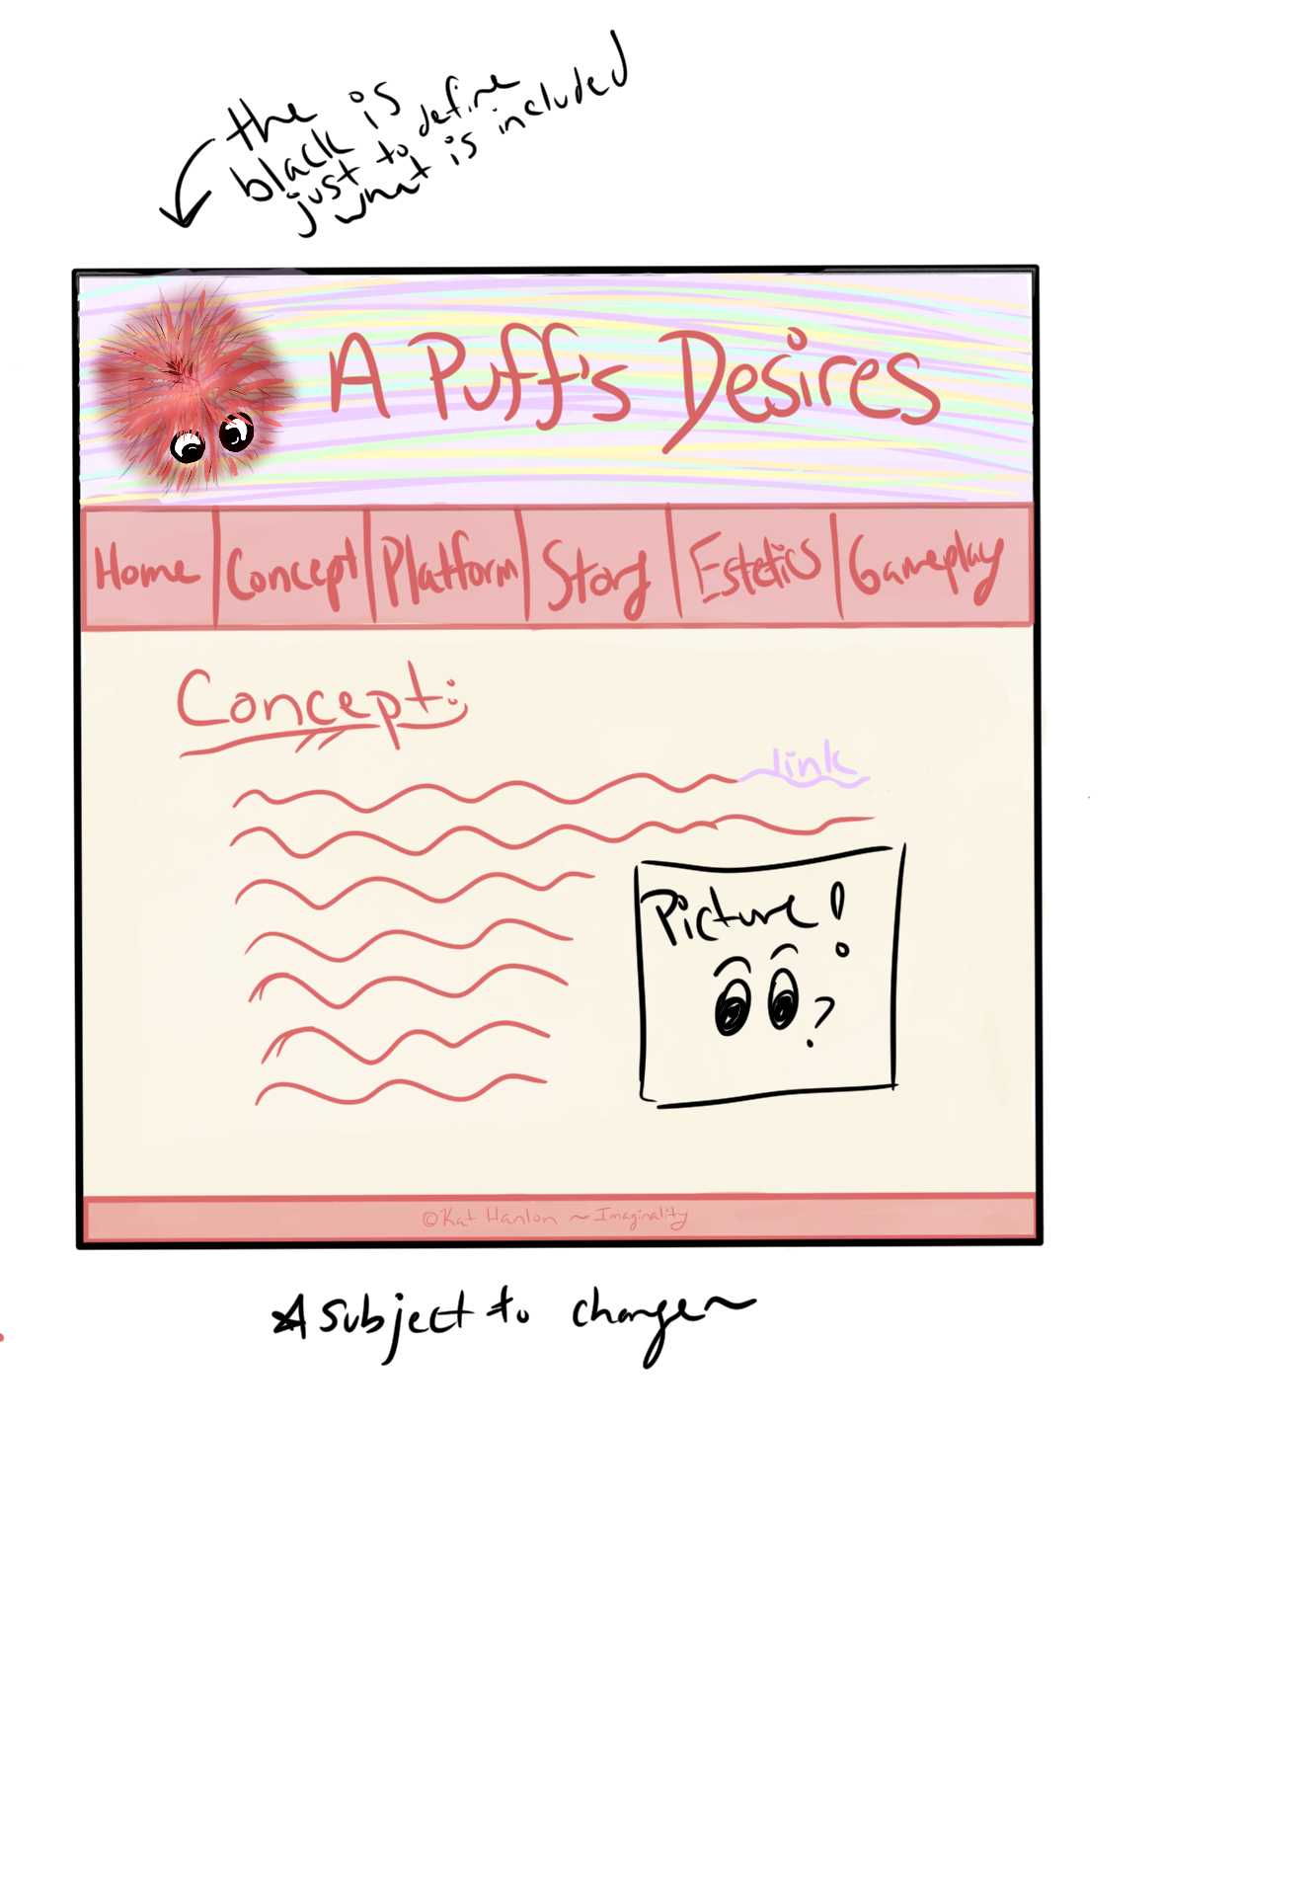

|  |
| --- |
| **bad site:** [**http://inetprivacy.com/a4proxy/**](http://inetprivacy.com/a4proxy/) |
| **Alignment:** How many different styles of alignment can you see on this page? Describe them:  There are four types of alignment that I can see on the page. The header and is stretched across the game, left aligned. The footer is stretched across the page and center aligned, as well as the bottom image being center aligned. The box on the right is right aligned and the main text is left aligned and goes until it hits the box then goes under the box.  Where is the strongest alignment line on this page? Why?  The strongest alignment line on the page is the left align as the main text is using that as well as the tri-colored header. |
| **Proximity:** Identify two elements of this site that, due to their proximity, appear to have a relationship.  Two elements that appear to have a relationship is the iNetPrivacy Software and Internet Privacy & Data Security Solutions due to both of them being at the top of the page within the time thin strip of the black box header.   Identify information at this site that "hangs" alone.  There is not really any information that hangs alone on the page as it as all crammed into the top half of the page, the text all but hits the box next to it. I wish things had more space for themselves. |
| **Repetition:** Does the repetition on this page draw attention to anything particular? What?  The only repetition that draws my attention is the green in the 3rd header bar and the green in the right box navigation.    Describe the repetitive element(s) used to the best advantage on this site.  The repetitive element that is used the best would have to be that they made all the links within paragraphs of text the same and easily distinguishable. |
| **Contrast:**  Identify the strongest area of contrast at this site.  The best area of contrast on this page is that the text is clearly visible against the background color of the page and that the links within the paragraph of text are easily differentiated from normal text.  Are there areas of this site that seem "muddy" or run together because of a   lack of contrast? What are they?  The areas that seem muddy are the header and the box navigation on the right. The header has to many sections all smushed together and contrasted in lines. For the box on the right, I wish it had lines or something separating the different choices within each section. |
| **Color & Type:**  Does the use of color and type on this page enhance or detract from   the content? How?  The use of type and color detract from the page. There is little use of bolding or headers, the right box navigation uses none of that. Also, the colors on the navigation systems, top and right side, draw too much attention from the actual page content. |

**Additional Notes:** I just really disliked this site, it hurt my eyes and I could barely focus on the content versus the navigation bars and box.

|  |
| --- |
| **good site:** [**http://sd.gov/governor/**](http://sd.gov/governor/) |
| **Alignment:** How many different styles of alignment can you see on this page? Describe them:  I can see two different types of alignment on the page. There is a two column system contained within a centered, stretched across the page alignment.  Where is the strongest alignment line on this page? Why?  The strongest alignment on the page is the stretched across, center aligned content, as that is what there is the most of. |
| **Proximity:** Identify two elements of this site that, due to their proximity, appear to have a relationship.  Two elements that appear to have a relationship due to their proximity is the Recent News section and the Quick Links sections as they are side by side and the only things using a column system.   Identify information at this site that "hangs" alone.  Information that seems to hang alone is the section just above the Recent News/Quick Links, the slideshow of info that is above it. |
| **Repetition:** Does the repetition on this page draw attention to anything particular? What?  The repetition of the darker blue-gray color draws your attention to the headers and navigation bar.   Describe the repetitive element(s) used to the best advantage on this site.  I believe the repetitive element used the best is the color, their colors even go with and match their pictures which makes me happy and calm. |
| **Contrast:**  Identify the strongest area of contrast at this site.  The strongest area of contrast is their pictures against the other elements that add a subtle spice of color and life to the page.  Are there areas of this site that seem "muddy" or run together because of a   lack of contrast? What are they?  There are no areas really lacking contrast or that seem muddy to me. |
| **Color & Type:**  Does the use of color and type on this page enhance or detract from   the content?  The use of color and type definitely enhance the content. The type used makes it seem official, as it as a site for a governor, and the colors are calming, with splashes of color and spice from the pictures, and are generally pleasing on the eye. |

**Additional Notes:** When I shrunk the width of the page I liked some of their choices about resizing and placement. If they made it responsive I would love it even more, once I realized it was not, it moved to “eh”.

When you're all done, post this completed file, renamed **Exercise-CRAP-YOURNAME.docx**, to the appropriate dropbox before next class.